


ANC350 Piezo Motion Controller

EPICS Developers Manual

Issue:  Date: | 2  15th April 2009

 | NAME | DATE | SIGNATURE
Prepared by | Alan Greer, Observatory Sciences Ltd. | 15 April 2009
Checked by | Philip Taylor, Observatory Sciences Ltd.
Released by

TABLE OF CONTENTS

1 Scope 3
2 Reference Documents 3
3 Introduction 4
4 Requirements 4
4.1 Hardware Requirements 4
4.2 Software Requirements 4
5 Installation 5
5.1 Installing Under Linux 5
5.2 Installing Under Windows 6
6 Running the Test Application 7
6.1 Running the EPICS Database 7
6.2 Running the EDM Screens 8
6.3 Global EDM Screen 9
6.4 Stepper Module EDM Screen 10
7 Using the Device Support Code 11
7.1 Configuration of EPICS Records and Application 11
8 Motor Record Support 15
8.1 Motor Record Database Configuration 15
8.2 Using the Motor Record with the ANC350 16
Appendix A. Commands And Status Memory Locations 18

Scope
This document describes the installation and use of EPICS device support code for the Attocube Systems’ Piezo Motion Controller (ANC350). The ANC350 electronics is a closed loop positioning and scanning system which can be used for up to six nano positioners and scanners. It can be controlled directly from the front panel or through a USB or ethernet interface. This document describes the EPICS software written to control the unit via the ethernet interface.

Reference Documents
- IOC Application Developer’s Guide, Marty Kraimer et al.
- EPICS R3.14 Channel Access Reference Manual, Jeffrey O. Hill.
- attocube systems’ Piezo Motion Controller User Manual, attocube systems.
- asynDriver: Asynchronous Driver Support, Marty Kraimer, Eric Norum and Mark Rivers.
- Motor Record and related software, Tim Mooney, Joe Sullivan, Ron Sluiter.

Introduction
The ANC350 EPICS software module contains device support code for longin and longout records to be used with an ANC350 motion controller (and associated boards). The device support code allows all command and status requests to be issued through these two records; longin records are used to request data and longout records are used to send commands (with data if necessary). The module contains two EPICS database template files, one for global control and one specifically designed to drive a stepper positioner. Also contained are edm screens that can be used to interact with a database generated by the template database files. A demonstration application is provided, set up to work with an ANC350 controller and three stepper boards.

EPICS motor record support is also provided. Although this removes the ability to fully control all aspects of the controller, it provides a well-recognized interface to drive the stages as if they were motors.

Requirements
This section details the hardware and software requirements for using the ANC350 EPICS device support code.

Hardware Requirements
The following hardware is required to run the device support code:
- Standard PC with an ethernet port.
- ANC350 present on the network. For operation with the EPICS device support code the ANC350 should be configured to have a static IP address.

Software Requirements
The following software is required to run the driver and device support code:
- Linux or Microsoft windows operating system. The device support code has been written using general asyn and EPICS base function calls and methods and as a result will be fully functional on any system that can compile the required versions of EPICS base and the asynDriver module. The device support code was written on CentOS 4.3 and tested on CentOS 4.3 and Windows XP.
- EPICS (version 3.14.8 or later)
- EPICS module ‘AsynDriver’ (version 4.10 or later)
- MSI extension for EPICS (version 5 or later). Required if building the supplied test application
- EDM to run engineering screens, if they are required.
- EPICS module ‘motor’ (version 6.4.2 or later) required to drive the axes using the standard motor record.
- (Windows only) cygwin installed.

Installation

Installing Under Linux
This section will cover installation of the device support code for the ANC350 on a Linux operating system. Before performing the following installation, ensure that EPICS version 3.14.8 or later is installed and the asynDriver version 4.10 or later and the module motor version 6.4.2 or later have been installed.

Unpack the ANC350 tar file and cd into the top directory. In here you will see the following files and directories:

Directory | Description
anc350App | This directory contains the device support code, a template database for a stepper module and a template edm screen to use with the database template.
ancTest350App | This directory contains a test application. A substitutions file sets up a system configured for an ANC350 with three stepper modules.
anc350MotorApp | This directory contains the motor record interface code.
configure | The configuration directory.
iocBoot | The boot directory for the test application. It contains the startup script that defines the IP address of the ANC350 (see below).
Makefile
runTestApp | Linux only. Bash script to start the EPICS test application and run the edm screens.
runTestAppWin | Windows only. Script to start the EPICS test application.
runGUI | Linux only. Bash script to start the edm application and open the test edl screen.

Before making the application it is necessary to add references to the EPICS installation and the asyn installation. Cd into the configure directory and edit the RELEASE file. Update the lines that define the location of the asyn installation and the motor module to point to wherever these modules are installed on your system. For example

ASYN=/usr/software/epics/asyn-4.10
MOTOR=/usr/software/epics/motor-6.4.2

Also update the line that defines the location of your EPICS installation. For example

EPICS_BASE=/usr/software/epics/base-3.14.8.2

Save any changes and exit. Cd back up to the top level. Finally the host architecture must be defined before the build can commence. From a terminal enter the following line:

export EPICS_HOST_ARCH=linux-x86

There is a test application supplied with the device support code. If this is to be used then the startup script should be altered. Cd into the iocBoot/iocancTest350 directory. Edit the st.cmd file and update the line that configures the asyn IP port with the IP address of the ANC350 unit on your network.

drvAsynIPPortConfigure(“IP1”,“10.2.2.71:2101”,0,0,0)

Now cd back to the top level and type make to build the device support code and the test application. The build should complete with no errors.

Installing Under Windows
This section will cover installation of the device support code for the ANC350 on a Windows operating system. Before performing the following installation, ensure that EPICS 3.14.8 or later is installed and the asynDriver version 4.10 or later has been installed. For the ANC350 test these were both installed using the cygwin (Linux-like) environment and the gcc compiler (version 3.4.4 for cygwin). All instructions in this section assume the developer is also using the cygwin environment and associated tools (www.cygwin.com).

Open a cygwin terminal and unpack the ANC350 tar file. Cd into the top directory. In here you will see the following files and directories:

Directory | Description
anc350App | This directory contains the device support code, a template database for a stepper module and a template edm screen to use with the database template.
ancTest350App | This directory contains a test application. A substitutions file sets up a system configured for an ANC350 with three stepper modules.
anc350MotorApp | This directory contains the motor record interface code.
configure | The configuration directory.
iocBoot | The boot directory for the test application. It contains the startup script that defines the IP address of the ANC350 (see below).
Makefile
runTestApp | Linux only. Bash script to start the EPICS test application and run the edm screens.
runTestAppWin | Windows only. Script to start the EPICS test application.
runGUI | Linux only. Bash script to start the edm application and open the test edl screen.

Before making the application it is necessary to add references to the EPICS and installation and the asyn installation. Cd into the configure directory and edit the RELEASE file. Update the lines that define the location of the asyn installation and the motor module to point to wherever these modules are installed on your system.

ASYN=/usr/software/epics/asyn-4.10
MOTOR=/usr/software/epics/motor-6.4.2

Also update the line that defines the location of the EPICS installation.

EPICS_BASE=/usr/software/epics/base-3.14.8.2

Save any changes and exit. Cd back up to the top level. Finally the host architecture must be defined before the build can commence. From a terminal enter the following line:

export EPICS_HOST_ARCH=cygwin-x86

There is a test application supplied with the device support code. If this is to be used then the startup script should be altered. Cd into the iocBoot/iocancTest350 directory. Edit the st.cmd file and update the line that configures the asyn IP port with the IP address and port number of the ANC350 unit on your network (see Section 7.1). The example below shows an ANC350 on a network with the IP address 10.2.2.71 listening on port 2101. The details of the ANC350 IP and port configuration can be found in [RD3].

drvAsynIPPortConfigure(“IP1”,“10.2.2.71:2101”,0,0,0)

Now cd back to the top level and type make to build the device support code and the test application. The build should complete with no errors.

Running the Test Application
Once the system has successfully compiled on either a Windows or Linux OS the test application should be executed to ensure a connection to the ANC350 is completed.

Running the EPICS Database
There are two scripts contained in the top-level directory to start the application. For Linux, execute the script runTestApp. For windows execute the script runTestAppWin from within the cygwin Bash shell (see section 5.2). Below is an example of the output generated when the system is started on Linux.

[ajg@osllx8 anc350]$ ./runTestApp
#!../../bin/linux-x86/ancTest350
## You may have to change ancTest350 to something else
## everywhere it appears in this file
< envPaths
epicsEnvSet(ARCH,"linux-x86")
epicsEnvSet(IOC,"iocancTest350")
epicsEnvSet(TOP,"/home/ajg/applications/anc350")
epicsEnvSet(ASYN,"/usr/software/epics/asyn-4.10")
epicsEnvSet(ANC,"/home/ajg/applications/anc350")
epicsEnvSet(EPICS_BASE,"/usr/software/epics/base-3.14.8.2")
cd /home/ajg/applications/anc350
## Register all support components
dbLoadDatabase("dbd/ancTest350.dbd",0,0)
ancTest350_registerRecordDeviceDriver(pdbbase)
## Load record instances
#dbLoadRecords("$(ASYN)/db/asynRecord.db","P=OSL:,R=ASYN,PORT=IP1,ADDR=0,OMAX=0,IMAX=0")
dbLoadRecords("db/ancTest.db", "")
drvAsynIPPortConfigure("IP1","10.2.2.71:2101",0,0,0)
cd /home/ajg/applications/anc350/iocBoot/iocancTest350
iocInit()
Starting iocInit
############################################################################
### EPICS IOC CORE built on Sep 6 2006
### EPICS R3.14.8.2 $R3-14-8-2$ $2006/01/06 15:55:13$
############################################################################
iocInit: All initialization complete
## Start any sequence programs
#seq sncxxx,"user=ajgHost"
epics>

Once the startup is complete and the records loaded the ANC350 can be controlled by setting various records present in the database.

Running the EDM Screens
To allow fast testing some edl engineering screens have been added; these can be started on Linux by executing the script runGUI present in the top-level directory. The screens can be converted to other formats (http://www.aps.anl.gov/epics/) if required to run on Windows but this has not been done within the ANC350 module as the edl screens can be run on Linux and will connect to an IOC running on Windows.

Once started the user is presented with the main screen. From this screen individual stepper control screens can be opened as well as the global control screen. The test application contains records for three steppers and each is represented on this display.

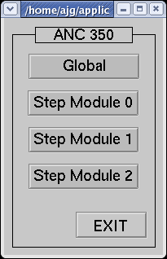
Figure 1 Main edl screen

Clicking on the global button opens the global parameters screen.

Global EDM Screen

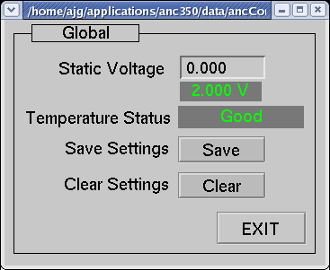
Figure 2 Global parameters screen

This contains an input for altering the static voltage. This is the reference voltage applied to the resistive readout system. The voltage can be set from 0.001 to 2.000V. The current voltage is displayed immediately below the input. Below the voltage indicator is another indicator displaying the temperature status. There are also buttons to save or clear the current settings.

Stepper Module EDM Screen
From the main display clicking on one of the step module buttons opens the step display for the corresponding step module.

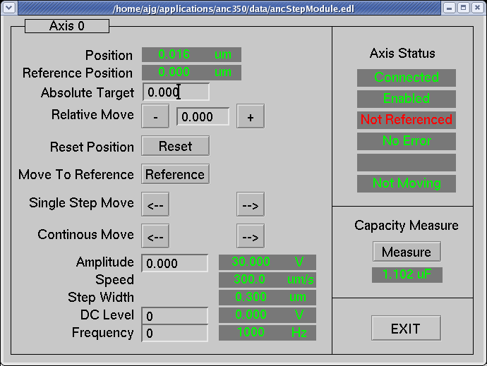
Figure 3 Step module screen

The screen presents the following indicators and controls:

- Position. This indicator displays the current position of the positioner connected to the respective axis followed by the unit of this value.
- Reference. Each /NUM positioner (see ANC350 manual) has its individual reference position, a physical marker on the grating. The displayed value corresponds to the distance between the reference position and the currently set zero position. To get the reference position after starting the system, the positioner has to travel over the marker only once.
- Absolute Target. Entering a value here will result in the positioner moving to this value. The move is executed immediately.
- Relative Move. Entering a value in here sets up a relative movement step size. To move the positioner by either the +ve or –ve amounts click on the corresponding button.
- Reset Position. Resets the current position to zero. This results in a loss of the reference position.
- Move To Reference. Moves the positioner to the reference.
- Single Step Move. Click either of these buttons to move the positioner by a single step.
- Continuous Move. Click and hold either of these buttons to move the positioner continuously. The positioner will move until the button is released.
- Amplitude. Value for the drive voltage of this Piezo. By changing this value the step size of the positioner can be varied. The allowed voltage values range from 0V to 70V.
- Speed. Indicates the positioner’s current travel speed.
- Step Width. Indicates the positioner’s current step size.
- DC Level. The applied DC voltage to the Piezo.
- Frequency. Here the desired frequency can be entered with which the positioner should move in the manual positioning mode.
- Axis Status. This consists of six indicators:
  - 1. Green if the positioner is connected.
  - 2. Green if the axis is enabled.
  - 3. Green if the positioner is referenced.
  - 4. Green if there are no errors in the signal of the sensor.
  - 5. This contains red text (hump detected) if the positioner reaches a mechanical end stop.
  - 6. The status of the positioner (moving or not moving).
- Capacity Measure. Clicking on the Measure button determines the actual capacitance of the connected positioner. The value is displayed in the indicator directly below the button.
- Exit. Click on this to close the screen.

Using the Device Support Code
The simple test application described in section 6 only presents a small subset of the possible commands and status items available through the ethernet interface of the ANC350 motion controller. Application developers are likely to want to create their own databases of records; this section explains what is required to use the device support for the ANC350.

Configuration of EPICS Records and Application
The ANC350 uses only long values when writing to and reading from its memory locations. Therefore only two record types are required to use the device support; they are the longin and longout record types. Longin records are used to request data from the controller and Longout records are used to issue commands.

To set up a record for use with the ANC350 ensure the devAnc350.dbd file has been included in the build. Set the DTYP field of the record to “ANC350”. Then the OUT or INP links need to be configured with the following information:

- Port Name. This must be the same name that is set in call into asyn in the startup script (see below). This is used by the asyn layer to ensure the record attempts communication with the correct controller.
- Signal Number. This is either the number of the axis for axis specific commands/requests, or zero for global commands/requests. It must be prefixed with the letter ‘S’.
- Memory Address. This is a hexadecimal format number that represents the location in the ANC350 that should be written to/read from. A complete listing of the locations and their description can be found in Appendix A.

As an example, to read the current position of axis 0 you would use a Longin record and could set the INP link to

@$(PORT) S0 0x0415

$(PORT) would need to be replaced with the name of the port created through asyn registration.

Two template database files are included with the device support code and they present many examples of the use of Longin and Longout records to read and set the data inside the ANC350.

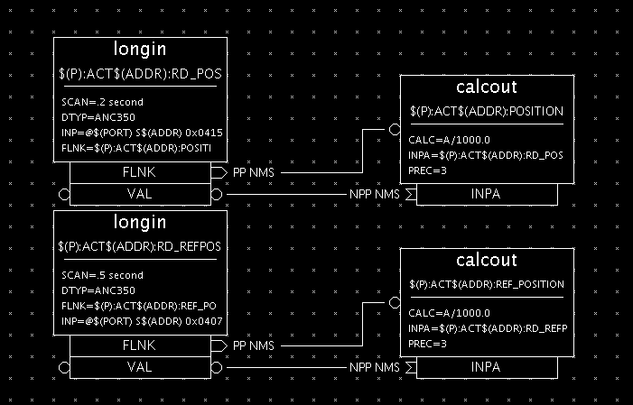
Figure 4 Reading the position and reference position from the ANC350

As well as setting up the necessary records there are some libraries that need to be added into the source Makefile of the application (found in the directory <appName>/src/ ). Figure 5 shows the complete source Makefile used for the test application supplied with the ANC350 device support code.

TOP=../..

include $(TOP)/configure/CONFIG
#----------------------------------------
# ADD MACRO DEFINITIONS AFTER THIS LINE
#=============================

#=============================
# build an ioc application
PROD_IOC = ancTest350

DBD += ancTest350.dbd
# ancTest350.dbd will be made up from these files:
ancTest350_DBD += base.dbd
ancTest350_DBD += asyn.dbd
ancTest350_DBD += drvAsynIPPort.dbd
ancTest350_DBD += devAnc350.dbd

# <name>_registerRecordDeviceDriver.cpp will be created from <name>.dbd
ancTest350_SRCS += ancTest350_registerRecordDeviceDriver.cpp
ancTest350_SRCS_DEFAULT += ancTest350Main.cpp
ancTest350_SRCS_vxWorks += -nil-

#The following adds support from base/src/vxWorks
ancTest350_OBJS_vxWorks += $(EPICS_BASE_BIN)/vxComLibrary

# Include the following libraries in the build
ancTest350_LIBS += asyn
ancTest350_LIBS += anc350
ancTest350_LIBS += $(EPICS_BASE_IOC_LIBS)

#===========================

include $(TOP)/configure/RULES
#----------------------------------------
# ADD RULES AFTER THIS LINE
Figure 5 Source Makefile for ANC350 test application

Finally, an asyn IP port must be configured at startup to connect to the ANC350 device; for this the IP address and port number of the device must be known. For the test application the startup script is shown below.

#!../../bin/linux-x86/ancTest350

< envPaths

cd ${TOP}

## Register all support components
dbLoadDatabase("dbd/ancTest350.dbd",0,0)
ancTest350_registerRecordDeviceDriver(pdbbase)

## Load record instances
dbLoadRecords("db/ancTest.db", "")

drvAsynIPPortConfigure("IP1","10.2.2.71:2101",0,0,0)

cd ${TOP}/iocBoot/${IOC}
iocInit()
Figure 6 Startup script for the ANC350 test application

The drvAsynIPPortConfigure function call sets up the asyn port. For detailed information see the asyn manual ([RD4]). The first argument supplied is the name of the port; this defines the port name that should be used in all longin and longout record INP and OUT fields. The second argument is a string that contains the IP an address and port number to connect to. A colon separates these. The next argument is the priority; a value of 0 indicates the use of epicsThreadPriorityMedium. The next argument is the “auto connect” argument and a value of 0 here ensures the asyn layer automatically connects to the port. The last argument is the noProcessEos argument. These arguments can of course be configured as required.

Motor Record Support
This section deals with using the motor record to drive individual axes on the ANC 350. When creating a new application ensure the asyn, motor and anc350 modules are all included in the configure/RELEASE file. To initialise the anc350 module the following lines should be added to the startup script (st.cmd).

drvAsynIPPortConfigure("IP1","10.2.2.71:2101","0","0","0")
anc350AsynMotorCreate("IP1","0","0","1")
drvAsynMotorConfigure("ANC1", "anc350AsynMotor","0","1")

The first line configures the asyn layer to communicate with the ANC 350 over an ethernet connection. This requires a name for the connection, followed by the IP address and port number of the ANC hardware. After this there are some configuration parameters that can be left at zero. For a full description of this function call see the asyn driver manual [RD4].
The second line creates the ANC 350 specific device driver. Its first argument must be the same name supplied to the previous function call. The address and card number follow this. Finally the number of axes should be supplied to this call. In the example above the device has been created with only a single axis.
The third and final call required sets up the motor record device support layer for the motor record. The first parameter can be any name assigned to this device (the name is used in the motor record itself, see below). The next parameter must be “anc350AsynMotor”. This ensures the motor device support uses the ANC 350 driver functions to attempt communications with the axes. The final two parameters supplied to this function call are the card number and the number of axes.

Motor Record Database Configuration
To add motor records to a database in the application simply add an entry to a suitable substitutions file that makes use of the motor record template. Foe example:

file ${MOTOR}/db/basic_asyn_motor.db {
pattern
{P, M, DESC, DTYP, DIR, VELO, VBAS, ACCL, BDST, BVEL, BACC, PORT, ADDR, MRES, PREC, EGU, DHLM, DLLM, INIT}
{T1:, M1, Desc, asynMotor, 0, 300.0, 50.0, 1.0, 0.0, 0.0, 0.0, ANC1, 0, 0.001, 3, um, 5000.0, -3000.0, 0}
}

The example substitution file above resulted in the following motor record

record(motor,"T1:M1")
{
field(DESC,"Desc")
field(DTYP,"asynMotor")
field(DIR,"0")
field(VELO,"300.0")
field(VBAS,"50.0")
field(ACCL,"1.0")
field(BDST,"0.0")
field(BVEL,"0.0")
field(BACC,"0.0")
field(OUT,"@asyn(ANC1,0)")
field(MRES,"0.001")
field(PREC,"3")
field(EGU,"um")
field(DHLM,"5000.0")
field(DLLM,"-3000.0")
field(INIT,"0")
field(TWV,"1")
}

The most important field is the “OUT” field. This must be set to point to the ANC 350 motor support. This is achieved by setting the value to ’@asyn(ANC1,0)’. The ANC1 should match the name defined in the startup script and the number after this represents the axis number (from 0 to n-1 axes).

Other motor record configuration is beyond the scope of this document: for further details, consult the documentation [RD5].

Using the Motor Record with the ANC350
Specific features available when using the ANC350 with the motor record include the following:
- Velocity. Changing the velocity will result in a change to the frequency of the axis. All axes are always driven in speed closed loop mode and so the change in frequency effectively changes the velocity.
- Jog. The motor can be jogged at a constant velocity in either direction.
- Move. Absolute and relative moves can be made.
- Referencing. The motor can be referenced. This will result in the axis searching for its reference mark. Once found the axis will stop moving and its position reset to zero. It is important to note that the ANC 350 hardware does not reset the actual count value for the device to zero when it crosses its reference mark: it simply remembers the count value at that position. The ANC 350 motor record support internally subtracts this saved reference position value from the actual value once the homing procedure is completed, ensuring that the position is always zero whenever the axis is positioned at the reference mark.
- Units. The motor record described above is set up to use um as the default unit. If the units were changed within the ANC controller then the motor record would need to be updated accordingly (EGU, PREC, MRES).

The figure below shows an example of a motor record running with an ANC 350 controller with a single axis.

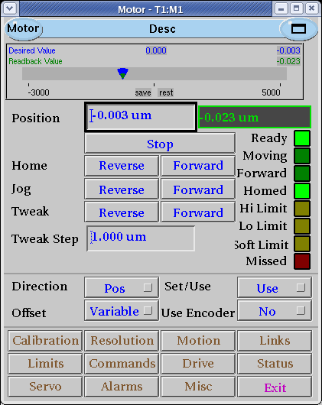
Figure 7 Motor record control screen example.

- Commands And Status Memory Locations

Below is a table of all commands and status locations within the ANC350. Any listed below that do not specify units are either simple on/off commands. Items that rely on the unit command (0x041D) have their units specified as [unit]. These units can be set by the unit command described below.
Most simple commands operate when the value is supplied as 1, and some commands turn off when the value is supplied as 0. For example, a continuous move starts when its value is set to 1, and will only stop when the value is set to 0.

Location | Global | Description
0x0404 |  | Read only. Provides information about the current states of an axis.  Bit 0 – Moving  Bit 1 – Hump detected  Bit 8 – Sensor error  Bit 10 – Sensor disconnected  Bit 11 – Reference valid  Bit 12 – Sensor disable
0x0560 | x | Temperature status. Value of 0 indicates temperature problem.
0x0415 |  | Read only. Position of a specific axis ([unit]). Value is scaled by a factor of 1000.
0x0516 |  | Read only. Count of rotations for position in case of rotator as positioner.
0x0407 |  | Read only. Reference position of the appropriate axis ([unit]). Value is scaled by a factor of 1000.
0x0517 |  | Read only. Count of rotations for reference position in case of rotator as positioner.
0x0441 |  | Read only. Minimum position for position limited positioners ([unit]). Value is scaled by a factor of 1000.
0x0442 |  | Read only. Maximum position for position limited positioners ([unit]). Value is scaled by a factor of 1000.
0x044F |  | Executes a reset of the position.
0x0408 |  | Defines the target position ([unit]). Value should be scaled by a factor of 1000.
0x0518 |  | Defines the count of rotations for the target position.
0x040D |  | Starts approach to the absolute target position (0x0408). Previous movement will be stopped.
0x0418 |  | Starts approach to a relative target position (0x0408). Previous movement will be stopped.
0x0444 |  | Starts approach to the reference position. Previous movement will be stopped.
0x0410 |  | Starts a one step position update in the forward direction. Previous movement will be stopped.
0x0411 |  | Starts a one step position update in the backwards direction. Previous movement will be stopped.
0x040E |  | Starts a continuous move in the forward direction.
0x040F |  | Starts a continuous move in the backward direction.
0x0400 |  | Set/read the amplitude (mV) for the positioner.
0x0542 |  | Set/read the speed of the positioner ([unit]/s). The value is scaled by a factor of 1000.
0x0549 |  | Set/read the step width of the positioner ([unit]). The value is scaled by a factor of 1000.
0x0514 |  | Set/read the DC voltage level (mV) of the positioner.
0x0401 |  | Set/read the frequency (Hz) of the excitation signal.
0x0447 |  | Switches the output relays of the amplifier.
0x051E |  | Starts a capacitance measurement.
0x0569 |  | Read only. The result of the capacitance measurement.
0x0526 | x | Read/set the reference voltage (mV).
0x050C | x | Sending a value of “1234” saves all parameters to controller flash. Sending a value of “4321” clears all parameters from flash.
0x0530 |  | Lower trigger threshold position ([unit]). Value is scaled by a factor of 1000.
0x0531 |  | Upper trigger threshold position ([unit]). Value is scaled by a factor of 1000.
0x0532 |  | Trigger polarity.
0x0533 |  | Number of assigned axis.
0x0534 |  | Epsilon ([unit]). Value is scaled by a factor of 1000.
0x0535 |  | Read only. Unit of trigger.
0x0568 |  | Switches bandwidth limitation. (Dither and scanner specific)
0x0561 |  | Switches the DC in connector. (Dither and scanner specific)
0x0563 |  | Switches the internal connection to the amplifier. (Dither and scanner specific)
0x0562 |  | Switches the AC in connector, only valid for dither axes.
0x0554 |  | Position loop range ([unit]).
0x054B |  | Gain of approach speed function in 1/s. The value is scaled by a factor of 1000.
0x054C |  | Enables approach speed function.
0x054D |  | Positioner offset (mV).
0x054E |  | Positioner gain ([unit]/V). The value is scaled by a factor of 1000.
0x054F |  | Maximum amplitude (mV).
0x0551 |  | Sensor direction (0: Forward, 1: Backward).
0x0553 |  | Number of periods per chosen unit for optical sensors ([unit]).
0x0544 |  | Average factor for speed feedback.
0x0545 |  | Average factor for position feedback.
0x053F |  | Sensitivity for speed feedback. The value is scaled by a factor of 1000.
0x0540 |  | Sensitivity for position feedback. The value is scaled by a factor of 1000.
0x053D |  | Positioner speed for target approach ([unit]/s). The value is scaled by a factor of 1000000.
0x053A |  | Positioner direction (0: Forward, 1: Backward).
0x0539 |  | Type of sensor (0: Optical, 1: Resistive).
0x0559 |  | Minimum position of the sensor ([unit]). The value is scaled by a factor of 1000.
0x055A |  | Maximum position of the sensor ([unit]). The value is scaled by a factor of 1000.
0x0527 |  | Gain for resistive transfer function ([unit]/V). The value is scaled by a factor of 1000.
0x0515 |  | Maximum frequency for the positioner (Hz).
0x0452 |  | Positioner type (0: Positioner is linear, 1: Positioner is rotary).
0x0519 |  | Shortest way algorithm for rotary positioners.
0x0450 |  | Enables hump detection.
0x041D |  | Sets the unit for the sensor.  0x00: mm  0x01: um  0x02: nm  0x03: pm  0x14: deg  0x15: mdeg  0x16: udeg
0x0558 |  | Sets the sensor average factor for the sensor ([unit]).
0x044B |  | Minimum duration (ms) of holding target position for successful target approach.
0x053B |  | Reference offset ([unit]). The value is scaled by a factor of 1000.
0x0567 |  | Internal averaging of the sensor signal.

