CDN/H(21)011
Issue 1: 12/08/2021

UNCONTROLLED WHEN PRINTED

Tspd-adq : Architectural Design Document
Author: Peter Heesterman

Abstract
This document describes the high-level software design of the Tspd-adq EPICS NDS3 application. It was originally developed by CosyLab for Teledyne to control and acquire data from ADQ digitiser modules. It has been extended to support the ADQ8 module type used by HRTS.

R.O.: Peter Heesterman | Reviewers: Edward Jones; David Kinna | Approver: John Waterhouse

Distribution
CODAS&IT
Table of Contents

1. Purpose 3
2. Scope 3
3. Introduction 3
3.1 Definition of Terms 3
4. Requirements 4
5. Data Acquisition Modes 4
6. Trigger Modes 4
7. Process Logic – Threads and messages 5
8. Process Logic – acquisition Classes 5
8.1 ADQDevice 6
8.2 ADQAIChannelGroup 6
8.2.1 Acquisition state 6
8.2.2 Acquisition mode selection 6
8.2.3 Trigger mode selection 6
8.2.4 Daisy-chain management (ADQ8 module type only) 7
8.2.5 Number of records and sample count 7
8.3 ADAIChannel 7
9. Process Logic – initialisation Classes 7
10. Process variables 8
10.1 Naming convention: 8
11. Suggested enhancements for a future version 9
12. adqdevice-opi 9
13. Revision history 9
14. References 9

Purpose
This document describes the architecture of the Tspd-adq application. Together with the System Maintenance Guide, this document is for the benefit of developers who need to maintain the software.

This document has been written after the completion of the software and software deployed and tested.

Scope
The document applies generically to Teledyne ADQ systems. However, it is particularly focused on the JET HRTS system ke11daq using [ADQ8], and to the MAST X-point Thomson Scattering system using [ADQ14].

Introduction
The JET HRTS system consists of 22 spectrometers which receive plasma-reflected laser light and split it into 4 wavelength bands. The laser fires at 50ms intervals, triggering a trace of typically 500 samples for each of typically 960 laser fires.
Each spectrometer requires 4 channels of digitisation, so that one ADQ8 module having 8 input channels can serve two spectrometers.
The new Teledyne DAQ system using 12 ADQ8 modules for HRTS has superseded an existing system based on (obsolete) LeCroy PXD114 digitisers.
The MAST X-Point Thomson Scattering is a new diagnostic using 12 ADQ14 modules. Each module has 4 input channels and acquires typically 600 samples at up to 90Hz.

Definition of Terms
The intended audience is assumed to have prior familiarity with [EPICS]. Nonetheless a brief glossary of EPICS terminology is given here.

Term | Definition
Asyn | An Interface between EPICS Drivers and Device Support
Channel Access | The network protocol used by EPICS applications
HRTS | High Resolution Thomson Scattering
IOC | Input Output Controller
JET | Joint European Torus
MAST | Mega Amp Spherical Tokamak
PV | Process Variable. A named value object that is accessible by means of Channel Access
PXIe | PCI Express eXtensions for Instrumentation

Requirements
The system is required to perform a number of functions. These include:
- Data acquisition for background frames.
- Data acquisition in response to laser triggers. This is required in (soft) real-time.
- Control of hardware parameters.
- Whether device(s) are operational.
- Any fault status.
- Any warning status (there could be more than one).
- Temperature monitoring of device components.

Data Acquisition Modes
Data acquisition operates in one of 4 possible modes:
- Multi-record mode. This means that data is collected into device on-board memory for later downloading into PC memory. The PC can poll the hardware in order to detect how many records have been acquired. The PC can then download numbered records while acquisition is in progress.
- Continuous streaming mode. Data is collected and continuously streams to the PC. This would require acquisition bandwidth sufficient to stream data at the acquisition rate. The author has not further investigated this mode.
- Triggered streaming. The hardware receives a trigger and responds by generating a record. Data can then be downloaded in an event-driven manner. This is the optimal mode for Thomson Scattering acquisition. This mode is not available (to date) for the ADQ8 module type, though this has been requested of Teledyne. This mode is available for the ADQ14 module type and had therefore been used for the MAST TS system.
- Raw streaming. Data is downloaded from the device without interpretation. The author has not further investigated this mode.

Trigger Modes
Note that [ADQAPI] has trigger mode numbers starting from 1, whereas the EPICS interface numbers the triggers from 0. Consequently, tspd-adq adds 1 to the trigger number before being applied.
- Software trigger. The device is instructed by software to trigger now. The author has not extensively sought to use this mode.
- External trigger. This is a digital input on the module. This mode is normally used for the [ADQ14] modules of MAST XTS.
- Level trigger. This uses an analogue channel input of the module. When the signal input exceeds the selected trigger level, the module is triggered. This mode has been used on daisy-chain master modules for the JET HRTS project.
- Internal trigger. The device is triggered by the on-module counter-timer at fixed intervals. This mode is used to generate the background frames which are required by JET HRTS.
- [DAISY]-chain trigger. Each slave module is able to trigger from the previous module in sequence. The daisy trigger is normally synchronised with the 10MHz clock; this delays the trigger by a known amount. Consequently, data samples at the start of the record are removed so as to align the data with the master module trigger. This trigger mode is numbered 23 in [ADQAPI].
- PXIe trigger. The PXIe backplane can distribute triggers to each module. This represents an optimal trigger methodology. However, this requires a suitable timing module to be installed in the chassis, and neither JET HRTS nor MAST XTS have this installed as part of the purchased options. This mode is numbered 14 in [ADQAPI].

Process Logic – Threads and messages
The application is heavily multi-threaded.
EPICS PV values are applied within the context of EPICS threads.
DAQ takes place within the context of a thread created through the [NDS3] infrastructure.

Process Logic – acquisition Classes
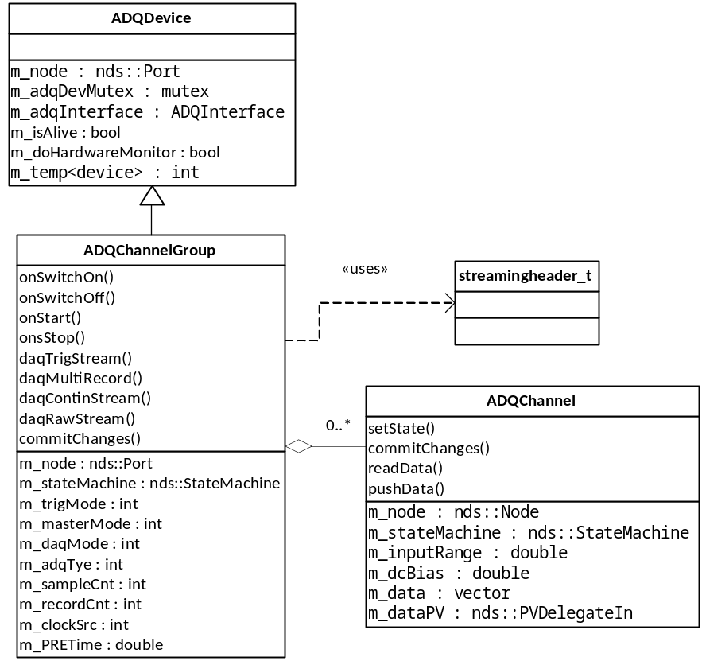

Figure 1 Acquisition Class Structure Diagram

ADQDevice
This class provides generic functionality of ADQ devices, without including data acquisition functionality. It is a base class for ADQAIChannelGroup.
- Temperature monitoring.
- Is device alive, communicable?
- Device type detection.
- Speed capability detection.

ADQAIChannelGroup
This class implements data acquisition functionality from ADQ devices. A channel group consists of one or more channels of acquisition.
Individual channels can be selected or excluded for acquisition by means of the channel mask.
The commitChanges method has been subdivided into commit<property> methods as named below in order to improve code manageability.

Acquisition state
NDS3 operates a state machine which controls acquisition state changes.
Possible states are:
- OFF – this is the software start-up state.
- SWITCHING_OFF – in transition from ON to OFF.
- INITIALIZING – in transition from OFF to ON.
- ON – system is ready to acquire, but is not yet doing so.
- STOPPING – in transition from RUNNING to ON.
- STARTING – in transition from ON to RUNNING.
- RUNNING – system is actively acquiring data. It may be waiting for triggers.
- FAULT – A fault has occurred.
Acquisition state transitions are implemented by the onSwitchOn, onStart, onStop and onSwitchOff methods.

Acquisition mode selection
The requested DAQ mode is applied with commitDaqMode, and subsequently invoked within onStart.
Triggered streaming mode is available only for certain module types, and then only if the necessary option has been purchased. This is the case for the ADQ14 modules installed with MAST XTS.

Trigger mode selection
The requested trigger mode is applied with commitTriggerMode.
With the ADQ8 module type, the function logic needs to take account of whether the module is designated a daisy-chain slave, in which case the daisy-chain trigger is selected.
Some restrictions apply also to the level trigger – it cannot be used for timestamp synchronisation.

Daisy-chain management (ADQ8 module type only)
The [DAISY] -chain consists of a master module (having daisy position 0) linked to a chain of slaves (having daisy position >= 1).
The master or slave selection is applied by commitDaisyChain.
The daisy position value is applied by commitTriggerDelayOrHoldoff to master and slave modules as a modification of pre- or post-triggering information, allowing for the maximum value of the daisy-chain propagation delay.
The daisy position of all modules in a daisy chain is used for a master module with the m_device_info variable in order to invoke the DaisyChainGetTriggerInformation API function. This provides information detail as to the actual propagation delay to each module. Processing code can use this in order to determine how many samples to discard to achieve trigger alignment in the data.

Number of records and sample count
The number of records/samples to be collected is applied by commitRecordCount.
In multi-record mode, on-board memory limits to total size of data that can be collected, this limit is applied here by limiting the sample count, if necessary.
Within streaming data mode(s), there is no limit to the total data collection size, so that (in principle) an infinite number of records can be selected for acquisition.

ADAIChannel
This class encapsulates the functionality of a single input channel, of which a module would have 1, 2, 4 or 8 (depending on the module type).
Selectable properties of a channel include:
- Input range
- Input offset (DC bias).
- Input impedance
- Channel decimation
These properties are applied within the commitChanges method.
Channel data is stored into the class using the readData method and is subsequently pushed to process variable outputs using the pushData method.

Process Logic – initialisation Classes

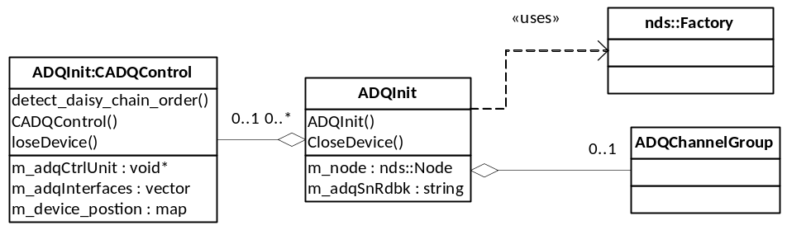

Figure 2 Initialisation Class Structure Diagram.

The ADQInit class creates and initialises an ADQChannelGroup class instance and provides channel access mapping through NDS3.
The ADQInit class owns a singleton class instance of ADQInit::CADQControl, which implements much of the functionality. This class holds m_adqControlUnit, an [ADQAPI] object which emits the list of available modules. These are stored in the m_adqInterfaces vector.
The detect_daisy_chain_order() method auto-detects the master and slave trigger interconnectedness of the ADQ8 modules. This information is stored in the m_device_position map. In the case of the JET HRTS project, there are two master modules, each having a chain of 5 slave modules.

Process variables

Naming convention:
PVs are templated and use a prefix ${PREFIX}:
- Which is ADQ$(DIGITNO) for JET HRTS, where DIGITNO is:
  - A_, CM, EO, GQ, IS, KU, V_, BL, DN, FP, HR or JT.
  - A..V indicate the 4-channel spectrometer name(s) that each module serves.
  - Each 8-channel module serves two 4-channel spectrometers, except that the ‘_’ character indicates that the second 4 channels of that module are unused.
- Which is SPD$(DIGITNO) for MAST XTS, where DIGITNO is:
  - A, B, C, D, E, F, G, H, I, J, K or L.
  - Each 4-channel module serves one 4-channel spectrometer.

$(PREFIX) is followed by -${ADQSN}, the digitiser serial number.

Channel PVs are further templated with a channel number.
This is done through either:
- ADQDevice.substitutions4 (for 4 channels) or,
- ADQDevice.substitutions8 (for 8 channels).

For JET HRTS names are like:
- PVs held by the ADQDevice class e.g. ADQ-A_06905:INFO:ISALIVE
- PVs held by the ADQAIChannelGroup class e.g. ADQ-A_06905:COM:DAQMODE
- PVs held by the ADAIChannel class e.g. ADQ-A_06905:COM::CH<0..7>:DATA

For MAST XTS names are like:
- PVs held by the ADQDevice class e.g. SPD-A-06009:INFO:ISALIVE
- PVs held by the ADQAIChannelGroup class e.g. SPD-A-06009:COM:DAQMODE
- PVs held by the ADAIChannel class e.g. SPD-A-06009:COM::CH<0..3>:DATA

Suggested enhancements for a future version
The ADQInit::CADQControl class has overview of all the modules that are used. The class could become an NDS3 data node, having individual module instances as child node(s). In which case:
- The class could control and monitor the acquisition state of all the modules.
- The class could apply ADQ8 daisy-chain induced data offset correction.
- The class could aggregate the module channel data and/or timestamps into one single acquisition frame, which could be published as one unit (possibly using [PVA]).
These tasks are currently carried out by [HRTSIoc].
The Trigger Mode PV is currently defined as an integer, but actual used values start from 1 in [ADQAPI] and the currently-used selection of trigger types is dis-contiguous there. The PV could be defined as an enum (mbbo/mbbi) variable having the same values as are used by [ADQAPI].
The code currently uses the Windows SDK functions SetPriorityClass and SetThreadPriority to apply elevated scheduling priority to the processing. This is done so as to prioritise enhance real-time DAQ performance reliability. This usage could be applied in a more cross-platform manner.

adqdevice-opi
An operator interface has been provided that is able to control, and visualise data of, one or more digitizer modules.
This can be used for testing/controlling the software, but it is restricted in terms of its capability to operate the system in an automated way, as (for example) the user must select acquisition state for each module individually. Also, only one data channel can be visualised at a time.

Revision history
Issue | Author | Date | Description
1 | Peter Heesterman | 12/08/2021 | Written after the development phase was completed.

References
Ref. | Document | Date | Details and version
ADQ8 | Datasheet ADQ8-8C
ADQ14 | Manual ADQ14
EPICS | EPICS Handbook
ADQAPI | ADQAPI Reference Guide | Mar 2021 | 57946
DAISY | ADQ8 Daisy-Chain Board Synchronization | Feb 2019
NDS3 | Contribution to Nominal Device Support V3 for standardizing device drivers | June 2019
PVA | EPICS V4 Developer's Guide
HRTSIOC | High Resolution Thomson Scattering Teledyne Data Acquisition: Architectural Design Document | 28-Jul-2021 | Issue 1
ADD | Tspd-adq : Software Maintenance Guide | 19/08/2021 | Issue 1

