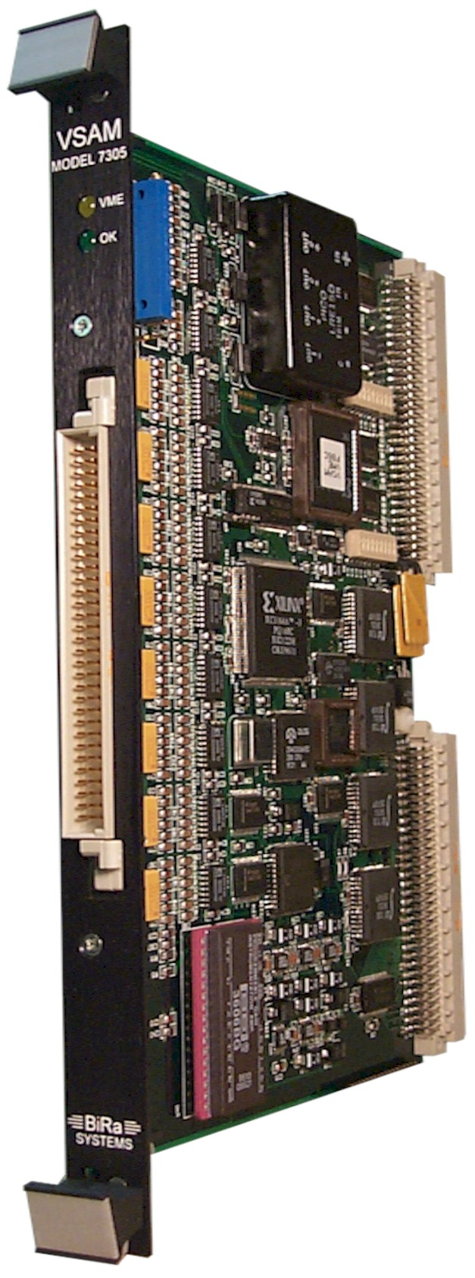

MODEL VME 7305

VME Smart Analog Monitor
(VSAM)

1.0 INTRODUCTION

This manual is a brief user-focused description of the VSAM (VME Smart Analog Monitor). Section 2.0 is a brief description of the VSAM’s operation. Section 3 describes the VSAM performance specifications. Sections 5.0 through 7.0 describe the VSAM’s power requirements, Software, and I/O Connections.

VSAM is a VMEbus-based, compact (6U, 1wide), 32-channel, micro-computer-controlled, analog multiplexer - A/D converter module.

Figure 1 on the next page is a simplified VSAM Block Diagram. Some components and connections have been omitted from this figure for simplicity. Note that the block diagram’s bus or multiple-signal runs are indicated by wide lines; single signal lines are unit-width. The block diagram shows the schematic diagram’s IC numbers and bus labels. The bus labels suggest the bus function and number of bus lines. Thus, AMP (0:3) indicates the 4-line amplifier gain control bus.

The analog components consist of 32 input low-pass input RC filters, a 32-channel differential mode, analog signal multiplexer, a calibration voltage reference, a reference signal analog multiplexer and a programmable instrumentation amplifier (PGIA). The PGIA converts the differential input analog signal to a single-ended signal that drives the 16-bit ADC. The amplifier’s high common-mode rejection reduces the perturbing effects of common-mode noise on the analog signals, and has eleven selectable, high-precision gain ranges.

As suggested by the name, VSAM’s internal micro-computer performs ‘Smart’ functions; these are described below. The micro-computer components are a Z80 microprocessor, a 16Kx8 EPROM program memory, a 2Kx8 static RAM, and the MUX-ADC Control chip. The micro-computer reads the ADC data, performs the signal processing and data formatting functions, and stores the output data in the VME Output Buffer. The MUX-ADC Control chip controls the PGIA gain, and analog and calibration multiplexers.

The VMEbus interface consists of address DIP switches, address comparators, a VMEbus Interface chip and the VME Output Buffer, a 32-bit Dual-Port RAM. Buffer contents are read by VMEbus bus read operations.

The 32 analog input signals are connected to the module via a front-panel 96 pin DIN connector. Input signal pin assignments are listed in Section 6.

A 6 MHz crystal oscillator is used as a time base.
Front panel activity indicators are BUS ACTV (bus active) and OK (Z80 program execution active) LEDs.

2.0 VSAM OPERATION

The VSAM’s analog components are high performance devices; however, VSAM’s performance is further enhanced by “Smart” functions performed by the micro-computer. These are: digital filtering of the analog signals, auto-ranging gain adjustment to maximize conversion resolution, operation over a 1000:1 dynamic range of the analog signals, and periodic auto-calibration to determine offset and gain corrections which are applied to each channel’s reading. The micro-computer’s signal processing determines the analog signal’s DC and normal mode 60 Hz noise components; both are loaded into the VME Output Buffer. The processor converts the data to floating point format and the data readout can be commanded to either big endian or little endian mode. These features are described in more detail below.

In performing these smart functions, the micro-computer sequences through the 32 analog input channels, measuring and storing each signal’s DC and AC voltage components in the VME Output Buffer. The measurement process consists of range acquisition, digital signal averaging over one 60 Hz period to remove normal mode 60 Hz noise, gain and offset correction, and conversion of the data to floating point format.

The 16 bit ADC is configured in bipolar mode which is equivalent to 15 bits uni-polar. The overall dynamic range of the VSAM is 26 bits, eleven bits resulting from control of the PGIA gain and 15 uni-polar bits from the ADC. The PGIA voltage gain, R, can be changed in 11 binary weighted values from 10.24 volts through 10mV. R is an integer whose value may be 0 through 10, and is stored in the least significant four bits of each channels data readout value.

This information is useful for determining the resolution, Vres, and the full scale voltage Vfs of a given input signal. Vres = Vinput*2**-15*2**-R. Vfs = 10.24*2**-R. See section 3.2 for range channel assignments

The micro-computer applies a linear calibration correction to each reading. The coefficients are obtained from a calibration procedure that measures offset values for each gain range of the PGIA and an overall system gain (effectively the gain of the ADC). This procedure assumes the internal voltage reference (REF01) has been accurately adjusted to 10.240 volts, and the gain precision of the PGIA is better than 0.02%. The calibration procedure is performed every ten seconds.

The processor determines the sign and range of a channel by requiring the ADC to operate in the upper half of its range. If this condition is not met at any time during the signal averaging process, the gain is corrected and the averaging restarted. The microcomputer calibrates the VSAM about every ten seconds. A 10.240 volt reference source and analog ground are multiplexed to the PGIA for calibration purposes.

The VSAM has two operating modes: Normal Scan and Fast Scan. In the normal scan mode, 64 equally spaced readings are digitally filtered over 1/60th of a second. Normal mode noise rejection at 60 Hz and its harmonics is at least 35DB. The 'fast' scan mode averages 8 readings in 2 milliseconds and does not provide normal mode 60 Hz noise rejection. This mode provides faster response for 'tweaking' purposes.

In the normal scan mode, the processing time per channel is 23 ms, consisting of 16 ms for digital filtering and 4 ms for correction and formatting. Thus, the total refresh interval for the 32 channels is 0.75 seconds if no ranging or polarity changes occur. The refresh time in fast scan mode is 0.30 seconds.

AC measurements are made continuously in both fast and normal scan modes, but is most useful in normal scan mode since it can 'see' 60 Hz components. AC measurements are made to determine the level of "contaminating" AC on the analog signal. For example, if the channel is measuring the shunt voltage on a magnet power supply, the AC measurement will check for a ripple component arising from a damaged filter section. The measurement records the maximum peak to peak excursion of the input voltage during the signal processing time of 1/60th second. The value (N), is stored in sixteen bit words as described in Section 3.3. The AC peak to peak voltage is Vpp = (20.48*(N/215))*2-R @ 60Hz, where N is an unsigned 15 bit number and R is the range byte associated to the given channel. The normal mode RC input filter decreases the sensitivity of the AC measurement by 6DB/octave above 60Hz. The algorithm used for AC measurements may cause N to vary between 0 and 30 for a clean DC signal; therefore, values of N > 30 are significant. The sensitivity of the AC measurement is 0.2% of the DC voltage at 60 Hz. The accuracy is +20/ 20%. The -3 dB frequencies for the signal’s normal (differential) component are about 33 Hz, and about 10 kHz for the common-mode component, respectively.

Output data is presented to the VMEbus as single precision IEEE floating point in units of volts. The floating point format is described in Section 3.4.

The BUS ACTV LED flashes about 0.5 seconds for each VME cycle. The OK LED flashes at one half the buffer update frequency provided that the calibration was successful and that the firmware revision wasn't requested, and that the processor is not halted by the diagnostic mode.

3.0 VSAM SPECIFICATIONS

3.1 ANALOG INPUT SPECIFICATIONS

Thirty two differential analog input channels.
Channel input impedance at DC is twenty meg-ohms.
Common mode low pass RC filter response is -3DB @ 10 KHz.
Maximum continuous DC voltage is 40 volts.
Maximum DC voltage for one second is 100 volts.
Input voltage, normal mode plus common mode, must be less than 10.3 volts for specified accuracy.
Common mode rejection between 0 and 60 Hz is 80 dB minimum.
The maximum source impedance, normal mode, is 2K ohm to attain the specified accuracy.
The maximum source impedance with an unbalanced common mode signal is a 100 ohms.

3.2 ACCURACY SPECIFICATIONS

Gain Ranges:

+/- 10 mV to +/- 10.24 volts full scale in 10 steps of 2X (11 gain values). The PGIA manufacturer guarantees the gain error to be less than 0.02% for all gain ranges.

Maximum voltage difference between channels must be less than 40 dB to attain the specified accuracy.

DC Resolution & Dynamic Range

The DC resolution is to 15 bits for each range setting, 300uV when R = 0 and 152nV when R = 10. The VSAM overall dynamic range, including the eleven ranges, is 26 bits, eleven bits resulting from control of the PGIA gain and 15 uni-polar bits from the ADC

Temperature Sensitivity: The VSAM maintains its specified accuracy between 0 and 50 degree Celsius.

DC Accuracy

0.1% of reading +/- 20 micro-volts on all ranges for the normal scan mode.

0.2% of reading +/- 40 micro-volts on all ranges for the fast scan mode.

0.01% of reading per month.

AC Measurements

AC Measurement Resolution is 0.2% of DC voltage @ 60Hz. Sensitivity decreases 6DB/octave above 60Hz.

AC Measurement Accuracy is +/-20% of reading.

3.3 SIGNAL PROCESSING

Data Acquisition Mode: The VSAM has two operating modes: Normal Scan (slow) and Fast Scan. Normal Scan is the usual operating mode. Fast Scan provides faster output data response for ‘tweaking’ purposes. Mode selection influences data processing as described below.

Calibration: The micro-computer performs calibration using a linear correction scheme. This scheme involves two assumptions: 1) the on board reference supply is adjusted correctly and, 2) the PGIA meets its 0.02% accuracy specification. About every ten seconds the 10.24 and the zero volt references (analog ground) are sampled and converted. The values of the zero volt reference for each gain setting of the PGIA are maintained in a look-up table. Offset correction is performed by subtracting the appropriate value from the converted channel data. The gain correction factor is determined from the value read on the 10.24 reference channel. The offset is removed from this channel and 10.24 is divided by this result. Each channel value is multiplied by this correction constant.
A Calibration failure: is reported by loading all 32 channels with 99.99 volts. A calibration failure occurs if the digitized value of the 10.24 volt and zero volt references do not digitize to a reasonable value. The 10.24-volt reference must be within 80% and 99.8% of full ADC value. The zero volt reference must be greater than –3% and less than +3% of full scale since there is a built-in offset of +1.5% of full scale.

Digital Filtering (DC component)

Normal scan mode: Each channel is averaged, normal mode, over 1/60 th of a second. Sixty four samples are accumulated then divided by sixty four. Normal mode rejection at 60 Hz and its harmonics is 35 dB minimum. The time base is a 6 MHz crystal oscillator.

Fast scan mode: Each channel is averaged, normal mode, over eight samples. No normal mode 60 Hz rejection is provided.

Channel Refresh Rate.

Normal scan mode Each channel requires 23 milliseconds for processing. The 20 milliseconds include 16 milli-seconds for averaging, and 4 for data correction formatting. Total refresh rate for the 32 channels is 750 milliseconds. The worst case refresh time is 2 seconds if all 32 channels see a large input step and polarity reversal.

Fast scan mode Each channel requires 4 milliseconds for processing. Total refresh rate for 32 channels is 300 milliseconds.

AC Measurements

The VSAM performs a crude measurement of the AC component of an input signal in both normal and fast scan modes, but the AC measurement is most useful in normal scan mode since 60 Hz AC signals are measured in normal scan mode. This function provides some indication of problems such as power supply ripple. AC signal components are measured and recorded continuously. The measurement records the maximum peak to peak excursion of the input voltage during the signal processing time. The value, N, is stored in sixteen bit words as described in Section 3.4. The AC peak-to-peak input voltage is V [p-p] = (20.48*(N/215))*2-R @ 60Hz. Where N is an unsigned 16 bit number and R is the range byte associated with the given channel. R is the PGIA range value. Residual values of N greater than 10 are significant on ranges of 5 and less and values of N greater than 30 on all other ranges. While this measurement is rough, AC signals of less than 3mV on ten volt signals are recorded and AC signals of less than 10uV on the most sensitive scale are recorded. The measurement accuracy is +/- 20% of the reading.

Range Information Gain range information is provided in the range byte as described in the Channel Range Readout paragraph below. The R value may range from 0 to 10. The full scale voltage is 10.24*2**-R.

3.4 VMEbus COMMAND AND DATA READOUT SPECIFICATIONS

BUS USAGE
The VSAM uses the Data Transfer Bus, and the SYSRESET* and SYSCLK* signals in the Utility Bus. The VSAM does not use the Data Transfer Arbitration Bus but the BG0IN* through BG3IN* lines are jumpered to BG0OUT* through BG3OUT* lines, respectively, for compatibility with other VMEbus units that may use bus arbitration. Similarly, the VSAM does not use the Priority Interrupt Bus but the IACKIN* line is jumpered to the IACKOUT* line for compatibility with other VMEbus units that may use this bus.

VSAM Address The VMEbus address mode is A24 with the upper 16 bits selected by internal dip switches. The VMEbus data format is D32 only. Unless commanded by a little endian mode command, data is stored in the VME Output Buffer memory in big endian mode, the standard VMEbus mode. Data can be stored in little endian mode by selecting the little endian bit in the command word as described in the Commands paragraph below.

SETTING THE BASE ADDRESS: Address Set Switches locations “SW1” and “SW2”
Set all address switches to (ON) except positions A20 & A23 at SW2, this places the VSAM module at Base Address 900,000 Hex.
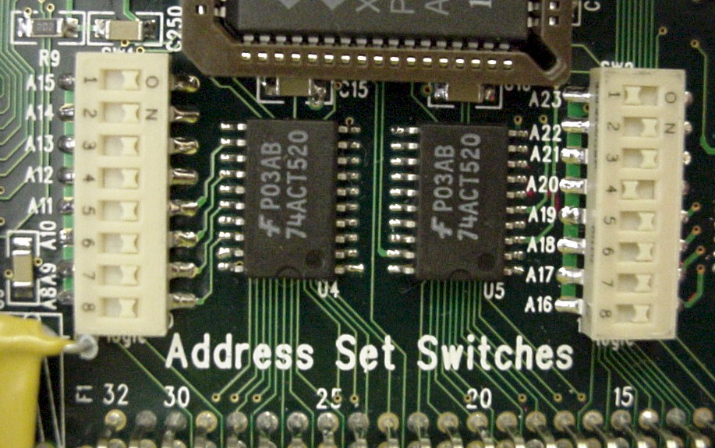

COMMANDS

System Reset Writing to base address + E0 Hex
Two seconds after a reset or power on, Valid data is available.

Mode Control Register
Write to address base + E4 Hex
D0 = 0 Normal channel scan. D0 = 1 Fast channel scan.
D1 = 0 Normal analog channel data. D1 = 1 Request firmware revision number. The revision number is returned in all channels in floating point format. D1 must be cleared to 0 to resume analog processing.
No AC processing is performed in this mode.
D3 = 0 Big endian mode. byte zero contains the most significant byte, the is standard VMEbus usage. If D3 = 1 Little endian mode, byte zero contains the least significant byte, the standard PCI bus usage.

Status Register
Read from address base + E4 Hex
D0 D0 = 0 Normal Scan; D0 = 1 Fast scan mode.
D1 D1 = 0 Normal data presented in channel buffers.
D1 = 1 Z80 Firmware revision number is presented in channel buffers.
D2 D2 = 0 Big endian mode. D2 = 1 Little endian mode.
D3 D3 = 1 Internal calibration successful. D3 = 0 Internal calibration failed.

Diagnostic Test Mode
Write to address base +F0 Hex
This command forces the micro-computer to halt. This mode is used to permit the VME Output Buffer (dual port memory) to be tested from the VMEbus without interference from the micro-computer. A System Reset must be used to clear this mode.

DATA READOUT

Channel DC Component Readout

Each channel is allocated one long word, 4 bytes, in VME address space. Channel 0 is assigned to VME base address = 0, channel 1 assigned to VME base address +1 and so on through 31.

There are four representations of the data that need to be considered. The value of each channel should be categorized by the following criteria below.
- The first is normal data that is representative of the analog voltages that is applied to the inputs.
- The second is that 99.999 volts value is readout on all channels immediately after reset or power-up, and when a calibration fails. See the calibration section for details.
- The third is 50.00 volts value is readout on individual channels if the input voltage is changing too fast for the channel to be digitized. The processor attempts to digitize the channel five times before it gives up and sends 50.00 volts to the channel buffer. A good attempt is defined as one that the ADC is not at zero or full scale.
- The fourth data type is one that one or more channels read back 10.24 volts. This is an indication that the input voltage is above 10.24.

Channel Range Readout
Starting at base address + 80 hex are 32 bytes of channel range information, R. One byte is assigned per channel. This information is used for diagnostic purposes to determine the range setting of the PGIA for each channel. The values range from zero to ten, where zero designates the 10.24 volt range, one designates the 5.12 volt range, and so on down to eleven which designates the 10 milli-volt range. The least significant byte is channel 0, the second least significant byte is channel one and so on. The following table illustrates the channel range data format:
Channel #
Word 80 hex 3 2 1 0
. . . .
. . . .
Word 98 hex 27 26 25 24
Word 9C hex 31 30 29 28

Channel AC Component Readout

AC measurement values are read out starting at base address +A0 hex. One 2-byte word is used for each channel. This range information must be read out in D32 mode, two channels per D32 word, and unpacked in software. This information is used for diagnostic purposes to determine the AC component of the input signal. The AC peak to peak voltage is V [p-p] = (20.48*(N/215))*2-R @ 60Hz. Where N is an unsigned 16 bit number as shown in the following table, and R is the range byte associated with a given channel as described in the Channel Range Readout paragraph above. Residual values of N greater than 10 are significant on ranges of 5 and less and values of N greater than 30 on all other ranges. While this measurement is rough, AC signals of less than 3mV on ten volt signals are recorded and AC signals of less than 10uV on the most sensitive scale are recorded. The measurement accuracy is +/- 20% of reading.

The following table illustrates the channel AC component readout format:

Channel #

Word A0 hex 1 0
Word D8 hex 29 28
Word DC hex 31 30

IEEE SINGLE PRECISION FLOATING POINT FORMAT

D31 = sign bit, (S), 0 = positive 1 = negative; D30-24 = exponent, (EXP); D22-0 mantissa.

The value = (S) + 2(EXP-127) * 1. (MANTISSA)

D  3  1 | D D  3 2  0 3 | D D  2 0  2 0
S EXP MANTISSA

- VSAM SOFTWARE

SOFTWARE

This software uses LabVIEW Version 4.1 and is a Windows 95 application written by Mr. Perry Anthony. “VSAM And VSAMTester Manipulation VI” has five basic blocks that are used to test the VSAM. (1) “Base Address” and “Memory Space” of the “MXI” board. (2) “Base Address” of the VSAM board, “Data Format” selection, “Data or Version Info” and “Scan Mode” selection. (3) “GPIB Address of HP34401A”. (4) “Base Address” of the VSAM Tester Board, “Reference Voltage On/Off” selection, “Voltage Scale (+/- 0.1, 1 or 10 Volts)” selection, “Desired Output Voltage” or “Desired DAC Setting”, “AutoRange ON/OFF” and selection of the “Bit Pattern for the 32 Channels”. (5) “Operation” selection ( Do VSAM Reset and Init, Get VSAM Status, Do VSAM Init, Do VSAM Read, Setup VSAM Tester and Read HP34401A Voltmeter), “VI Status”, “VSAM Control Register”, “DAC Value” (Hexadecimal), “DAC Value” (Decimal), “Readback of Reference Voltage using HP34401A” and individual channel “Value”, “Diff from Ref”, “% Diff”, “Range” and “Peak to Peak Voltage Variation (AC Component)”. This application VI uses a 0.05% accuracy compare for PASS/FAIL criterion, however the VSAM accuracy specification is 0.1%. This “VI” can also be used as an isolated manipulator for the VSAM.

VSAM EPICS DRIVERS WEB LINK:
ftp://ftp.slac.stanford.edu/groups/controls/soft/epics/

LabView Software Development Link from SLAC
http://www.slac.stanford.edu/grp/efd/babar-work/files/labview.html

HARDWARE

National Instruments VME - PCI8000 Series interface link is used to connect the PCI - based computer directly to the VMEbus using the high-speed Multisystem eXtension Interface bus (MXI). National Instruments PCI - GPIB high-performance Plug and Play IEEE 488 interface is used to link the computer to the HP 34401A, a 6 ½ - digit, high - performance digital multimeter. A SLAC designed “VSAM Tester Module” (DAC) is used to provide analog voltages to the “VSAM” via the front panel connector.

- Reference Voltage:
ON / OFF

- Reference Voltage:
Normal / inverted

- Voltage Scale:
10 Volts / 1 Volts / 0.1 Volts

- Data Format:
Big Endian / Little Endian

- Data or Version Info:
Data / Version

- Scan Mode:
Normal / Fast

- Operation:
Do VSAM Reset and Init
Get VSAM Status
Do VSAM Init
Do VSAM Read
Setup VSAM Tester
Read HP34401A Voltmeter

NOTE: The VSAM Tester is a VME
DAC that stimulates the VSAM via the Front
Panel Connector.

5.0 VSAM POWER REQUIREMENTS

The VSAM uses +5 volts @ 1.4 amperes connected to the P1 and P2 +5 VDC pins. The VSAM does not use the bus + and - 12 volt power; an internal DC-to-DC converter powered by + 5 VDC provides the + and - 15 volt power required by the analog circuitry. A - 5 volt regulator provides the - 5 volt power required by the ADC.

6.0 I/O CONNECTIONS

VMEbus P1 AND P2 CONNECTOR PIN-OUTS

The VSAM conforms to the VME IEEE 1014 VMEbus specification. The VSAM does not use some bus signals. These are: IACK*, IRQn*, +5STDBY and SYSFAIL*. VSAM does not use the bus + and - 12 volt power as noted above.

FRONT PANEL ANALOG CONNECTOR PIN-OUT

The Analog signal input connector is a standard DIN 96 male contact type with retaining screws. The pin-out is as follows:

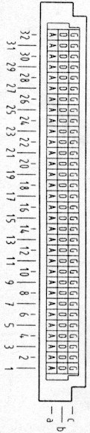
CHAN +INPUT -INPUT CHAN +INPUT -INPUT

0 A1 A2 16 B17 B18
1 A3 A4 17 B19 B20
2 A5 A6 18 B21 B22
3 A7 A8 19 B23 B24
4 A9 A10 20 B25 B26
5 A11 A12 21 B27 B28
6 A17 A18 22 C1 C2
7 A19 A20 23 C3 C4
8 A21 A22 24 C5 C6
9 A23 A24 25 C7 C8
10 A25 A26 26 C9 C10
11 A27 A28 27 C11 C12
12 B1 B2 28 C17 C18
13 B3 B4 29 C19 C20
14 B5 B6 30 C21 C22
15 B7 B8 31 C23 C24

The 10.240 volt reference and returns may be used to power external thermal couple "ice point" reference planes:

10.240 VOLT REFERENCE through 5.1k 1% resistor B9 C25
10.240 VOLT RETURN B10 C26
Shields and grounds:
ANALOG RETURN B11 C27
GROUP SHIELD B12 C28

7.0 WARRANTY
Equipment manufactured by Bi Ra Systems for use in the United States is warranted against defects in design, workmanship, and materials for a period of one (1) year from the date of shipment. Bi Ra Systems will repair or replace, at its option, any such equipment found to be defective on a return to factory basis. Repair charges will be applicable after the warranty period has expired. Transportation charges for shipping the equipment to Bi Ra Systems shall be paid by the customer, while transportation charges for the return of the repaired equipment will be paid by Bi Ra Systems. Priority shipping methods are available at the customer's expense. SOFTWARE products by Bi Ra Systems are furnished under the terms and conditions of a separate Software Product License Agreement is warranted for a period of ninety (90) days from the date of shipment to conform to the Software Product Description (SPD) applicable at the time of purchase. This warranty is contingent upon the proper use of the software as detailed in the Software Product License Agreement and is limited to the remedy of any non-conformance of the Software to the SPD. PRODUCTS PURCHASED BY BI RA SYSTEMS FOR RESALE WILL CARRY THE ORIGINAL EQUIPMENT MANUFACTURER'S WARRANTY, IF ANY.

These warranties shall not apply to equipment or software that has been modified or serviced by other than a Bi Ra Systems or an authorized distributor service engineer.

All warranties are contingent upon proper use of the product or system. These warranties will not apply (i) if adjustment, repair or parts replacement is required because of accident, unusual physical, electrical, or electro-magnetic stress, neglect, misuse, failure of electric power, air conditioning, humidity control, transportation, failure to rotating media not furnished by Bi Ra Systems, operation with media not meeting or not maintained in accordance with Bi Ra Systems specification or causes other than ordinary use; or (ii) if the product or system has been modified by the purchaser; or (iii) where Bi Ra Systems serial numbers or warranty date decals have been removed or altered. In addition to the forgoing, any application on-site warranty will not apply (i) if prerequisite equipment (as specified by Bi Ra Systems price list, equipment specifications, or contract(s) is missing, or (ii) if the product or system has been installed by the purchaser without the supervision of or prior written approval of Bi Ra Systems. Equipment may contain used parts which are equivalent to new in performance when used in the equipment. BI RA SYSTEMS MAKES NO WARRANTY OR MECHANTABLILITY OR FITNESS FOR A PARTICULAR PURPOSE OR ANY OTHER WARRANTY EITHER EXPRESS OR IMPLIED, EXCEPT AS IS EXPRESSLY SET FORTH HEREIN.
Outside the United States, the equipment warranty is limited to the replacement of the equipment and excludes shipping, insurance, taxes, forwarders' fees, customs, or any other charges.
THE WARRANTY PERIOD MAY VARY IN COUNTRIES OUTSIDE THE UNITED STATES. CONTACT BI RA SYSTEMS OR YOUR LOCAL AUTHORIZED DISTRIBUTOR FOR SPECIFIC WARRANTY DETAILS.

LIMITATIONS OF LIABILITY
The purchaser's exclusive remedy or any claim of any kind for loan or damage connected with, or resulting from the design, manufacture, sale, delivery, resale, or repair or use of any products furnished by Bi Ra Systems including but not limited to any claim of negligence or other breach, shall be the repair or replacement, F.O.B. factory, of the product or part thereof giving rise to such claim. Bi Ra Systems liability for such repair or replacement shall in no event exceed the contract price allocable to the products or part which gives rise to the claim. BI RA SYSTEMS SHALL IN NO EVENT BE LIABLE FOR INCIDENTAL OR CONSEQUENTIAL DAMAGES.

RETURN OF PRODUCTS
Bi Ra Systems must be notified before any product is returned for any reason. The Customer Service Department must issue a Return Material Authorization (RMA) number before any product can be accepted for credit, exchange, or repair. In order to provide an RMA number, Customer Service will need the complete model number, serial number, original purchase order number, and details regarding the reason for return and the service required.

All returns for CREDIT or EXCHANGE are subject to Bi Ra Systems approval and will incur a minimum restocking charge of ten (10) percent, as well as any incoming transportation charges or other fees incurred by Bi Ra Systems.

All returns for WARRANTY REPAIR must include a description of the problem and the name of a technical contact in case the problem must be discussed. If the product is out of warranty, the customer must contact Bi Ra Systems for an estimate of the repair charges and include a purchase order number for the estimated repair charges.

Transportation charges for shipping the products to Bi Ra Systems shall be paid by the customer. Transportation charges for the return of the products that have be exchanged shall be paid by the customer, while transportation charges for the return of the repaired equipment will be paid by Bi Ra Systems. The return shipment will be by UPS services, air freight, or truck. Premium methods of shipment are available at the customer's expense and will be used only when requested. If Bi Ra Systems selects the carrier, Bi Ra Systems will not thereby assume any responsibility or liability in connection with the shipment nor shall the carrier be in any way construed to be the agent of Bi Ra Systems.

After obtaining a Return Material Authorization (RMA) number, customers should return the product to:
BI RA SYSTEMS, INC.
2404 COMANCHE NE
ALBUQUERQUE, NEW MEXICO 87107
TELEPHONE: (505) 881-8887
FAX:(505) 888-0651
SERVICES
Contact Bi Ra Systems for details regarding the following services: complete module design and development for both CAMAC and FASTBUS products (this includes the design, complete drafting package from schematic to artwork done on a CADNETICS/INTERGRAPH CAE/CAD System, proto type development and testing, and production level products), Systems Integrated, Installation, On-Site Warranty Repair, Module Exchange Program, Service Contracts, Applications Software Support, and Training. Bi Ra Systems now has a new WEB PAGE address: http://www.bira.com, E-mail: info@bira.com, and we also provide a credit card service for Visa and Master card.

