# NERC LMTF Load Modeling Process

Initial Draft: 2/26/2020

Tony Faris, BPA

## Objectives

A composite load model is used by planners across North America to run power system studies and simulate response of load to system events. The development of load models can be a complex process, requiring engineering expertise to collect and interpret large amounts of historical measurement data. The Load Modeling Task Force (LMTF) of the North American Electric Reliability Corporation (NERC) began a renewed effort to generate accurate load models in 2019, by expanding upon numerous past efforts that have completed across the region.

At the root of the effort is the composition of loads into seven major load types: Motor A, Motor B, Motor C, Motor D, Power Electronic, Static Resistive, and Static Current. For any given feeder, the contribution of each of these load types can vary greatly based on numerous factors, including season, time of day, and day of week. The goal of LMTF is to generate load composition data sets for three main periods of interest: summer peak, winter peak, and spring light load.

When looking across multiple feeders, load patterns and response can be traced to numerous factors, but perhaps the most fundamental one is regional climate. For this reason, each of the major areas in NERC (ERCOT, MRO, NPCC, PJM, SERC, SPP, and WECC) was divided into unique climate regions. The NERC LMTF worked with each regional entity to select representative cities within each climate region, and developed initial composition datasets for these cities. The regional entities then mapped all of their feeders to the appropriate representative city, creating a full load composition within the load model. This document outlines the process undertaken by the NERC LMTF to develop the load compositions for these representative cities.

## Load Modeling Methodology

The overall methodology outlined in Figure 1 is divided into three major steps. First, offline studies are completed to compile the *city-dependent* and *city-independent* metadata required for this process. Using this metadata for each city, 24-hour load shapes are generated for each of the three seasons under study. Finally, these load shapes are translated into load composition percentages using “Rules of Association” mapping information.

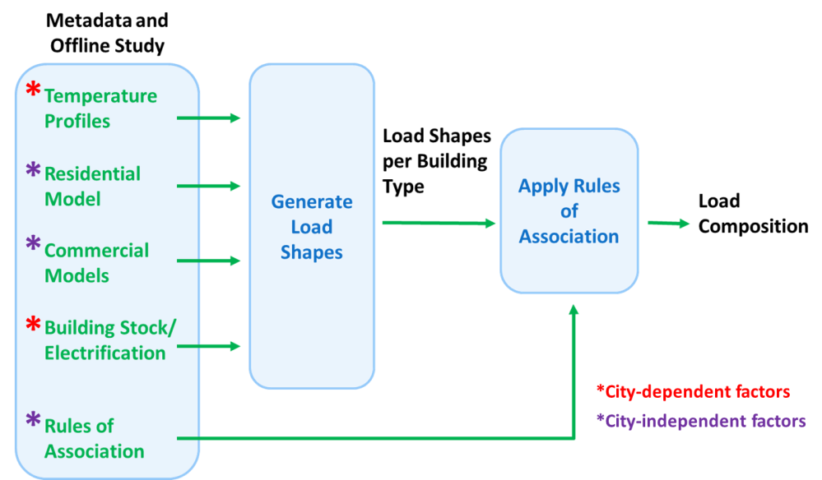

Figure : Load Modeling Methodology

Each city requires three 24-hour weather profiles, identifying summer, winter, and spring days respectively. Electrification percentages for heating, cooling, water heating, and cooking are specified for each city, as well as each type of building. The residential and commercial buildings are modeled such that end use loads are dependent on the hour-of-day and weather conditions. The following sections will outline the process of creating the weather profiles, building models, and electrification percentages.

## Weather Profiles

When creating weather profiles, it is important to note that both temperature *and* humidity factor greatly into end use load behavior. For this reason, a Heat Index (HI) is calculated, as defined by the National Weather Service (<https://www.weather.gov/safety/heat-index>). The HI provides an indication of the “feel” of the temperature, and is a better indicator of behavior than temperature alone.

There are multiple methods for collecting weather data and deriving the 24-hour HI profiles. Past efforts have used the Typical Meteorological Year (TMY) dataset provided by the National Renewable Energy Laboratory (NREL) to identify historical peak load days in summer and winter, as well as light load days in spring. The NERC LMTF team has chosen to collect historical weather data and use statistical analysis to determine these days of interest, using the following process:

1. For each city in the study, 20 years of hourly temperature and humidity data were collected. For US cities, this was retrieved from the National Oceanic and Atmospheric Administration (NOAA) website via their Local Climatological Data (LCD) set. For Canadian cities, these data were found on the website for the Government of Canada (Canada.ca). Both data sets provide hourly measurements, and appropriate steps were taken to interpolate or remove invalid points.
2. The Heat Index was calculated for each hour in the 20 year data set, using the NWS algorithm.
3. Daily high HI and low HI were computed for each day in the 20 year data set.
4. A data range was defined for each season, providing bounds for summer, winter, and spring. Only measurements within the specified date range were considered during the remainder of the process.
5. For the 20 years of summer days, calculate the 90th percentile for the high Heat Index. This will identify a “hot” or “peak” summer day, while avoiding the record high or “super-peak”. Figure 2 shows a sample histogram for this information, with a dashed line indicating the 90th percentile high for this city. Five summer dates were recorded when the high Heat Index reached this value.



Figure : Sample Summer Heat Index Histogram

1. The previous step was repeated for winter, calculating the 10th percentile low Heat Index. Five winter dates were recorded when the low Heat Index reached this value. Figure 3 shows a sample histogram for this case.



Figure : Sample Winter Heat Index Histogram

1. For spring, it was assumed that the minimum amount of cooling and heating occurs when the Heat Index is bound between 68 and 72 degrees. From the 20 year highs and lows, the day where HI was most tightly bound in that range was selected as the representative spring day.
2. In reality, end use load behavior (i.e., duty cycle for heating and cooling) lags behind current temperature/HI. Therefore, an adjusted HI is calculated using a weighted average of the “current” HI and the HI recorded during the previous two hours by the following equation:

***HIadj = (0.6 * HIt) + (0.3 * HIt-1) + (0.1 * HIt-2)***

This adjusted HI value is used for all steps forward.

1. Two days with the same high HI may exhibit widely different 24-hour profiles. For example, the ideal summer day for study contains a peak Heat Index in the late afternoon (4:00 to 6:00 pm). Also, the HI at the end of the day (11:00 pm) will be roughly equal to the HI at the beginning of the day (12:00 midnight). However, not all days display this behavior, as weather events throughout the day may affect the 24-hour HI profile. To account for this, plots are created for the 24-hour HI measurements for the five recorded dates described in steps 5 (for summer) and 6 (for winter). An example is shown in Figure 4:



Figure : Sample 24-Hour Heat Index Profiles

From the plot, it’s clear that Day 1 reaches a peak at an atypical time, and would be a poor choice for a representative weather profile. However, Day 3 reaches a peak in late afternoon and “completes a cycle”, with the HI at the end of the day similar to the HI at the beginning. Therefore, Day 3 is a more appropriate choice for a representative weather profile for this city. The 24-hour HI values are recorded, and the process is repeated for winter.

1. Steps 1-9 are repeated for every city in the study. These 24-hour Heat Index profiles are recorded for all three seasons.

## Building Models

Both residential and commercial models are generated using a collection of end use load types. For residential buildings, these end uses are defined by the Residential Building Stock Assessment (RBSA) created by the Northwest Energy Efficiency Alliance (NEEA). For commercial buildings, these end uses are defined by the California Commercial End-Use Survey (CEUS). Each end use is categorized by its dependence on weather (temperature/humidity) and hour-of-day. Table 1 lists all the end uses, as well as their application to building types and their dependencies.

Table : Residential and Commercial End Uses and Categories

|  |  |  |  |  |
| --- | --- | --- | --- | --- |
| End Use | Residential | Commercial | Weather-Dependent | Time-Dependent |
| Resistive Heating | X | X | X | X |
| Heat Pump | X | X | X | X |
| Cooling | X | X | X | X |
| Air Compressor |  | X |  | X |
| Computer | X |  |  | X |
| Cooking |  | X |  | X |
| Dryer | X |  |  | X |
| Entertainment | X |  |  | X |
| Freezer | X |  |  | X |
| Lighting | X | X |  | X |
| “Miscellaneous” |  | X |  | X |
| Motor |  | X |  | X |
| Office Equipment |  | X |  | X |
| “Other” | X |  |  | X |
| Oven | X |  |  | X |
| Plugs | X |  |  | X |
| Process |  | X |  | X |
| Refrigeration | X | X |  | X |
| Ventilation |  | X |  | X |
| Washer | X |  |  | X |
| Water Heating | X | X |  | X |

Weather-dependent end uses (heating and cooling) are assigned an hourly slope and intercept dependent on the Heat Index for that given hour. All model parameters are defined on a kW-per-square foot basis. For example, residential resistive heating, heat pump, and AC load (in kW/sqFt) for hour 0 and hour 1 are defined as:

*RH(t=0) = SlopeRH(t=0) x HI + IntRH(t=0) RH(t=1) = SlopeRH(t=1) x HI + IntRH(t=1)*

*HP(t=0) = SlopeHP(t=0) X HI + IntHP(t=0) HP(t=1) = SlopeHP(t=1) X HI + IntHP(t=1)*

*AC(t=0) = SlopeAC(t=0) X HI + IntAC(t=0) AC(t=1) = SlopeAC(t=1) X HI + IntAC(t=1)*

Similarly, weather-independent end uses (e.g. lighting, cooking, etc.) are assigned an hourly kW per square foot, which varies by hour of day. However, since Heat Index does not impact these end uses, no linear coefficients are necessary.

With these values defined, the residential and commercial building models are essentially lookup tables, defining hourly kW/sqFt for each end use, or the weather-dependent linear coefficients used to generate kW/sqFt. The following sections describe the process of determining the values to populate the lookup tables.

### Residential Building Model

As part of their RBSA study, NEEA compiled one year of hourly end-use measurements from roughly 100 homes in the Northwest. This “8760” data was delivered to the NERC LMTF team, and was used as the basis for generating the residential building model. Using the square footage given for each home, an hourly estimate of kW/sqFt for each *weather-independent* end-use was calculated as the mean across all buildings in the study. These hourly kW/sqFt values were entered into the lookup tables for the residential model.

Limited heating and cooling information in the RBSA 8760 data set required a different process for determining the hourly kW/sqFt for *weather-dependent* end uses. To calculate the linear coefficients, three years of historical SCADA data was pulled for a largely residential distribution substation in the Vancouver, WA area. The corresponding Heat Index values for the same time period were also collected, and the following process was completed:

1. Based on historical weather information, plot the substation load for a mild summer day and a relatively warm summer day. Assume only base load is present for the mild day, while base load and AC is present for the warmer day. Figure 5 shows the observed Heat Index for these two days, and Figure 6 shows the corresponding measured load.



Figure : Heat Index for Mild and Warm Summer Days



Figure : Substation Load for Mild and Warm Summer Days

1. Using warm summer day feeder load, divide by the total *weather-independent* end use kW/sqFt determined from the RBSA data for each hour. The mean across 24 hours provides an estimate for the residential square footage sourced by the feeder under study.
2. Determine the hourly difference between the load on the warm day and the load on the mild day. This provides an estimate of the hourly kW of air conditioning, shown in Figure 7.



Figure : Estimated Residential Cooling for Substation

1. Assuming linearity relative to Heat Index, calculate the slope and intercept of AC load per square foot. Repeat for each hour in the 24-hour period under study. The slope across the full 24 hours is shown in Figure 8.



Figure : Slope of Residential Cooling, Relative to kW/SqFt

1. Repeat steps 1-4 for heating in winter relative to spring base load day. Assume only base load and heating (no AC) in winter.
2. When hourly *weather-dependent* linear coefficients are determined, input them into the lookup table. For the summer building model, assume coefficients of 0 for heating. Similarly, assume coefficients of 0 for AC in the winter building model. For spring, use both the summer AC and winter heating coefficients as calculated.

Note that the analysis software provides a cutoff that will limit heating and cooling loads to positive values only. If the linear equation for heating or cooling produces a negative value based on a given Heat Index, the load for that end use is fixed to zero.

### Commercial Building Model

Similar to the RBSA, the CEUS provides an 8760 hourly end-use dataset based on metering and simulations for fifteen climate zones across California. Figure 9 shows a map of these climate zones.

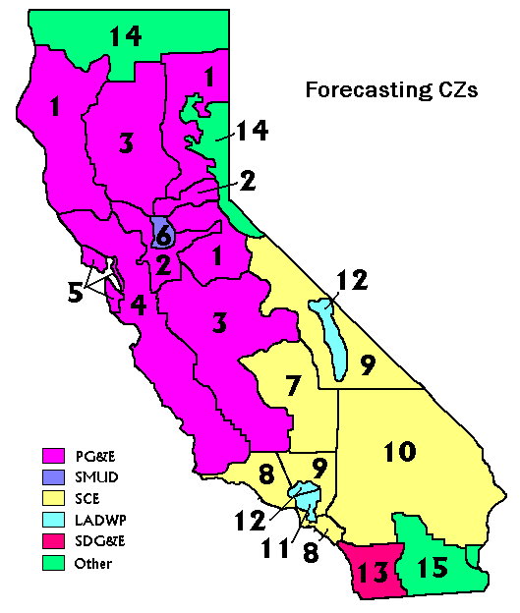

Figure : California Climate Zones Used in CEUS

Information in the CEUS is categorized by commercial building type, including: college, grocery, health, lodging, large office, miscellaneous, refrigerated warehouse, restaurant, retail, school, small office, and warehouse. The CEUS provides the square footage for each building type for each zone, as well as the square footage of building area for each end use. For example, the CEUS lists the number of square feet of restaurants with air conditioning for each climate zone in the study.

For the purposes of this study, region 6 (Sacramento area) was primarily used to develop the commercial building models. However, a similar process can be followed for other regions to further refine the model. The methodology for developing the model is as follows:

1. Collect hourly historical weather data for the selected region for the time period reported by the CEUS. Compute the corresponding Heat Index.
2. Retrieve historical weather for the summer time period.
3. Select a building type (e.g., grocery or restaurant) and retrieve the hourly end use kW and square footage information for that building type for summer.
4. Calculate the hourly kW/sqFt for each end use.
5. Generate hourly scatter plots for each recorded end use, including both weather-independent and weather-dependent loads. Figures 10 and 11 show examples of interior lighting load observed at 4:00 am and 4:00 pm during summer days at grocery stores. Note the values are relatively constant across all days, but as expected, lighting load is nearly double in the afternoon relative to the early morning.



Figure : Grocery Store Lighting Load at 4:00 am



Figure : Grocery Store Lighting Load at 4:00 pm

1. For *weather-independent* loads, calculate the hourly mean of kW/sqFt. Insert these values into lookup table for the selected building.
2. For *weather-dependent* loads, perform a linear regression fit to determine the coefficients for hourly kW/sqFt. Insert these values into the lookup table for the selected building. Figures 12 and 13 show cooling load for grocery stores at 4:00 am and 4:00 pm respectively. Note the higher overall load, as well as greater sensitivity to Heat Index (larger slope of the regression fit) for the afternoon when compared to the early morning.



Figure : Grocery Store Cooling Load at 4:00 am



Figure : Grocery Store Cooling Load at 4:00 pm

1. Repeat steps 3-6 for all building types in the CEUS.
2. Repeat steps 2-8 for spring and winter time periods.

## Feeder composition

Load composition can vary greatly depending on the number of each building type supported by a given feeder. For this study, feeder composition is classified into four categories:

***Residential/Suburban (RES):*** Mostly single family residential homes, with smaller commercial buildings, including schools, retail, restaurants, etc.

***Commercial (COM):*** Downtown areas primarily made up of large office buildings and condominiums

***Mixed residential and commercial (MIX):*** Areas comprised of single family residential homes with small offices and shopping centers.

***Rural/agricultural (RAG):*** Rural areas, with farms, small restaurants, and retail.

For each city in the study, a set of city/feeder pairs are created, combining the city with the each of the four feeder types. For example, Boston is assigned four city/feeder pairs: BOS_RES, BOS_COM, BOS_MIX, and BOX_RAG. Each pair is provided a feeder composition, listing an estimate of the number of square foot of each commercial building type (as provided by CEUS), as well as a single family residential. Table 2 shows the default feeder composition initially applied to all cities, though these values are user-definable per city/feeder pair.

Table : Default Feeder Composition

|  |  |  |  |  |
| --- | --- | --- | --- | --- |
| Building Type | RES Square Ft. | COM Square Ft. | MIX Square Ft. | RAG Square Ft. |
| Residential Home | 6000000 | 0 | 3000000 | 600000 |
| College | 0 | 0 | 0 | 0 |
| Grocery | 90000 | 90000 | 135000 | 45000 |
| Health | 40000 | 40000 | 60000 | 0 |
| Large Office | 0 | 4200000 | 0 | 0 |
| Lodging | 0 | 1000000 | 300000 | 50000 |
| Miscellaneous | 10000 | 10000 | 20000 | 0 |
| Refrigerated Warehouse | 0 | 0 | 100000 | 0 |
| Restaurant | 100000 | 125000 | 200000 | 25000 |
| Retail | 600000 | 600000 | 800000 | 60000 |
| School | 400000 | 0 | 400000 | 100000 |
| Small Office | 0 | 100000 | 600000 | 0 |
| Warehouse | 150000 | 0 | 400000 | 500000 |

## Electrification

To determine end use load shapes, electrification percentages for heating, cooling, water heating, and cooking are required for each building type, both residential and commercial. Individual electrification values are difficult to acquire for each city, so default percentages are estimated using the Residential Energy Consumption Survey (RECS) and Commercial Energy Consumption Survey (CBECS), provided by the U.S. Energy Information Administration (EIA). These sample surveys use the U.S. census regions and divisions (Figure 14) and provide estimates of total square footage for each building type within a region. They also list the square footage serviced by electric heating, cooling, water heating, and cooking. From this information, electrification percentages are estimated for each of these four end uses on a per-region basis.

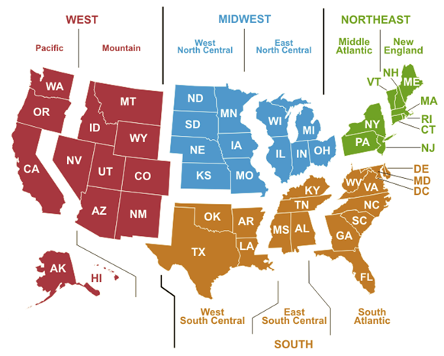

Figure : U.S. Census Regions Used for RECS and CBECS

Based on the location (region) of each city, a lookup table is created with these electrification percentages for all city/feeder pairs. The values in Tables 3 and 4 are defaults, and can be user-defined if more accurate information is acquired for a given city.

Table : Default Residential Electrification Percentages

|  |  |  |  |  |  |
| --- | --- | --- | --- | --- | --- |
| Region | Heat Pump | Other Electric Heat | Cooling | Water Heating | Cooking |
| New England | 3% | 10% | 75% | 36% | 59% |
| Middle Atlantic | 3% | 11% | 88% | 31% | 43% |
| East North Central | 3% | 17% | 92% | 34% | 57% |
| West North Central | 4% | 18% | 92% | 40% | 75% |
| South Atlantic | 24% | 32% | 95% | 72% | 78% |
| East South Central | 24% | 39% | 93% | 76% | 75% |
| West South Central | 8% | 45% | 95% | 58% | 71% |
| Mountain | 8% | 19% | 78% | 31% | 67% |
| Pacific | 7% | 25% | 66% | 32% | 53% |

Table : Default Commercial Electrification Percentages

|  |  |  |  |  |  |
| --- | --- | --- | --- | --- | --- |
| Region | Heat Pump | Other Electric Heat | Cooling | Water Heating | Cooking |
| New England | 9% | 2% | 77% | 45% | 27% |
| Middle Atlantic | 9% | 6% | 89% | 41% | 31% |
| East North Central | 5% | 8% | 90% | 39% | 33% |
| West North Central | 7% | 14% | 87% | 49% | 32% |
| South Atlantic | 27% | 20% | 91% | 62% | 30% |
| East South Central | 17% | 23% | 88% | 59% | 31% |
| West South Central | 10% | 30% | 81% | 47% | 25% |
| Mountain | 10% | 13% | 84% | 40% | 31% |
| Pacific | 15% | 21% | 88% | 51% | 22% |

## Software data flow

Once all metadata is compiled, the algorithm can be run to compute load composition. This process is divided into two main stages: calculating load shapes and applying the rules of association.

### Calculating Load Shapes

The process for calculating load shapes is as follows:

1. Select a city/feeder pair.
2. Retrieve the 24 hour Heat Index profile for the given city for summer. A sample plot is given in Figure 15.



Figure 15. Heat Index Profile for Portland, Summer

1. For each building type, retrieve electrification percentages for heating, cooling, water heating, and cooking.
2. Cycle through all the end uses for each building type, referencing the lookup table for hourly building model coefficients. For heating and cooling, this will be a slope and intercept. For other end uses, this will be a single value for a given hour.
3. Apply the 24 hour Heat Index profile to the *weather-dependent* end uses. This will create a 24-hour kW/sqFt value for each end use, per building.
4. Apply electrification percentages and feeder composition to each end use. This creates the final load shapes, per end use for each building type. As an example, Figure 16 shows a plot of three end use load shapes for restaurants in a Portland Mixed feeder during summer. Note that refrigeration is relatively constant throughout the day, cooking is highest during business hours, and cooling reaches a peak at a time corresponding to the peak Heat Index for the day.



Figure : Sample End Use Load Shapes

1. Repeat steps 2-6 for winter and spring.
2. Repeat steps 1-7 for all city/feeder pairs.

For the purposes of load composition, only end use load shapes are calculated, and remain separated by building type. However, for confirmation and analysis, total end use load shapes are calculated and plotted, as required. Figures 17, 18, and 19 show total load shapes for Portland RES, COM, and MIX feeders, respectively, under all three seasonal conditions.



Figure : Total Load Shapes, Portland RES Feeder



Figure : Total Load Shapes, Portland COM Feeder



Figure : Total Load Shapes, Portland MIX Feeder

### Applying Rules of Association

The rules of association provide a mapping of end use load shapes to the seven load types by defining a fraction of each end use associated with each type. For example, residential air conditioning is defined as 80% Motor D, 10% Motor B, and 10% Motor C. Four individual tables have been created based on building types: residential, lodging/condominium, large/downtown office, and general commercial. To calculate the total load composition factors:

1. For each building, retrieve the corresponding rules of association table.
2. Cycle through end uses, multiplying load shapes by percentages referenced in the rules of association. Calculate the sum of all kW for each load type.
3. Calculate the load composition as a percentage of the total. Figures 20, 21, and 22 show the 24 load composition for Portland RES, COM, and MIX feeders, respectively.



Figure : Load Composition for Portland RES Feeder



Figure : Load Composition for Portland COM Feeder



Figure : Load Composition for Portland MIX Feeder

1. Repeat the process for each city/feeder pair, and for each season.

## Conclusions and Next Steps

The process undertaken by NERC LMTF has yielded positive results, generally in agreement with past efforts for load modeling and composition. Load composition values align with common sense expectations and trends are consistent across regions. However, much work remains to help minimize assumptions throughout the process, tune building models, and refine results. As of this writing, numerous metering studies are underway to increase the breadth of residential and commercial datasets, allowing for more accurate and modernized building models. Regional entities are increasing their involvement, which will improve visibility and refinement of such factors as electrification and feeder composition.

## Appendix: Sample Results

Planning studies are primarily concerned with load composition at peak or light load times. For the initial data set, the periods of interest are defined as:

* + Summer at 4:00 pm
  + Winter at 8:00 am
  + Spring at 3:00 am

Results for a particular time slice can be visualized with pie charts. Samples of these pie charts are provided below. **Note: Pie charts are available for all city/feeder pairs, and can be added if necessary.**

### Boston

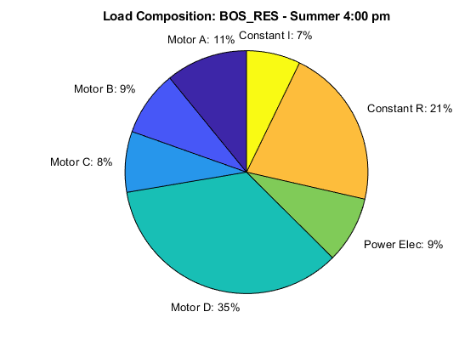

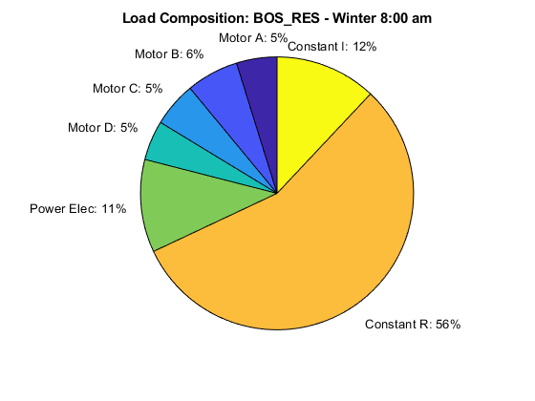

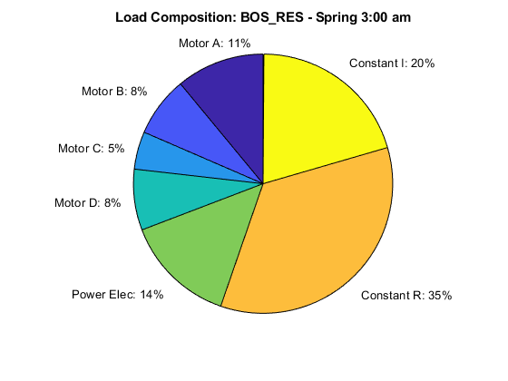

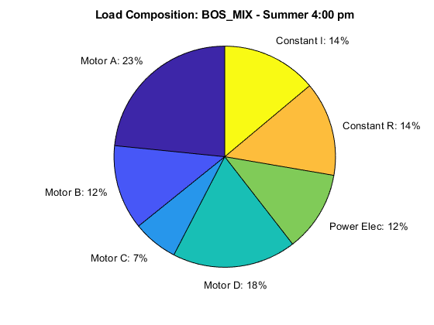

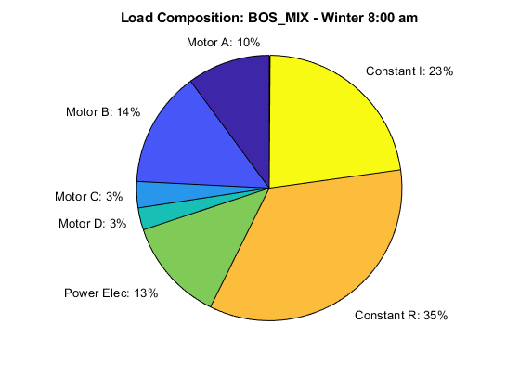

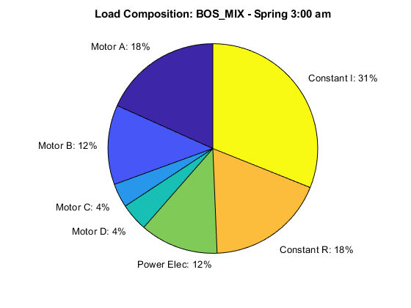

### Miami

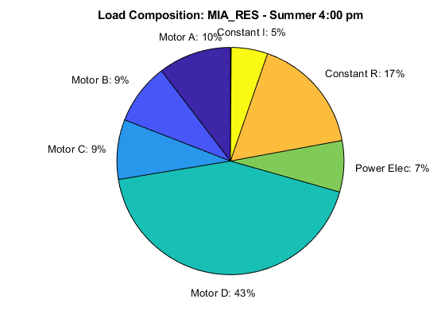

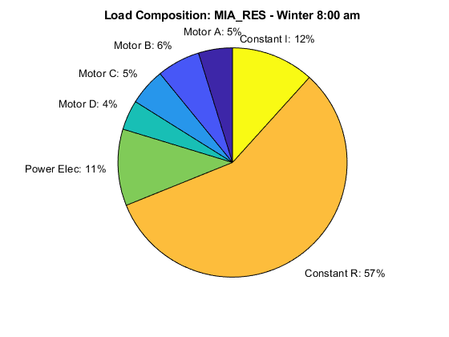

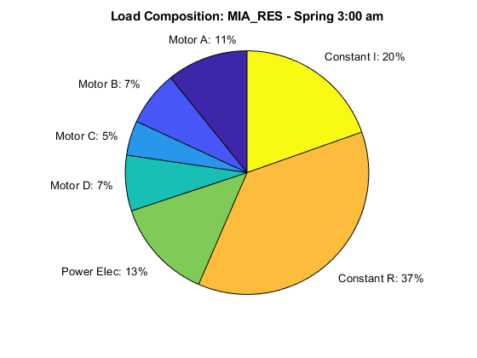

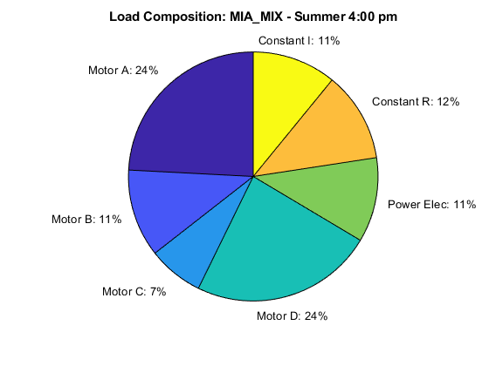

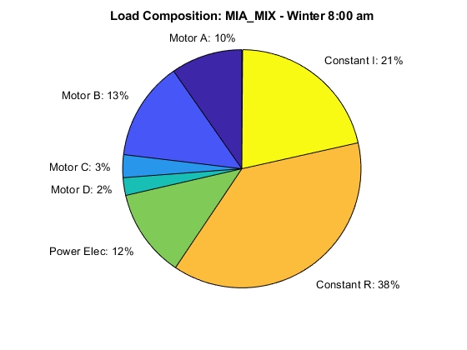

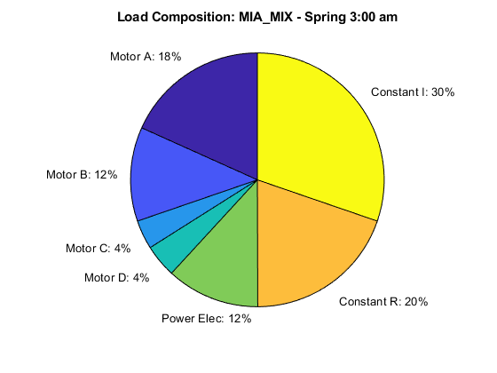

### Phoenix

