Subdue Graph Visualizer

The members of the Committee approve the
Masters Project of Gayathri Sampath

Dr. Lawrence Holder
Supervising Professor

Dr. Diane Cook

Dr. Lynn Peterson

Subdue Graph Visualizer

by

Gayathri Sampath

Presented to the Faculty of the Graduate School of
The University of Texas at Arlington in Partial Fulfillment
of the requirements for the degree of

Master of Science
In

Computer Science and Engineering

The University of Texas at Arlington

May 2001

Supervising Committee
Dr. Lawrence Holder
Dr. Diane Cook
Dr. Lynn Peterson

Acknowledgements
I would like to thank Dr. Lawrence Holder for providing me guidance throughout the course of this project. He provided extensive background knowledge and support. His advice and suggestions have been invaluable. I would also like to thank Jesus Gonzalez for providing clarifications on the Subdue software from time to time and referring me to helpful books and reference material. I gratefully acknowledge the tremendous encouragement and assistance provided by all my friends and family.

Abstract
Subdue Graph Visualizer
Gayathri Sampath, M.S.
The University of Texas at Arlington , 2001
Supervising Professor: Dr. Lawrence Holder
Any pattern discovery process is aided by a visual description of the input and output. The Subdue program is a graph-based discovery system that discovers structural relationships between data elements. Interesting patterns are found in the data by compressing the input graph. It is difficult even for a person with sufficient domain knowledge to understand and analyze these patterns when they are output as symbols and numbers. Hence the need for a graphical tool that enables the visualization of the input graph and the subgraphs that are found during the discovery process.
For this project we developed the Subdue Graph Visualizer (SGV) that pictorially represents the input graph and the substructures discovered by Subdue. The visual elements associated with the input graph are initially defined by the user of the system along with the input graph to Subdue. When Subdue executes, the patterns are sent to the SGV program, which displays the substructures as they are discovered and highlights the instances of the substructures in the original input graph.
Other visualization techniques were analyzed for their suitability to effectively display the patterns discovered by Subdue. The SGV has been implemented in Java and uses a client-server method of communication with Subdue. Examples demonstrate the successful implementation of SGV. Details on how to use the tool effectively are also described.

CONTENTS
1. Introduction vi
2. The Subdue System 2
3. Other Visualization Tools 6
3.1 Dotty 6
3.2 Visualization of Compiler Graphs (VCG) 7
3.3 GraphEd 8
3.4 DaVinci 8
3.5 OpenGL 9
4. The Subdue Graph Visualizer 11
4.1 Communication with Subdue 11
4.2 Input to SGV 12
4.3. Description of Output 16
5. Test Cases 18
5.1. Sample Screen shots 18
5.2 Explanation of Output 25
6.Conclusion 27
6.1 Advantages of SGV 27
6.2 Limitations of SGV 28
6.3 Future work 28
Appendix A: Input file with graphics for the triangle-square problem 30
References 34

List of Figures
Figure 1: Sample input 3
Figure 2: Graph representation of the database 4
Figure 3: Discovered substructures and instances 4
Figure 4: Sample from input file to SGV 14
Figure 5: Extract from input file in Figure 4 16
Figure 6: Main graph of Input 1 19
Figure 7: Substructure 1 of Input 1 showing the substructure 20
with the highest compression 20
Figure 8: Substructure 2 of Input 1 showing the substructure with the second highest compression 21
Figure 9: Main Graph of Input 2 22
Figure 10: Main Graph of Input 3 23
Figure 11: Substructure 2 of Input 3 showing the substructure with the second highest compression 24

1. Introduction
The growth in the field of Knowledge Discovery has pressured the visualization field into providing tools that enable the analysis of patterns that are discovered during the data mining process. So too for a discovery tool like Subdue that analyzes structural data represented as a graph. Subdue is a powerful data mining tool which uses the minimum description length (MDL) principle to discover substructures and then uses these substructures to compress the input graph [1]. The substructures represent the structural concepts in the data. The goal of this project is to provide a visualization tool for Subdue, the Subdue Graph Visualizer (SGV), so that the input graph and the substructures discovered can be analyzed with ease. Previous efforts in the visualization of patterns have led to graphical interfaces that display the input and the substructures in a graph format. However, these efforts try to decide on their own how to visualize the graph, which is not always the best representation for interpretation by the domain scientist. Our approach allows the user to tailor the visualization of the data.
The following sections describe the SGV in detail and explain how it enhances the capabilities of the Subdue system. Section 2 describes the Subdue discovery tool. Section 3 describes some of the other visualization tools that were considered for this project. Section 4 describes the SGV tool and its capabilities. Section 5 describes the test datasets that were used on this tool and shows some sample screenshots. Lastly, Section 6 concludes and discusses future directions for this work.

2. The Subdue System
The Subdue substructure discovery system finds interesting and repeating substructures in data represented as a labeled graph. The graph is a representation of the information contained in the records of the database along with relations between these records. The vertices of the graph represent events and the edges represent the relationships between the events. Each line of the input graph file represents a vertex or an edge. Each vertex or edge can be labeled.
One approach to pattern discovery in structural data is the identification of common substructures within the data. A substructure is a subgraph contained in the input graph [1]. Once a substructure is found, a pointer to the substructure could replace all instances of it [4]. One method that could be used to evaluate the subgraphs is compression. The graph could be compressed in its number of vertices and edges, and the substructure that does this best is chosen. This substructure is then replaced by a single vertex in the graph to represent the substructure [2]. Another method for finding the best substructure is using a function of the substructure’s size and number of occurrences. Any of these three methods can be used to evaluate the best substructure.
Subdue uses the minimum description length (MDL) principle to choose the best substructures such that the description length metric is minimized. The discovered substructures represent interesting structural concepts in the data. These substructures can be used to compress the original database. Subdue uses a computationally bounded inexact graph match that identifies similar, but not identical, instances of a substructure and finds an approximate measure of closeness of two substructures [4].
The search for a substructure is done using a single vertex as the initial substructure. At each iteration a substructure is expanded by adding an edge in all possible ways to generate new substructures. The search method can also be biased by using some background knowledge on the data [2]. Once the substructure has been generated and its instances identified, any of the methods mentioned above can be used to find the best substructure. The algorithm continues to search until all the substructures have been considered or the computational limit has been reached. Figure 1 shows a sample input database that could be converted to a graph representation (Figure 2) [4]. The objects in the figure become labeled vertices in the graph, and the relationships become labeled edges. The graphical representation of one of the substructures discovered by the Subdue system and its instances from the input are shown in Figure 3.

Input
R1
C1

S1
T1

S2
T2

S3
T3

S4
T4

Figure 1: Sample input

object
triangle
shape
object
square
shape
on
object
square
shape
object
triangle
shape
on
Input Graph
on
object
triangle
shape
object
square
shape
object
circle
shape
on
on

object
rectangle
shape
on
on
on

object
square
shape
object
triangle
shape
on

Figure 2: Graph representation of the database
Substructure Instances
on
object
triangle
shape
object
square
shape

S1
T1

S2
T2

S3
T3

S4
T4

Figure 3: Discovered substructures and instances

The Subdue system can be controlled by command-line arguments such as limit, number of iterations, number of substructures to be retained, etc. To enable the display of the visual elements, the argument ‘display’ has to be specified in the command-line.
Subdue -display [other arguments] graphfile
where graphfile is the input graph file. See section 4 for an explanation and example of Subdue's input file format.

3. Other Visualization Tools
The primary characteristics that a visualization tool must have to effectively describe the patterns discovered by the Subdue system are,

- Ability to draw basic geometric figures such as point, line, triangle, etc.
- Ability to draw text
- Ability to communicate and interface easily with the Subdue system
- Ability to define new shapes by the user of the system
- Ability to draw the input graph and the substructures in separate windows
- Ability to navigate within the windows - such as scrolling, resizing and zooming
- Ability to specify color of the objects drawn in the windows

Before developing the SGV tool, a search for a suitable visualization tool yielded a set of tools that satisfied some but not all of the above requirements. Given below is a list of these tools and why they were not suitable for Subdue.

3.1 Dotty
Dotty is a customizable graph editor. Its main components are a programmable viewer and graph layout generators. Dotty can run stand-alone, but it can also be programmed to act as a front-end for other applications [9].
Dotty was found to be unsuitable for visualizing the substructures discovered by Subdue, because it does not provide extensibility as far as defining new shapes within the graphics.

3.2 Visualization of Compiler Graphs (VCG)
The VCG tool [8] reads a textual and readable specification of a graph and visualizes the graph. If not all positions of nodes are specified, the tool lays out the graph using several heuristics such as reducing the number of crossings, minimizing the size of edges, centering of nodes. The VCG tool allows folding of dynamically or statically specified regions of the graph. It uses colors and runs on X11 and MS Windows 3.1. The VCG tool is intended to visualize large graphs that are automatically generated by programs such as debuggers. This tool has navigation capabilities such as arbitrary zooming of graphs and scaling. There is even a facility to load fonts and icons that are fully scalable. 254 colors are supported. Different shapes of nodes are available: boxes, triangles, rhombs and ellipses. Different kinds of edges are available: normal edges, near edges, back edges and bent near edges. The latter are useful for different applications. Fisheye views are possible so that in cases where the graph is very large, it is possible to see the both the focus point end detail and the overview over the graph at the same time. It is also possible to interface to program animations that provide the VCG tool with a sequence of graph descriptions.
Despite all these features, it is still not a suitable tool for Subdue, because new shapes cannot be defined. Also, multiple windowing capabilities are limited.

3.3 GraphEd
GraphEd [7] is an extensible graph editor. It supports directed and undirected, labeled graphs of unlimited size and degree, with self-loops and multiple edges. Edges are polylines with an arbitrary number of segments. There are several options to customize the graphical appearance of nodes and edges. The object-oriented user interface supports all operations that are necessary for the construction and manipulation of graphs. The user is assisted in placing nodes, edges and labels. Graph grammars can be used as a macro system to create structured graphs. GraphEd's modular structure and the application interface support the easy integration of algorithm modules. The user may construct graphs interactively, select algorithms from a menu, and view the results of an algorithm directly on screen. GraphEd communicates with other programs via a simple file format. The format is extensible so that other programs may easily add their own information.
This tool aids the analysis of graphs more than visualizing the graphs. The requirement here is to be able to visualize what the graphs themselves represent and that is not possible with GraphEd. Also the ability to add complex new shapes is not facilitated by GraphEd. Therefore, with regard to the requirements stated above, GraphEd is not a suitable graph visualization tool for Subdue.

3.4 DaVinci
DaVinci [5] is an interactive tool to visualize directed graphs. The graph layout in DaVinci reflects the hierarchical relationships. Graphs are loaded in DaVinci using a specific format called term representation. These graphs can be edited interactively by the user using an external graph editor application. This editor or any other DaVinci application is responsible for exclusively controlling and manipulating the structure of a graph. The external application sends menu events to the graph editor to inform about interactions from the user. DaVinci offers some very useful interactive operations to work with graph visualization such as scaling and some useful navigation features such as scrolling. DaVinci has built-in support for multi-view and multi-graph. These features offer the opportunity to work on the same graph in different coupled windows (views) or to load many graphs in several uncoupled windows at the same time.
DaVinci was found unsuitable for visualization of Subdue substructures because it does not offer the flexibility of defining new shapes. This feature is essential because the domain of the input usually is never so simple as to include only graphics such as boxes and circles.

3.5 OpenGL
OpenGL is a graphics environment for developing portable, interactive 2D and 3D graphics applications. With broad industry support, OpenGL is an open, vendor-neutral, multi-platform graphics standard. All OpenGL applications produce consistent visual display results on any OpenGL API-compliant hardware, regardless of operating system or windowing system [6].
Despite such flexibility, the reason for the unsuitability of OpenGL for Subdue is the lack of windowing capabilities such as scrolling. This feature is essential for visualization, because most often the input graph is too large to be completely visible on the screen.
Some other visualization tools were also analyzed but were found unsuitable due to the lack of one or more of the above requirements. Due to these limitations we decided to implement our own visualization tool for Subdue.

4. The Subdue Graph Visualizer
The Subdue Graph Visualizer (SGV) portrays the input graph and substructures discovered by Subdue. The visualization for the input graph has been achieved by specifying the graphic elements of the input along with the vertex and edge specifications in the input file to Subdue. With the graphics specification given in the input file, SGV displays the input graph in a window. As substructures are discovered by Subdue, they are communicated to the SGV. The SGV displays these substructures in a separate window and highlights their instances in the input graph.
This tool has been developed using the Java programming language (JDK version 1.2) on the Linux operating system. The communication between Subdue and the SGV is accomplished through socket programming.

4.1 Communication with Subdue
The communication between Subdue and SGV is achieved through TCP sockets. When the display option is specified in the command line of the Subdue call, Subdue opens a socket for communication and waits at a predefined port. The SGV program, when started, runs its socket communication program and opens the predefined port for communication with Subdue. Subdue then sends the filename of the input to SGV. This file, if it exists in the current executing directory of SGV, is then parsed and the input stored in a similar structure to that of Subdue.
Once communication has been set up, Subdue continues with its processing of the input. As substructures are discovered, the vertex and edge numbers of the instances of these substructures are sent to the SGV program, which then displays one instance of the substructure in a separate window, at the same time highlighting all the instances in the main graph. When Subdue finishes executing, the socket is closed and Subdue stops. The SGV is still active for further user interaction, though no more socket communication is possible. The discovered substructures are stored in a list so that the user can review them at leisure. The substructures can be viewed in a window with a scrolling facility. All the instances of the current substructure are highlighted in the main graph window, which has a zoom facility that enables viewing of minute or closely drawn features.

4.2 Input to SGV
The input to the SGV consists of the vertices and edges of the input graph, numbered and labeled, with each vertex or edge carrying an optional graphical description. This input is parsed and stored in array-like data structures such that each element of the array corresponds to a vertex. Each array element also carries the graphical description associated with it, if it exists. Each edge is specified as a pair of numbers (the numbers correspond to vertex numbers) and a label for the edge. An optional graphic description may also be specified here. Each edge description is parsed and stored along with the first vertex in the pair that specifies the edge.
For the example input described in the previous section, a part of the input file to SGV could be as shown in Figure 4. For the complete input file refer to Appendix A.

v 1 object ((text "1" (200.0 150.0 ) (font Courier size 12) (color green fill no)))
v 2 object ((text "2" (200.0 450.0 )))
.
.
v 5 object ((text "Square" (200.0 250.0 ) (font Courier size 10) (color green fill no) ) )
.
.
v 11 triangle ((polygon (( 150.0 200.0) ( 250.0 200.0) (200.0 100.0)) (color blue fill no)))
.
.
.
v 15 square ((polygon ((150.0 300.0 ) (250.0 300.0 ) (250.0 200.0 ) (150.0 200.0 ) ) (color green fill no)) )
.
.
.
v 19 circle ((circle (750.0 200.0 ) 100.0 (color green fill no)) )
v 20 rectangle ((polygon ((100.0 400.0 ) (900.0 400.0 ) (900.0 300.0 ) (100.0 300.0 ) ) (color green fill no)) )
e 1 11 shape
e 2 12 shape
.
.
e 5 15 shape
.
.
e 9 19 shape
e 10 20 shape
e 1 5 on
e 2 6 on
.
.
e 5 10 on
e 9 10 on
e 10 2 on
.
.

Figure 4: Sample from input file to SGV

Here, as in the input to Subdue, ‘v’ represents vertex and ‘e’ represents edge. The number that follows ‘v’ is the vertex number, which is followed by the label for that vertex. The graphics description, if any, starts at this point. Similarly for an edge, the vertex numbers of the two vertices that this edge connects is specified after ‘e’, followed by the label for the edge. The graphic description, if any, is given after the label.

The syntax for the graphics is best described by its grammar, given below.
objectlist → object | (object objectlist)
object → (shape, color)
shape → (polygon | circle | string)
polygon → polygon, points
points → (x₁ y₁ z₁) | ((x₁ y₁ z₁) points)
circle → circle (x_{c} y_{c} z_{c}) radius
string → text (font ft size sz) (x₁ y₁ z₁)
text → text
text → text | A-Z | a-z | 0-9 | special chars
color → ( colortype , shade)
colortype → red | blue | green | black | white
shade → fill | nofill

The input is parsed based on the rules given above. The graphics can be specified as a list of objects, where an object is a graphical element that is associated with a shape and color. A shape is represented here by a polygon, a circle or a string of characters. A polygon is represented by a group of points (can be just one). Successive points are connected by lines. A point consists of the x-coordinate, the y-coordinate and an optional z-coordinate. With this representation, any n-sided (n ≥ 1) geometric shape can be drawn. A circle can be drawn by specifying its center (represented by the 3 coordinates) and the radius. A string is a series of characters consisting of numeric, alphabetic or punctuation characters. Color represents the color with which the graphical element is drawn. Colortype specifies the colors that are currently possible. Shade specifies whether the object is shaded or not. The attributes font type, font size, color of the objects and shading, all have default values specified within the program. If the user does not specify values for these attributes, the default values are taken to be applicable.
For instance, Figure 5, which is an extract from Figure 4, specifies that for vertex 1 with label object, the graphics associated with it consists of a string, specified in quotations, positioned at coordinates (200,150). It also specifies that the font of the text should be Courier, in 12 point, and the color of the text should be green and not shaded. The shading specification does not apply here anyway, because text cannot be shaded. But for other objects such as triangle or circle, shading is possible and in those cases a “fill yes” would indicate that the object should be shaded in the specified color.

v 1 object ((text "1" (200.0 150.0 ) (font Courier size 12) (color green fill no)))

Figure 5: Extract from input file in Figure 4

4.3. Description of Output
After parsing and storing the input, the SGV program displays the input graph in a window. This window is resizable, scrollable and provides mechanisms to zoom. Upon receiving the substructure information from the Subdue program, the SGV displays this substructure in a second window along with the compression value achieved with this substructure. At the same time, all instances of this substructure are highlighted in the main graph (in red color, by default). As and when the substructures are received by the SGV, they are sorted in descending order of compression value and displayed. After all the substructures have been received and displayed, the SGV program gives the user the option of reviewing these substructures at the user’s convenience.
For a better understanding of the output, some sample screen shots are shown in Section 5.1 and explained in Section 5.2.

5. Test Cases
The SGV tool has been tested on three input graphs. The first input graph consists of basic geometric shapes and text. The graphics for this input are specified along with the input graph consisting of twenty vertices and nineteen edges.
The second input graph is similar to the first in that it consists of the same geometric figures and text copied three times. There are sixty vertices and fifty-seven edges in this input. All these edges and vertices are labeled.
The third input graph is a chemical compound structure made up of Benzene, Carbon and Hydrogen linked through single and double bonds. Benzene, Carbon and Hydrogen are represented as B, C and H respectively.

5.1. Sample Screen shots
The following figures show some sample screenshots taken when SGV was executed on three input cases.

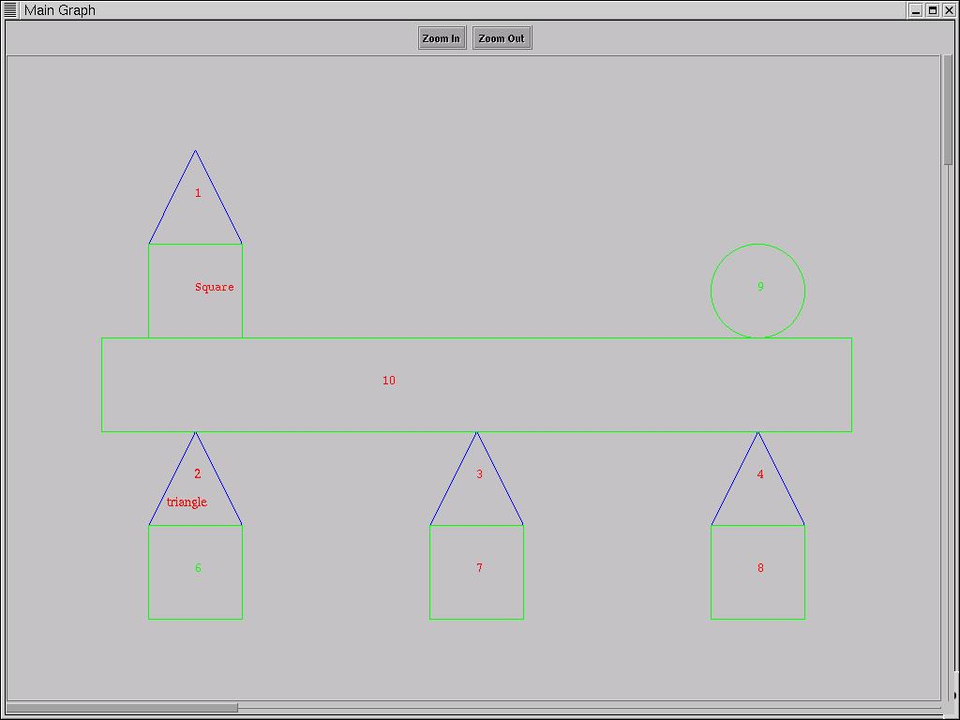

Figure 6: Main graph of Input 1

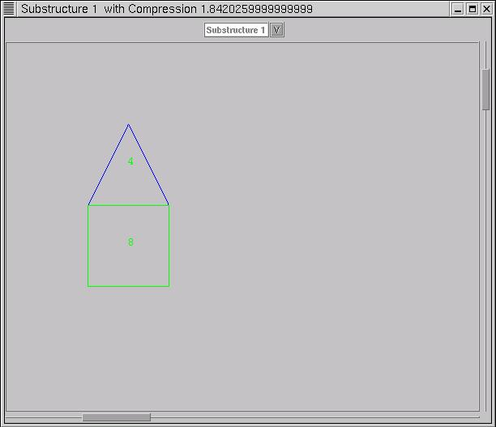

Figure 7: Substructure 1 of Input 1 showing the substructure

with the highest compression

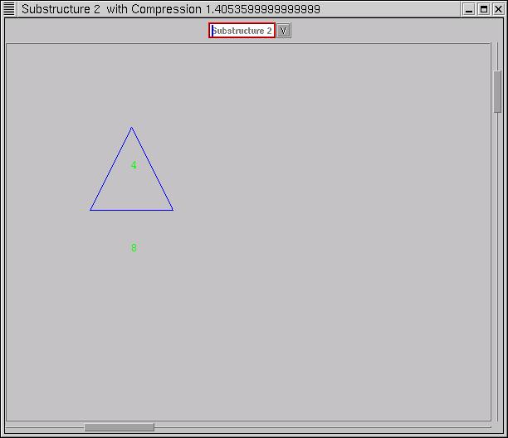

Figure 8: Substructure 2 of Input 1 showing the substructure with the second highest compression

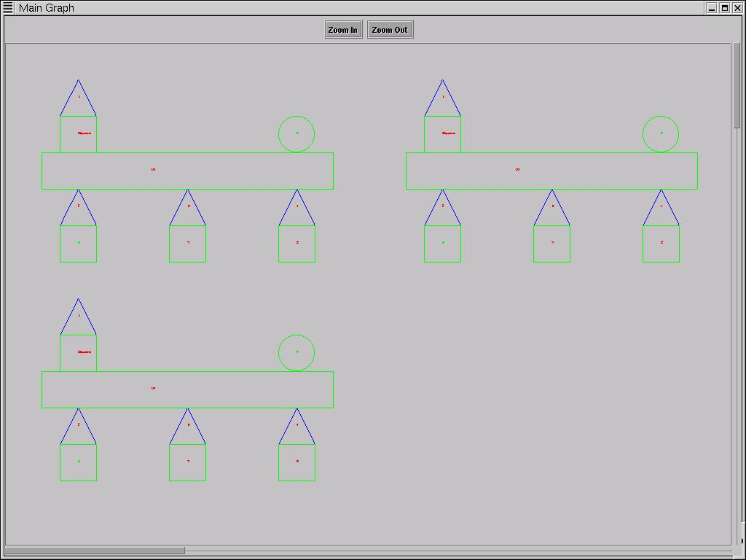

Figure 9: Main Graph of Input 2

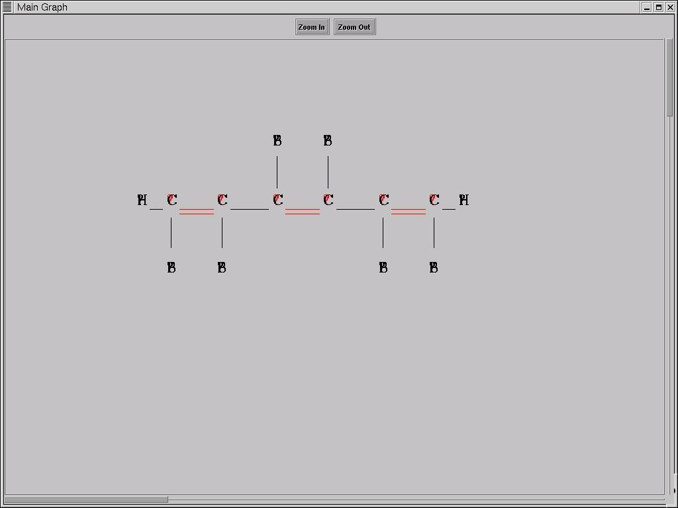

Figure 10: Main Graph of Input 3

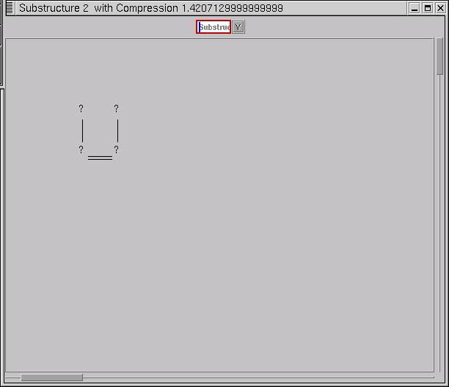

Figure 11: Substructure 2 of Input 3 showing the substructure with the second highest compression

5.2 Explanation of Output
Figure 6 shows the input graph containing four triangles, four squares, a circle and a rectangle, all with text placed inside them. The triangles are placed on the squares.
The window titled ‘Main Graph’, provides buttons for zooming in and out of the picture. The window also provides scrolling capability for cases where the picture does not fit completely on the screen.
Figure 7 shows a substructure discovered by Subdue, which has a compression value of 1.842. This substructure is displayed in a separate window. This window contains a list of all the substructures that Subdue discovers. The compression value happens to be the highest compression achieved by any of the six substructures discovered by Subdue and therefore is the first substructure in the list. When this substructure is selected for viewing in the window, all instances of this substructure are highlighted in the main graph window. Intuitively, it is obvious from the main graph shown in Figure 6, that this substructure has four instances in the main graph and has the highest compression.
Figure 8 shows another substructure discovered by Subdue with a compression value of 1.405. Again, intuitively, it is obvious that this substructure also occurs often in the main graph. The other four substructures discovered by Subdue are not shown here.
Figure 9 shows the second test case graph. Here the picture has been zoomed out so that the entire graph is visible on the screen. As explained before, this graph is derived from the first test case by duplicating the graph. Subdue found six substructures of different compression values but similar structure to that of the first test case.
Figure 10 shows the third test case input graph. This is a chemical structure consisting of Benzene (B), Hydrogen (H), and Carbon (C) elements connected through single and double bonds. Subdue found five substructures with this input.
Figure 11 shows one of these substructures with a compression value of 1.420. As in the other cases, when this substructure is selected for viewing, all instances of it are highlighted in the main graph.

6.Conclusion
Knowledge discovery in structural databases involves identifying the substructures that occur often in the data. The substructures represent new concepts found in the data and provide a means of reducing the complexity of the data. The understanding of the relationships within the data and the patterns found by the discovery process is enabled further by a visual description of the data.
The main objective of this project has been to provide a suitable visualization tool for Subdue and the substructures that are found during the discovery process. The Subdue Graph Visualizer accomplishes the requirements of such a tool, which are discussed in Section 3. This document discusses the SGV in detail and why it is suitable for Subdue. The experiments that are presented in this report demonstrate the ability of the SGV to display the input and the output graphs of Subdue. The following sections summarize the advantages and limitations of this tool as well as future work that could be done to enhance the tool further.

6.1 Advantages of SGV
- The SGV communicates very easily with Subdue through a TCP socket. No user interaction is required for communication.
- The SGV can be easily programmed to accept shapes that have not been previously defined.
- The grammar for defining the input to SGV can easily be modified for new concepts.
- The colors that are currently available can be easily expanded to include more colors and shades.
- The windowing capabilities of SGV can be modified easily to allow for panning, scaling, etc.
- The text capability of SGV can be expanded to accept more fonts and styles.
- SGV executes only if the display argument is specified in the command line of Subdue. SGV does not execute by default whenever Subdue executes. Therefore the user is given the option to use the visualization feature or not.
- When SGV executes, the program waits for Subdue to communicate with it. Therefore there is no interruption or delay of Subdue’s execution.
- The input file to Subdue can include the visual specifications as well. There is no need for separate input files to Subdue and SGV.

6.2 Limitations of SGV
- The display feature works only through one iteration of Subdue. The SGV program will not execute for multiple iterations of Subdue.
- The display feature does not work for parallel implementations of Subdue.

6.3 Future work
Future work on SGV could provide enhancements to features such as windowing capabilities, text font and size. Currently the highlight feature in the main window is accomplished by coloring the instances of the new substructure with a fixed color. This could be made more user-interactive whereby the user is allowed to specify what mechanism of highlighting should be used.
The parallel version of Subdue may be taken into consideration and SGV modified in such a way that the substructures discovered by each parallel implementation of Subdue can be displayed.
Currently SGV can handle input from Subdue only for one iteration. SGV could be modified to accept input from Subdue when Subdue is executing through multiple iterations.
Continued work on SGV will provide a powerful, user-modifiable visualization tool to help users better understand the structural patterns discovered by Subdue.

Appendix A: Input file with graphics for the triangle-square problem
This input file is for the example referred to in Figures 1,2 and 6.
v 1 object ((text "1" (200.0 150.0 ) (font Courier size 12) (color green fill no) ) ( text "99" (100.0 150.0) (font Courier size 12) (color green fill no) ) )
v 2 object ((text "2" (200.0 450.0 ) ) ( text "100" (200.0 450.0) ) )
v 3 object ((text "3" (500.0 450.0 ) (font Courier size 12) (color green fill no)) )
v 4 object ((text "4" (800.0 450.0 ) (font Courier size 12) (color green fill no) ) )
v 5 object ((text "Square" (200.0 250.0 ) (font Courier size 12) (color green fill no) ) )
v 6 object ((text "6" (200.0 550.0 ) (font Courier size 12) (color green fill no) ) )
v 7 object ((text "7" (500.0 550.0 ) (font Courier size 12) (color green fill no) ) )
v 8 object ((text "8" (800.0 550.0 ) (font Courier size 12) (color green fill no)) )
v 9 object ((text "9" (800.0 250.0 ) (font Courier size 12) (color green fill no)) )
v 10 object ((text "10" (400.0 350.0 ) (font Courier size 12) (color green fill no)) )
v 11 triangle ((polygon ( ( 150.0 200.0) ( 250.0 200.0) (200.0 100.0)) (color blue fill no)) )
v 12 triangle ((polygon ((150.0 500.0 ) (250.0 500.0) (200.0 400.0)) (color blue fill no)) )
v 13 triangle ((polygon ((450.0 500.0 ) (550.0 500.0 ) (500.0 400.0 )) (color blue fill no)) )
v 14 triangle ((polygon ((750.0 500.0 ) (850.0 500.0 ) (800.0 400.0 )) (color blue fill no)) )
v 15 square ((polygon ((150.0 300.0 ) (250.0 300.0 ) (250.0 200.0 ) (150.0 200.0 ) ) (color green fill no)) )
v 16 square ((polygon ((150.0 600.0 ) (250.0 600.0 ) (250.0 500.0 ) (150.0 500.0 ) ) (color green fill no)) )
v 17 square ((polygon ((450.0 600.0 ) (550.0 600.0 ) (550.0 500.0 ) (450.0 500.0 ) ) (color green fill no)) )
v 18 square ((polygon ((750.0 600.0 ) (850.0 600.0 ) (850.0 500.0 ) (750.0 500.0 ) ) (color green fill no)) )
v 19 circle ((circle (750.0 200.0 ) 100.0 (color green fill no)) )
v 20 rectangle ((polygon ((100.0 400.0 ) (900.0 400.0 ) (900.0 300.0 ) (100.0 300.0 ) ) (color green fill no)) )
e 1 11 shape
e 2 12 shape
e 3 13 shape
e 4 14 shape
e 5 15 shape
e 6 16 shape
e 7 17 shape
e 8 18 shape
e 9 19 shape
e 10 20 shape
e 1 5 on
e 2 6 on
e 3 7 on
e 4 8 on
e 5 10 on
e 9 10 on
e 10 2 on
e 10 3 on
e 10 4 on

References
[1]. L. B. Holder, D. J. Cook and S. Djoko. Substructure Discovery in the SUBDUE System. In Proceedings of the AAAI Workshop on Knowledge Discovery in Databases, 1994.
[2]. L. B. Holder and D. J. Cook. Discovery of Inexact Concepts from Structural Data. In IEEE Transactions on Knowledge and Data Engineering, Volume 5, Number 6, 1993.
[3]. D. J. Cook and L. B. Holder. Substructure Discovery Using Minimum Description Length and Background Knowledge. In Journal of Artificial Intelligence Research, Volume 1, 1994.
[4]. D. J. Cook, L. B. Holder and S. Djoko. Knowledge Discovery from Structural Data.
[5]. Link for DaVinci: http://www.tzi.de/daVinci/
[6]. Link for OpenGL: http://www.opengl.org
[7]. Link for GraphEd: http://www.infosun.fmi.uni-passau.de/GraphEd/
[8]. Link for VCG: http://www.cs.uni-sb.de/RW/users/sander/html/gsvcg1.html
[9]. Link for Dotty: http://seclab.cs.ucdavis.edu/~hoagland/Dot.html

