

OilEd 2.0 Quick Start
Sean Bechhofer
Information Management Group
Department of Computer Science
University of Manchester

seanb@cs.man.ac.uk

Overview
OilEd is a simple editor that allows the user to create and edit OIL ontologies. The main intention behind OilEd is to provide a simple, freeware editor that demonstrates the use of, and stimulates interest in, OIL. OilEd is not intended as a full ontology development environment — it will not actively support the development of large-scale ontologies, the migration and integration of ontologies, versioning, argumentation and many other activities that are involved in ontology construction. It should, however, provide enough to allow the basic construction of OIL ontologies and demonstrate the power of the connection to the FaCT reasoner.

This is a quick user guide to the OilEd ontology editor. It assumes that the user knows what OIL is and the basics of OIL ontologies. If you don't, check out the OIL Home Page

System Requirements
OilEd requires Java1.2. If you wish to use the reasoning services, you will also need an installation of the CORBA-FaCT reasoner (available from http://www.cs.man.ac.uk/~horrocks/software). This is now bundled with the OilEd distribution. All of OilEd's editing functionality will be available without the reasoner, but you won't be able to verify models.

Installing OilEd
OilEd comes as a standalone installer (using Zero-G's InstallAnywhere package). If you've got as far as reading this, then you've probably been able to install it! Running the installer will prompt for a location to install the software to. An uninstaller will be added that allows removal of the editor at a later date.

Acknowledgements
The development of this tool was supported by Interprice GmbH and the Free University of Amsterdam.

The OIL textual parser was developed using Robert Kosara's Bonfire system. More information in Bonfire is available from the Bonfire Home Page:
http://www.ifs.tuwien.ac.at/~rkosara/Bonfire/index.html

RDF support is provided through Sergey Melnik's implementation of an RDI API. More details on this are available from:
http://www-db.stanford.edu/~melnik/rdf/api.html

The look and feel of the editor has been strongly influenced by existing tools such as Protégé 2000.

This product includes software developed by the Apache Software Foundation (http://www.apache.org).

Warnings

This is not a finished product. It has not been thoroughly tested. It lacks much of the necessary functionality required of a full scale ontology editor. It will almost certainly break or crash at some point and you will lose bits of work. You are advised to save your work frequently to avoid disappointment.

This release of the Tool will no doubt contain a number of bugs. Any serious crashes, please report to seanb@cs.man.ac.uk. Note however that we have no maintenance strategy for OilEd, so the software is provided as-is. The tool is limited (see Limitations below), but hopefully offers sufficient functionality for the construction of example ontologies. You are advised to read this manual before using OilEd as it contains important information concerning some of the more idiosyncratic aspects of the tool!

Changes
This version of OilEd contains a number of changes and enhancements. Support for DAML+OIL and RDFS has been improved, with the inclusion of parsers as well as renderers. Better support for container and documentation editing are also included along with some updates and improvements to the interface with the reasoner.

Due to a change in the mechanism for exporting and parser, menu bar items appear in a different order to earlier versions.

The Small Print

Copyright © The Victoria University of Manchester 2001

All rights reserved. Permission to use, copy and distribute this software [and any related documentation] in whole [or in part] for any purpose (except as detailed hereunder) is hereby granted without fee provided that the above copyright notice and this permission notice appear on all copies of the software [and any related documentation]. Permission is not granted to disassemble, decompose, reverse engineer, or alter this file or any other files in the package. This freeware may be reproduced [only in its entirety] for circulation as 'freeware' without charge. This freeware may not be used without the permission of The Victoria University of Manchester for sale or incorporation into any other product sold. Source code for this software is proprietary information of The Victoria Universoty of Manchester, Department of Computer Science.

This software is provided 'as-is' and without any warranty of any kind, express, implied or otherwise, including without limitation, any warranty of merchantability or fitness for a particular purpose. In no event shall The Victoria University of Manchester be liable for any special, incidental, indirect or consequential damages of any kind, or any damages whatsoever resulting from loss of use, data or profits, arising out of or in connection with the use or performance of this software.

Main Menus

The menu bar provides access to functionality that in general applies to an entire ontology.

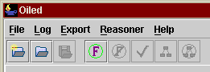
Figure 1 Main Menus

File Operations
The File menu provides a number of items relating to the creation, opening and saving of ontologies. OilEd works on projects, each of which contains an OIL ontology. Multiple projects can be open at one time, but classes cannot be moved between them — editing of each ontology is independent.

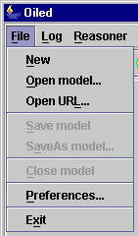
Figure 2 File Menu
Options are:
- New Start a new, empty, ontology
- Open Model Open an existing ontology. The editor will open either OIL RDFS schema (the default), OIL standard text files, or DAML+OIL (in RDF).
- Open URL Open an ontology from a URL.
- Save Model Save the current ontology. OIL RDFS is used by default as the representation format. Use Export if you wish to save using a different format.
- SaveAs Model Save the current ontology with a new file name
- Close Model Close the ontology
- Preferences Adjust the editor's behaviour.
- Exit Exit from OilEd

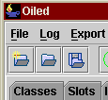
Figure 3 File Toolbar Buttons
New, Open Model and Save Model are also available via toolbar buttons.

Logging
A number of the operations of the editor will cause logging information to be recorded. This will be written to the log file (available in the file OilEdlog.txt in directory logs). The logging information can also be viewed using Show Activity Log in the Log menu.

Ontology Editor
Once an ontology has been loaded or created, the editor has a number of panels showing classes, slots, individuals, axioms and the container. These panels are made up of a number of components, which display lists of expressions, slots or constraints. The panels allow editing of the respective lists, through both right-button menu actions and buttons beneath the panel. Key panels are described below.

Description Editor
A core aspect of the interface is the description editor. This pane will appear in a number of guises and allows the construction and editing of an arbitrary frame description, i.e. a specification of a class that has a number of superclasses and a number slot constraints.

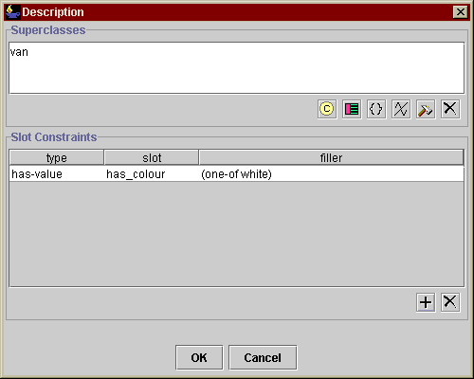
Figure 4 Description Editor
Figure 4 shows a description editor. The upper pane contains a list of superclasses and the lower pane shows a list of slot constraints. Both these panes are described in more detail below.

Expression Editor
The expression editor allows the editing of arbitrary class expressions, including boolean expressions such as and/or or not. Figure 5 shows an example of the expression editor.
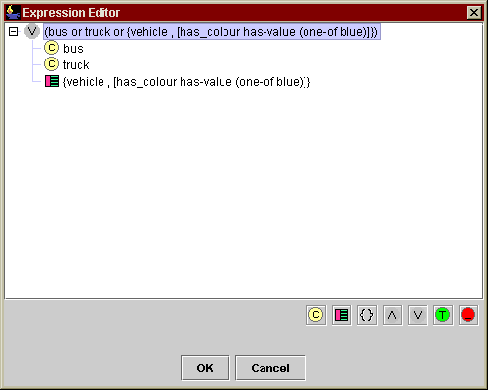
Figure 5 Expression Editor
The editor uses a tree to display the structure of the expression — the example shows an or expression with two class names and an arbitrary frame as arguments. Subexpressions can be expanded and collapsed using the standard Jtree controls. A right button menu gives access to various operations such as adding, removing or editing arguments to a boolean expression as shown in Figure 6. The root of the expression can be reset using the buttons at the bottom of the screen — note that this will replace the entire expression.

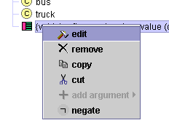
Figure 6 Expression Editor menu
Note that boolean expressions such as and and or must have at least one argument.

Expression List
The expression list holds a number of expressions and allows editing of the list.

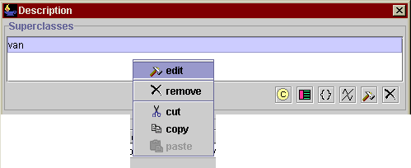
Figure 7 Expression List
Figure 7 shows an expression list along with its popup menu (accessible through a right mouse click). the selected expression can be edited, removed or copied, or a previously copied expression can be pasted. Depending on the user preferences (see below), the menu may also include options for adding new expressions. Alternatively, new expressions (class names, frame descriptions or set expressions) can be added to the list using the buttons below the list. If edit is selected, an expression editor will be opened. Again, the user preferences may be set to open appropriate editors for each expression type (e.g. a class list, description editor or individuals list), but the default is to open the expression editor. In some cases (e.g. the range of a slot), it may be appropriate to allow concrete type expressions in the expression list, and corresponding options will be available.

Slot Constraint List
The slot constraint list holds a number of slot constraints and allows editing of the list.

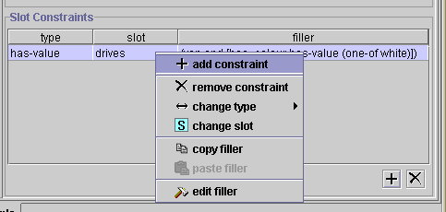
Figure 8 Slot Constraint List
Figure 8 show a slot constraint list along with its popup menu. New constraints can be added, and the selected constraint can be removed or edited. When adding a new constraint, a list of slots is offered for selection, then a choice of whether the filler is a class, arbitrary frame expression or a set expression. Slot constraints are has-value (existential quantification) by default but can then be edited. Editing can involve a change to the type of the slot constraint (has-value (existential quantification) value-type (universal quantification), cardinality), a change of the slot, in which case a slot list is provided for selection, editing of the filler — as with the expression list, an appropriate editor will be opened, copy of the filler to the clipboard or pasting of the filler from the clipboard.

Slot List
The slot list holds a number of slots and allows editing of the list.

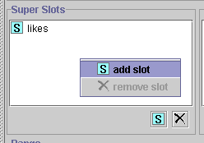
Figure 9 Slot List
Figure 9 shows a slot list along with its popup menu. Slots can be added and removed.

Button Panels

For each of the panels described above (Expression List, Slot Constraint List and Slot List), buttons below the panel offer immediate access to a number of the functions without having to use the popup menu.

Set Expressions
A set expression is a "one-of" construction and consists of a list of individuals. When editing or creating set expressions, a list of individuals is provided — any selected will be appear in the one-of. Multi selections can be made using the appropriate combination of modifier keys, for example in Windows, holding down <Ctrl> while clicking will select/deselect a single item, while holding down <Shift> will select a range.
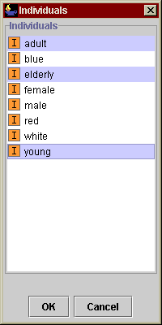
Figure 10 Set Expression Selection
Figure 10 shows an individual list with a number of individuals selected corresponding to the set expression one-of (adult, elderly, young).

Concrete Type Expressions
Concrete Type Expression is primitive. Concrete type expressions are entered by simply typing the (OIL standard) syntax in a given field. The expression's syntax will be checked before the expression is added. The syntax is given below.

<concrete-type-exp> ::= <int-exp> | <string-exp>
<int-exp> ::= "integer" |
"(" <int-pred> <%INTEGER> ")" |
"(" "range" <%INTEGER> <%INTEGER> ")" |
"(" <int-exp> ("and" <int-exp>)+ ")" |
"(" <int-exp> ("or" <int-exp>)+ ")" |
"(" "not" <int-exp> ")"
<int-pred> ::= "min" | "max" | "greater-than" | "less-than" | "equal"
<string-exp> ::= "string" |
"(" <string-pred> <%STRING> ")" |
"(" "range" <%STRING> <%STRING> ")" |
"(" <string-exp> ("and" <string-exp>)+ ")" |
"(" <string-exp> ("or" <string-exp>)+ ")" |
"(" "not" <string-exp> ")"
<string-pred> ::= "min" | "max" | "greater-than" | "less-than" | "equal"

Classes
The class pane displays a list of all classes on the left hand side, in alphabetical order. Selecting a class will then display its definition in the right hand pane. The definition consists of a description editor (see above) along with some documentation and a pair of radio buttons indicating whether the class is primitive (necessary conditions) or defined (necessary and sufficient conditions). Although the OIL language supports multiple definitions, OilEd does not and requires each class to have a single definition. If the editor encounters an input file that contains multiple definitions, it will convert the later definitions to axioms — note that this will not in any way change the semantics of the ontology as a class definition is simply an alternative presentation of an axiom.

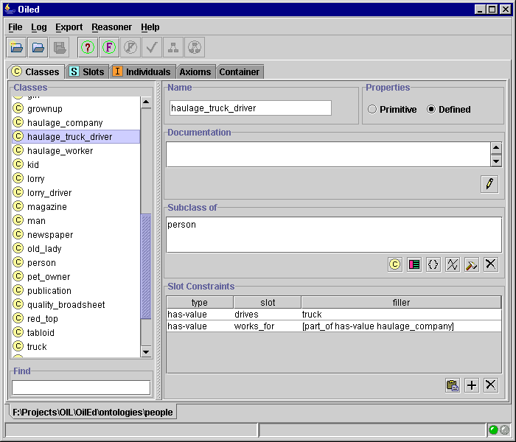
Figure 11 Class Panel
Figure 11 shows the class panel focused on the definition of a haulage_truck_driver: a person who drives a truck and works for some part of a haulage company. The editing facilities of the expression and slot constraint panels provide direct editing of the class definition. Documentation can be edited by clicking on the button below the documentation field. Note that including some punctuation characters and returns in the documentation entry will cause problems with the Oil textual parser.

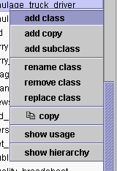
Figure 12 Class List Menu
The class list panel provides a menu allowing addition of classes, renaming of classes and removal. Options here are:

- add class add a new class (primitive by default).
- copy class add a new class with the same definition as the currently selected class.
- add subclass add a new class with the currently selected class as a super.
- rename class rename the currently selected class.
- replace class replace the currently selected class with another.
- copy copy the currently selected class to the clipboard.
- remove remove the class from the ontology.
- show usage show where the class is used.
- show hierarchy show the class's position in the hierarchy.

When adding a class, a name is requested — this must be a new name that is not already used by a class, slot or individual. Similarly when renaming. If classes are renamed, the renaming will be propagated throughout the ontology. Classes cannot be removed if they are used anywhere in the ontology (as part of a definition of class, slot or individual, or within an axiom) — in this case a warning will be given. When replacing classes, the class being replaced can be removed if required. Names should not contain spaces. The Oil textual parser doesn't really like punctuation, so it's best to avoid the use of punctuation characters (although underscores are ok). Similarly, the Oil textual parser will not allow spaces in class names. This restriction can be enforced during editing by unsetting the appropriate checkbox in the preferences panel. You are advised to use the RDFS (or DAML+OIL) formats if you wish your ontology to use spaces with names. See the comments below concerning class names and the reasoner.

Class Hierarchy
Double clicking on a concept in the class panel will bring up a simple hierarchy viewer. This shows the position of a class w.r.t its super and sub classes. Refocusing the hierarchy viewer will refocus the class panel.

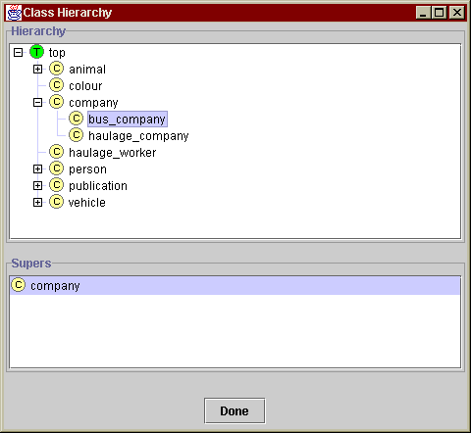
Figure 13 Class Hierarchy Viewer
The upper half of the pane shows the class hierarchy, the lower half shows other supers of the focus concept (the viewer uses a simple tree structure to display the hierarchy, and so cannot show multiple parents). Clicking a parent in the lower pane will refocus the upper pane to show the focus in the concept of the selected parent.

See the Reasoning section below for a discussion of the philisophy behind OilEd's hierarchies.

Slots
The slot pane displays a list of all slots on the left hand side, in alphabetical order. Selecting a slot will then display its definition in the right hand pane. The definition shows any super or inverse slots, range and domain restrictions. In addition, checkboxes indicate whether the slot is transitivite, symmetric or functional.

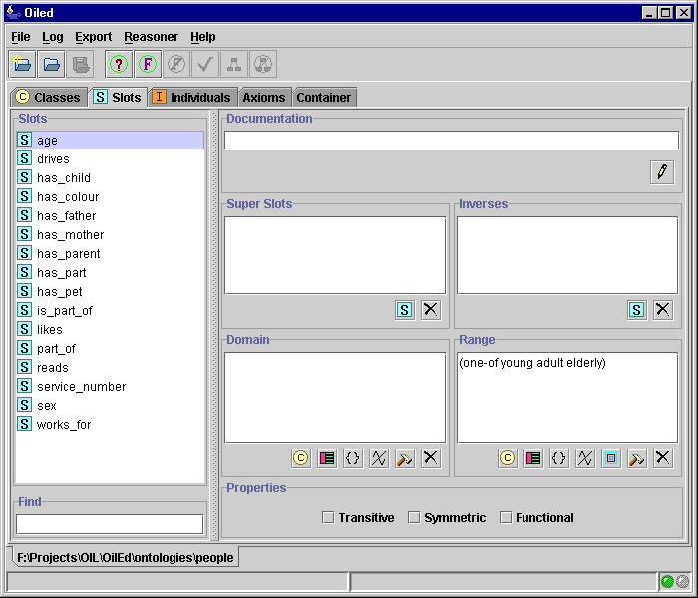
Figure 14 Slot Panel
Figure 14 shows the slot panel focused on the definition of a slot age. This slot has a restriction on its range, saying that the only fillers permissible are drawn from the set {adult, elderly, young}. The editing facilities of the expression and slot constraint panels provide direct editing of the slot definition. As with the class panel, a popup menu allows addition, renaming and removal of slot definitions. Similar restrictions apply to the removal of slots when in use.

Individuals
The individual pane displays a list of all individuals on the left hand side, in alphabetical order. Selecting a slot will then display its definition in the right hand pane. The definition shows any superclasses of the individual along with relationships to other individuals.

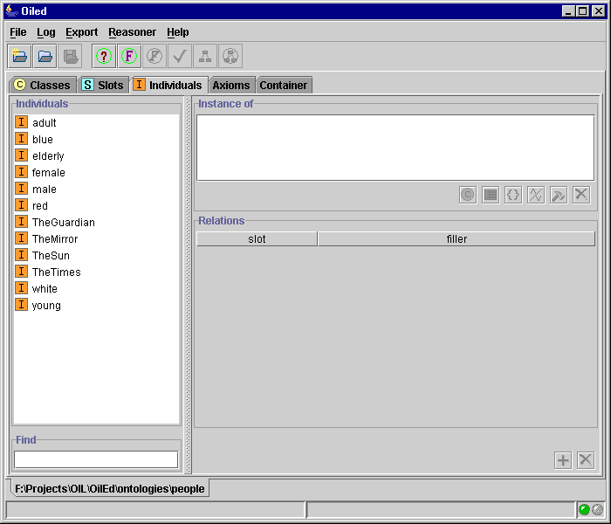
Figure 15 Individual Panel
Figure 15 shows the individual panel focused on the definition of India, a country which is part of Asia. The expression and relations list panel allow editing of the individual's definition and a popup menu on the individual list allows addition, removal and renaming as with the class and slot panels. Relations to other individuals can be added and removed.

Axioms
The axiom pane displays a list of all axioms on the left hand side. Selecting an axiom will then display its definition in the right hand pane. Different axioms have slightly different displays, but in general the axiom panels include expression lists for the arguments to the axiom.

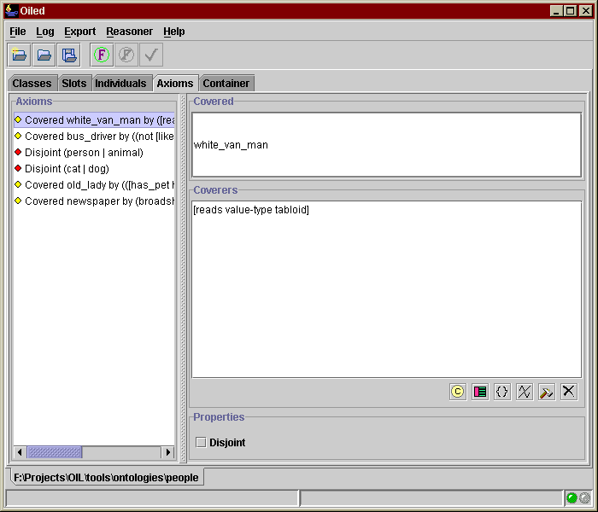
Figure 16 Axiom Panel
Figure 16 shows the axiom panel focused on a covering axiom which states that white_van_man is covered by the slot-constraint has-value reads tabloid (the only newspapers that white van man reads are tabloids). The covering axiom panel includes a check box for recording whether the covering is disjoint. Panels for disjoint and equivalence axioms simply show a list of the disjuncts or equivalences which can be edited using the usual editing facilities.

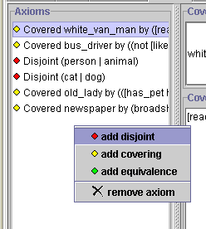
Figure 17 Axiom List Menu

The axiom list provides a popup menu (see Figure 17) which allows addition of new axioms and removal of the selected axiom.

Container
A default container is written to any new ontologies. The container panel displays the current values of fields in the container.

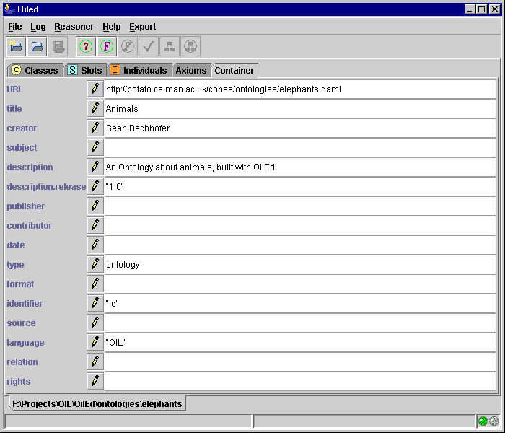
Figure 18 Container Panel
The small pen buttons allow editing of the fields within the container. The OIL text parser is notoriously fussy about the format of strings. If you intend editing the container, you are advised to use RDFS or DAML+OIL format for your ontology.

The ontology container also allows you to edit the URL of the ontology. This URL is used as the default namespace during output of RDFS-based ontologies.

Reasoning
In order to use OilEd's reasoning capabilites, the CORBA-FaCT reasoner must be installed and running. This document does not provide instructions about the installation and use of CORBA-FaCT, but assumes that the reasoner is installed and working properly. Please Note: This version of OilEd requires an up to date version of the CORBA-FaCT reasoner (version 2.30.5) running SHIQ. An installation of the reasoner is now supplied with OilEd.

OilEd provides a connection with the FaCT reasoner that allows satisfiability checking of models and discovery of implied subsumptions. Please see the note below concerning case sensitivity!

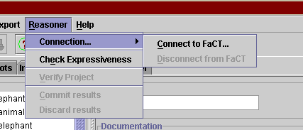
Figure 19 Connecting to FaCT
Use the Connect to FaCT… menu option to connect to a running CORBA-FaCT server. A dialog will prompt for host and port information. Once connected, Verify Project will become active. Selecting verification causes the following:
- The ontology is translated to SHIQ/FaCT, and this is then transmitted to FaCT for classification
- Each class in the ontology is checked for satisfiability.
- For each class in the ontology, its supers (according to the classifier) are determined.
Depending on the operators used in the ontology (to be precise the presence of inverse roles or cardinality restrictions), the classifier may be able to classify using the FaCT reasoner rather than SHIQ (which will produce better performance). Check Expressiveness will check to see which reasoner is required for the current ontology.

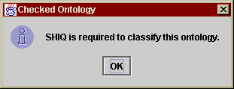
Figure 20 Checking Expressiveness
Figure 20 shows the results of checking an ontology which requires the SHIQ classifier .

After the verification process, a short report is written to the activity log, recording any unsatisfiable concepts found. In addition, unsatisfiable concepts will now appear in red in the class list.

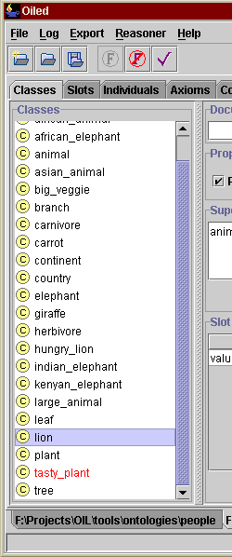
Figure 21 Unsatisfiable Classes
Figure 21 shows the class list after verification. In this case, the class tasty_plant has been found to be unsatisfiable. At this point, new subsumption relations and unsatisfiability information can be discarded or added to the model. See the section on Hierarchies below for a detailed discussion of the effects of these actions.

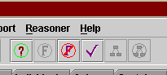
Figure 22 FaCT Toolbar Buttons
Control of the FaCT connection and verification are also available via toolbar buttons.

Hierarchies
The issue of hierarchies is a thorny one and there are still many issues that require resolving concerning the way that OiLEd deals with hierarchies. The current version takes a simple approach to displaying hierarchies, using a tree structure along with extra information about other parents. However, deciding exactly what that hierarchy should be raises many interesting questions.

OilEd without FaCT

If we disregard the FaCT reasoner, the superclasses shown in the concept hierarchy are those classes which have been explicitly asserted as being superclasses of a class. Note that OilEd itself does no reasoning at all. If a concept driving_man has the superclass (man and driver), then the class hierarchy will not show man or driver. If the concept has the two classes man and driver asserted individually as superclasses, then they will appear in the class hierarchy. In addition, OilEd will not try and maintain a sparse concept hierarchy. Thus if we add classes animal, mammal and dog, and assert that a mammal is a kind of animal, and a dog is both a mammal and an animal, the subclass link between dog and animal (which is now redundant) will still be present, as shown in Figure 23.

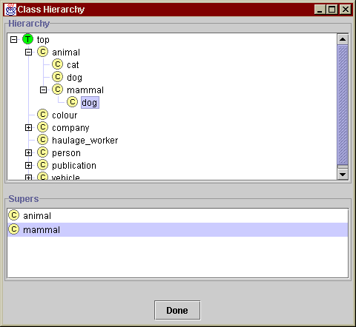
Figure 23 Redundancy in Hierarchies
The hierarchy viewer is also currently unable to cope with circular hierarchies. Thus if we have three classes a, b and c, with a a subclass of b, b a subclass of c and c a subclass of a (in other words they're all equivalent), the classes don't get displayed in the hierarchy. This is a bug.

OiLEd with FaCT
When the reasoner comes into play, the situation becomes rather more complicated. If the reasoner is asked to verify the model, the subclass hierarchy is replaced with the hierarchy determined by the reasoner. Thus in our example above, (but no change is made to the definitions of the classes). Figure 24 shows the state of the hierarchy after verification.

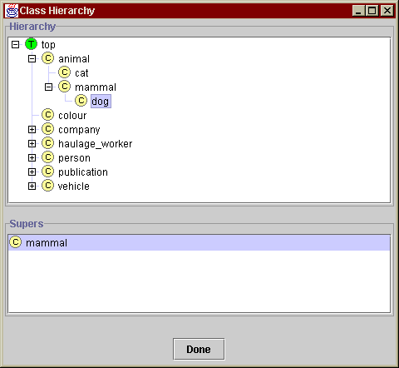
Figure 24 Hierarchy post Verification
At this point, if we elect to Discard changes, the hierarchy will be returned to its original state (and any information about unsatisfiability will be discarded). Alternatively, the subsumption relations can be added to the ontology through Commit changes. This will add new superclasses corresponding to any discovered relationships that do not already occur. How such superclasses are added is determined by the preference settings. If Sparse Hierarchies is unselected, OiLEd will simply add any superclasses that it finds into the definition — this may result in the creation of non-sparse hierarchies and redundant superclasses. Alternatively, if Sparse Hierarchies is selected, OiLEd will attempt to prune any redundant parents and maintain a sparse hierarchy. Be aware that this behaviour may cause unexpected results.

Identifiers & Case Sensitivity

OilEd as a standalone application is case sensitive. Thus if we introduce classes Cat, cat and CAT, these will all be treated as different classes. The current implementation of the CORBA-FaCT reasoner, however is not case sensitive. Thus the reasoner will consider the three classes introduced above to be the same. This may cause unpredictable results. It is probably best to avoid the use of object names that are distinguishable only through case. In addition, the reasoner will not like class names containing some punctuation characters (for example the colon character :). Again, for these reasons, it is best to stick to alphanumeric names, using underscores in multi-word indentifiers.

Export
By default, OilEd uses OIL-RDFS as it’s format for storing ontologies. OilEd can also export ontologies in a number of different formats.

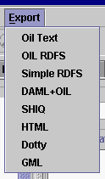
Figure 25 Export menu
Renderers which are currently available include:

- OIL Text The ontology is exported as OIL Standard text.
- OIL RDFS The ontology is exported as an OIL RDFS description (OilEd’s default).
- Simple RDFS The ontology is exported as a simple RDFS description. The class hierarchy is simply exported as rdfs:subClassOf triples. Slots are also output along with rdf:range and rdf:domain expressions where possible.
- DAML+OIL The ontology is exported as a DAML-OIL description (both the schema from 2000/12 and 2001/03 are available).
- SHIQ The ontology is exported as a SHIQ knowledge base which can be read into FaCT at a later date for classificaton.
- HTML A simple HTML rendering of the ontology is exported. This can be useful for static viewing of ontologies or for display on a web site.
- Dotty The basic class hierarchy is exported in a format that Dotty (AT&T's grapher) can read. If the model has been verified, the graph will represent the state of the inferred hierarchy. Note that Dotty's parser is rather fussy and objects to hyphens in node names. For this reason it's better to use underscores in class names.
- GML The basic class hierarchy is exported in Graph Markup Language. If the model has been verified, the graph will represent the state of the inferred hierarchy.

The OIL RDFS uses the RDFS OIL schema given at:

http://www.ontoknowledge.org/oil/rdf-schema/2000/11/10-oil-standard

DAML-OIL output uses the schema:

http://www.daml.org/2000/12/daml+ont

and

http://www.daml.org/2001/03/daml+oil

The RDFS and DAML+OIL support are reasonable stable. Note that the OIL RDF schema definition is looser than the Oil Standard definition, so there may be descriptions of OIL ontologies that conform to the schema, but which OilEd rejects. Vanilla RDFS descriptions can be read — any resources that occur from outside of the RDF, RDFS and OIL namespaces will be ignored.

A note on DAML+OIL

DAML+OIL output is still rather experimental — you'd be advised to be careful when using it. It's probably best not to build nuclear power station controllers based on it, for example. OilEd will read DAML+OIL, but is rather fussy about the ontologies it will deal with. Warnings may be generated during reading of DAML+OIL — check the log for details. The editor will try and pull facts together into class descriptions rather than leaving them as axioms, but this may not always provide the results that you expected. Concrete datatypes are not dealt with properly by OilEd when using DAML+OIL. Any concrete type expressions are simply output as the class OILED_DATATYPE.

RDFS based formats and identifier clashes
OilEd will read RDFS and DAML+OIL descriptions of ontologies. Be aware, however, that the parsers are not particularly sophisticated. In the current version, for instance, the parser simply ignores any namespace parts of identifiers and simply uses the fragment to name a class. For instance the RDF statement:

<rdf:Class rdf:ID=http://mydomain.com/ontology#Cat/>

will result in the introduction of a class Cat. If there is another statement

<rdf:Class rdf:ID=http://yourdomain.com/models#Cat/>

then OilEd will consider it to refer to the same class. This is not an ideal situation, but is less of a problem when using the editor to construct an ontology as all the classes will be, by default, defined within the namespace given by the URL of the ontology.

User Preferences

A limited amount of customisation is possible. This is accessible via the Preferences panel as shown in Figure 26.

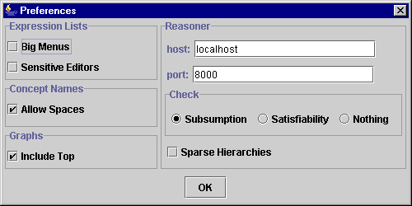
Figure 26 Preferences Panel

Current options available are:

- Big Menus Menu actions for addition of classes, frames, expressions and set expressions will be included in the expression list panel.
- Sensitive Menus Appropriate editors will be opened up on expressions in the expression list panel.
- Allow Spaces Allow the use of spaces in concept names (will cause problems with Oil text format).
- Include Top Include the top concept in any graphs produced (GML/Dotty).
- Reasoner defaults Set the host and port information for the reasoner.
- Check
  - Subsumption OilEd will check the satisfiability of concepts and look for implied subsumption relationships.
  - Satisfiability OilEd will only check for satisfiability.
  - Subsumption OilEd will do no checking, but simple sends the model to the reasoner .
- Sparse Hierarchies Controls the behaviour when adding inferred super classes. If checked, OilEd will remove any superclasses which are redundant.

Note that some of the reasoner options available in earlier version of OilEd are no longer available. This is due to improvements in the reasoner.

There is no plugin architecture as such for parsers and renderers, but a certain amount of configuration is possible, as described in config.txt in the installation.

Limitations and Known Bugs
This is a (non exhaustive) list of the limitations of the current version of OilEd. Most of these will be fixed during the next few iterations of development, however, some (such as import, include and the issues around modularisation) are longer term issues that will not be fully addressed.

- No hierarchical slot displays.
- The class hierarchy viewer can be temperamental. In particular, if the class hierarchy contains cycles, classes in the cycle may not show up in the hierarchy.
- Concrete type expression editing is miminal.
- No undo. In particular be aware that if a popup editor has no cancel button, the changes you are making happen immediately.
- Semantics of import is unclear. Currently, if the editor encounters an import statement in an oil text file, the class definitions of the imported ontology will be displayed but cannot be edited. When the ontology is saved, however, all definitions are saved, and any information about import or wherer the definitions came from is discarded.
- There is no support for the modularisation of ontologies, other than via import (with the limitations listed above).
- Problems with case sensitivity when the reasoner is used.
- Axiom editing is primitive. The covered expression cannot be edited in a covering expression.
- Some of the redrawing is flaky.
- Any comments in the original Oil text files will be discarded.
- RDFS parsers ignore name spaces in class identifiers.

Filename extensions are important here. If the file has a .oil extension, the editor will assume it's oil standard, if the extension is .rdfs, the editor will assume it's RDFS, if .daml it assumes it's DAML+OIL.
As highlighted within this manual, the Oil textual format is very limited, particularly with respect to string handling (concept names, documentation, container entries etc). For this reason (and as the textual format is likely to become obsolete), you are advised to use the OIL RDFS format for your ontologies.
OilEd does not do automatic content detection, so you have to tell the editor what format to expect the ontology in (RDFS, DAML+OIL or text). Also be aware that if you have to connect to the web via a proxy, then you need to set Java up accordingly. In this case, you may have to explicitly run Java rather than using the .exe provided.
Note that although multiple ontologies can be open at one time, editing is discrete — each ontology has its own clipboard and expressions cannot be copied between them.
Slot constraint types can be confusion. An existential constraints asserts that there must be at least one filler with the given type. A universal constraint asserts that all fillers of the slot must be of the given type, but does not necessarily assert the existence of such a filler.
No class hierarchies in the current version.
It is important to understand the differences between defined and primitive classes. This document does not attempt to explain this — consult the OIL documentation for further elaboration on this point.
A warning will be generated in the log.
This is very similar to the approach used in Protégé.
Axiom addition is rather clumsy at present. Disjointness axioms should have at least two arguments, and equivalence axioms should have exactly two. This is not enforced at creation time. However, when the editor is asked to save the ontology, it will check that the axioms are valid. If not, a warning is issued and save does not take place. The log will show some indication of the offending axiom.
Note, however, that it's your responsibility to ensure that the reasoner connected to is the appropriate one. Also, be aware that if FaCT is used rather than SHIQ and the ontology contains inverse roles or cardinality restrictions, then the reasoner may fail to spot inconsistencies or subsumptions.
OIL Standard text (as implemented by OilEd) is rather fragile. In particular, comments and container information can't contain new lines or a number of punctuation characters.
The XML SHIQ knowledge bases produced by OilEd have no DTD declarations. This may cause a slight problem with the earlier releases of the FaCT demo client. If you have problems trying to compile SHIQ files with the original client, try inserting the text <!DOCTYPE KNOWLEDGEBASE SYSTEM "fact.dtd"> after the initial <?xml…> declaration (ensuring that fact.dtd is in the same directory as the knowledge base).
Note that this may make things more difficult — if this option is selected, it can be hard to migrate from, say, a class expression to a frame description.

