Our Contribution

Modifications
- With the continuous development of devices to be more efficient while reducing their bulky nature, for our contribution, we decided to replace the RLC circuit with a band-pass active filter, due to the bulky nature of the inductor, parasitic noises larger inductances introduce, and the need for functionality at any frequency range, negative implications, initially not considered by the paper. Instead of using the traditional KVL to compare, the second-order transfer functions for each are compared.
- We also revised the model diagram from a passive RLC to a band-pass active filter with a Sallen-Key topology.
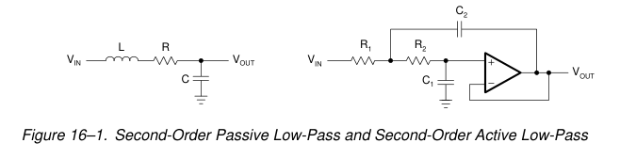
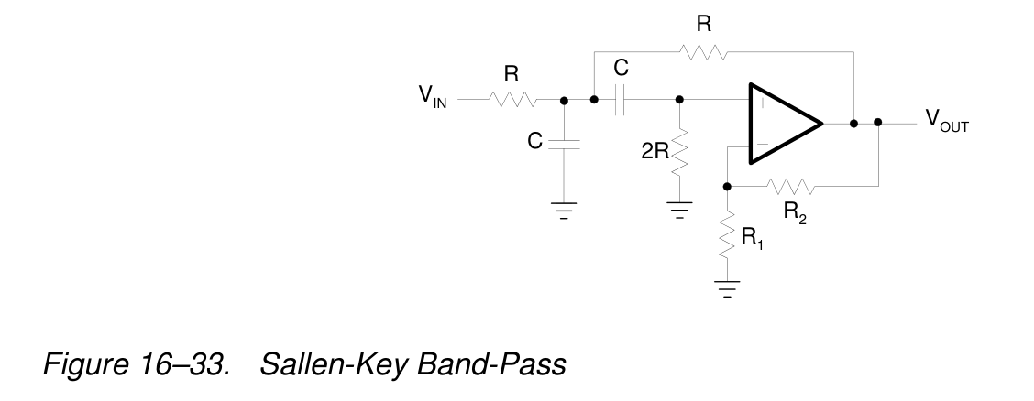[1]

Our Results
Theory
- A filter is a device that passes electric signals at certain frequencies or frequency ranges while preventing the passage of others. High-frequency band-pass filters (several hundred MHz) are used for channel selection in telephone central offices. Data acquisition systems usually require anti-aliasing low-pass filters and low-pass noise filters in their preceding signal-conditioning stages. System power supplies often use band-rejection filters to suppress the 60-Hz line frequency and high-frequency transients. [1]
- At high frequencies (> 1 MHz), all of these filters usually consist of passive components such as inductors (L), resistors (R), and capacitors (C). They are then called LRC filters. In the lower frequency range (1 Hz to 1 MHz), however, the inductor value becomes very large and the inductor itself gets quite bulky, making economical production difficult.
- In these cases, active filters become important. Active filters are circuits that use an operational amplifier (op amp) as the active device in combination with some resistors and capacitors to provide an LRC-like filter performance at low frequencies. [1]
- Transfer functions in the Laplace s domain will be used instead of the usual response-time model to compare, since solving the model in the traditional frequency-time domain yields complex integro-differential models. [2] The behaviour of the complex response-time models can be obtained from the parameters of the traditional model.
- Transfer fn = Vout/Vin and

- Transfer function for 2nd order band pass
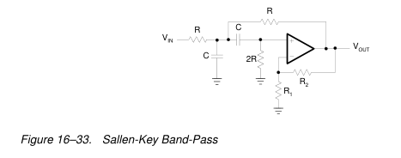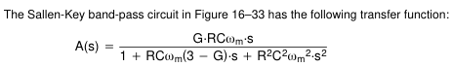
[omega_m is not part]
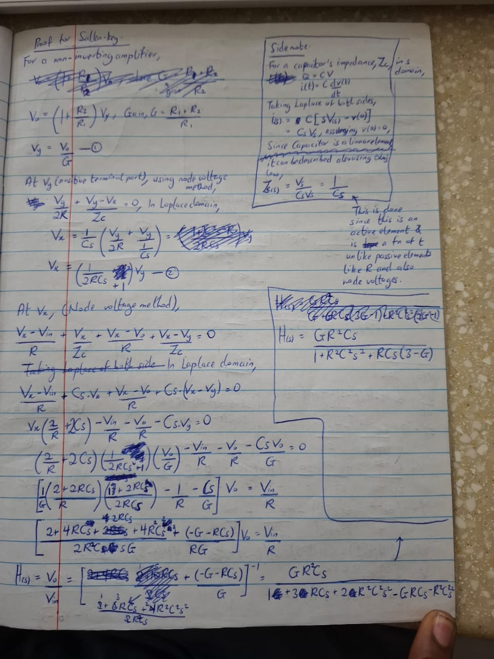

- Transfer fn for standard RLC series circuit, configured for band pass
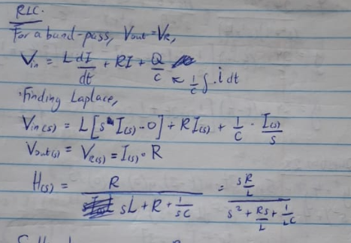

Results
Graphs to compare damping conditions
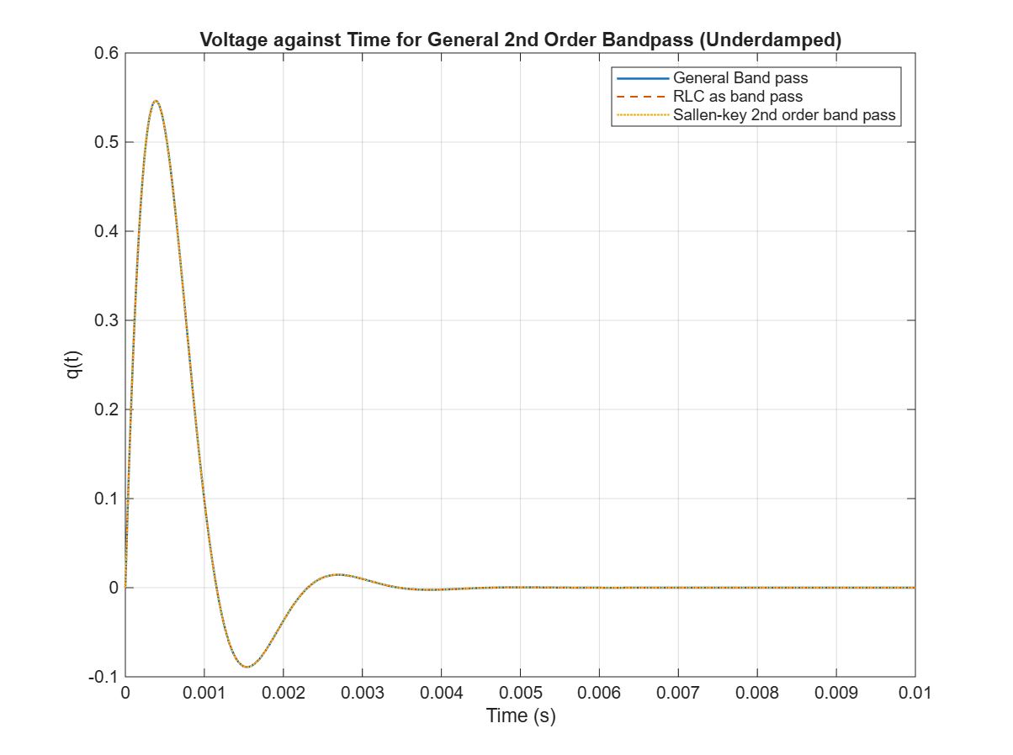
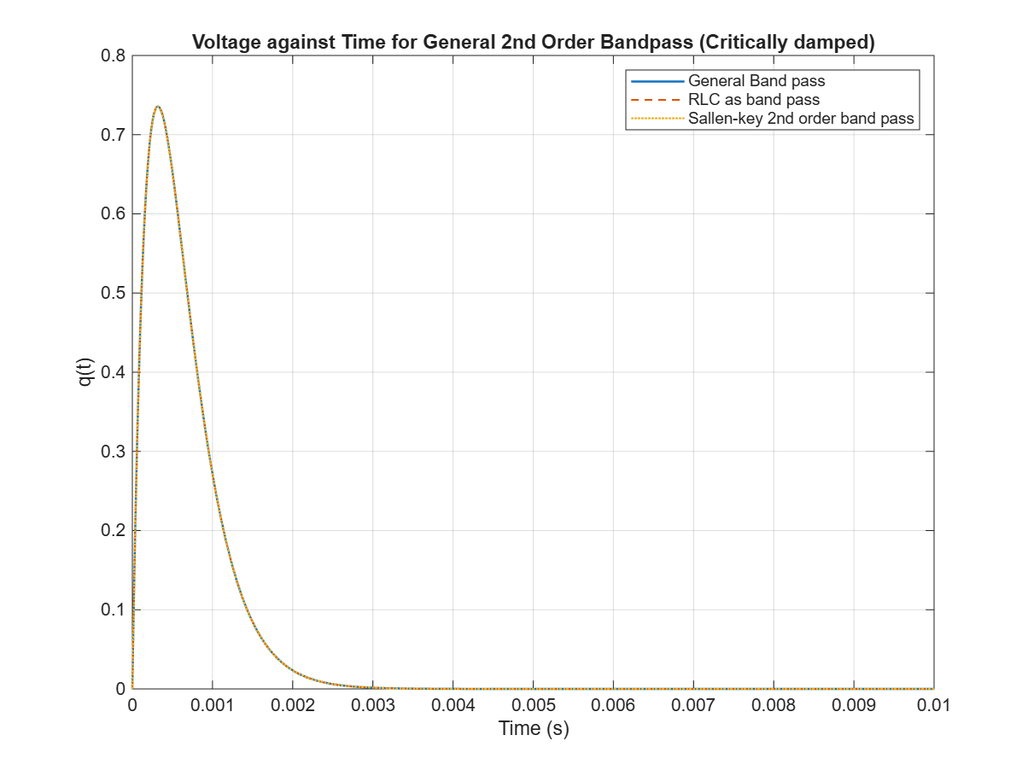
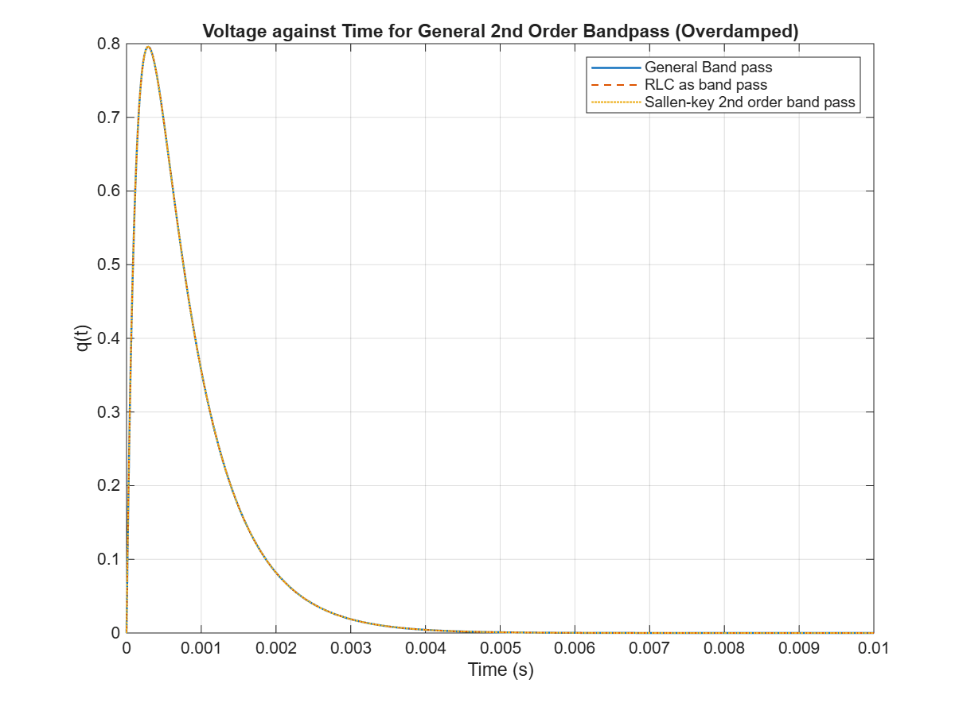
The above graphs show a comparison of the step responses for the standard band pass, RLC series and Sallen key topology circuits, for all three damping conditions. It can be deduced from all three plots that though the RLC and sallen key topologies have totally different component configurations, the step response from both are identical when made to fit the general case.

Limitations and Further Research
- One crucial limitation this research uncovered was that a direct replacement for an RLC circuit is impossible. One needs to consider the use case, whether for filtering circuits or surge suppression circuits, as well as the frequency the circuit would be working with, factors not considered directly by KVL-based or transfer function second-order models. Each type of active filter circuit has its own use case and cannot serve as a direct replacement.
- In conducting further research, we will explore the use of Antoniou Gyrators, circuit segments we discovered later in our research, to directly replace the inductors, without changing the R and C for a series RLC circuit. It would also help analyse the charge response directly, unlike the voltage response used in our modifications.
- Also, further comparisons would be made for other second-order Sallen-Key topology pass circuits to consider which could serve as a more generalised solution to standard RLC series circuits.

References
[1] B. Carter and R. Mancini, “Op Amps for Everyone: Fifth Edition,” Op Amps for Everyone: Fifth Edition, pp. 1–458, Jul. 2017, Accessed: Aug. 13, 2026. [Online]. Available: https://www.oreilly.com/library/view/op-amps-for/9780128116470/XHTML/B9780128116487000169/B9780128116487000169.xhtml
[2] J. W. Nilsson and S. Riedel, Electric Circuits, 9th ed. USA: Prentice Hall Press, 2010.

