You have provided 500 shifts performance data related to fleet operations in a coal mine. Your goal is to define KPIs of shifts and categorise good, average, bad shifts based on the KPIs. Find key factors (i.e. features) that we can define good, average and bad shifts, and then build a model that predicts the performance (good, average, bad) of the next shift.

Questions:

1. How would you define good, average and bad shifts?
2. What are the key factors that define good, average and bad shifts?
3. What are the thresholds of key factors to reach a good shift?
4. How to predict the performance of the next shift?

Hints corresponding to answer each question above:

1. Clustering approach or any other technique to define good, average and bad shifts. For example, when simply using production as KPI, production of good shift > 13000bcm, 13000bcm > production of average shift > 11000bcm, production of bad shift < 11000bcm.
2. Consider feature engineering to obtain key factors that define a good, average and bad shift.
3. Consider sensitivity analysis focusing on good shifts and their value ranges (min and max) (e.g. in a good shift cycle time varies from 20min to 30min).
4. Build a prediction model (e.g. probabilistic, regressions, trees, neural network) to predict a good shift.

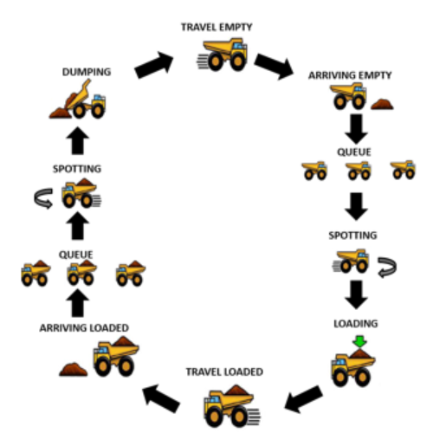

Figure 1: One complete truck cycle.

Definitions of features:

* See column_description.xlsx

Output:

* 25 - 30 minutes (maximum) powerpoint presentation (including 10 minutes Q&A) during the interview
* Python source code

Programming language: Python (local PC)

Time allocation to prepare the work: One day (maximum)