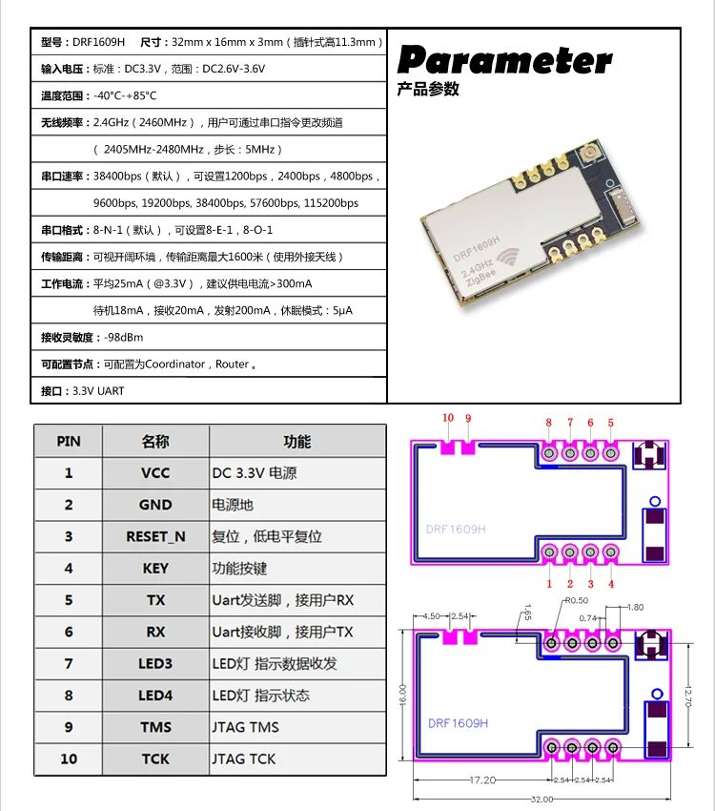

PIN on board | PIN on CC2630F128RHB 5x5 | Name of PIN | PIN assignment
1 | VCC | VCC | VCC
2 | GND | GND | GND
3 | 19 | RESET_N | RESET_N
4 | 22 | DIO_9 | KEY
5 | 6 | DIO_0 | TX
6 | 7 | DIO_1 | RX
7 | 8 | DIO_2 | LED3
8 | 9 | DIO_3 | LED4
9 | 13 | JTAG_TMSC | JTAG TMS
10 | 14 | JTAG_TCKC | JTAG TCK

