Bass Guitar Project:
A MIDI Controlled Robotic Bass Guitar

Idaho State University
College of Technology
5th Semester
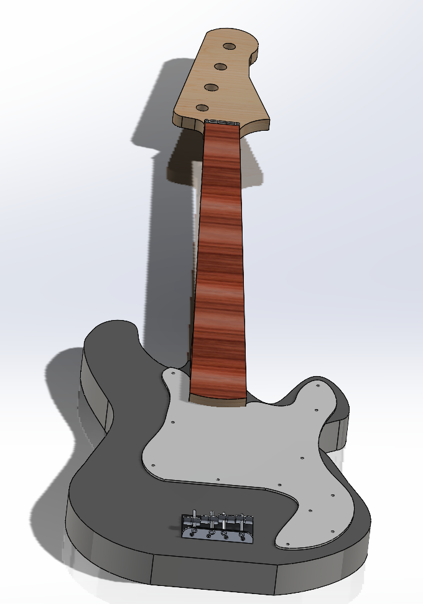
Prepared For: Shane Slack
Prepared By: Owen Fujii
12/09/2024
Table of Contents
Abstract 5
Background Information 5
Proposed Problem 6
System Overview 7
Master Processor 9
String Slave 15
Plucking Slave 17
Calibration Procedure 21
Troubleshooting 22
Serial Troubleshooting 26
Plucking Unit Troubleshooting 29
Slave Unit Troubleshooting 31
Engineering Log 32
Cost Analysis 33
Conclusion 34
Recommendations 35
Appendix A: Citations 37
Appendix B: Mechanical Drawing 38
Appendix C: Schematics 41
Additional Information 47

Table of Figures
Figure 1: Original Bass Guitar 5
Figure 2: Full System Diagram 8
Figure 3: Master Flowchart 9
Figure 4: String Select Flowchart 12
Figure 5: MIDI Received 13
Figure 6: I2C Master Transmission 13
Figure 7: Master Breadboard Testing Layout 14
Figure 8: String Slave Program Flowchart 15
Figure 9: Slave Breadboard Testing Layout 17
Figure 10: Plucking Slave Program Flowchart 18
Figure 11: Plucking Solenoid Array 18
Figure 12: Alternating Solenoid Waveform 20
Figure 13: Hex Switch 22
Figure 14: PIC Status Indicators 23
Figure 15: System Troubleshooting Flowchart 24
Figure 16: Processor Troubleshooting 25
Figure 17: Power Schematic 25
Figure 18: Oscillator Out Test Point 26
Figure 19: MIDI Test Point 27
Figure 20: Serial Troubleshooting Flowchart 27
Figure 21: I2C Test Points 28
Figure 22: Plucking Unit Troubleshooting Flowchart 29
Figure 23: Plucking Unit Output Header 30
Figure 24: String Unit Troubleshooting Flowchart 31
Figure 25: Bass Guitar Neck Drawing 38
Figure 26: Bass Guitar Body Drawing 38
Figure 27: Bass Bridge Saddle Drawing 39
Figure 28: Bass Bridge Drawing 39
Figure 29: Solenoid Block Drawing 40
Figure 30: Solenoid Firing Pin Drawing 40
Figure 31: Schematic Cover Page 41
Figure 32: Master Processor Schematic 41
Figure 33: E String Slave Processor Schematic 42
Figure 34: Plucking Processor Schematic 42
Figure 35: Plucking Solenoid Array Schematic 43
Figure 36: A String Slave Processor Schematic 43
Figure 37: D String Slave Processor Schematic 44
Figure 38: G String Slave Processor Schematic 44
Figure 39: E Slave Solenoid Array Schematic 45
Figure 40: A Slave Solenoid Array Schematic 45
Figure 41: D Slave Solenoid Array Schematic 46
Figure 42: G Slave Solenoid Array Schematic 46
Figure 43: Power In Schematic 47

Index of Tables
Table 1: Bass Musical Note Distribution 10
Table 2: MIDI Note Distribution of 4-String Bass 10
Table 3: I2C Bitmap 13
Table 4: Bass Standard Tuning 22
Table 5: Slave Address Allocations 28
Table 6: Hours Summary 32
Table 7: Project Bill of Materials 33

Abstract
The concept of this project is to create and implement a bass guitar that can be controlled with MIDI. While synthesizers can create relatively accurate recreations of piano; they struggle to properly emulate the timbre of guitars and basses. As such there is potential for creating a robot to interface with a bass guitar. This project covers the development of a new MIDI controlled bass guitar that aims to correct design issues that were identified with the last design. Development was focused on the electronics that will interpret the MIDI commands and control external hardware. Additionally, work completed for this project was focused on paving the way for future development of this project.

Background Information
The bass guitar project was originally conceived in Figure 1. The concept behind this design is fully integrated with both the bass control as well as the amplifier. The design functions using a stepper motor for each of the strings that moves the “fret” to the correct position. The note is fretted when the solenoids on both sides of the carriage are polarized. The string’s vibrations are then captured via an optical sensor as opposed to a traditional magnetic pickup. This implementation was not able to be observed during the current semester because the Electro-Static Discharge(ESD) sensitive components had experienced a damaging shock which resulted in the project no longer working.
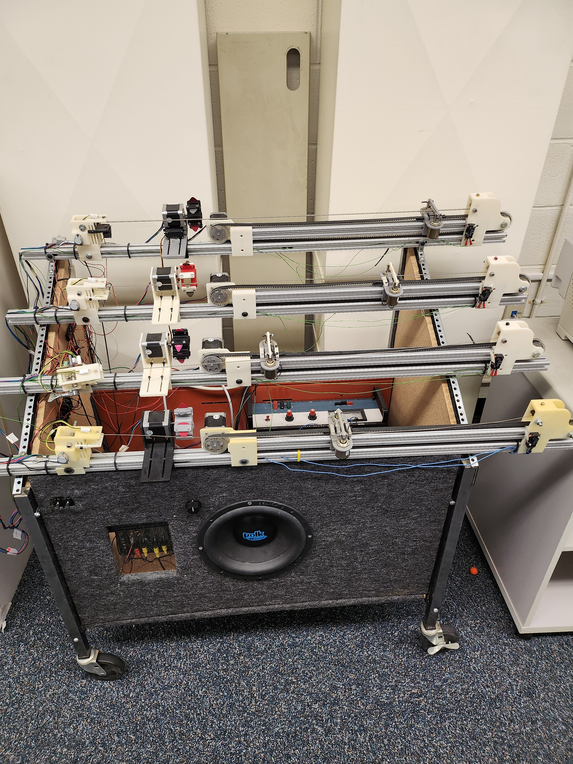Figure 1: Original Bass Guitar

Proposed Problem
As mentioned in the background information section this project already had a prior revision in accomplishing the goal of having a bass guitar that is able to play itself. However, there are several issues with the prior version that will addressed with the new version. The first issue is that the original version was not built using a normal guitar that a person would play. The custom setup of the original design has a more simplistic nature which reduces certain issues with external geometry and noise which could be induced into a magnetic pickup. However, the simplicity of this system lacks the ability to truly capture the soul of a bass guitar. The overall configuration of an instrument has a major affect upon its sound and overall harmonic content. Furthermore, the way that an instrument is played can have a massive effect on the overall nature of its sound as well. For instance, the majority of bass players opt to use their fingers when playing. Historically this is because double bass, sometimes called a standing bass, where played with either a bow or fingers. The era of electrified basses took longer to develop compared to electric guitars because of sub par application. Thus, many early records were played with double basses even if electric guitars were in use. As a result, when electric basses finally took the scene many players stuck with “finger-style” playing. Moreover, finger-style playing results in a deeper, warmer sound from the instrument which provides the perfect sound for bass for many genres. The original design makes use of revolving picks to get each string to vibrate. When playing bass with a pick the resulting sound is considerably brighter than when using one’s fingers. This brighter sound works well in the context of hard rock and metal, but does not create the low, soft bass sound that most would contribute to the instrument. With the new version a “plucking” unit will be developed that more closely emulates how a human finger strikes the strings.
Another aspect that has a massive effect upon the sound of electric bass guitars is the pickup and its placement. The original version makes use of an optical based sensor at the rear of the unit at the very tip of the string. There are two main issues. First is that the string is mounted backwards which results is different sound since the string is thinner at the top. Secondly placing the sensor at the very end where the string is very tight results in a very bright and thin sound. This is a sonic quality associated with piezo style pickups on acoustic guitars. Once again this does not fully encapsulate the sonic qualities of a bass guitar. To resolve this issue this revision will be built off a Precision Bass guitar. These basses are well known for their clean, warm sound which has resulted in thousands of records making use of these basses.
The primary focus of this project is to make a simple to use MIDI controlled bass guitar that closely matches the sound of what it would be like if a human were to play the instrument. Because of these ambitions, the project will be restarted from the ground up to be based around a functional P-bass. Furthermore, it will make use of a solenoid based fretting and plucking system as opposed to the stepper motor system that was used in the prior version. Given the significant changes to the project and its basic philosophy this project will have two stages. Stage one, which will be the goal of this semester, is to develop a robust electronic platform and firmware to control the bass guitar. Stage two will focus on taking the developed electronics and then implementing the hardware to play the bass. Following this pipeline the primary focus/goal should be achievable after two semesters of development.

System Overview
Figure 2 shows the block diagram for the entire bass guitar system and the structure in which it is built. Controlling the system is handled using the Musical Instrument Digital Interface, MIDI, serial protocol to provide data to the system. MIDI is a protocol which was specifically designed for implementation with musical systems. It is generally used as a one way serial protocol utilizing a 31.25kHz baud rate. Data is sent in three bytes which comprised of a Control/Address byte, Pitch byte, and Velocity byte. MIDI uses the upper nibble of the control byte to specify the operation. For example when an 8 is issued in the control byte it indicates to stop playing a note, refer to Table 3 for command structure. The lower nibble of the control byte is the address of the musical instrument that is being addressed. Since this is only 4 bits MIDI can only utilize 16 devices with a single system without modifications to the protocol. MIDI can be used on the majority of higher level devices, such as computers and tablets, with the proper software installed. For this project Anvil Studio 64-bit was the program of choice due to being free and highly configurable. The pitch bytes specifies the note which is to be played using 7 bits, excludes MSB, which gives 0-127 notes. The velocity byte is similar in that it uses 7-bits. However, this byte specifies how hard or soft a note is to be played. The simplistic nature of MIDI makes it an easy protocol to implement with instruments and does not require the instrument to transmit data back to the head.
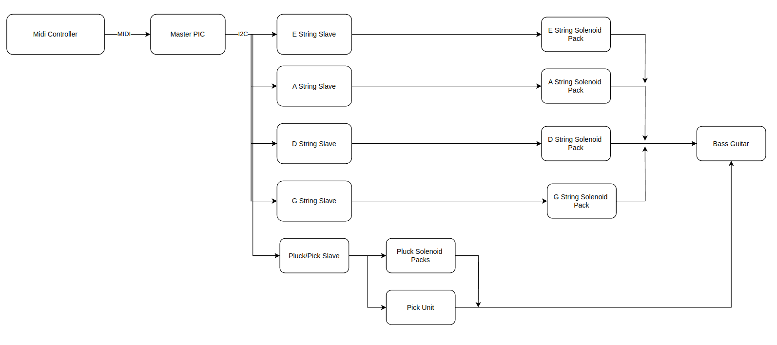Figure 2: Full System Diagram

Master Processor
The MIDI from the control device is then sent to the Master Pic. This PIC16F1788 is tasked with handling all the significant calculations for issuing commands on what note to play.
The figure above shows the basic nature of how the master functions in a simplified form. Important blocks of the flowchart are the address change ISR and the string select block. Because MIDI has limited addresses, it is important that a selectable address system be in place in cases where some devices have a fixed address as to not have duplicates. More important than this is the string select section of the system. As a general rule most instruments have duplicate notes of the same pitch that have a different location or fingering necessary to play the note. This is because it provides economy of motion where an alternate way of playing allows for notes to be played quickly without straining the player. Stringed instruments such as the guitar and bass are especially noticeable with their duplicate notes. Looking at Table 1 it can be observed that each higher string is exactly 5 pitches higher than the last string. This is referred to tuning in Fifths, and basses, regardless of how many strings they have, follow this method for standard tuning. The bass that is to be implemented in this project is a Squier P-Bass which has 20 frets. When including the open strings and the 4 strings, this provides 84 positions which could be played. However, because of the way that basses are tuned there are only 35 unique notes which can be played on the instrument. Which can be observed in the two tables below showing the musical notes as well as the their MIDI representation.
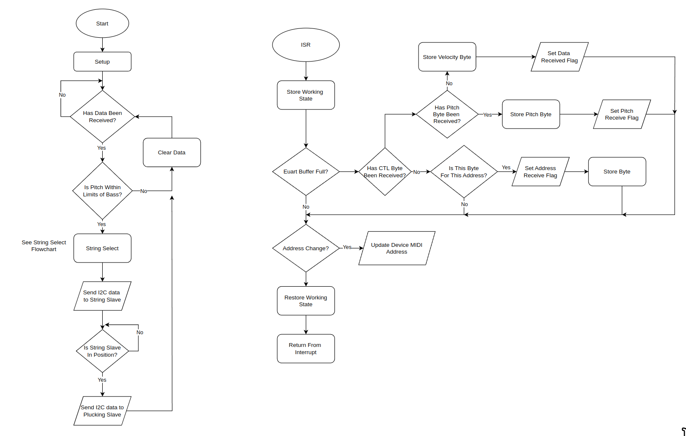Figure 3: Master Flowchart
Table 1: Bass Musical Note Distribution
Fret | E string | A string | D string | G string
0 | E1 | A1 | D2 | G2
1 | F1 | A#1 | D#2 | G#2
2 | F#1 | B1 | E2 | A2
3 | G1 | C2 | F2 | A#2
4 | G#1 | C#2 | F#2 | B2
5 | A1 | D2 | G2 | C3
6 | A#1 | D#2 | G#2 | C#3
7 | B1 | E2 | A2 | D3
8 | C2 | F2 | A#2 | D#3
9 | C#2 | F#2 | B2 | E3
10 | D2 | G2 | C3 | F3
11 | D#2 | G#2 | C#3 | F#3
12 | E2 | A2 | D3 | G3
13 | F2 | A#2 | D#3 | G#3
14 | F#2 | B2 | E3 | A3
15 | G2 | C3 | F3 | A#3
16 | G#2 | C#3 | F#3 | B3
17 | A2 | D3 | G3 | C4
18 | A#2 | D#3 | G#3 | C#4
19 | B2 | E3 | A3 | D4
20 | C3 | F3 | A#3 | D#4

Table 2: MIDI Note Distribution of 4-String Bass
Fret | E string | Hex | A string | Hex | D string | Hex | G string | Hex
0 | 28 | 1C | 33 | 21 | 38 | 26 | 43 | 2B
1 | 29 | 1D | 34 | 22 | 39 | 27 | 44 | 2C
2 | 30 | 1E | 35 | 23 | 40 | 28 | 45 | 2D
3 | 31 | 1F | 36 | 24 | 41 | 29 | 46 | 2E
4 | 32 | 20 | 37 | 25 | 42 | 2A | 47 | 2F
5 | 33 | 21 | 38 | 26 | 43 | 2B | 48 | 30
6 | 34 | 22 | 39 | 27 | 44 | 2C | 49 | 31
7 | 35 | 23 | 40 | 28 | 45 | 2D | 50 | 32
8 | 36 | 24 | 41 | 29 | 46 | 2E | 51 | 33
9 | 37 | 25 | 42 | 2A | 47 | 2F | 52 | 34
10 | 38 | 26 | 43 | 2B | 48 | 30 | 53 | 35
11 | 39 | 27 | 44 | 2C | 49 | 31 | 54 | 36
12 | 40 | 28 | 45 | 2D | 50 | 32 | 55 | 37
13 | 41 | 29 | 46 | 2E | 51 | 33 | 56 | 38
14 | 42 | 2A | 47 | 2F | 52 | 34 | 57 | 39
15 | 43 | 2B | 48 | 30 | 53 | 35 | 58 | 3A
16 | 44 | 2C | 49 | 31 | 54 | 36 | 59 | 3B
17 | 45 | 2D | 50 | 32 | 55 | 37 | 60 | 3C
18 | 46 | 2E | 51 | 33 | 56 | 38 | 61 | 3D
19 | 47 | 2F | 52 | 34 | 57 | 39 | 62 | 3E
20 | 48 | 30 | 53 | 35 | 58 | 3A | 63 | 3F

This therefore provides a unique challenge when implementing the MIDI protocol because there is no where in normal transmissions that would designate the string the note requested should be played on. While it would be possible to just have the system choose notes on the E string until all notes are out and then move to the next string with the higher notes; such a method does not fully utilize the instrument nor does it represent how a human player would play. As a result it is necessary for the master to use a basic algorithm to determine which string that a note should be played on. The figure below shows the evaluation that the master makes in order to determine which slave it should select to play the note. It is because of this evaluation the master runs at the 32MHz, the maximum clock speed of the 1788 series PICs, to complete these calculations as quickly as possible. This is to avoid issues with the next byte being received before the current command has been issued to the slaves. The evaluation is based upon the numeric value of the note received in relation to the last note that was played. Based upon this relation the master will select which string that the note should be played. The purpose of this evaluation is to retain “economy of motion” as a human player would.
Once this evaluation is complete the slaves are addressed via Inter Integrate Circuit, I2C. Similarly to running the microprocessor as fast as possible to avoid issues, the I2C line is running at 400kHz. There are two different slaves addressed per received MIDI command received one of string slaves and the pluck slave. The string slaves require a two byte transmission. First is the address byte which is found through the string select evaluation. The second byte the the pitch of the note which is passed on from the MIDI data received. However, this byte is modified to use the MSB for enabling or disabling the fretting solenoid for the slave addressed, see Table 3 for bitmap. For the pluck slave a three byte transmission is used. The first byte is the address which is not changed as there is only one slave. Next the velocity byte is sent without modification from the MIDI received. Finally the third byte carries a the majority of the control information for the slave. It specifies whether or not use the plucking unit or the picking unit, mute a note, and what string to play.
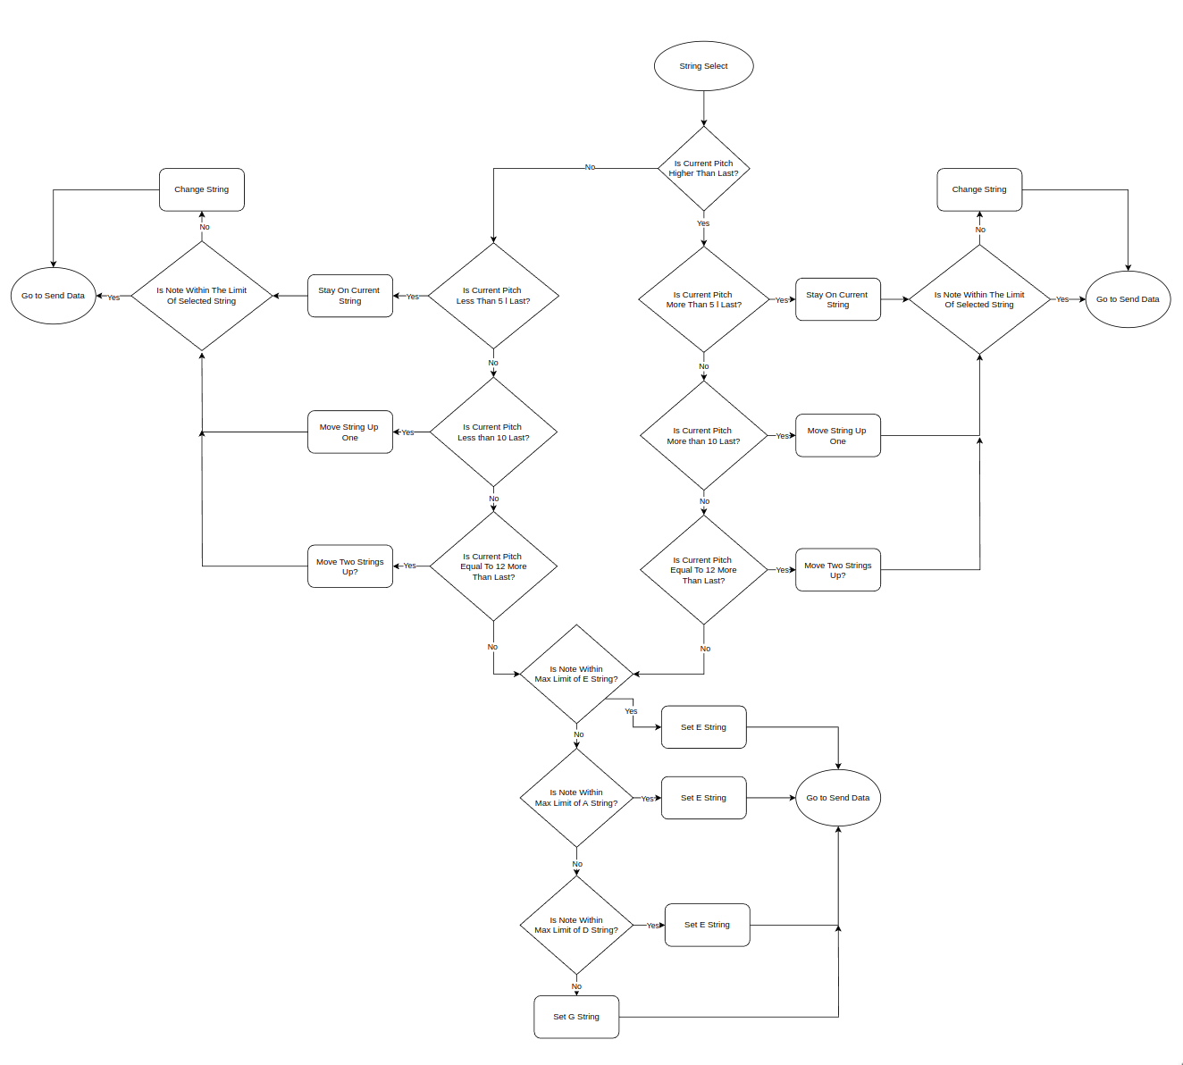Figure 4: String Select Flowchart
Table 3: I2C Bitmap
Byte | Bit7 | Bit6 | Bit5 | Bit4 | Bit3 | Bit2 | Bit1 | Bit0
Pitch | M | P | P | P | P | P | P | P
Velocity | x | V | V | V | V | V | V | V
String | F | x | x | M | E | A | D | G
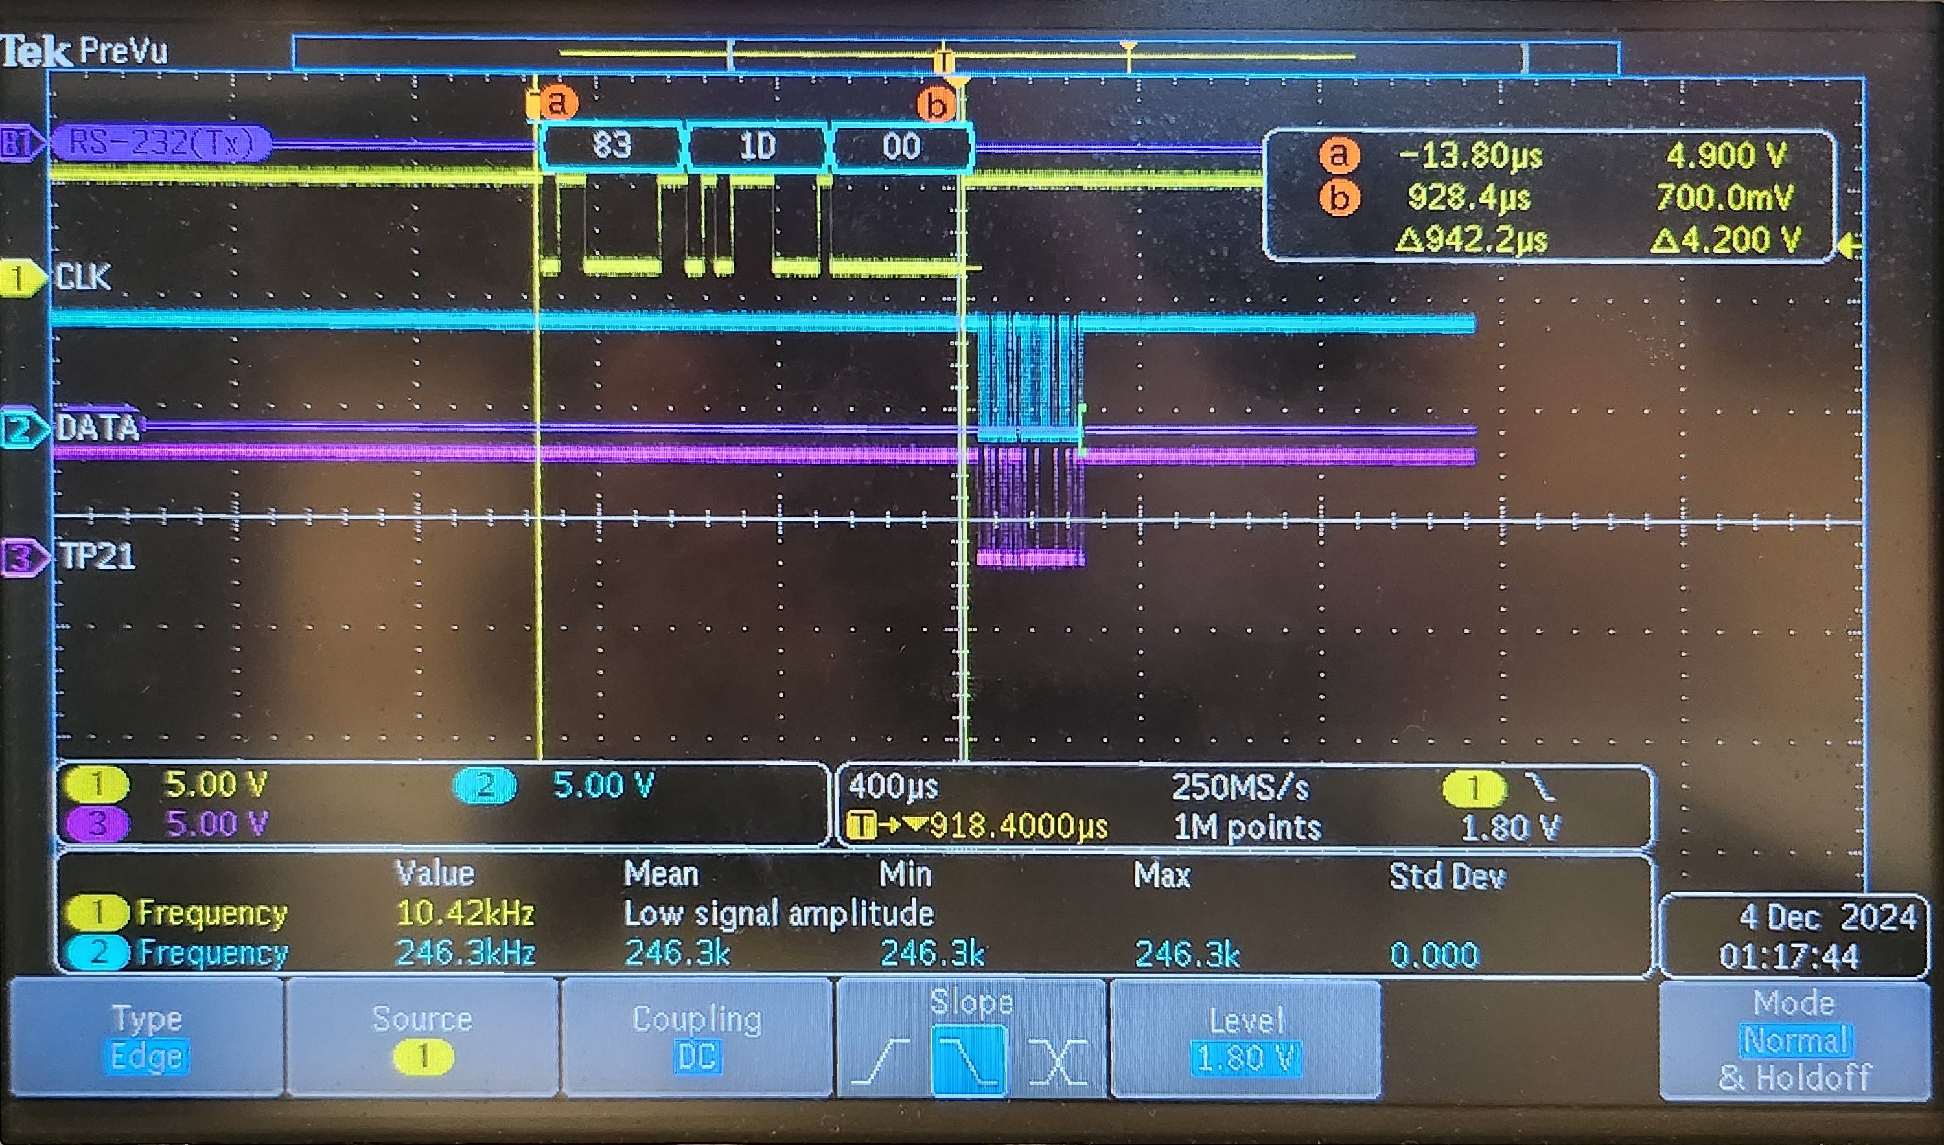Figure 5: MIDI Received
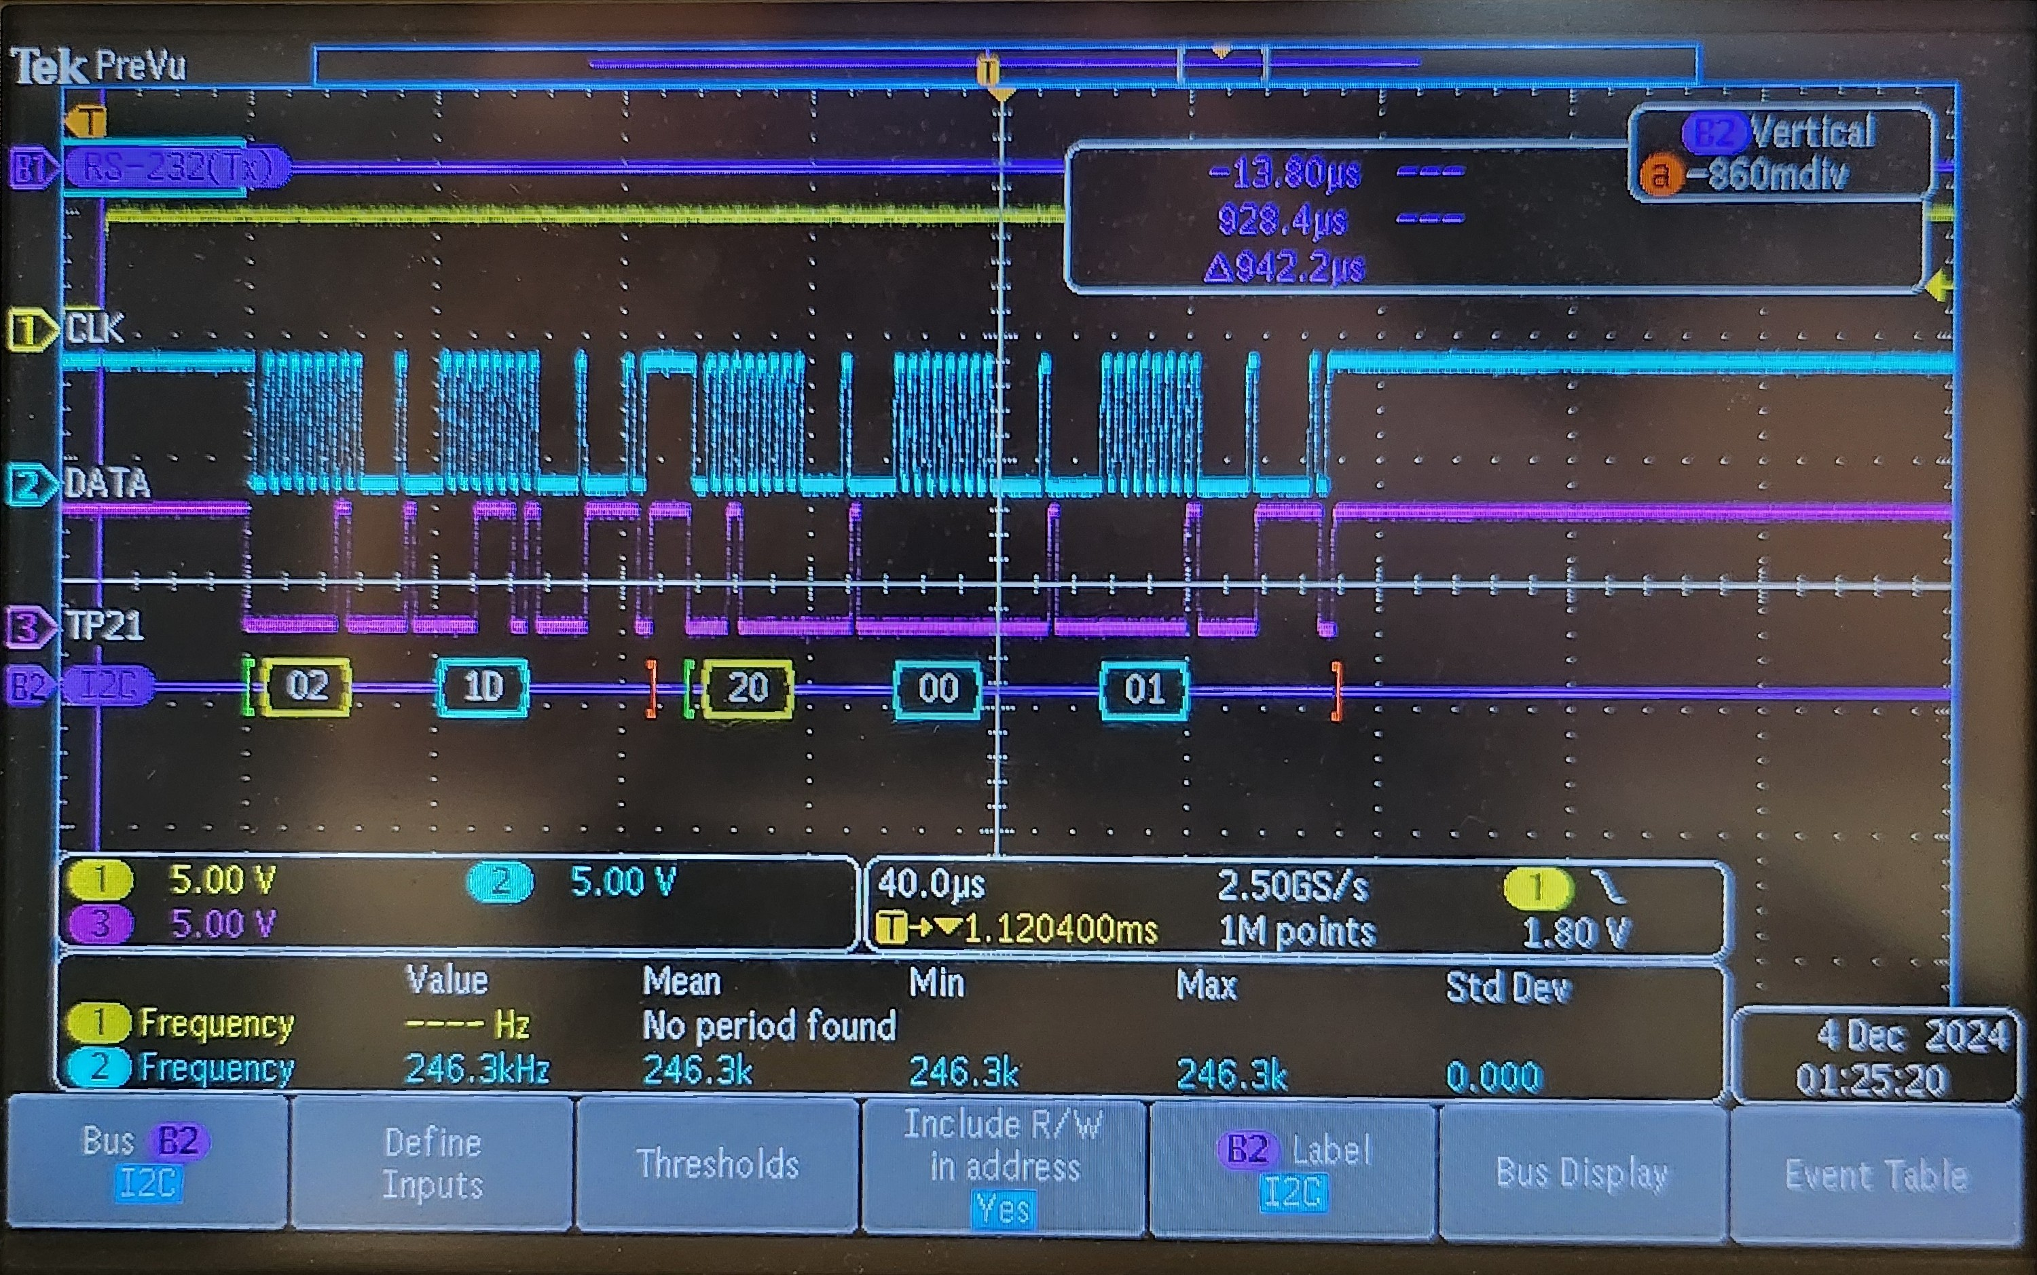Figure 6: I2C Master Transmission
The above figures show how the transmission process is handled by the master. First, MIDI is received at the UART port of the PIC which is shown in figure 5. MIDI has a baud rate of 31.25kHz which translates to 32us per bit or 320us per byte, including start and stop bits. The goal of the I2C transmission structure is to finish all internal calculations and transmit data before the next MIDI byte has been received. With the processor running at 32MHz the cycle time, Fosc/4, is 125ns. Thanks to this processing speed the time from the end of the MIDI transmission to when the I2C data is presented is approximately 35us, Figure 6. Then for the two transmissions to the slaves an additional ~232us is taken; resulting in approximately 267us for the processor to finish its commands to the slave. This is well within the targeted window for achieved the desired objectives before the next MIDI byte can be received. Note that in Figure 6 the I2C clock, channel 2, is longer pulse spaces at times. This is the result of the slaves clock stretching which does slightly reduce the time is takes to achieve full broadcast. In the initial phases of development the slaves were set to run at 4MHz. However, the effect of clock stretching was so significant that it entirely negated the I2C line running at 400kHz. As a result the slaves were changed to operate at 16MHz instead. This preserves purpose behind operating the I2C in this way. Moreover, this method of serial communication helps to avoid any collision errors that could occur with the processor failing to address the UART buffer or the interrupt being issued when the I2C is in the middle of a transmission. Furthermore, this ensures responsiveness from the system as the slaves have as much time as possible to handle the commands before the next command has been received. In testing, these decisions resulted in a highly responsive system that was almost real time to the MIDI GUI.
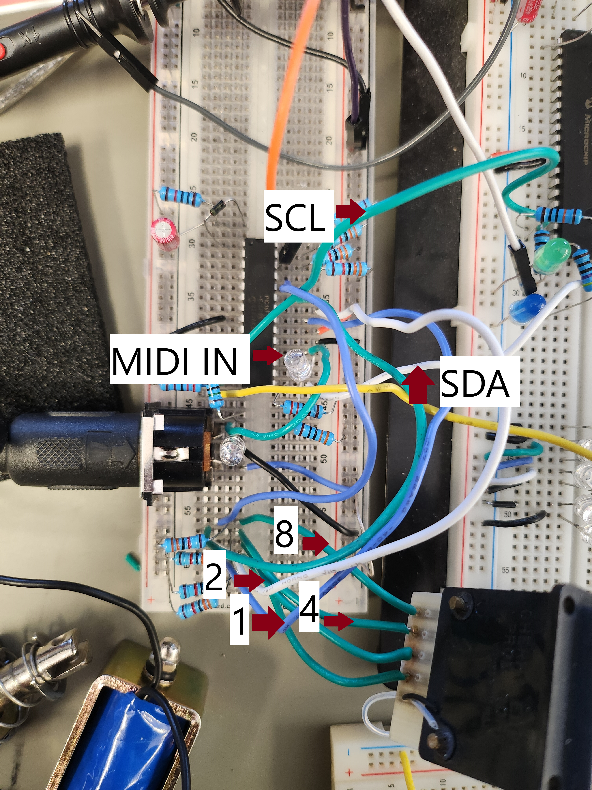Figure 7: Master Breadboard Testing Layout

String Slave
As mentioned previously the system for this project is broken into several blocks which allows for a better distribution of the load on each processor. There are 4 string slaves which use the same program with the only adjustment being the notes which they have been specified to play. Thus, for this section focus will be made on the E string slave but the flowcharts and processes are the same across the other processors as well. The purpose of the string slave is to fret the note that is to be played on the associated string. To play the note the slave will control a large array of solenoids with one solenoid designated for each fret. This is opposed to the gantry system that was previously used in the original system because the time delay from moving the gantry causes notes to be skipped. During development there was an attempt to implement a gantry system to reduce the number of solenoids needed. However, as with the prior design, it was not possible to reliably move the system fast enough before issues were caused with the system with MIDI being received before the last instruction could be executed. This is because of how long a bass guitar neck, Figure 25, is and the relatively short time that is given between each musical note. As a result it was decided to maintain development with a solenoid array system. Because of the necessary number of solenoids required the string slaves are 1789 processors instead of the 1788 that is used with the master. Fundamentally the 1789 is the same as the 1788 and the share the same datasheet, but the 1789 adds an additional PORTD and a few extra pins for PORTE. This gives the required number of pins to allow for the slave to control the necessary solenoids and controls without the need for an additional processor.
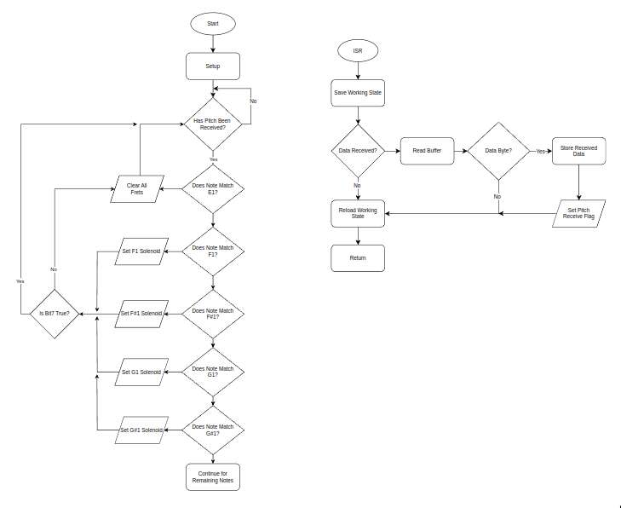Figure 8: String Slave Program Flowchart
The flowchart in Figure 8 shows how the current version of the program evaluates which solenoid to trigger based upon the the pitch byte received. The current method of evaluation is so cumbersome that even the flowchart does not include all 20 evaluations because it is unnecessarily long. It is because of this cumbersome, inefficient method of analyzing the pitch byte that the string slave does not work in its current form. The serial communication to the device works, observable in Figure 6, but the correct outputs are not handled correctly with the received data. Moreover, troubleshooting this program is difficult because of how long the evaluations take and the methods used to complete them. As a result the current iteration of the string units does not work. This is elaborated on later in the recommendations of the program, but this program will be mostly scraped in favor of trying to find a more efficient way of evaluating the received data.

Plucking Slave
Unlike the string slaves, there is only one plucking unit. Thus, for every transmission by the master, the plucking unit will be addressed after the string slave. This is so that the correct string slave can fret the note before the plucking unit activates. The plucking slave receives two bytes from the master. The first is the velocity byte which tells the unit how hard or soft to strike the string. this byte is directly given to the slave from the MIDI data received to the master. The next byte is the string byte, refer to Table 3 which is created internally by the master. The plucking slave is designed to accommodate two different units for striking the string. The first is the plucking unit which is comprised of solenoid packs, see Figure 11, which attempt to emulate how a human finger strikes a string. The reasoning behind using two units is to alleviate stress on the solenoids as well as allow them to play faster. Because the unit alternates which solenoid is activated the one that was fired does not need to return to rest to be fired again. This allows the unit to then operate much faster than it would using only a single solenoid.
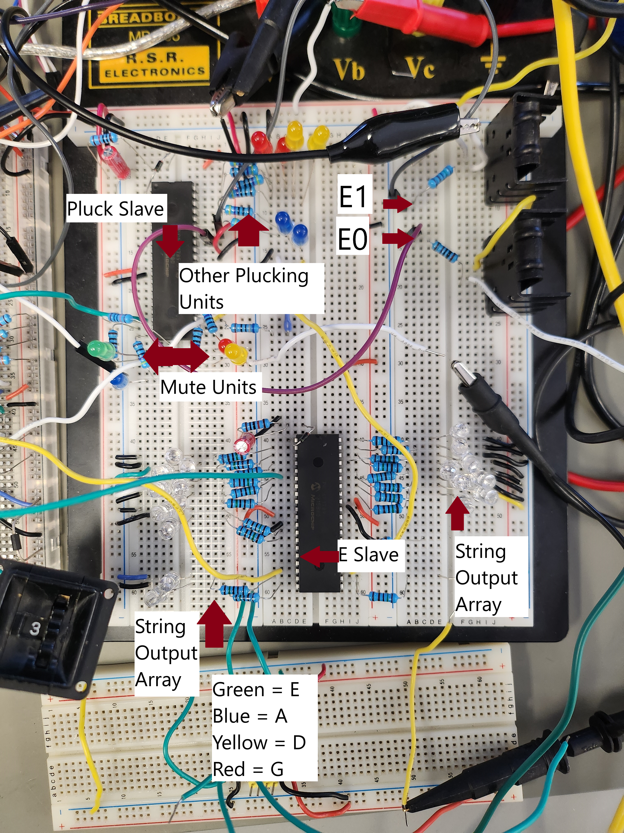Figure 9: Slave Breadboard Testing Layout

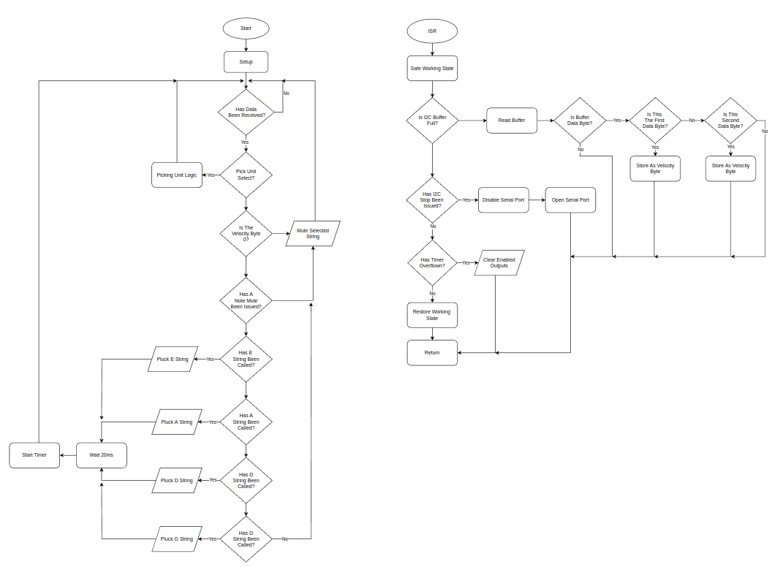Figure 10: Plucking Slave Program Flowchart
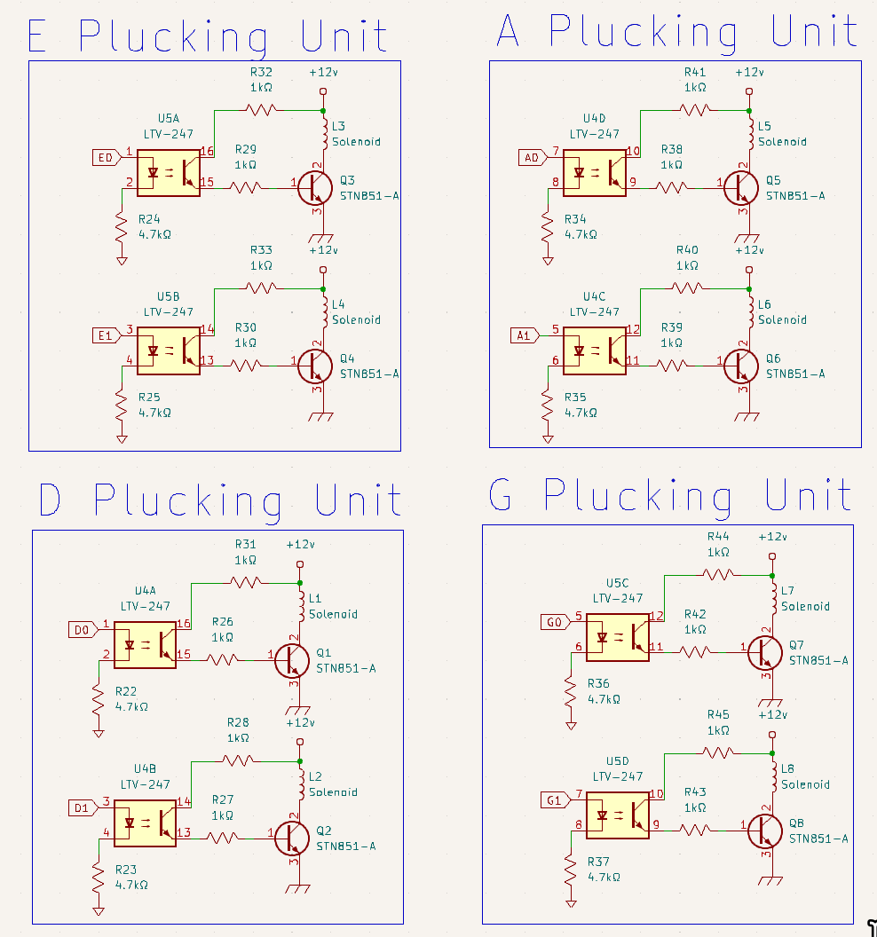Figure 11: Plucking Solenoid Array
Below shows the output present at E0 and E1 on the schematic above. Channel 1, yellow, is E0 and it shows the approximately 20ms pulse that is used to enable the solenoid to strike the string. As for Channel 2, purple, it shares this same output pulse but is not activated at the same time as E0. This alternation is handled internally by the PIC. The ideal pulse to enable the solenoid is such that it needs to be long enough to adequately enable the solenoid to full power but not long enough to cause the unit to negatively affect the string from openly vibrating. As the mechanical platform has not been developed the 20ms pulse was determined as a “snappy” enough pulse to start testing. This pulse width is handled by Timer 1 and as such has more than enough resolution to be much longer or shorter depending on what is needed despite this processor being operated at 16Mhz. Furthermore the drive/force behind the solenoids is also dependent upon the biasing of the transistors.

The above shows the current gain that is provided by the transistor into what is being driven through the solenoid. The JF-1093B solenoids that are used with this project are 12v, 2A solenoids with a holding force rated at 25 newtons. Because bass guitars have larger gauge strings, compared with a guitar, the require a minimum of 20 newtons to fret the note. The above current functions well for driving the solenoids for plucking because a short, high energy burst is required. However, holding the solenoids that fret the notes at this current could be problematic as this current could heat up the device opening the risk of damage. As a result more testing with the ideal current for different purposes of the solenoids still needs to be conducted.
Because of the plucking unit’s use of solenoids the velocity bit is not used. The reason comes down to simplicity as some sort of variable current driver would be necessary for each solenoid. This would add additional cost and complexity not to mention taking up more port options. While this means that the project will not have the ability to articulate notes with variable intensity it should still sound like a player for the majority of songs. Another feature included with the plucking slave is the muting unit which serves to stop notes when the string is not in use. The default state of the system is to mute all strings. This is to reduce open string ring. Open string ring refers to the tendency of stringed instruments to have other strings vibrate even when not directly struck. This is caused by the vibrational resonance of the instrument causing adjacent strings to resonant. Players typically use their hands or muting devices to limit this resonance. When a string has been issued to be plucked the corresponding mute will release and allow the string to vibrate freely. The mute unit will not re-engage until a MIDI 8 command has been issued or the velocity byte is 0.
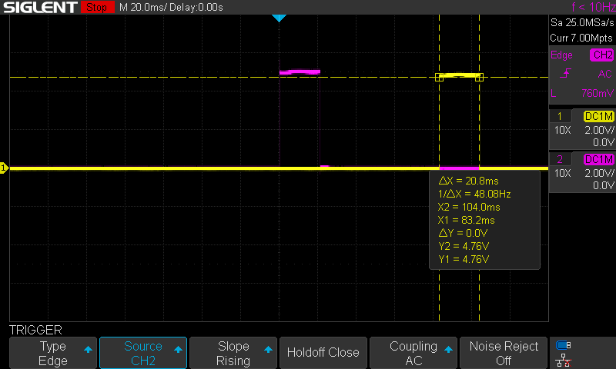Figure 12: Alternating Solenoid Waveform
As mentioned in the system diagram, Figure 2, a picking unit has been designated for this project. However, in the interest of development time the picking unit is not implemented outside of protocol support for this feature. While not all bass players use a pick when playing, it would still be a fruitful addition to the project if this feature is eventually added. If the picking unit makes use of some kind of rotational motor, servo or stepper, the velocity byte could then be implemented in changing how quickly the pick is hit against the string. This would actually give greater possibilities when it comes to note articulations.

Calibration Procedure
The calibration that is necessary for this project is relatively straight forward as the majority of conditions are handled within software. However, there are two areas that the user/operator must set/calibrate preceding use of the device. The first is that the bass must be tuned. currently all tuning is handled manually by the operator, refer to recommendations for more, using his or her own hands and some sort of tuning device. There are a wide area of tuner styles that exist some of the most popular include headstock tuners, plugin tuners, and phone tuners. For ease of use and availability it is recommended to use a free tuner app for a mobile device.
To tune the bass first plug the instrument into an amp so that it is loud enough for the phone to hear. Then begin plucking the E string, the largest string, until the phone begins to display the name of the note being played. Adjust the tuning peg, the large key like knob at the tip of the headstock, until the note begins to change. To make the string higher in pitch turn the peg counter clockwise, or away from the player, whereas clockwise will reduce the pitch. Keep adjusting the tuning peg until the note displayed by the phone matches E at perfect pitch. Repeat this process for the rest of the strings. It is important that the bass be tuned every time that it is used to retain proper notes. This is because the bass can loose its tune because of environmental factors. The neck can shift slightly due to humidity and temperature which will cause the bass to go out of tune. It theoretically possible to use tunings outside of the standard tuning for the bass guitar. However, the software cannot accept notes outside of the ones found in Table 1. Because of this, alternate tunings must still be programmed to standard in MIDI. Additionally, the selection that is determined by the master focuses on the notes relativity to the others. For this reason drop tunings, where the lowest string is a lower pitch than standard the rest are the same, is not recommended. If not tuned properly the bass will not produce the music that is sent to it.
Table 4: Bass Standard Tuning
String | 1 | 2 | 3 | 4
Note | E1 | A1 | D1 | G2

Once tuned, the MIDI instrument address must be verified/calibrated. The hex switch below is where the MIDI address of the device is set. Depending on the MIDI software being used it may use either hex or decimal to indicate channel. If decimal then the displayed number is one less than the address that must be set in the software. Thus, it is important to identify the MIDI address prior to starting any communications so that the correct device is being used. Furthermore, when using other MIDI devices, it is important that MIDI devices do not have overlapping addresses. Otherwise the correct parts may not be played by the desired instrument.

Troubleshooting
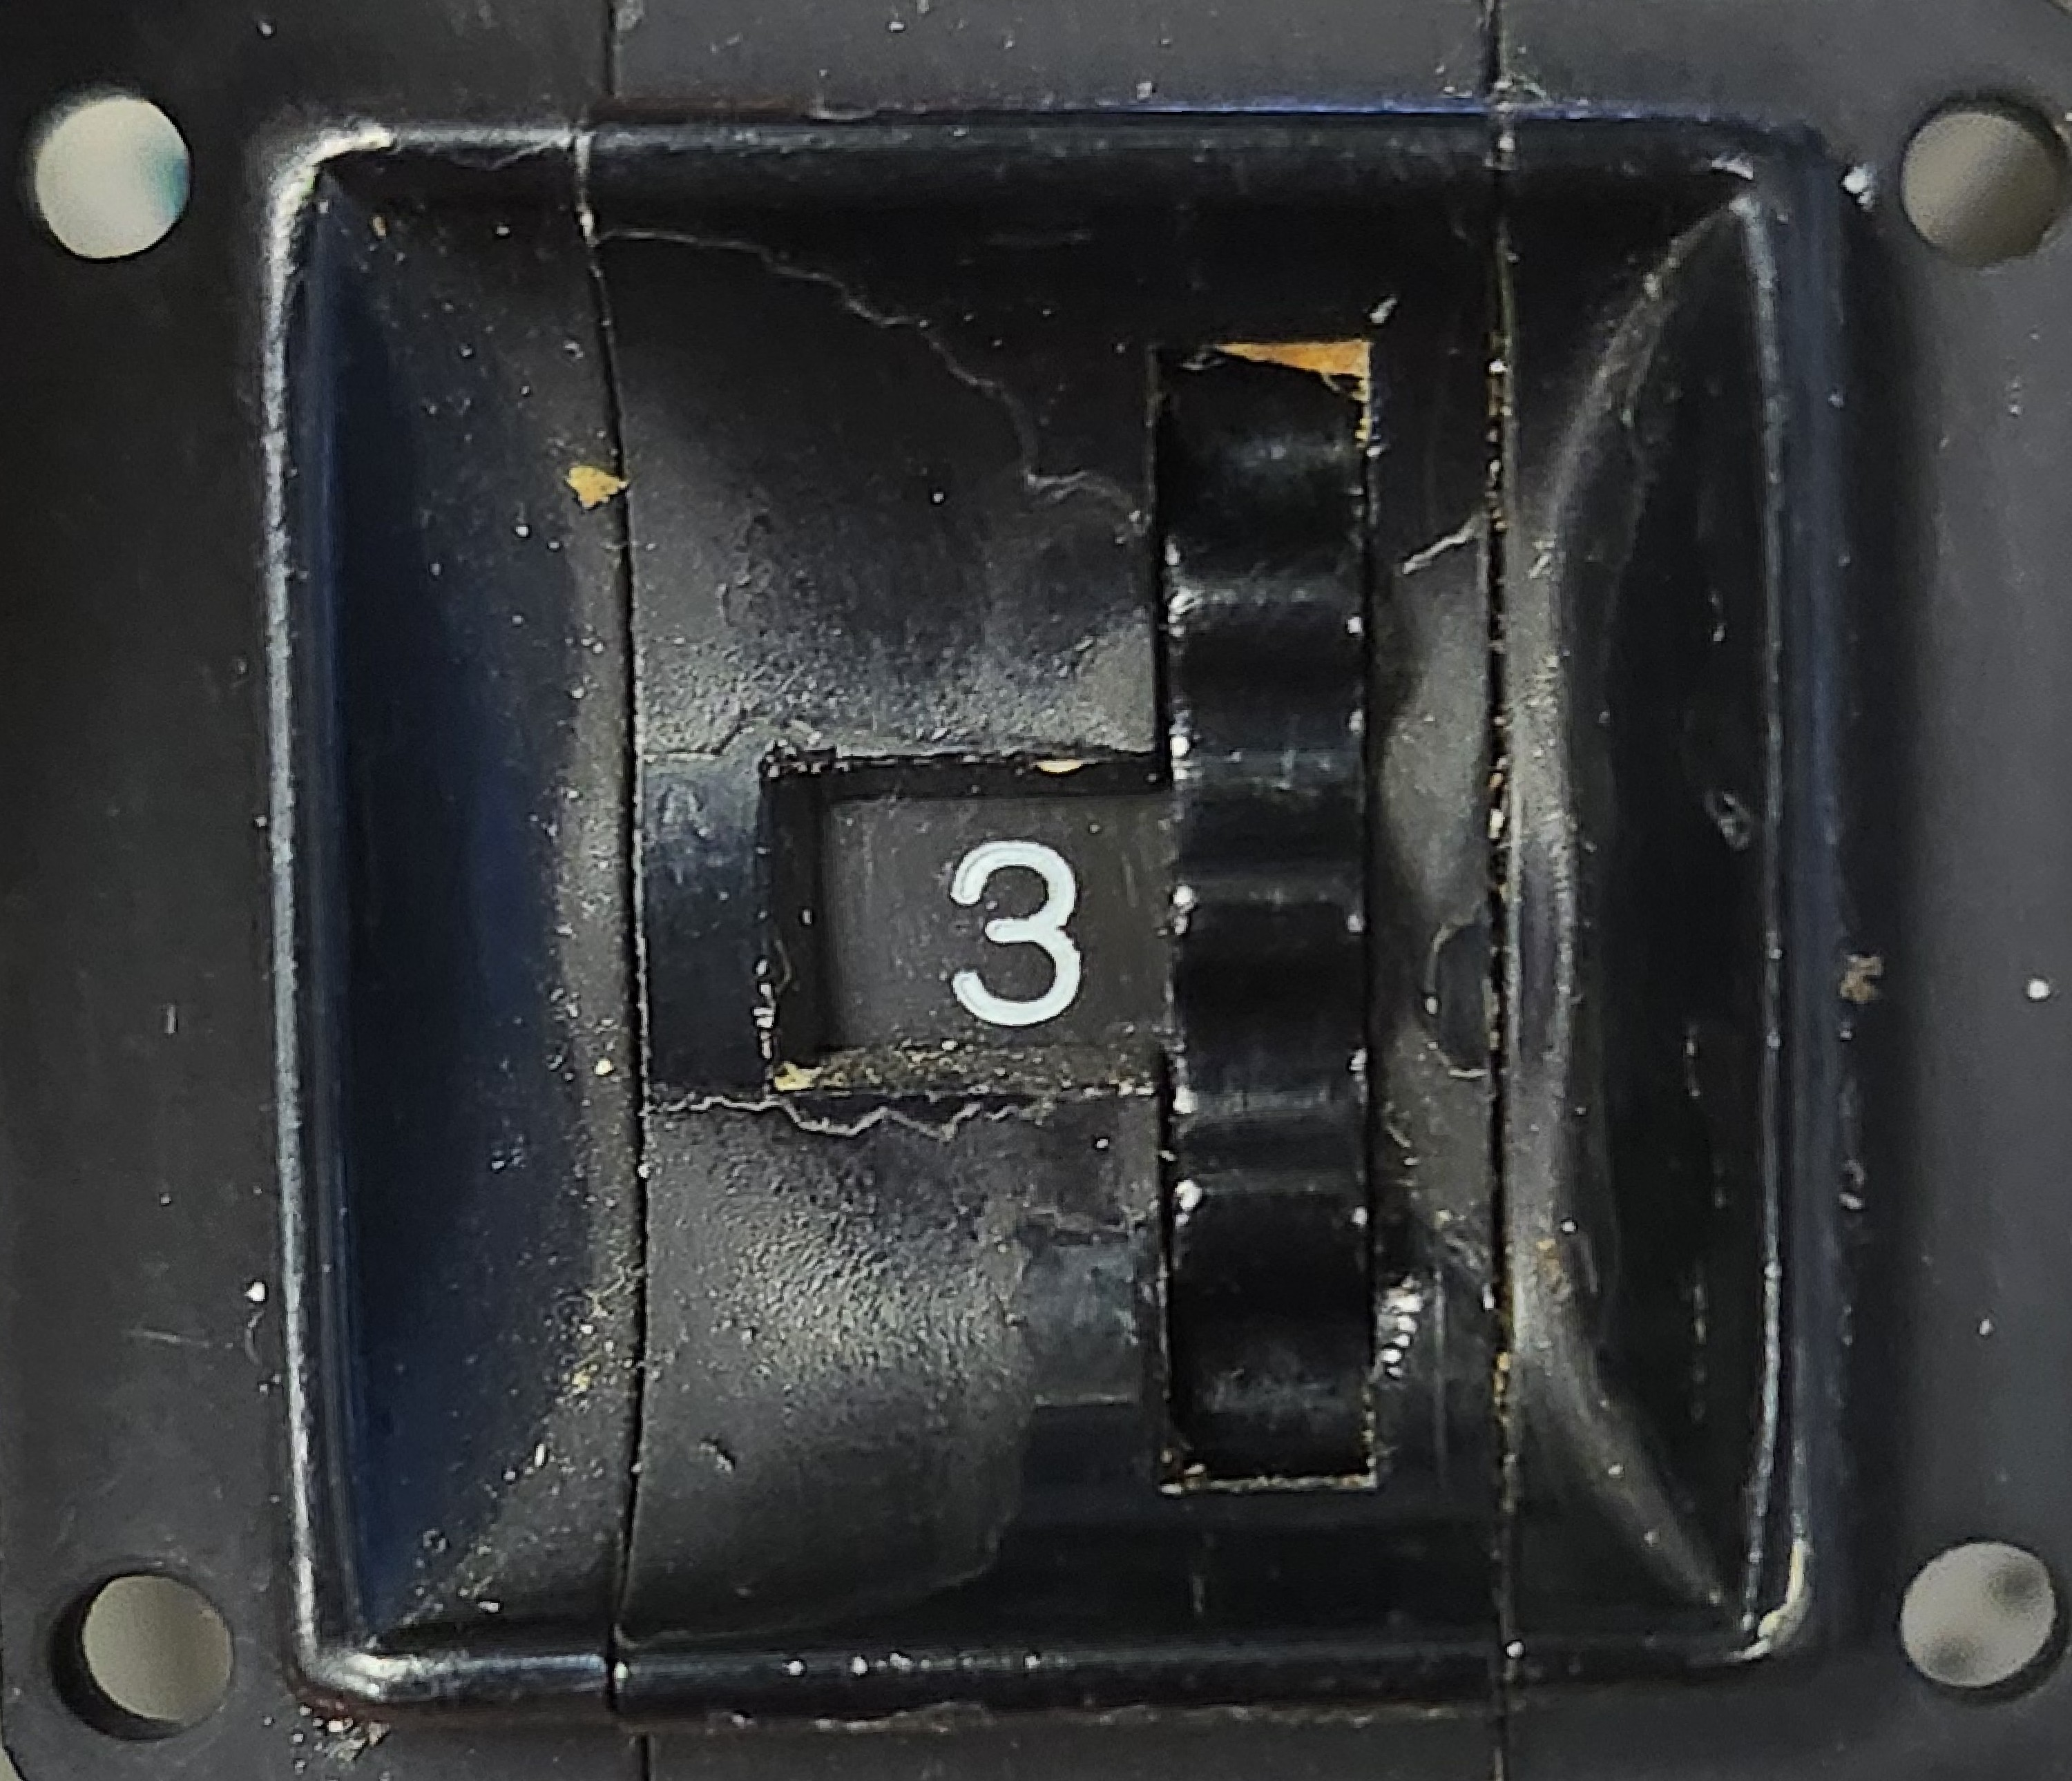Figure 13: Hex Switch
Troubleshooting is critical for getting a system up and running in a timely manner. This system has several distinct blocks, Figure 2, with 6 different microprocessors. To streamline the troubleshooting process, test points and indicators have been included. The figure below shows the LED indicators that have been included for the processors. All the slaves have a STATUS and ACTIVE LED, but the master only has the STATUS indicator. The ACTIVE LED on the slaves is triggered when the slave has been addressed over I2C. This LED is then cleared when the slave has finished its task. The purpose of this LED is to verify that the slaves are executing the code based on the received data. Whereas, the STATUS LED is enabled when the processor finishes the setup portion of the code. This LED indicates that the processor has power and has finished its start up procedure. At all times these LED’s should be active. Should one not be active then this indicates an issue with that processor, Figure 14, and should be addressed prior to troubleshooting other parts of the system.
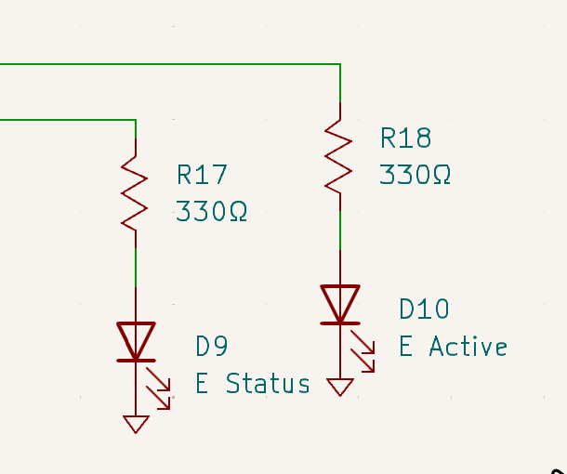Figure 14: PIC Status Indicators
The main causes behind a processor not working deal primarily with power or issues with the internal oscillator. The first step is to identify if there is power to the processor. If some processors are on while others are off it can be assumed that power is operational as they all share the same point, TP11 in Figure 17, but trace damage or a poor solder point could result in an fault. If the 5 volts is present at the test point verify the power pin for whichever processor does not have its status light on. Once power to the processor has been verified proceed to the next step in troubleshooting.
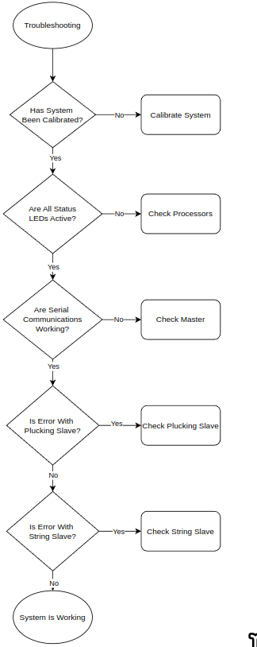Figure 15: System Troubleshooting Flowchart
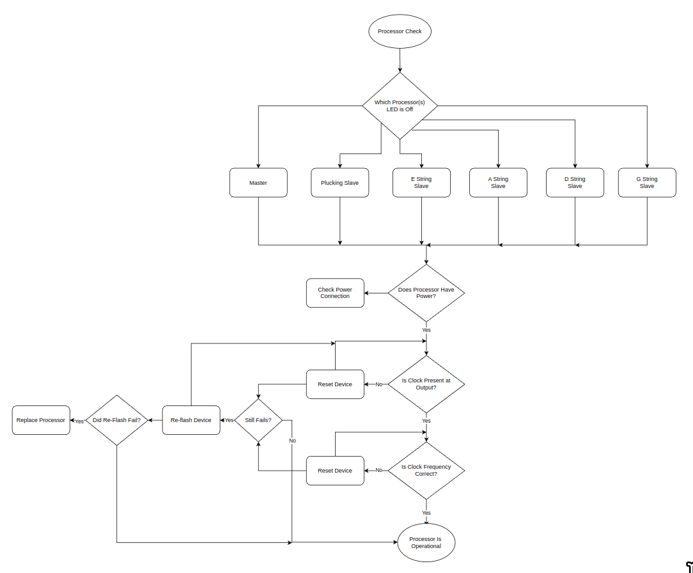Figure 16: Processor Troubleshooting
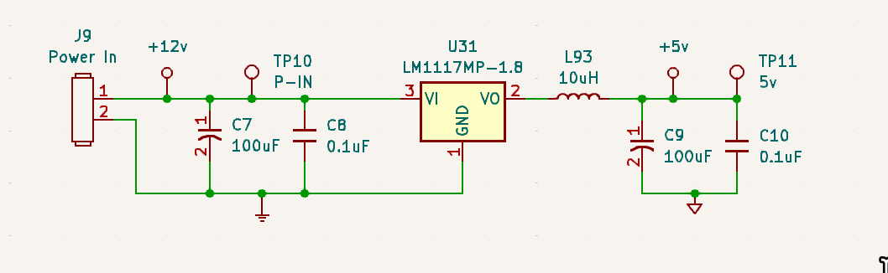Figure 17: Power Schematic
All processors have a test point like the one in Figure 18 above. As discussed previously, the processors are running at 16MHz or greater. This clock is an internal oscillator as opposed to an external crystal. Because the system clock is generated internally there is greater possibilities for issues especially with the master running at 32MHz. The first instructions that are executed by the processor dictate how to run the internal oscillator. In order to the use the 32MHz setting the internal phase lock loop (PLL) must be operational otherwise the system will default back to 16MHz which would affect the serial baud rates. The processors poll the OSTS bit in the OSCSTAT, pg 87 (Microchip), to verify that the oscillator is running how it was configured. In the case of the master it also polls the PLLR bit to wait for the PLL to be ready prior to defining the oscillator. While there are precautions taken in software to prevent instances of oscillators not starting correctly it does not mean it is impossible. Thus it is important to verify that the offending processor has its oscillator running.
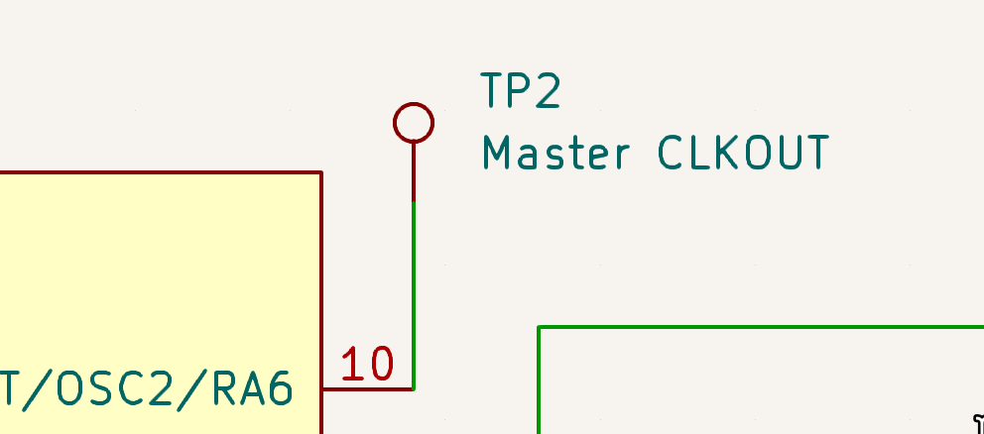Figure 18: Oscillator Out Test Point

Serial Troubleshooting
Besides the need for power and oscillation, the most likely cause of system errors is the serial communication network. This is because all commands are interpreted and then translated to the slaves via the master. If an error with the incoming MIDI occurs or the internal algorithm that the master uses to select strings occurs then the system will not function as intended. Following the flowchart in Figure 15, the first step should be verifying that a MIDI signal is being received from the MIDI controller. In the event that there is not a signal check all connections as well as the software being used. Next verify that the MIDI address being received is addressing the bass itself. The MIDI address is the lower nibble of the command byte and it should match the number on the hex switch attached to the device, compare Figure 5 and 13. Should the addresses match the UART line is operating as intended.
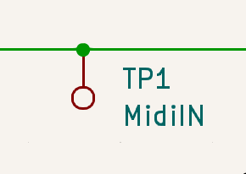Figure 19: MIDI Test Point
Once UART is verified the I2C line should be checked using the test points below. When idle, both lines should be held high. If they are not high then one of the slaves is holding the line low which will prevent transmissions once the MIDI is received. Resetting all processors will release the line and allow I2C transmissions to proceed. Ordinarily failures of the I2C line from the master or slaves should be rare as the software attempts to catch the majority of issues and resolve them internally. On the other hand, issues with the algorithm are more likely to occur due to the way in which they are calculated and verified.
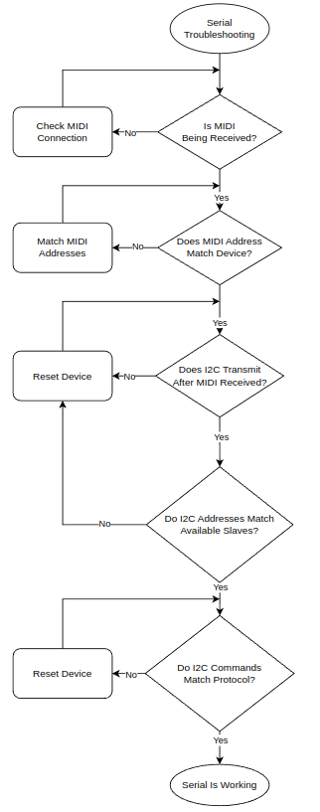Figure 20: Serial Troubleshooting Flowchart
There are two errors that could arise with the algorithm. The first is an addressing error caused by an issue when manipulating which string to use. As can be observed below, the address designations of each slave result in only one bit being true. Addressing errors due to improper manipulation by the master can often manifest themselves as multiple bits being true in the address. When this occurs a string slave will not be addressed and the plucking unit will pluck multiple strings. This because the slave address is used to build the string byte. In the event of this error power cycle the master as this error will persist otherwise.
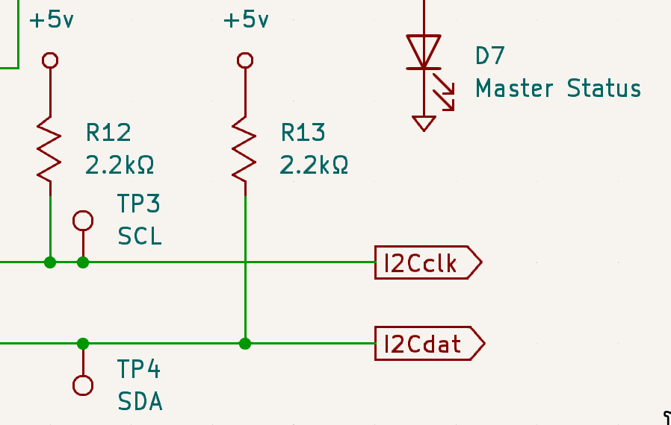Figure 21: I2C Test Points
Table 5: Slave Address Allocations
Slave Device | Decimal Address | Hex Address
E Slave | 1 | 0x02
A Slave | 2 | 0x04
D Slave | 4 | 0x08
G Slave | 8 | 0x10
Plucking Slave | 16 | 0x20
Another error that could occur with the master and its I2C transmissions relates to selecting the wrong string for the given note. The software is designed to check each operation before sending it to the slaves, but there is still potential for an issue with these evaluations. Troubleshooting these errors is harder than the prior example as the system will still function and the I2C itself functions as intended. However, this is still an issue with the serial communication because the master is not addressing devices as intended. These errors will result in the fretting unit not fretting a note while the plucking unit will pluck an open string. Finding these errors requires know which note that is desired to be played and comparing the note sent to the limits of the addressed string, Table 1. In the event that the note is outside the limits of the string, reset the master device, and if the error persists it may be a software issue that should be documented and accessed to determine how to improve firmware.

Plucking Unit Troubleshooting
In the event that there is an error with the plucking unit the first step is to reset the device. This restores the status of the device to startup and clears potential errors in the registers for the alternation logic. After the reset, resend commands to the device and determine if the device now functions normally. If there is a solenoid(s) that is not firing, remove the solenoid array from header 6 and probe the output that is not working. Verify that there is an output from the processor before moving on to troubleshoot the solenoids themselves. Figure 22 shows the the progression of checking the outputs sequentially to determine fault. Of the components that could fail it is the output transistors that are at the most risk, Figure 11. The reason for this is that the solenoids are being driven with approximately 1.6A of current. While the transistors are configured as switches, this does not mean that they are immune to dropping power across the device. Fast sequences of notes require the devices to saturate quickly and give little time for heat to dissipate. The alternating system does reduce this load, but it is still possible that the transistors could become saturated with heat which could induce failure.
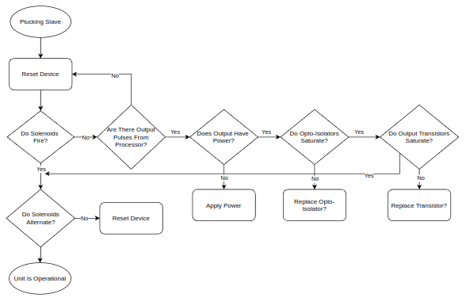Figure 22: Plucking Unit Troubleshooting Flowchart
Once the output functionality of the solenoids has been verified the final check is to check the alternation. The alternation of the outputs is controlled by a general purpose register(GPR) that sets one bit and then clears an adjacent bit. An example E0 is bit0 of the GPR and E1 is bit1, when bit0 is set E0 is fired and then bit0 is cleared while bit1 is set. This pattern is flipped when E1 is set. As such if the GPR has adjacent bits set it can cause irregular behavior that is undesirable. Thus the only recourse is to reset the device. As a whole the majority of issues with this slave device can be resolved with simply resetting the device.
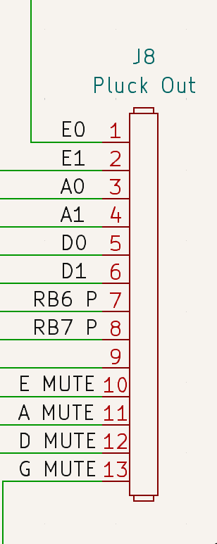Figure 23: Plucking Unit Output Header

Slave Unit Troubleshooting
The string slave units are very basic in structure both firmware and hardware alike. Given the simplicity of the firmware the likelihood of issues is very low. As a result a reset will be sufficient to clear an issues that may occur. However, the hardware of this unit is at a greater risk of failure because the solenoids are energized for long periods of time to fret the desired note. Due to this, the transistors and solenoids are at a greater risk of damage from heat. Given these points it is important to monitor the solenoids during normal operations to ensure that they do not overheat.
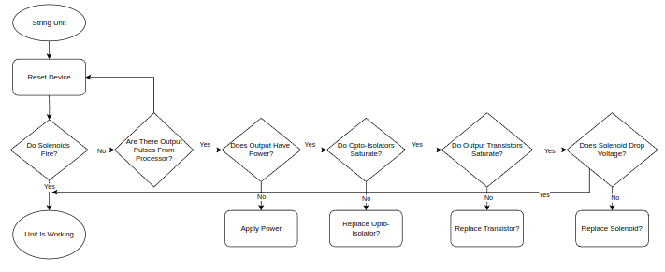Figure 24: String Unit Troubleshooting Flowchart

Engineering Log
Time management and distribution is highly important to project efficacy. The above table shows the summarized time distribution on what the time of the project was spent on. The longest time spent was the coding of the slave devices. This is because there are two programs, but also that there was a significant of troubleshooting during this period with ensuring that I2C worked correctly with all the devices on the line. Troubleshooting as a whole, while not a distinct block, makes up a significant portion of this project because three different programs had to be created to accommodate the configuration of this project.
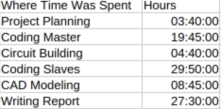Table 6: Hours Summary
Some of the time that had the most significant effect on the project was the project planning stage. In taking time at the beginning of the project to create a clear vision for the breakdown of the project it saved significant time in development. By more or less developing the basics of the block diagram that would become Figure 2. Having a clear vision accelerated the development of the processors by having a focused concept behind what each program will accomplish. Although, certain aspects of the project were not finished, like the string program, the overall progression of the project in the time spent this semester has been a very well spent.

Cost Analysis
The above table shows the projected bill of materials for this project as well as the labor cost for this semester. It can be observed that this project has a fairly steep cost. Given the wage cost, labor is the majority of the cost at $4,750.00 for the 95 hours put into this project over the course of the semester. However, the cost per unit is also relatively expensive at $1,530.19. The majority of this cost, over 84%, is for the solenoids to operate the bass guitar. Each individual solenoid costs approximately $14 because they have to be able to exceed 20 newtons of force. To get this force the coil and overall assembly must be made with more material to meet these specifications. Moreover, there are many solenoids that are necessary because of how this project has been configured. Each string requires 23 solenoids; 20 are for fretting, 2 for plucking, and 1 for muting. Thus, with a 4 string bass a total of 92 solenoids are necessary. This is where the majority of the cost comes from for the project in the needed transistors, opto-isolators, and resistors required to support said solenoids. The cost of the processors and their supporting hardware is insignificant in comparison.
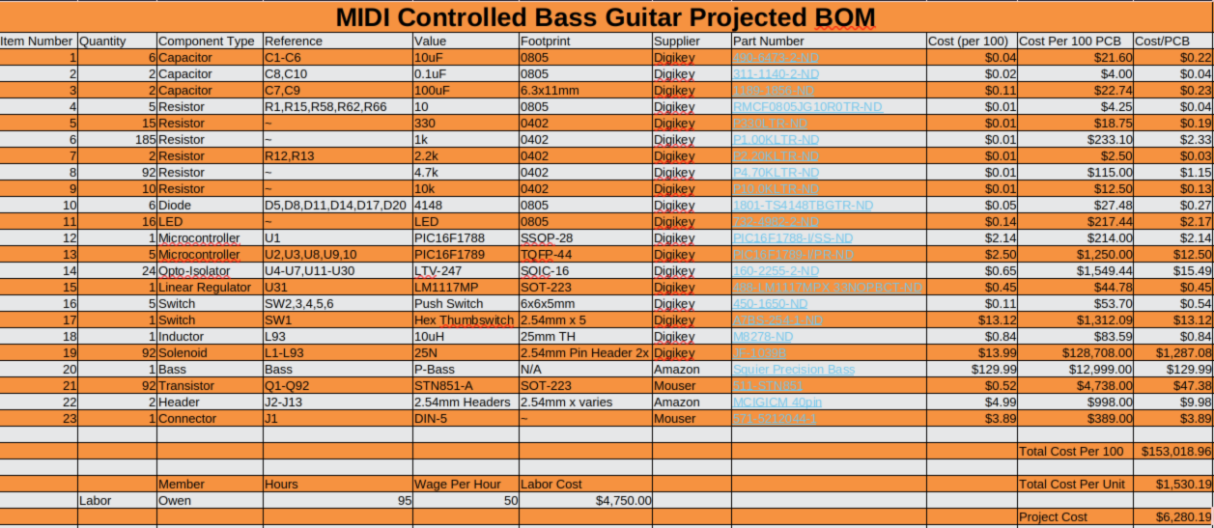Table 7: Project Bill of Materials
The reason that this BOM is treated as a projected budget is because it does not fully encapsulate the full cost of the project. There are two major factors which will lead to the project being more expensive than it is currently. The first is that the PCB has not been designed yet. As the size of the board could not be determined the cost of the PCB could not be quoted based on dimensions. However, given the need for the solenoid drive system the cost of the boards will be higher than projects that use smaller boards. Furthermore, the cost of the 3d-printed parts could not be predicted as no interfacing models have been designed yet. This cost is the most dynamic and unpredictable of all the costs because it will depend on how many iterations of designs will be necessary to come up with a working mechanical platform. Although 3d-printing generally considered an inexpensive way to prototype and iterate designs, the needed volume of printed parts will still have a noticeable impact on the cost of this project. As a whole this project will have a fairly steep cost compared to some of the others that are currently in development. Despite this cost, the end product will present a valuable example of how electronics can be integrated to interface with systems that were designed around humans.

Conclusion
As described in the proposed problem section of this report, pg 5-6, the goal of this semester was to develop the electronics and firmware for this project. Figure 2 shows the system overview for the entire project. From that figure the parts that were developed this semester were the master, E slave, and the plucking slave. Of these programs it was the master program which received the most development of all the programs. This is because, as mentioned in its dedicated section, this processor handles the MIDI commands and addresses slaves based on internal decisions. As of the writing of this report the master program functioned as desired during all mock up testing with its slaves. Having this program done is a big boost to the progress to this project because it is the most critical. Additionally, the plucking slave program has also passed the preliminary testing conducted. While not as complex as the master, the pluck slave does have multiple tasks and functions which it has to handle from the data that it is provided from the master. Moreover, the reliability of the plucking and muting units of this project are critical to the sound of the instrument. As a result having this program done in conjunction with the master means that this project is on track for its development.
Unfortunately, the final slave program for the string units was not fully developed. This was due to a multitude of factors including lack of time as well as an overly complex flowchart. Figure 8X shows the current flowchart that was used to develop the program. The way that each pitch byte is matched with its MIDI equivalent requires such a long evaluation that even the flowchart does not include the repetitive cycle to its entirety. This method of evaluating the pitch byte is process intensive and provides a greater likelihood of errors with the code. For the aforementioned reasons the currently developed code for this slave will be discarded, excluding the I2C section, and a more efficient, simple way to fret the correct notes will be pursued. While having the E slave finished would have been closer to completely accomplishing the development goals for this semester; it is not a significant setback because this program is the simplest of them all and a newly developed version should be relatively quick to finish.
Altogether, the overall progress of the project has been proceeding very well. Finishing the preliminary development for the master and plucking slave accomplished the majority of the primary goal for this semester of development. Moreover, the rough CAD models that were made to represent the bass guitar will help greatly with stage two of development. Additionally the schematic and hardware configuration for this project has been finished to the point that a PCB can begin designed. So while the entirety of stage one has not been finished; the project as a whole is progressing as intended.

Recommendations
For the continued development there are several important recommendations on where to focus development. First would be to design the PCB for the project. This is because having a PCB will make it easier to test the current programs because the processors will be fixed to the board with their control hardware and all the correct outputs to the designated port. Next would be to redevelop the program for the string slaves. Finishing the development is critical to being able to actually test the mechanical platform with the bass guitar. Finally would be to work on how to implement all the solenoids and functions on to the bass body. This is the goal of stage two of development and is important to finish so that the bass can actually be played by the solenoids. In terms of time, this stage of development will likely take as long if not longer than the electronics to implement. Finishing the aforementioned recommendations will result in the completion of the primary goal of the project in creating a bass guitar that can be controlled by MIDI. A final recommendation, once the project can reliably play music, would be to implement a picking unit to the bass guitar that could be enabled with a special MIDI command. This would allow for greater tonal options for the bass. Support for this feature is already partially implemented into the command structure in addition to an external port being reserved for use.

Appendix A: Citations
Microchip. (2015). “PIC16F1788/9.” Microchip technology incorporation, Retrieved from https://www.microchip.com/en-us/product/PIC16F1788#document-table

Appendix B: Mechanical Drawing
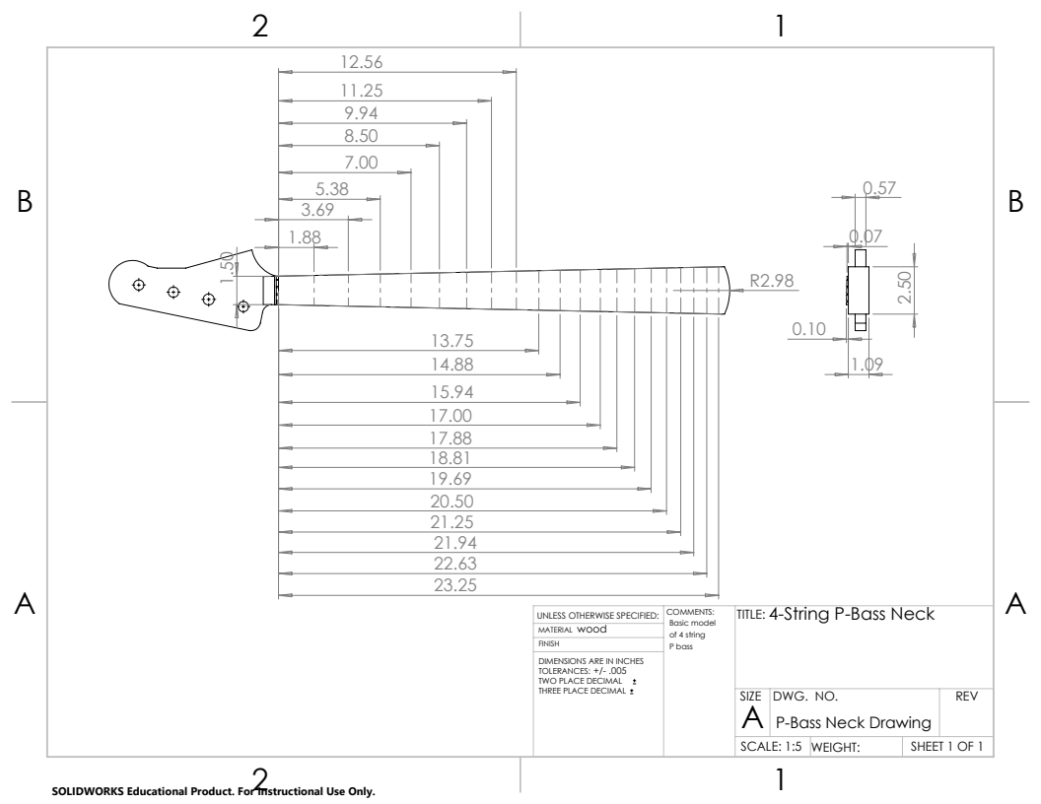Figure 25: Bass Guitar Neck Drawing
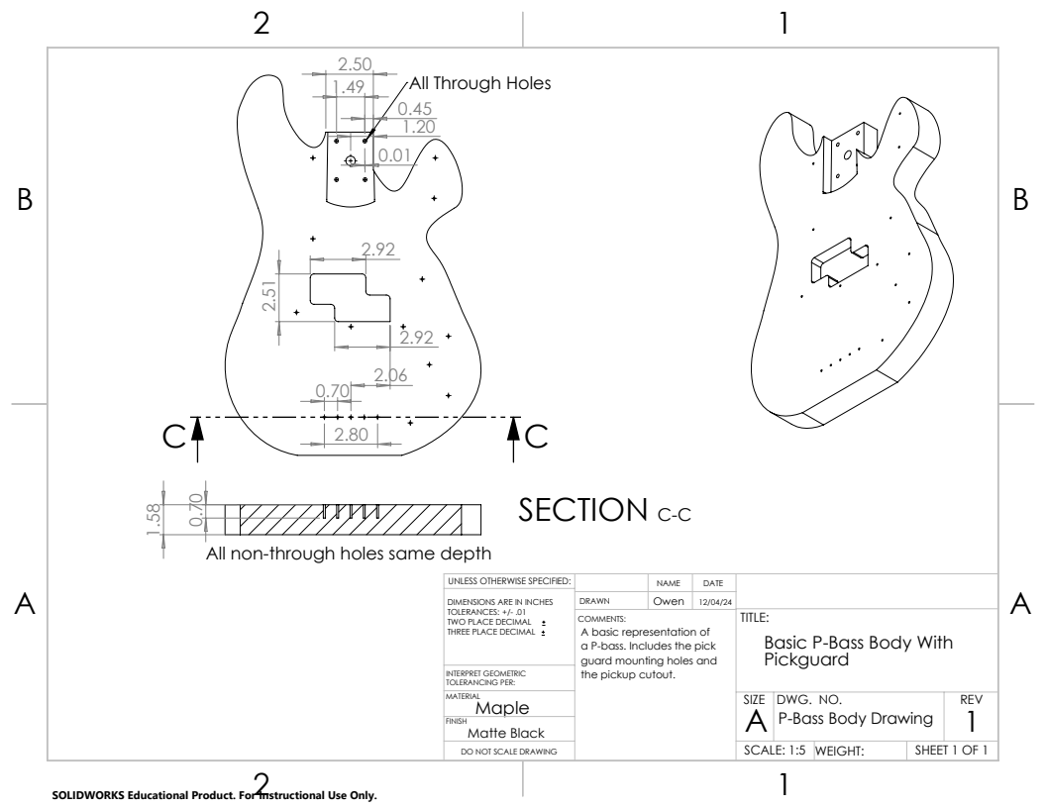Figure 26: Bass Guitar Body Drawing
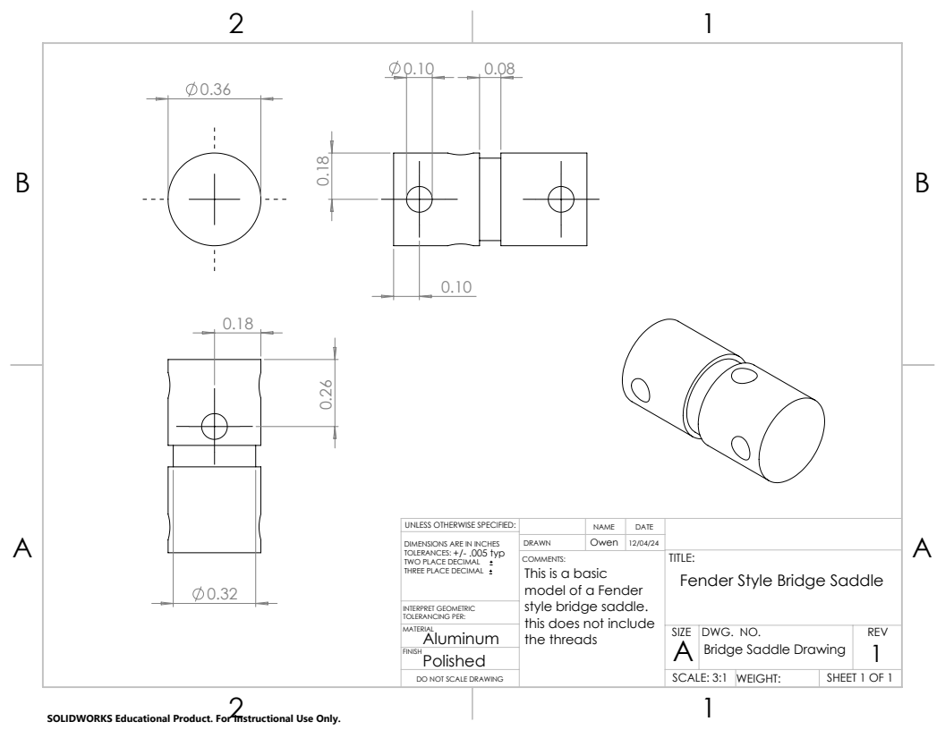Figure 27: Bass Bridge Saddle Drawing
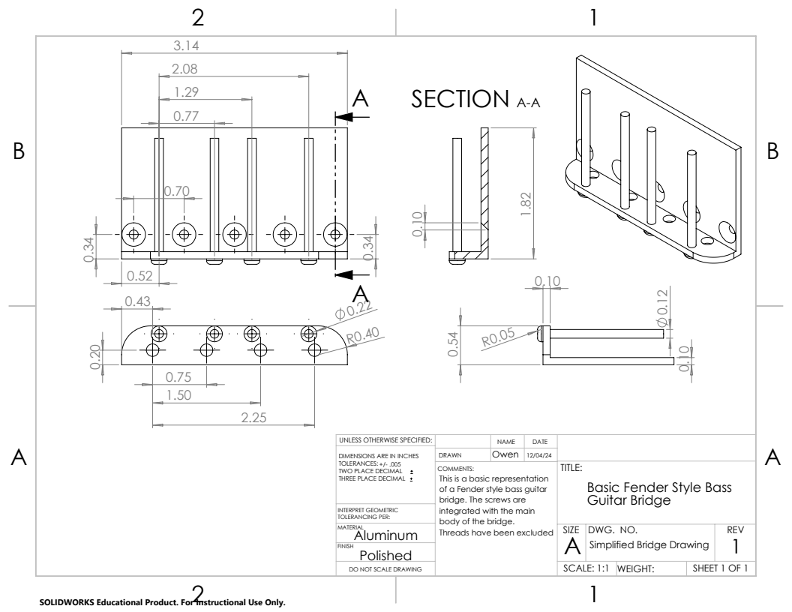Figure 28: Bass Bridge Drawing
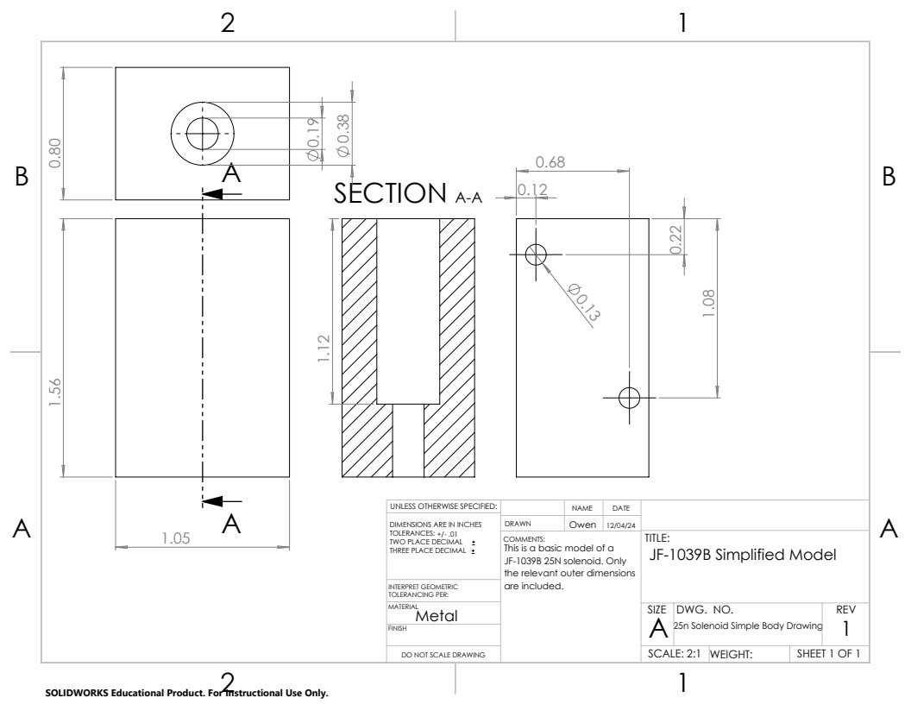Figure 29: Solenoid Block Drawing
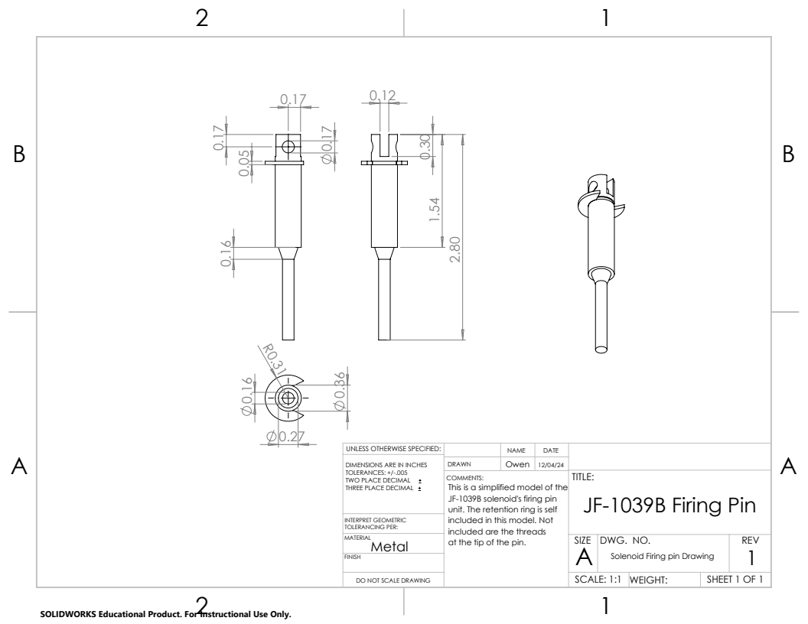Figure 30: Solenoid Firing Pin Drawing

Appendix C: Schematics
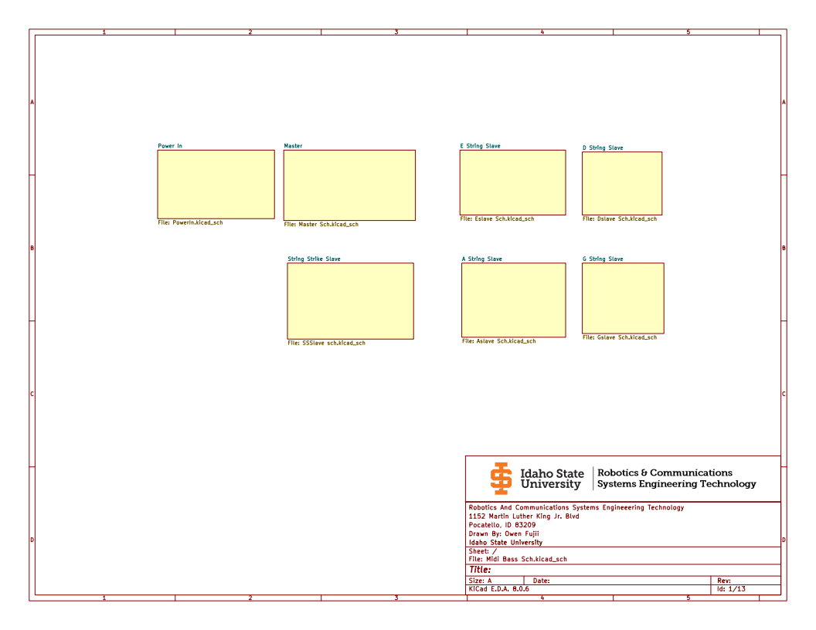Figure 31: Schematic Cover Page
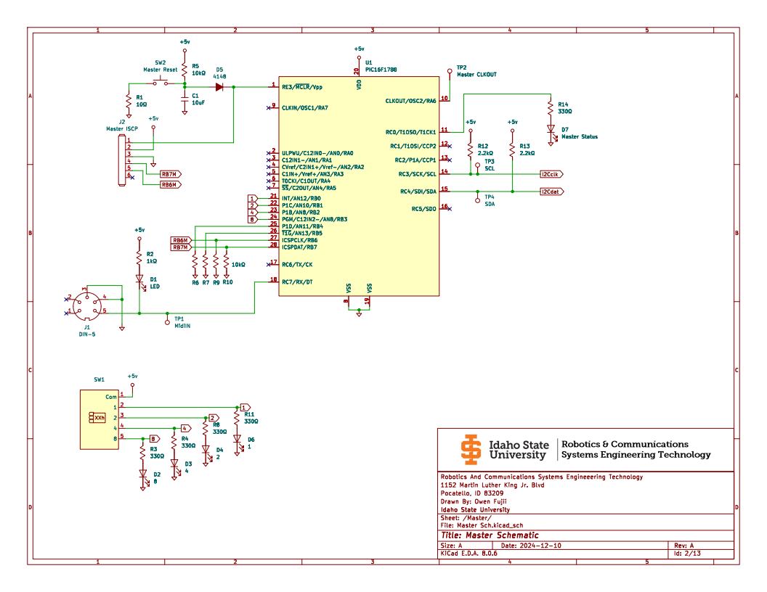Figure 32: Master Processor Schematic

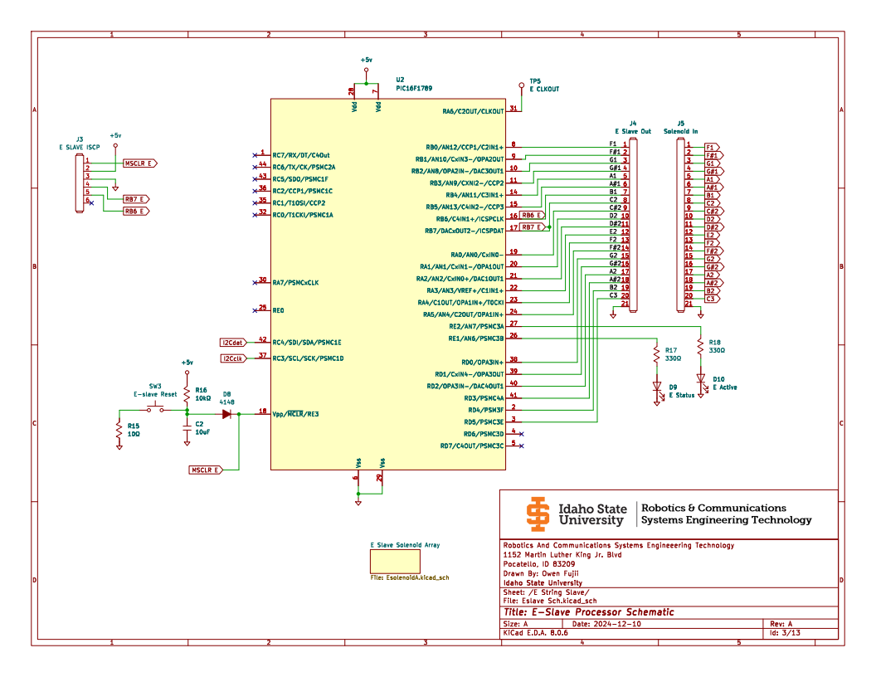Figure 33: E String Slave Processor Schematic
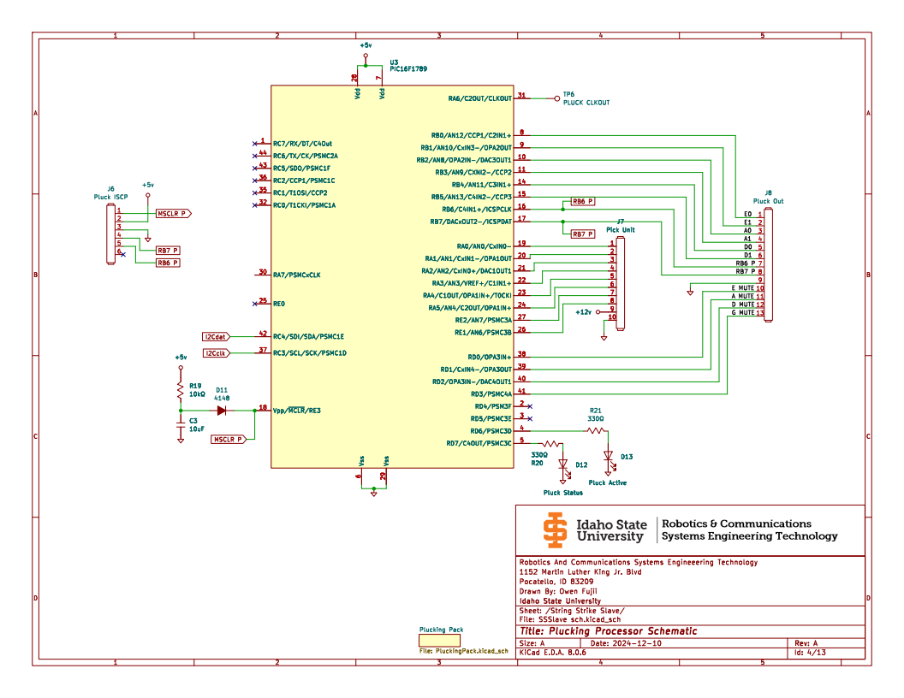Figure 34: Plucking Processor Schematic
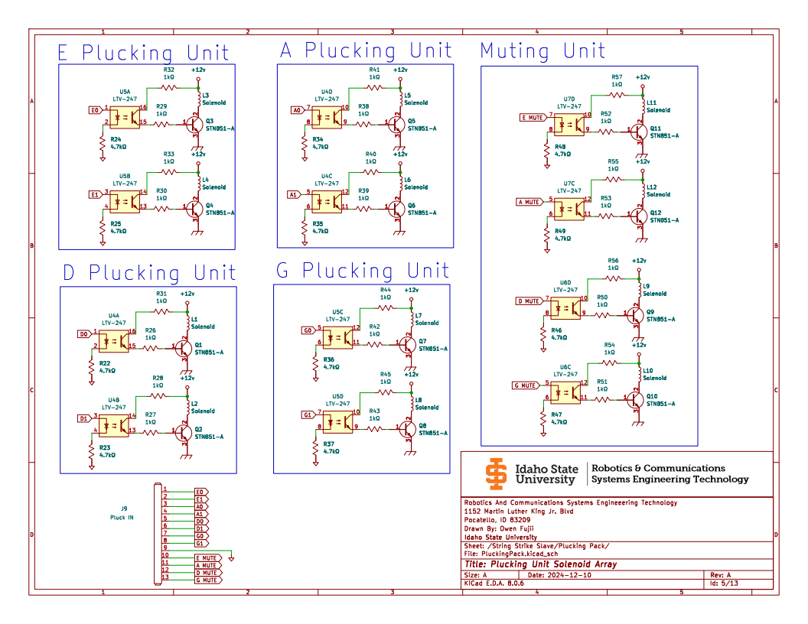Figure 35: Plucking Solenoid Array Schematic
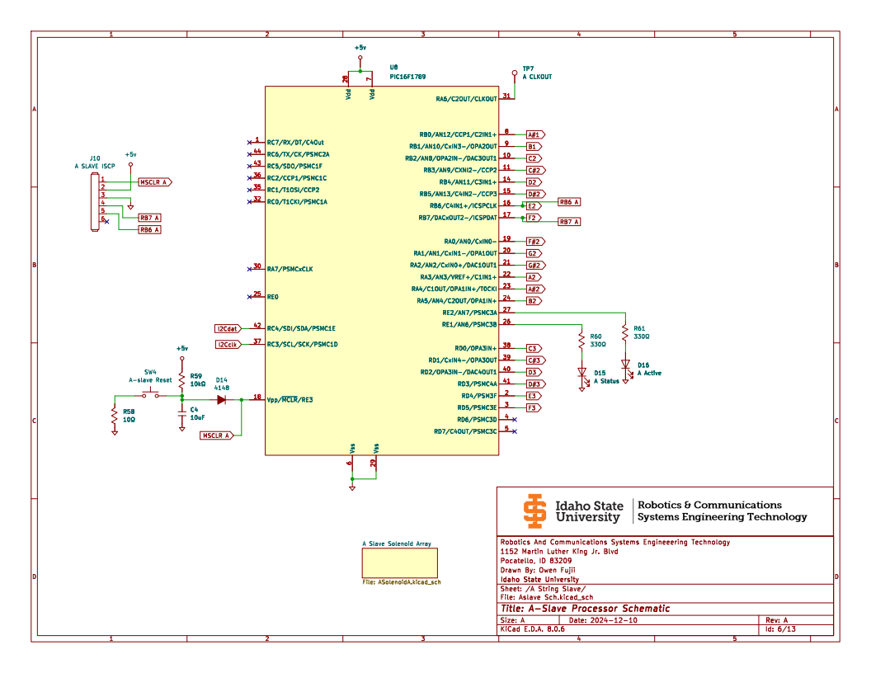Figure 36: A String Slave Processor Schematic

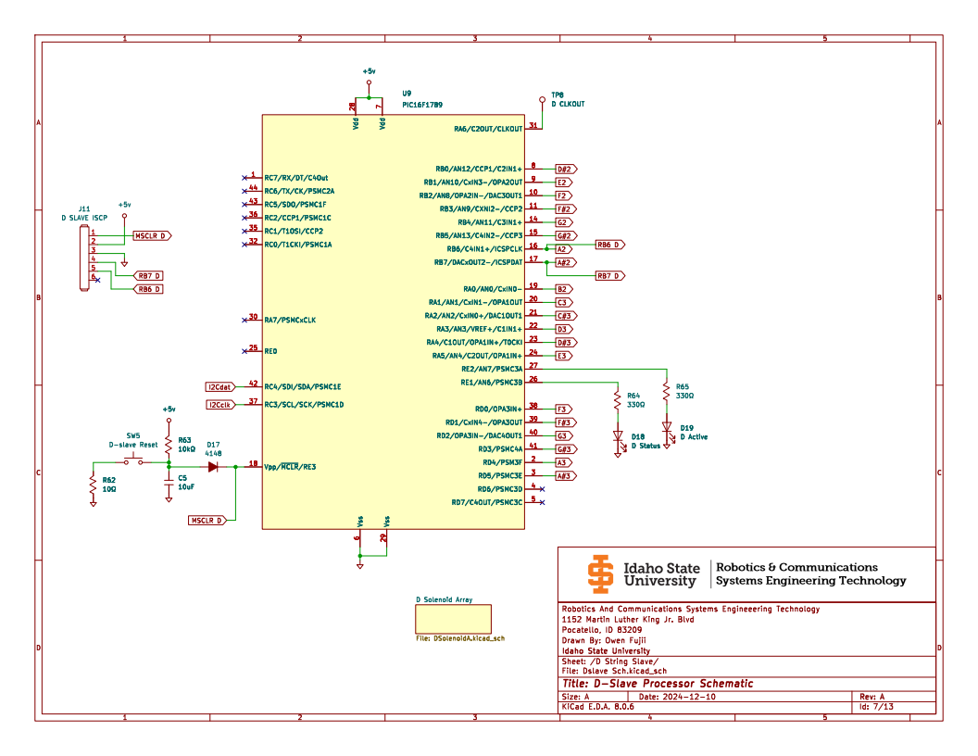Figure 37: D String Slave Processor Schematic
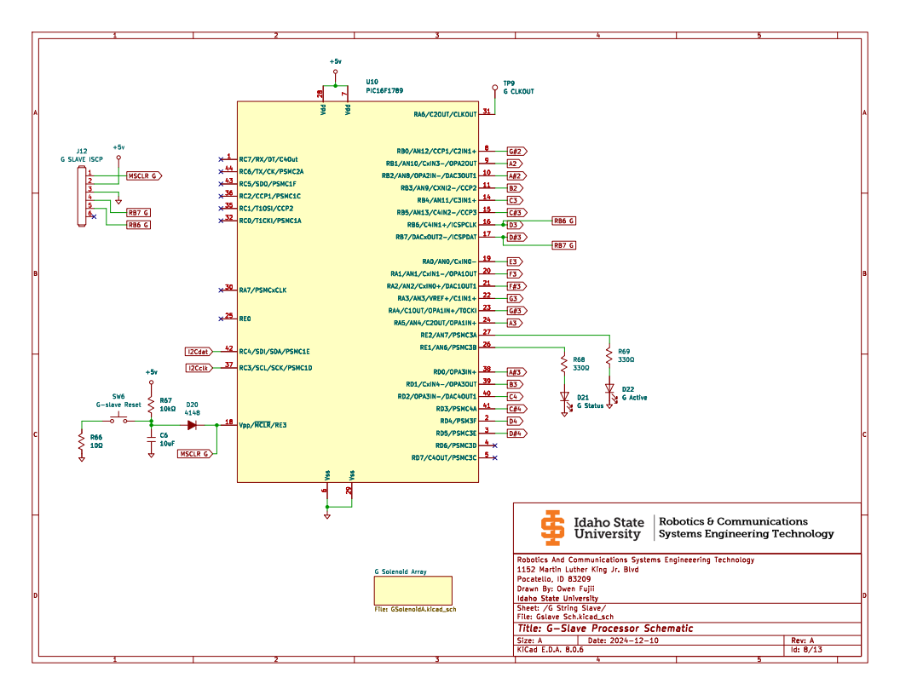Figure 38: G String Slave Processor Schematic

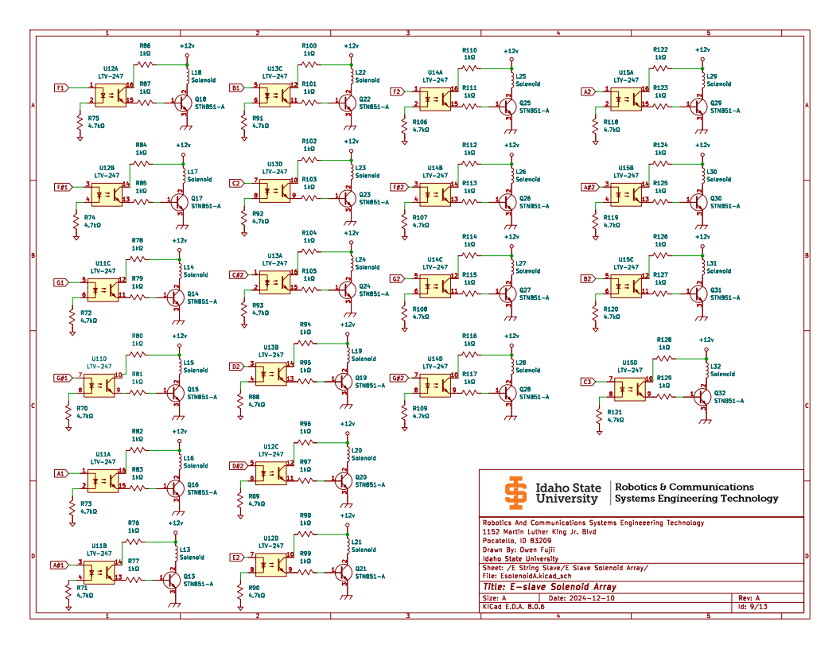Figure 39: E Slave Solenoid Array Schematic
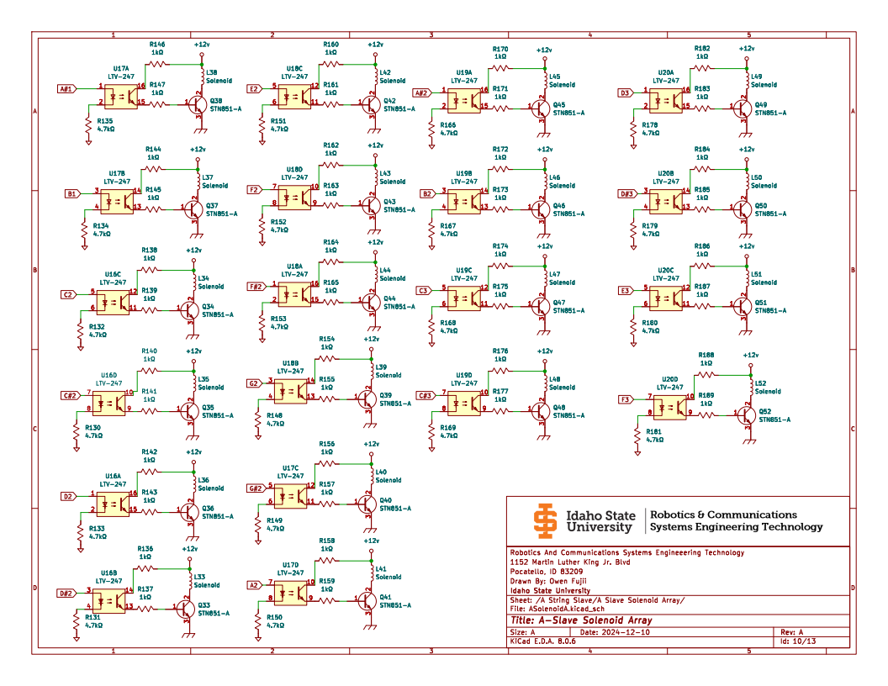Figure 40: A Slave Solenoid Array Schematic

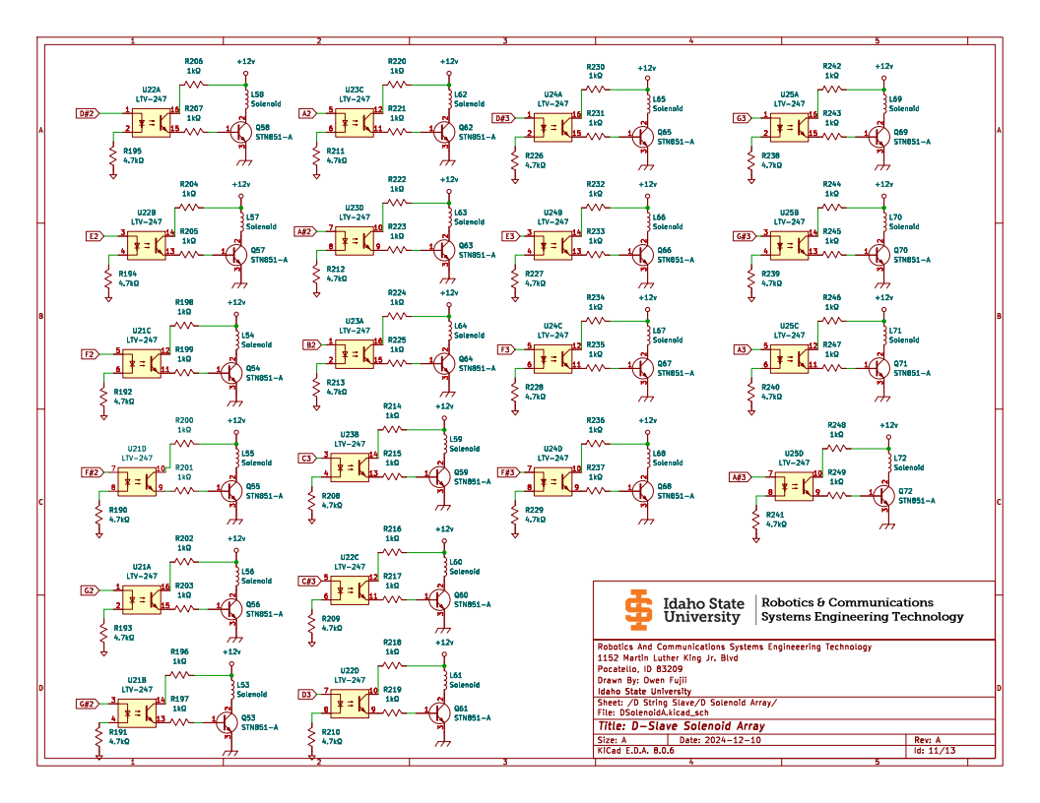Figure 41: D Slave Solenoid Array Schematic
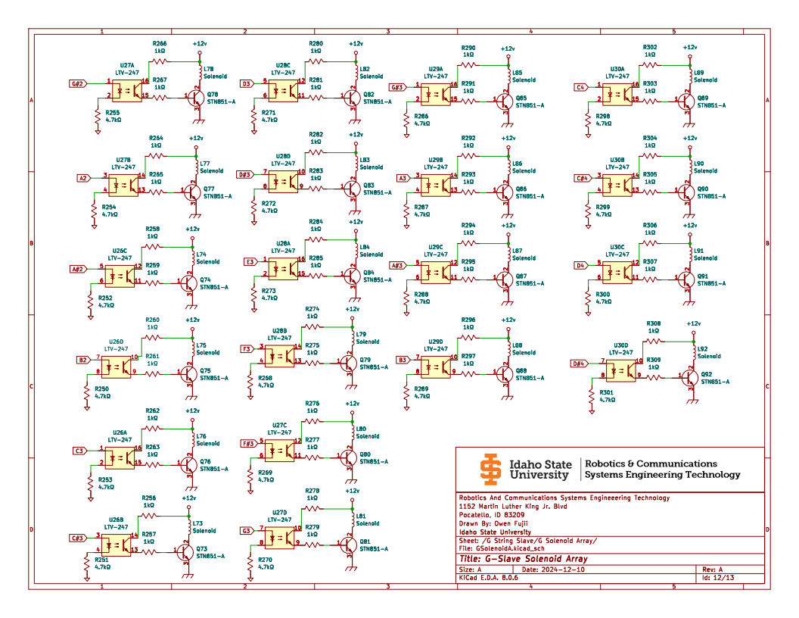Figure 42: G Slave Solenoid Array Schematic

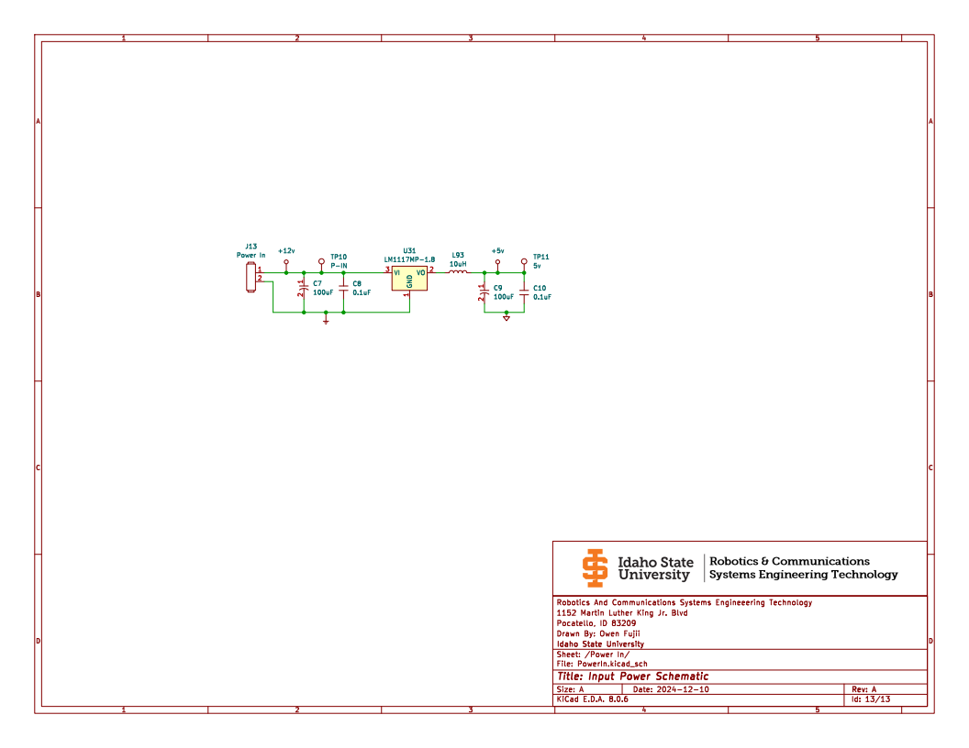Figure 43: Power In Schematic

Additional Information
Refer to the GitHub for even more resources and information regarding this project including all programs for all devices. The Testing branch has all current developments, Main is the current stable version of all code.


