Technical Design Document
Student Exam Grades Program
Name: Slade Miller
Course: COP 2373
1. Program Description
The Student Exam Grades Program consists of two separate Python programs. The first program collects student information, including first name, last name, and three exam grades, and writes the information to a CSV file named grades.csv. The second program reads the CSV file and displays the student information on a formatted table..
2. Program One: create_grades.py
Function Name: create_grades_file()
Description:
This function collects student names and three exam grades from the instructor. It writes a header row and each student's information to grades.csv.
Parameters:
None.
Variables:
- student_count — stores the number of students to enter.
- file — represents the opened CSV file.
- writer — writes rows to the CSV file.
- student — controls the loop for entering each student's information.
- first_name — stores the student's first name.
- last_name — stores the student's last name.
- exam1 — stores the first exam grade.
- exam2 — stores the second exam grade.
- exam3 — stores the third exam grade.

Logical Steps:
- Ask the instructor how many students will be entered.
- Open grades.csv in write mode using the with statement.
- Create a CSV writer using the csv module.
- Write the column headings: First Name, Last Name, Exam 1, Exam 2, and Exam3.
- Use a loop to collect each student's first name, last name, and three exam grades.
- Write each student's information as a separate record in the CSV file.
- Display a confirmation message after the records have been saved.
Return Value:
None. The function writes the student records to grades.csv.
3. Program Two: read_grades.py
Function Name: display_grades()
Description:
This function reads the student records from grades.csv and displays them in a formatted table with aligned columns.
Variables:
- file — represents the opened CSV file.
- reader — reads the CSV records.
- rows — stores the rows read from the CSV file.
- column_widths — stores the required display width for each column.
- column — identifies the column being processed.
- width — stores the calculated width of a column.
- row_number — tracks the current row being displayed.
- row — represents a student's record or the header row.
- formatted_row — stores a row formatted for table display.
- divider — stores the line separating the header from the student records.

Logical Steps:
- Open grades.csv in read mode using the with statement.
- Use csv.reader to read the contents of the file.
- Store the rows in a list.
- Check whether the file contains any data.
- Calculate the width required for each column.
- Display each row with aligned columns.
- Print a divider underneath the header row.
4. File Structure
The assignment uses three files:
- create_grades.py — collects student information and creates the CSV file.
- read_grades.py — reads and displays the saved student information.
- grades.csv — stores the header and student records.
Both Python programs and the CSV file should be saved in the same project folder.
5. Testing and Output
Test Procedure:
- Run create_grades.py.
- Enter two students and their first names, last names, and three exam grades.
- Verify that grades.csv is created and contains the correct headers and student records.
- Run read_grades.py.
- Verify that the student records appear in a formatted table and that the column headings are correct.

Create_Grades.py
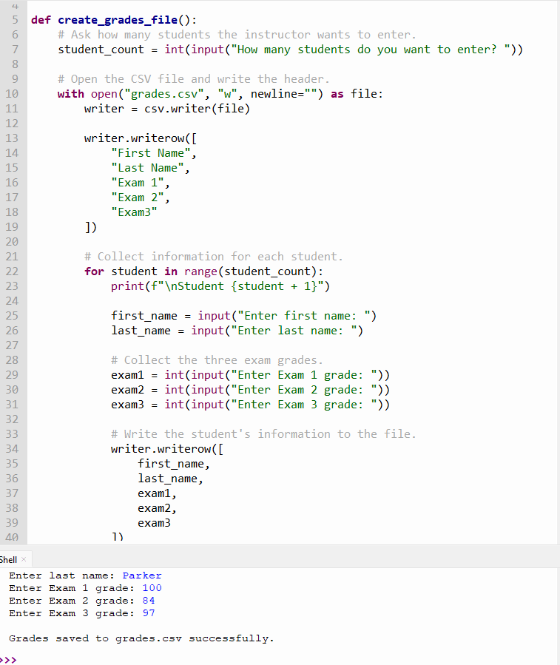

Read_Grades.py
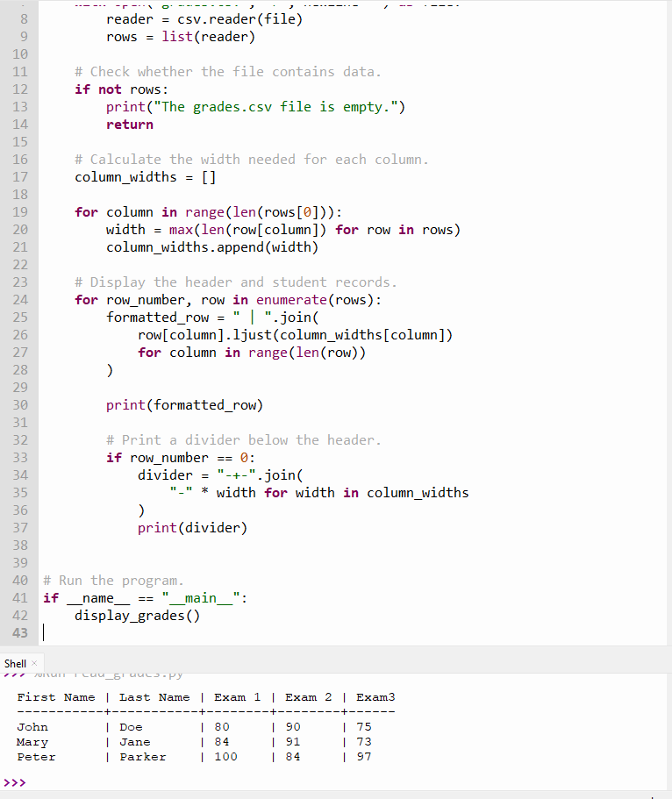

Conclusion
This assignment demonstrates how to collect user input, define and call functions, work with CSV files, use file-handling statements, and format output into a readable table. Separating the data-entry and data-display tasks into two Python programs makes the program easier to organize and maintain.
https://github.com/slade963/COP2373

