|  |
| --- |
| Genesee Valley Central School |
| Swivl |
| How it works |
|  |
| **Jake R Slaght** |
| **May 12, 2015** |

Contents

Table of Figures 2

Introduction 3

Uses 4

“Deconstruction” of the Swivl 5

Use the Swivl 6

Powering up and Connecting the Remote, Swivl, and iPad 6

Recording with Swivl 6

Getting the Swivl to Follow 6

“Freezing” The Swivl 6

Saving the Recordings 6

Images 7

Works Cited 13

# Table of Figures

Figure 1: Overview 7

Figure 2: Front Top of Swivl 7

Figure 3: Infrared Eye 7

Figure 4: Power Port 8

Figure 5: Back Ports 8

Figure 6: Remote in Housing 8

Figure 7: Empty Remote Housing 9

Figure 8: Side View Showing Remote Housing Location 9

Figure 9: Top of Remote 9

Figure 10: Side of Remote 10

Figure 11: Swivl Apple App Icon 10

Figure 12: App Main Menu 11

Figure 13: Swivl Recording Library 11

Figure 14: Swivl in Use 12

# Introduction

The Swivl bot is a recording device that with the assistance of a RFID Infrared remote control with microphone can record both audio and video from a distance of a maximum of 10 feet with clear audibility.

In the case of the school the device the Swivl utilizes in an Apple iPad.

# Uses

The Swivl is a classroom intended device meant to record lessons and activities for future examination and use at a later date by students and teachers. This could be used for small casted media projects in the communications courses or in an art class for a panorama or 360° recording of a location.

# “Deconstruction” of the Swivl

The Swivl robot is a small white and black flat-bottom based machine with a power port on the right hand side bottom, four ports on the back for a variety of device connections, the remote storage location, and the iPad holding shim. Power button and rotational buttons are located in front.

See the image section for all images of the Swivl. Figure 1 show the Swivl, the remote, the audio cord, and the power adapter. Not visible is the one installed shim. Not pictured: Apple iPad, iPad cord, the other shims

# Use the Swivl

This will be simple to use and understand step by step guide, there will be images located below it with references to them in the steps

## Powering up and Connecting the Remote, Swivl, and iPad

1. Set up Tripod to appropriate height
2. Install Swivl onto Tripod if not already
3. Power on the iPad
4. Place iPad into Swivl so the audio port is down close to the Swivl
5. Plug in the Audio cable provided into both the Swivl and the iPad, ensure a snug fit on both sides
6. Plug in iPad charging cable if necessary (Figure4)
   1. This will **not** stop the Swivl from wanting to go the full 360° but it will risk tangling, use caution
7. Open up the Swivl Application (Figure 11)
8. Select ‘Capture’ (Figure 12)
9. Select ‘Capture’ in left corner (Figure 13)
10. Remove the remote from the Swivl body and close hatch (Figures 6,7 and 8)
11. Power on the remote by pressing and holding the power button (Figure 10)
    1. The LED light will light up when on
12. Press and hold down the power button to turn on Swivl(Figure 2)
    1. The Swivl will react to the remote’s location now

## Recording with Swivl

(Figure 14)

1. Press down the Record Button on the side of the remote(Figure 10)
2. Record Audio and Visual
   1. 10 feet is the **max** range for clear Audio
3. Press down the Record Button on remote again to end recording

## Getting the Swivl to Follow

1. Ensure that remote is visible to the Swivl’s eye(Figure 3)
2. Move slowly left or right and the machine will follow
3. Up and down requires the remote to be placed above or below the starting location of the remote and the big button pressed and held down(Figure 11)
   1. This is a slow process but it does work

## “Freezing” The Swivl

1. At any time to stop the Swivl from following the remote while the user moves press the big button on the remote with a checkmark in it. (Figure 11)

## Saving the Recordings

1. Tether iPad to a computer
2. Trust the system on the iPad
3. Open up the iPad’s Drive
4. Select ‘DCIM’
5. Click ‘Date Modified’ until the content is placed in chronological order with current date at top
6. Copy and Paste desired content from iPad to computer
7. Untether iPad from computer

# Images

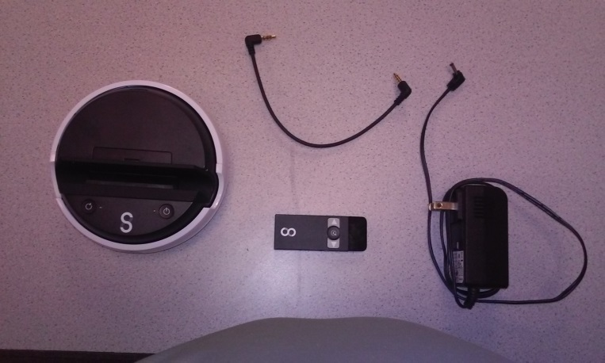

Figure 1: Overview

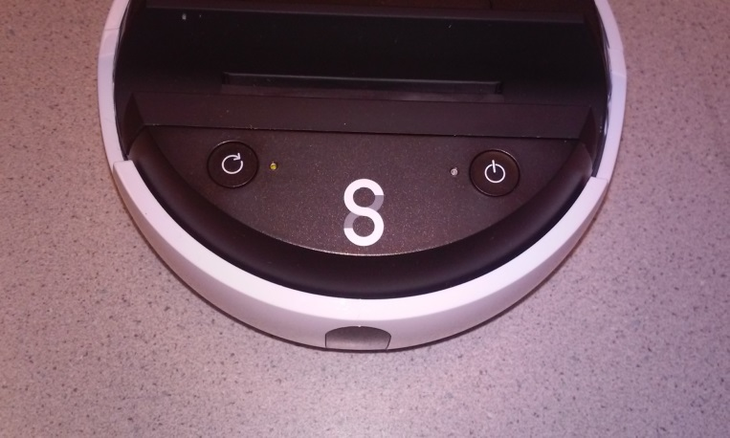

Figure 2: Front Top of Swivl

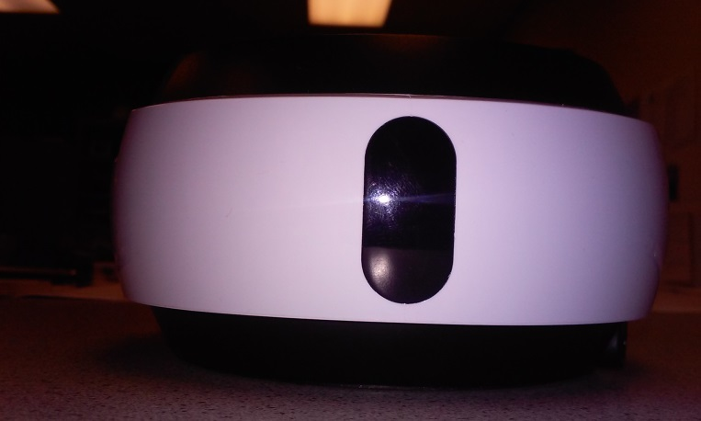

Figure 3: Infrared Eye

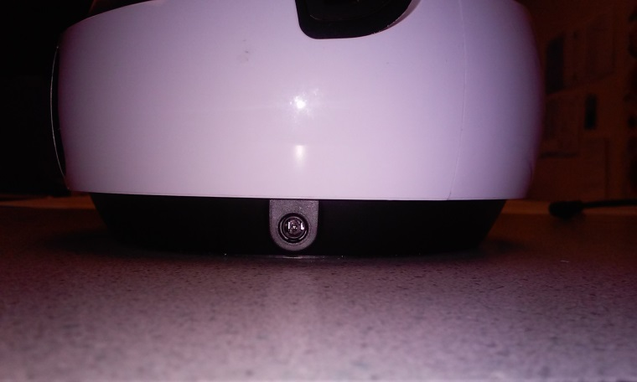

Figure 4: Power Port

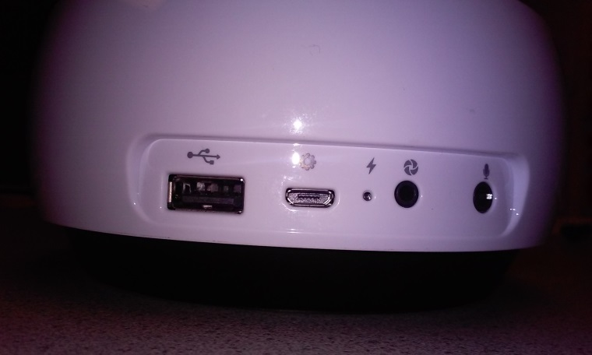

Figure 5: Back Ports

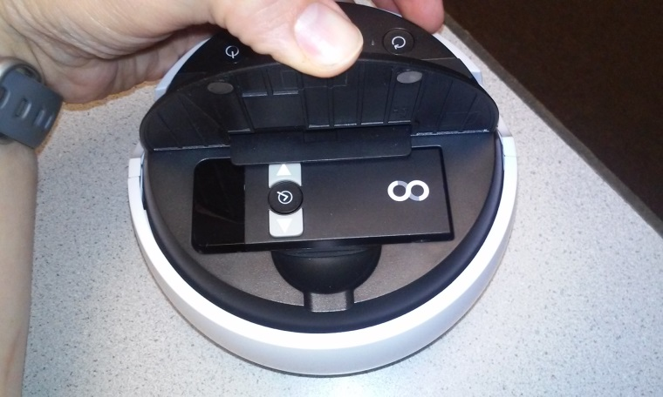

Figure 6: Remote in Housing

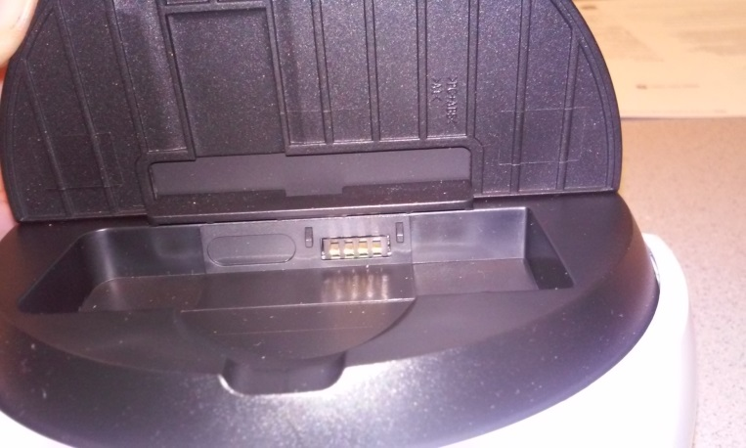

Figure 7: Empty Remote Housing

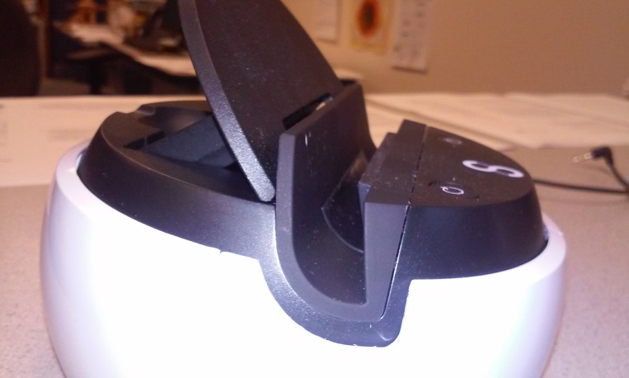

Figure 8: Side View Showing Remote Housing Location

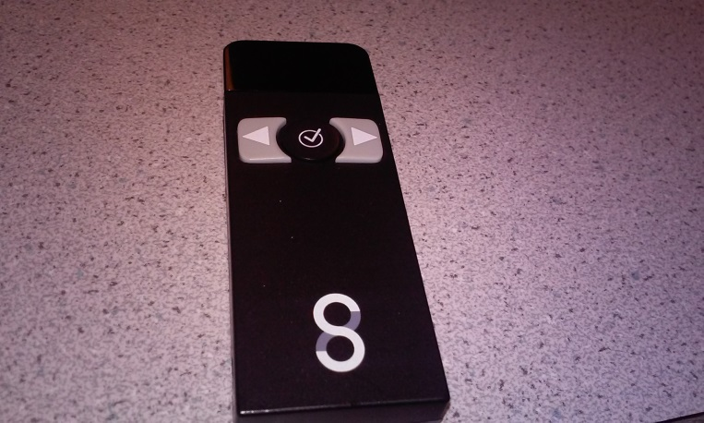

Figure 9: Top of Remote

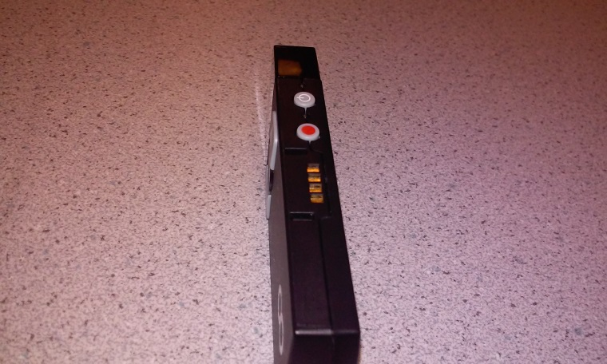

Figure 10: Side of Remote



Figure 11: Swivl Apple App Icon

Source: (Swivl)

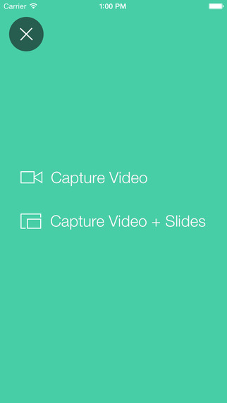

Figure 12: App Main Menu

Source: (Swivl, Swivl Menu)

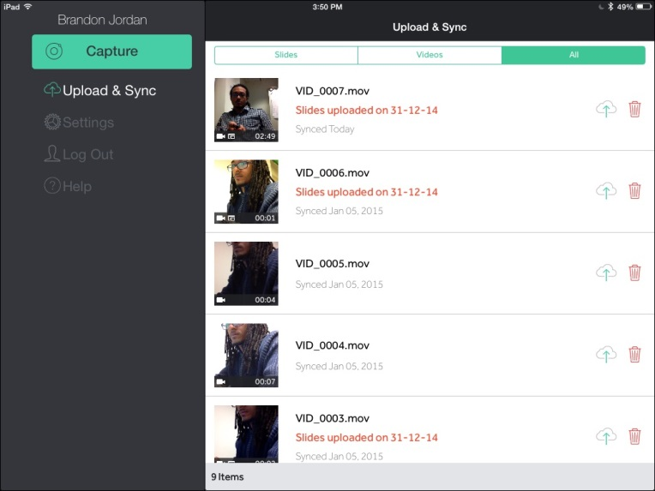

Figure 13: Swivl Recording Library

Source: (Illinois)

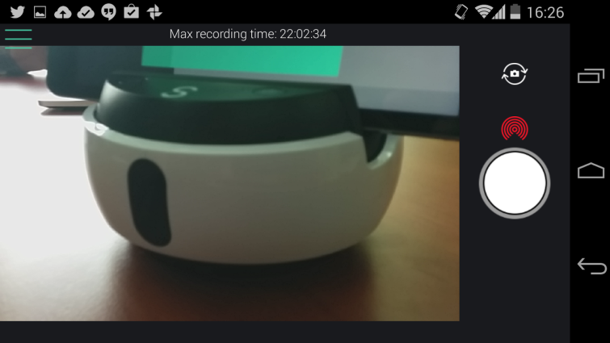

Figure 14: Swivl in Use

Source: (Google)

# Works Cited

Google. (n.d.). Retrieved May 11, 2015, from https://lh3.ggpht.com/r0AGs7nvDGHl9l_Kn2rfvaVUPtDorTZ6Ts8jl2Aq7rH_rM2UuBp_LKldfk44MXZJ5l4=h900

Illinois. (n.d.). Retrieved May 11, 2015, from http://publish.illinois.edu/brandonjatcitesdmg/files/2015/01/image.jpg

Swivl. (n.d.). Retrieved May 11, 2015, from http://a4.mzstatic.com/us/r30/Purple1/v4/0c/cf/7d/0ccf7d70-6941-2df0-3307-cd96151997ae/icon175x175.png

Swivl. (n.d.). *Swivl Menu*. Retrieved May 11, 2015, from http://a5.mzstatic.com/us/r30/Purple3/v4/a4/c8/60/a4c86007-325b-47a7-4978-17e1600c1681/screen322x572.jpeg