1

FitNesse with .NET

Improving the Testing Process: Turning Tests Into Specifications
Traditional testing processes carry two significant weaknesses. One, there is a large gap, called development, that takes place between what the customers asks for and what gets tested after development. It’s not uncommon for customers too look at tested software and say, “That’s not what I asked for”. Two, typical feature specifications require immense amounts of effort to maintain because the software and requirements are always in flux. Feature specification documents can be riddles with lies. But tests, because they must always pass, will never tell a lie.
FitNesse is an Acceptance Testing framework that supports Test Driven Development. Customers specify features in FitNesse before development on these features begins. Developer takes these specifications and execute them within FitNesse to see if their code meets the requirements. In the manner, there is no gap between specification and testing. A customer will always get what she asks for because her specs are the tests. FitNesse also eliminates the nightmare of maintaining feature specs. The tests are the specs and since they must always pass, they can never get out of date.

Tool: FitNesse
Version: 20050731
Homepage: http://fitnesse.org
Power Tools Page:
Summary: An Acceptance Testing framework written as a Wiki that supports Test Driven Development.
License Type: GPL
Resources | http://fitnesse.org, Fit for Developing Software : Framework for Integrated Tests by Rick Mugridge and Ward Cunningham
Supported Frameworks | Java, .NET, C++, Ruby, Python, Delphi, Perl, Objective-C, and many more.
Related Tools | FIT, Wiki, FitLibrary

Requirements
FitNesse, although it supports a variety of programming language platforms, is written in Java. As of version 20050731, the Java 1.4 (or higher) runtime environment is required in order to run FitNesse. It will run on any version of Windows, Mac OS X, Linux, and Unix.

Setting Up and Running
The download is just a zip file that you can unzip in a reasonable place. Within the extracted fitnesse directory there is a run.bat file. Double click on run.bat to start the FitNesse web server. If port 80 is already in use on your computer, you will need to edit the run.bat file, adding the –p command line option, which changes the port that FitNesse uses. When FitNesse successfully start, you’ll a message similar to the following.
FitNesse (20060220) Started...
port: 8081
root page: fitnesse.wiki.FileSystemPage at FitNesseRoot
logger: none
authenticator: fitnesse.authentication.PromiscuousAuthenticator
html page factory: fitnesse.html.HtmlPageFactory
page version expiration set to 14 days.

Using the FitNesse Wiki
Once started, you may use FitNesse by opening a browser and loading the URL http://localhost/ (If using an alternate port, the URL would be http://localhost:<port>/). Error: Reference source not found shows what the page should look like. This is called the FrontPage of the FitNesse wiki. There is much to talk about here but first, let’s talk about the top button in the navigation bar on the left; the one that says, “Edit”. When you click this button, an edit page will appear containing all of the content of the FrontPage in a format called wiki text. Wiki text is a simple markup language used to create wiki pages. When you view a wiki page, the wiki text for that page is converted into HTML that looks something like Error: Reference source not found. Anybody who visits this page may add, delete, or modify the wiki text.
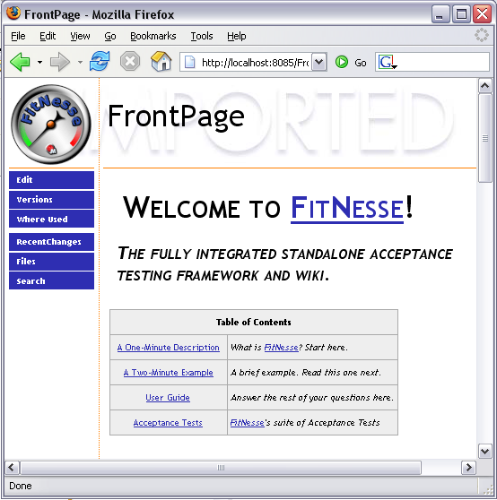
Figure 1-1. FrontPage for freshly installed FitNesse instance
New pages may be added to the wiki by creating a WikiWord. Taking at least two words, removing the spaces between them, and making the first letter of each word capital, creates a WikiWord, for example FrontPage. Whenever a WikiWord appears in the wiki text, it is rendered as a link to the page by the same name. By simply naming new pages, you can extend and grow the wiki as needed.
A unique aspect of FitNesse is that it allows the creation of pages within pages. In many ways it is like the directory structure of you operating system where every wiki pages is a directory. Given the wiki path, FitNesse.UserGuide, tells us that the page UserGuide exists with the FitNesse page. The ability to create these deep page structures is useful for organization an other reasons discussed later.
To learn more about wiki’s, visit http://en.wikipedia.org/wiki/Wiki.

Configuring FitNesse for .NET
FitNesse may be used with any programming language, however you must configure it for each language. For .NET, three variables must be defined by using the following wiki text:
!define COMMAND_PATTERN {%m %p}
!define TEST_RUNNER {dotnet\FitServer.exe}
!define PATH_SEPARATOR {;}
Any wiki page that contains these variables is configured for .NET and only for .NET. When such a page is executed as a test, FitNesse will see the variables and make use of the .NET extensions. Conveniently, child pages inherit variables. Any page that has a parent page configured for .NET is, through variable inheritance, also configured for .NET. This means the entire wiki could be configured for .NET by simply adding these variables to the root page (http://localhost:<port>/root).

Building a Project with FitNesse
It’s time to build a project. We’re going to build a simple application called ClockIn that may be used to keep track of the hours that people work. As you will see, FitNesse plays an integral part of the development process.
One of the first things we need to do is set up a section of the FitNesse wiki for our work. I will create a page called ClockIn that will be the root page for the project wiki and acceptance tests. After creating the page I add the following wiki text:
!c !3 A simple program to keep track of hours.

!define COMMAND_PATTERN {%m %p}
!define TEST_RUNNER {dotnet\FitServer.exe}
!define PATH_SEPARATOR {;}
!path dotnet\fit.dll
The first line is a simple title for the page. Following that are 3 lines that starting with !define. These are variables definitions that tell FitNesse how to execute tests. In this particular case they point to the .NET extensions that allow us to run our tests against .NET code. The final line (!path dotnet\fit.dll) tells FitNesse where to find the code it will execute. We’ll be adding more !path elements once we write some code.
One thing worth mentioning is that we will only need to include these configurations on this page. Child pages inherit variables and path elements. That means that any page anywhere beneath the ClockIn page is automatically configured. If we later decide to change the configuration, we need only change the ClockIn page.

The First Test
With our ClockIn page in place, we can create our first test, or rather, our first specification. Typically it is the “customer” who drives the creation of acceptance tests. “Customer” is a loose term for anyone who is responsible for defining the behavior of the system. It may be the actual customer, a business analyst, a subject matter expert, or even a tester. For this exercise, your humble narrator will be the customer.
A brief explanation of the application is in order. Error: Reference source not found shows a sketch of the one and only window of the ClockIn application. On the left is a login form. Users will login to the system using this form. On the right is a section for the current user. When a user logs in, their name appears on the right and they are automatically clocked in. The next time the user logs in, they are automatically clocked out and the number of hours since they clocked in is displayed.
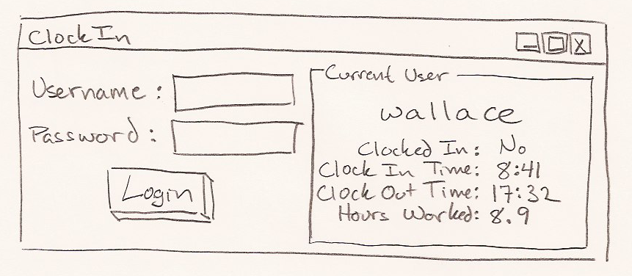
Figure 1-2. Sketch of the ClockIn application
Since logging in is such a central piece, our first specification will describe how it works. On the ClockIn wiki page, we’ll add the following wiki text.
^TestLogin
As you can see, this is a WikiWord. It creates a link to the new test page we’d like to create. The ^ makes TestLogin a child page of ClockIn. Prefixing the page name with Test, although optional, conveniently adds the test property to the new page.
After saving the changes, a ? appears after the ^TestLogin. Clicking on it takes us to the edit screen for the TestLogin page. Here we specify the behavior of Login functionality. Here is the wiki text used.
!c !3 Login: Users of the system login by providing their username and password.

Add some users to the system.
!|Users|
|username|password|
|wallace|cheese|
|grommit|nopenguins|

Wallace uses the correct password and successfully logs in.
!|Login Window|
|enter|username|wallace|
|enter|password|cheese|
|press|Login|
|check|logged in|yes|

Grommit uses the correct password and successfully logs in.
!|Login Window|
|enter|username|grommit|
|enter|password|nopenguins|
|press|Login|
|check|logged in|yes|
The first line is brief description of the functionally we are specifying. Below that are 3 annotated tables. The | syntax is used to build tables. The resulting web page is shown in Figure 1-3.
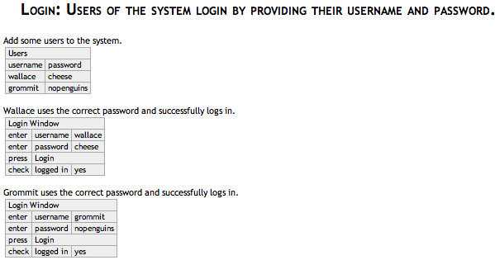
Figure 1-3. Login specification
Because this page has the Test property, there is a Test button on the left-hand side of the page. Pressing the Test button executes this specification. If you we were to run the test at this point, the tables would turn yellow with error messages saying there is no code to test. This is where the developers take over.
Implementing the First Test
Now that the developers have a FitNesse test in hand, they know exactly what to do. Unlike typical requirements docs or feature specs, this specification is written in such details that it executes. There is no ambiguity, which make the developers’ job much easier.
Developers will look at this test and they may read the plain text to get a feel for what’s going on. But the meat of FitNesse tests is the tables. When executed, everything on the page is ignored except the tables. Looking at the first table, we see that the first row says Users. This tells us that we need a Fixture called Users or UsersFixture.
A Fixture is a .NET class that acts as glue between the tests and the application. They are trivial code that reads the tables and makes calls to the application. Below is the code for UsersFixture.
using fit;

namespace ClockIn
{
public class UsersFixture : ColumnFixture
{
public string username;
public string password;

public override void Execute()
{
SetupFixture.appContext.AddUser(username, password);
}
}
}
There are several flavors of Fixtures, each corresponding to a different table structure. UsersFixture is of the ColumnFixture flavor. When using a ColumnFixture, every column in the table corresponds to a member on the Fixture. In this case, every row of the table will insert a value into both the username and password member variables, and then call Execute(). The Execute() methods adds users to the system.
The next table, titled “Login Window”, is executed by LoginWindowFixture, which is an ActionFixture. In ActionFixture tables, every row is an action. You may add any action you want to an ActionFixture, but out of the box it comes with, Enter, Press, and Check. That makes them useful for simulating form window where you Enter text, look at (Check) labels, and Press buttons. Every action in an ActionFixture table corresponds to a member on the Fixture class. Below is the code for LoginWindowFixture.
using fit;

namespace ClockIn
{
public class LoginWindowFixture : ActionFixture
{
public string username;
public string password;
public bool loggedIn;

public LoginWindowFixture()
{
actor = this;
}

public void Login()
{
loggedIn = SetupFixture.appContext.Login(username, password);
}

public string LogInTime
{
get { return SetupFixture.view.clockedInTime.ToString("H:mm"); }
}

public string LogOutTime
{
get { return SetupFixture.view.clockedOutTime.ToString("H:mm"); }
}

public double HoursWorked
{
get { return SetupFixture.view.hoursWorked; }
}
}
}
Before this test will run, we need to add a bit more structure. What we need is a SetUp page. SetUp and TearDown are pages that have special meaning in FitNesse. If a SetUp page exists in a hierarchy, every test page in the hierarchy will be prefixed with the content of SetUp. The content from TearDown will be added to the end of every test page in the hierarchy. We’ll create a SetUp page, with the following content, just inside the ClockIn page.
!|Import|
|ClockIn|

!|Set up|
The first table uses the ImportFixture included in the framework. It includes the ClockIn namespace in the search path allowing us to use “elegant” fixture names in our fixture tables. Without this, we would have to use fully qualified class names in the first row of every table. For example the second table here would have take on the following, less readable format.
!|ClockIn.SetupFixture|
The SetupFixture, which is of the plain Fixture flavor, sets up a testable environment by instantiating all of the production objects and appropriate mock objects.
using fit;

namespace ClockIn
{
public class SetupFixture : Fixture
{
public static ClockInContext appContext;
public static MockView view;

public override void DoTable(Parse table)
{
view = new MockView();
appContext = new ClockInContext(view);
}
}
}
At this point, there is enough structure to execute the TestLogin page. The results will be red now, telling us that the application doesn’t behave properly. Once the developers implement the desired functionality, the test will be green when executed.
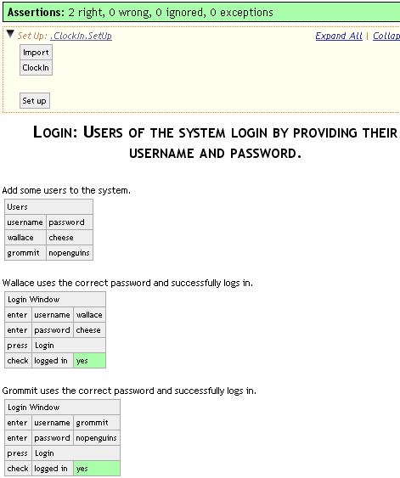
Figure 1-4. TestLogin specification passing
More Specifications
Of course this is not the only specification. For the first iteration of the ClockIn application, 4 specifications were given to the developers. They are listed on the ClockIn page in the wiki.
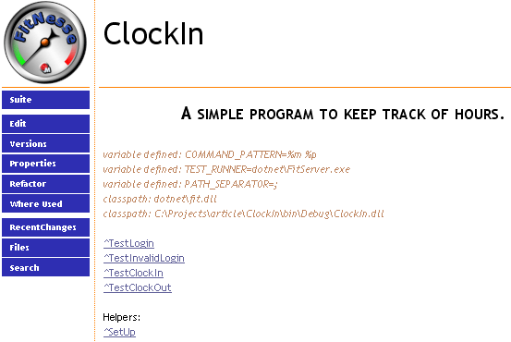
Figure 1-5. ClockIn page in final state
There’s a test to specify the behavior of failed logins, one for clocking in, and another for clocking out. All of these tests are grouped together in the same hierarchy and the ClockIn page has the Suite property turned on. This means that we can run all the tests by pressing the “Suite” button on the ClockIn page.
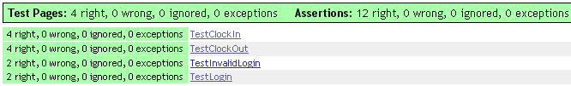
Figure 1-6. Suite results

end
If Possible:

<target name="ats" description="runs FitNesse tests">
<copy file="fitnesse\dotnet\TestRunner.exe"
tofile="ClockIn\bin\Debug\TestRunner.exe"/>
<copy file="ClockIn_test.config"
tofile="ClockIn\bin\Debug\TestRunner.exe.config"/>
<exec program="ClockIn\bin\Debug\TestRunner.exe"
resultproperty="EXITCODE">
<arg value="-v"/>
<arg value="-nopaths"/>
<arg value="-results"/>
<arg value="CornerStone.results"/>
<arg value="localhost"/>
<arg value="8085"/>
<arg value="ClockIn"/>
<arg value="ClockIn\bin\Debug\fit.dll"/>
<arg value="ClockIn\bin\Debug\Fixtures.dll"/>
</exec>
</target>

Notes on Figures
See O’Reilly’s guidance on illustrations here:
http://ora-design.ora.com/illus_dept/!author.html
Basically that breaks down to: check for Moire patterns on your scrollbars (directions on that link), use the best monitor you have, and don’t convert or otherwise fool with the format.
NOTE: do not resize graphics in the Word files. Just insert them full-sized and the smart folks at O’Reilly will handle getting them properly sized on the page.
Please use the following format for figure filenames: “wdpt-ch4-xsd1-opening.png” where “wdpt” is the prefix for our book’s title (Windows Developer Power Tools), “ch4” is the chapter number for the article you’re working on, and “xsdl-opening.png” is the name of the tool you’re writing on plus a sensible label for what’s being shown.
Please fill out the List Of Figures file as shown in the example in that file.
Figure 1-7. Figures get inserted using the “Figure With Caption” on the Oreilly Tools widget

NOTES FOR INDEX
Please help the book have a killer index. Collect all terms you think should be added into an index and consolidate them in a separate text file. Include terms for tools, major framework classes you might use, concepts (“cyclomatic complexity” or “mathematical differentiation”), or any terms you would like to see in a good index.

NOTES ON LISTS
- Use the O’Reilly toolbar for lists
- This one is a bullet list.
- Duh.

NOTES ON CODE EXAMPLES
Code can’t be more than 85 characters per line. Paste in your example code, style it as “Code”, then select ORATools →Inspect→Check Code Line Lengths.
Also fix up any tabs in your code. Use ORATools →Repair→Replace Tabs With Spaces.

NOTES ON FORMATTING
Inline references to methods, classes, or any type of code-related stuff (GC.WaitForPendingFinalizers(), for example) must be formatted as “Literal” using Alt-L,C.
Filenames, directories, applications all get formatted as Technical Italic. For example: ExcelXmlWriter.Generator.exe is a filename.

Usage
Ok, so the user can setup and run the tool… how do they actually use it in their everyday life? Make workflow recommendations, tips, tricks, things that make this a compelling tool.
This doesn’t need to be specifically titled “Usage.” Something like “Using the Metrics” or “Creating a Project” is fine, especially if there are several distinct steps for a tool.

See Also
Reference to other similar topics in the book.

Support
Lay out where the tool is supported. Note whether the tool is stabile, beta, alpha, etc. Also note whether development on the tool is stale or active. Wrap this part into the summary.

Summary
This should be your general statement on the tool, kind of like a elevator speech. Cover any Pros and Cons that were not already mentioned in the article as well as any thoughts on the future development of the tool.

Other notes:
- Figures: see O’Reilly’s guidance for making screenshots at http://ora-design.ora.com/illus_dept/!author.html. Basically save everything in unaltered, untweaked PNG format.
- Figure naming: use this convention for filenames: “wdpt-ch8-crmetrics-first-window.png”. That’s “wdpt” for Windows Developer Power Tools, the chapter, the tool name, and something descriptive of the shot.
- Index terms: keep a list of terms from your article you’d like to see in the index. At a minimum, list all tools, framework classes, critical concepts. Think of stuff YOU would look for in the index.

