

**Adv Web Application Dev**

**Lab02**

**By**

**Sannihith**

**Results**

1. **Addition: 2+2**

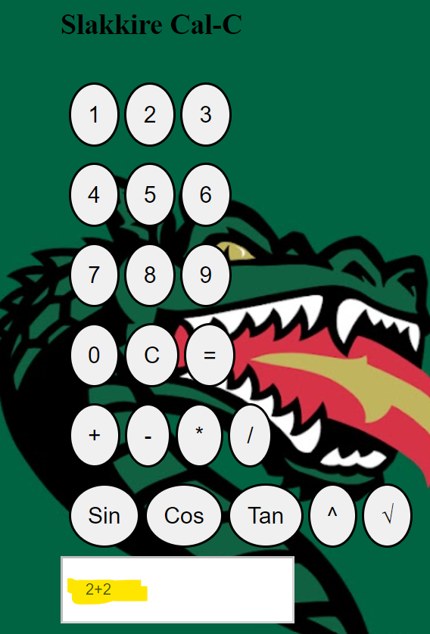

**Result:**

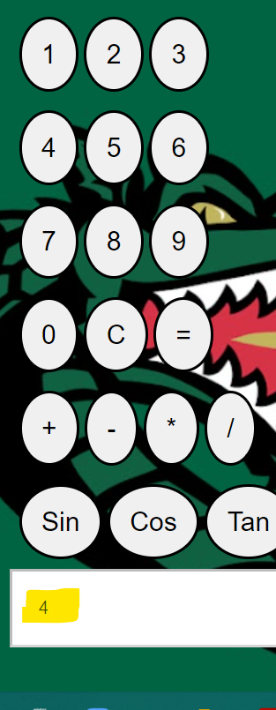

1. **Subtraction: 5-4**

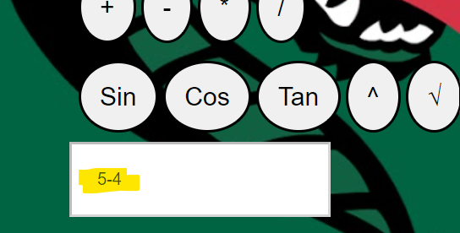

**Result:**

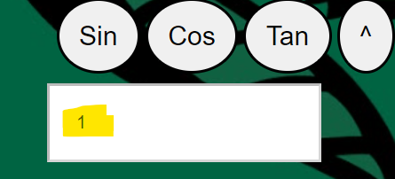

1. **Multiplication: 5*5**

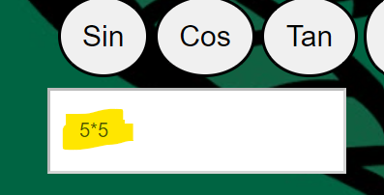

**Result:**

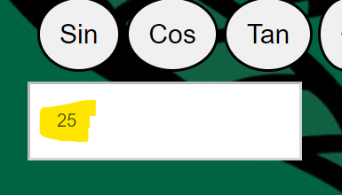

1. **Division:**

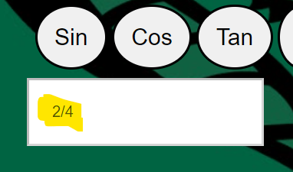

**Result:**

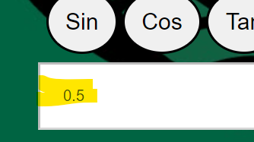

**Reference:** [**https://www.geeksforgeeks.org/html-calculator/**](https://www.geeksforgeeks.org/html-calculator/)

[**https://www.makeuseof.com/build-a-simple-calculator-using-html-css-javascript/**](https://www.makeuseof.com/build-a-simple-calculator-using-html-css-javascript/)

[**https://www.javatpoint.com/html-calculator**](https://www.javatpoint.com/html-calculator)

[**https://www.youtube.com/watch?v=QS6Y0ezhyCs**](https://www.youtube.com/watch?v=QS6Y0ezhyCs)