NewSystem — Detailed ERD & Data Dictionary v1.0
Reference: NewSystem Master PRD v1.0 | Date: 10 Oktober 2026 | Status: Conceptual/logical schema, not production DDL.

1. Architecture and non-negotiable invariants
PostgreSQL modular-monolith baseline. Shared DB is not shared ownership: each domain owns writes. Cross-domain references use stable UUIDs and policy-checked API/query contracts; foreign keys are enforced inside ownership boundaries and cross-context references are checked at command layer or through replicated read models. Database physical schema, partitions, and accounting policy require technical review before migration.
Every tenant business row carries tenant_id/organization_id (except global platform metadata); legal entity scope determines financial books and payroll; plant scope determines operations. Use bigint/numeric for monetary and quantity arithmetic, never binary floating point. Times stored UTC with explicit plant timezone. Include created_at, updated_at, created_by, row_version, source_system where applicable.

2. Conceptual ER diagrams (editable Mermaid)

ERD-01: Core
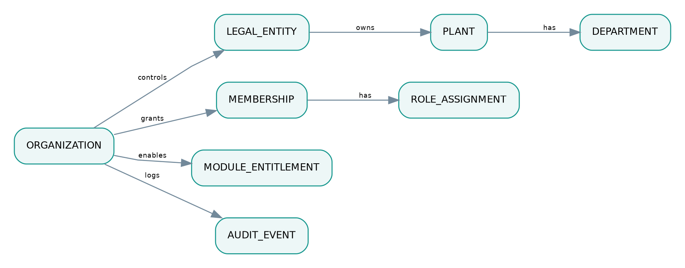
Diagram preview — editable Mermaid source included in package.

ERD-02: Crm To Erp
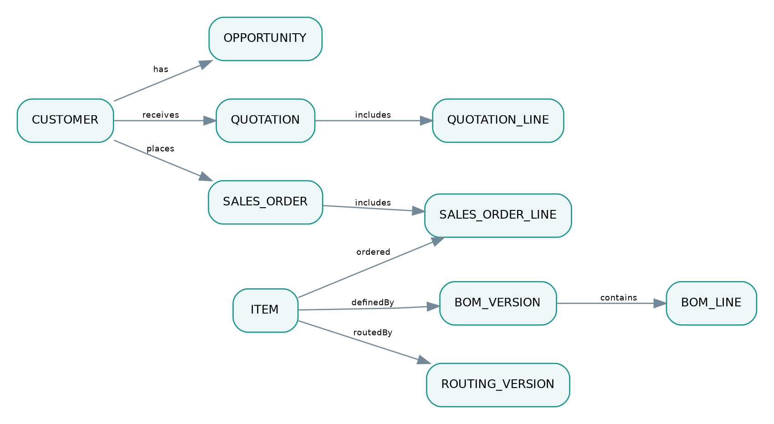
Diagram preview — editable Mermaid source included in package.

ERD-03: Inventory
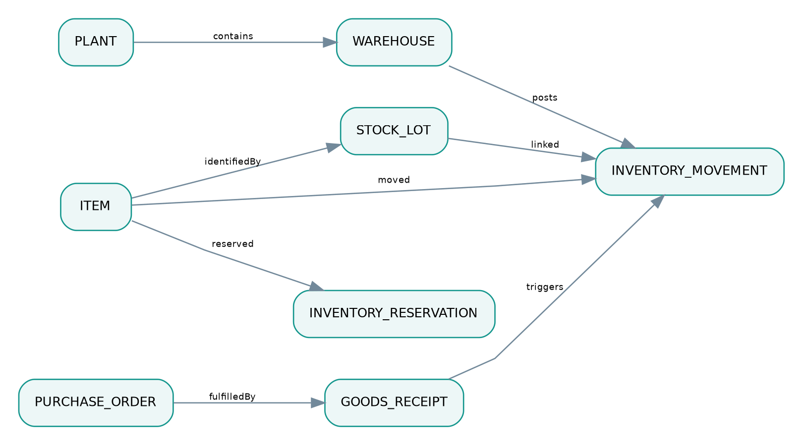
Diagram preview — editable Mermaid source included in package.

ERD-04: Production Quality
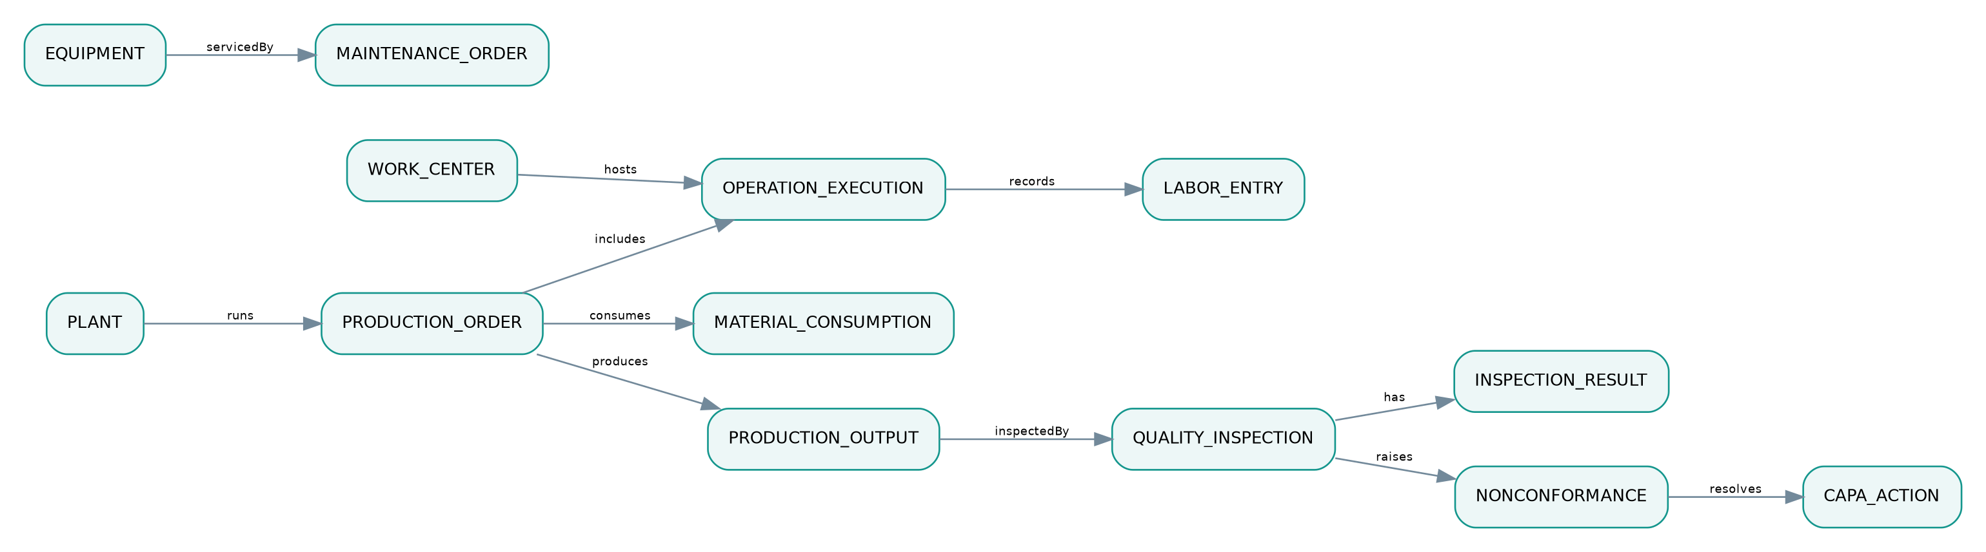
Diagram preview — editable Mermaid source included in package.

ERD-05: Hris Finance
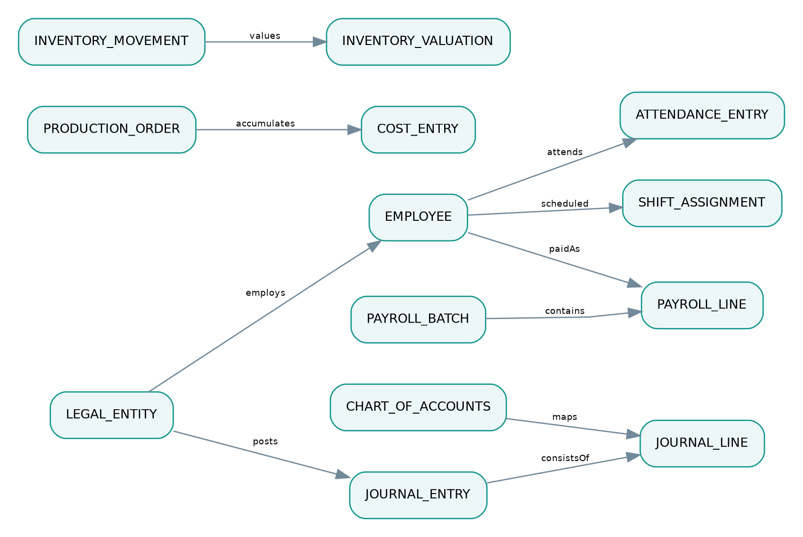
Diagram preview — editable Mermaid source included in package.

ERD-06: Workspace Ai
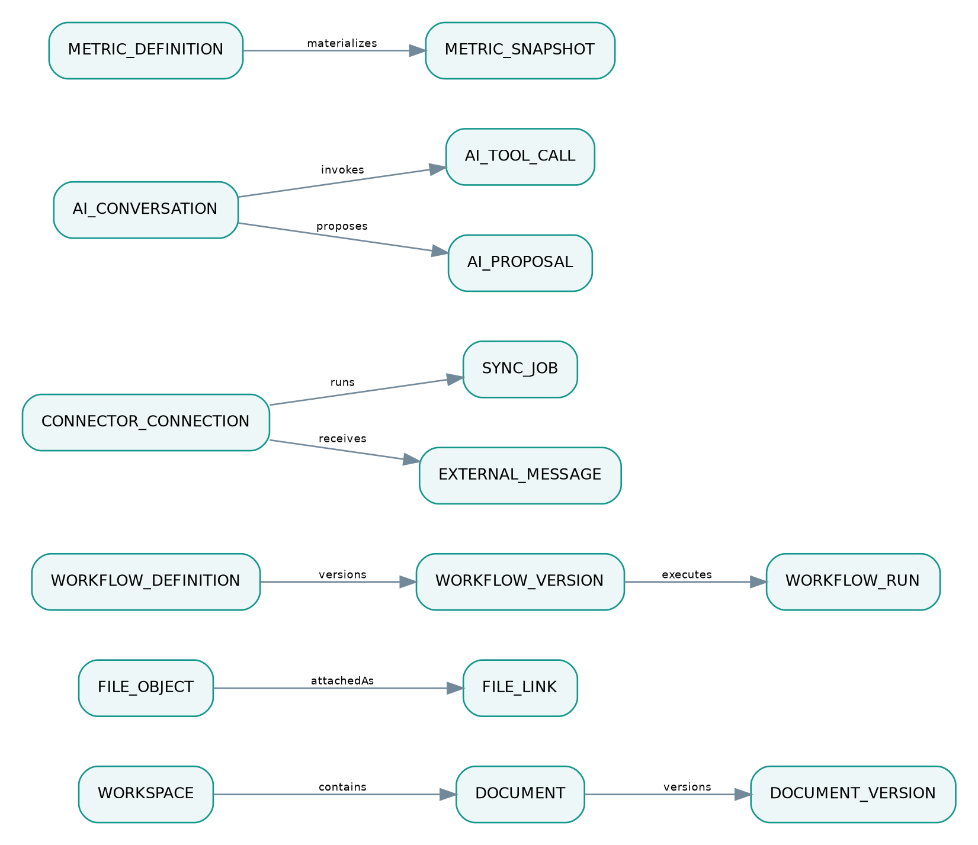
Diagram preview — editable Mermaid source included in package.

Context: CORE — Organization, roles and tenancy
Entity/table | Required fields (not exhaustive) | Key constraints and rules
organization | id, name, status | UNIQUE(slug); tenant root
legal_entity | id, organization_id, company_name, currency, tax_country | FK organization; accounting boundary
plant | id, legal_entity_id, code, timezone, mode_config | UNIQUE(entity_id,code)
department | id, plant_id, parent_id, code | recursive tree
membership | id, organization_id, user_id, employment_ref | UNIQUE(org,user)
role_assignment | id, membership_id, role_id, scope_type, scope_id | scope-bound grants
permission_policy | id, organization_id, resource, action, rule_version | explicit deny overrides grants
module_entitlement | id, organization_id, module_code, plan_code, effective_from | dependency validation
audit_event | id, organization_id, actor_id, resource, action, occurred_at | append only

Context: CRM — Customer-to-order
Entity/table | Required fields (not exhaustive) | Key constraints and rules
customer | id, organization_id, legal_entity_id, account_code | tenant-scoped customer
contact | id, customer_id, email, role | PII access policy
lead | id, customer_id?, owner_id, source, status | customer nullable until conversion
opportunity | id, customer_id, stage, amount, probability | pipeline stages versioned
quotation | id, customer_id, version, status, currency | immutable approved version
quotation_line | id, quotation_id, item_id, qty, unit_price | FK quotation
sales_order | id, quotation_id?, customer_id, entity_id, version, status | unique official number
sales_order_line | id, sales_order_id, item_id, qty, promised_date | allocation by line
customer_case | id, customer_id, order_ref?, status, severity | tickets and RMA link

Context: ERP — Planning, procurement and warehouse
Entity/table | Required fields (not exhaustive) | Key constraints and rules
item | id, organization_id, sku, kind, base_uom | unique SKU tenant
item_uom_conversion | id, item_id, from_uom, to_uom, factor | factor > 0
bom_version | id, item_id, version, status, effective_from | approved snapshot
bom_line | id, bom_version_id, component_item_id, qty, scrap_pct | qty > 0
routing_version | id, item_id, version, status | approved routing
routing_operation | id, routing_version_id, work_center_type, sequence, standard_time | unique sequence by routing
warehouse | id, plant_id, code, type | UNIQUE(plant,code)
stock_lot | id, item_id, lot_no, expiry_at?, qms_status | expiry optional
stock_balance | id, warehouse_id, item_id, lot_id?, quantity | derived/materialized only
inventory_movement | id, tenant_id, item_id, lot_id?, from_location?, to_location?, qty, txn_id | append-only posted ledger
inventory_reservation | id, demand_ref, item_id, lot_id?, qty, status | cannot exceed allocatable stock
purchase_request | id, entity_id, requestor, status | approved policy
purchase_order | id, entity_id, supplier_id, status, version | official sequence
goods_receipt | id, purchase_order_id, warehouse_id, received_at | no stock until posted

Context: MES — Production execution
Entity/table | Required fields (not exhaustive) | Key constraints and rules
production_order | id, plant_id, item_id, plan_qty, status, bom_snapshot, routing_snapshot | snapshot on release
work_center | id, plant_id, code, capacity_group | capacity calendar
operation_execution | id, work_order_id, routing_operation_ref, work_center_id, status, good_qty, reject_qty | qty >=0
labor_entry | id, operation_id, employee_id, start_at, end_at, labor_minutes | link to HRIS identity
material_consumption | id, work_order_id, movement_id, item_id, lot_id, qty | FK inventory movement
production_output | id, work_order_id, item_id, lot_id, qty, candidate_status | QMS gate before available
equipment_downtime | id, equipment_id, operation_id?, begin_at, end_at?, reason | time validity

Context: QMS_CMMS — Quality & maintenance
Entity/table | Required fields (not exhaustive) | Key constraints and rules
inspection_plan | id, item_id, revision, inspection_type, acceptance_rule | versioned plan
quality_inspection | id, plant_id, lot_ref, source_ref, status, inspector_id | independent disposition
inspection_result | id, inspection_id, characteristic, observed_value, passed | tolerance bound
quality_hold | id, item_id, lot_id, qty, placed_by, status | locks inventory allocation
nonconformance | id, plant_id, source_ref, severity, status | traceable NCR
capa_action | id, ncr_id, owner, due_at, effectiveness_status | approval and follow-up
equipment | id, plant_id, code, work_center_id?, condition | unique plant equipment code
maintenance_order | id, equipment_id, type, status, released_by | safety release required
maintenance_part | id, maintenance_order_id, movement_ref, qty | inventory link

Context: HRIS — People & payroll
Entity/table | Required fields (not exhaustive) | Key constraints and rules
employee | id, entity_id, employee_no, status, pii_ref | restricted PII
employment_contract | id, employee_id, version, effective_from, pay_grade_ref | restricted
shift_definition | id, plant_id, code, starts_at, ends_at | timezone aware
shift_assignment | id, employee_id, shift_id, scheduled_date, status | competence check
attendance_entry | id, employee_id, clock_in, clock_out, source | approval for edit
leave_request | id, employee_id, leave_type, status, days | balance policy
overtime_request | id, employee_id, shift_ref, minutes, approval_id | approved minutes
payroll_batch | id, entity_id, period, status, journal_ref? | no silent recalc after finalized
payroll_line | id, batch_id, employee_id, gross, deductions, net | restricted; masked reporting
competency_record | id, employee_id, competency_code, expires_at | eligibility to work center

Context: ACCOUNTING — Financial system of record
Entity/table | Required fields (not exhaustive) | Key constraints and rules
chart_of_accounts | id, entity_id, code, account_type, active | unique COA code entity
fiscal_period | id, entity_id, starts_at, ends_at, locked | closed prevents posting
journal_entry | id, entity_id, period_id, status, source_ref, posted_at | unique source posting
journal_line | id, journal_id, account_id, debit, credit, cost_center_id | sum debit=sum credit
ar_invoice | id, sales_order_id?, entity_id, status, due_at, version | unique invoice number
ap_bill | id, purchase_order_id?, supplier_id, status | 3-way-match
payment | id, entity_id, account_id, amount, state | bank reconcile
inventory_valuation | id, movement_id, item_id, value, valuation_method | reconcile to GL
cost_entry | id, work_order_id, cost_type, source_ref, amount | planned/actual/final status
fixed_asset | id, entity_id, cost, depreciation_policy | period close policy
tax_document | id, entity_id, invoice_ref, external_status | official provider integration

Context: WORKSPACE_CONNECT — Documents, automation & external systems
Entity/table | Required fields (not exhaustive) | Key constraints and rules
workspace | id, organization_id, scope_type, scope_id | ACL shared/personal
document | id, workspace_id, business_ref?, classification, status | authoritative document key
document_version | id, document_id, version_no, object_key, checksum, final_flag | final version immutable
file_object | id, tenant_id, storage_backend, object_key, mime_type, scan_status | ACL required
file_link | id, file_id, resource_type, resource_id | cross-domain pointer
workflow_definition | id, organization_id, name, latest_version | version controlled
workflow_version | id, definition_id, version, published_at?, config | validated schema
workflow_run | id, workflow_version_id, correlation_id, status | retry/idempotent
approval_request | id, resource_ref, approver_scope, status | SoD check
connector_connection | id, tenant_id, provider, scopes, secret_ref, status | secrets outside DB
sync_job | id, connection_id, cursor_ref?, status, retry_count | checkpoint/duplicate defense
external_message | id, connection_id, provider_message_id, thread_ref, safe_content_ref | untrusted by default

Context: AI_ANALYTICS — Business intelligence and controlled AI
Entity/table | Required fields (not exhaustive) | Key constraints and rules
metric_definition | id, tenant_id, code, formula_version, grain | governed semantic layer
metric_snapshot | id, metric_id, scope_ref, as_of_at, value, source_watermark | explicit data freshness
knowledge_index_ref | id, source_file_id, acl_version, indexed_at | retrieval permission check
ai_conversation | id, tenant_id, user_id, scope_json, retention_policy | scoped access
ai_tool_call | id, conversation_id, tool, policy_decision, result_ref | audit and SoD
ai_proposal | id, conversation_id, command_type, payload_hash, risk_tier, status | approved execution only
forecast_run | id, metric_id, model_version, training_window, error_metric | baseline comparison
integration_outbox | id, producer_domain, aggregate_id, event_type, event_id, committed_at | atomic outbox
integration_inbox | id, consumer_domain, event_id, processed_at | UNIQUE(consumer,event_id)

3. Shared keys, references and cardinality
- organization_id is the tenant partition boundary. A legal_entity_id belongs to exactly one organization; a plant belongs to one legal entity in a given effective period.
- Document attachment uses file_link(resource_type, resource_id) plus application-level validation; no unsafe cross-tenant references.
- Production order has bom_snapshot_id and routing_snapshot_id (or embedded immutable snapshots) to avoid retroactive changes.
- Source references on financial postings include source_type + source_id + source_line_id + posting_rule_version, with uniqueness preventing duplicate source posting.
- Lots can be consumed into multiple output lots and output lots can use multiple input lots: maintain a dedicated lot_genealogy_edge(input_lot_id, output_lot_id, quantity, conversion_process_ref) for N:M traceability.
- Where stock_balance exists, treat as derived/materialized state; stock ledger is authoritative. Use serialized movements or inventory availability locks for concurrent reservations.
- Separate planned vs actual vs reconciled cost snapshots and never present provisional value as final.

4. Ledger and posting rules
Ledger / store | Immutable entry | Reconciliation
Inventory movement | Signed quantity per item/lot/location/source | Location on-hand = sum movements; holds/reservations separate
Manufacturing costing | Cost source + allocation basis + revision | Work order cost and inventory valuation bridge
Journal | Balanced debit/credit lines; currency/fx/period | Debits = credits at journal, entity and period
Workflow execution | State transitions, retry, attempts | One logical job and at-most-one business mutation
Document versions | Binary hash + approved metadata | Finalized version byte hash stable
AI action ledger | Proposal, approval, typed tool, execution receipt | Action ties to approving human and business record

5. Critical constraints / indexes
-- Schematic; adapt schema names, partial indexes and permissions before execution.
CREATE UNIQUE INDEX ux_inbox_event ON integration_inbox(consumer_domain, event_id);
CREATE UNIQUE INDEX ux_business_idempotency ON command_receipt(organization_id, domain_code, idempotency_key);
CREATE UNIQUE INDEX ux_item_sku ON item(organization_id, sku);
CREATE UNIQUE INDEX ux_plant_code ON plant(legal_entity_id, code);
CREATE UNIQUE INDEX ux_document_version ON document_version(document_id, version_no);
-- Revenue / PO / payroll official number unique by legal entity + fiscal scope.
-- CHECK(quantity >= 0) on operation reports, reservations and QC portions where applicable.
-- CHECK(debit >= 0 AND credit >= 0) on GL journal lines; sum debits/credits in atomic posting routine.

6. Deletion, retention and privacy
Soft deletion only for non-posted reference records; legal and financial records use policy-controlled retention and reversals. Payroll PII encryption and scoped access, audit and break-glass workflow. External file deletion must not invalidate official archived byte snapshot and checksum. For tenant deletion and portability, define export and legal hold prerequisites.

7. Transaction boundary guidelines
- ERP Inventory: stock posting atomic with quantity ledger and outbox record.
- Accounting: journal posting atomic with journal lines, source uniqueness and outbox.
- MES: operation completion and material issue may need distinct verified commands; do not assume distributed atomicity.
- Workflow/AI: never directly update another domain's tables; send typed authorized commands.
- Analytics: consume domain events with watermark, data freshness and reconciliation queries.

8. Recommended migration and test plan
- Create core tenant + company/plant and RBAC schemas with tenant isolation tests.
- Create shared item/UOM and CRM order schemas.
- Implement inventory and financial ledger constraints before any UX bulk mutation.
- Implement MES production snapshots/lot genealogy and QMS disposition.
- Introduce HR payroll and accounting clearing reconciliation tests.
- Introduce DMS/Connect/Automation and idempotent outbox workers.
- Introduce AI/BI semantic read models with row-level/attribute-level authorization and red-team tests.

9. Open design decisions
- PostgreSQL RLS + app RBAC combined policy design and DB role separation.
- Lot/serial allocation grain per vertical and intercompany inventory ownership.
- Costing policy (weighted average, FIFO, standard cost variance), valuation timing and overhead rates.
- Consolidation multi-currency and legal entity tax reporting policy.

