NewSystem — Detailed UML Specification v1.0
Reference: NewSystem Master PRD v1.0 | Date: 10 Oktober 2026 | Status: Pre-implementation design, subject to architecture sign-off.

1. Design intent & notation
UML here is a modeling contract, not executable code. Diagrams use editable Mermaid syntax. Commands mutate the owning domain; events announce committed changes; queries are permission-filtered. All state transitions are server-authoritative. Trace IDs and tenant/entity/plant scopes must propagate end-to-end.

2. Use-case catalogue
ID | Actor | Use case | Owning suites | Security / invariant
UC-01 | Owner/CEO | Choose company/plant and view consolidated KPIs | Core, BI | Scope-filtered KPIs only; finance data by legal entity
UC-02 | Tenant Admin | Activate industry pack, production mode, and module entitlement | Core | Prerequisites met before activation
UC-03 | Sales | Create quotation, request ATP/CTP, confirm order | CRM, ERP | Confirmation reserves approved commercial version
UC-04 | PPIC | Net material requirements and release work orders | ERP, MES | BOM/routing snapshot immutable after release
UC-05 | Purchasing | Create PR, approve RFQ comparison, issue PO | ERP, Workflow | Maker-checker and spending limits
UC-06 | Warehouse | Receive, put away, reserve, transfer and issue lots | ERP Inventory | Posting exactly-once by idempotency key
UC-07 | Operator | Start/pause/complete assigned job card | MES | Only assigned plant/work center; duplicate output rejected
UC-08 | QC Inspector | Inspect, hold, reject, release/rework | QMS | No shipment of held stock; SoD release
UC-09 | Maintenance | Record breakdown, repair, test, release equipment | Maintenance | Safe machine release approval
UC-10 | HR Manager | Manage employment/shift/leave/payroll | HRIS | Confidential PII separated from MES
UC-11 | Finance | 3-way-match AP, post GL, AR, close periods | Accounting | Balanced journals, locked periods immutable
UC-12 | Department Admin | Configure workflow rules/forms and publish versions | Automation | Simulate + approve before activation
UC-13 | Employee | Create or upload business documents/files | Workspace | DMS ACL, malware scan, versioning
UC-14 | Document Approver | Approve and finalize official document | Workspace | Final version immutable; authority check
UC-15 | Integration Admin | Authorize email/Drive/OneDrive and map fields | Connect | Least-privilege OAuth; health/audit
UC-16 | Module Copilot User | Ask, analyze, simulate, create drafts | AI | Permission-aware retrieval and tool use
UC-17 | CEO/Authorized Manager | Ask Company Copilot for cross-suite diagnosis | AI, BI | Entity scope, data freshness, auditable evidence
UC-18 | Platform Ops | Provision tenant, monitor platform health | Control Center | No default tenant business-data access

UML actor-to-domain view
flowchart LR
CEO[Owner / CEO] --> BI[Company AI & BI]
SALES[Sales] --> CRM[CRM & Sales Orders]
PPIC[PPIC] --> ERP[ERP Planning / Inventory]
OP[Operator] --> MES[MES Shop Floor]
QC[QC Officer] --> QMS[QMS]
HR[HR Manager] --> HRIS[HRIS]
FIN[Finance] --> ACC[Accounting]
ADMIN[Org Admin] --> CORE[Core & Workflow]
ALL[Authorized Users] --> DMS[Workspace & Connect]
BI --> CORE
CRM --> ERP
ERP --> MES
MES --> QMS
QMS --> ACC
HRIS --> ACC
DMS --> CORE

3. Key UML class / aggregate diagram
classDiagram
class Organization {+uuid id; +string name; +status}
class LegalEntity {+uuid id; +currency; +taxRegion}
class Plant {+uuid id; +productionModes[]}
class Item {+uuid id; +sku; +uom}
class BOMVersion {+uuid id; +version; +approvalStatus}
class RoutingVersion {+uuid id; +version; +operations}
class SalesOrder {+uuid id; +status; +revision}
class ProductionOrder {+uuid id; +status; +bomSnapshotId; +routingSnapshotId}
class OperationExecution {+uuid id; +actualQty; +actualTime; +status}
class InventoryMovement {+uuid id; +quantity; +lotId; +postingState}
class Inspection {+uuid id; +disposition; +evidence}
class CostEntry {+uuid id; +type; +amount; +sourceRef}
class JournalEntry {+uuid id; +periodId; +postedAt}
class DocumentVersion {+uuid id; +sha256; +finalizedAt}
Organization "1" --> "*" LegalEntity : controls
LegalEntity "1" --> "*" Plant : operates
Item "1" --> "*" BOMVersion : definedBy
Item "1" --> "*" RoutingVersion : routedBy
SalesOrder "0..1" --> "*" ProductionOrder : drives
ProductionOrder "1" --> "*" OperationExecution : tracks
ProductionOrder "1" --> "*" InventoryMovement : references
ProductionOrder "1" --> "*" Inspection : checkedBy
ProductionOrder "1" --> "*" CostEntry : accumulates
CostEntry "*" --> "0..1" JournalEntry : accountedIn
SalesOrder "1" --> "*" DocumentVersion : generatedDocs

4. State models and guarded transitions
Each transition requires explicit actor permission, expected resource version, validation, and audit. An event is published only after persistence succeeds.

4.1 Sales Order
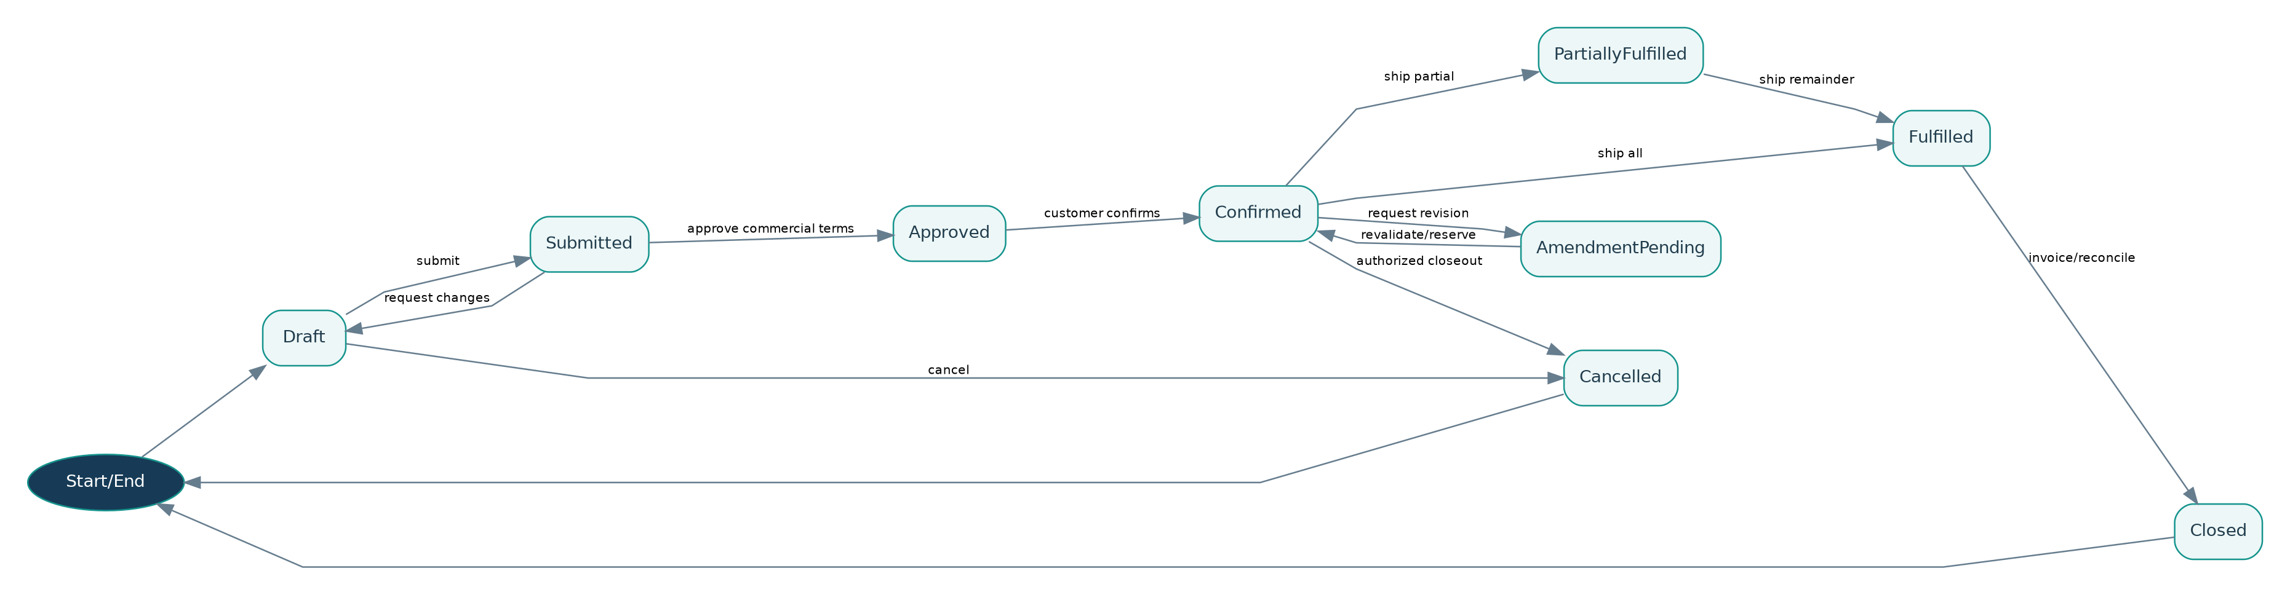
Diagram preview — editable Mermaid source included in package.

4.2 Purchase Order
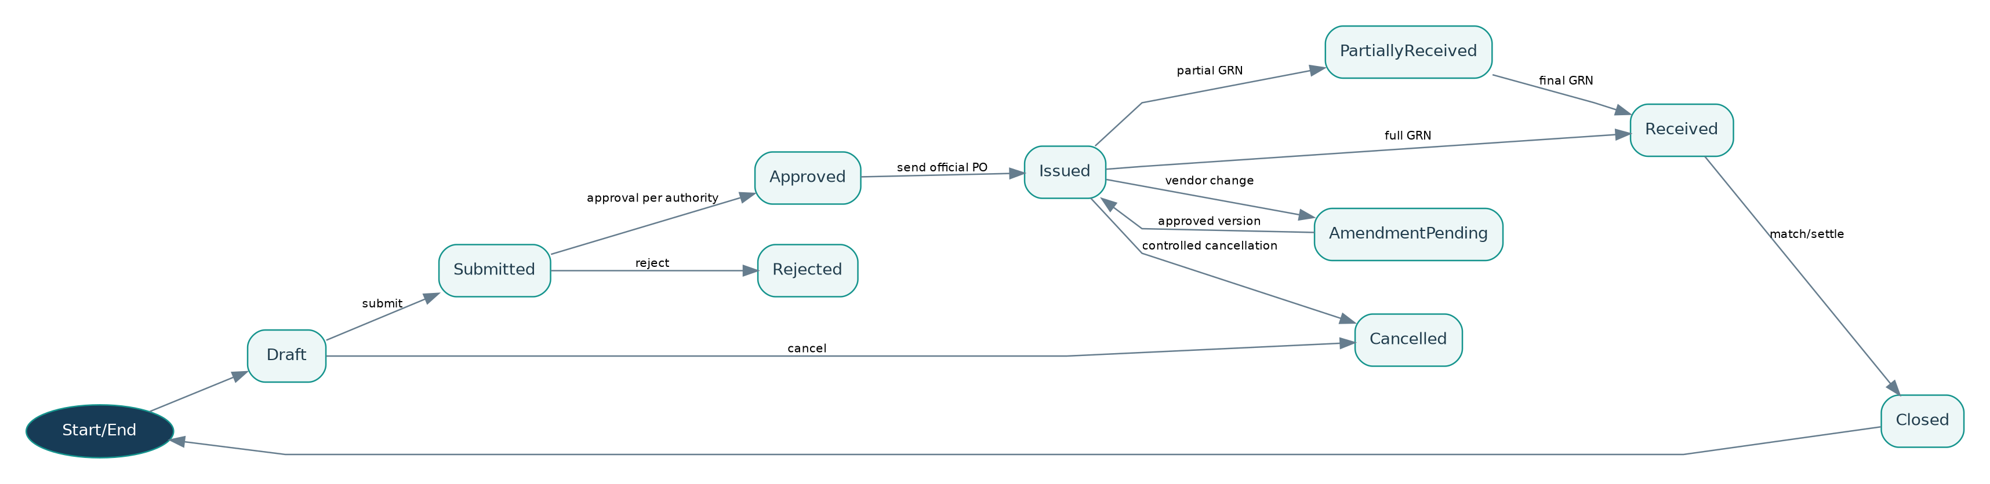
Diagram preview — editable Mermaid source included in package.

4.3 Production Order
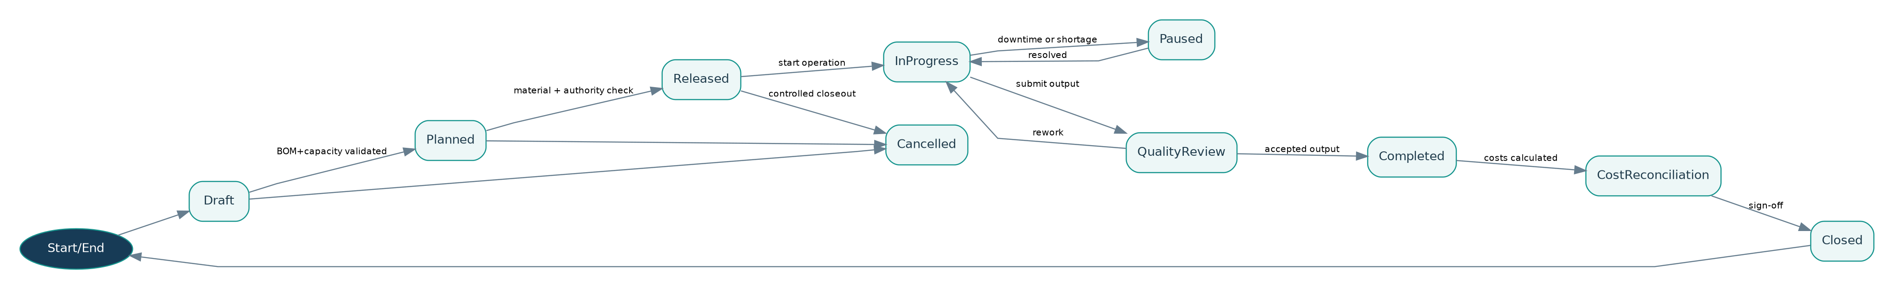
Diagram preview — editable Mermaid source included in package.

4.4 Invoice
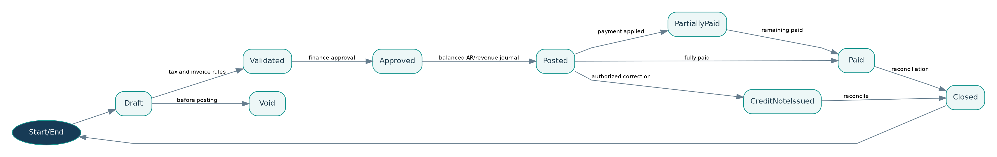
Diagram preview — editable Mermaid source included in package.

4.5 Workflow Version
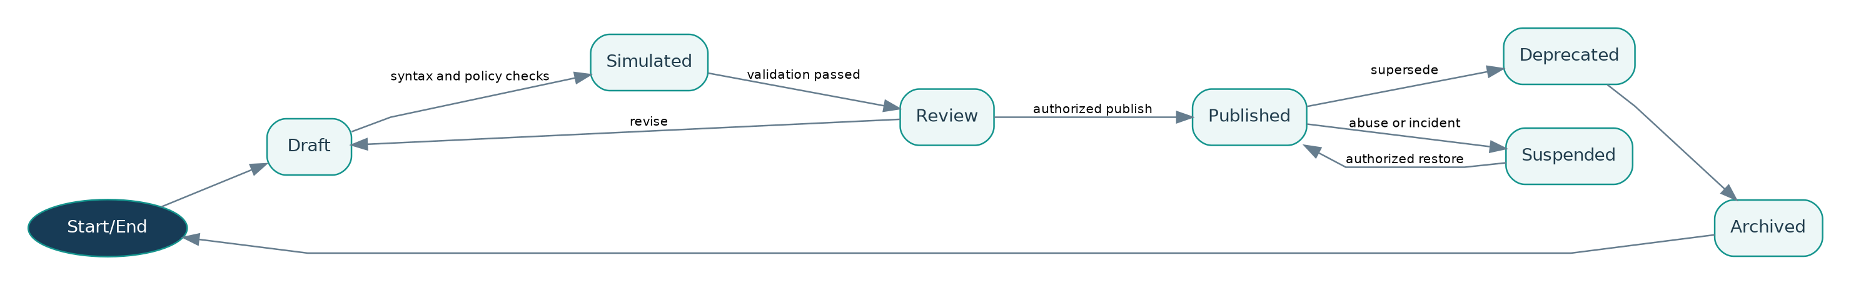
Diagram preview — editable Mermaid source included in package.

4.6 Official Document
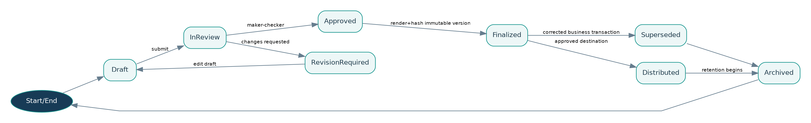
Diagram preview — editable Mermaid source included in package.

4.7 Offline Transaction
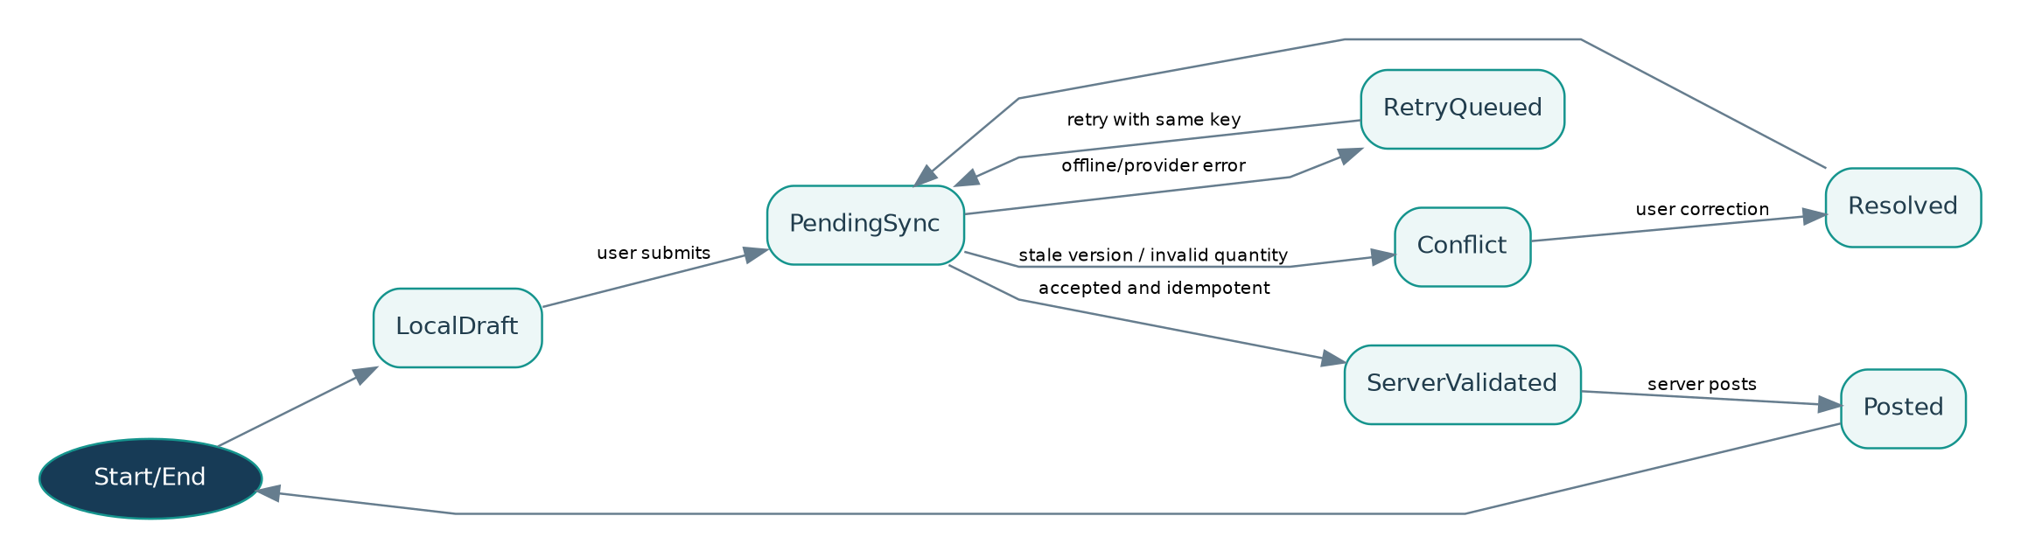
Diagram preview — editable Mermaid source included in package.

5. Sequence diagrams — boundary contracts

SQ-01 Lead-to-Cash
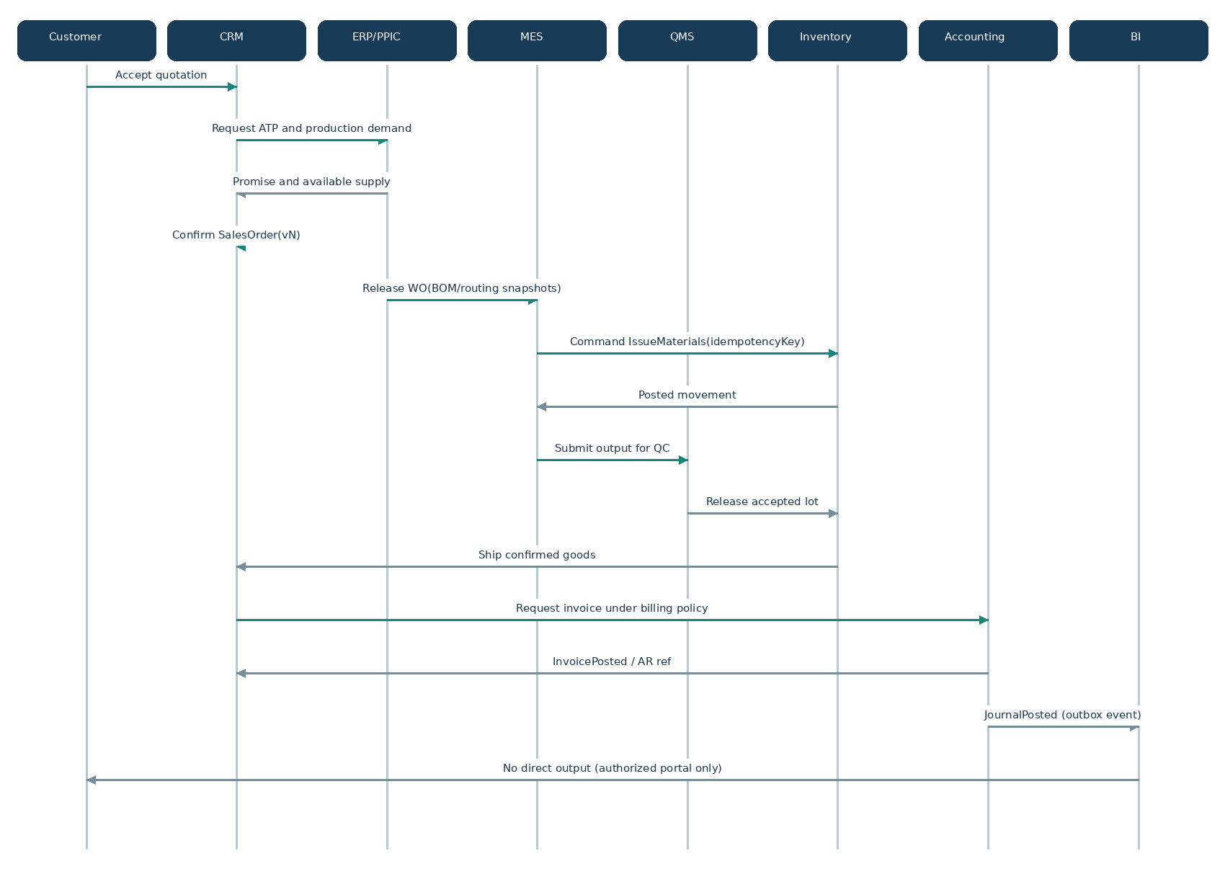
Diagram preview — editable Mermaid source included in package.

SQ-02 Procure-to-Pay
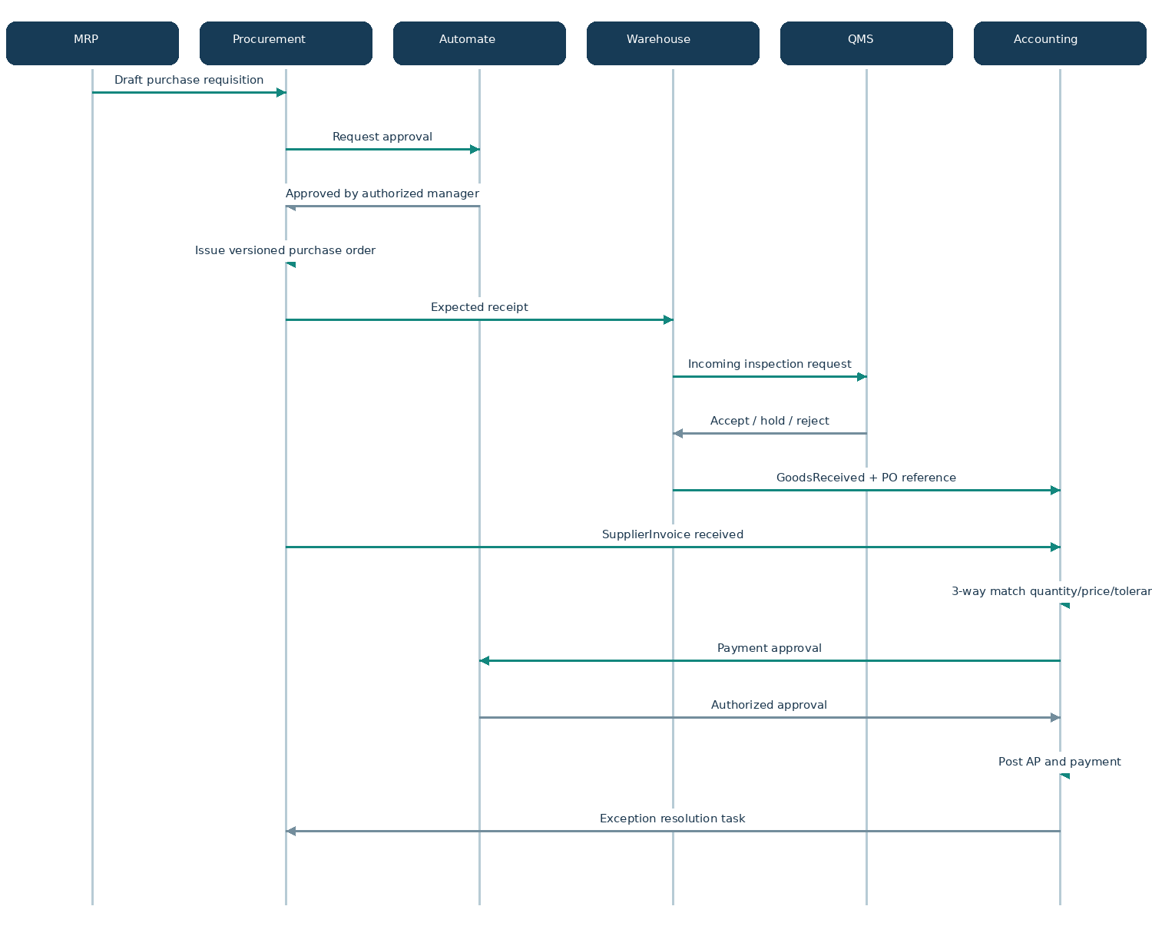
Diagram preview — editable Mermaid source included in package.

SQ-03 Plan-to-Produce
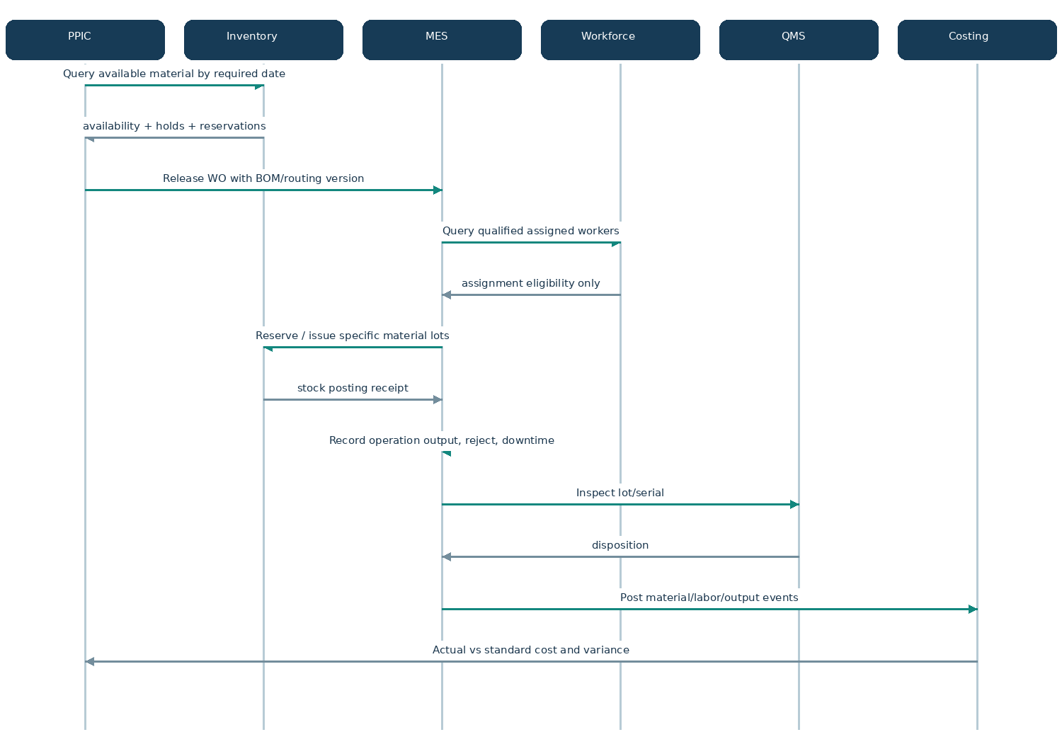
Diagram preview — editable Mermaid source included in package.

SQ-04 Hire-to-Payroll-to-Cost
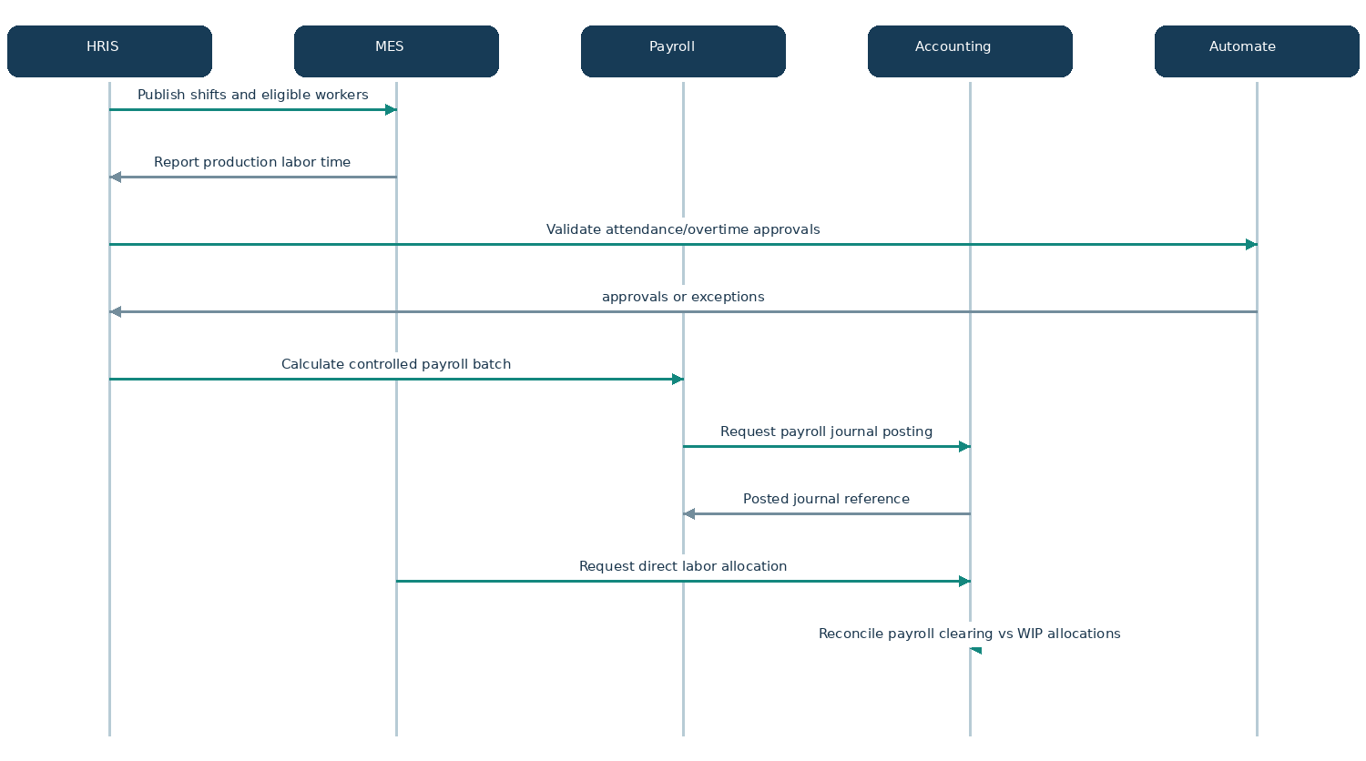
Diagram preview — editable Mermaid source included in package.

SQ-05 Official Document & Email
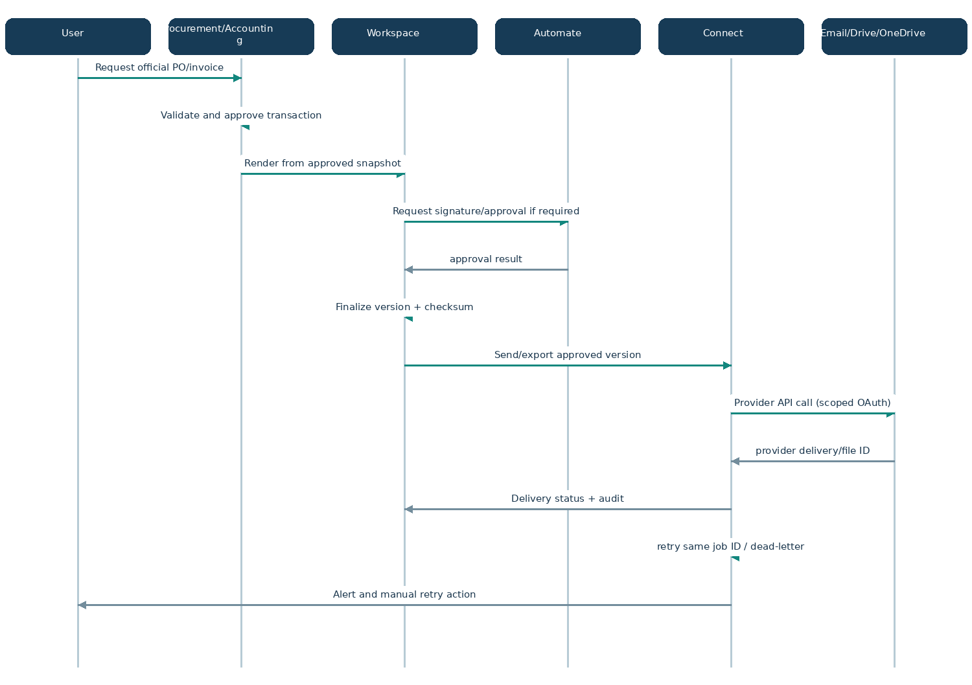
Diagram preview — editable Mermaid source included in package.

SQ-06 Email-to-Draft
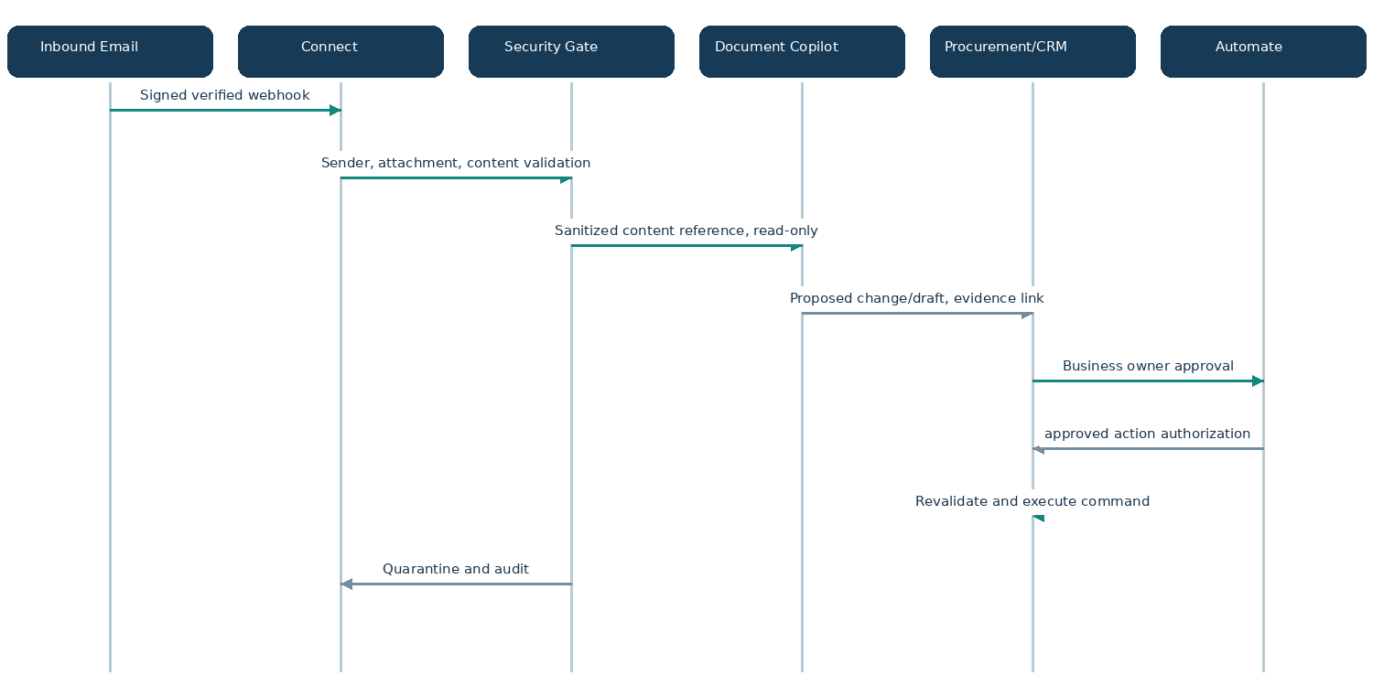
Diagram preview — editable Mermaid source included in package.

SQ-07 Company Copilot-to-Action
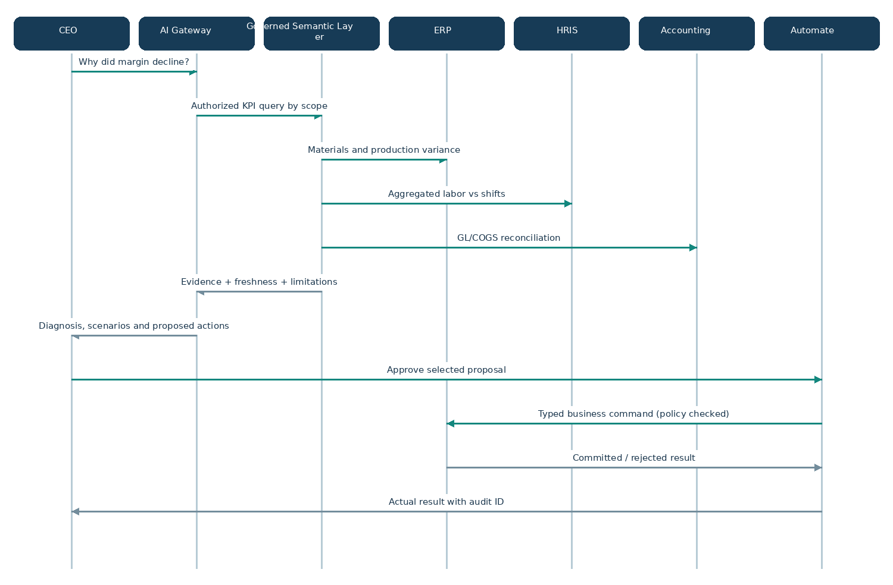
Diagram preview — editable Mermaid source included in package.

SQ-08 Offline Shop Floor Sync
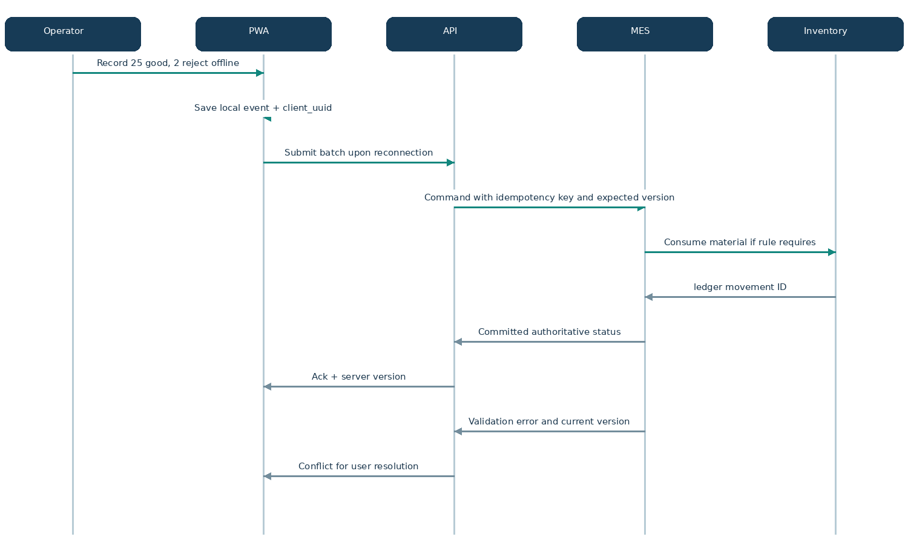
Diagram preview — editable Mermaid source included in package.

SQ-09 Breakdown-to-Recovery
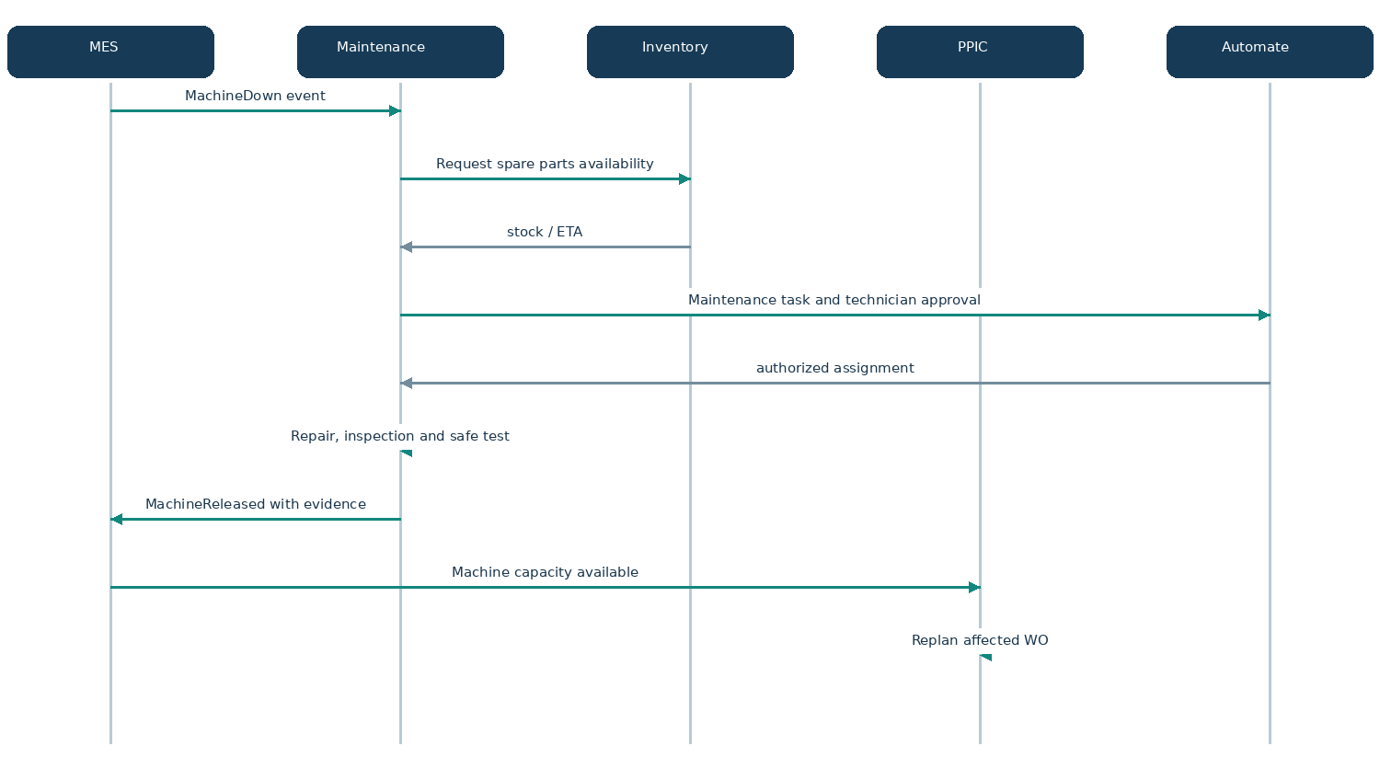
Diagram preview — editable Mermaid source included in package.

6. Failure and compensation patterns
Failure | Required behavior | Owning service | Recovery check
Event delivered twice | Inbox/event_id de-dup; same business result | Consumer domain | Posted stock, invoice or labor entry appears once
Long-running saga fails | Persist state and compensating steps; no partial hidden success | Automate orchestrator | Human-visible failed/compensated status
QC hold after output | Prevent allocation/shipment of affected quantity | QMS + Inventory | ATP excludes held stock
Sales order changed after WO release | Version amendment and impact analysis; never mutate WO snapshot silently | CRM + PPIC | Reconciliation of previous material reservation
Provider upload/email fails | Retry with same logical job; escalation and dead-letter | Connect | Official document remains finalized independent of delivery
Offline client repeats POST | Same client_uuid + expected version; server authoritative | MES API | Single output event and movement ledger
Payroll vs MES hours disagree | Attendance and production time differentiated; create variance task | HRIS + Finance | Clearing cost bridge reconciles
AI tool suggests restricted action | Deny at gateway and owner command boundary | AI + Core | Audit denied attempt; no mutation

7. Authorization sequence
Diagram preview — editable Mermaid source included in package.

8. Implementation checks
- No changes to inventory or GL through a UI-only field edit; require valid domain command.
- Post-once invariant enforced with unique idempotency keys scoped by tenant and action.
- Workflow and document versions never retroactively mutate approved resource snapshots.
- All AI actions receive a policy decision separate from natural-language model suggestions.
- Use-case coverage: UC-01..UC-18; end-to-end sequence coverage SQ-01..SQ-09; source process coverage BP-01..BP-10.

9. Open decisions for sign-off
- Precise states for production partial close and controlled cancellation (depends on costing policy).
- Customer billing milestones and Indonesian tax integration provider/approval model.
- Inventory valuation approach per legal entity and WIP reconciliation intervals.
- Ability to execute hybrid batch and discrete steps within one work order vs linked orders.

