## Introduction

For this WebInt project we choose to create a website where users can find and create cocktails recipe. We thought the website user-friendly and we axed the choice of the recipe on the ambience. We thought that the ambience is the main criterion for the choice of a cocktail, indeed you will not drink the same beverage during a party and on a beach for the holidays.

To do this we used HTML5, CSS and JavaScript. We added pictures and downloaded fonts.

Repartition of the work: Gabriel and Saad worked on the Home Page and the Mood Pages, Olivier worked on the Adding a cocktail Page.

Now, let’s move on each page of our website.

## The head banner

You can find this banner on each page. We create 8 buttons below the image:

* Home button: This button is use to come back on the home page.
* There are 7 buttons with different mood name: these buttons redirect on a page with all cocktails that contain cocktails related to the selected mood.

There is also two buttons to sign up/Login

There is the code here:

|  |
| --- |
| <**div** class="top-bar" style="text-align: center;">  <**button** type="button" class="index-btn">Make A Cocktail</**button**> </**div**> <**div** class="navbar">  <**a** href="./index.html">Home</**a**>  <**a** href="./Festive.html">Festive</**a**>  <**a** href="./Chill.html">Chill</**a**>  <**a** href="./Sexy.html">Sexy</**a**>  <**a** href="./After.html">After</**a**>  <**a** href="./Pre-Drinks.html">Pre-Drinks</**a**>  <**a** href="./Alternative.html">Alternative</**a**>  <**a** href="./categoryPage.html" class="add-nav">Add a Cocktail</**a**>  <**a** href="#Login" class="log">Login</**a**>  <**a** href="#Login" class="log">Sign Up</**a**> </**div**> |

## The Home Page

It is the index.html in our directory.

This is what it looks like:

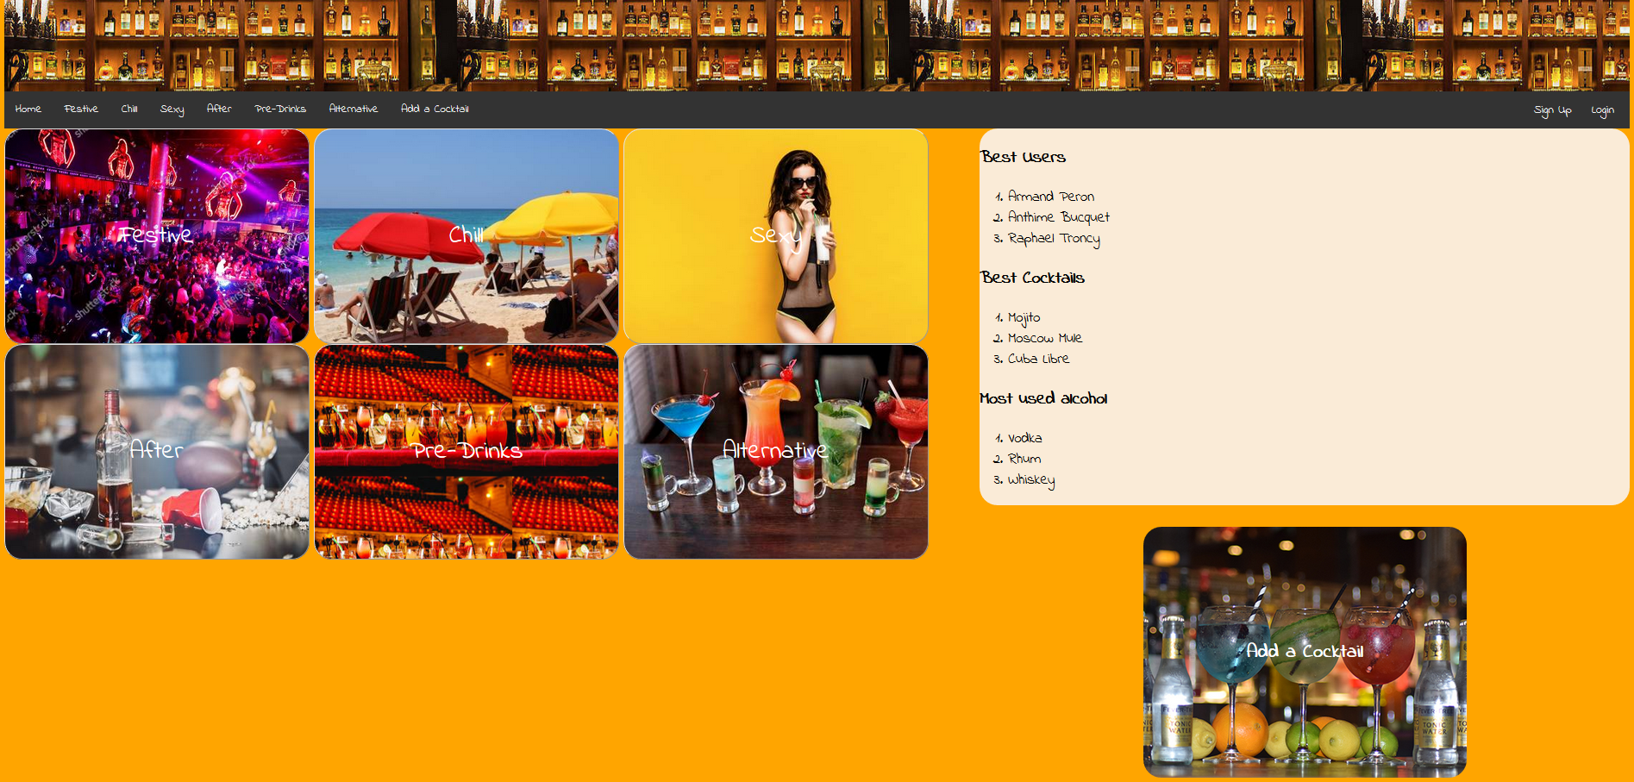

Each vignette on the left corresponds to a certain mood. These vignettes are actually buttons that redirects you to the page of the corresponding mood. On the right side, there is à collection of rankings and below there is another button that is a actually à link to the page for adding cocktails(categoryPage.html)

To give the images as background, we used the attribute background-image in the CSS file for each button.

As you can notice, this page is divided into two columns. To do this we had the following structure

|  |
| --- |
| <**div** class="row">  <**div** class="col-1">  mood vignettes here  </**div**>  <**div** class="col-2">  rankings here  </**div**> </**div**> <**div** class="row">  <**div** class="col-2">  button to go categoryPage.html  </**div**> </**div**> |

## The Adding a Cocktail Page

It is the categoryPage.html in our directory.

The user can edit his own recipe on this page, he has to select the acohol(s) and the soft beverage(s) that he wants to add. Then he can choose the glass that he wants to use.

To do this we use JavaScript for the choice of the glass. See the function below:

|  |
| --- |
| function showImage(loadingImage){  var hiddenImg = document.getElementById('glass').src=loadingImage;} |

And we call this function in the html, with the onclick argument. In the last div we set the default glass, we choose the Highball one because it is the most common one:

|  |
| --- |
| <**article**>  <**h3**>Now choose the glass:</**h3**>  <**div** class="container">  <**input** type="image" src="img/verreWhisky.jpg" class="imgGlasses" onclick=showImage('verreWhisky.jpg')>  <**input** type="image" src="img/verreMartini.jpg" class="imgGlasses" onclick=showImage("verreMartini.jpg")>  <**input** type="image" src="img/verreHighball.jpg" class="imgGlasses" onclick=showImage('verreHighball.jpg')>  </**div**>  <**div** class="container">  <**img** id = "glass" class="hid_img" src="img/verreHighball.jpg">  </**div**>  </**article**> |

## 

## The Mood Pages

These pages are similar to the index page in the same that they have the same structure in terms of columns and rows.

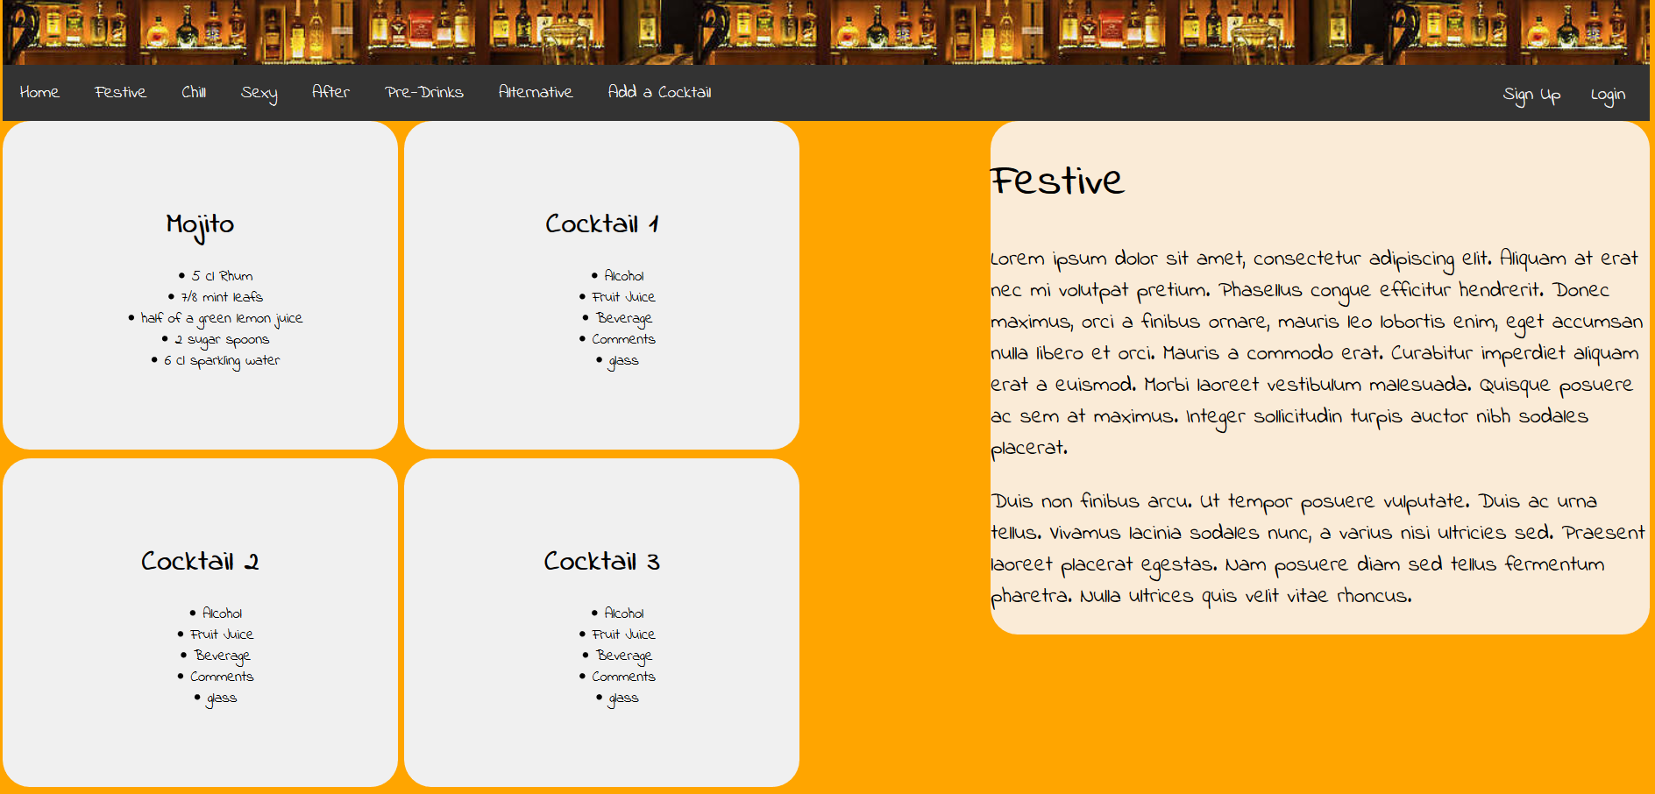

Here each vignette displays à recipe and when you click on à cocktail, an image of it appears on the bottom right of the page along with à like button. This functionality is implemented with the following javascript code

|  |
| --- |
| function picture(cocktail){  if (document.getElementById('bigpic').style.display === 'none') {  document.getElementById('bigpic').style.display='block';  document.getElementById('grey').style.display='block';  } else {  document.getElementById('bigpic').style.display='none';  document.getElementById('grey').style.display='none';  document.getElementById('red').style.display='none';  } } |

Again the vignettes are button and the function picture() which displays the cocktail is called with onclick like here for example in the Festive.html file.

|  |
| --- |
| <**button** type="button" class="recipe" onclick="picture()">  <**h1**>Mojito</**h1**>  <**ul**>  <**li**>5 cl Rhum</**li**>  <**li**>7/8 mint leafs</**li**>  <**li**>half of a green lemon juice</**li**>  <**li**>2 sugar spoons</**li**>  <**li**>6 cl sparkling water</**li**>  </**ul**> </**button**> |

When the picture appears, à heart-shaped like button also appears below the picture:

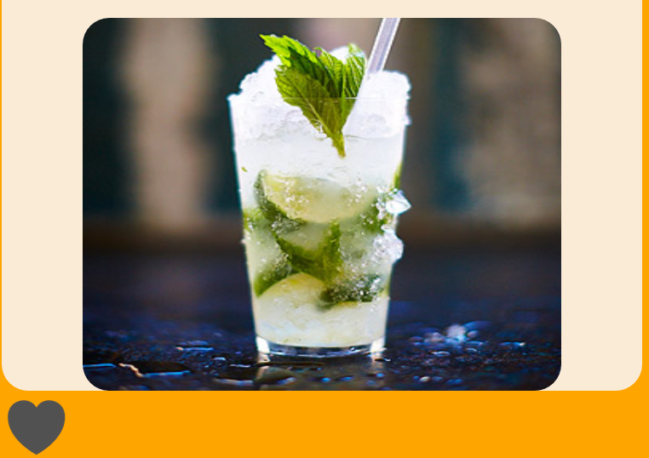

When clicked on, the heart becomes red with the combination of the following javascript and html code:

|  |
| --- |
| <**div**>  <**img** id="bigpic" src="img/Mojito.jpg" style="display:none;"/>  <**input** type="image" src="img/heart-grey.png" id="grey" onclick="like()" style="display:none;">  <**input** type="image" src="img/heart-red.png" id="red" onclick="like()" style="display:none;"> </**div**> |

|  |
| --- |
| function like(){  if(document.getElementById('grey').style.display === 'none' && document.getElementById('red').style.display==='block'){  document.getElementById('grey').style.display='block';  document.getElementById('red').style.display='none';  } else if(document.getElementById('grey').style.display === 'block' && document.getElementById('red').style.display==='none'){  document.getElementById('grey').style.display='none';  document.getElementById('red').style.display='block';  } } |

## Mobile Version

Due to lack of time, we don’ t do a good mobile version. However, if we used Bootstrap we should have a good mobile version.