Slamet Rahayu

**MIS Application**

**Technology Used:**

- Java Springboot

- Postgresql

- Bootstrap

- Jquery

**Environment Requirement:**

- Java jdk17

- Intellij idea or similiar IDE

**Installation:**

- clone repo: <https://github.com/slamet-rahayu/mis-application.git>

- on your IDE run mvn install

**Run project in development:**

- edit application.properties to match your environment config

- import sql files provided in this repo into your db

- on your ide run mvn spring-boot:run

- you should also run integration application here:

- if success you can access <http://localhost:8081> on your browser

**Using Application**

to be able to use the application you must have an account first, you can register on the sign-up page by registering a username and password.

Go to <http://localhost:8081/register>

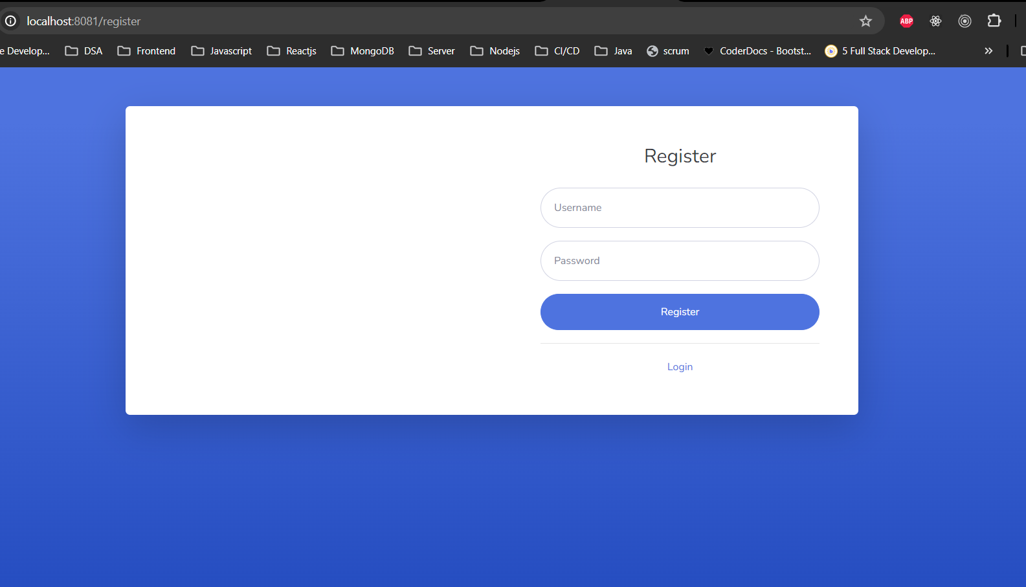

After register success please login using account you have been registered

Go to <http://localhost:8081/login>

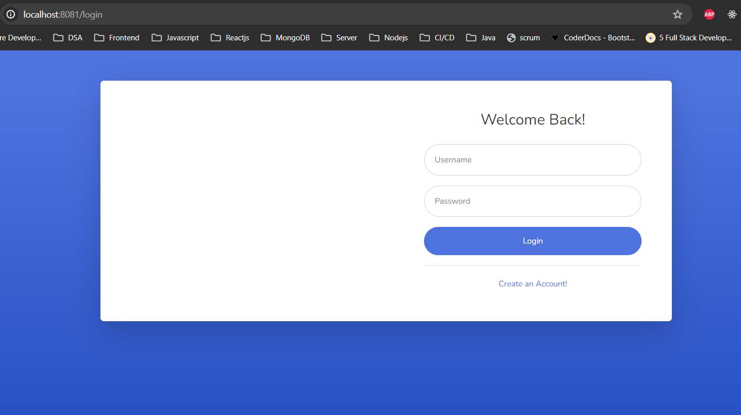

After login success you should be redirected to dashboard page

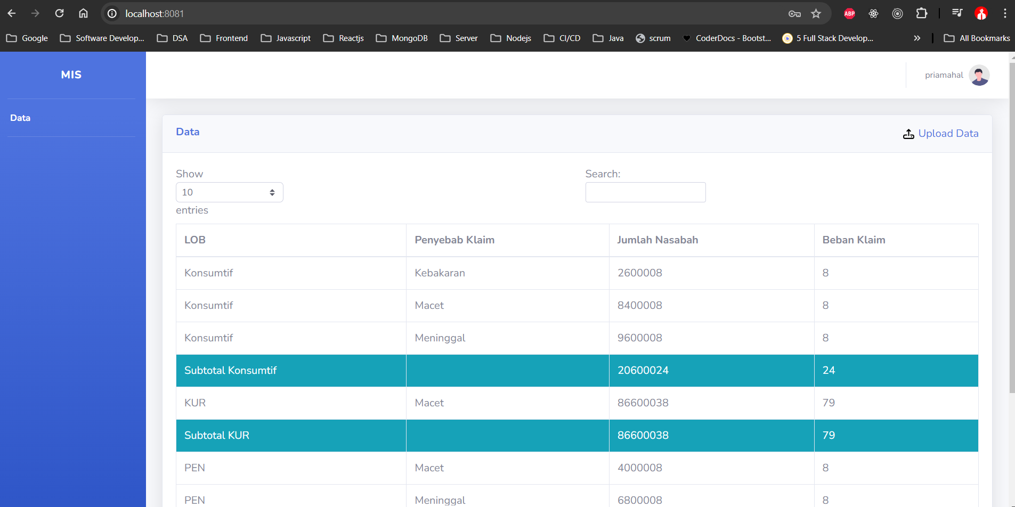

You can add data by uploading excel file, you can get example excel file in this repository project.

To upload data navigate to upload page by clicking Upload Data link with upload icon,

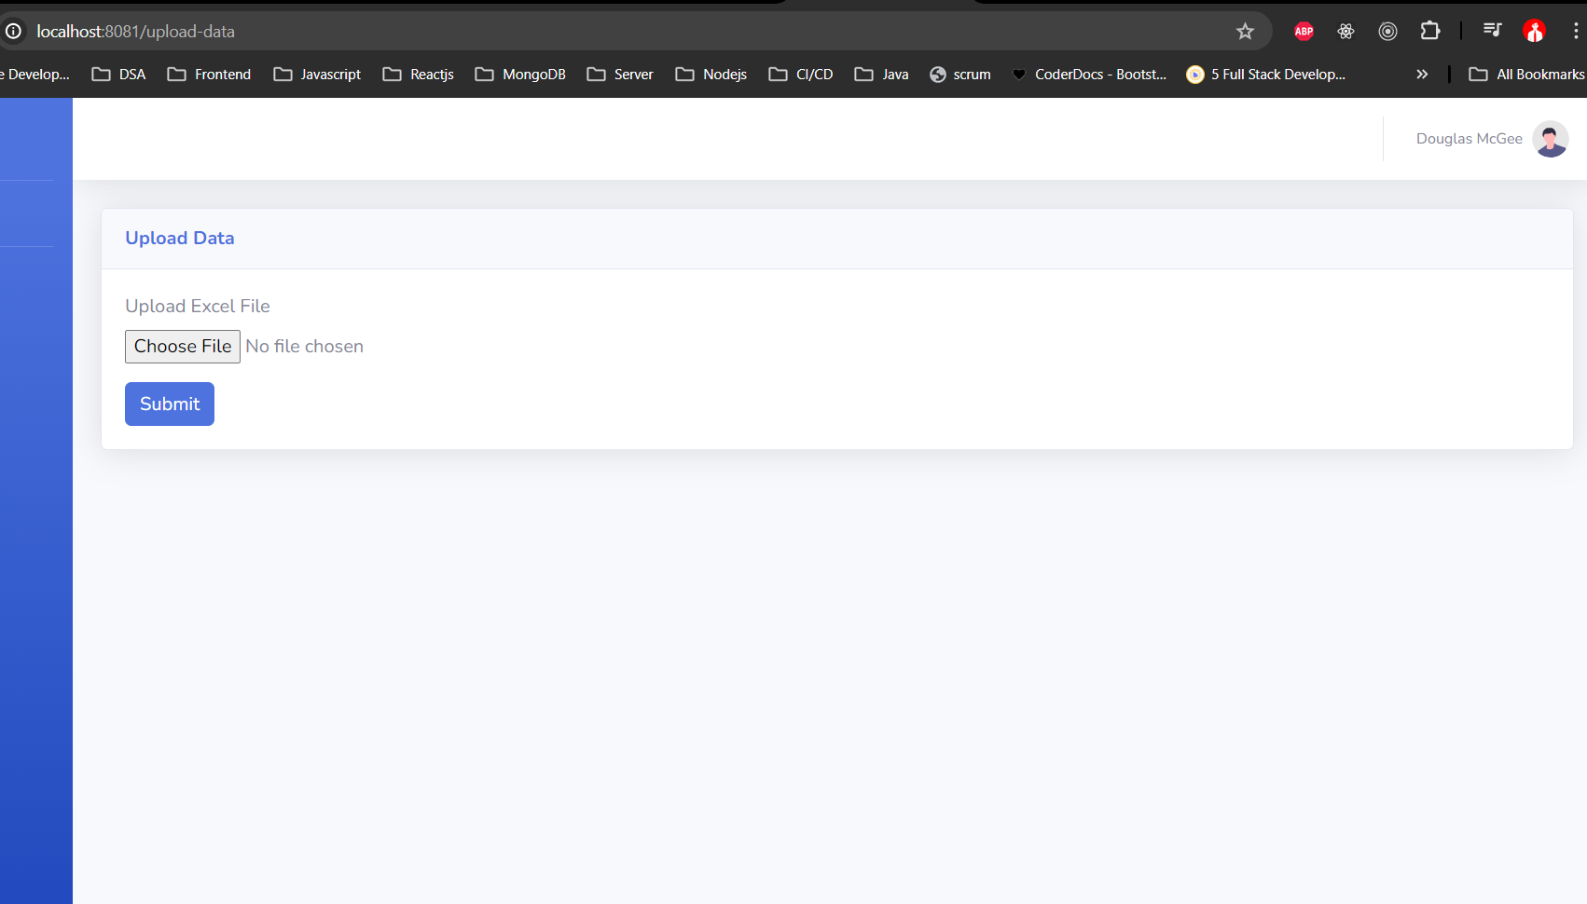

**Before perform upload data please make sure that integration app is running, because it also save data to integration app**

If you want to logout app you can click profile image and clik logout

