Thin-Metal Film Study for E. Coli Sensitive 3-D Printed Biosensor

Sherly Lande¹, Eric White², Fareed Dawan², Patrick Mensah², Samuel Ibekwe², Guoqiang Li^{2,3}

¹Department of Biological and Chemical Engineering, Illinois Institute of Technology
²Department of Mechanical Engineering, Southern University and A&M College
³Department of Mechanical and Industrial Engineering, Louisiana State University

Abstract: Thin gold films were sputtered on various substrates at varying parameters to determine the optimum film coating for use in a 3D printed biosensor. The surface morphology of the films were studied along with the film-to-substrate adhesion, the electrical, and the mechanical properties. It was found that under a low vacuum working pressure, quality films with no surface contamination were deposited. As-is titanium substrates showed the best film-to-substrate adhesion compared to that of as-is silicon, and polyimide. It was also shown that film deposition rate is an important factor in forming an optimized film with good electrical and mechanical characteristics. These and future studies will build the foundation for fabricating and implementing high quality film for use in a 3D printed E. Coli biosensor.

Keywords: 3-D Printing, Additive Manufacturing, Biosensor, Thin-Metallic Films, E. Coli

- Introduction

Detection of pathogens remains critical as their presence in consumables continues to be prevalent. Recently, reports of Escheria Coli (E. Coli) within marketed and packaged foods, beach waters, and drinking water has led to the recall of thousands of products, the temporary closure of beaches, and thousands of annually reported illnesses. The Center for Disease Control (CDC) recently reported that E. Coli infection is responsible for over 260,000 illnesses and more than 30 deaths annually [1]. It is critical that rapid detection methods and devices for pathogenic strains of E.Coli are readily available not only to the industry but to the general public and households as well. Currently, the widely used method to determine whether a source or supply of water is contaminated with pathogenic bacteria involves the collection of a sample of water which is sent off site to a testing laboratory where it is cultured within a petri dish then visually checked for the presence of bacteria under a microscope. This process and obtaining results from the test can take anywhere from 2-4 days [2]. There are also faster sensors available, however even these take about 20 min to produce a result [3]. This is very inconvenient when the use of the water has to be delayed or when an alternative water source has to be found. Biosensors typically are constructed from polymers housing thin-metallic antigen coated films to transform a chemical change to an electrical signal. In the detection of E. Coli within a liquid medium the Environmental Protection Agency’s (EPA) maximum contamination level (MCL) is zero per 100 mL [4].

Towards this end, we propose the fabrication of a relatively inexpensive and simple 3-D printed biosensor capable of accurately monitoring and rapidly detecting minute levels of E. Coli within aqueous solutions. Focus is on the deposition and characterization of a thin-metallic gold layer on a filter membrane. The filter membrane structure serves as a bacteria capture medium. The gold metallic film serves as the sensing mechanism.
An illustration of the proposed fabrication and detection scheme is shown in Figure 1. The contaminated water source will complete the circuit by bridging the gap between the gold electrodes. The pathogen level of concentration will affect the current reading. The gap is part of the filter membrane construction. Also shown is the CAD drawing using SolidEdge ® of the lid for the cup which was created using an assembly between two cylinder shapes. The top cylinder has a hole with a diameter of 50 mm which will be used as a path way to the filter for the water. The button cylinder was created as sort of like a slot holder for the filter with the same dimensions for a US copper penny. Both cylinder were mated together in SolidEdge® assembly which means they will be printed out as one piece in the 3D printer.

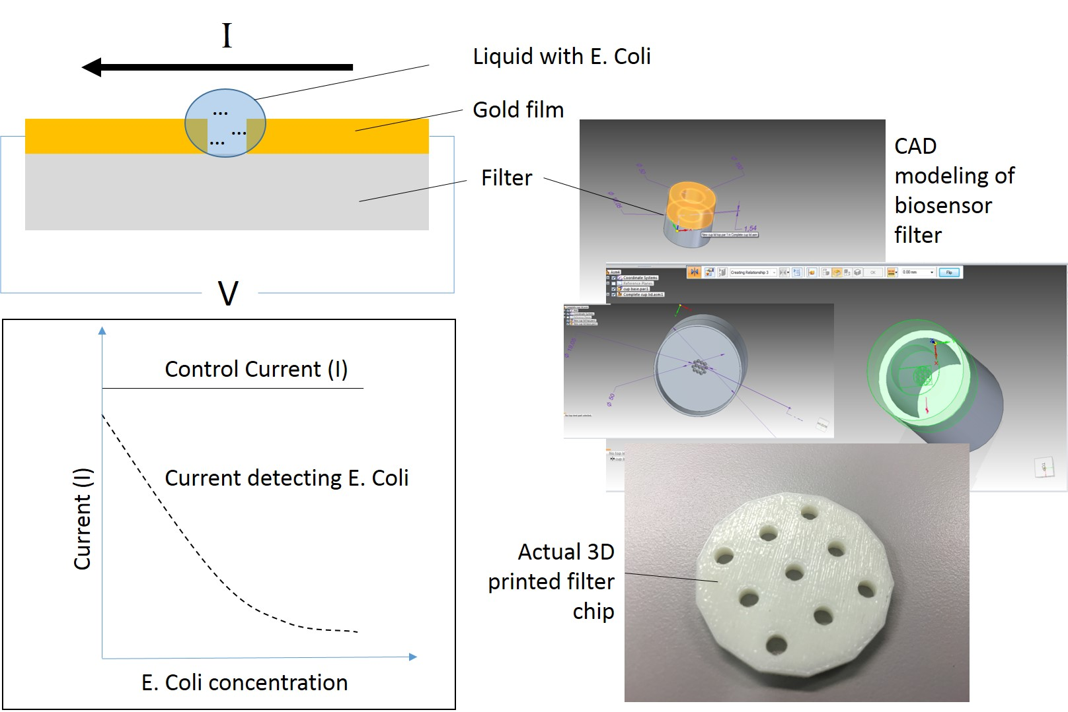

Figure 1. Illustration of the proposed biosensor detection scheme, also showing the CAD modeling and actual 3D printed filter chip.

The liquid sample is collected in a sterilized vile then dispensed over the filter membrane. The membrane does not allow contaminants larger than E. Coli to pass through. A small control current is passed through the sensing film. As the contaminants/bacteria collect on the film, due to the resistant nature of the presence of E. Coli, the control current is expected to drop. The amount of change in the current is then correlated with the level of contamination present on the filter.

- Methodology
Silicon wafers (University Wafer®), titanium sheets (GoodFellow®), and polyimide (Kapton®) films were cut to 1 cm x 2 cm chips to serve as substrates for the deposition of gold films. The 3D printed filter chips were fabricated using the Stratasys® 380mc. The gold films were deposited using the Denton® Desk V Sputterer. Depositions were performed at varying plasma currents ranging from 10 mA to 80 mA. Initial and working chamber pressure conditions were continuously monitored for each run. The rotational speed of the substrate stage was set to midway for all depositions. Manual film depositions for a gold thickness of 500 um were done for all substrates. The Phantom (NanoScience ®) Desktop scanning electron microscope (SEM) was used to capture both optical and electron microscopic images of the gold film coatings. This aided in determining the surface quality and morphology of the film coatings. The tape test (ASTM D3359) was performed on all samples to qualitatively determine the gold-to-substrate interfacial adhesive property. Nano-Electrical Contact Resistance (NanoECRTM) nanoindentation using the TriboIndenter (Hysitron®) was used to determine the electrical and mechanical properties of the films. A conductive Boron-doped diamond Berkovich tip was used to perform the measurements. A voltage of 1.5 V was applied and the current was measured during a linearly increasing tip force load from 0 to 600 uN followed by a linearly decreasing force load all within a time interval of 20 sec.
3. Results
Film deposition at varying plasma currents between 10 to 80 mA resulted in corresponding deposition rates. As expected, an increase in the plasma-assisted sputter current resulted in an increase in the film deposition rate. Based on the tape adhesion test and as shown in Figure 2, microscopy revealed that an increase in the deposition rate for Au on Si resulted in a decrease in the film-to-substrate adhesion. This is likely due to the time allowance for the gold-sputtered particles to position and cool between the growths of monolayers as opposed to a rapid deposition rate. Silicon may require surface treatment or and added adhesive laye`r before deposition. Au on Ti however displayed very good interfacial adhesion. The electrical and mechanical test results are shown in Figure 3. Current-vs-depth shows that the current increases as the depth within the film increases. Load-versus-depth indirectly reveals the actual thickness of the films as opposed to the manual film thickness end-point. There appears to be a mismatch. The mechanical properties for each indentation shows that for films deposited at a low rate, the reduced modulus is high whereas the hardness of the film increases. Although, the hardness overall does not change significantly.
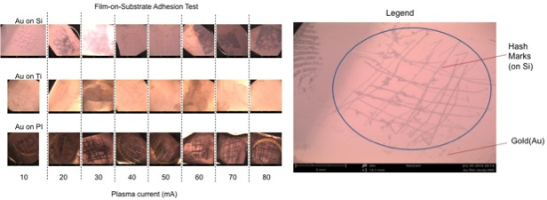
Figure 2. Gold film-on-substrate adhesion tests with a legend showing an example of the tape test.

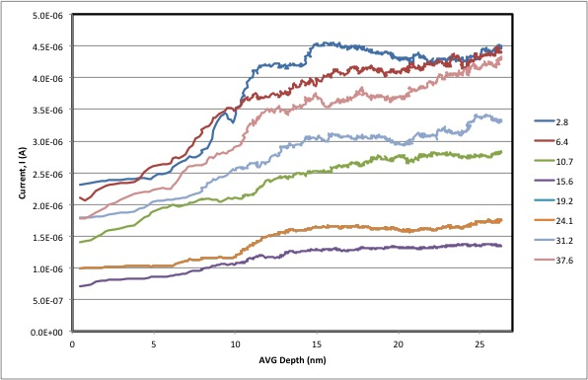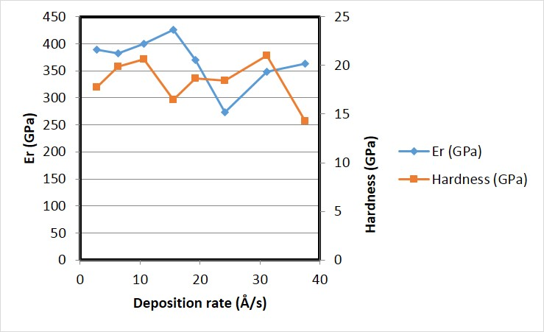
Figure 3. Electrical (current vs film depth) mechanical (reduced modulus and hardness vs film deposition rate) properties of gold on silicon.
4. Conclusion

Thin gold films are at the core of biosensors and rapid pathogen detection technology. This work presented here forms the basis towards the development of an optimum film coating for implementation in a 3D printed biosensor. With gold and titanium both classified as biocompatible metals, it was found that the adhesive strength of gold on as-is titanium is superior to as-is silicon, that the film deposition rate is an important factor in forming an optimized film with good electrical and mechanical characteristics.
Future work will investigate the deposition of the optimum gold film coating on a high-surface area titanium nanotube surface for increased sensitivity. The gold-on-titanium will be coated onto the biosensor filter chip. The investigators have obtained non-pathogenic strains of E. Coli and will proceed to test the speed and sensitivity performance of the 3D printed sensor.

5. Acknowledgments

The current work is funded by the NSF EPSCoR CIMM project under award #OIA-15410795. We also acknowledge Dr. Eduardo Martinez and Ms. Baghian of the Department of Biological Sciences at Southern University for providing non-pathogenic strains of E. Coli for testing purposes.

6. References

[1] http://www.cdc.gov/ncezid/dfwed/PDFs/national-stec-surveillance-overiew-508c.pdf
[2] http://www.water-research.net/index.php/bacteria
[3] http://www.meridianbioscience.com/diagnostic-products/foodborne/immunocard-stat/immunocard-stat-e-coli-o157-plus.aspx
[4] https://www.epa.gov/dwreginfo/revised-total-coliform-webinar-primacy-agencies

