**Basic**

## The Three States

* Git has three main states that your files can reside in: committed, modified, and staged. **Committed** means that the data is safely stored in your local database. **Modified** means that you have changed the file but have not committed it to your database yet. **Staged** means that you have marked a modified file in its current version to go into your next commit snapshot.

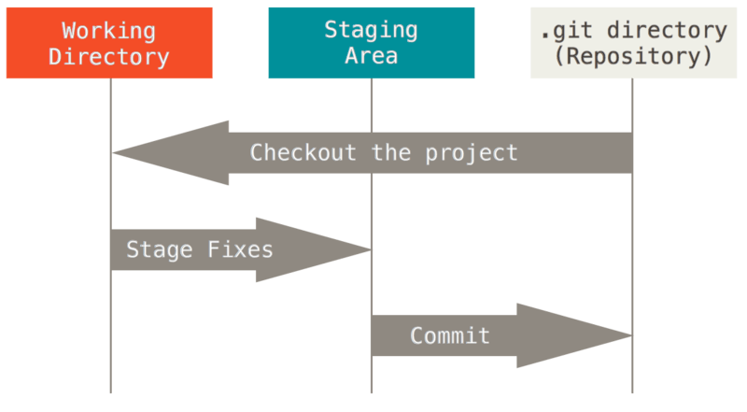

* **Git directory** is where Git stores the metadata and object database for your project. This is the most important part of Git, and it is what is copied when you clone a repository from another computer.
* **Working directory** is a single checkout of one version of the project. These files are pulled out of the compressed database in the Git directory and placed on disk for you to use or modify.
* **Staging area** is a file, generally contained in your Git directory, that stores information about what will go into your next commit. It’s sometimes referred to as the “index”, but it’s also common to refer to it as the staging area.

## Git Setup

* **Identity**

**$** git config --global user.name "John Doe"

**$** git config --global user.email johndoe@example.com

* **Checking Your Settings**

**$** git config –list

* Git help

**$** git help <verb>

**Errors**

## xcrun: error: invalid active developer path

xcrun: error: invalid active developer path (/Library/Developer/CommandLineTools), missing xcrun at: /Library/Developer/CommandLineTools/usr/bin/xcrun

* **Reinstall xcode command line， ……**

xcode-select --install

**Or switch path**

sudo xcode-select -switch /