# Baseline error

*Figure 1* through *Figure 4* below show the difference and the RMSE of the estimated position in ENU for both data sets 3 and 4. These figures do NOT include solutions for troposphere and ionosphere delays

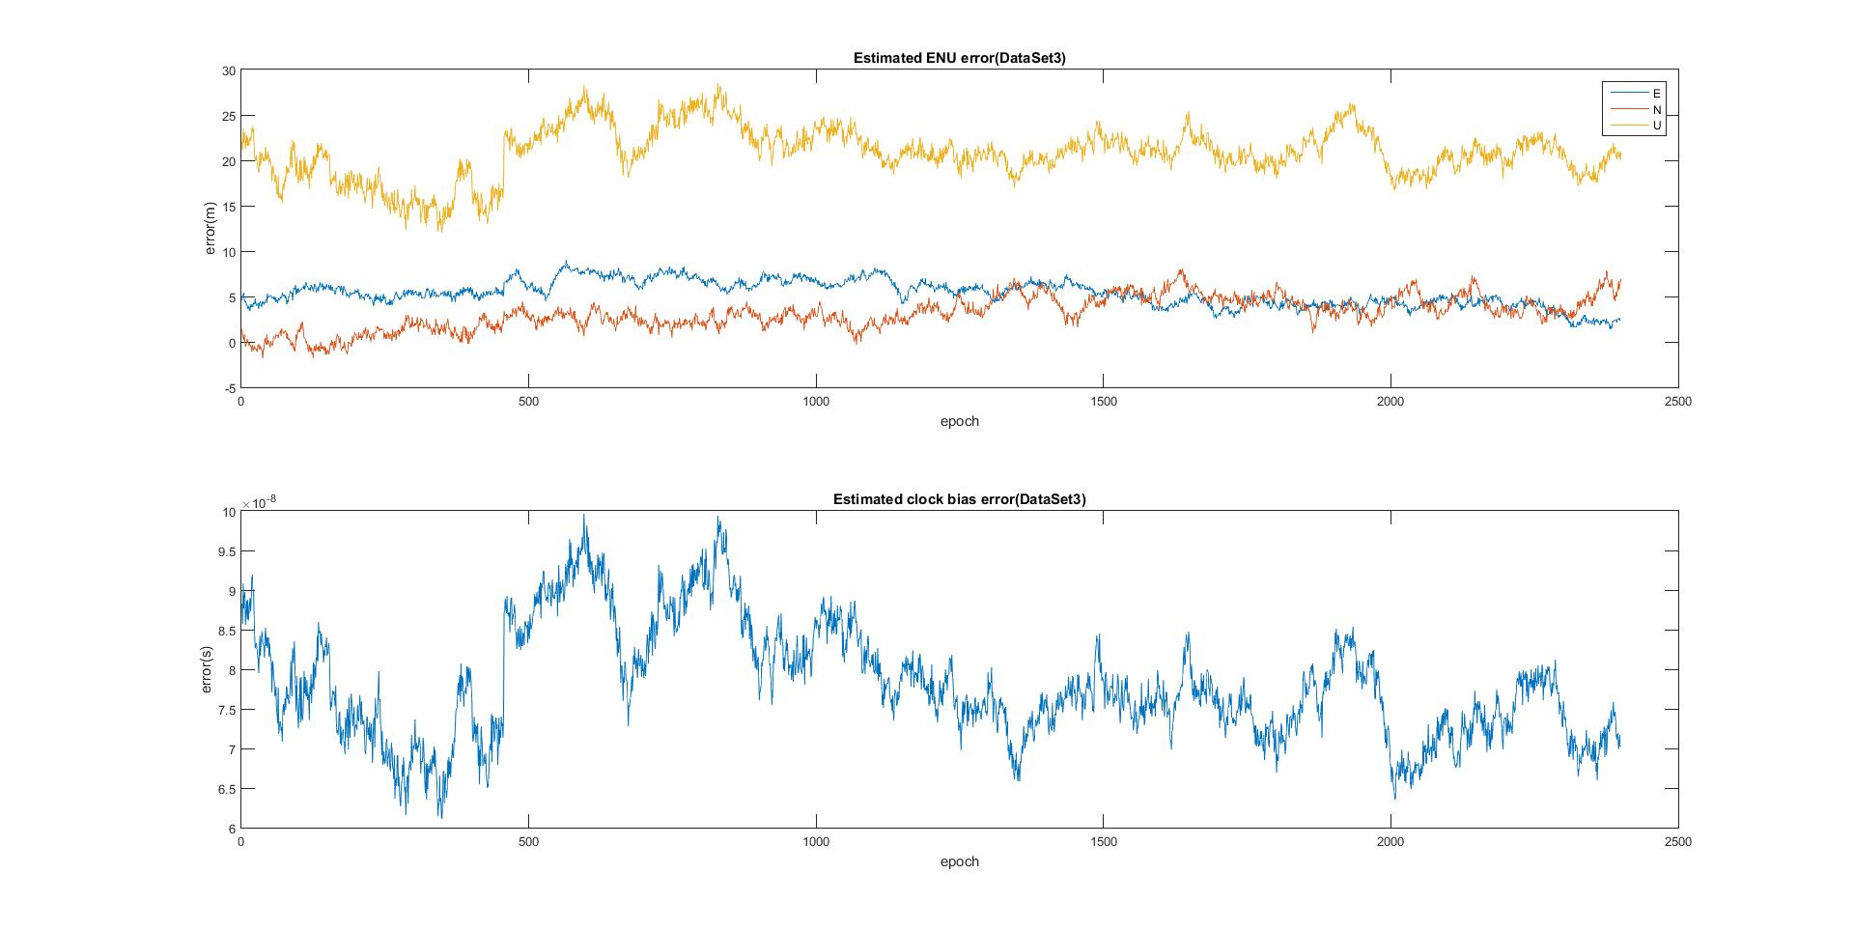

Figure 1

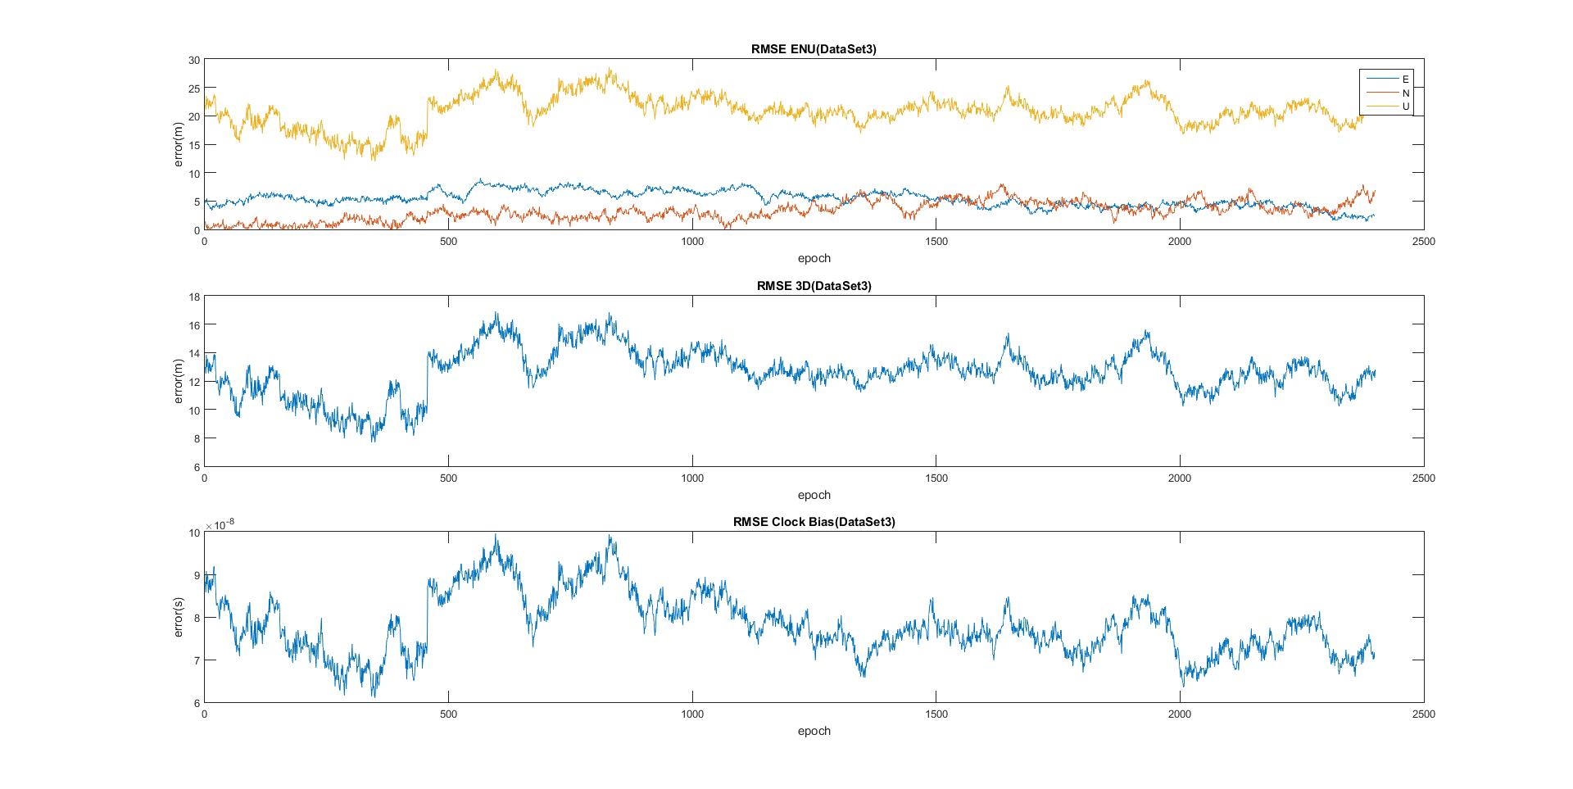

Figure 2

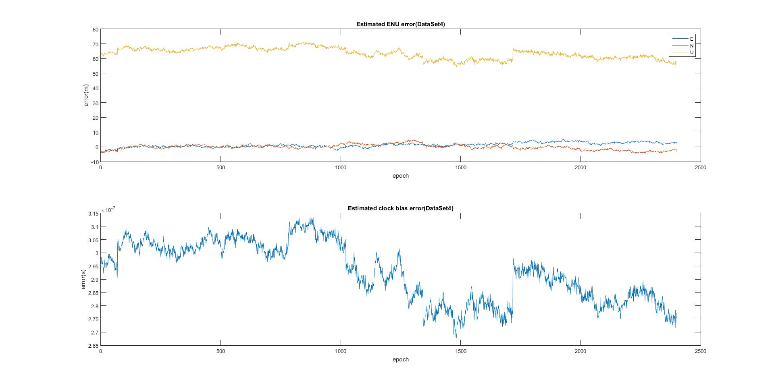

Figure 3

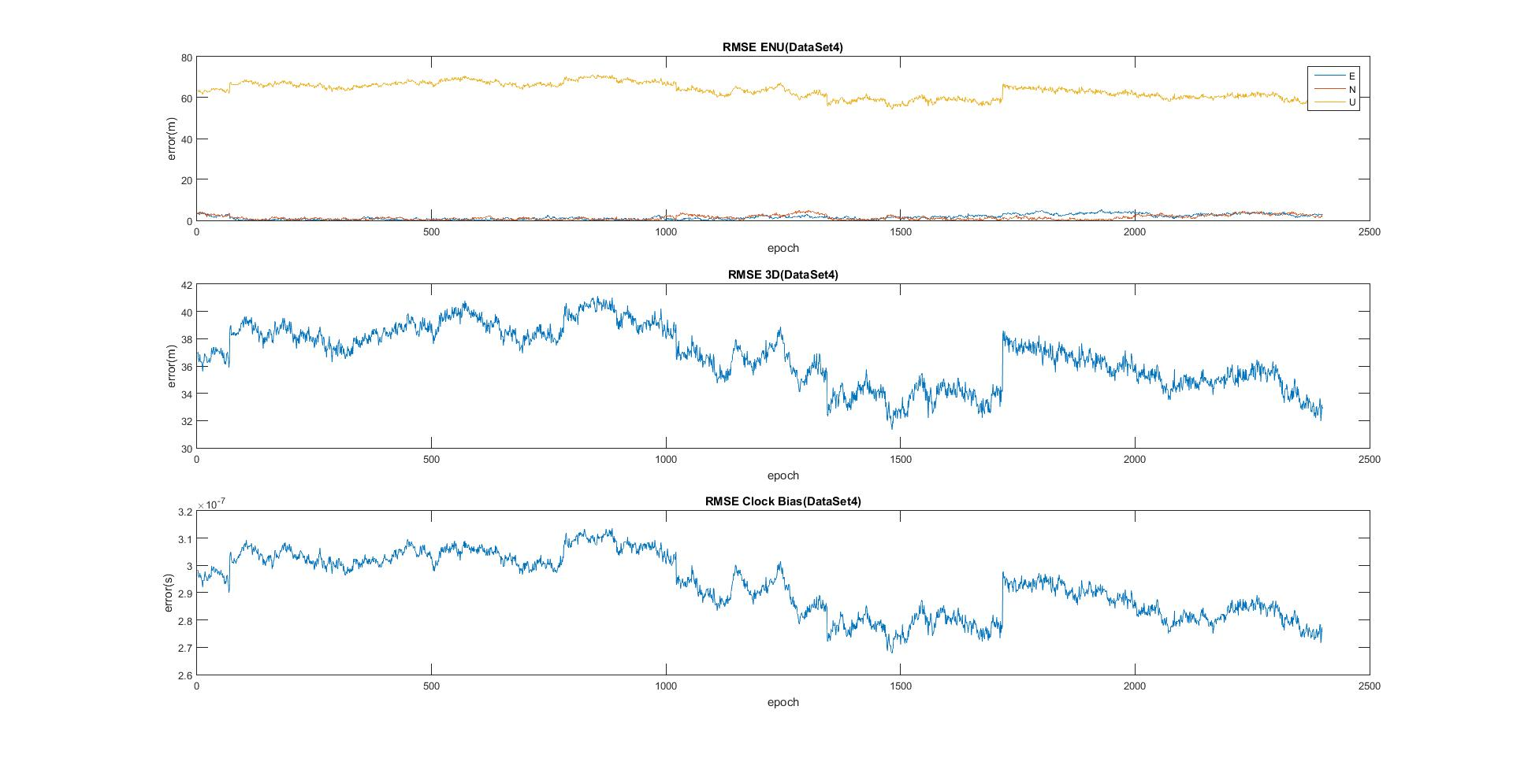

Figure 4

From looking at the previous 4 figures it is easy to see a few major differences between data set 3 and data set 4. For example, from figures 1 and 2 the near epoch 500 the addition of another satellite can be noticed, but in figure 3 and 4 there appears to be many changes in the number of satellites in view. The error in Up is also significantly higher in data set 4. Figures 5 and 6 show the difference between L1 and L2 codes for both data sets. Figure 6 shows what appear to be instant dramatic changes in pseudorange prior to it returning to its normal range. This could be because of a change in satellite which is not handled by the code currently or by some unknown source of error, causing these sattelites to appear to change position. These changes in pseudorange are likely the cause of the error being so large for dataset 4. Figure 5 confirms the addition of a seventh satellite near the 500th epoch.

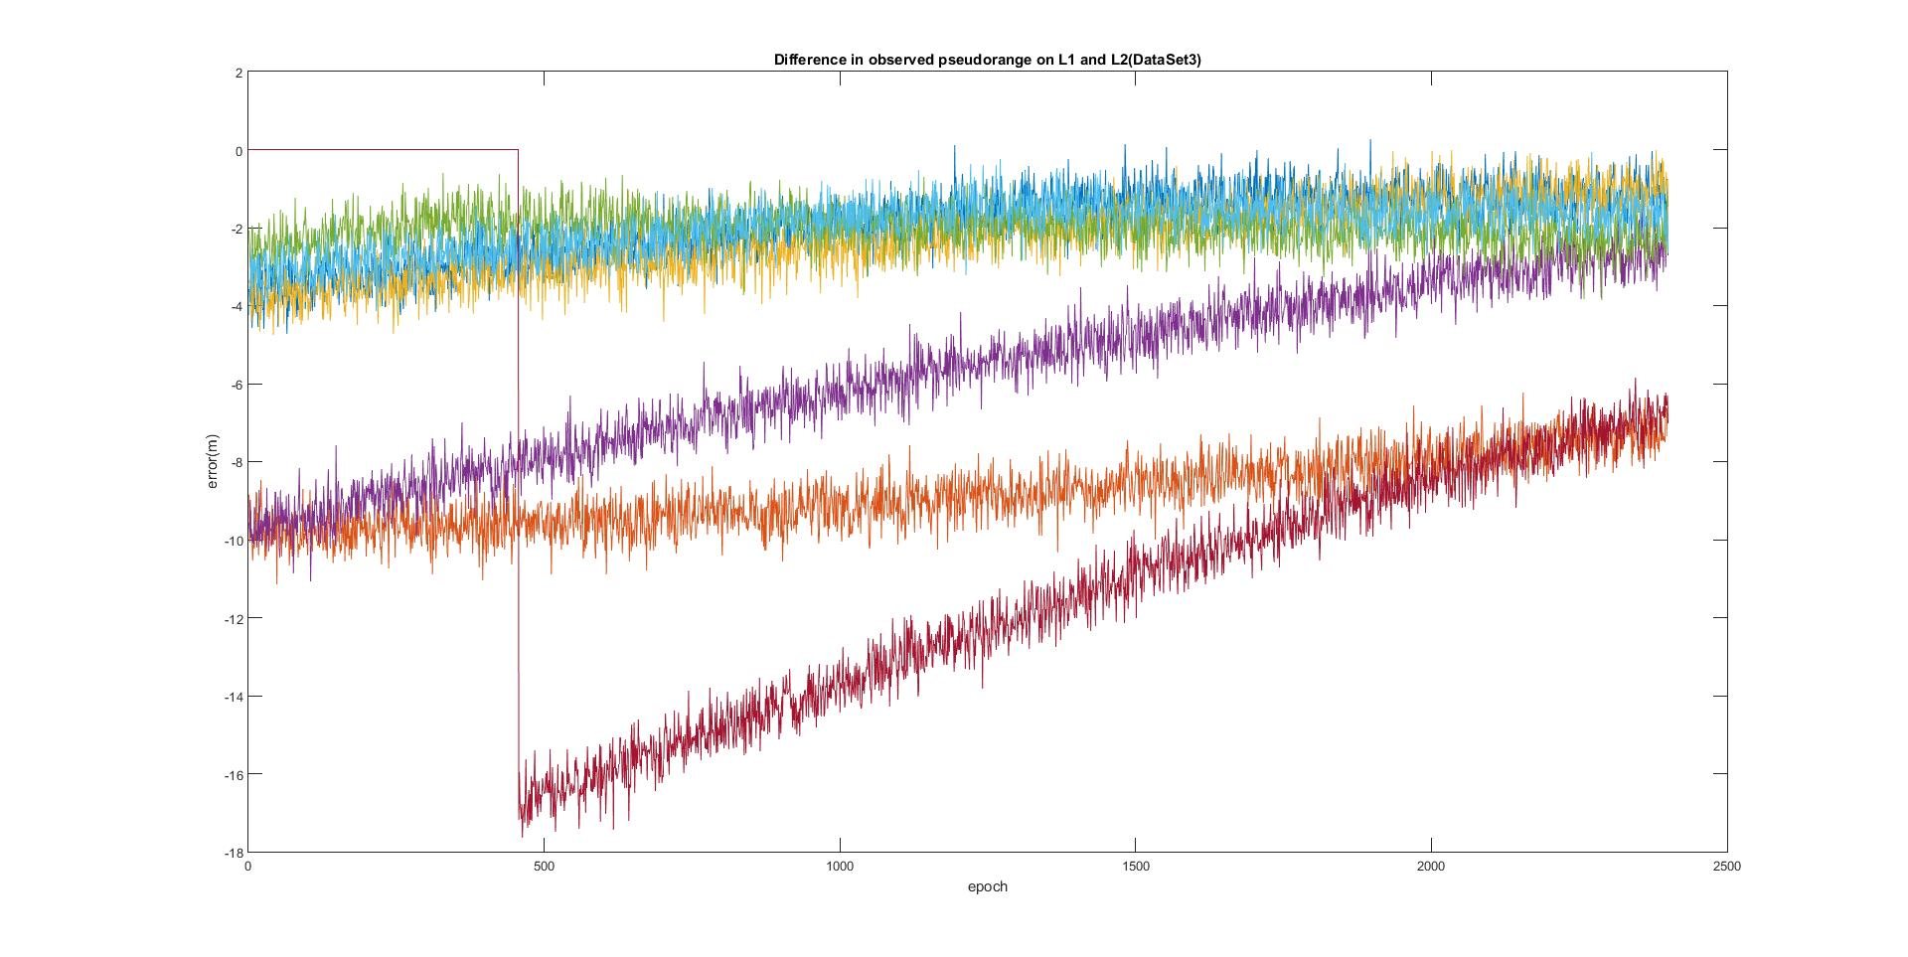

Figure 5

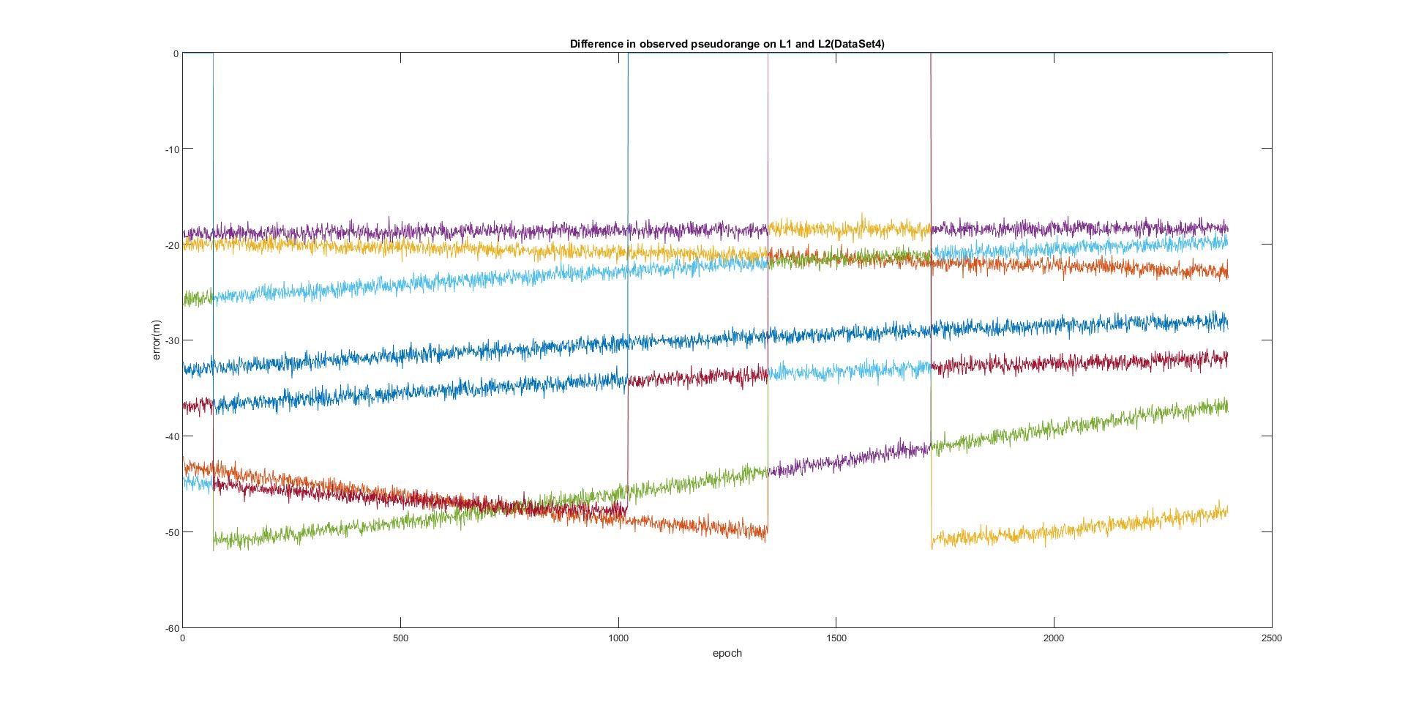

Figure 6

# Error with Troposphere Solution

Figures 7 through 10 show the effect of providing a solution for the troposphere delay. This delay was estimated using the Saastamoinen model, with the parameters listed in table 1, and multiplied by an elevation dependent mapping function that can be found in the attached code. The immediately apparent result of compensating for the troposphere is the reduction of error in the up direction. But upon closer inspection, the clock bias error has been reduced by near half, as well as the effects of the change in number of satellites is not as apparent.

Table 1: Saastamoinen model parameters

|  |  |
| --- | --- |
| **Total Pressure** | 1013 mbar |
| **Temperature at Receiver** | 288.15 K |
| **Partial Pressure due to Water Vapor** | 12.8 mbar |

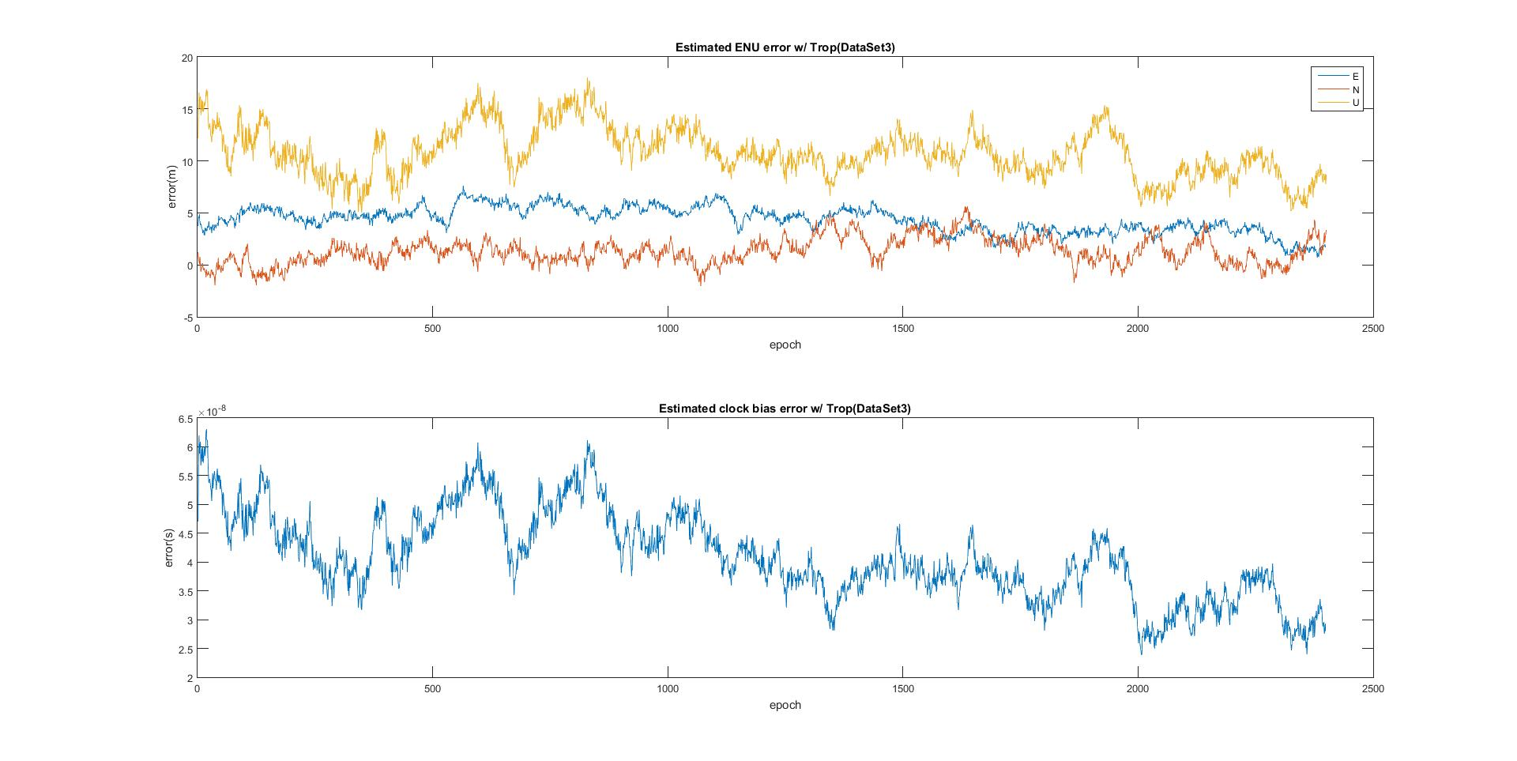

Figure 7

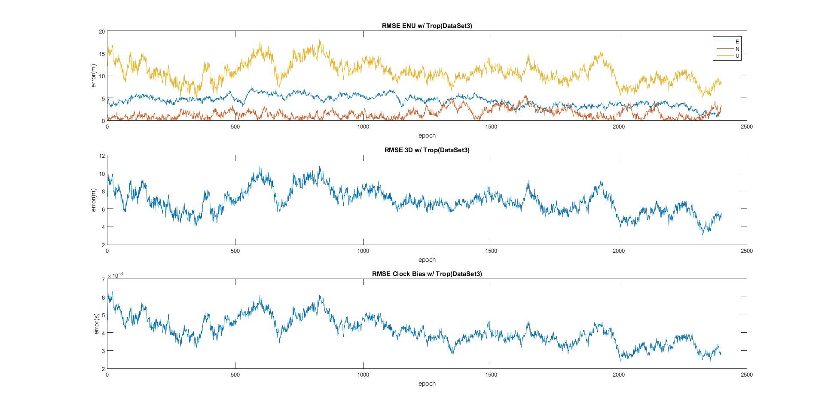

Figure 8

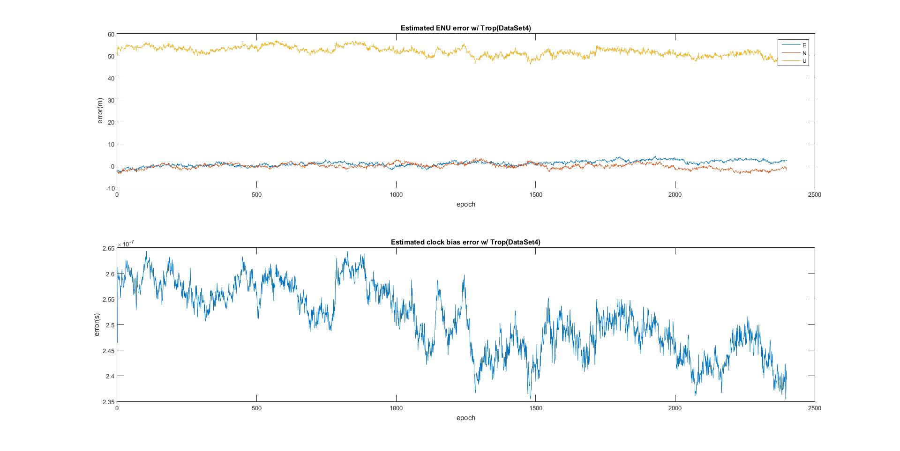

Figure 9

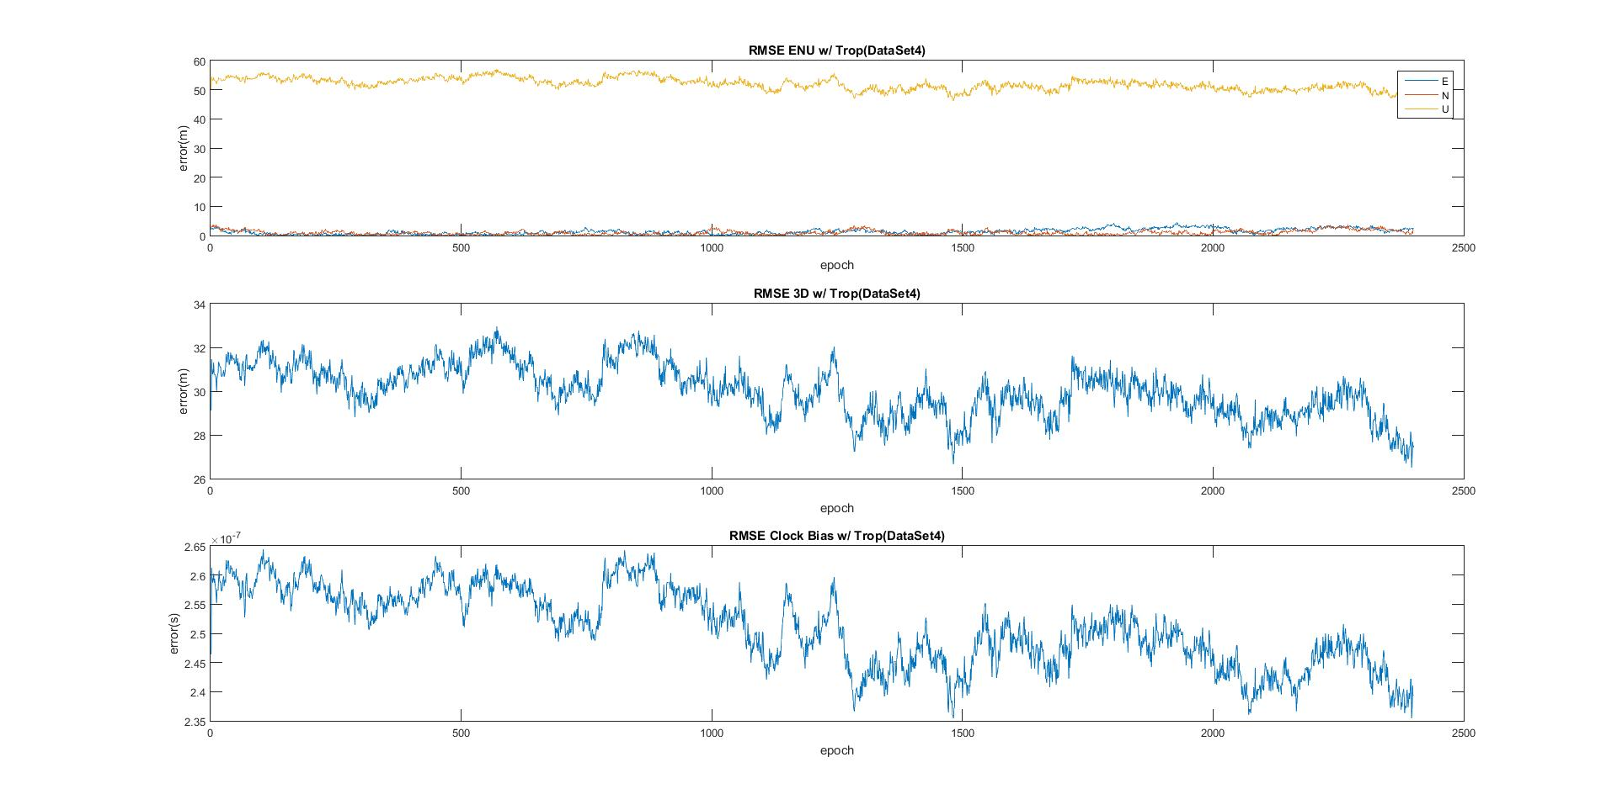

Figure 10

# Error with Troposphere and Ionosphere Solutions

To include the ionosphere the Klobuchar model was used to estimate the zenith delay of the ionosphere, which was multiplied by an obliquity factor generated by the thin shell model, making assumptions for the mean radius of Earth 6367444.5 meters and the mean height of the ionosphere to be 350 kilometers. Parameters used for the Klobuchar model are listed in table 2 below. Figures 11 through 14 show the effects of including the ionosphere delay along with the troposphere delay. It’s interesting to note that the error in up and clock bias appear to increase after a change in the number of satellites in data set 3. However in data set 4 the error in up and clock bias appear to decrease throughout the observation period.

Table 2: Klobuchar model parameters

|  |  |
| --- | --- |
| **A1** | 5e-9 sec |
| **A2** | 8.6599e-8 sec |
| **A3** | 50400 sec |
| **A4** | 100800 sec |
| **Local Time Offset from Beginning of GPS Week** | 19.45 hr |
| **Max TEC** | 72.53 TECU |
| **Min TEC** | 68.45 TECU |

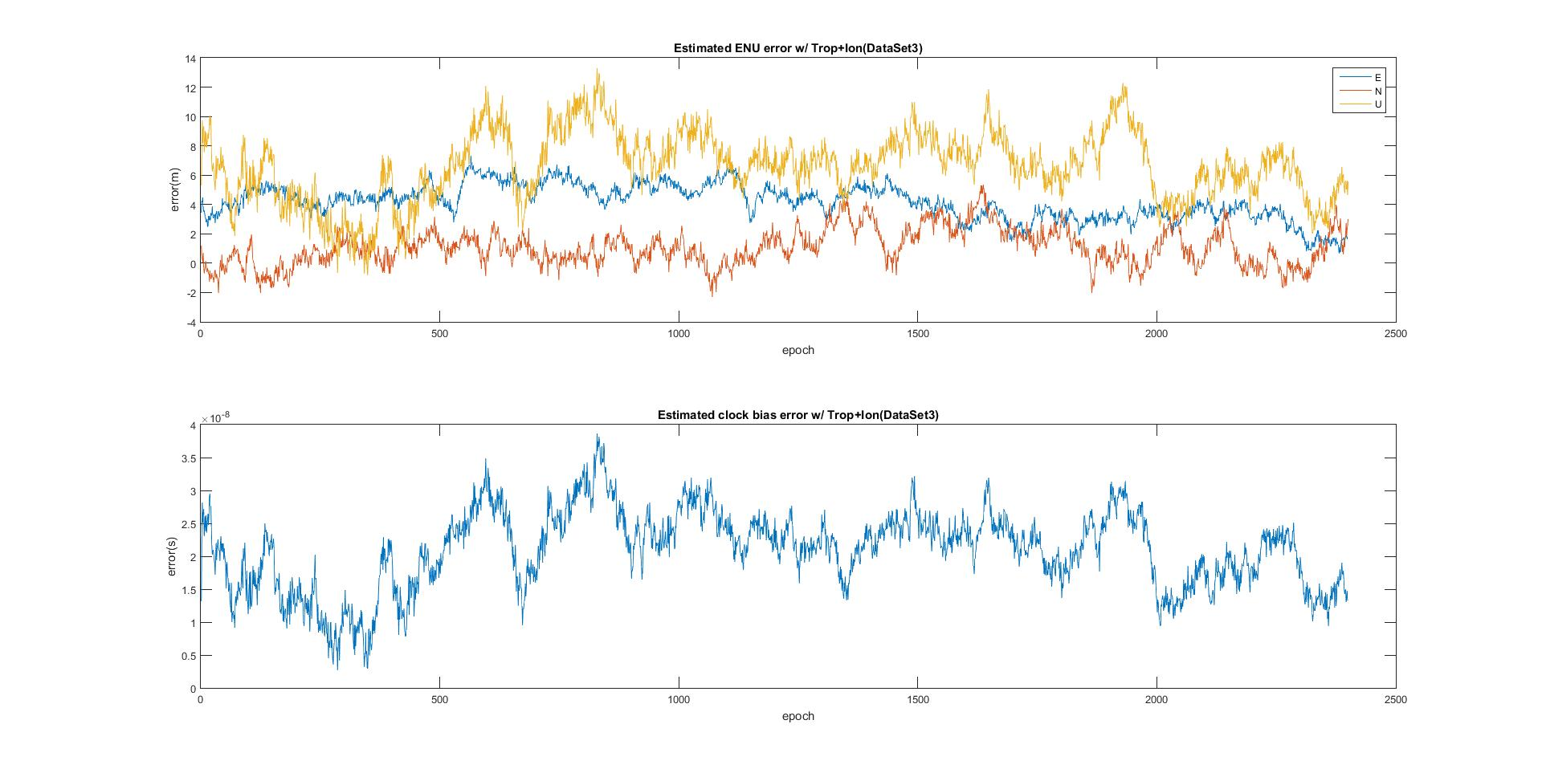

Figure 11

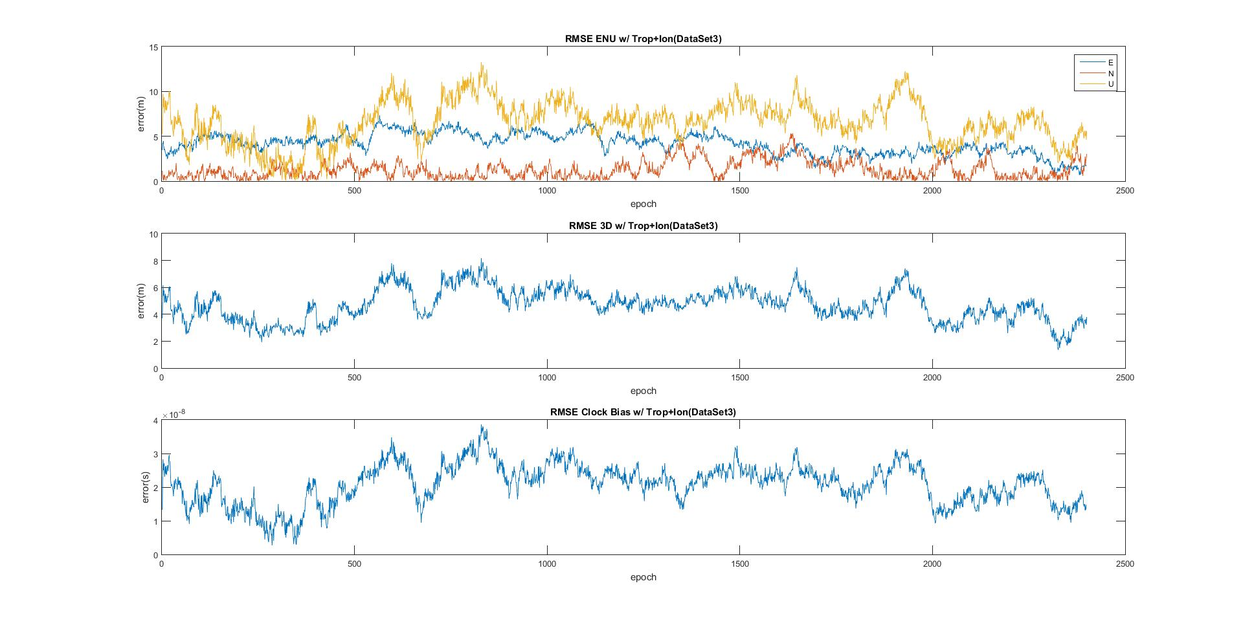

Figure 12

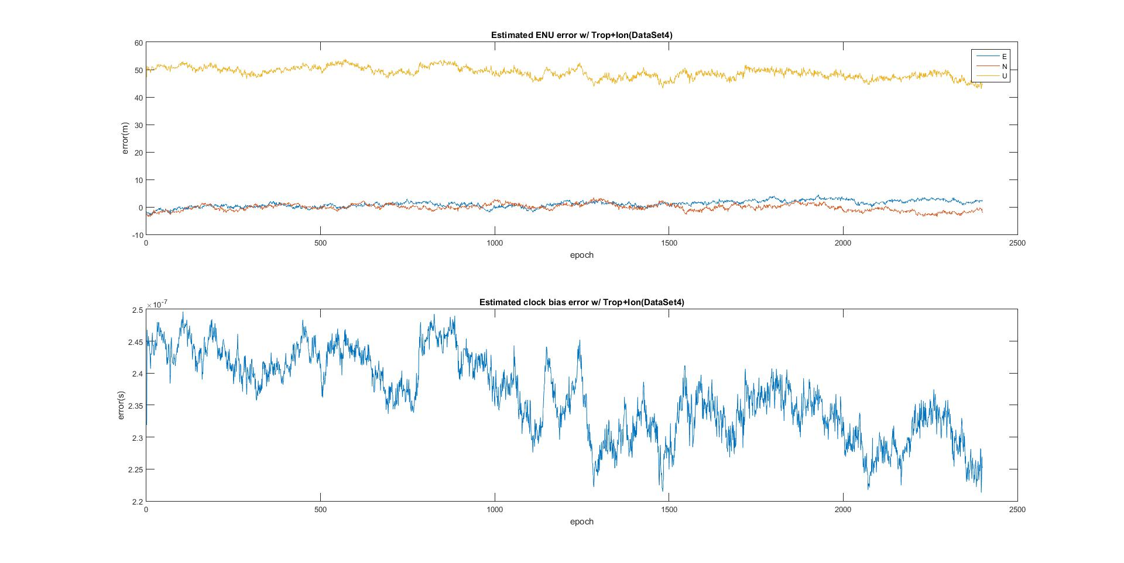

Figure 13

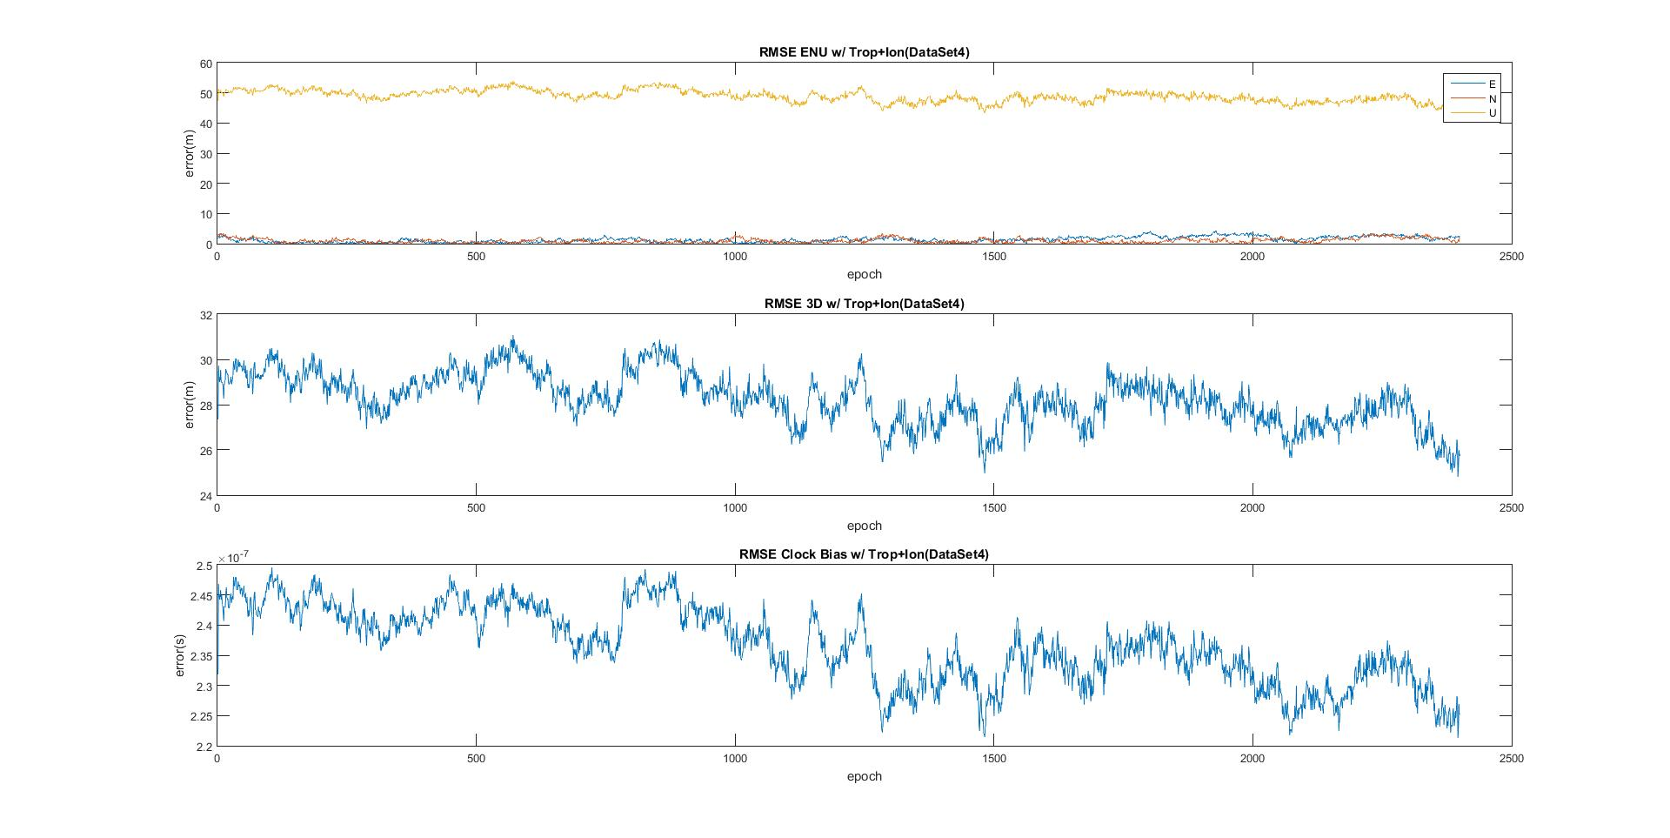

Figure 14

# Error with Dual Frequency Data

Figures 15 through 18 show the effects of using dual frequency data to negate the effects of the ionosphere. While the error gets closer to zero for both data sets, the effect is much greater on data set 4. There appears to be a consequence of the error in Up being less precise for both data sets. Use of the ionosphere free data seems primarily to benefit data with large error, with a larger increase in accuracy compared to a loss of precision. Data set 3 does not suffer such a large error, and the loss of precision does not seem worth the apparent increase in accuracy.

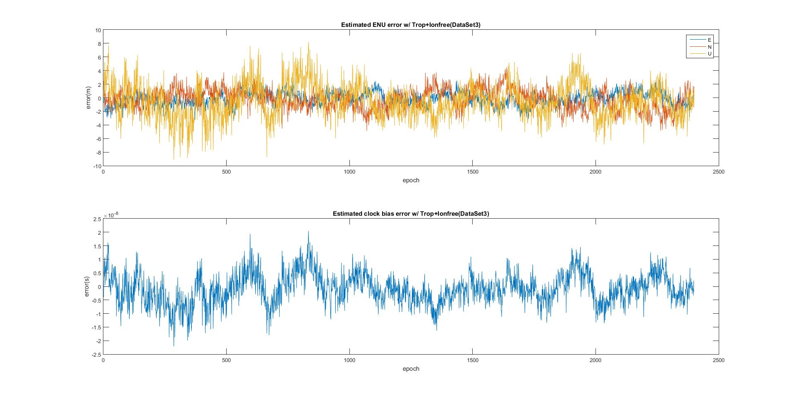

Figure 15

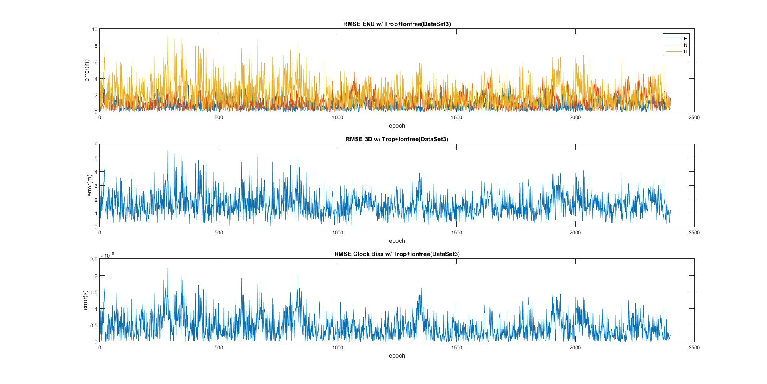

Figure 16

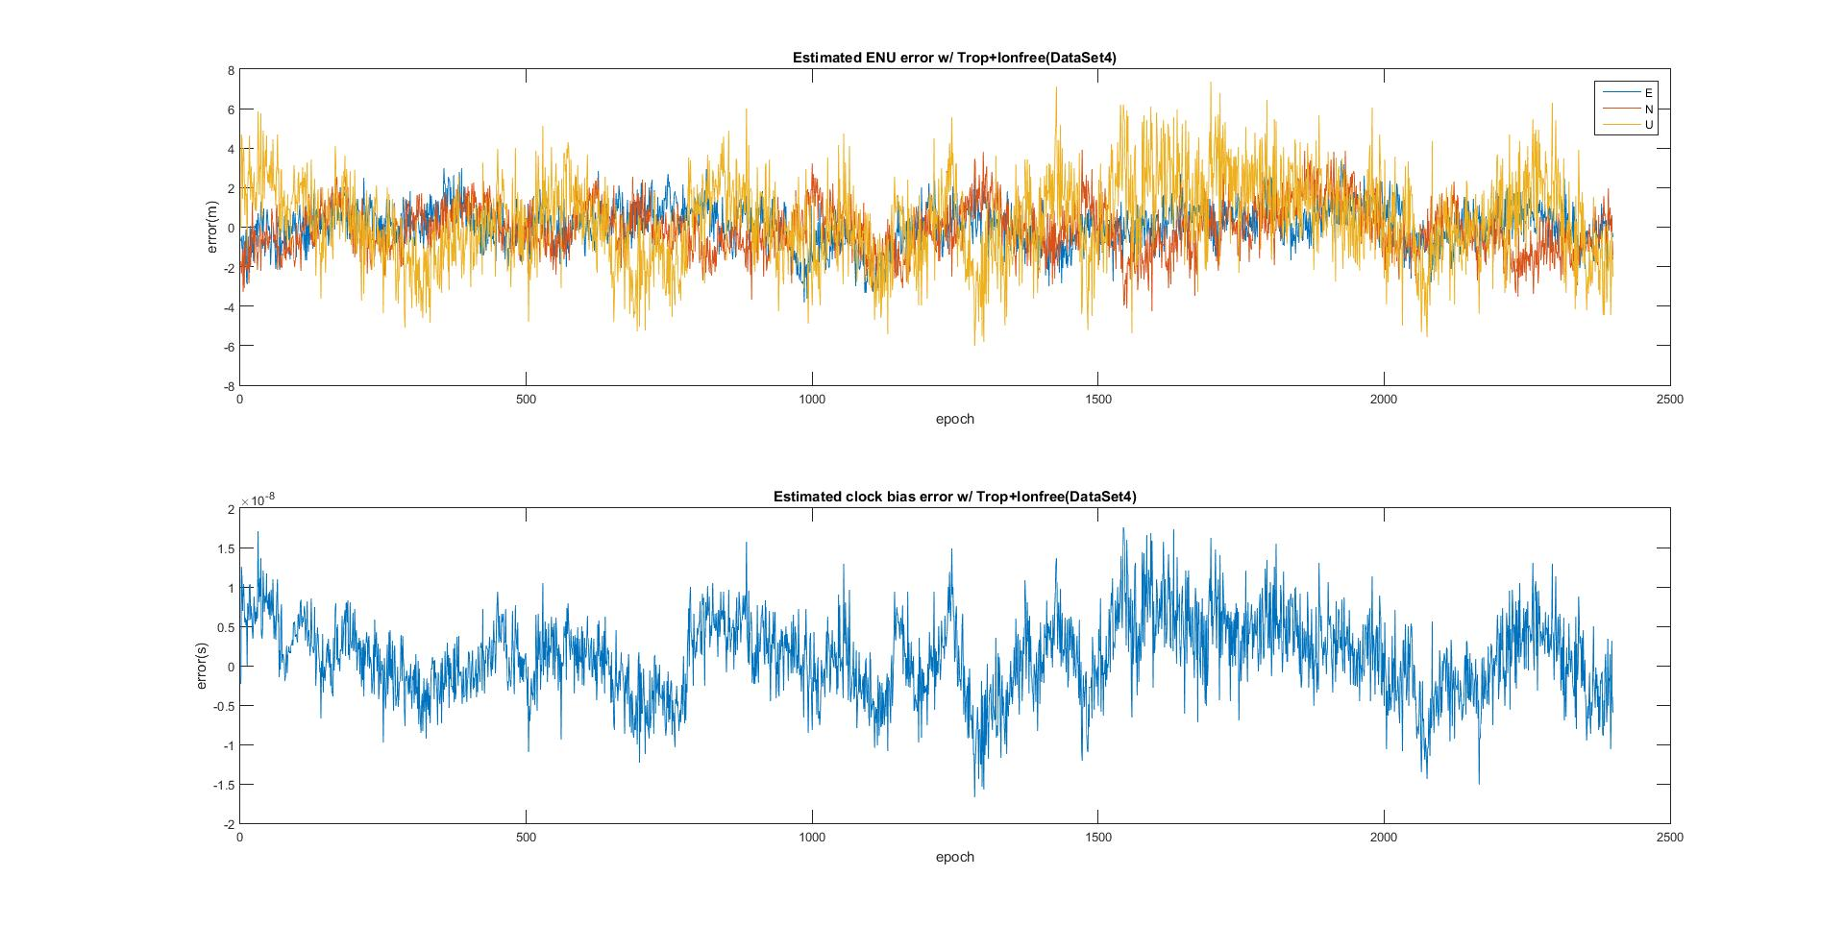

Figure 17

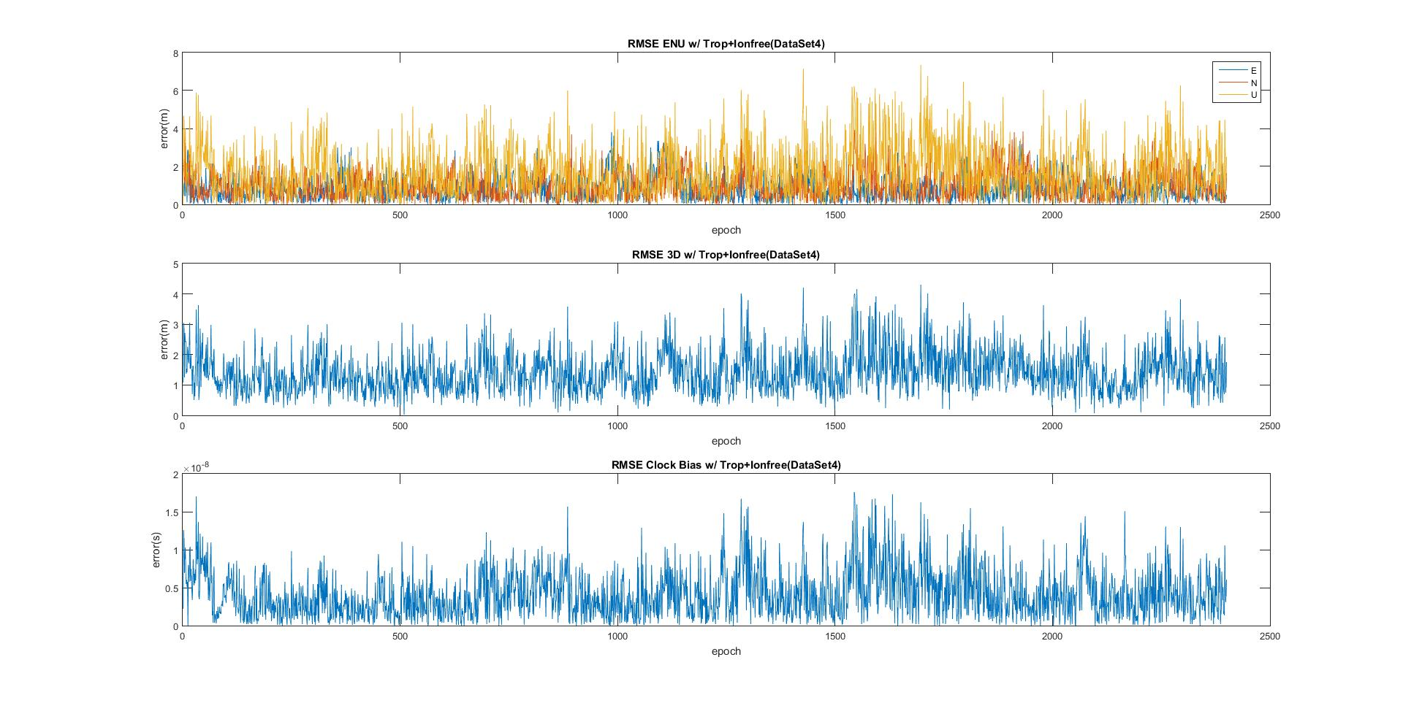

Figure 18

# Conclusions

Referencing the figures in Appendix A it is obvious to see that the modeling of the troposphere has a larger impact on reducing error for lower elevation satellites and in Figure 19, this can be observed by looking at the Up direction error with and without the troposphere and how the data with modeled troposphere doesn’t spike when a new satellite is introduced. The impact on low elevation satellite data makes sense when one thinks that the signal would have to travel through much more troposphere if it is closer to the horizon, where as it will pass through roughly the same amount of ionosphere.

# Appendix A

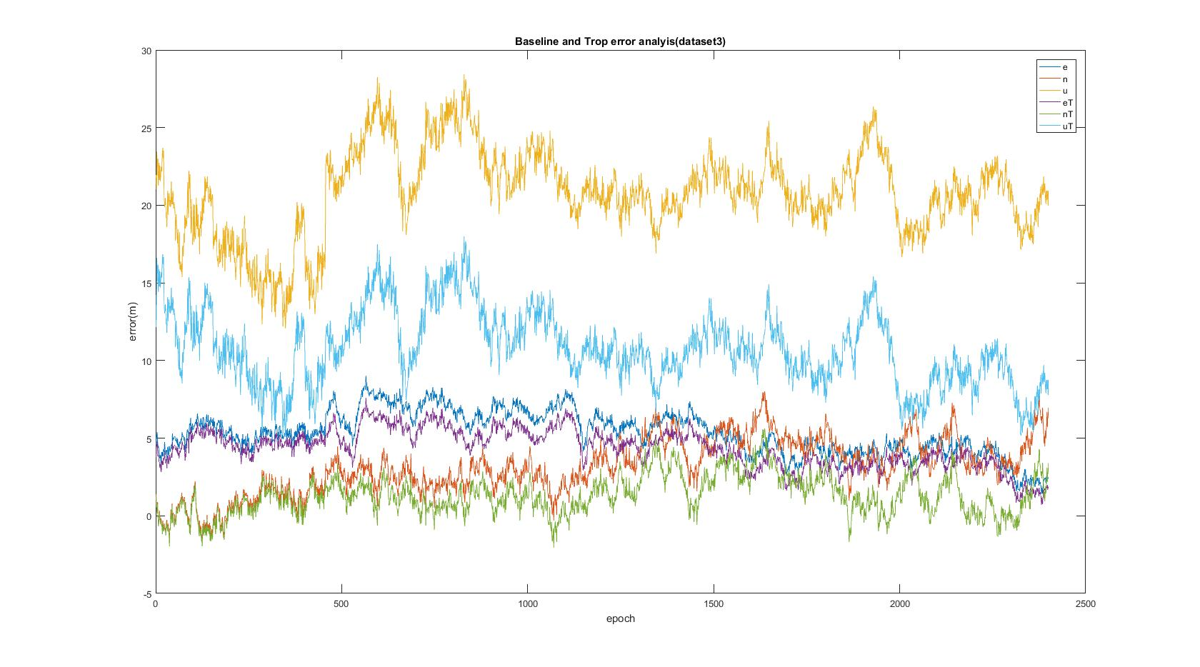

Figure 19

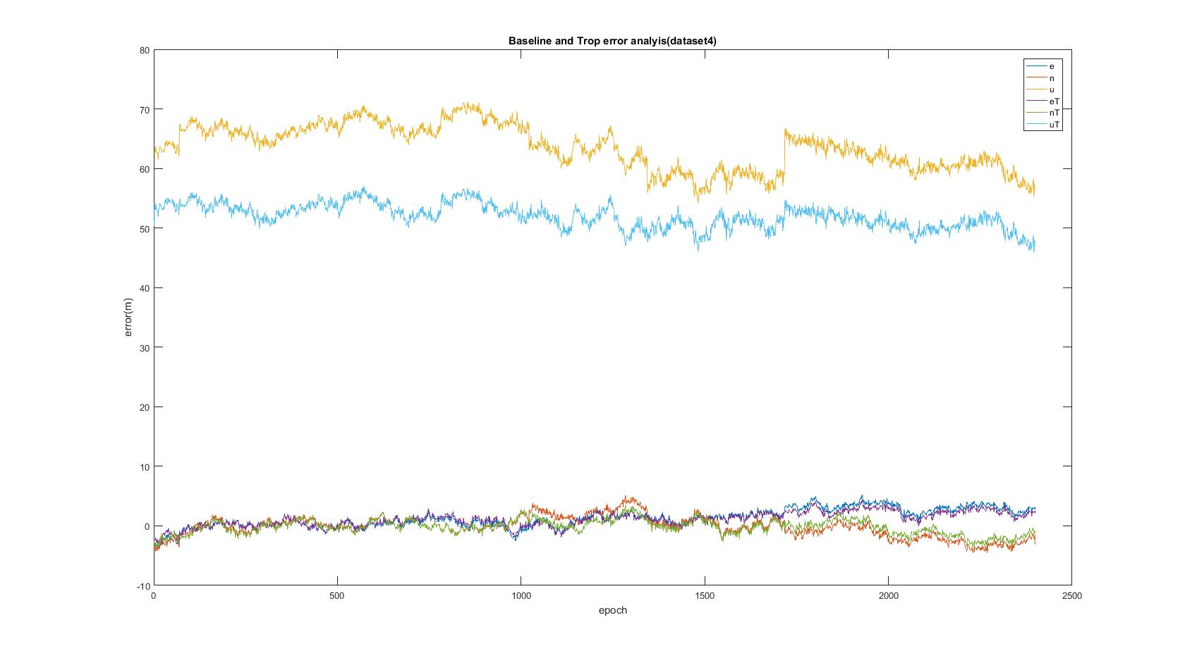

Figure 20

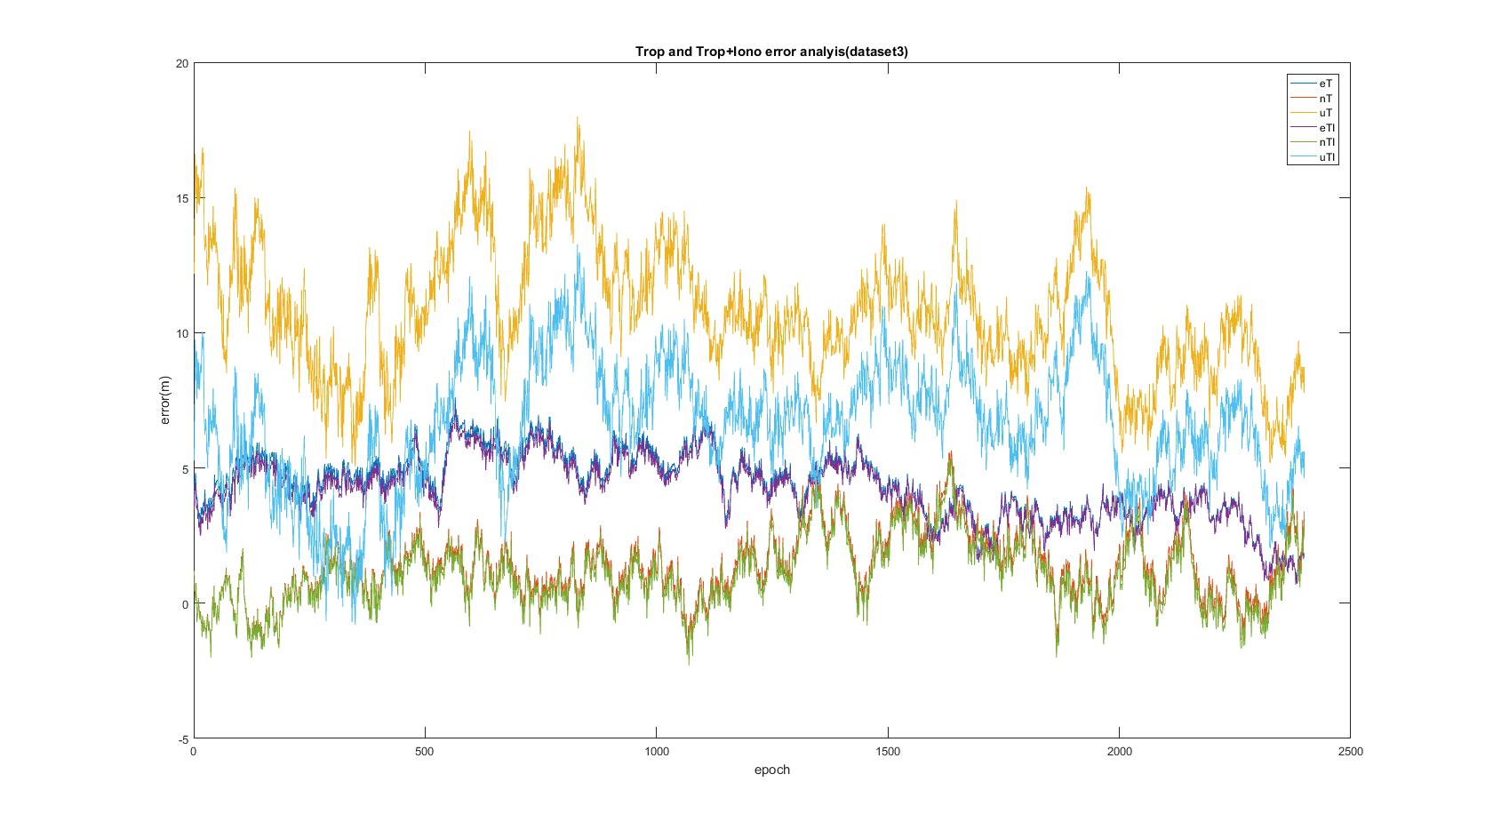

Figure 21

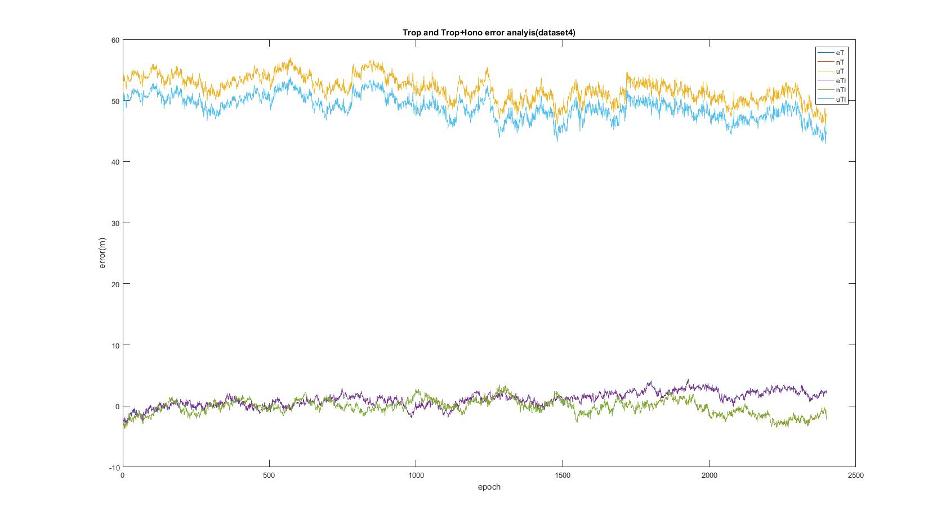

Figure 22

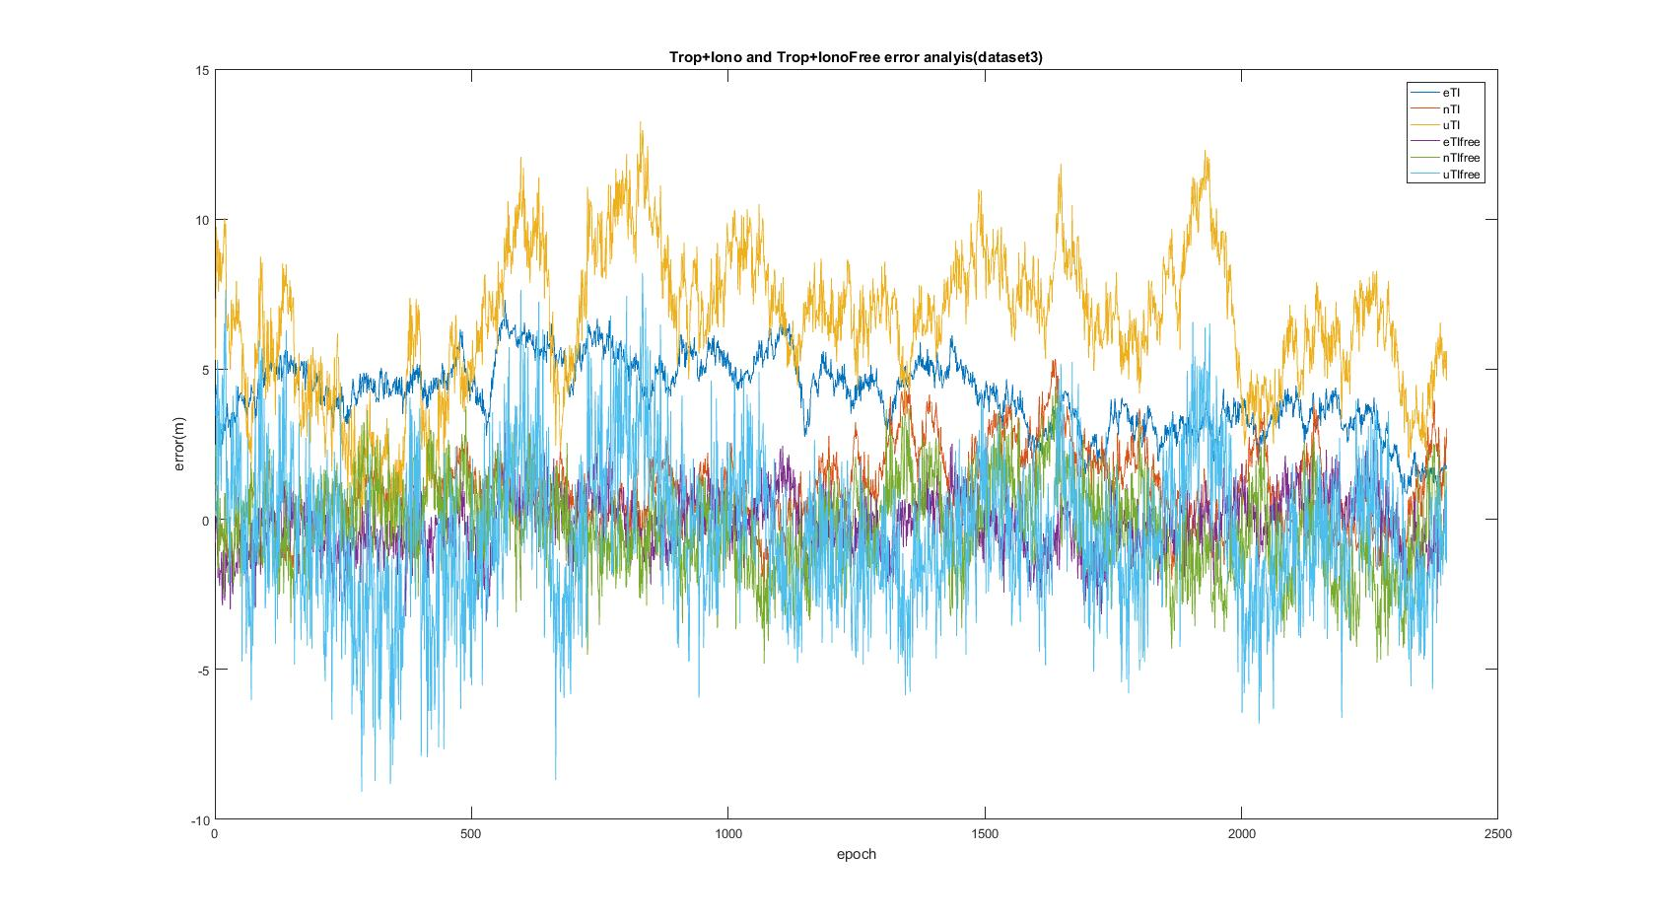

Figure 23

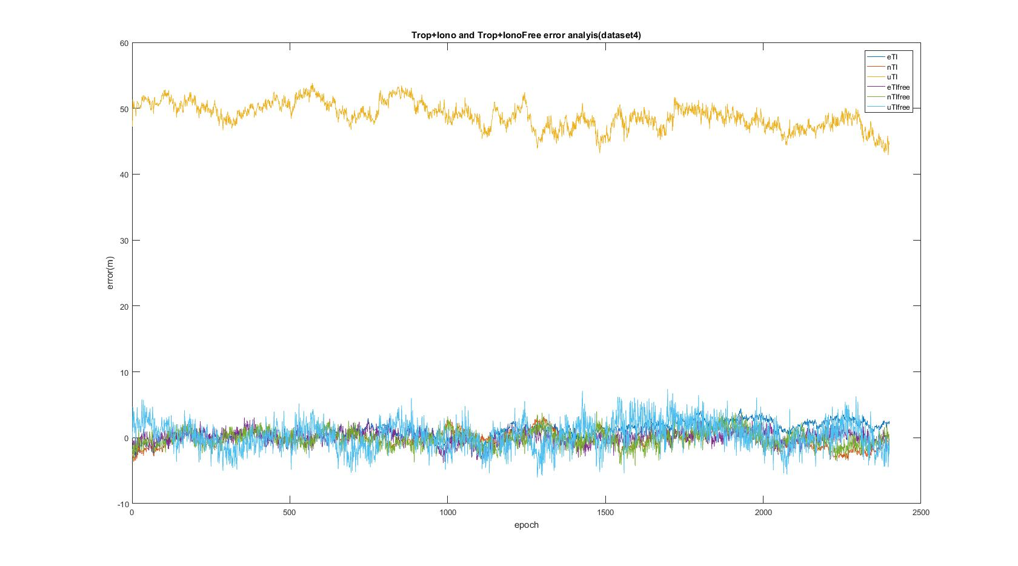

Figure 24

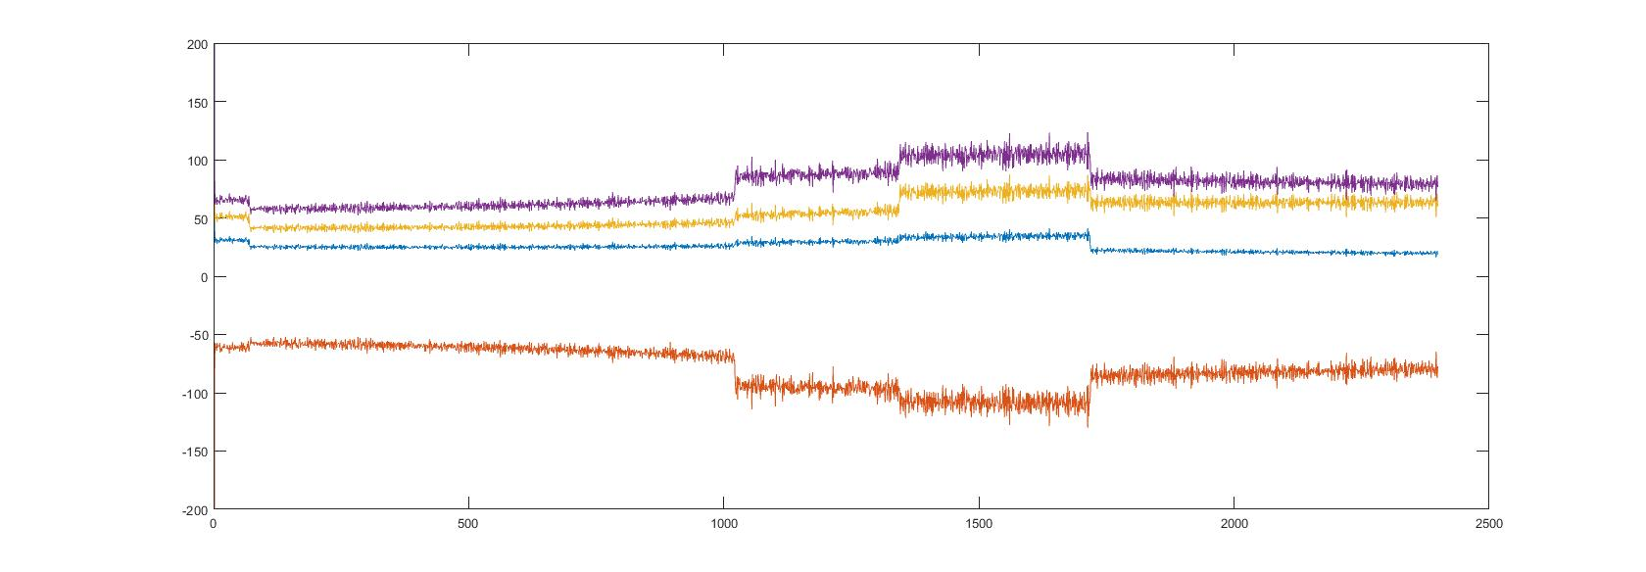

Figure 25:Postfit w/ Ionosphere delay(data set 4)

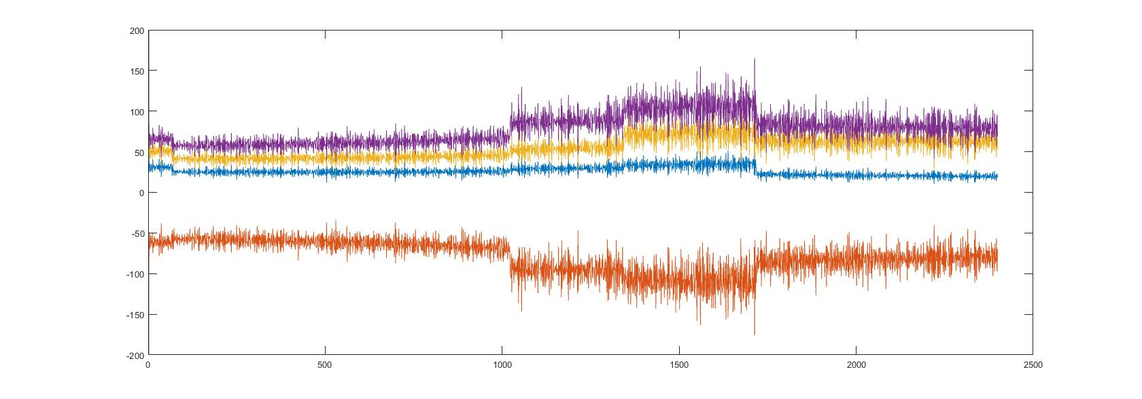

Figure 26:Postfit w/ dual frequency ionosphere free(data set 4)

# Appendix B

## Homework Problem Code

%HW 2 Problem 1

%Sean Lantto

clear all

load('dataSet4.mat')

%Setting Constants

N=2400; %number of epochs

c=299792458; %speed of light, m/s

xyznom=nomXYZ;

xyz=xyznom;

%Atmospheric considerations

trop=input('Include Troposphere delay(1 for yes 0 for no)');

if trop==1

Po=input('what is your total pressure?(mbar)');

To=input('what is your temperature?(kelvin)');

eo=input('what is your partial pressure do to water?(mbar)');

else

Po=0;

To=0;

eo=0;

end

A1=0;

A2=0;

A3=0;

A4=0;

klo=0;

tshell=0;

ion=input('Include Ionosphere delay(1 for yes, 0 for no)');

if ion==1

ionfree=0;

A1=input('define A1(sec)');

A2=input('define A2(sec)');

A3=input('define A3(sec)');

A4=input('define A4(sec)');

timeoffset=input('How many hours since begining of gps week?');

timeoffset=timeoffset*3600; %convert to seconds

whichion=input('1 for klorbuchar, 2 for thin shell');

if whichion==1

klo=1;

elseif whichion==2

tshell=1;

end

elseif ion==0

TECU=0;

ionfree=input('Would you like to use the dual-frequency iono-free model?(1=yes, 0=no)');

end

%For P1 data

for i=1:N

%Seperate out pseudorange and Satxyz for epoch i

if ionfree==0

pr=prDataP1(1:nSat(i),i);

elseif ionfree==1

pr=(2.546*prDataP1(1:nSat(i),i))-(1.546*prDataP2(1:nSat(i),i));

end

Satxyz=satsXYZ(1:nSat(i),:,i);

Nsats=nSat(i);

W=zeros(nSat(i));

llh=xyz2llh(xyz);

if ion==1

t=mod(time(i),86400)+timeoffset;

else

t=0;

end

%Create weight matrix

for x=1:nSat(i)

Satenu(x,:)=xyz2enu(Satxyz(x,:),xyznom);

sinel(x,:)=(Satenu(x,3))/(norm(Satenu(x,:)));

el(x,i)=asind(sinel(x,:)); %elevation angle

W(x,x)=sinel(x,:); %weighting matrix as a function of elevation angle

mel(x)=1/(sqrt(1-((cosd(el(x,i))/1.001).^2))); %mapping function for troposphere delay as a function of elevation angle

end

%Use function LLSPos to get xyz estimate at each epoch;

[xyzEst(:,i),clockBiasEst(:,i),PDOP(:,i),TDOP(:,i),GDOP(:,i),prefit,postFit(:,i),TECU(:,i)]=LLSPos(Satxyz,pr,nomXYZ,clockBiasNom,Nsats,c,W,trop,ion,mel,llh,Po,To,eo,A1,A2,A3,A4,t,el(:,i),klo,tshell,ionfree);

%substitute xyz estimate for epoch i to be xyz nom for epoch i+1

nomXYZ=xyzEst(:,i)';

clockBiasNom=clockBiasEst(:,i)';

for x=1:nSat(i)

preFit(x,i)=prefit(x);

end

%Find Truth ENU

xyz=truthXYZ(:,i);

orgxyz=xyznom;

enu(:,i)=xyz2enu(xyz,orgxyz);

truthenu(:,i)=enu(:,i);

%find ENU

xyz=xyzEst(:,i);

orgxyz=xyznom;

enu(:,i)=xyz2enu(xyz,orgxyz);

estenu(:,i)=enu(:,i);

RMSEenu(1,i)=sqrt(mean((estenu(1,i)-truthenu(1,i)).^2));

RMSEenu(2,i)=sqrt(mean((estenu(2,i)-truthenu(2,i)).^2));

RMSEenu(3,i)=sqrt(mean((estenu(3,i)-truthenu(3,i)).^2));

RMSEclkB(i)=sqrt(mean((clockBiasEst(i)-(truthClockBias(i)/c)).^2));

RMSE3d(:,i)=sqrt(mean((estenu(:,i)-truthenu(:,i)).^2));

end

%plot enu error

figure

diffenu=(estenu-truthenu);

diffclkB=clockBiasEst-(truthClockBias/c);

subplot(211)

plot(1:N,diffenu)

ylabel('error(m)')

xlabel('epoch')

legend('E','N','U')

title('Estimated ENU error(DataSet4)')

subplot(212)

plot(1:N,diffclkB)

ylabel('error(s)')

xlabel('epoch')

title('Estimated clock bias error(DataSet4)')

figure

subplot(311)

plot(1:N,RMSEenu)

ylabel('error(m)')

xlabel('epoch')

legend('E','N','U')

title('RMSE ENU(DataSet4)')

subplot(312)

plot(1:N,RMSE3d)

ylabel('error(m)')

xlabel('epoch')

title('RMSE 3D(DataSet4)')

subplot(313)

plot(1:N,RMSEclkB)

ylabel('error(s)')

xlabel('epoch')

title('RMSE Clock Bias(DataSet4)')

figure

plot(1:N,(prDataP1-prDataP2))

ylabel('error(m)')

xlabel('epoch')

title('Difference in observed pseudorange on L1 and L2(DataSet4)')

## Linear Least Squares Estimator

function [xyzEst,clockBiasEst,PDOP,TDOP,GDOP,prefit,postFit,TECU]=LLSPos(Satxyz,pr,nomXYZ,clockBiasNom,Nsats,c,W,trop,ion,mel,llh,Po,To,eo,A1,A2,A3,A4,t,el,klo,tshell,ionfree)

%Linear Least Squares positioning

%Sean Lantto

%pre-allocation

% prComp=zeros(nSat(i));

% uNom2Sat=zeros(nSat(i),3);

for k=1:Nsats

%find computed pseudorange for each sat in epoch i

prComp(k)=norm(Satxyz(k,:)-nomXYZ)+clockBiasNom*c;

uNom2Sat(k,:)=(Satxyz(k,:)-nomXYZ)/norm(Satxyz(k,:)-nomXYZ);

if trop==1

prComp(k)=prComp(k)+mel(k)*TropSaastamoinen(llh,Po,To,eo);

end

if ion==1

if klo==1

OFk=1+16*(0.54-(el(k)/180));

prComp(k)=prComp(k)+OFk*Iono(A1,A2,A3,A4,t,c);

TEC=Iono(A1,A2,A3,A4,t,c)*(1575420000^2)/40.3;

TECU=(TEC*OFk)/(10^16);

elseif tshell==1

TECU=0;

Rearth=6367444.5; %radius earth in meters

hi=350000; %assumed mean of the ionosphere in meters

zenangle=90-el(k); %zenith angle for satellite k

OFtshell=1/(sqrt(1-(((Rearth*sind(zenangle))/(Rearth+hi))^2)));

prComp(k)=prComp(k)+OFtshell*Iono(A1,A2,A3,A4,t,c);

end

else

TECU=0;

end

end

%Estimate position without atmosphere

G=horzcat(-uNom2Sat,ones(Nsats,1)); %form geometery matrix for each epoch

H=inv(G'*W*G);

%find deltaRho and Delta X

deltaRho=pr-prComp';

dX=H*G'*W*deltaRho;

%estimate position and clock bias

xyzEst=nomXYZ'+dX(1:3);

clockBiasEst=clockBiasNom+(dX(4)/c);

PDOP=sqrt(H(1,1)+H(2,2)+H(3,3));

TDOP=sqrt(H(4,4));

GDOP=trace(H);

prefit=deltaRho;

postFit=pinv(H')*H'*H*dX;

end

## Ionosphere Function

function IzL1=Iono(A1,A2,A3,A4,t,c)

%generates Ionospheric zenith delay on L1 using klorbachur model

if abs(t-A3)<(A4/4)

IzL1c=A1+A2*cos((2*pi*(t-A3))/A4);

else

IzL1c=A1;

end

IzL1=IzL1c*c;

End

## Troposphere Function

function Tropo=TropSaastamoinen(llh,Po,To,eo)

Tzd=0.002277*(1+0.0026*cos(2*llh(1))+0.00028*llh(3))*Po;

Tzw=0.0022777*((1255/To)+0.05)*eo;

Tropo=Tzd+Tzw;

end