POC evaluation steps: Jenkins Auto Deployment to web server.

1. Web site hosted on NGINX – red hat server. Plain site to update on regular basis

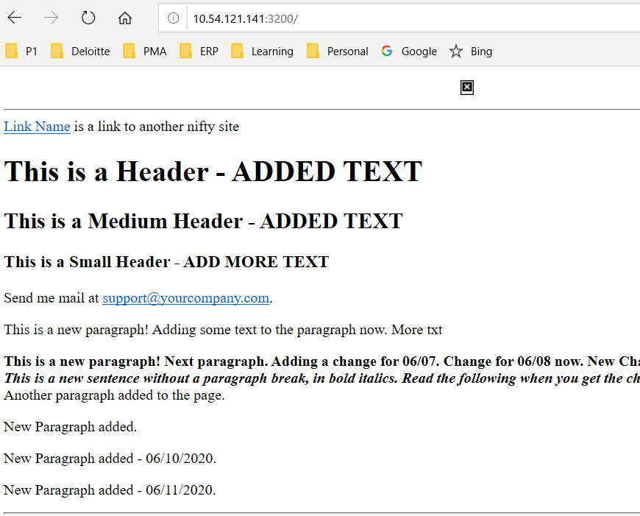

1. Update content html, php, js, css file etc on editors by web dev.

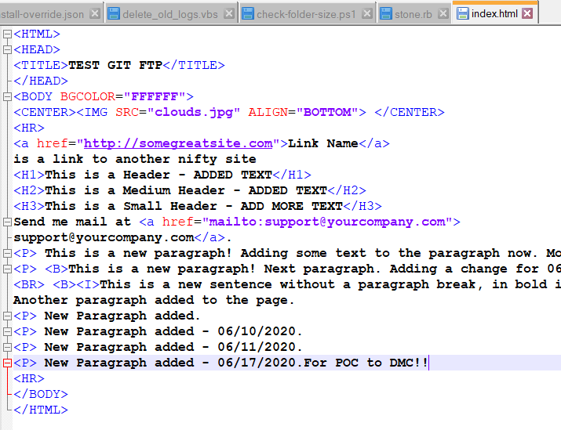

1. Commit the change to the git repo assigned to the project

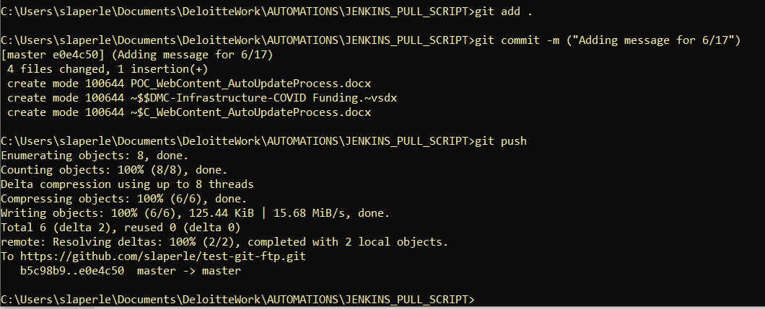

1. Jenkins site activity will display the job auto configured to deploy the content from repo to the web server (NGINX). Jenkins Pipeline Job below is test-ftp – shows it auto processed within a few mins of the commit to repo above.

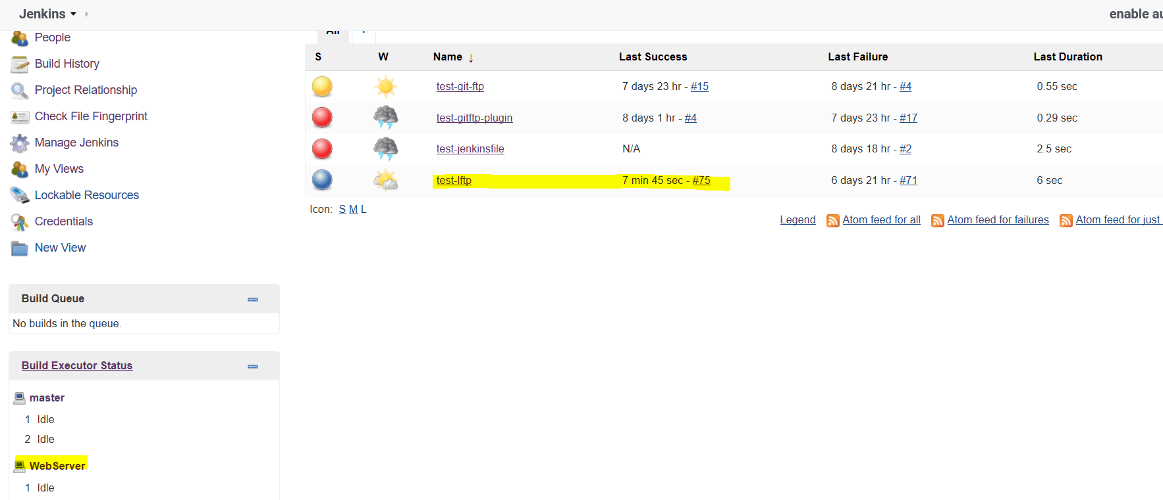

* Some info on the Jenkins build and process shows the commit message from the repo, and changes summary.

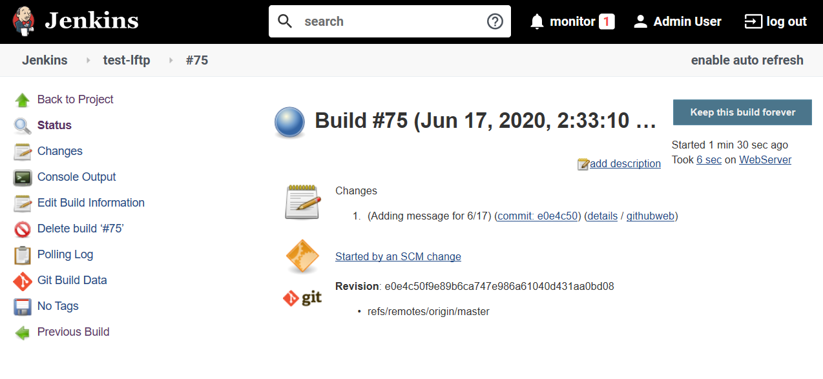

* The console output shows the process in detail, showing the update and changes made to the files in the repo which get pushed to the web server node.

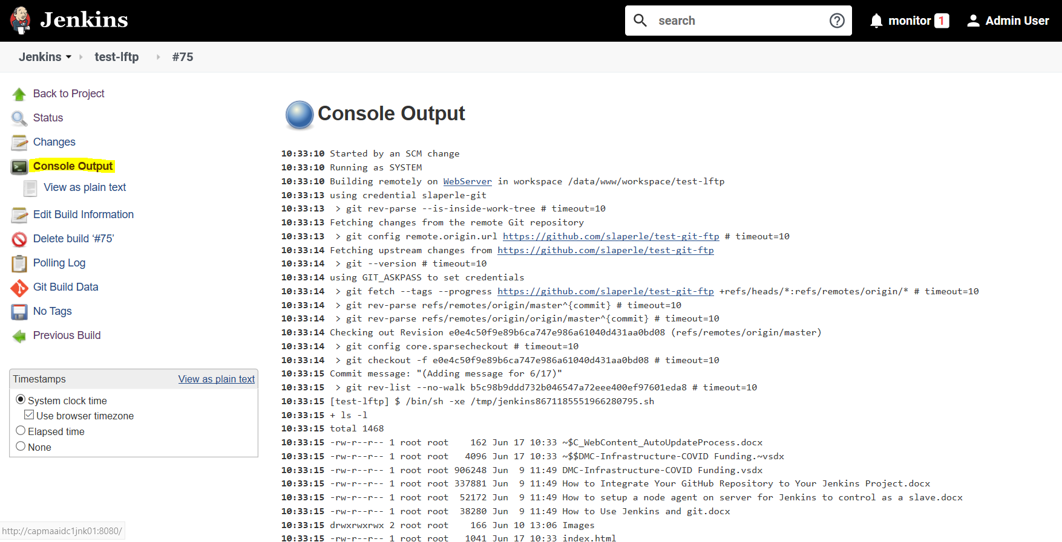

1. Refresh on the web site will keep the site content updated

