Treadmill Controller Wiring Guide
Single treadmill • StampPLC and StamPLC AC • Firmware revision 5 • 16 September 2026
This guide covers the installed controller connections and checks before operation. The four-wire optical sensor still needs its exact model confirmed; its cable colors are not an approved pinout.

Wiring overview
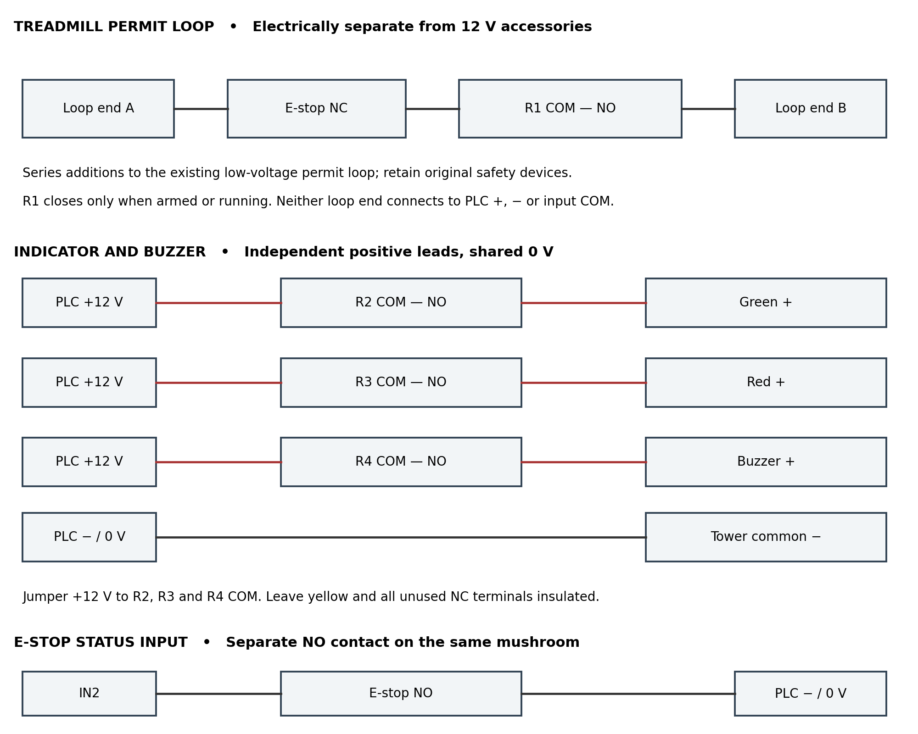
Logical connections are shown, not the physical terminal order. Use the printed COM, NO and NC markings on each relay. NC means closed when unactuated; NO means open when unactuated. The input COM is a different terminal from each relay COM.
The treadmill remains on its original mains supply. R1 and the mushroom NC interrupt only its verified low-voltage stop or permit circuit. This arrangement does not disconnect treadmill mains power.

Power and terminal connections
Isolate the controller and treadmill supplies before wiring. The StamPLC AC provides 12 V at up to 1 A total through the side connection, shared by the controller and accessories. Its AC relay output is unused and kept off by this sketch. [1]
Connection | Destination or purpose
Controller supply line | Through the selected controller branch fuse to the StamPLC AC line input. Verify the fuse rating and type for the module, wiring and installation.
Controller supply neutral | StamPLC AC neutral input. Follow the module markings; never identify terminals by position alone.
Protective earth | Protective-earth terminal and exposed conductive parts requiring bonding. Keep the treadmill protective earth intact; do not switch or fuse it.
StamPLC AC side connector | Mates directly with StampPLC. Do not add an independent supply in parallel.
StampPLC + | 12 V accessory supply when powered by this AC module; verify with a meter before connection.
StampPLC − | DC 0 V return for sensor, light tower and E-stop NO status circuit.
Input COM | Jumper to StampPLC + for this NPN/sinking input arrangement. Do not jumper it to −.
AC switched output | Leave unconnected and guarded. It is a mains output, not a spare isolated dry-contact relay.

The branch fuse protects the controller supply wiring; it does not protect the treadmill motor circuit. Mains wiring, fuse coordination and bonding must be checked for the actual supply and local installation. Route mains separately from the permit loop, sensor and FRAM wiring.

Relay assignments
Relay | COM connection | NO connection
R1 treadmill | One side of the verified permit-loop interruption | Other side, through the mushroom NC contact in series
R2 green | +12 V accessory supply | Tower green positive lead
R3 red | +12 V accessory supply | Tower red positive lead
R4 buzzer | +12 V accessory supply | Tower buzzer positive lead

Tower common negative connects to −. This requires independent red, green and buzzer inputs. Do not assume wire colors from another light model. Yellow is unused. The unused NC terminal shares its relay COM; do not use R1 NC as a PLC feedback input.

Inputs and optical sensor
The input channels share one input COM. For a sinking sensor, M5Stack specifies COM connected to the sensor supply positive. [2]
Input | Connection
IN1 optical count | Verified NPN output from the optical interrupter. Sensor supply goes to +12 V and its return to − only if its rated supply includes 12 V.
IN2 E-stop status | One terminal of the separate mushroom NO contact. The other NO terminal connects to −. Pressing the mushroom closes this circuit.
IN3 through IN8 | Unused; leave disconnected.
Input COM | One jumper to +12 V, shared by IN1 and IN2.

The mushroom NC contact belongs only in the treadmill permit loop. Its NO contact belongs only between IN2 and −. Do not electrically bridge the two circuits. A broken wire in the NO status circuit cannot be detected as an E-stop press; EST OK is not proof that the NC circuit is intact.

Four wire optical sensor pending identification
Do not assign the white wire by color. It may be another output or a mode input. Leave it individually insulated until the exact sensor diagram is checked. Brown for positive, blue for return and black for output are common conventions, not confirmation for this unit. Confirm supply voltage, NPN versus PNP, output function and white-wire requirements before energizing the sensor.
If the sensor is PNP, the input arrangement must be reviewed together with IN2 because COM is shared. Do not change the COM jumper for only one input. No 12 V sensor wire connects directly to an ESP32 GPIO or the Grove I2C pins.

FRAM connection
StampPLC PORT A | MB85RC256V connection
Yellow wire / GPIO2 | SDA
White wire / GPIO1 | SCL
Black wire / GND | GND
Red wire / 5 V | Only a breakout supply input explicitly rated for 5 V with compatible I2C levels. Never connect to bare 3.3 V VCC.
Regulated 3.3 V supply | VCC for a bare 3.3 V breakout; I2C pull-ups must also use 3.3 V.

Preserve the already working FRAM power arrangement. Firmware expects address 0x50; on an adjustable bare board this normally means A0, A1 and A2 low, with write protection disabled. Confirm the breakout markings. Keep I2C wiring short and inside the enclosure. PORT A pin colors above are the M5 cable mapping, distinct from the optical sensor cable. [2]

Assembly and test checks
- Use labeled distribution connectors for +12 V and 0 V. Do not force multiple wires into a terminal unless the terminal is rated for them. Label IN1, IN2 and both ends of the permit-loop wires.
- For short, low-current sensor and signal wiring, 22 AWG stranded wire is a practical choice where the terminals accept it. Size accessory feeds for their combined current and length. Mains conductor size, insulation and protection need a separate installation check; signal-wire sizing is not a mains specification.
- With power isolated and the treadmill disconnected, check R1 COM–NO is open when the relay is unpowered. Check mushroom NC continuity when released and open circuit when pressed; check the separate NO contact does the opposite.
- Power only the controller. Measure + to − for approximately 12 V. Confirm R1 remains off at startup. Check the sum of controller, sensor and indicator loads against the AC module budget.
- Press and release the mushroom: EST must change between STOP and OK. This unit uses the tested inverted E-stop setting. Do not change wiring solely to match an assumed firmware polarity.
- After identifying and connecting the optical sensor, move the flag slowly through the slot. OPT must alternate. With the treadmill disconnected, set a small target from the web page, hold B for one second and release, then generate known pulses. Confirm one count per flag cycle and R1 off at target.
- Verify green on R2 while armed or running, red on R3 while stopped, and a brief buzzer command on R4 at a stop. Confirm the completed count stays displayed. Hold C for three seconds and release: Reset OK - stopped should appear and R1 must remain off.
- Before connecting the treadmill, verify from its own documentation and testing that opening this particular low-voltage loop stops it, and restoring the loop requires a separate manual start. Retain original safety devices. A qualified installer should validate the completed stop circuit.
- Test the installed system with no person on the treadmill: E-stop, target stop, pulse timeout, power loss and restart. Record the actual coast-down. The saved target count marks the stop command, not an exact mechanical stopping position.

Reference documents
[1] M5Stack StamPLC AC documentation and linked schematic: https://docs.m5stack.com/en/stamplc/StamPLC_AC
[2] M5Stack StamPLC documentation and IO schematic: https://docs.m5stack.com/en/core/StamPLC
Project assignments and operating checks: StampPLC_Treadmill_Controller.ino revision 5. Confirm terminal markings on the installed hardware. Sensor model, light lead functions and the treadmill permit-loop endpoints remain equipment-specific.

