Title Goes Here

Myfirstname Mylastname1,✉, and Yourfirstname Yourlastname2

09 June, 2020

Text of abstract

1 University of One Place  
2 University of Another Place

✉ Correspondence: [Myfirstname Mylastname <[fl@oneplace.edu](mailto:fl@oneplace.edu)>](mailto:fl@oneplace.edu)

Keywords: keyword 1; keyword 2; keyword 3

Highlights: These are the highlights.

# Introduction

Here is a citation (Marwick, 2017)

# Background

|  |  |
| --- | --- |
| Part | Name |
| 600 | Magnuson-Stevens Act Provisions |
| 622 | Fisheries of the Caribbean, Gulf of Mexico, and South Atlantic |
| 635 | Atlantic Highly Migratory Species |
| 648 | Fisheries of the Northeastern United States |
| 660 | Fisheries Off West Coast States |
| 665 | Fisheries in the Western Pacific |
| 679 | Fisheries of the Exclusive Economic Zone Off Alaska |
| 680 | Shellfish Fisheries of the Exclusive Economic Zone Off Alaska |
| 697 | Atlantic Coastal Fisheries Cooperative Management |
| # Metho | ds |

# Results

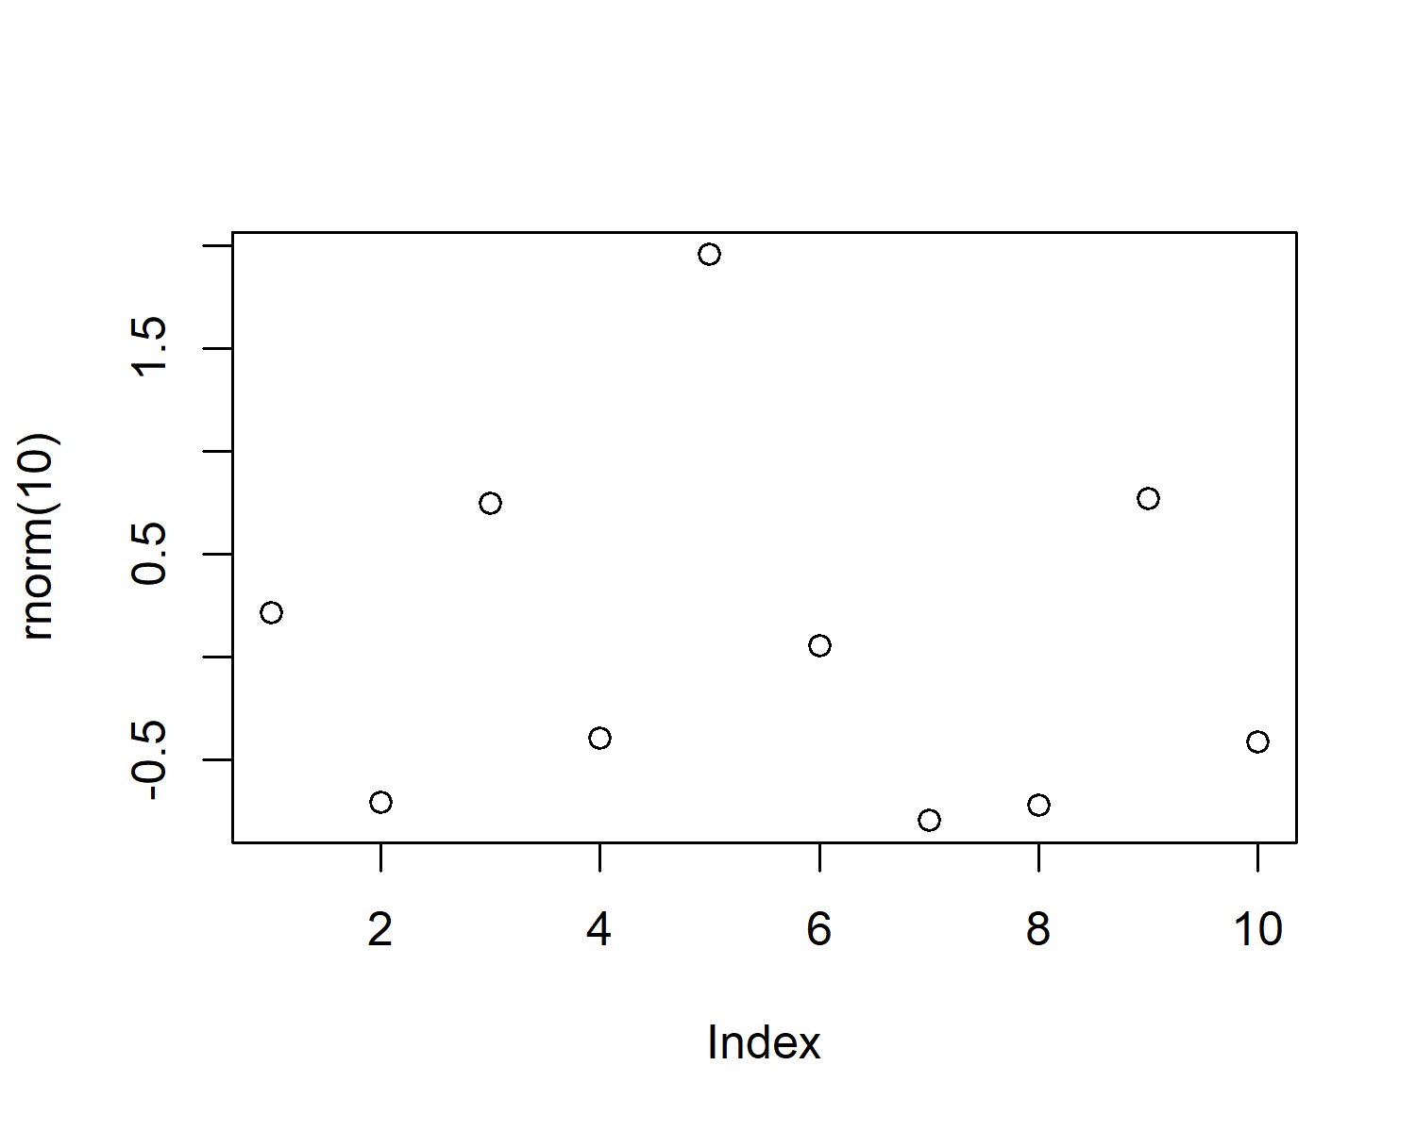

Figure 1: A plot of random numbers

Figure 1 shows how we can have a caption and cross-reference for a plot

Here is an example of inline code 3.14 in the middle of a sentence.

# Discussion

# Conclusion

# Acknowledgements

# References

Marwick, B., 2017. Computational reproducibility in archaeological research: Basic principles and a case study of their implementation. Journal of Archaeological Method and Theory 24, 424–450. <https://doi.org/10.1007/s10816-015-9272-9>

### Colophon

This report was generated on 2020-06-09 12:24:25 using the following computational environment and dependencies:

#> - Session info ---------------------------------------------------------------  
#> setting value   
#> version R version 3.6.1 (2019-07-05)  
#> os Windows 10 x64   
#> system x86_64, mingw32   
#> ui RTerm   
#> language (EN)   
#> collate English_United States.1252   
#> ctype English_United States.1252   
#> tz America/New_York   
#> date 2020-06-09   
#>   
#> - Packages -------------------------------------------------------------------  
#> package * version date lib source   
#> assertthat 0.2.1 2019-03-21 [1] CRAN (R 3.6.1)   
#> backports 1.1.5 2019-10-02 [1] CRAN (R 3.6.1)   
#> bookdown 0.18 2020-03-05 [1] CRAN (R 3.6.3)   
#> callr 3.4.3 2020-03-28 [1] CRAN (R 3.6.3)   
#> cli 2.0.2 2020-02-28 [1] CRAN (R 3.6.3)   
#> crayon 1.3.4 2017-09-16 [1] CRAN (R 3.6.1)   
#> desc 1.2.0 2018-05-01 [1] CRAN (R 3.6.1)   
#> devtools 2.2.2.9000 2020-03-30 [1] Github (r-lib/devtools@f77c14e)  
#> digest 0.6.25 2020-02-23 [1] CRAN (R 3.6.3)   
#> ellipsis 0.3.0 2019-09-20 [1] CRAN (R 3.6.3)   
#> evaluate 0.14 2019-05-28 [1] CRAN (R 3.6.1)   
#> fansi 0.4.1 2020-01-08 [1] CRAN (R 3.6.3)   
#> fs 1.3.2 2020-03-05 [1] CRAN (R 3.6.3)   
#> glue 1.3.2 2020-03-12 [1] CRAN (R 3.6.3)   
#> highr 0.8 2019-03-20 [1] CRAN (R 3.6.1)   
#> htmltools 0.4.0 2019-10-04 [1] CRAN (R 3.6.3)   
#> knitr 1.28 2020-02-06 [1] CRAN (R 3.6.3)   
#> magrittr 1.5 2014-11-22 [1] CRAN (R 3.6.1)   
#> memoise 1.1.0 2017-04-21 [1] CRAN (R 3.6.1)   
#> pkgbuild 1.0.6 2019-10-09 [1] CRAN (R 3.6.3)   
#> pkgload 1.0.2 2018-10-29 [1] CRAN (R 3.6.1)   
#> prettyunits 1.1.1 2020-01-24 [1] CRAN (R 3.6.3)   
#> processx 3.4.2 2020-02-09 [1] CRAN (R 3.6.3)   
#> ps 1.3.2 2020-02-13 [1] CRAN (R 3.6.3)   
#> R6 2.4.1 2019-11-12 [1] CRAN (R 3.6.3)   
#> Rcpp 1.0.4 2020-03-17 [1] CRAN (R 3.6.3)   
#> remotes 2.1.1 2020-02-15 [1] CRAN (R 3.6.3)   
#> rlang 0.4.6 2020-05-02 [1] CRAN (R 3.6.3)   
#> rmarkdown 2.1 2020-01-20 [1] CRAN (R 3.6.3)   
#> rprojroot 1.3-2 2018-01-03 [1] CRAN (R 3.6.1)   
#> sessioninfo 1.1.1 2018-11-05 [1] CRAN (R 3.6.1)   
#> stringi 1.4.6 2020-02-17 [1] CRAN (R 3.6.2)   
#> stringr 1.4.0 2019-02-10 [1] CRAN (R 3.6.1)   
#> testthat 2.3.2 2020-03-02 [1] CRAN (R 3.6.3)   
#> usethis 1.6.1 2020-04-29 [1] CRAN (R 3.6.3)   
#> withr 2.1.2 2018-03-15 [1] CRAN (R 3.6.1)   
#> xfun 0.12 2020-01-13 [1] CRAN (R 3.6.3)   
#> yaml 2.2.1 2020-02-01 [1] CRAN (R 3.6.2)   
#>   
#> [1] C:/Users/scott.large/Documents/R/win-library/3.6  
#> [2] C:/Program Files/R/R-3.6.1/library

The current Git commit details are: