Arts Club of IISER Kolkata

Introduction
Arts Club of IISER Kolkata is undoubtedly the ultimate powerhouse for creativity in the campus, where all forms of imagination and visual expression are celebrated under one roof. Unlike a laboratory or classroom environment, this student body run club enlivens the student community through a variety of events and activities. This club is a great community that often partners with the various other Club for activities in order to integrate multiple fields, conducts various workshops on watercolors, charcoal paintings, paper crafting and digital arts, etc. The club operates and is managed by students themselves, including elected Office Bearers and club members.

CURRENT OFFICE BEARERS :
Tenure 26-27
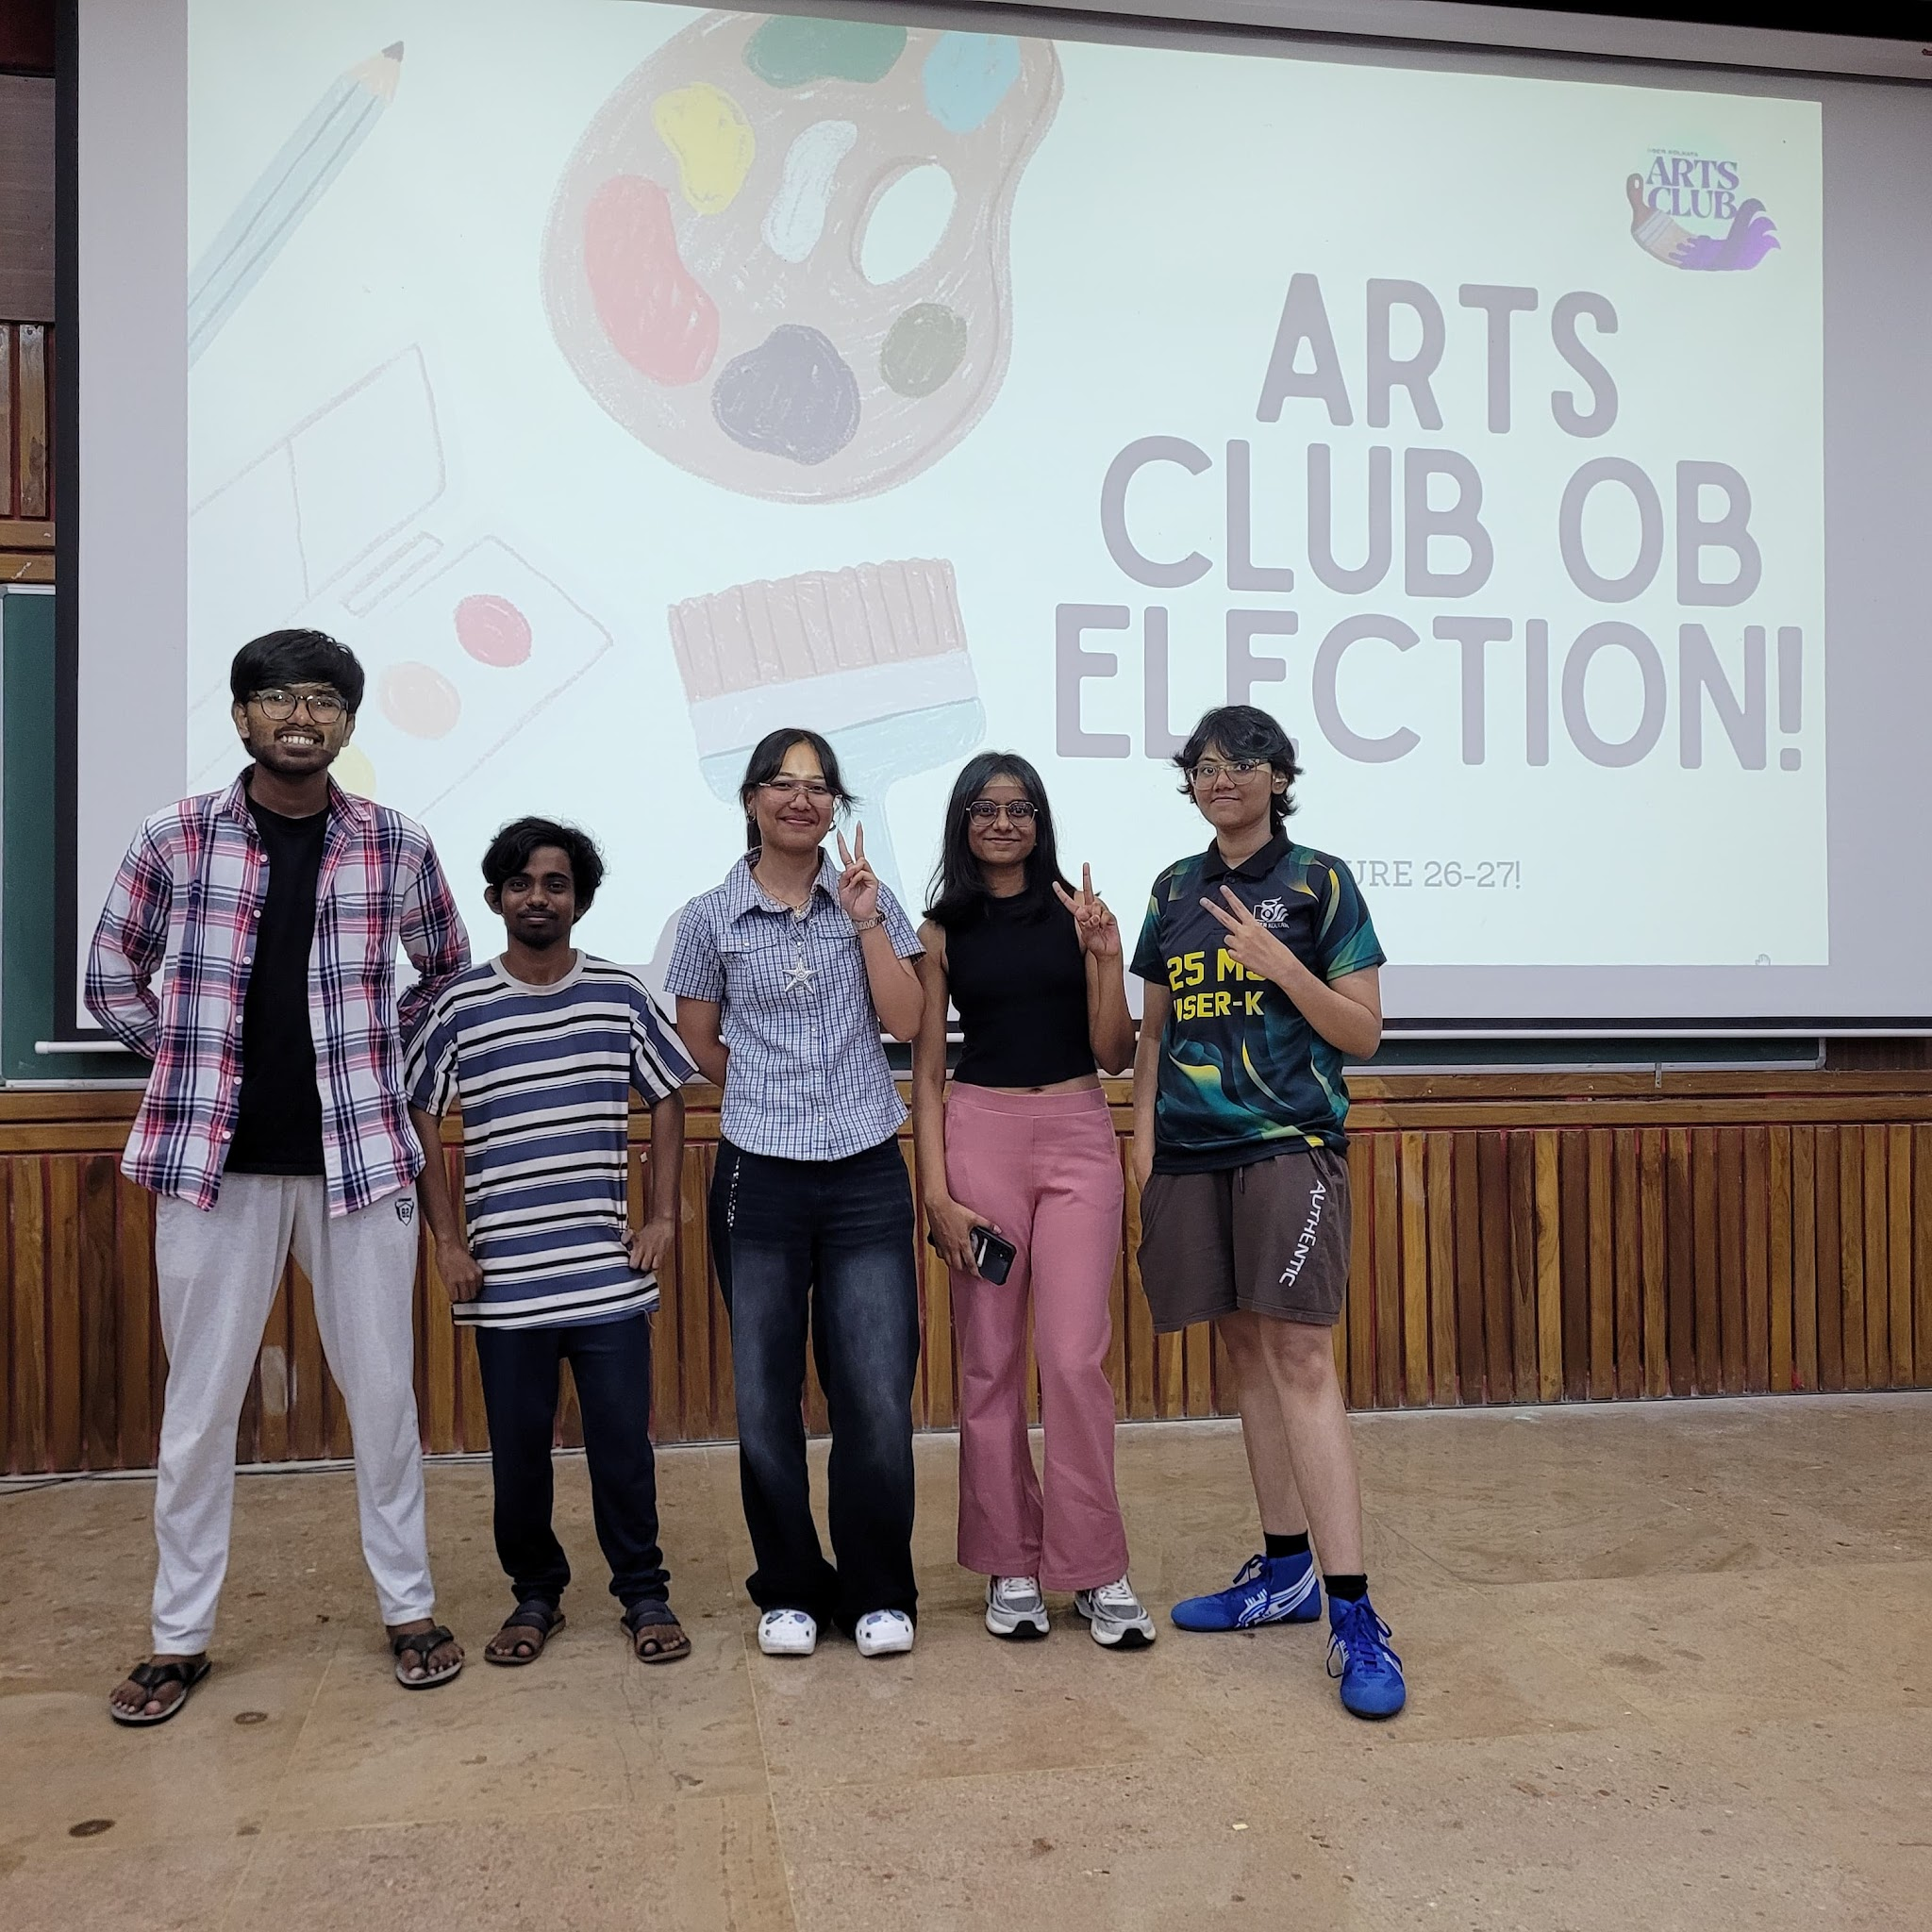
(L-R;Omkar,Soumik,Ritisneha,Moupiya,Samadrita)
Name | Position | E-mail ID | Phone No.
Omkar Shinde | Secretary | oss25ms034@iiserkol.ac.in | +91 9823787760
Soumik Roy | Convener | sr24ms009@iiserkol.ac.in | +91 6299325462
Samadrita Saha | Treasurer | ss25ms057@iiserkol.ac.in | +91 8900626325
Moupiya Mondal | Event Organiser | mm25ms282@iiserkol.ac.in | +91 8017425916
Ritisneha Shyamali | Social Media Manager | rs25ms076@iiserkol.ac.in | +91 9707732565

PREVIOUS OFFICE BEARERS

Tenure | Secretary | Convener | Treasurer | Event Organiser | Social Media Manager | OB Mentor
2025-2026 | Nandita Sriram | Harman | Shristi Chanda | Soumik Roy | Ruksana Taj
2024-2025 | Sneha Chakraborty | Nandita Sriram | Tanisha Nath | - | -
2023-2024 | Rounak Mukhopadhyay | Aikya Banerjee | Ditsa Roy
2022-2023 | Kusumita Pradhan | Fathima Anjum EC | Sourashis Das
2021-2022 | Trishita Patra | Biyas Choudhury | Baivab Kumar Saha
2020-2021 | Aesha Lahiri | Mukil M | Sourin Chatterjee

Flagship Events
1.Chitrakavyam
Chitrakavyam is an exhibition-cum-auction that celebrates the artistic talents of our student community. The event provides a platform for students to showcase their paintings and creative works while also giving them an opportunity to sell them to interested buyers.
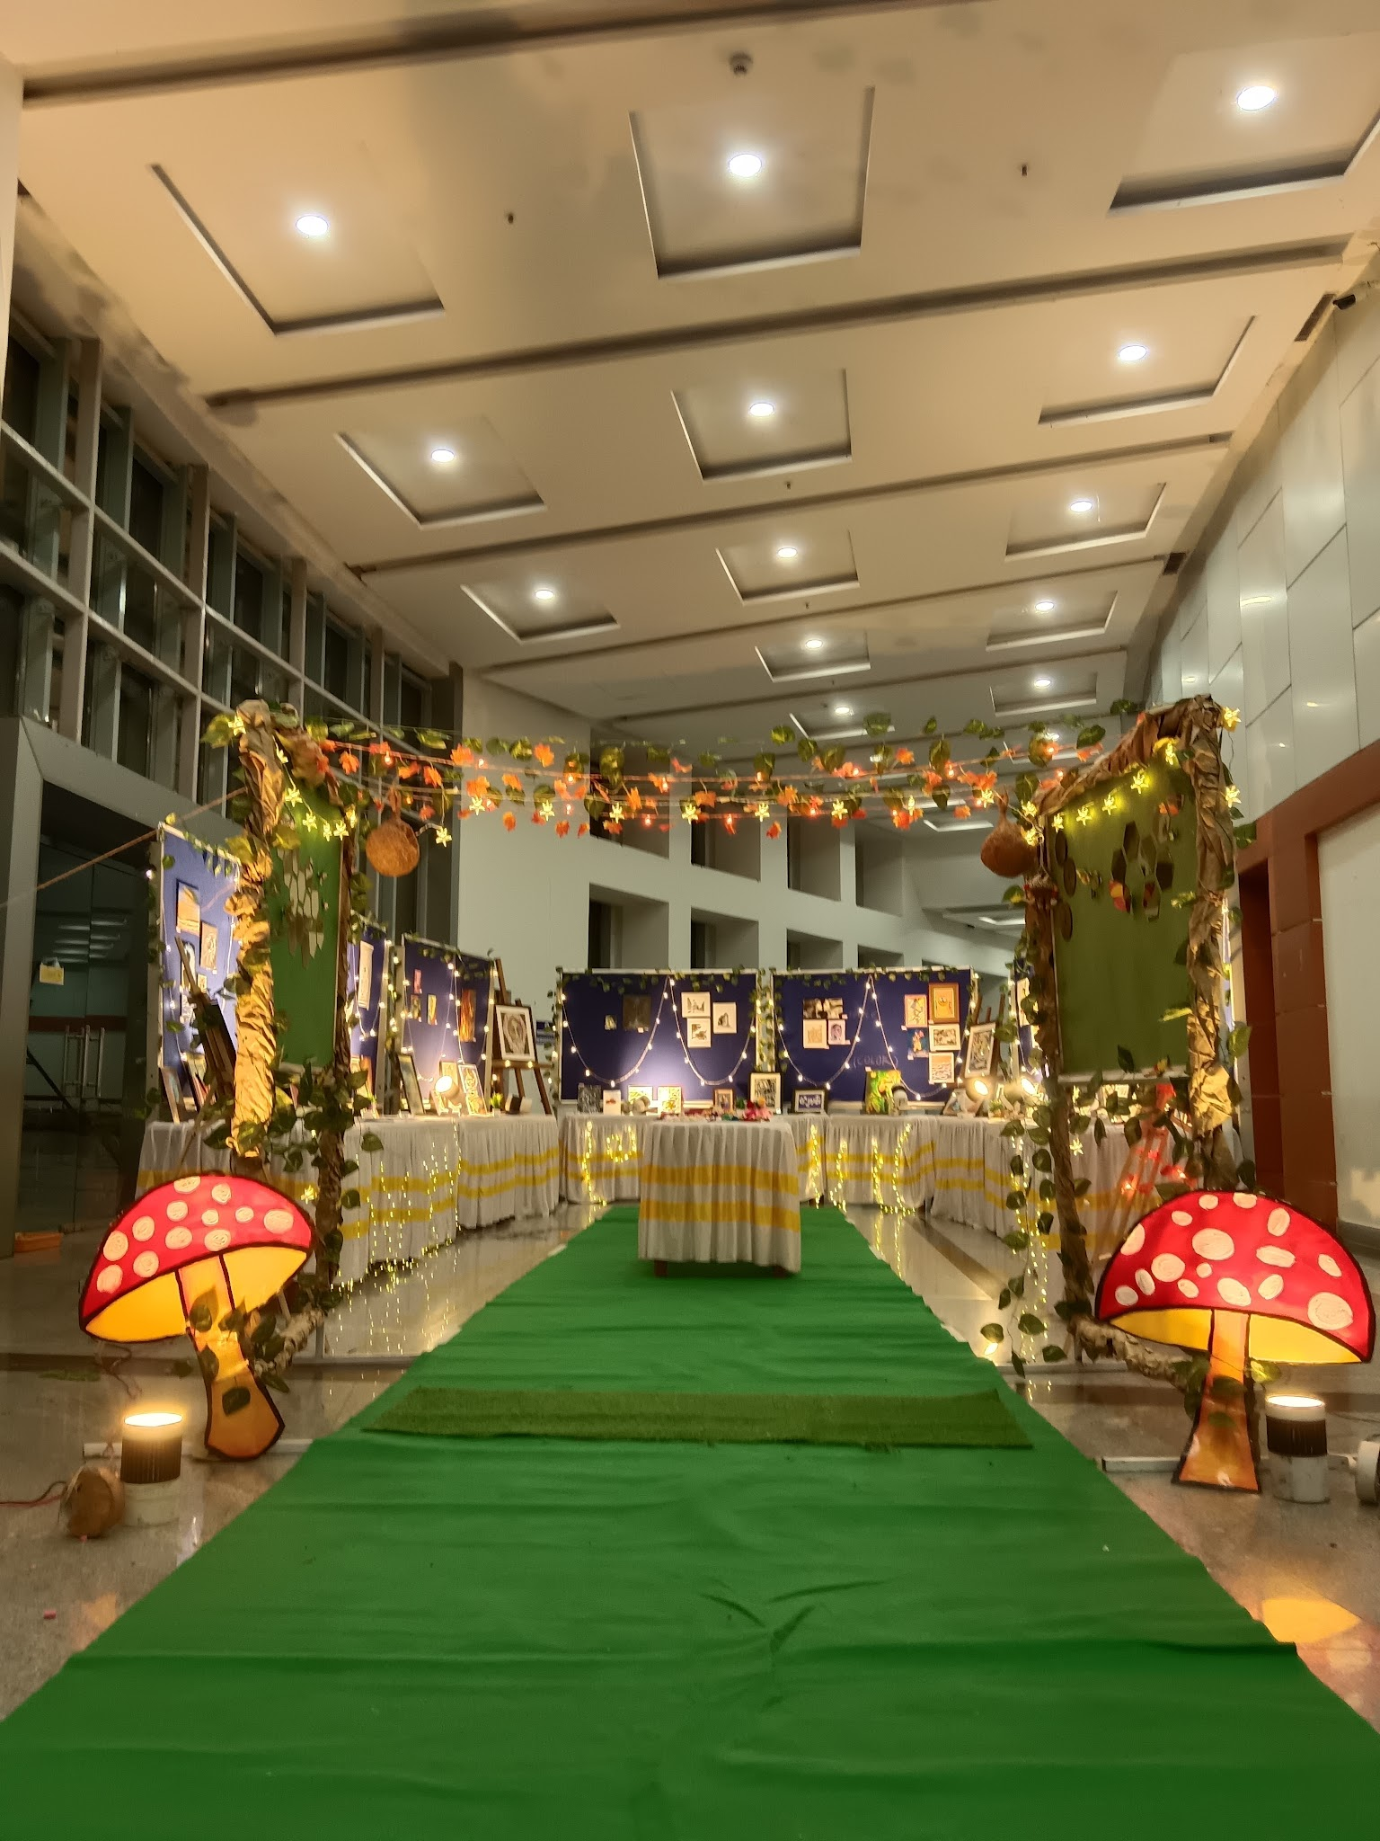

2. Halloween
Halloween Party is a celebration packed with spooky fun and entertainment. From the costume party and escape room challenges to the DJ night and interactive stalls, the event offers an exciting experience where students can dress up, socialize, and enjoy a memorable evening together.

Social media
Insta
https://www.instagram.com/arts_club_iiserk/
Facebook
https://www.facebook.com/1214318562031239/
Email
arts.activity@iiserkol.ac.in
Whatsapp
https://chat.whatsapp.com/LYvsjScmj8i8pMR6H7abUi

