Intro of the Club
By the students, for the students.
IISER Kolkata Campus Radio (IKCR) is the definitive voice of the student community. From the vibrant celebrations of campus culture to the pressing issues thar affect our daily lives, we are here to bridge the gap. Whether its highlighting student grievances, addressing administrative policies, or capturing the unique, everyday occurrences around the campus. If it happens at IISER K you’ll hear it here.
Unfiltered, unbiased, and unapologetically student-first. Tune in to stay connected.
Email: radiok@iiserkol.ac.in

Past OBs
Tenure | CEO  (Chief Executive Officer) | COO  (Chief Operating Officer) | CFO  (Chief Financial Officer) | PRO  (Public Relations Officer) | OB Mentor
25-26 | Samarjit Das (24MS071) | Aditya Das (24MS073) | Aditya Haldar (24MS072) | Agnish Mandal (24MS092) | Dhruba Sinha (22MS194)
24-25 | Dhruba Sinha (22MS194) | Swaraj Ray (22MS186)  & Sourajit Das (22MS185) | Hrishikesh Sen (22MS065) | Amrut Milind Phutane (22MS206)  & Pragyan Goswami (23MS168) | -
23-24 | Dhruba Sinha (22MS194) | Swaraj Ray (22MS186)  & Sourajit Das (22MS185) | Madhura Narayan Joshi (22MS221) | Hrishikesh Sen (22MS065)  & Rohan Roy (20MS110) | -
22-23 | Aritra Das (21MS061) | Sayantan Khan (20MS041)  & Swarnendu Saha (20MS152) | Mohit Srivastava (21MS194) | Ram Kripal Singh Yadav (21MS082)  & Rithwik Raina (21MS050) | -
21-22 | Tanisha Garg (20MS080) | Hanna Huvaiz (20MS132)  & Isha Bhagwat Paresh (19MS130) | Sumit Garai (18MS062) | Adrija Adhikary (19MS124)  & Sreetama Bhaduri (20MS095) | -
20-21 | Diptatanu Das (17MS004) | Adrija Adhikary (19MS124)  & Kaustav Gangopadhyay (15RS048) | Debdeep Chatterjee (17MS003) | Sumit Garai (18MS062)  & Akhil Kumar Nandi (17MS014) | -

Current OBs (Tenure 2026-2027)
CEO (Chief Executive Officer)  Rishiraj Chatterjee  Contact no-  Email- rc25ms165@iiserkol.ac.in  Photo  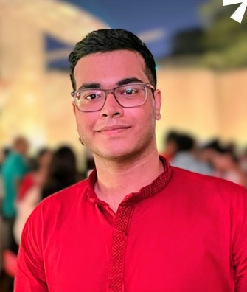 | COO (Chief Operating Officer)  Arkadeep Bandyopadhyay  Contact no-  Email- ab24ms191@iiserkol.ac.in  Photo  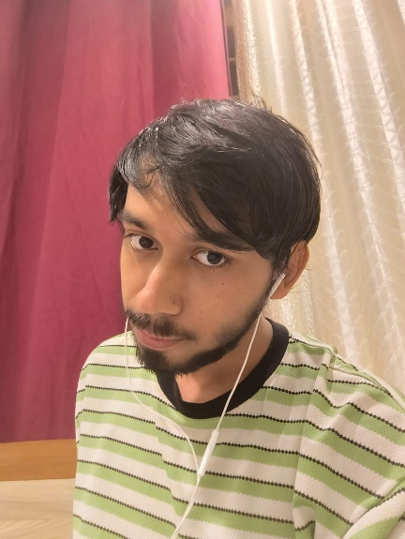
COO (Chief Operating Officer)  Nitin Kumar  Contact no-  Email- nk25ms061@iiserkol.ac.in  Photo  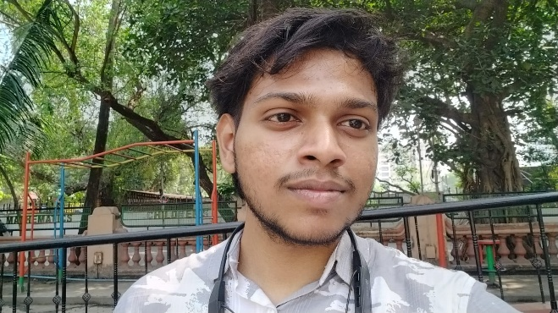 | CFO (Chief Financial Officer)  Arham Alam  Contact no-  Email- aa25ms075@iiserkol.ac.in  Photo  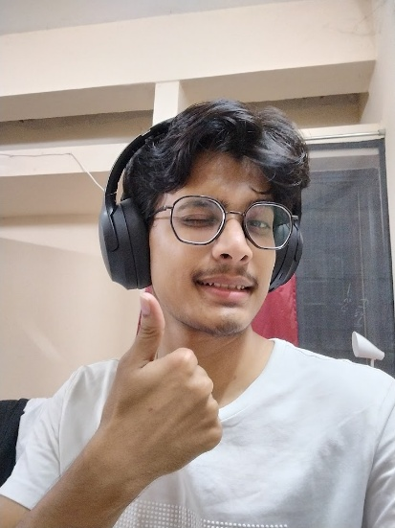
PRO (Public Relations Officer)  Anwesha Mondal  Contact no-  Email- am24ms054@iiserkol.ac.in  Photo  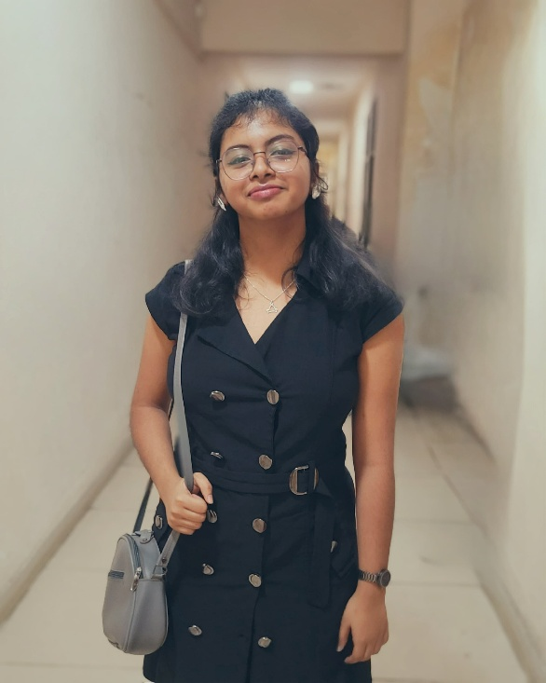 | PRO (Public Relations Officer)  Barkha Debbarma  Contact no-  Email- bd25ms116@iiserkol.ac.in  Photo  

Events and Photos
Flagship events of IISER Kolkata Campus Radio include
Smarane Rabindranath
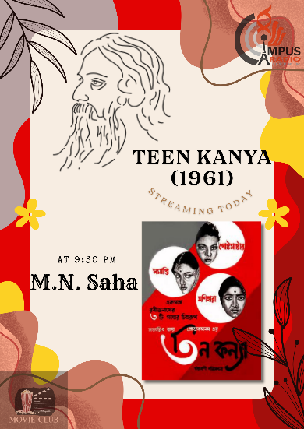
Mahishasur Mardini
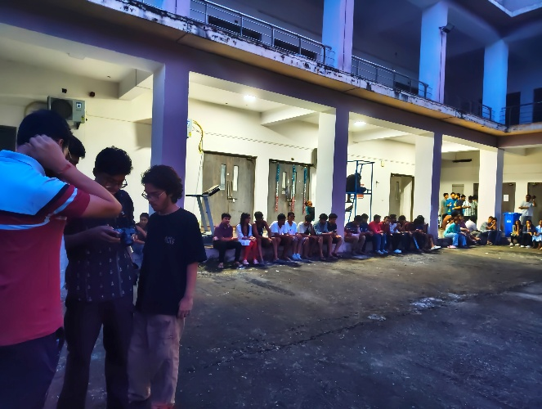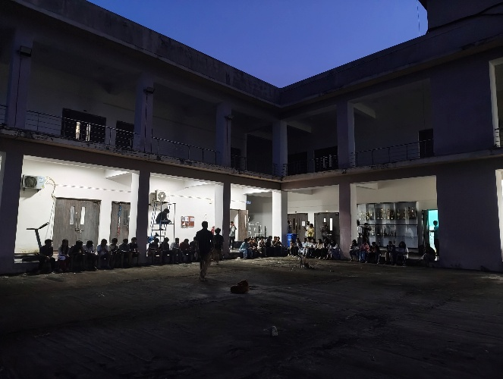
Parakram Divas (Netaji Jayanti)
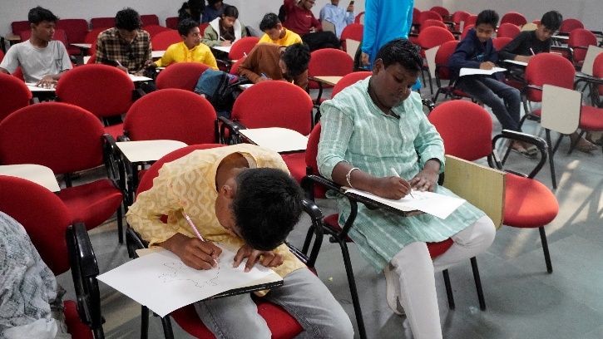
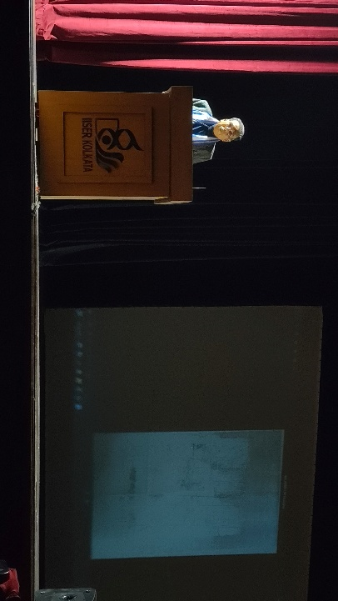
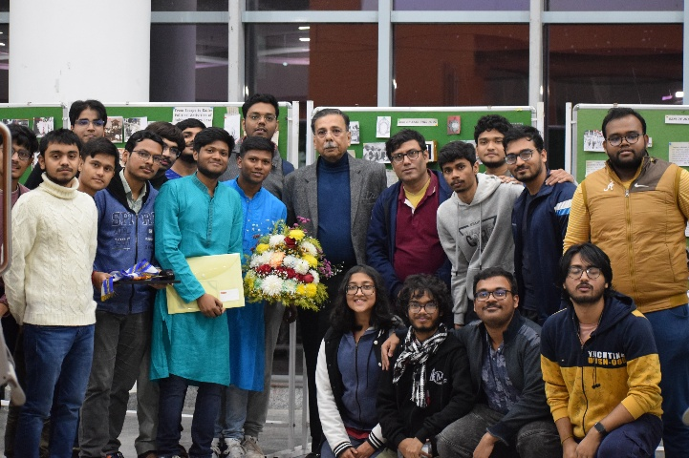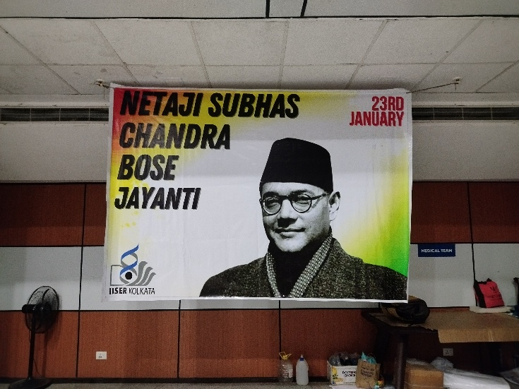
Cupidology
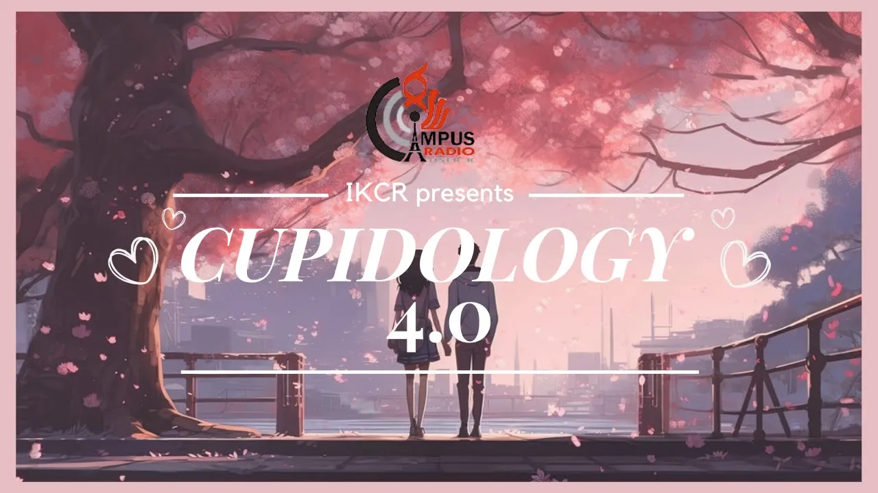

Not Just this, Campus Radio does coverage of events all throughout the year
Including but not limited to

Sport Tournaments
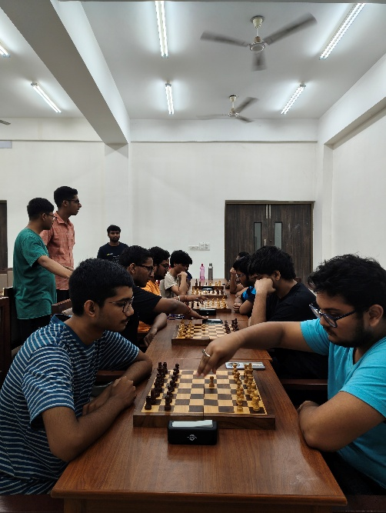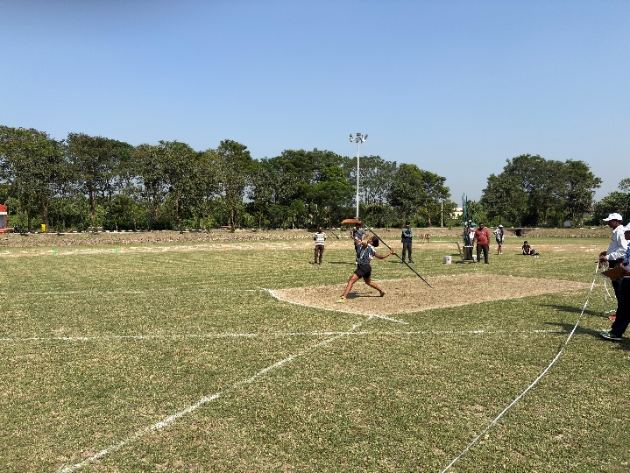

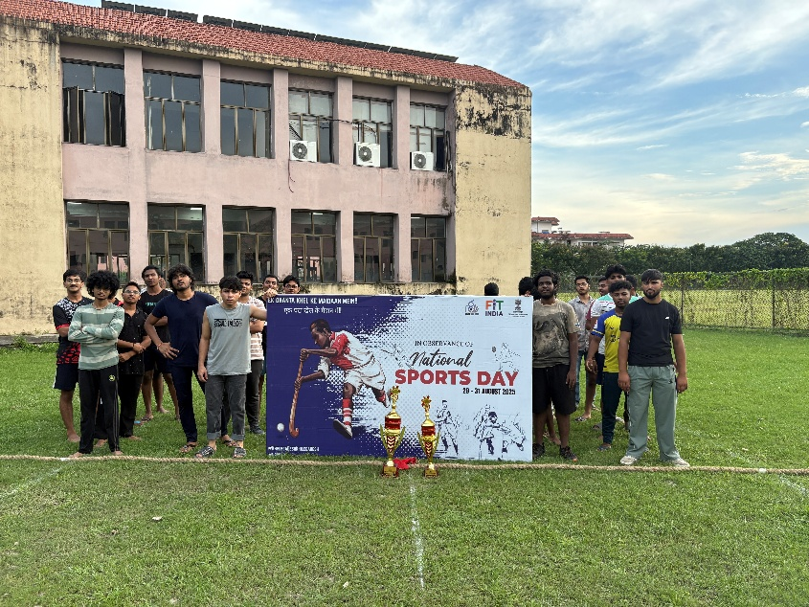
Cultural Events
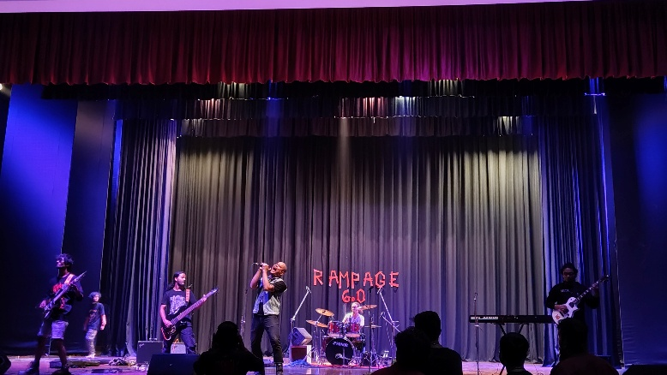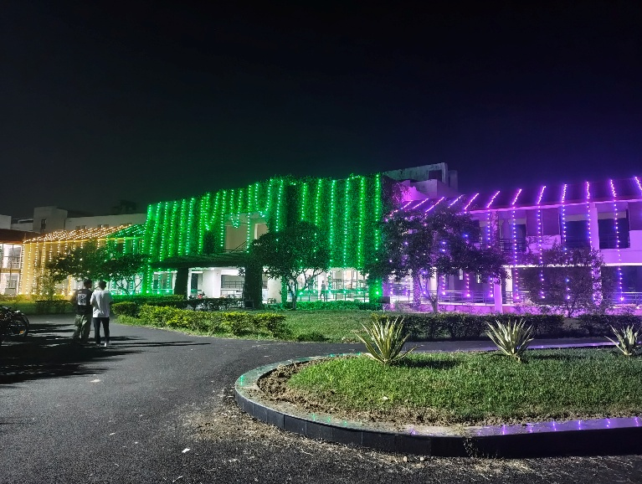
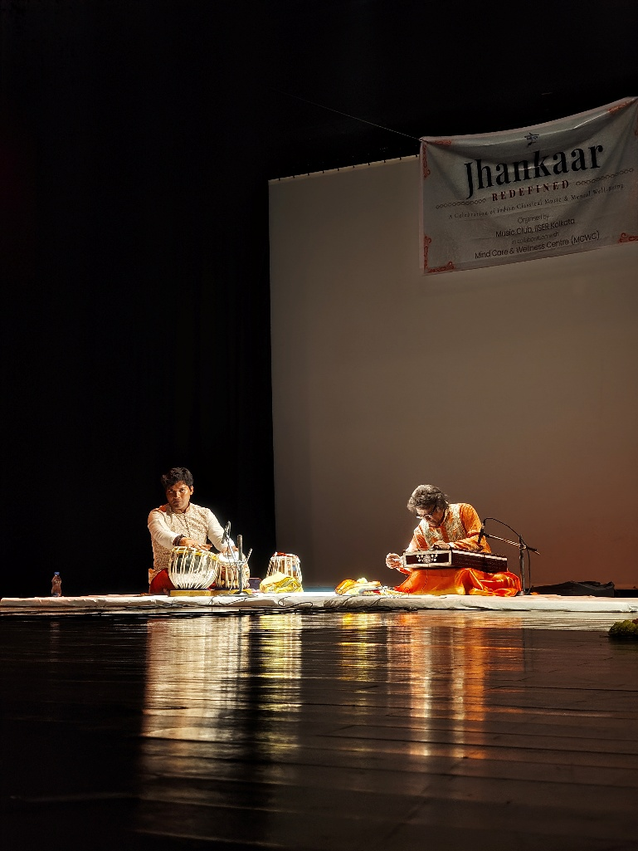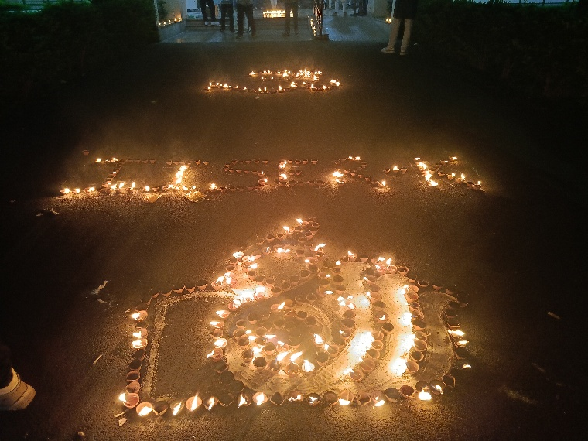
Orientations and Elections
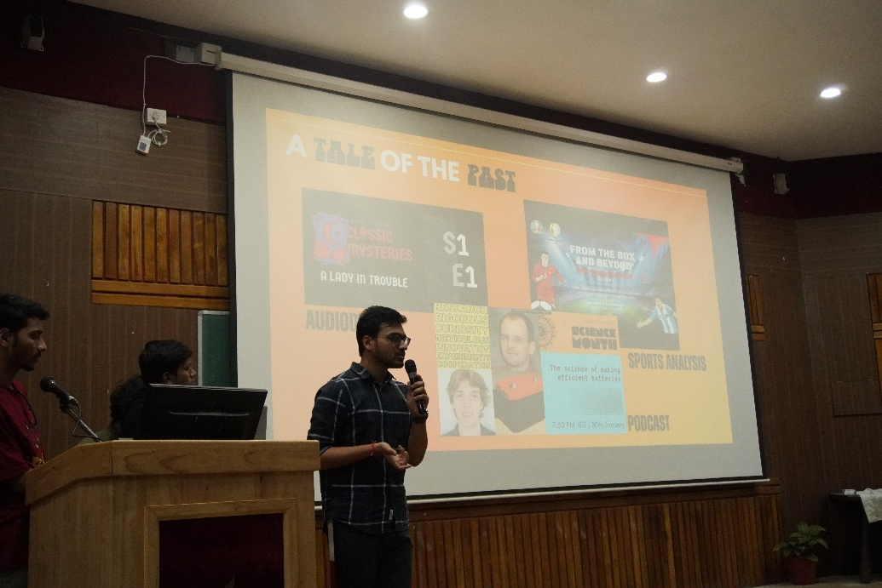
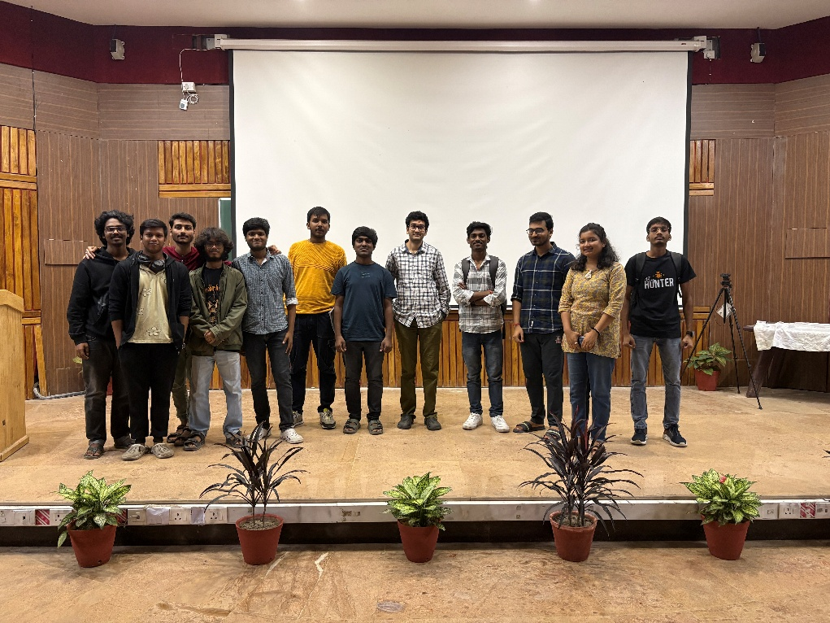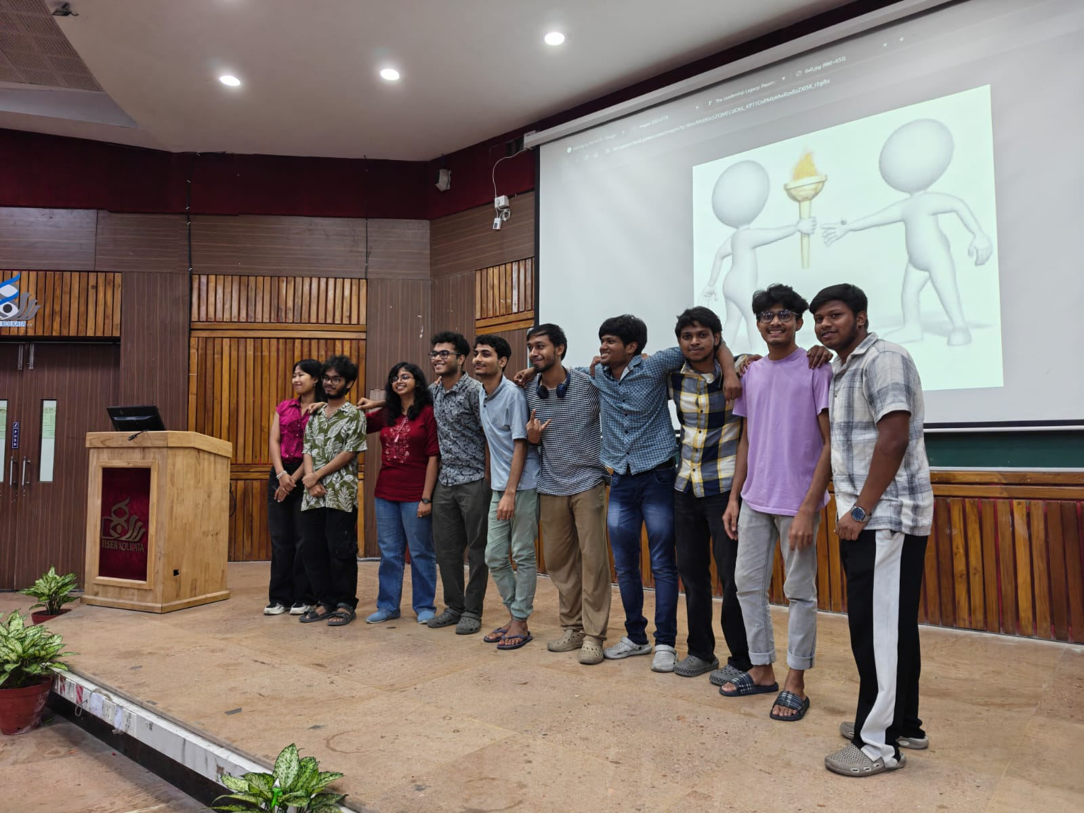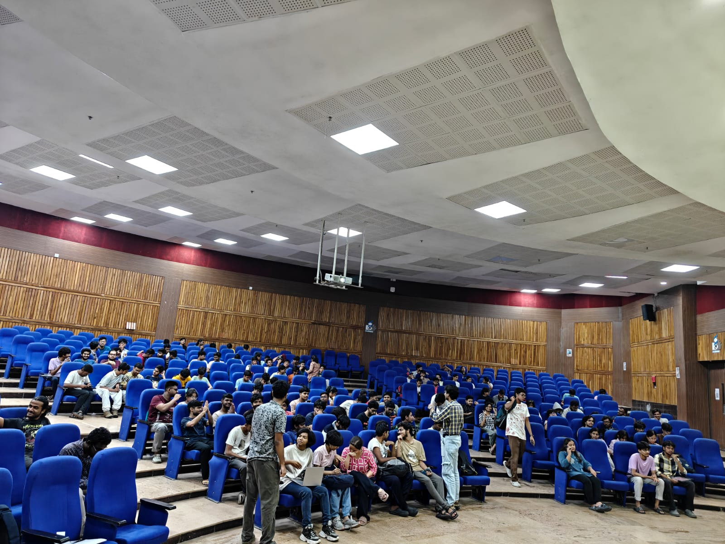

Interviews
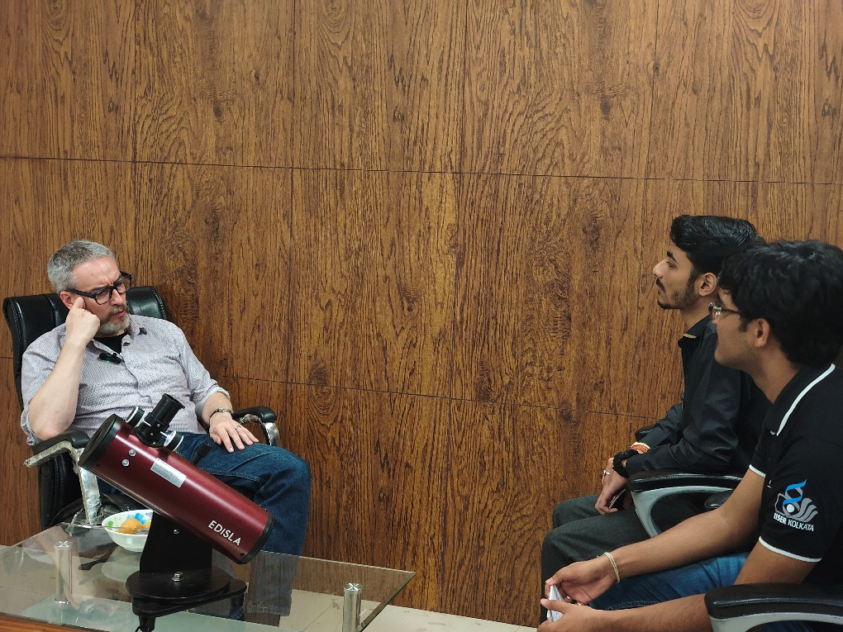
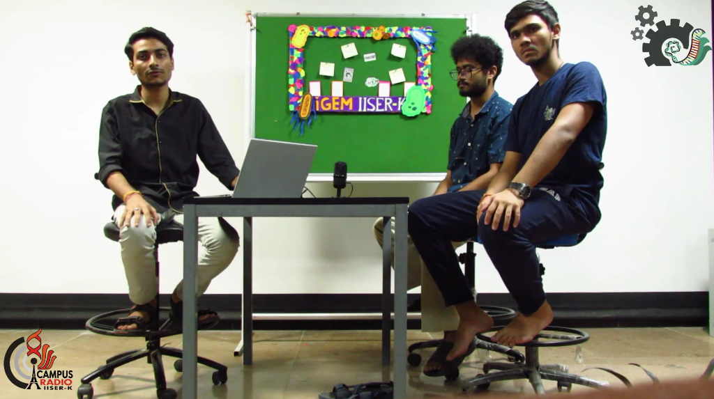
National Science Day
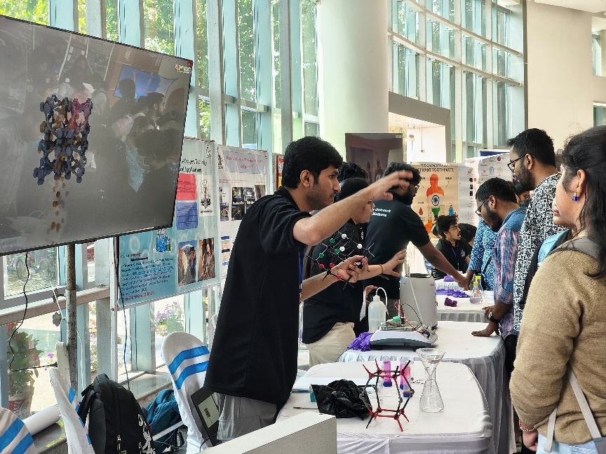
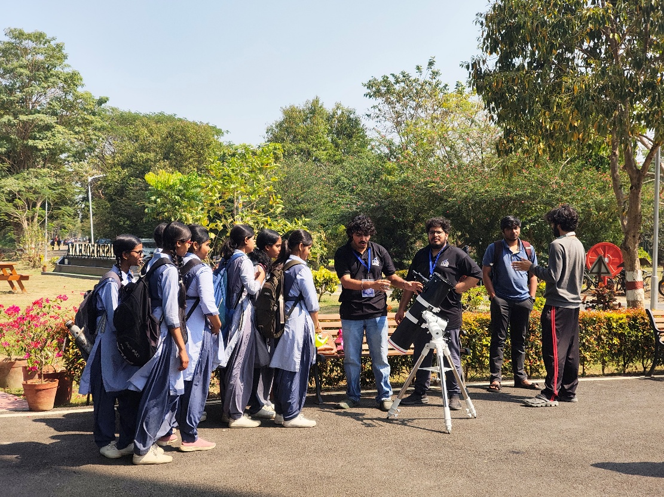

IICM Achievements
2025 IICM didn’t have the campus radio specific event of Bandwidth (radio jockey)
2024 IICM IISER Kolkata received no position in Bandwidth Event
2023 IICM IISER Kolkata received Gold Medal in this first ever edition of Bandwidth
Here is the link to the Gold Performance https://youtu.be/CqRT4dx6g2M?si=ga7uD381KE4K-iKf

Social Media Handles


