Intro of the Club
Movie Club is set to provide all enthusiastic people here at IISER K with an exquisite taste in movies.
We stream, we craft, we develop films, believing in the idea that if you love movies enough, you can make a good one. A club which brings people from different backgrounds, cultures, tastes and social skills together, under the banner of love for movies.
Email: movie.activity@iiserkol.ac.in

Current OBs (Tenure 2026-2027)
Secretary  Samarjit Das  Contact no- 8761072134  Email- sd24ms071@iiserkol.ac.in  Photo  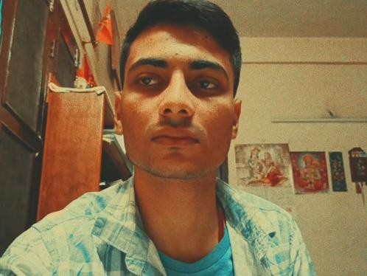 | Convener  Snigdho Biswas  Contact no- 8100109448  Email- sb25ms055@iiserkol.ac.in  Photo  
Treasurer  Uditansh Gupta  Contact no- 7380430340  Email- ug25ms002@iiserkol.ac.in  Photo   | Social Media Manager  Spoorthi Shyamaprasad  Contact no- 6360185016  Email- ss24ms032@iiserkol.ac.in  Photo  

Past OBs
Tenure | Secretary | Convener | Treasurer | OB Mentor
25-26 | Shakti Swarup  Sahoo (23MS035) | Siddharth Sampath (23MS071) | Agnija Basu (24MS076) | Soumita Ghosh (22MS197)
24-25 | Diptanuj Sarkar (22MS038) | Soumalya Bera (23MS039) | - | -
23-24 | Soumita Ghosh (22MS197) | Monish Majumder (21MS245) | - | -
22-23 | Souptik Choudhary (20MS107) | Titas Raha (20MS004) | Mubeen Moidunni Padinharayil (21MS087) | -
21-22 | Aniket Sabar (20MS033) | Piduri Ritwik (20MS227) | - | -
20-21 | Ankur Pal (17MS047) | Abhishek (17MS063) | Nivedaa Dhandapani (19MS023) | -

Events and Photos
Flagship events of Movie Club include
🡪Visit to KIFF
🡪Interbatch Filmmaking Competition
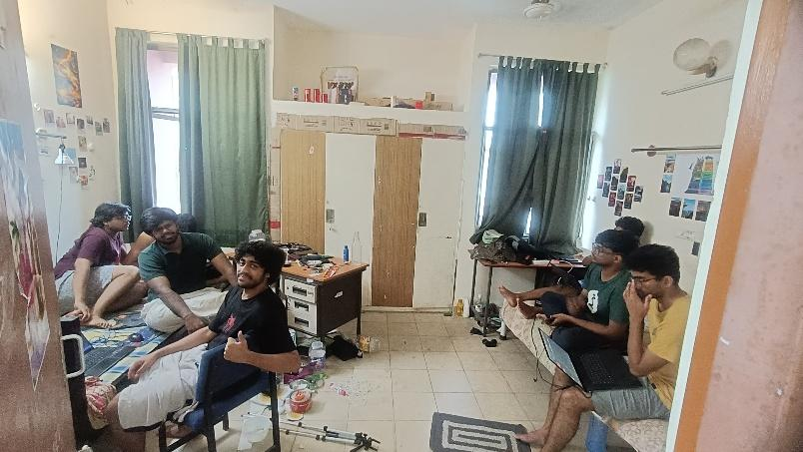
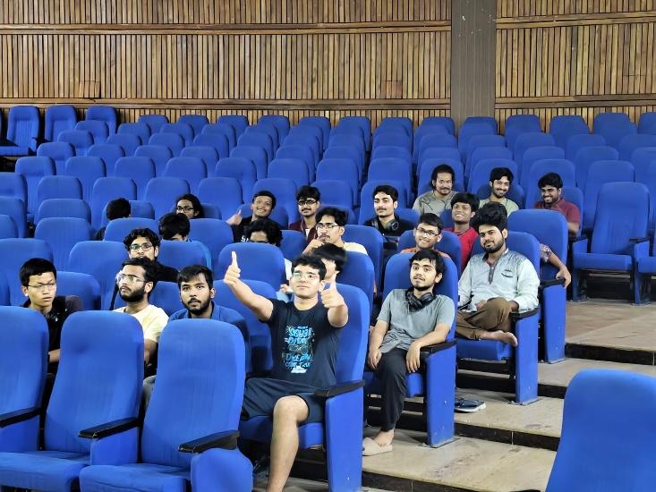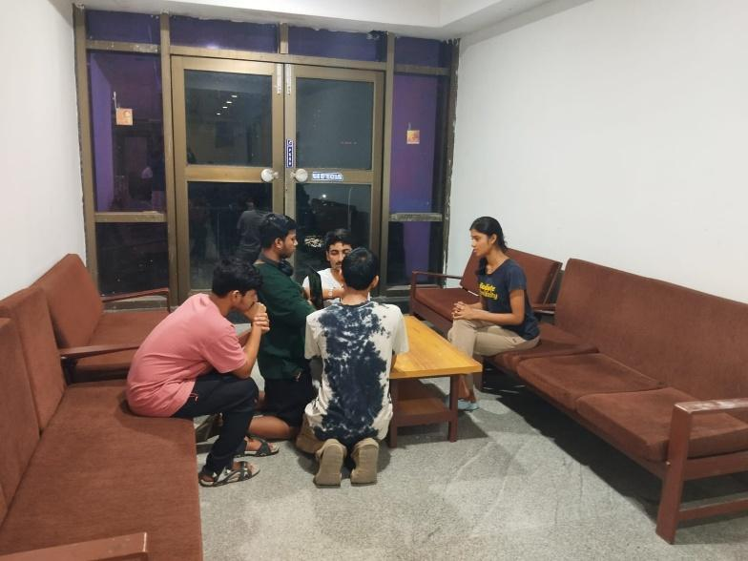
Few Pics from Interbatch Film making

While the Club Regularly streams movies during weekends and hosts post movie discussions as well, and a few more social media based competitions as well
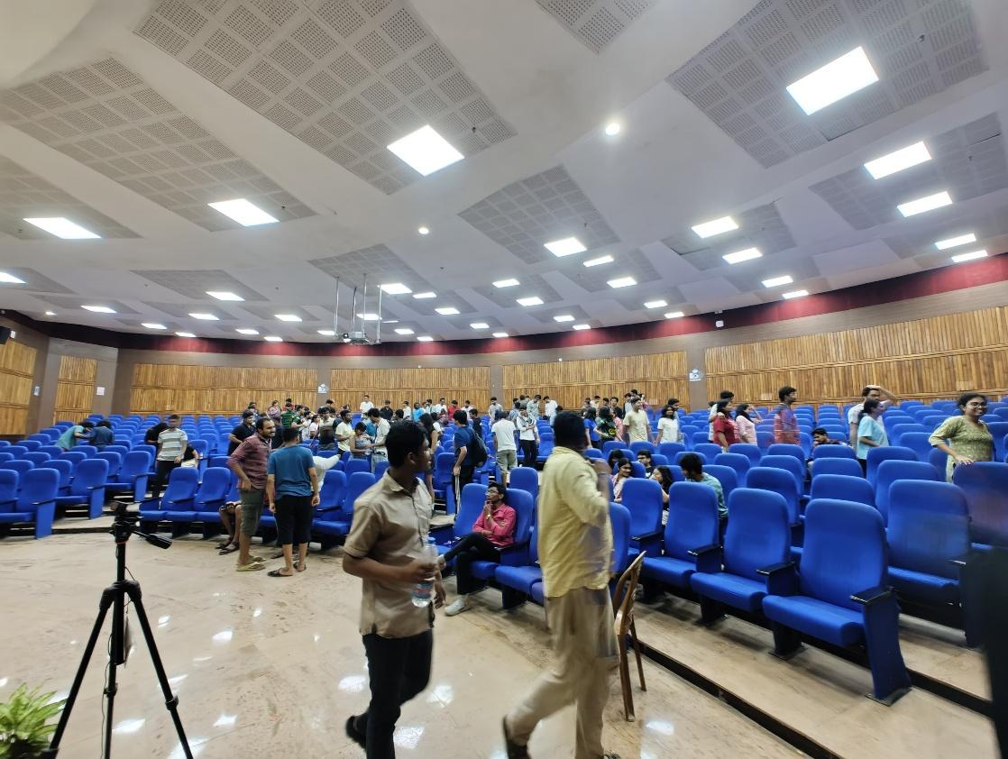
A regular day of Screening
The Club further plans to Host collaborative events with other clubs, host a film fest at IISER K and continue the legacy
IICM Achievements
2025 & 2023 IICM The Club had promising submissions for the short film making competition but received no position
2024 The Club brought in Bronze Medal with the short film Orphaned
2025- https://youtu.be/n34WUHfNMys?si=U_9LAwQutLy8p5l_

2024-
Bronze Winner https://youtu.be/Cb4CFsdGlRw?si=6pDl-VwsnZgfkF1H
Another Submission in IICM 2024 https://youtu.be/2PYP7YkZx5g?si=Sqmk5DxMdHVp7jiG

Club Assests
Currently the club has a gimble DJI RS3 Mini, which can be procured by duly mailing to the club OBs on the movie club email address given above
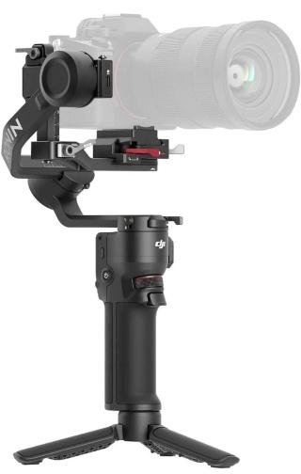

Social Media Handles


