- Intro:(Room no: 104)
The Music Club of IISER Kolkata is a community of students brought together by the love for music. From casual jamming sessions to large scale events throughout the year, the club acts as a space where our students can learn, perform and grow as musicians.
For many of us, the music room is much more than just a room filled with instruments. It is where friendships are formed, bands are created and ideas turn into performances. Whether someone has been learning an instrument for years or has just picked one up for the first time, the club provides a welcoming space to explore and enjoy music together.
Over the years, the club has grown not only in the number of members but also in the scale and quality of its activities. As students who actively use and care for this space, we hope to continue building an environment where creativity can flourish.
- The Current OBs:
  - Secretary- Niranjan K
    - Ph No: 7356309609
    - Email: nk25ms007@iiserkol.ac.in
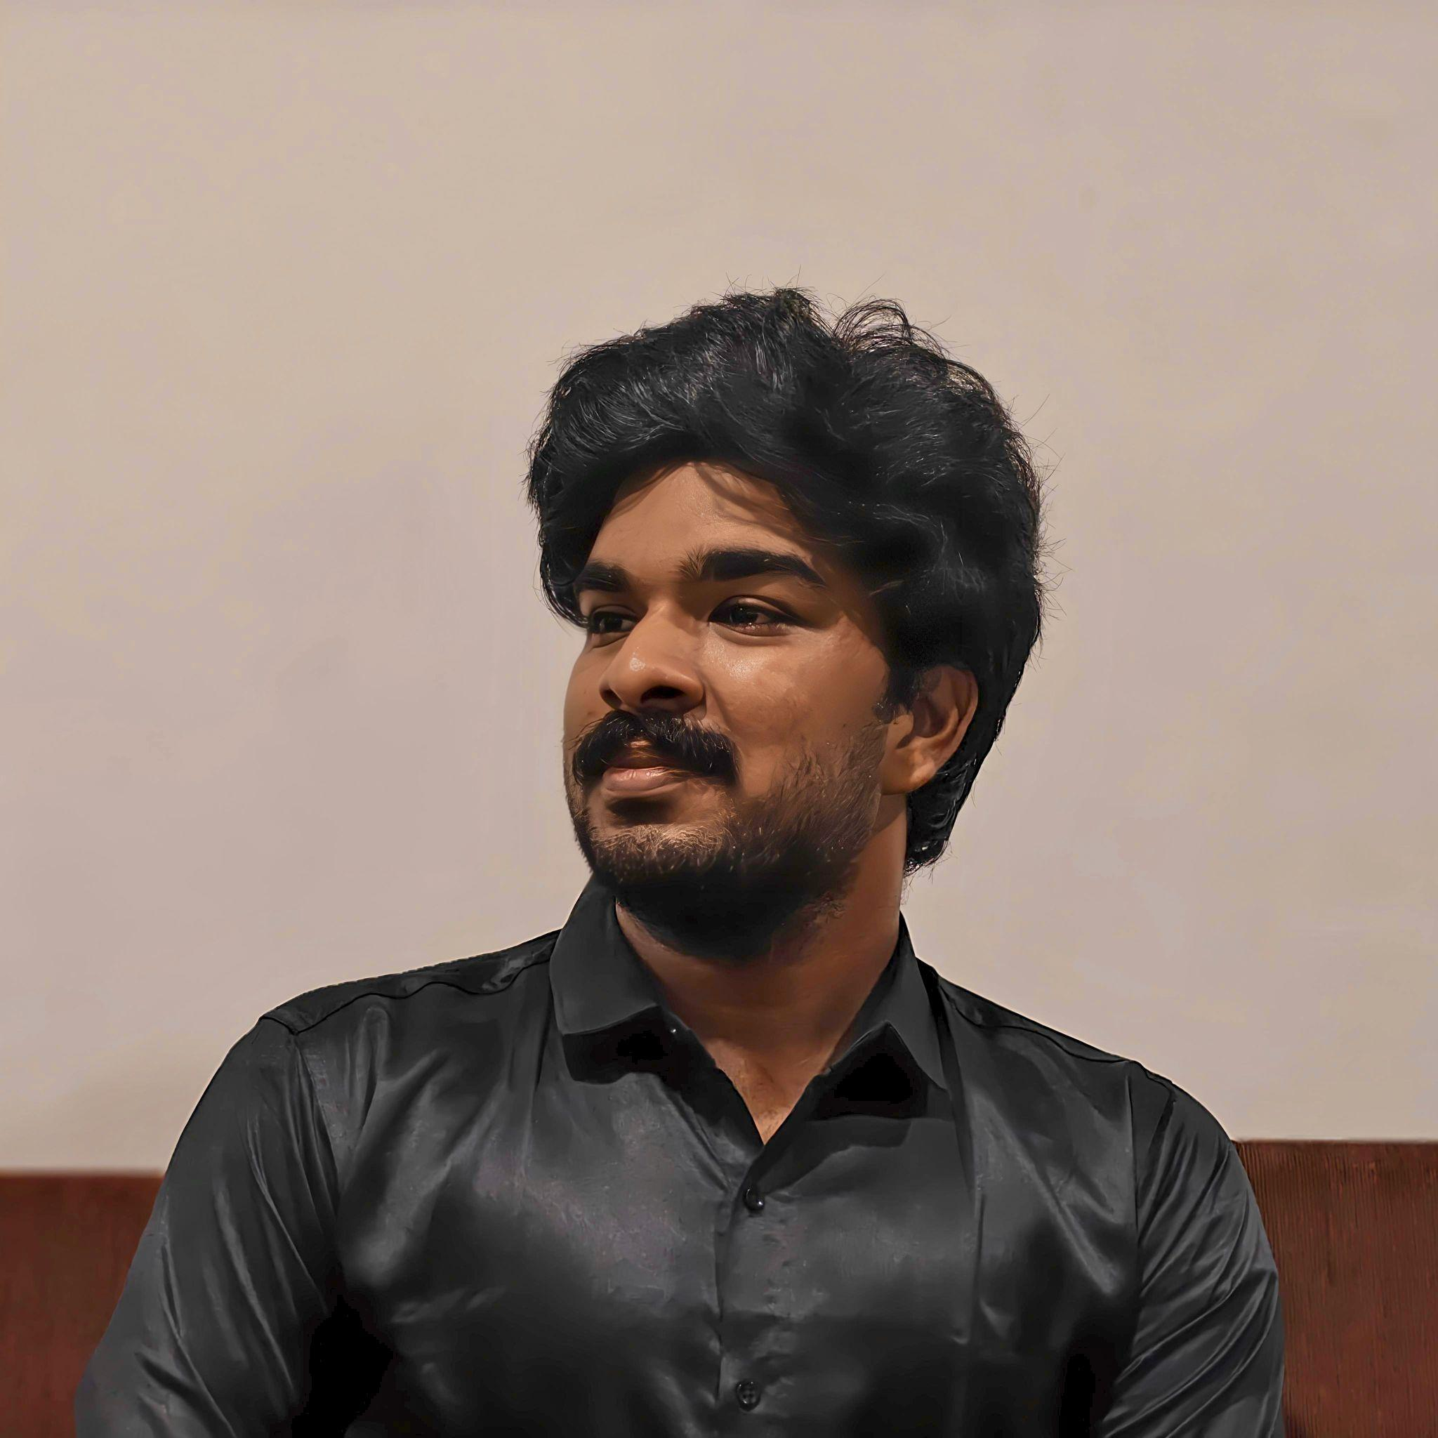

  - Convener- Barboza Shanaya Joseph
    - Ph No: 9309416515
    - Email: bsj25ms033@iiserkol.ac.in
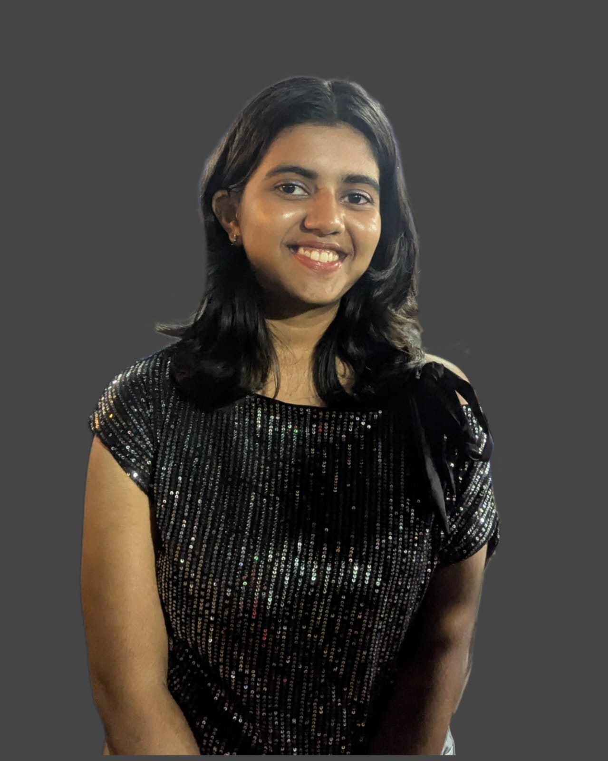

  - Treasurer- Adarsh Ranjan
    - Ph No: 9508321116
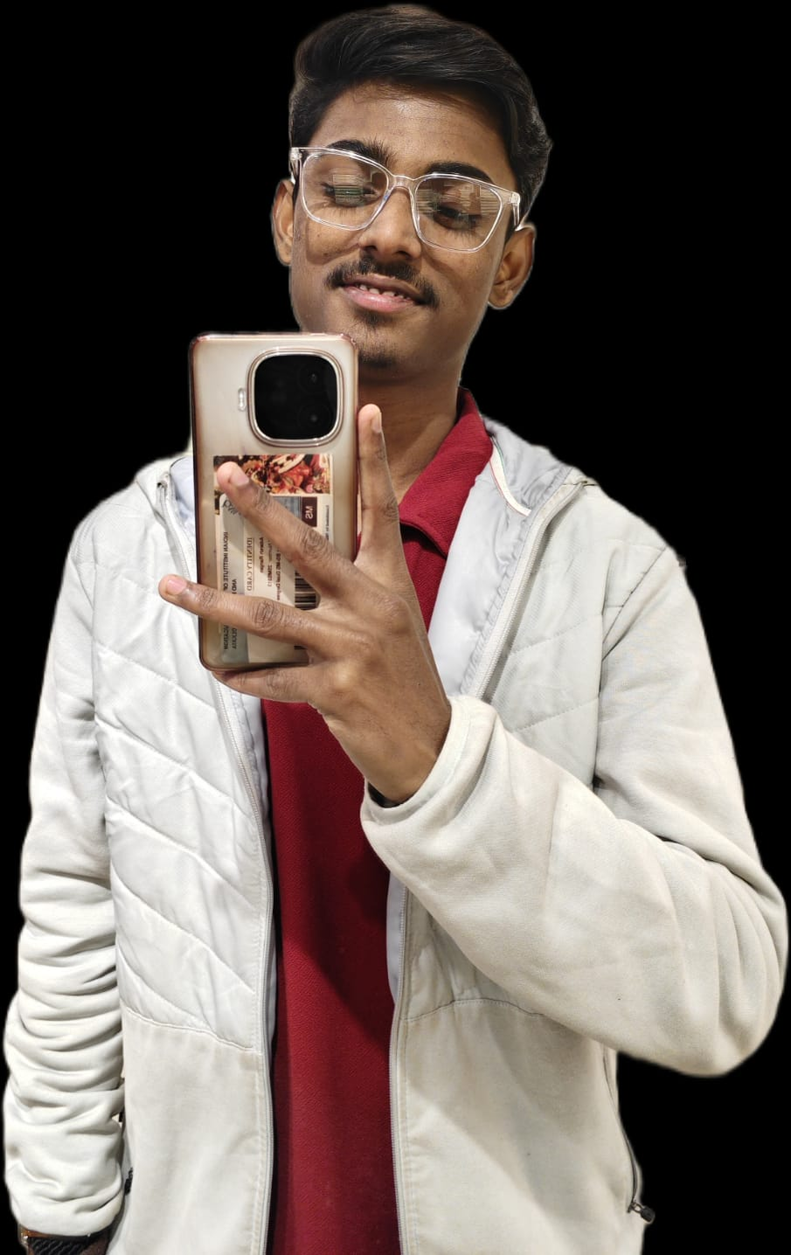
    - Email: ar25ms313@iiserkol.ac.in

  - Event Organizer- Neil Joshi
    - Ph No: 9455512777
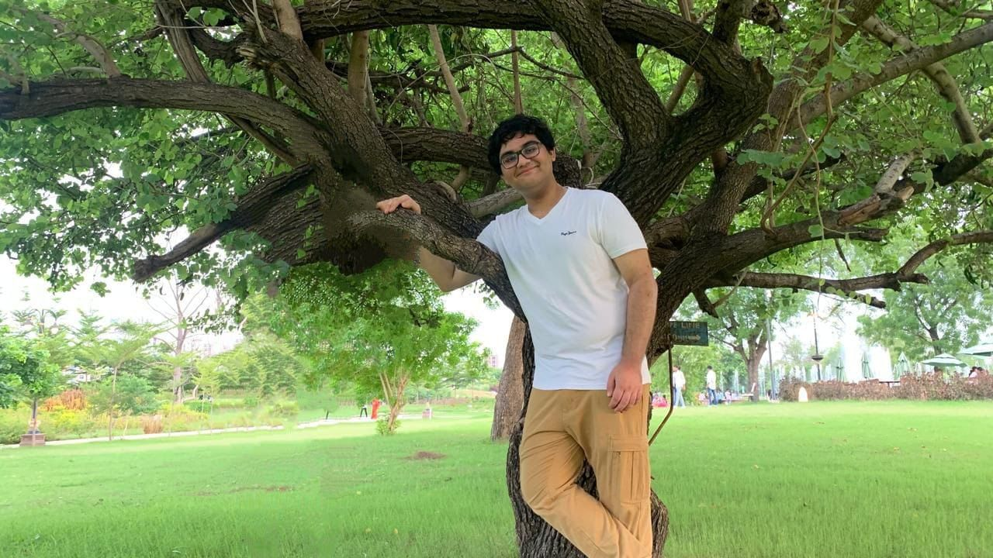
    - Email:nj25ms247@iiserkol.ac.in

  - Social Media Manager- Marvellyne Grace Kharshiing
    - Ph No: 8415936637
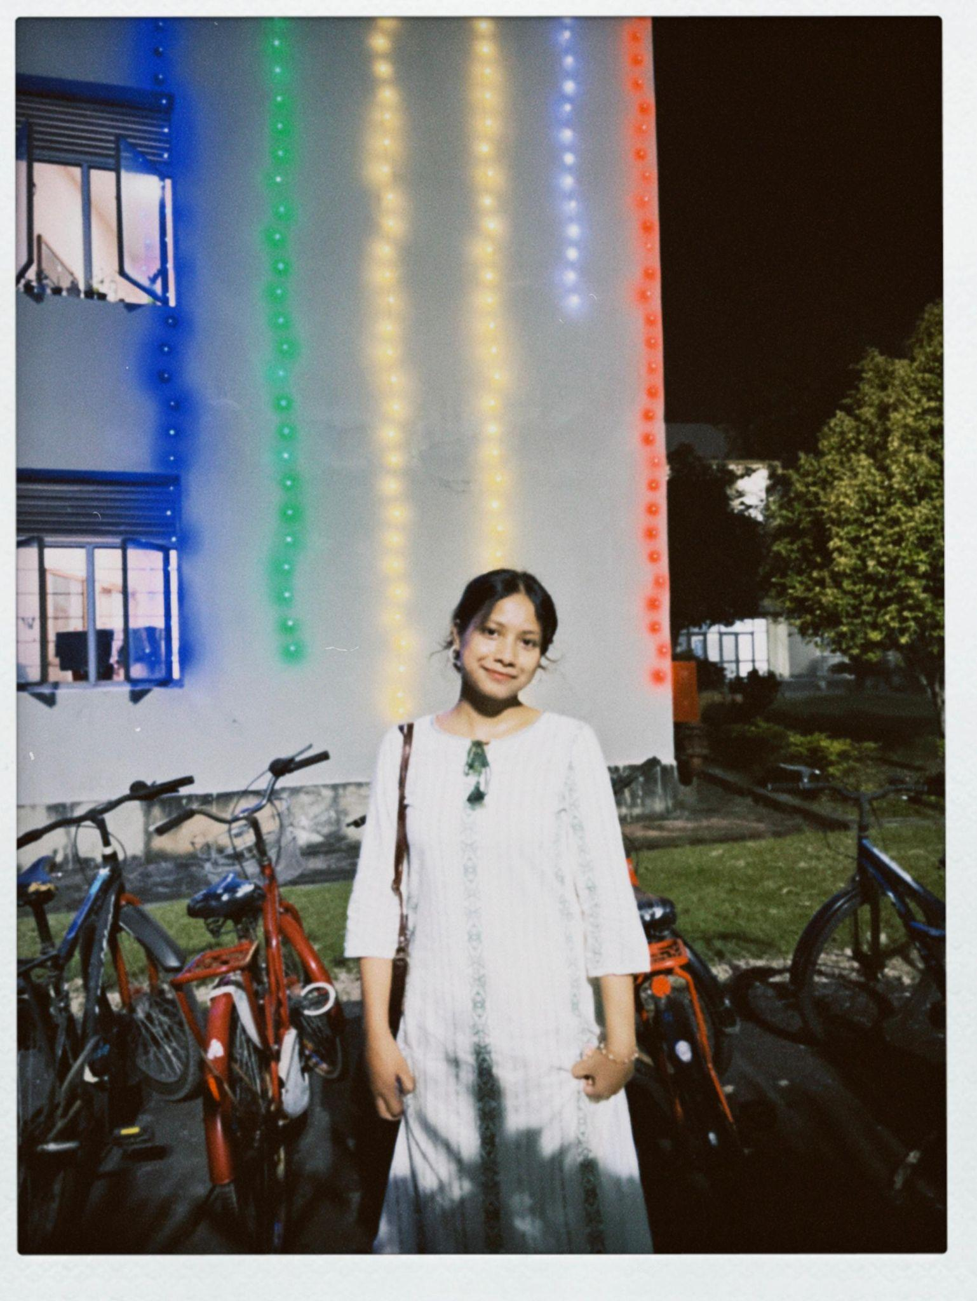
    - Email: mgk25ms085@iiserkol.ac.in
- Past OBs:

Tenure | Secretary | Convener | Treasurer | EO | Social Media Manager
2025-26 | Abyartha Roy | Peeyush Athankar | Arkadeep Bandyopadhyay | Swapnaneel Sengupt | Kshitij Singh Dagar
2024-25 | Anubhab Das | Adil Krishna P | Vakamulla Riddhiman | Aaheli Nath | Asish Kumar Patra
2023-24 | Arghya Chaudhuri | Anubhab Das | Akash Maitra | • Tushar Pal,  • Asish Kumar Patra,  • Adil Krishna P | -
2022-23 | Deepak Verma | Arghya Chaudhari | Sanchari Saha | - | -
2021-22 | Rounak Mukhopadhyay | Swapnil Sengupta | Rajit Sen | - | -
2020-21 | Sroyon Sengupta | Aayush Srivastav | Soumi Bhattacharya | - | -

- Events and Photos:
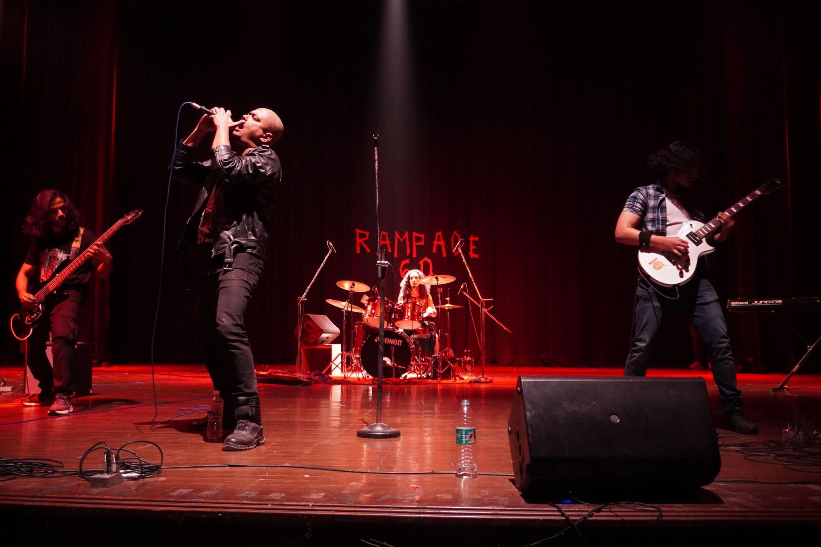
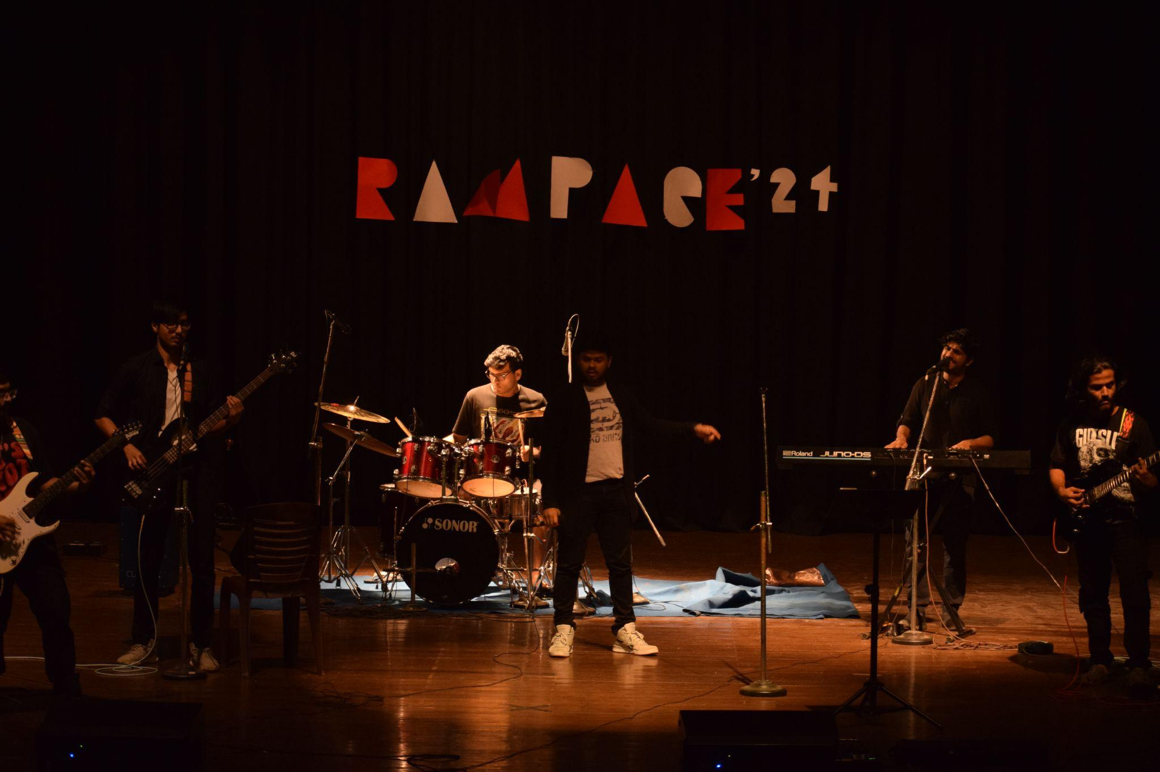
  - RAMPAGE:
Rampage is the Music Club's flagship event and is built around the annual Battle of Bands. It brings together bands from both IISER Kolkata and outside institutions, creating a space for musicians to perform, compete, and share their music with a larger audience.

  - JHANKAAR:
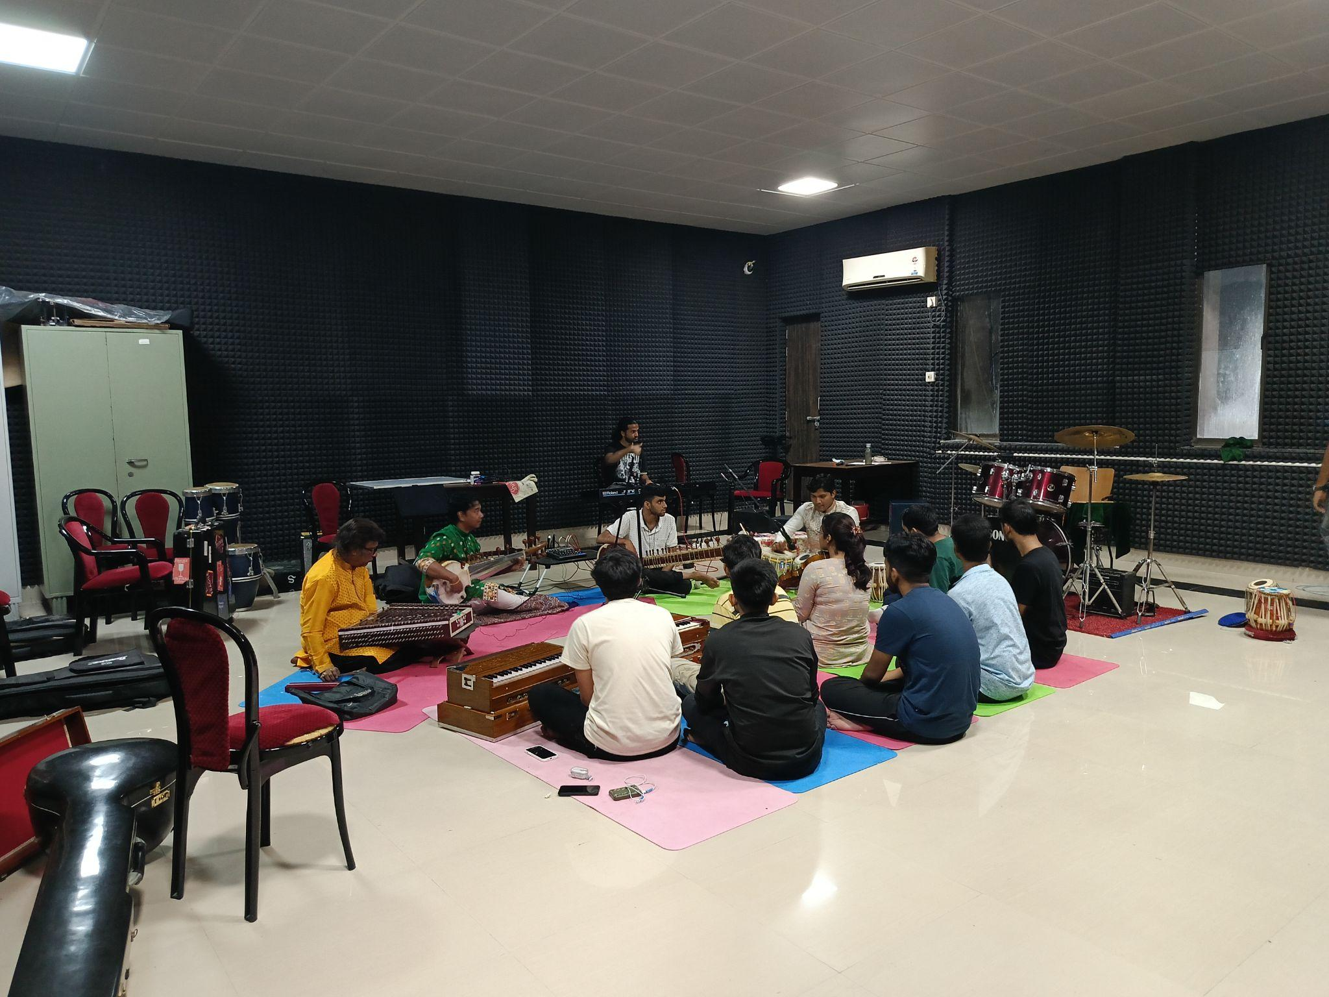
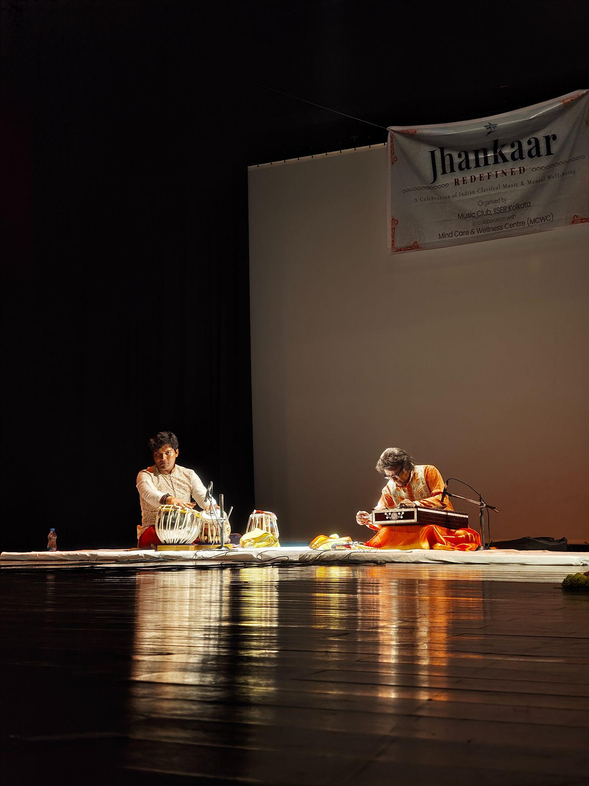
Jhankaar is our annual classical music event, where accomplished artists are invited to perform and interact with students. Along with the performances, participants also get the opportunity to learn through workshops conducted by them.

  - VOICE:
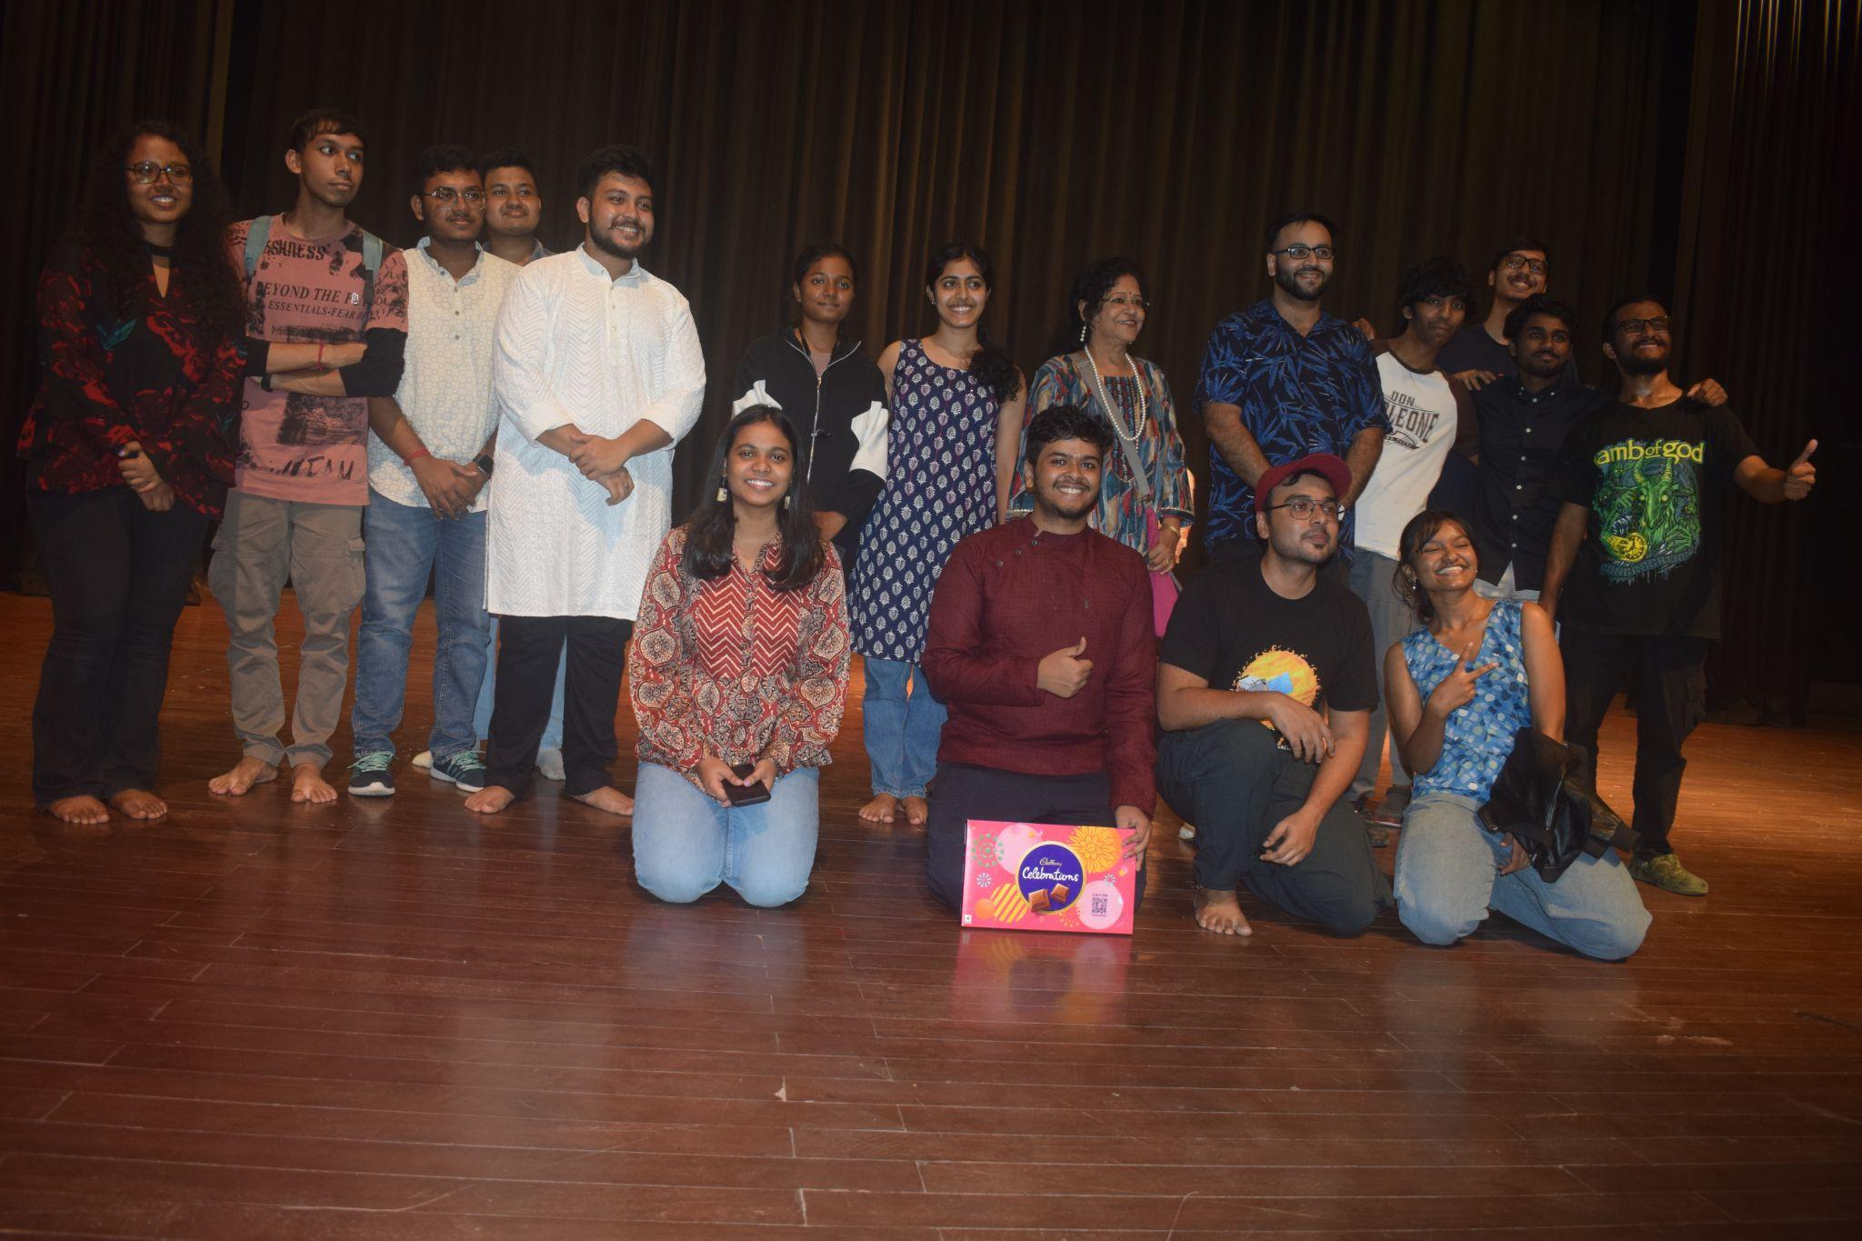
The Voice is the club's annual singing competition and one of the most popular events among vocalists on campus. It also serves as the selection platform for IISER Kolkata's vocal representatives for IICM every year.

- IICM Achievements:
  - 2025: 3rd in Battle of Bands, 3rd in Duet
  - 2024: 2nd in Battle of Bands, 2nd in Mehfil, 3rd in Duet, 1st in Western
  - 2023: 1st in Battle of Bands, 1st in Mehfil, 3rd in Duet
  - Photos:
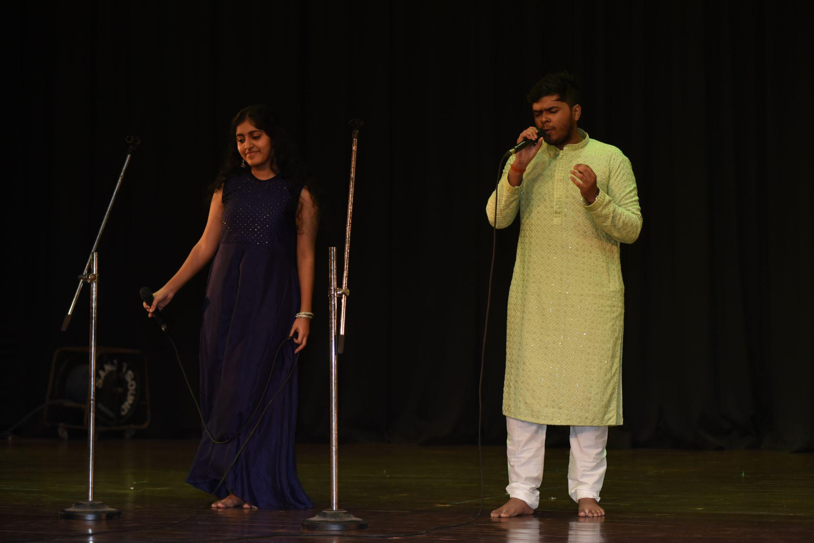
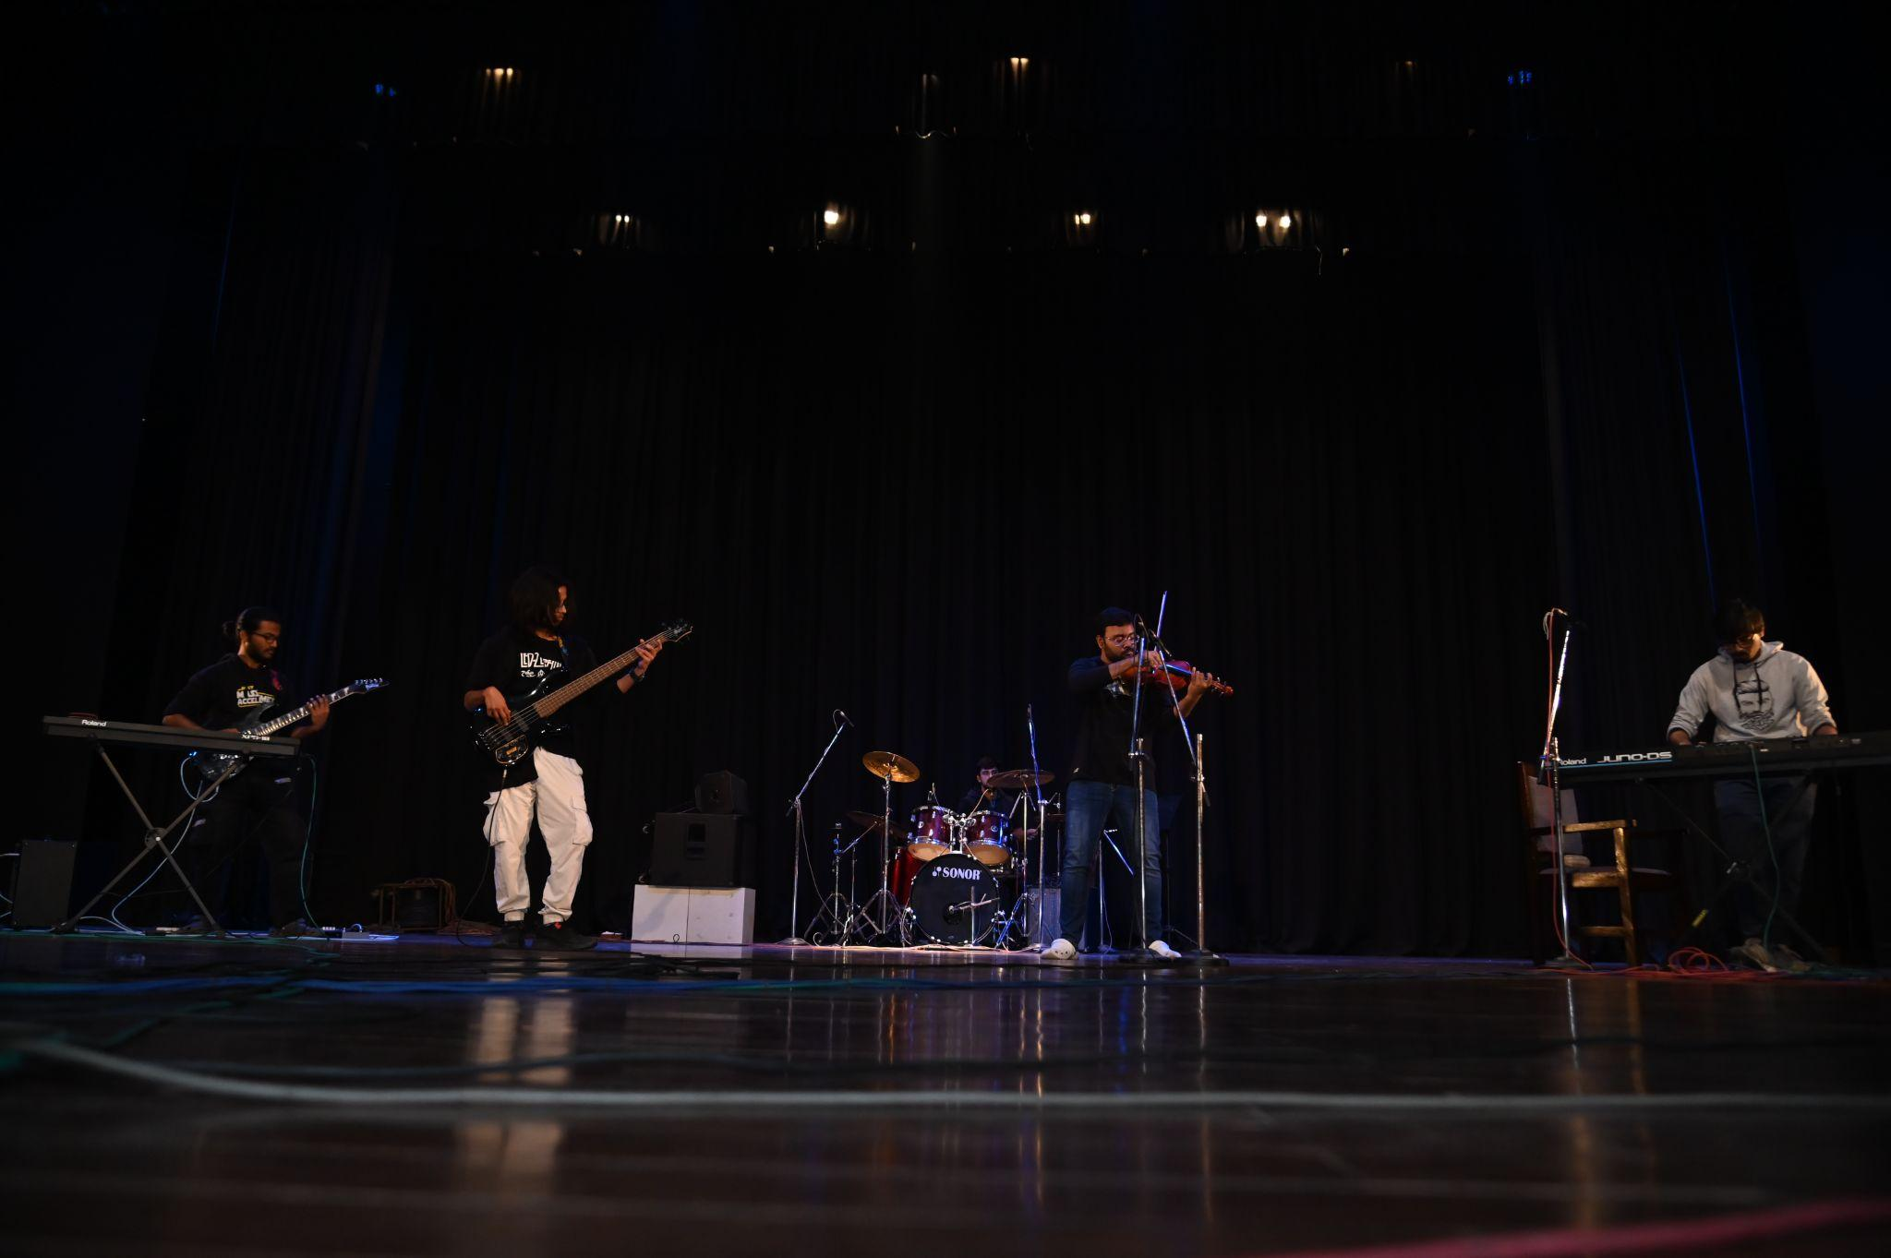
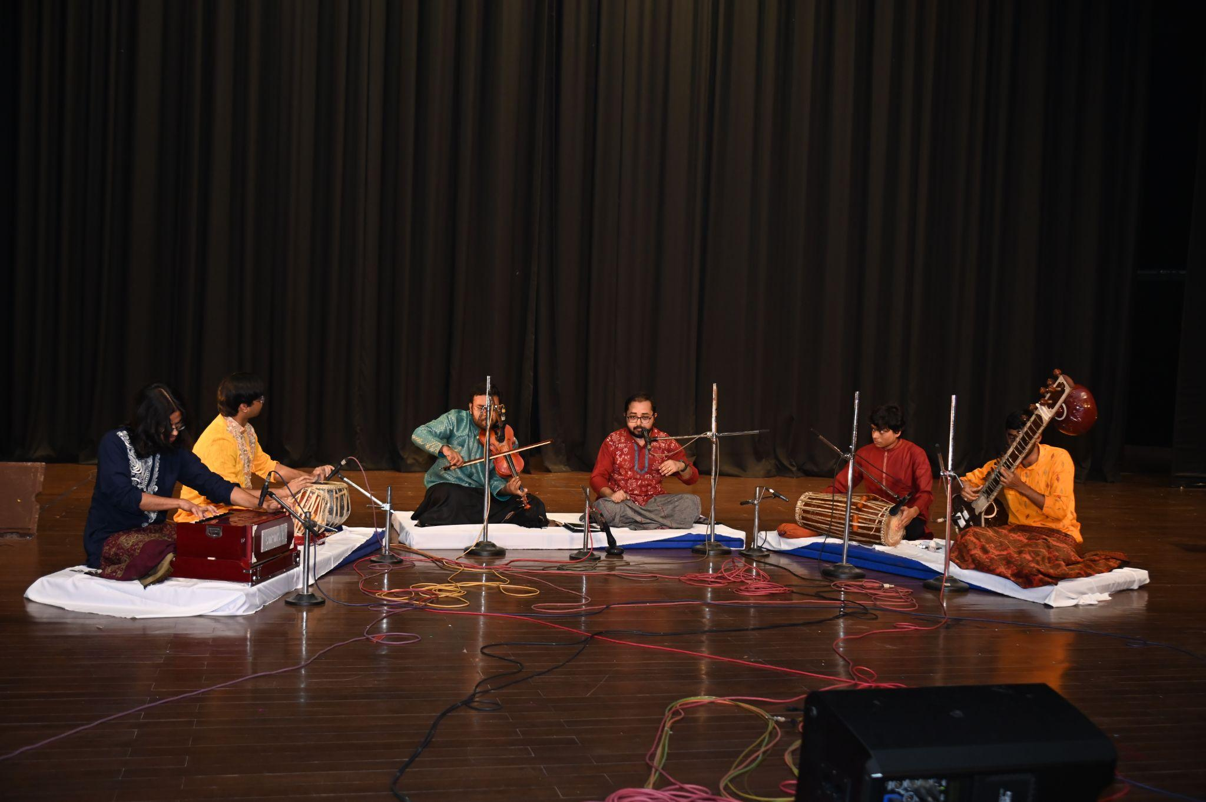
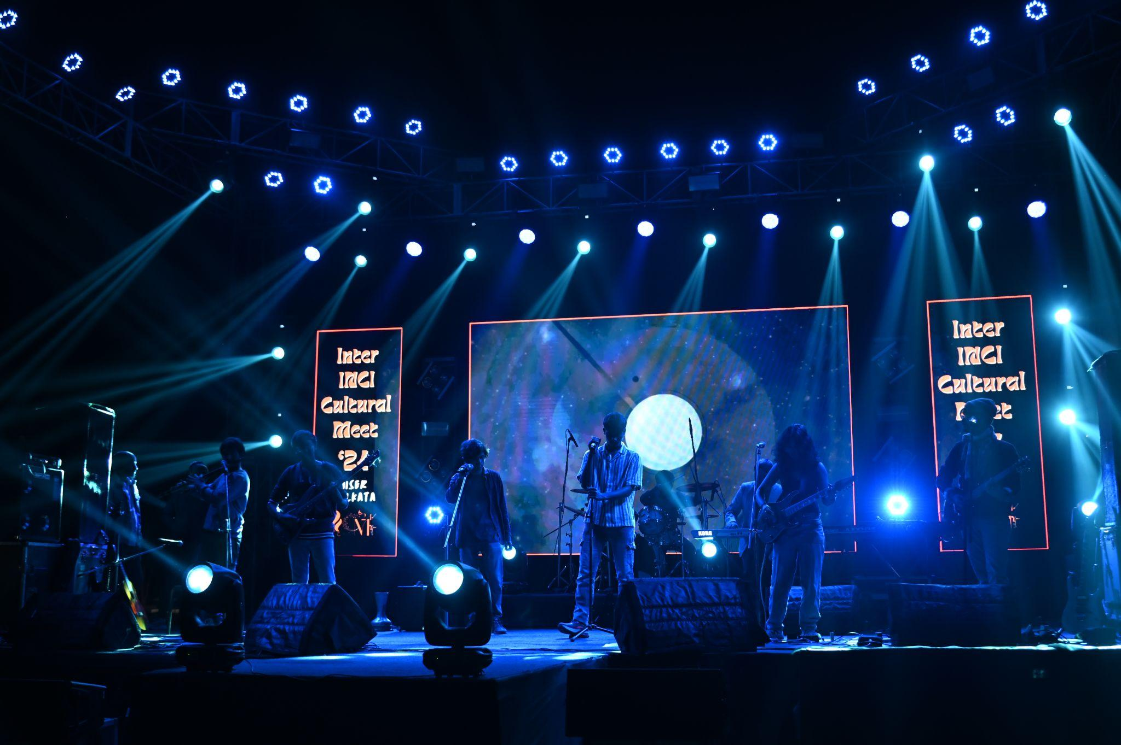
- Social Media Handles:
  - Instagram: Link
  - Youtube: Link
  - Facebook: Link

