To join our club fill your name , email, contact number and profile photo

➤Secretary:Sayan Das
Email: sd25ms229@iiserkol.ac.in
Contact number:+91 7318893532
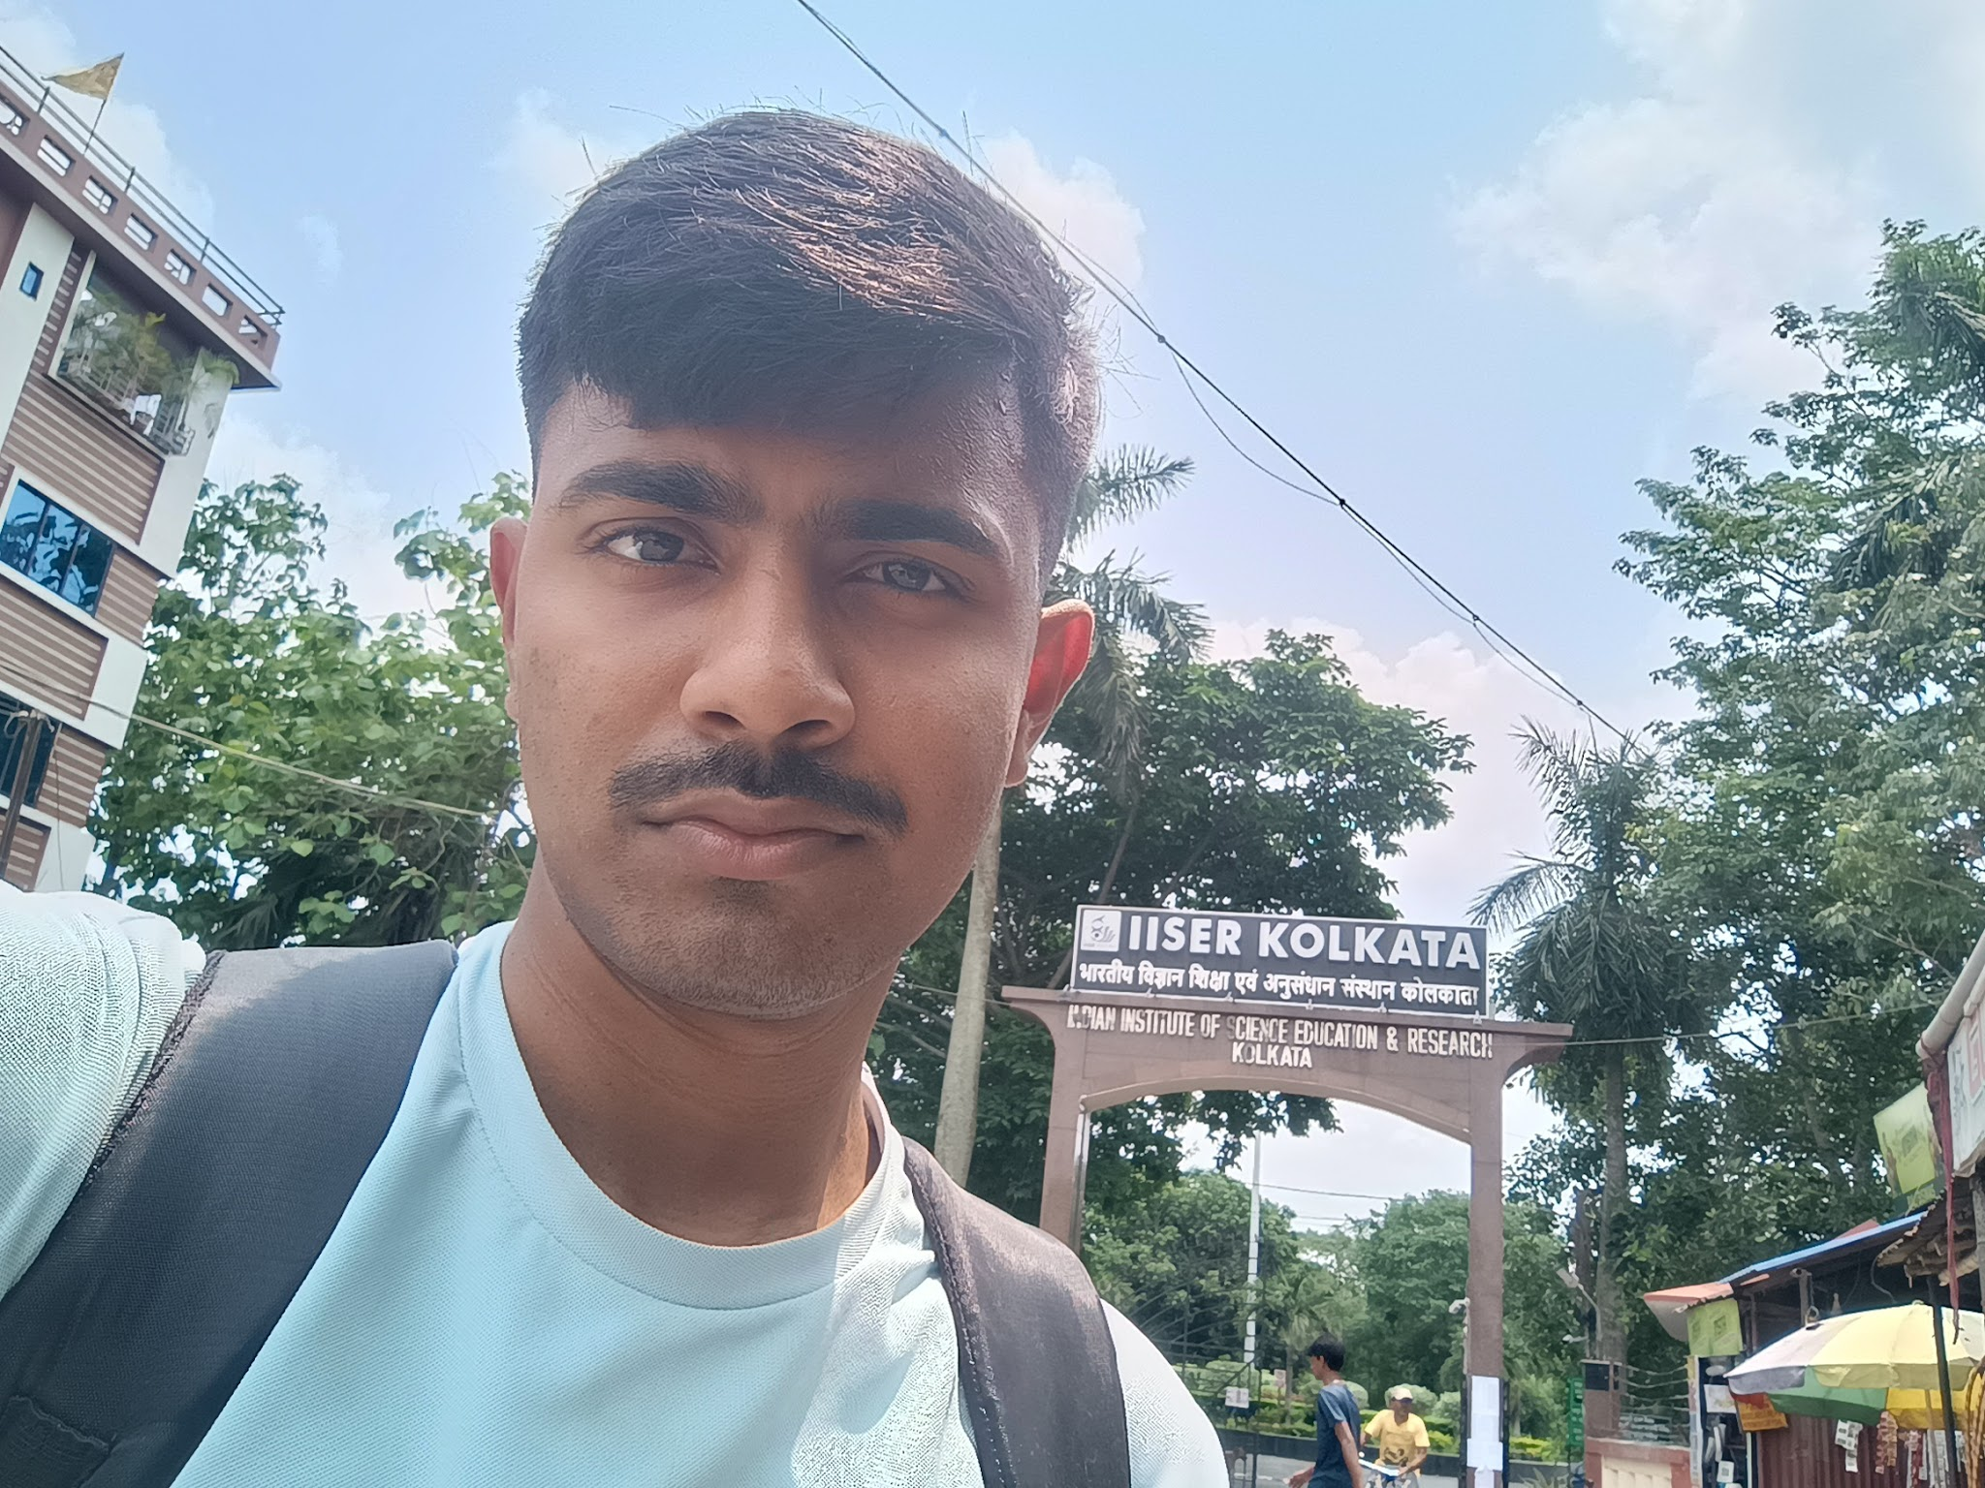

➤Treasurer:Shuvam Behera
Email: sb25ms311@iiserkol.ac.in
Contact number:+91 7328058070
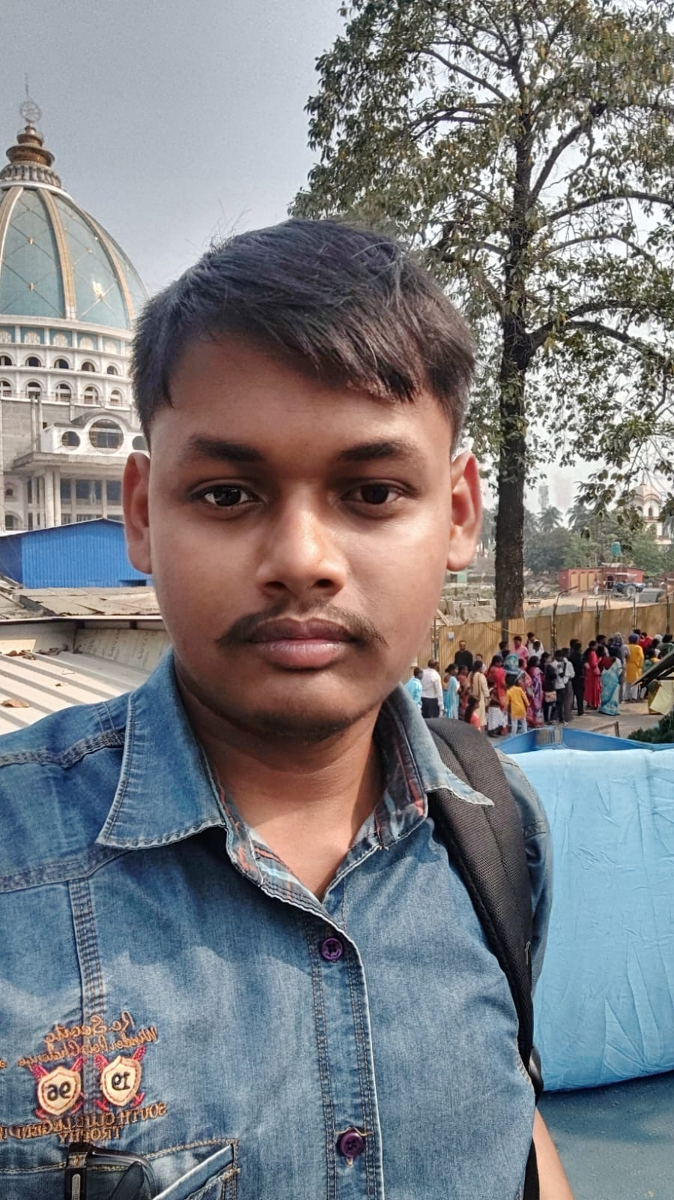
➤Treasurer:Tansukh
Email:t25ms263@iiserkol.ac.in
Contact number:+91 8306454858
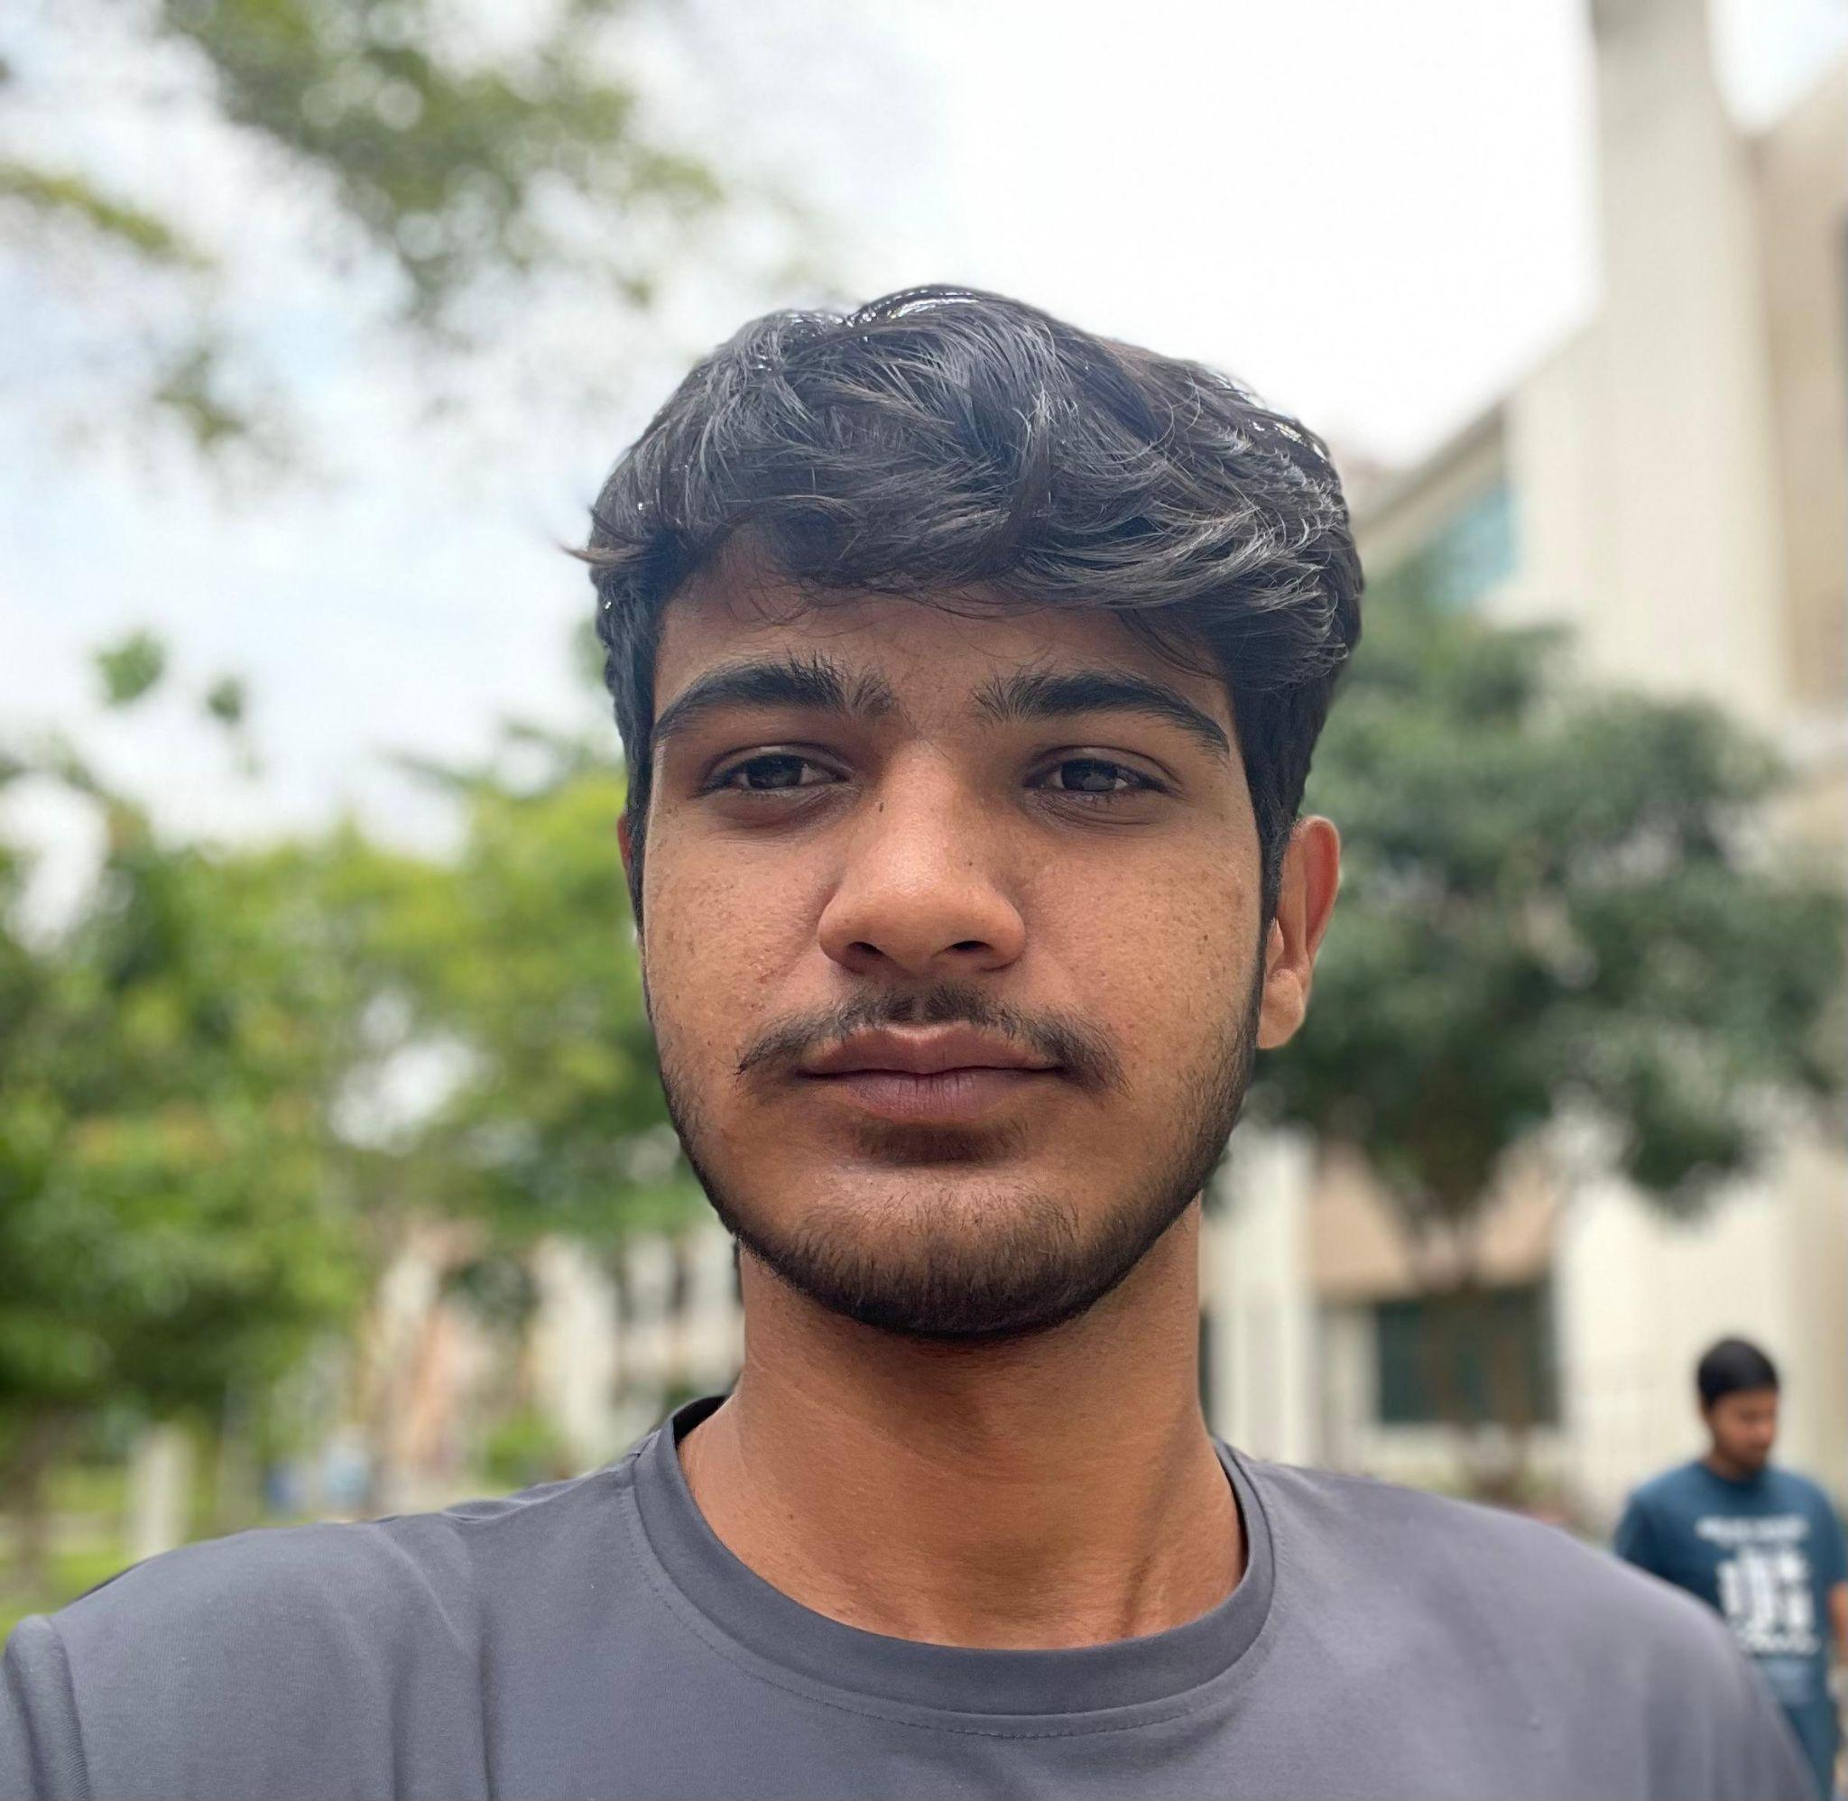

➤Convenor:Rohit Ranjan
Email: rr25ms230@iiserkol.ac.in
Contact number:+91 6203965277

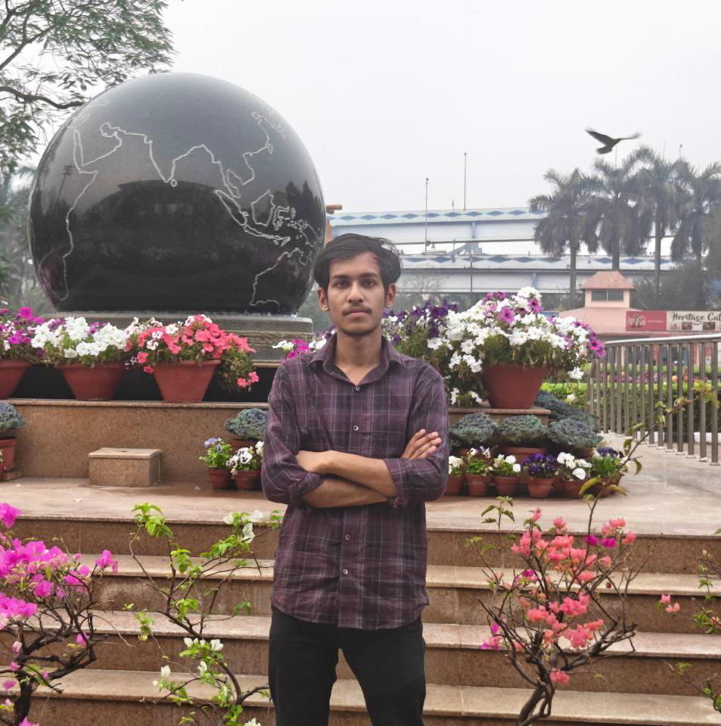

➤Convenor:Punyata
Email: ps25ms125@iiserkol.ac.in
Contact number:+91 9382956727


➤ Convenor : SHIVAM
Email : s24ms025@iiserkol.ac.in
Contact number : +91 6395078865
