ATHLETICS CLUB OB'S 2026-27

➤Secretary:Sayan Das
Email: sd25ms229@iiserkol.ac.in
Contact number:+91 7318893532
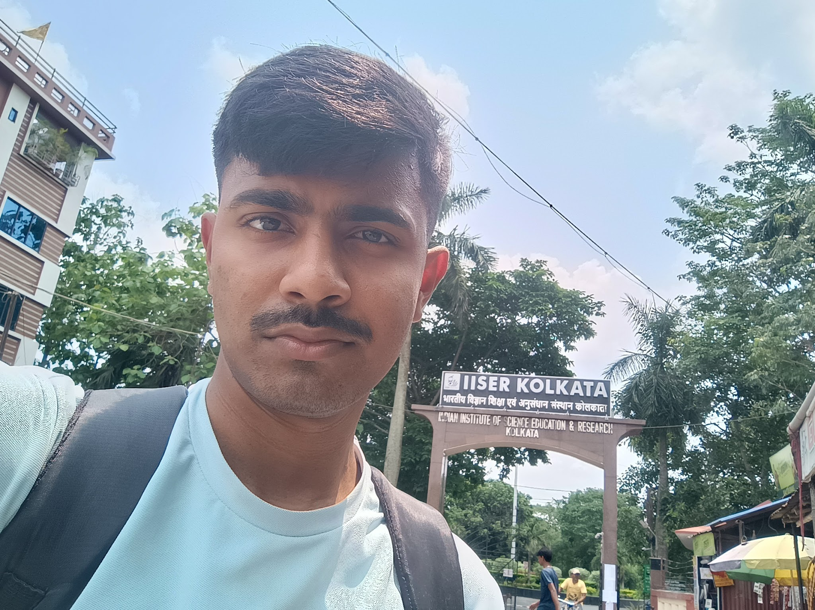

➤Treasurer:Shuvam Behera
Email: sb25ms311@iiserkol.ac.in
Contact number:+91 7328058070
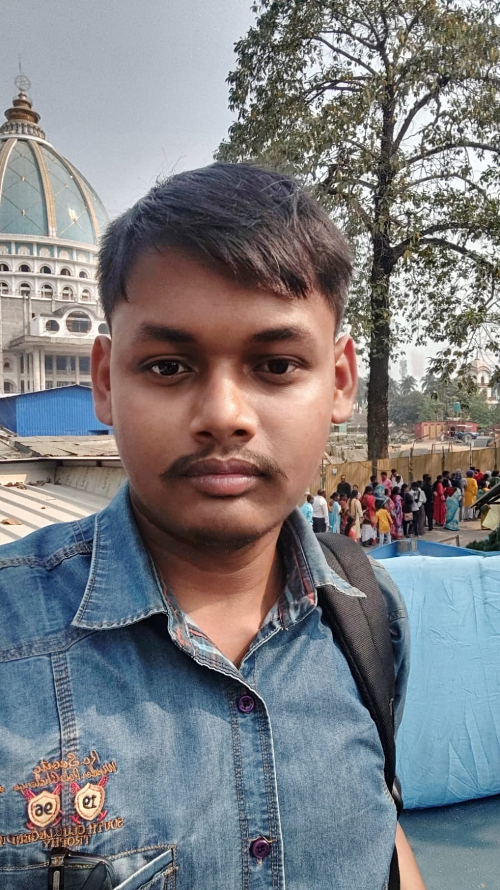
➤Treasurer:Tansukh
Email:t25ms263@iiserkol.ac.in
Contact number:+91 8306454858
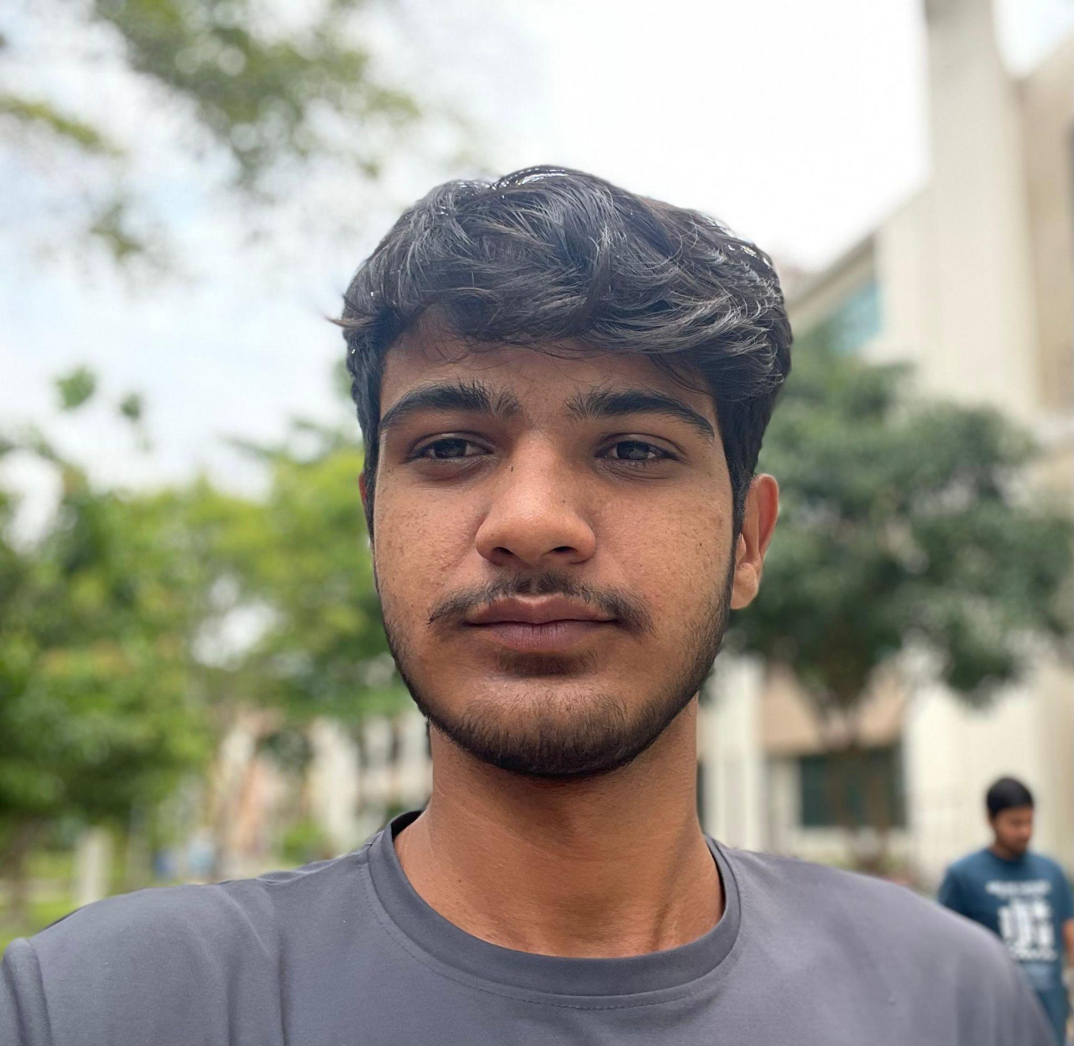

➤Convenor:Rohit Ranjan
Email: rr25ms230@iiserkol.ac.in
Contact number:+91 6203965277
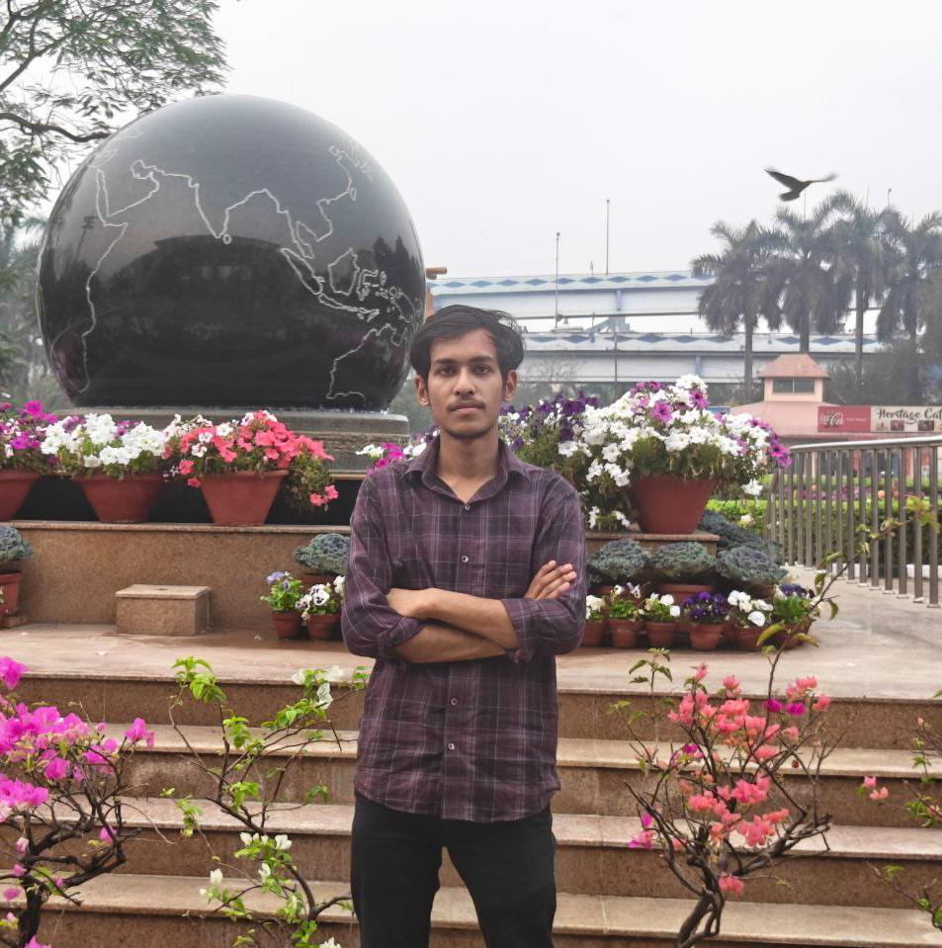

➤Convenor:Punyata
Email: p25ms125@iiserkol.ac.in
Contact number:+91 9382956727


