Secretary: Sandeep Kanekal
Contact number: 7619482261
Email: sk24ms100@iiserkol.ac.in
Photo:
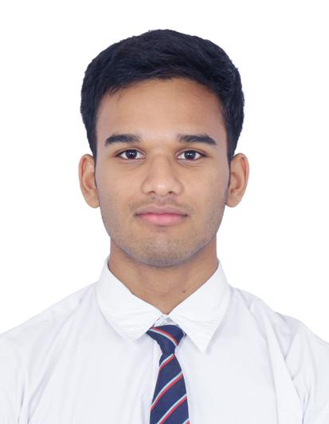

Convener : Mahfooz Alam
Contact Number : 7905891623
Email : ma24ms132@iiserkol.ac.in
Photo:
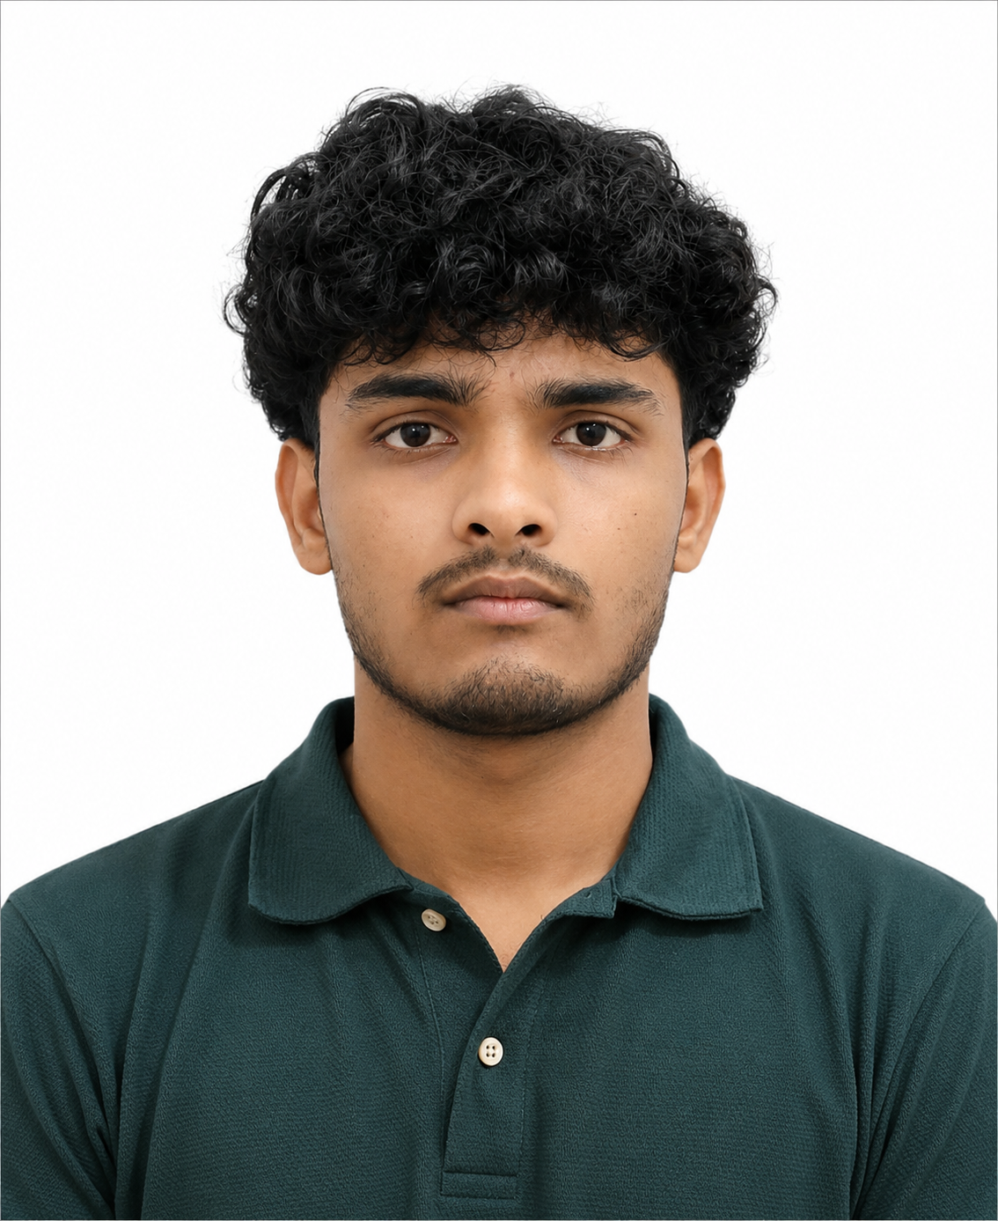

Treasurer: Subhradip Mondal
Contact Number: 8100624619
Email: sm24ms087@gmail.com
Photo:
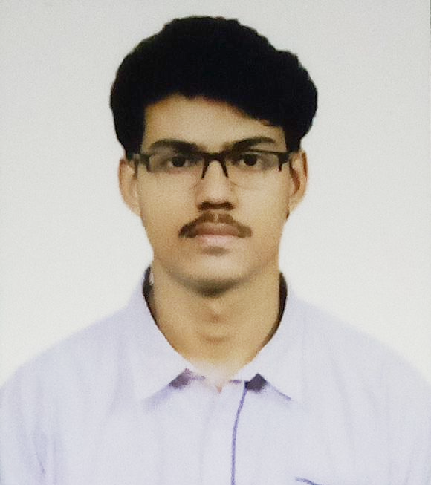
Convener : Iishaan Pyne
Contact Number : 7003017022
Email : ip24ms135@iiserkol.ac.in
Photo:

