ACTIVE PLAYERS OF OUR CLUB

1)Neeraj Kumar
25MS
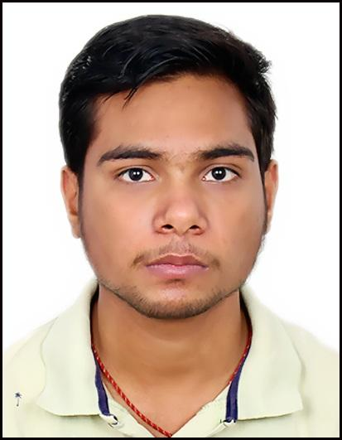

2)Aditi Bhuyan
25MS
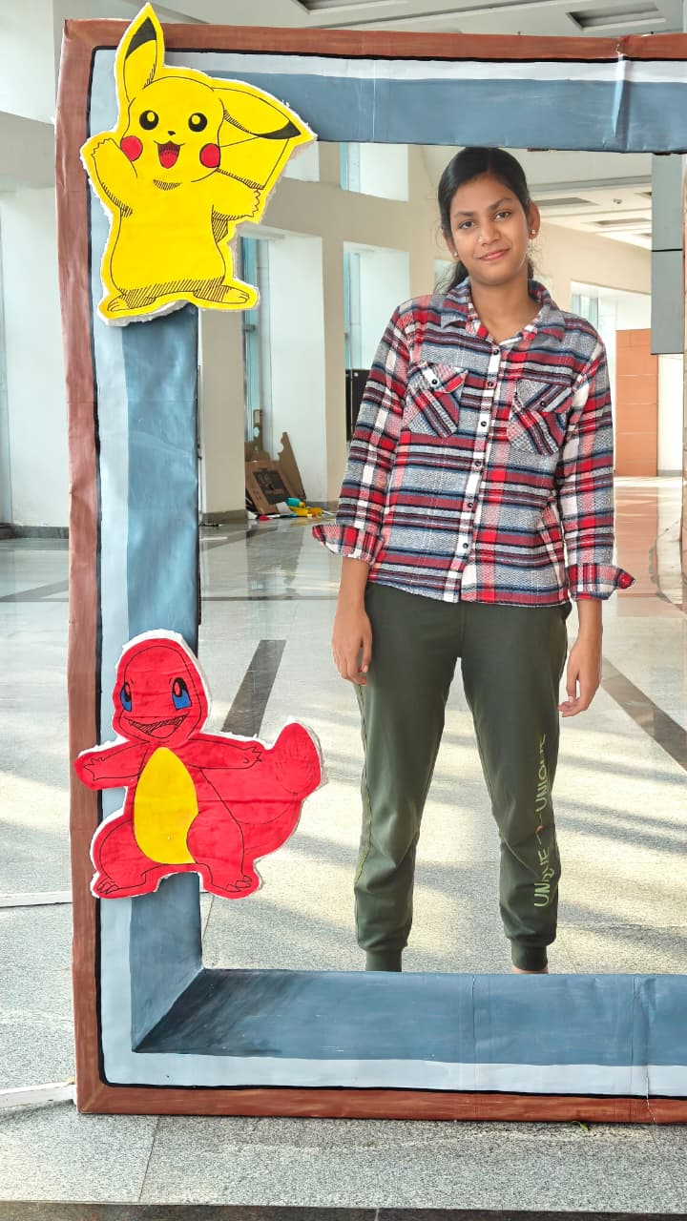

3)Nikku Repswal
25MS
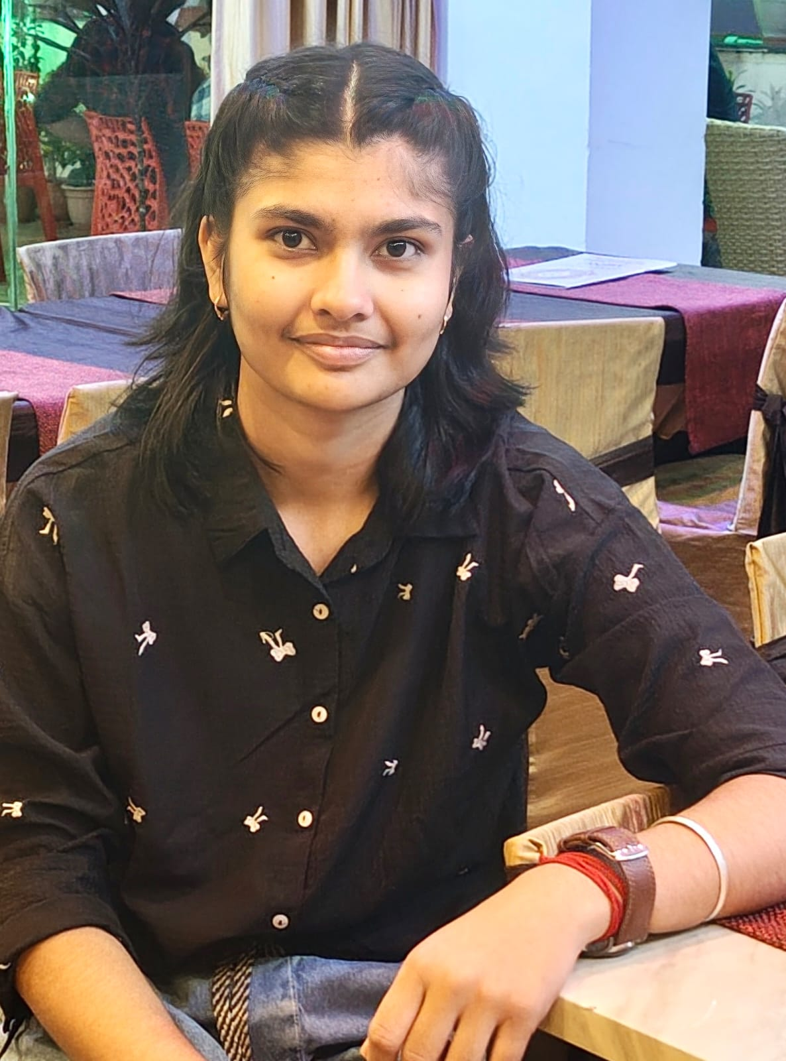

4)Krish Kumar
25MS
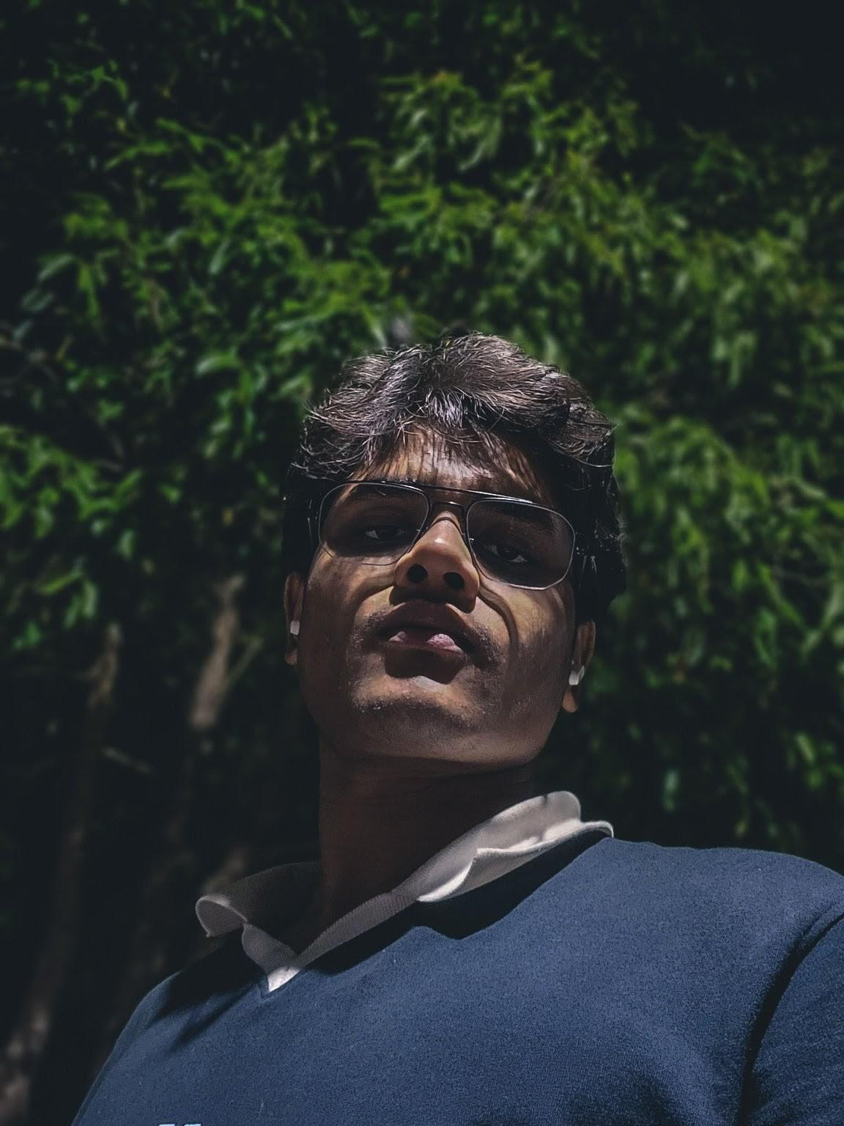

5) Siba Prasad Behera
23MS 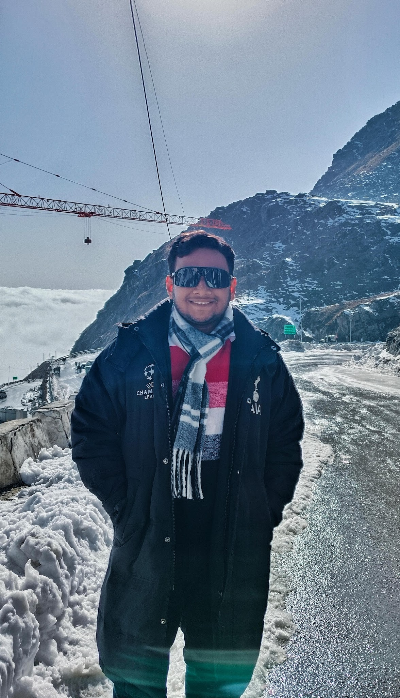

6)Arvind Mohan
23MS
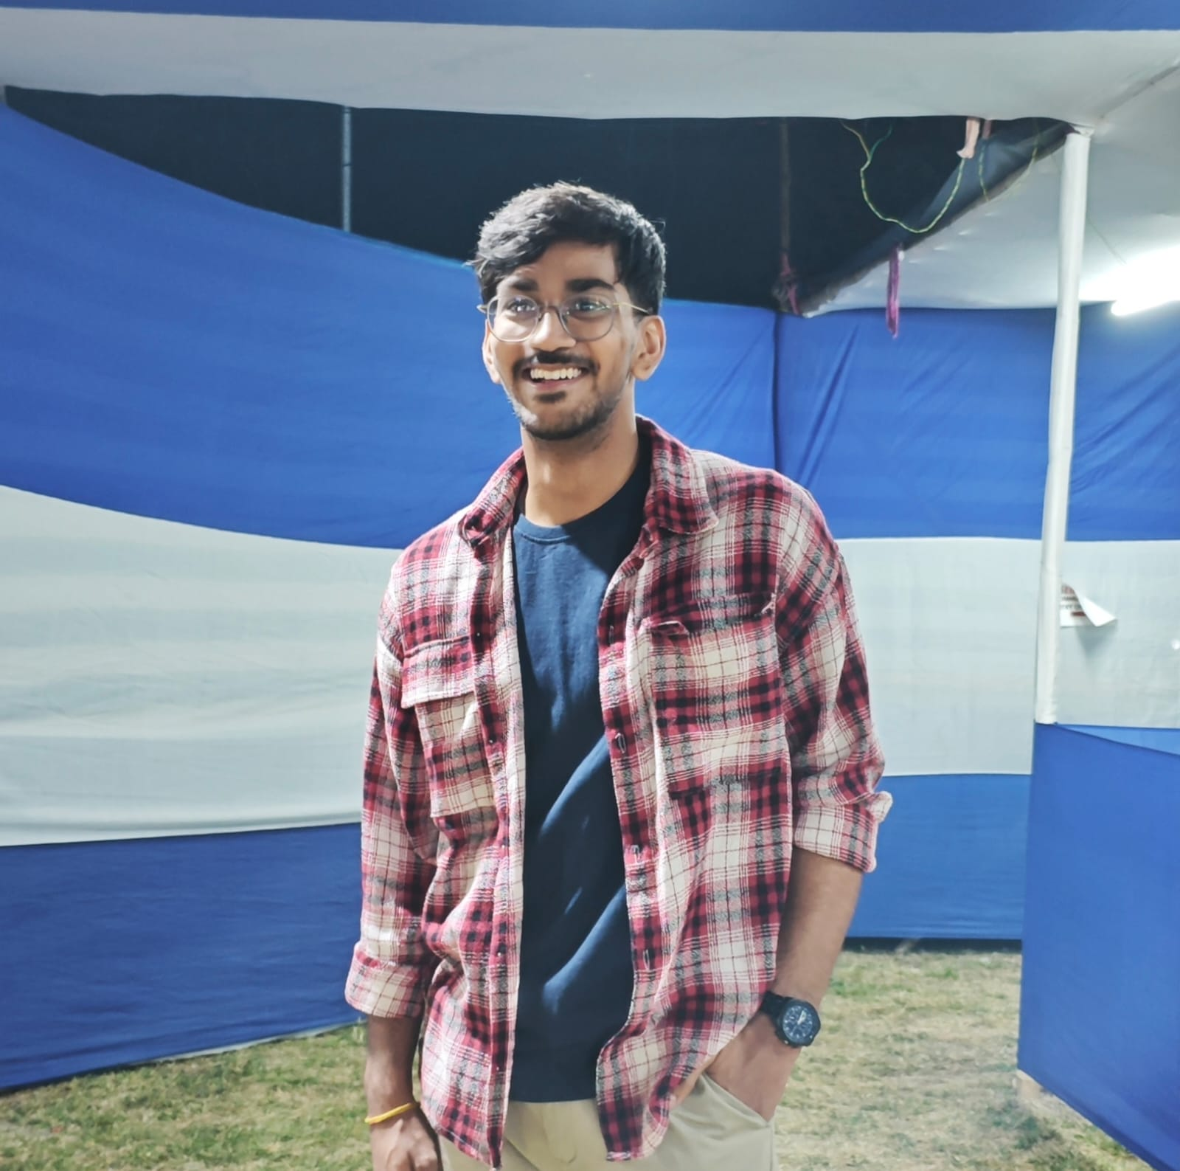

7)Avipsa Das
25MS
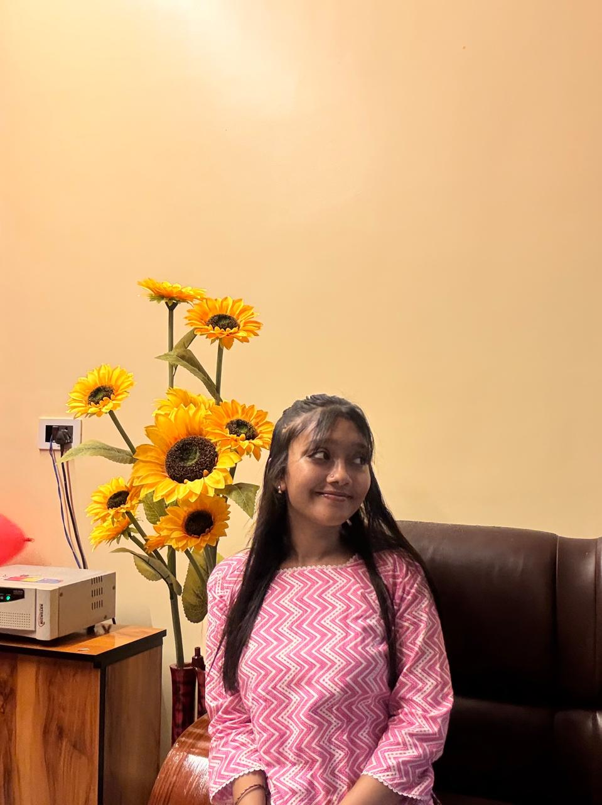

8)Pallavi Sabar
(22MS)
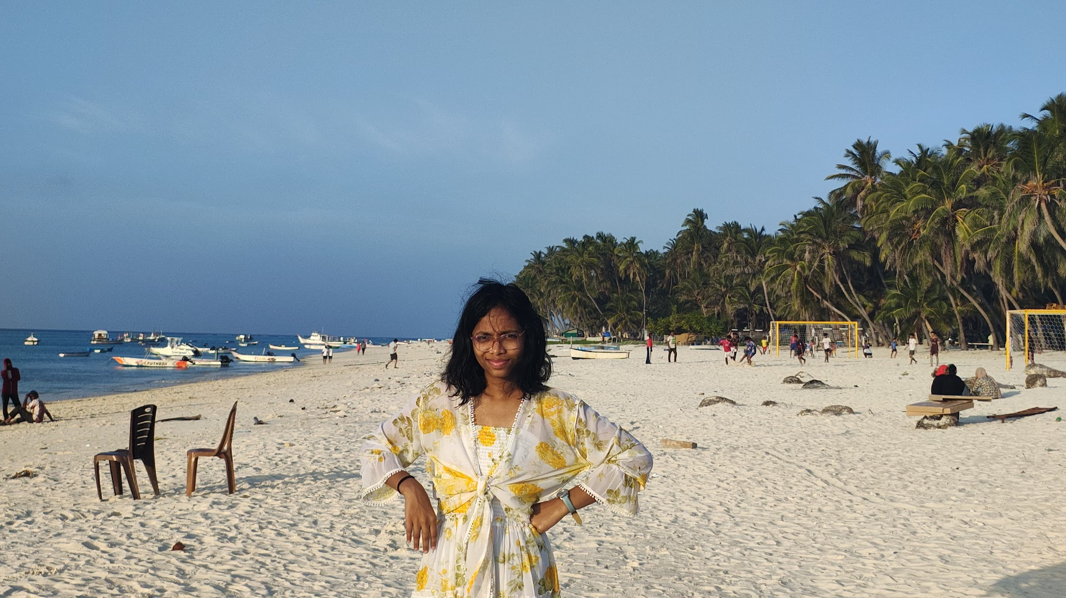

9)Kumar Rishank
25MS
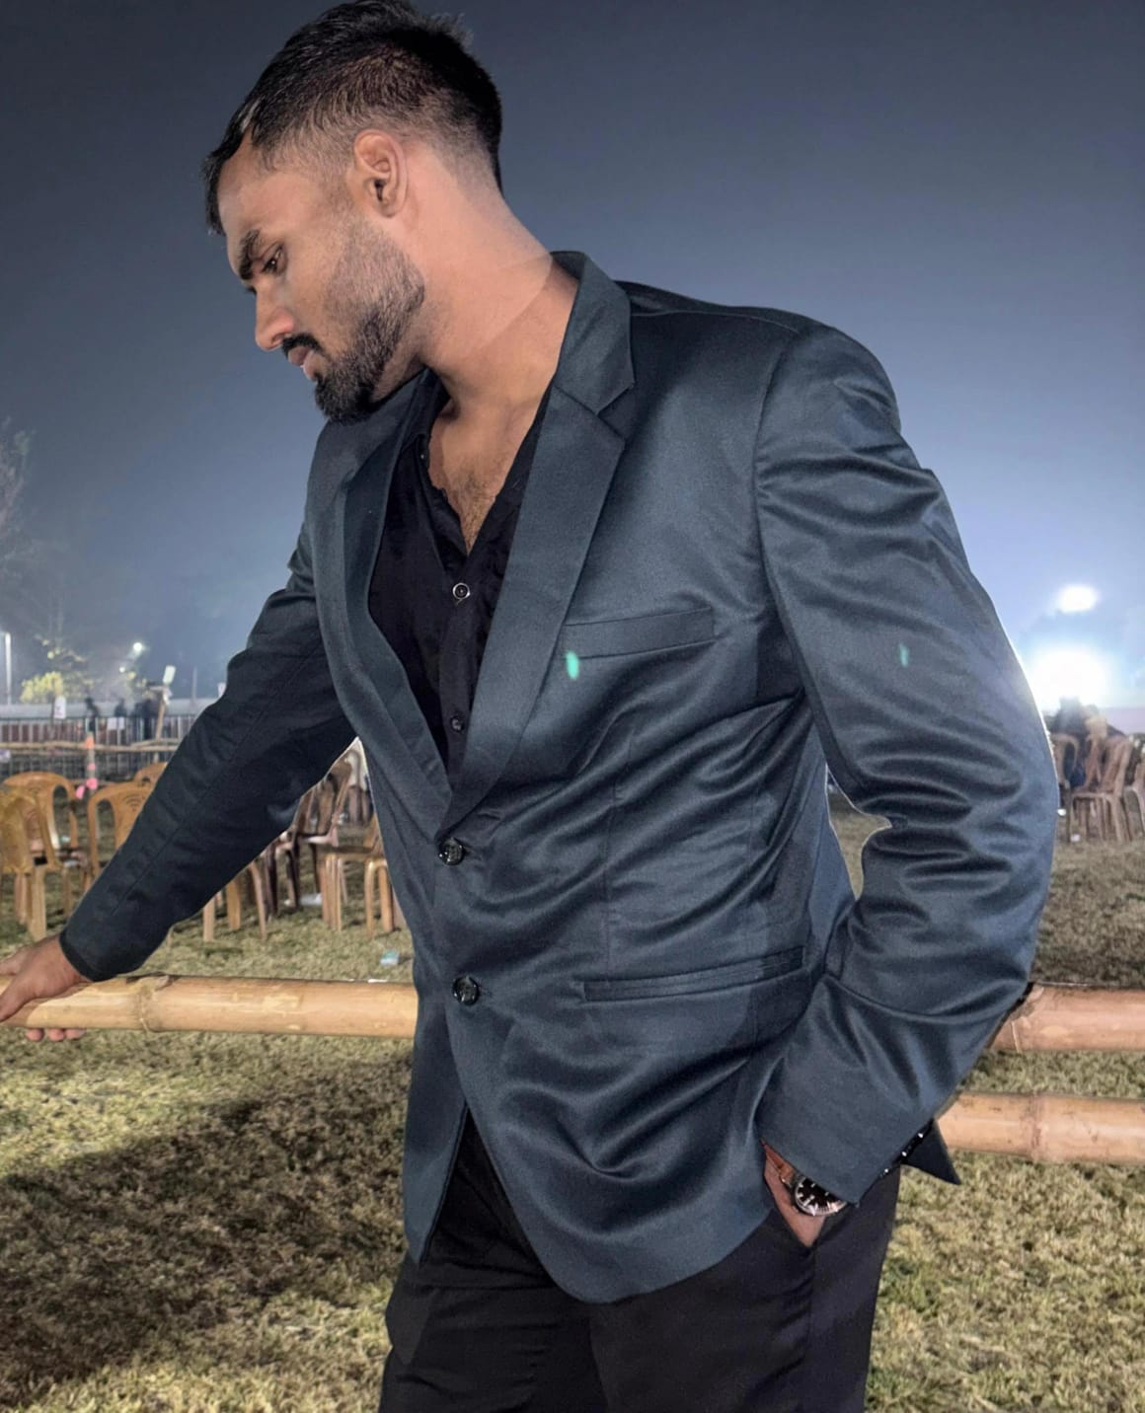

10)Abhishek Aditya
25MS
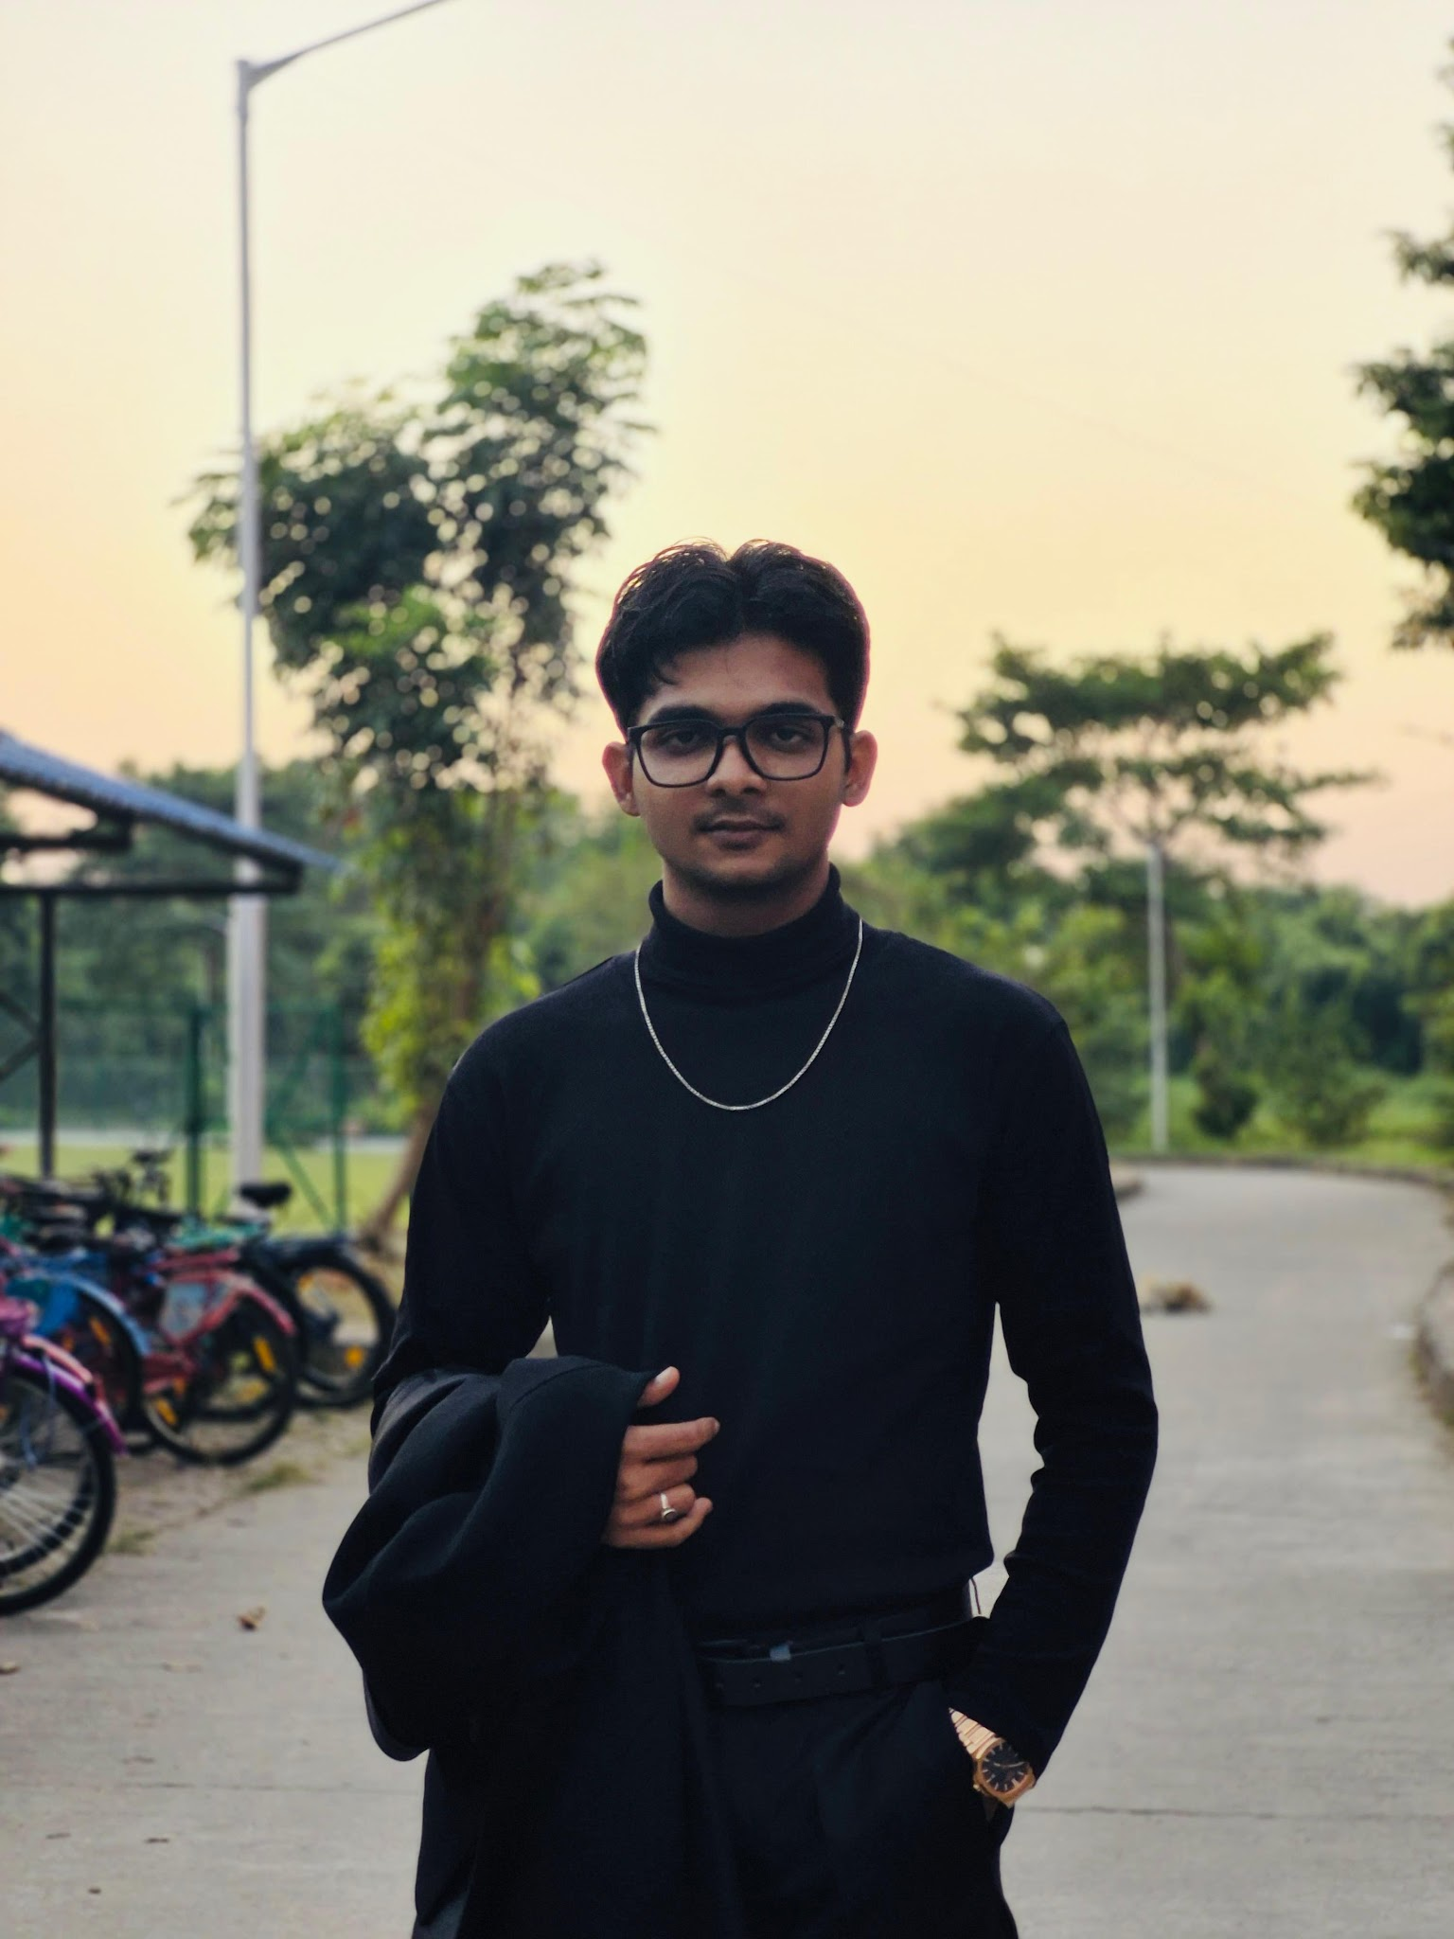

11) Rahul Beniwal
25MS
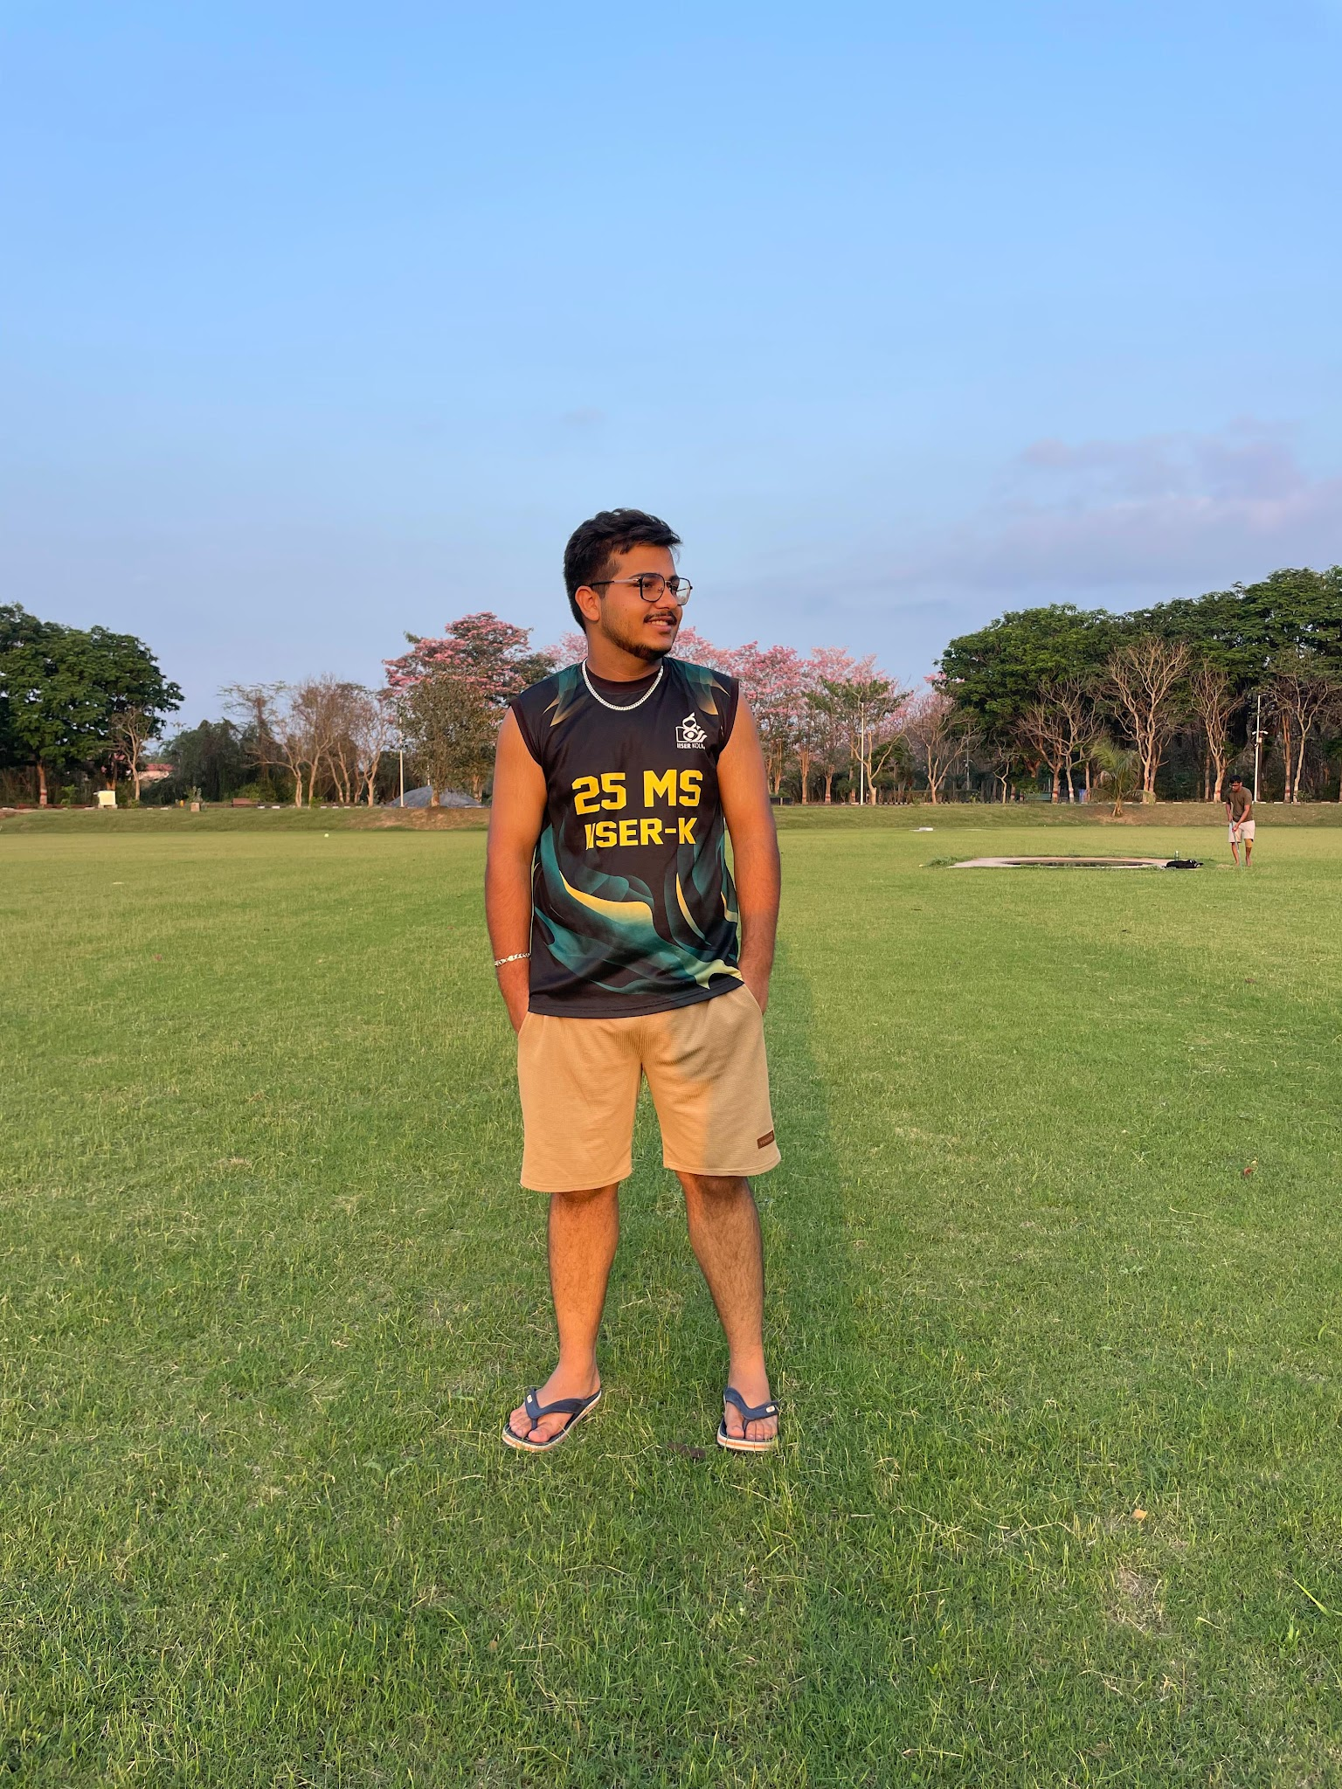

12)Sandipta Adhikary
25MS 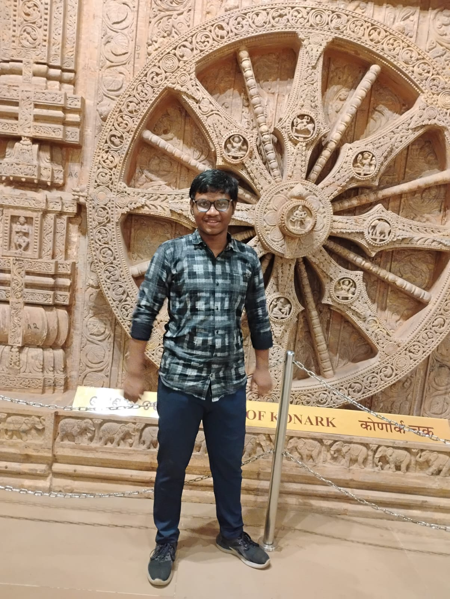

13)Banoth Harshitha 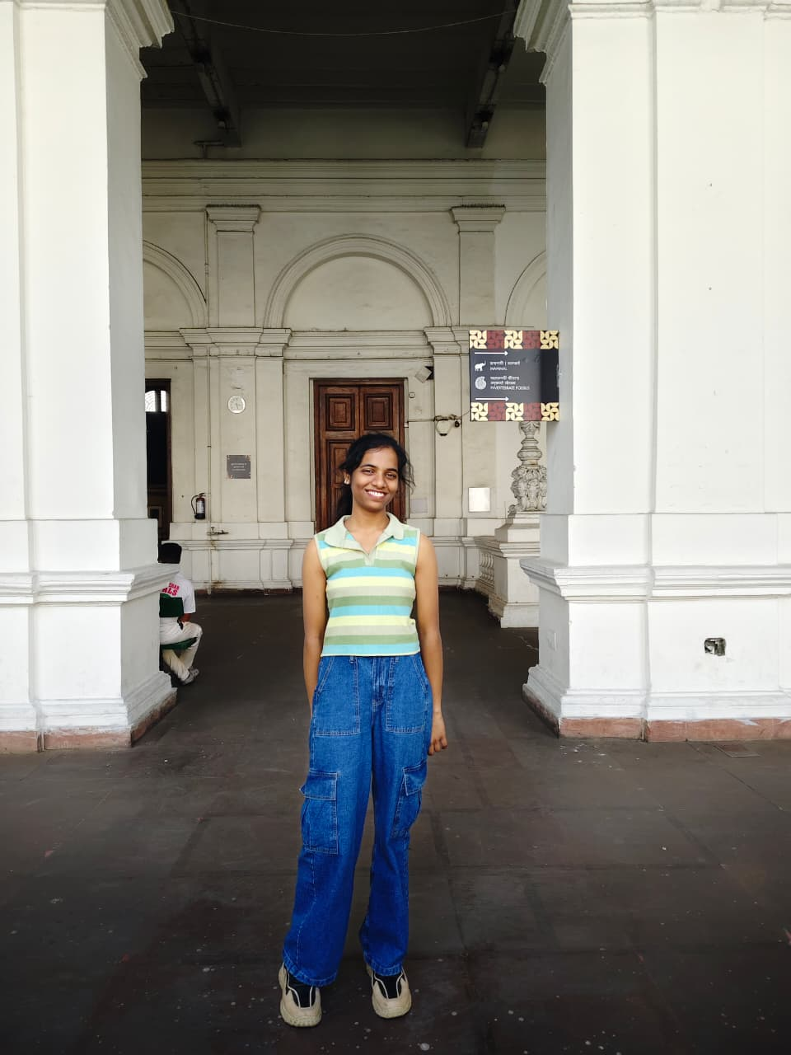

14)Swarali Shingne 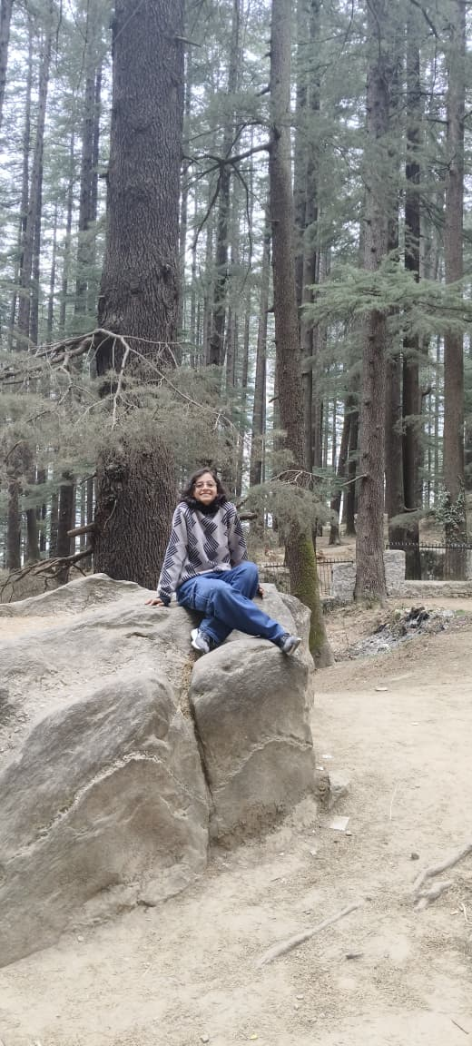

15) Subarna Sultana
25MS 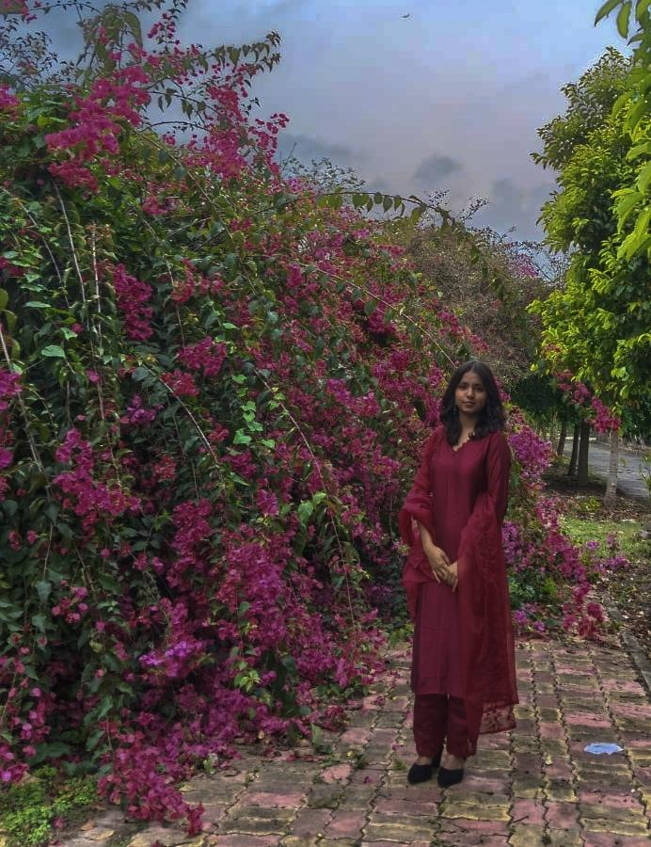

16)Mirza Mohammed Hasnain Baig
22MS 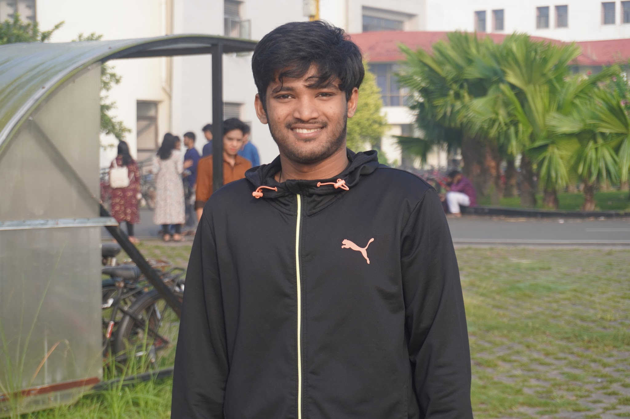

17)Lipsa Rani Senapati
22MS 