KABADDI CLUB OBS 2026-27

- SECRETARY-AAKSHI KUMARI
CONTACT-+91 89360 51800
EMAIL- ak25ms286@iiserkol.ac.in
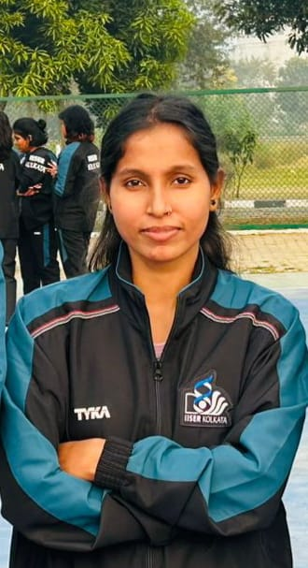

- CONVENOR-SAMIDHA NAGOSE
CONTACT -+91 83298 90468
EMAIL- sn25ms324@iiserkol.ac.in
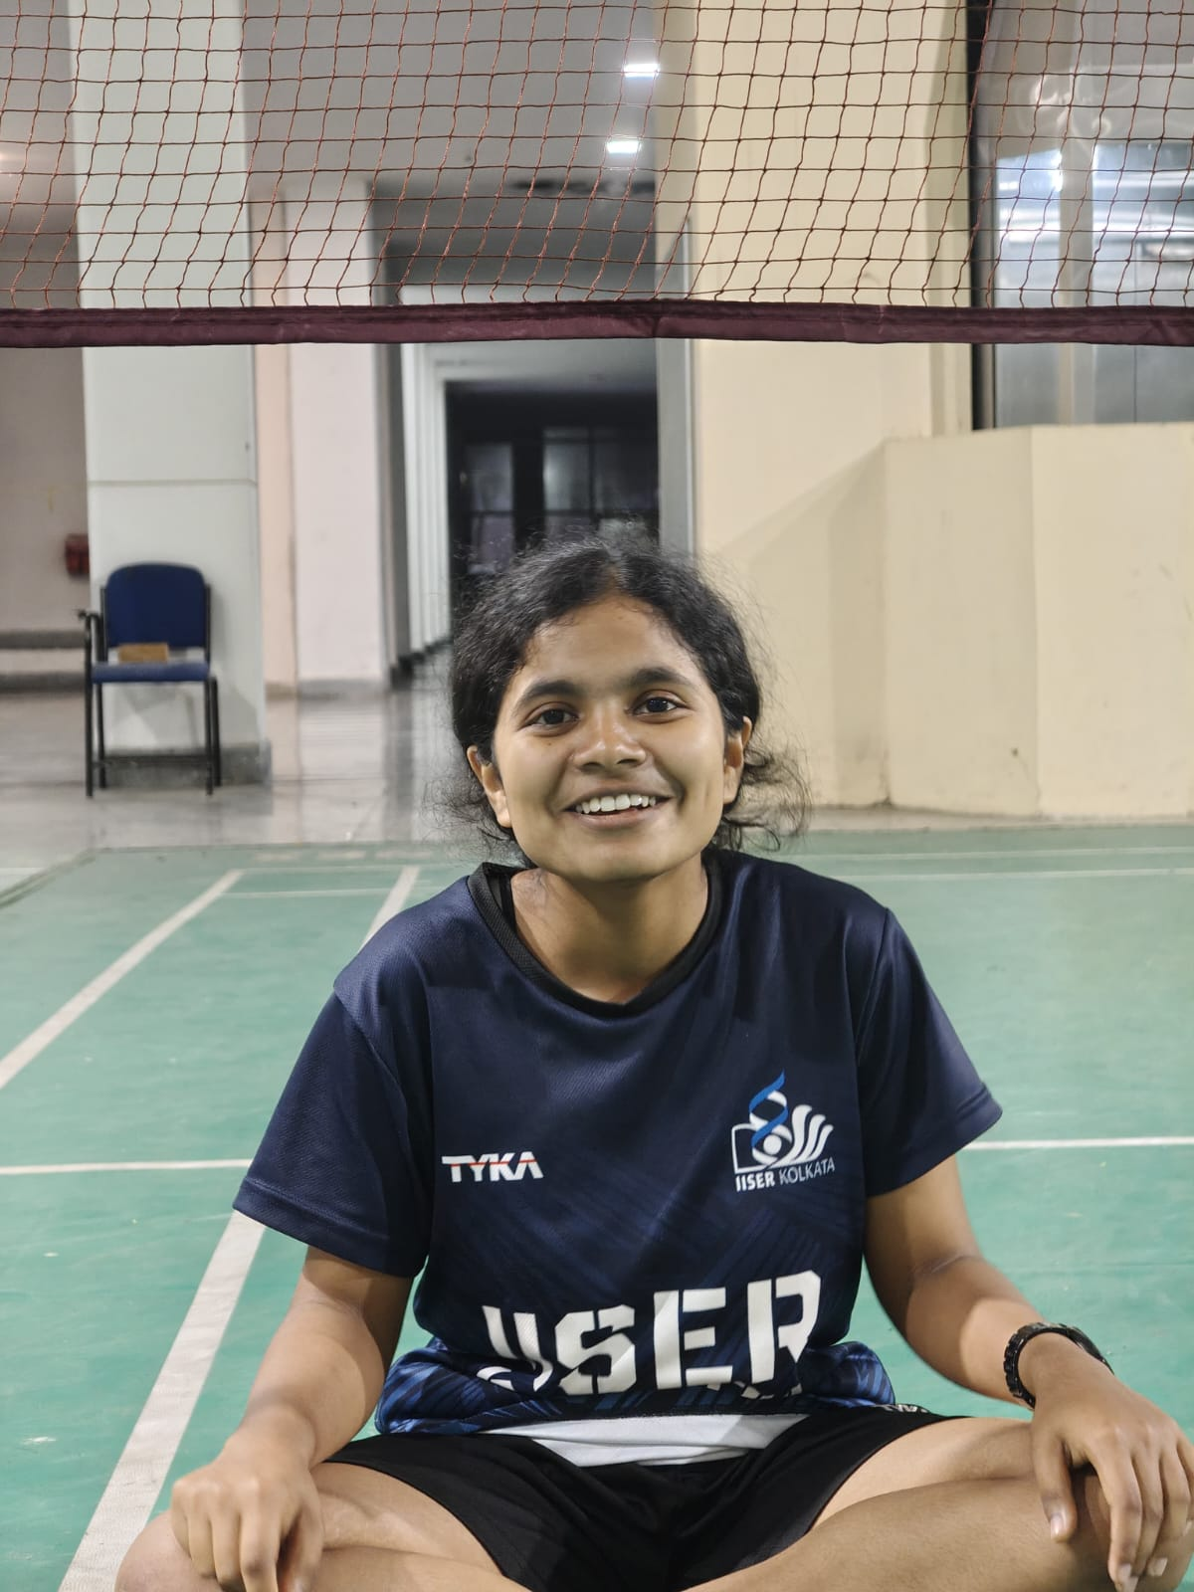

- CONVENOR-SHAURYA AGARWAL
CONTACT-+91 73108 25186
EMAIL- sa25ms204@iiserkol.ac.in


- TREASURER -BANISHREE MOHANTA
CONTACT-+91 96928 79660
EMAIL- bm25ms217@iiserkol.ac.in
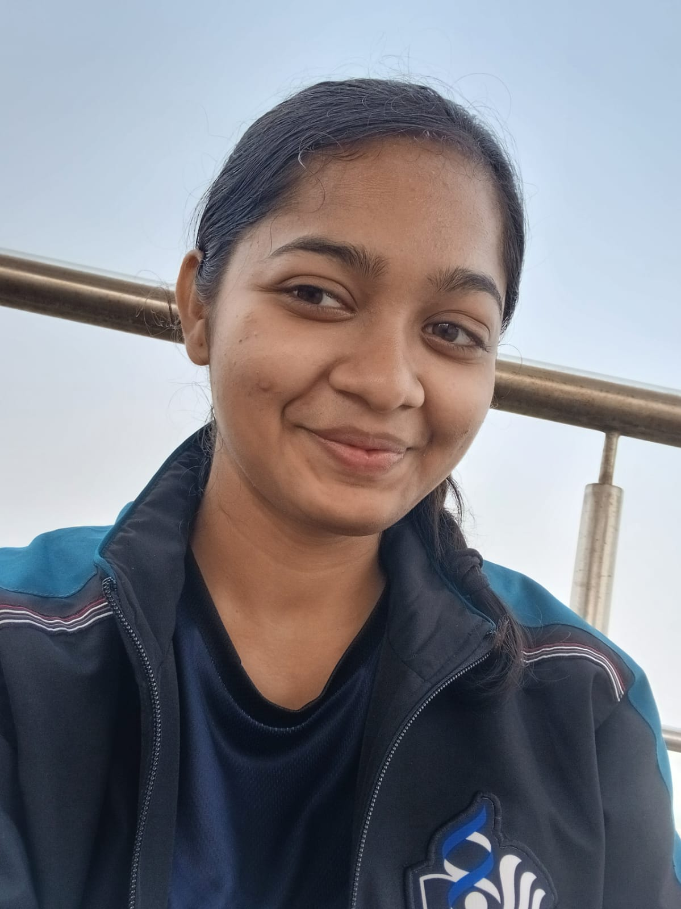

- TREASURER -ANJANEYA KAR
CONTACT-9348013796
EMAIL- ak25ms327@iiserkol.ac.in
