OBs for the 2026-27 tenure

Secretary: Kr. Rishank(25MS092)
Email: kr25ms092@iiserkol.ac.in
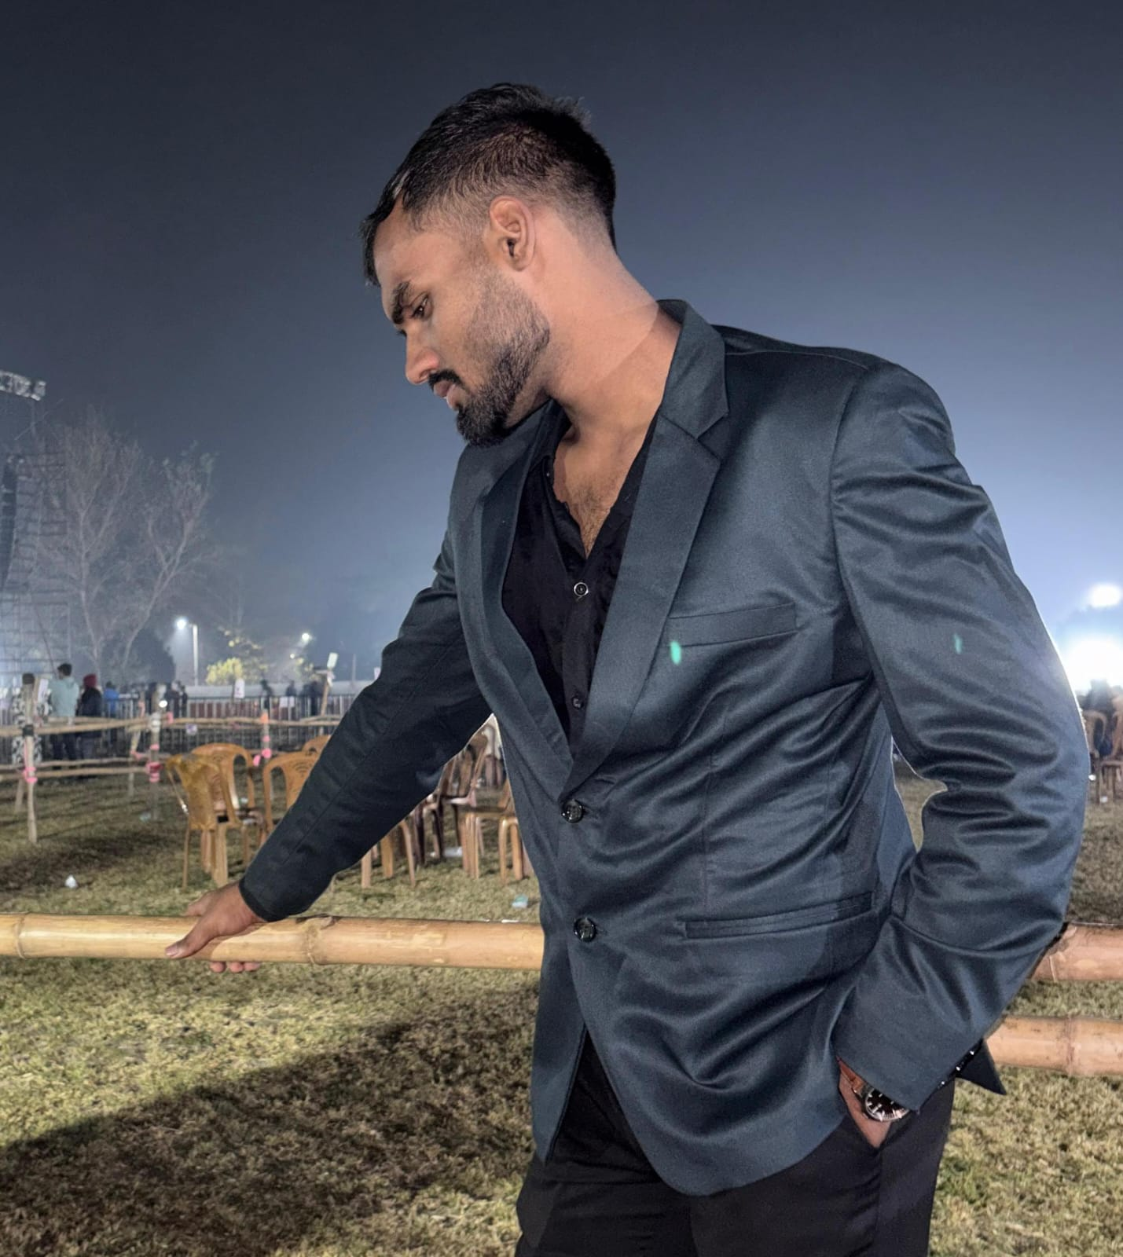
Treasury: Rahul Beniwal(25MS312)
Email: rb25ms312@iiserkol.ac.in
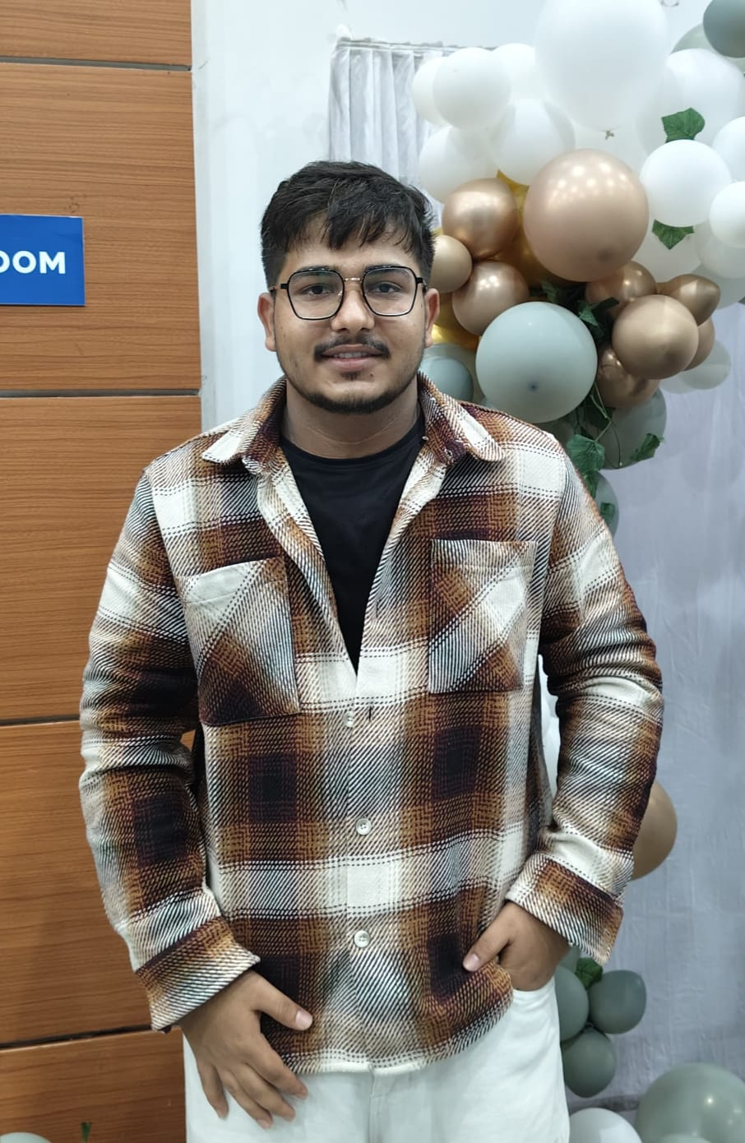

Convener: Kajori Deb Barman(25MS013)
Email: kdb25ms013@iiserkol.ac.in
