Q1 Are/how are plant communities in fallen log patches different from those in the open?

1. Abundance
   1. **Analysis**:

Here, we compared the total number of plants between log and open plots.

* 1. **Changes Made**:

The abundance of plants is now summarised at the block level. To avoid bias from the unequal number of plots in each plot type, we calculated the average total plant count for each plot type within each block.

* 1. **Results**:

There was no difference in plant abundance between the log and open plots across all three years.

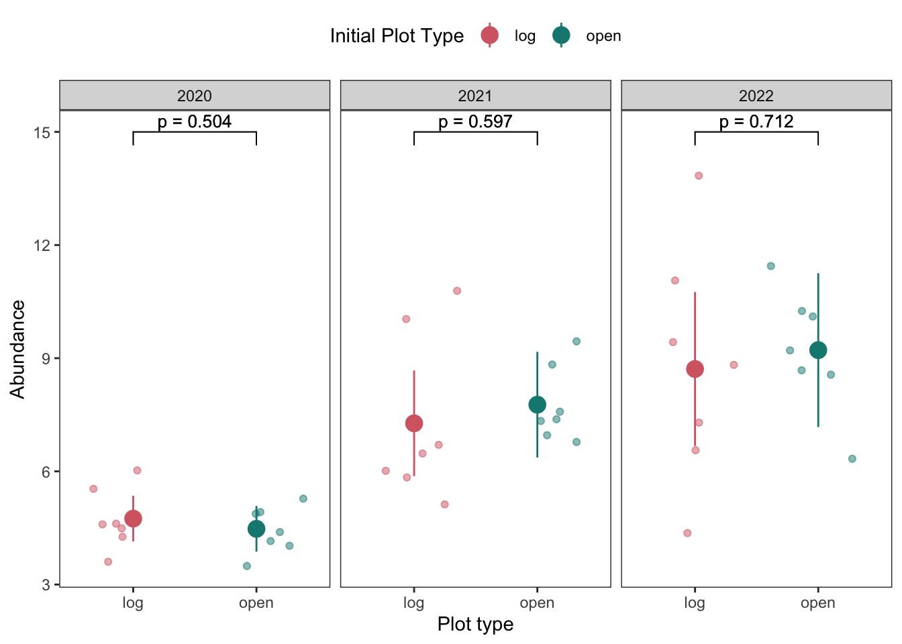

Figure 1 Each jitter is the average total plant count for each plot type within a block. Lines show the 95% confidence interval.

1. Diversity
   1. **Analysis**

Here, we compared the Shannon diversity index between log and open plots.

* 1. **Changes Made**

The Shannon diversity index is summarised at the block level. Since SDI is relatively less biased by the difference in plot number, each row in the data matrix represents the sum of species count for each species in the same plot type within a block.

2.3 **Results**

There was no difference in plant diversity between the log and open plots across all three years.

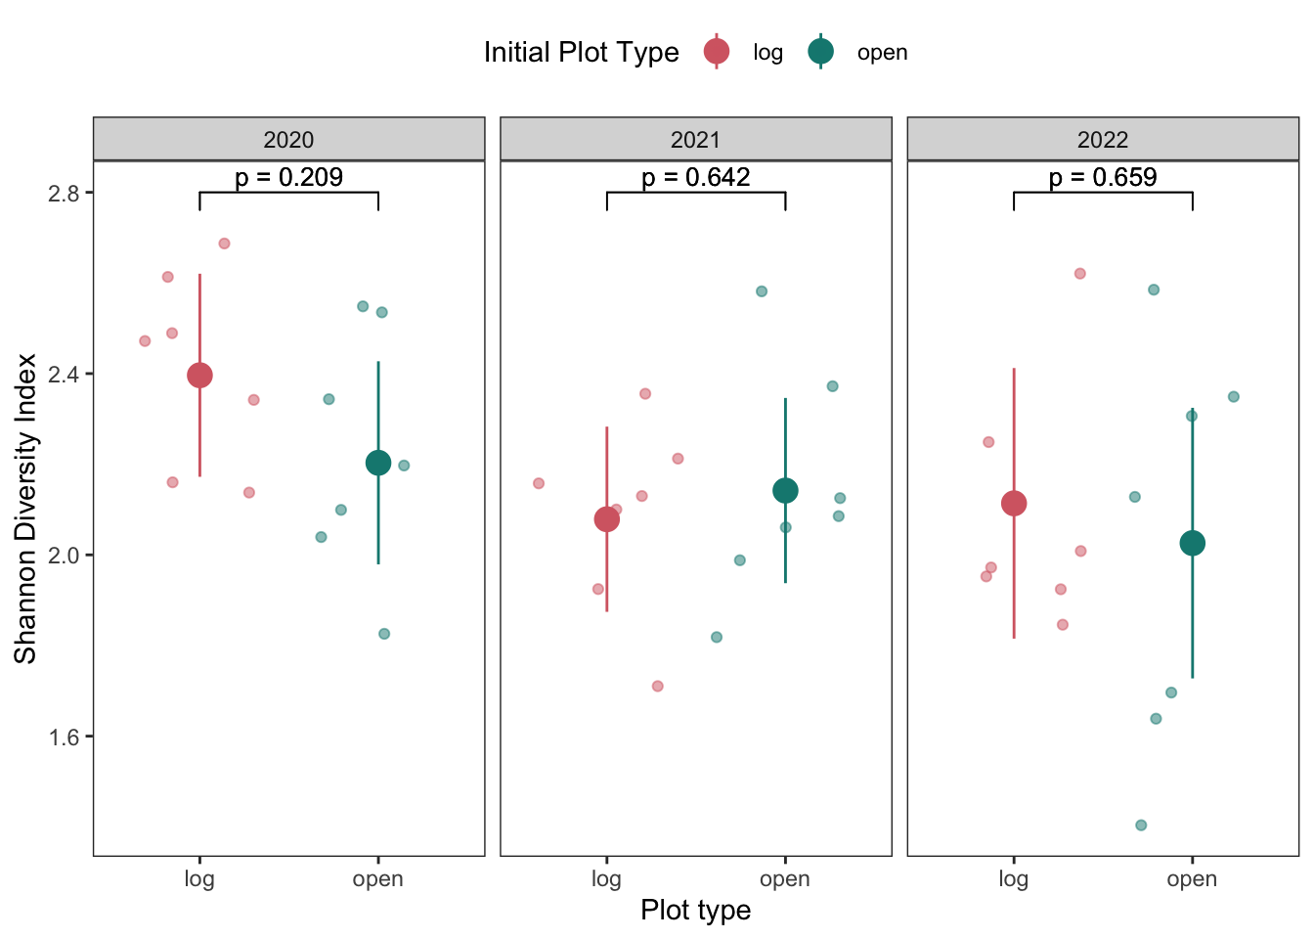

Figure 2 Each jitter is the Shannon diversity index for each plot type within a block. Lines show the 95% confidence interval.

1. **Composition**
   1. **Analysis**

We used a redundancy analysis to compare the plant composition in log and open plots. Further, we performed a permutation test and variation partitioning to determine the significance of and proportion of variation in the plant community, which was explained by "plot treatment" and "block," respectively. Plant composition was also visualised with NMDS plots and tested with an analysis of similarity (ANOSIM),

* 1. **Changes made**

The RDA analysis includes plot treatment and block as fixed effects. NMDS plots are represented in two dimensions (k=2).

* 1. **Results**

“Plot treatment” (i.e. plot type) significantly affected the plant composition in 2021 and 2022 only. “Block” was found to be a consistent and significant factor that impacted the plant composition across all three years studied. It also explained a much greater proportion of the variation.

* 1. **Note**

Numeric results can be found in the [HTML](https://github.com/slaubrie/log-project-western-australia/blob/main/log-project-aubrie-winnie.html) document. From the RDA analysis and permutation test, displayed are R-squared values representing the variation in plant composition explained by “block” and “plot treatment” together and separately. The second result box under each year label is the variation partition table; we can find the adjusted R-squared column where X1 represents the variation explained by "plot type”, and X2 represents the variation explained by "block”. The third box shows the ANOSIM results, which show whether the difference in plant composition between the two plot types is significant.

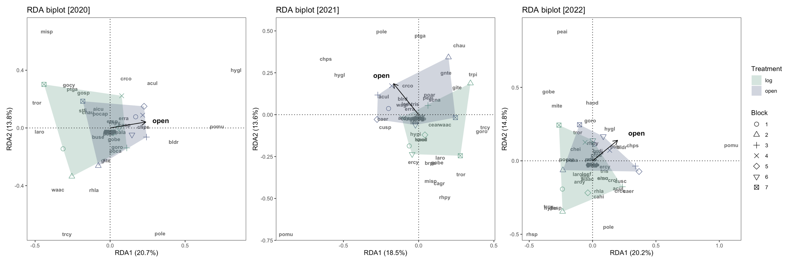

**Figure 3** RDA biplots of plant species composition of log and open plots across seven blocks.

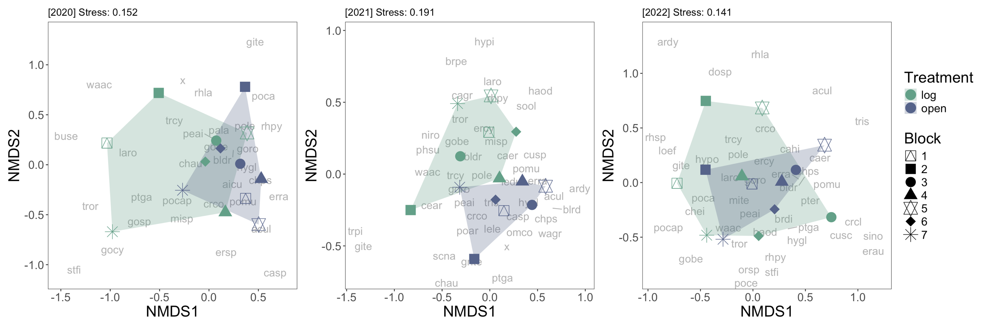

**Figure 4** NMDS plots show differences in plant species composition between log and open plots across seven blocks.

**Q2** Why are plant communities in fallen log patches different from patches in the open?

1. Nutrient composition comparison between log and open
   1. Analysis

We used the Wilcoxon rank sum test to compare soil nutrient levels between log and open plots.

* 1. Changes made

Added unit.

* 1. Results

Log plots have significantly higher plant available nitrogen and total carbon than open plots.

**Figure 5** Boxplot of different soil elements in log and open plots. Asterisks indicate significant differences between plot treatments.

1. Plant abundance ~ nutrient composition (P, pH, N, C and CEC as additive terms) + (1|year)
   1. Analysis

We used an LMER to model the effect of all soil components on the abundance of plant individuals (composite data pooling data from 2020, 2021, and 2022). We included “year” as a random intercept. Additionally, we performed a model dredging (MuMln package) to obtain all possible models with different combinations of variables from the global model. We then performed model averaging on the model subset with the cumulative sum of Akaike Information Criterion weights equal to 0.95. The relative importance of each soil element was ranked by each element’s sum of weight in all models within that subset containing it.

* 1. Changes made

We removed K from the initial global model since it can be inferred from P based on the PCA results. We performed model averaging on top of model dredging, using another approach (instead of p-value) to inspect the relevancy of each soil element to plant abundance.

* 1. Results

Soil P was the most influential soil element in affecting plant abundance. Soil pH, N, and C were similar in their importance in explaining differences in plant abundance.

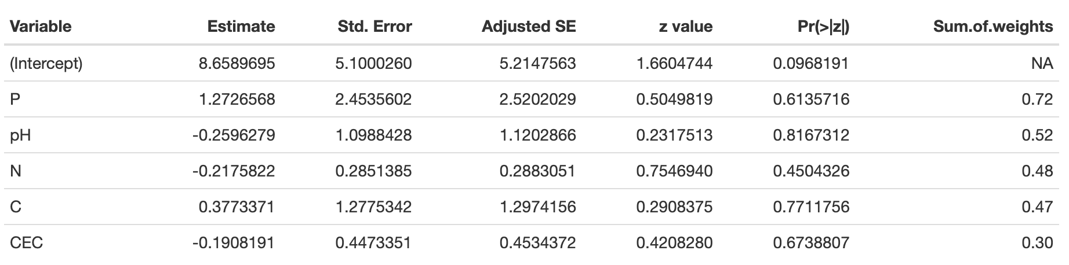

**Table 1** Results from model averaging: plant abundance ~ nutrient composition (P, pH, N, C and CEC as additive terms) + (1|year)

1. Plant diversity ~ nutrient composition (P, pH, N, C and CEC as additive terms) + (1|year)
   1. Analysis

Same as 5.1.

* 1. Changes made

Same as 5.2.

* 1. Results

Soil P was the most influential soil element in affecting plant diversity. Soil pH and C were similar in their importance in explaining differences in plant diversity. Soil N was not included in any of the models within the 0.95 AIC benchmark.

**Table 2** Results from model averaging: plant diversity ~ nutrient composition (P, pH, N, C and CEC as additive terms) + (1|year)

1. Plant composition ~ nutrient composition (P, pH, N, C and CEC as additive terms) + condition(year)
   1. Analysis

We used a redundancy analysis to assess the relationship between plant composition (composite data pooling data from 2020, 2021, and 2022) and soil nutrient elements with year as the conditional term. The significance of each nutrient element was tested with a permutation test.

* 1. Changes made

We plotted three years of data and their relative relationship to different soil elements. We also visualised the turnover of blocks in the nutrient space.

* 1. Results

All nutrient elements significantly explained differences in plant composition. However, these differences in soil seem to be explained by a larger spatial pattern (e.g., block). At a higher resolution, though, Soil C and N seem to drive the differences between log and open plots.

* 1. Note

We tried to present this same set of data with NMDS and further tested the influence of soil elements with ANOSIM. However, a big drawback is that we could not factor “year” in.

**Figure 6** RDA biplots of plant species composition of log and open plots from 2020 to 2022 constrained by year. Arrows show the explanatory soil variables. Polygons show grouping by plot treatment.

**Figure 7** RDA biplots of plant species composition of log and open plots from 2020 to 2022 constrained by year. Arrows show the explanatory soil variables. Polygons show grouping by block number.