Communication framework for vehicle ad hoc network

on freeways

(Paper #6)

Final Report

Presented by: Slava Ustinov, 309930006
Ron Meiry, 301224283

Contents
Preface 1
Contents 2
1. Introduction 1-1
1.1 Definitions and abbreviations 1-1
1.2 Overview 1-2
1.3 Goals of the simulation 1-3
1.4 Assumptions 1-4
Design and Flow 1-5
1.5 Overview 1-5
1.6 Modules overview 1-6
1.7 Application Interfaces 1-10
1.8 Results and Test measurements 1-11

Introduction

Definitions and abbreviations

Abbreviations:
VANET - Vehicular Ad hoc Network – The network type this article deals with
SVID - Safety/Vehicular Information Delivery – The new protocol suggested by this article
SIP - Session Initiation Protocol – The existing application layer protocol used by SVID
SRV - SIP-based Relay Vehicle – An infrastructure related vehicle
AV - Ancillary Vehicles – Regular vehicles on the road that use the infrastructure
CN - Core Network – Static network of servers to support the scheme
MR-BS - Multihop Relay Base Stations
FLR – Frame Loss Rate

Overview

The need for a stable and efficient communication framework for VANET is a rising issue.
Most of the current VANET communication schemes allow only a short range communication, forcing the need for vehicles to relay messages across road. This method suffers from high jitter (unstable trip times), caused by various wireless and protocol effects, which makes them unsuitable for real-time applications. This article presents an SVID framework which is consisted of an application-layer VANET communication protocol. This scheme is consisted of the following component:
- A high-power vehicle, called SRV, that acts as a relay station, which provides connectivity to other regular vehicles around it.
- Base stations which are located alongside the road, which provide connectivity from the SRVs to the CN.
- A CN that consists of 3 main servers:
- Location server – holds the location records of all clients.
- Registrar server - authenticates and authorizes clients.
- Guard server – routes requests to the client's current location, able to reroute messages
to other base-stations.

The SVID's goals:
- Allowing real-time emergency messages with minimal propagation time to all relevant
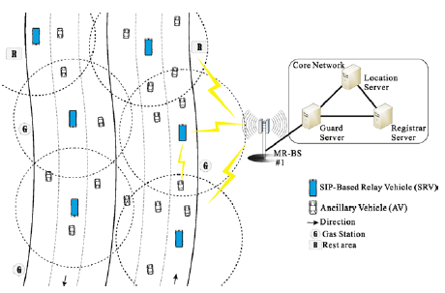
vehicles.
- Providing tools for car-fleet management.

Goals of the simulation
In our simulation, we'll focus only on the safety-related attributes of SVID and measure the efficiency of these procedures. Using the model, we'll examine the following parameters:
- Maximum propagation time of an emergency FLOOD message from one of the vehicles to
all relevant vehicles.
- Number of thrown packets due to queue overflow at the SRV.
- Average frame loss rate per AV as a function of the number of AVs.
- The number of collisions as a function of the number of AVs.

Assumptions

- Our layer 2 protocol is WiMAX. In this simulation we'll ignore all physical attributes related to working with a wireless medium, except for an error rate.
- Our FLOOD transmission time is a parameter.
- AVs won't switch between different SRVs.
- SRVs will have constant communication with a single base station, periodically sending registration messages to imitate transition between different base stations.
- Our highway's traffic will be in one direction only.
- The maximum range between an AV and it's SRV as given by a parameter.
- The maximum range between an SRV and the BS is the road's length.
- We'll use the following error probability function:

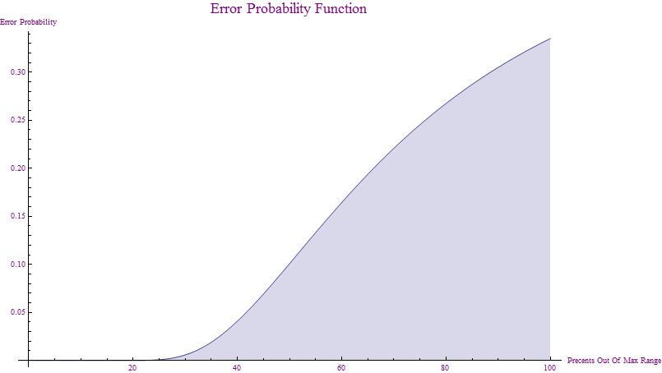

Design and Flow

Overview

As described before, the system is built out of the following components:
AVs, SRVs, single MR-BS, single core network with all of its components. The basic modules and network topology are described below:

AV – A regular vehicle on the road (can be considered as an End Device). Such vehicle can ask to register to the network through the SRV. On registration success, it'll be able to send and receive emergency FLOOD messages that originate from other vehicles.
SRV – Relay vehicle. It relays all data traffic between the AVs and the core network, via a BS.
BS – A static base station alongside the road. It's responsible for connecting between SRVs and the core network.
CN – The core network. Contains the following servers:
Guard Server – The gateway for all incoming and outgoing traffic from the CN.
Makes routing decision based on the content of the message.
Registrar Server – Responsible for registration and authentication of all SRVs and
AVs.
Location Server – Responsible for keeping location information regarding
all vehicles in the network.

System diagram with:
2 SRVs,
3 AVs per SRV

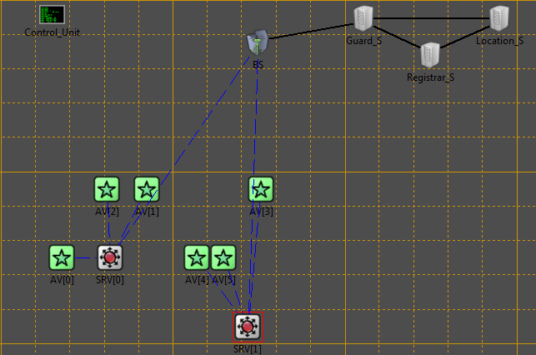

Modules overview

Simple Module: WiMAX
Description: Represents a physical layer protocol: WiMAX.
Variables: Data Rate – The transmission rate in Mbps
Buffer Size – The buffer size for incoming messages
Number of Frequencies – The number of frequencies in the OFDMA.
SRV transmission range – The maximum range between an SRV and his AVs.
Road length - The maximum range between an SRV and the BS.
Functions: initialize() – initialize WiMAX parameters.
handleMessage (cMessage* msg) –
For outgoing messages: Queue up the messages and send them one by one.
There are separate queues for FLOOD message and regular messages.
If an outgoing FLOOD message is received, it's sent immediately over a dedicated channel.
A separate queue exists for outgoing FLOOD messages.
For incoming messages: Forwards the message to the IP/UDP layer, creates an ACK and places it at the front of the regular queue.
At an AV, all outgoing messages require an ACK.
At an SRV and BS, FLOOD messages do not require an ACK.

Statistics Gathering: Gathers statistics about:
- The amount of thrown messages due to full message buffer.
- The amount of received corrupt packets.

Simple Module: Ethernet
Description: Represents a physical layer protocol: Ethernet.
Variables: none
Functions: initialize() – initialize Ethernet parameters.
handleMessage (cMessage* msg) –
For outgoing messages: Queue up the messages and send them one by one.
For incoming messages: Forwards the message to the IP/UDP layer.

Statistics Gathering: none

Simple Module: UDP_IP
Description: Represents the 3rd and 4th layer protocols: IP and UDP.
Variables: none
Functions: initialize() – initialize the IP/UDP parameters.
handleMessage (cMessage* msg) –
For messages from the SIP: Queue up the messages and send them one by one.
For incoming messages: Forwards the message to the SIP.

Statistics Gathering: none

Simple Module: SIP_Guard
Description: Represents the 5th layer protocol: SIP. This version runs on the Guard server.
Variables: none
Functions: initialize() – initialize the SIP parameters.
handleMessage (cMessage* msg) –
For incoming messages:
- FLOOD messages are checked and sent to the BS and Location server only if they're relevant (It's the first time we've seen this FLOOD message).
- Register messages are routed to the Registrar server.
- HELLO messages are routed to the Location server.
- Register OK messages are routed to the BS.

Statistics Gathering: none

Simple Module: SIP_Registrar
Description: Represents the 5th layer protocol: SIP. This version runs on the Registrar server.
Variables: none
Functions: initialize() – initialize the SIP parameters.
handleMessage (cMessage* msg) –
For incoming messages: Checks the content of the message, replies and updates the database if required.
Statistics Gathering: none

Simple Module: SIP_Location
Description: Represents the 5th layer protocol: SIP. This version runs on the Location server.
Variables: none
Functions: initialize() – initialize the SIP parameters.
handleMessage (cMessage* msg) –
For incoming messages: Checks the content of the message, replies and updates the database if required.
Statistics Gathering: none

Simple Module: SIP_Proxy
Description: Represents the 5th layer protocol: SIP. This version runs on the SRVs.
Variables: FLOOD transmission time.
Keep alive message period – The period of HELLO messages.
isBreaking – Indicates whether this vehicle is breaking due to a crash or
a FLOOD message.
Functions: initialize() – initialize the SIP parameters.
handleMessage (cMessage* msg) –
For incoming messages: Checks the content of the message and relays it:
- New FLOOD messages are sent down to the WiMAX.
- HELLO messages from SRVs are logged and deleted.
CreateAndSendARelocationMsg() – Sends a message to the control module,
requesting the next position for this vehicle. Sent every 2 seconds.
Statistics Gathering: Gathers statistics about the amount of crashed between vehicles.

Simple Module: AV_OnBoard_Computer
Description: Represents the 5th layer protocol: SIP. This version runs on the Avs.
Variables: KeepAliveMsgPeriod – time between keep-alive messages in ms.
EmergecnyMsgPeriod - time between emergency messages in ms.\
isBreaking – Indicates whether this vehicle is breaking due to a crash or
a FLOOD message.
Functions: initialize() – initialize the SIP parameters.
handleMessage (cMessage* msg) – Generates registration messages, keep-alive
messages and emergency FLOOD messages.
CreateAndSendARelocationMsg() – Sends a message to the control module,
requesting the next position for this vehicle. Sent every 2 seconds.

Statistics Gathering: Gathers statistics about the propagation time of FLOOD messages.

Simple Module: Control_unit
Description: Handles all vehicle relocation across the road.
Variables: Road Length – The road's length.
SRV transmission range – The maximum range between an SRV and his AVs.
Number of lanes
Percentage of crazy driver
Lane switch probability
IS_STATIC – Dictated whether the vehicles are moving or not.
Functions: initialize() – initialize parameters.
handleMessage (cMessage* msg) – Receives a relocation request from a
vehicle, calculates a new position for it and checks if it has crashed. A vehicle
that has changed lanes cannot crash at that timepoint.

Statistics Gathering: none

Compound Module: AV
Description: Represents a normal vehicle on road that uses the network.
Each vehicle will communicate with only one of the SRVs and will pick a random uniform location on the road (our location is one-dimensional) within the SRV's transmission range.
Variables: Position.
Contained Modules: AV_OnBoard_Computer, UDP_IP, WiMAX.

Compound Module: SRV
Description: Represents a SRV on the road.
All SRVs will communicate with the same BS.
Variables: Position, WiMAX Transmission Range.
Contained Modules: SIP_Proxy, UDP_IP, WiMAX.

Compound Module: BS
Description: Represents a Base-Station alongside the road.
Communicates with all the SRVs and the core network.
Contained Modules: Ethernet, WiMAX.

Compound Module: Guard_Server
Description: Represents the Guard server in the core network.
Makes routing decisions based on the SIP content of the message.
Contained Modules: SIP_Guard, UDP_IP, Ethernet.

Compound Module: Registrar_Server
Description: Represents the Registrar server in the core network.
Responsible for authenticating and registering new members.
Contained Modules: SIP_Registrar, UDP_IP, Ethernet.

Compound Module: Location_Server
Description: Represents the Location server in the core network.
Responsible for storing the location of vehicles on the road.
Contained Modules: SIP_Location, UDP_IP, Ethernet.

Application Interfaces

The parameters defined by omnetpp.ini for each run:
- Road_Length – The length of the highway section.
- Num_Of_SRVs – Number of SRVs that'll be uniformly distributed across the road.
- Num_Of_AVs_Per_SRV – The number of AVs that'll be uniformly distributed withing the transmission range of every SRV.
- Amount_Of_Frequencies_At_SRV – The amount of orthogonal frequencies avialable for the WiMAX protocol. Note that one of these frequencies is always used for connection with a BS.
- SRV_Transmission_Range – The WiMAX range.
- Emergency_FLOOD_Transmission_Time_In_MS
- WimaxQueueSize– The buffer size for all WiMAX devices.
If a buffer is full, all incoming message will be discarded.
- Keep_Alive_Msg_Period – The time period between keep_alive messages sent by AVs to their SRV.
- NumOfLanes – The number of lanes on the road.
- PercentageOfCrazyDrivers
- P_laneswtich – The probabilty that a vehicle switches lanes.

Results and Test measurements

Most of the results presented in the article are based on a comparison with the VANET scheme and on the abilities of the WiMAX protocol. Since we don't have a fully operational WiMAX protocol and we haven't simulated the VANET scheme, the only comparison we can make is to the Average FLR per connection as a function of the number of AVs.
Besides that, we've decided to gather data about some other parameters of our system that we thought were important, such as:
- The number of crashes as a function of the number of AVs.
- The average number of thrown packets at the SRVs as a function of the number of AVs.
- The maximum propagation time of a FLOOD message across the network as a function of the number of AVs.

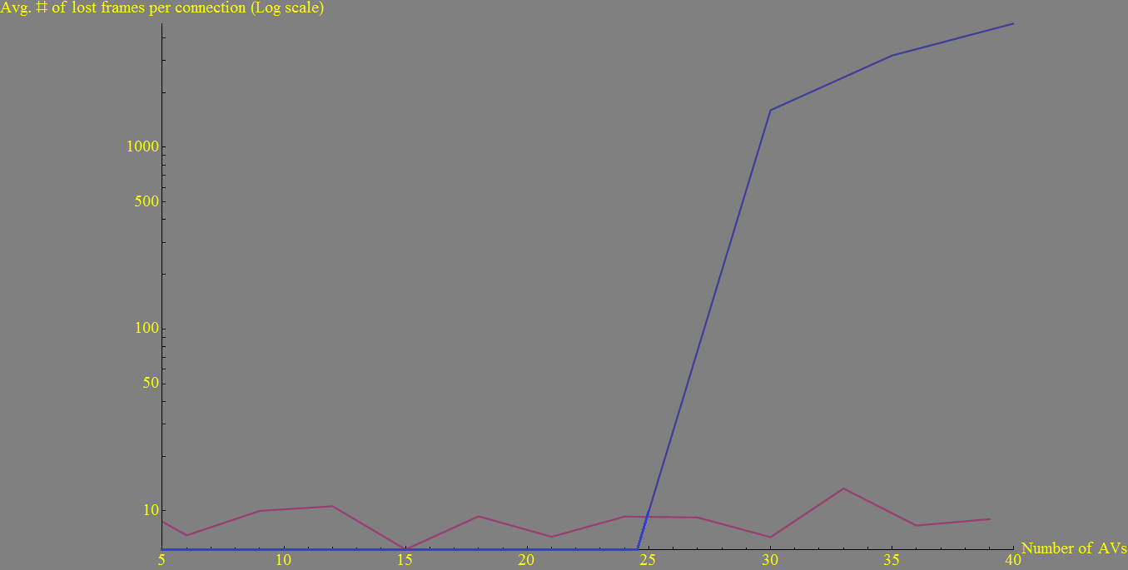
Average number of lost frames per connection as a function of the number of AVs
Article graph
Our graph

As can be seen, our graph is fairly different form the article's. The discrepancy comes from our implementation of the WiMAX protocol. Our WiMAX is a simple S&W protocol which doesn’t really simulate an actual WiMAX protocol.
Furthermore, our error function (as shown before) probably doesn’t represent the actual error rate between two users.
Since the locations of AVs around the SRVs a drawn randomly, we can see that the error rate is pretty much steady at around 9 frames per AV, over 600 simulated seconds.

Maximum FLOOD propagation time as a function of the number of AVs

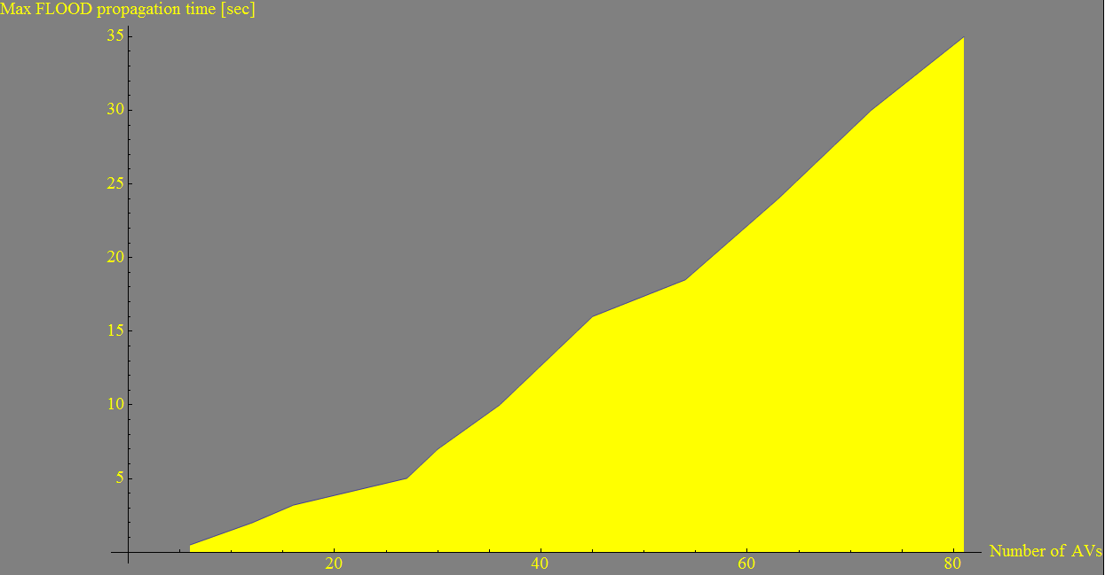

The maximum propagation time is determined by several parameters:
1. The number of messages at the SRV's buffer.
2. The retransmission timeout.
3. The frame error rate.

We can see that for more than 20 AVs per SRV the maximum propagation time is higher than 5 seconds, possibly making some of these FLOOD messages useless when regarding to the safety feature they're supposed to support.
Average number of thrown packets at an SRV as a function of the number of AVs

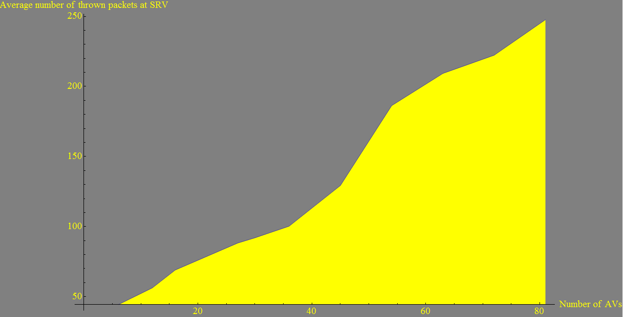

Though this graph looks at the average amount of thrown packets across the network, most of the packets are thrown by the SRVs at the rear end of the road, since they’re affected by all FLOOD messages arriving from vehicles in front of them, causing them to transmit that FLOOD themselves.
Number of collisions as a function of the number of AVs

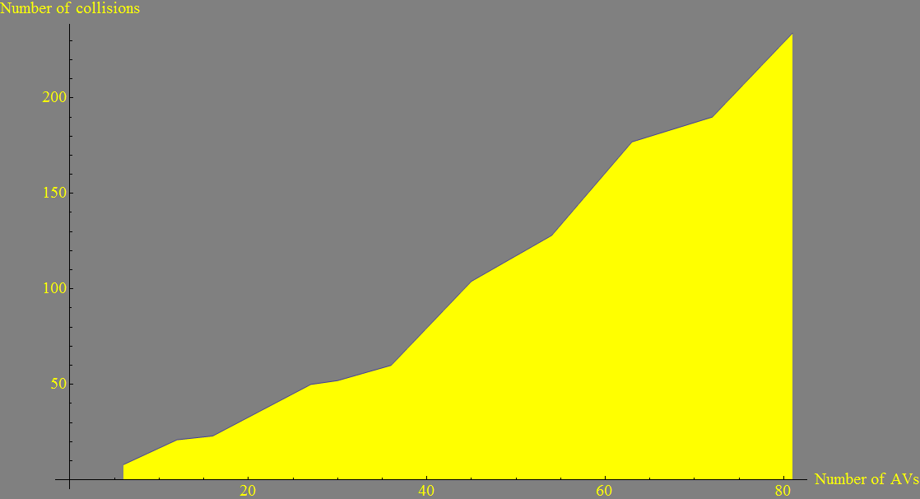

As expected, the number of collisions rises, somewhat linearly, as a function of the number of AVs per SRV.

