Intro_to_R_II

2023-05-18

## Intro to R (Part II)

### Section 1. Set working directory, install packages, training data sets

# Set working directory  
# setwd(<working_dir>)  
  
# Get working directory  
getwd()

## [1] "C:/Users/slava/OneDrive - University of Lethbridge/R_training"

# Install R packages  
# install.packages(<package_name>)  
# example:  
# install.packages("ape")  
# install.packages(c("ape", "MASS"))  
  
# Install Bioconductor packages:  
# Go to Bioconductor package's web page and  
# copy the installation code block into the R session  
  
# Check Bioconductor packages's web site and package vignette  
  
# Get help for functions  
# ?t.test # or  
  
# help(t.test)  
  
# Pre-loaded data  
# data()  
# data(mtcars)  
# head(mtcars)  
#   
# data("carnivora")  
# head(carnivora)  
#   
# data("USArrests")  
# head(USArrests)  
#   
# ?mtcars  
# ?USArrests

### Section 2. Import and export data

# Write tab delimited file   
data("mtcars")  
write.table(mtcars, file="mtcars.txt", sep="\t")  
# ?write.table  
  
# Write comma separated file  
write.csv(mtcars, file="mtcars.csv")  
  
# Read tab delimited file  
cars <-   
 read.table("mtcars.txt", sep = "\t", header = T, stringsAsFactors = F)  
cars

## mpg cyl disp hp drat wt qsec vs am gear carb  
## Mazda RX4 21.0 6 160.0 110 3.90 2.620 16.46 0 1 4 4  
## Mazda RX4 Wag 21.0 6 160.0 110 3.90 2.875 17.02 0 1 4 4  
## Datsun 710 22.8 4 108.0 93 3.85 2.320 18.61 1 1 4 1  
## Hornet 4 Drive 21.4 6 258.0 110 3.08 3.215 19.44 1 0 3 1  
## Hornet Sportabout 18.7 8 360.0 175 3.15 3.440 17.02 0 0 3 2  
## Valiant 18.1 6 225.0 105 2.76 3.460 20.22 1 0 3 1  
## Duster 360 14.3 8 360.0 245 3.21 3.570 15.84 0 0 3 4  
## Merc 240D 24.4 4 146.7 62 3.69 3.190 20.00 1 0 4 2  
## Merc 230 22.8 4 140.8 95 3.92 3.150 22.90 1 0 4 2  
## Merc 280 19.2 6 167.6 123 3.92 3.440 18.30 1 0 4 4  
## Merc 280C 17.8 6 167.6 123 3.92 3.440 18.90 1 0 4 4  
## Merc 450SE 16.4 8 275.8 180 3.07 4.070 17.40 0 0 3 3  
## Merc 450SL 17.3 8 275.8 180 3.07 3.730 17.60 0 0 3 3  
## Merc 450SLC 15.2 8 275.8 180 3.07 3.780 18.00 0 0 3 3  
## Cadillac Fleetwood 10.4 8 472.0 205 2.93 5.250 17.98 0 0 3 4  
## Lincoln Continental 10.4 8 460.0 215 3.00 5.424 17.82 0 0 3 4  
## Chrysler Imperial 14.7 8 440.0 230 3.23 5.345 17.42 0 0 3 4  
## Fiat 128 32.4 4 78.7 66 4.08 2.200 19.47 1 1 4 1  
## Honda Civic 30.4 4 75.7 52 4.93 1.615 18.52 1 1 4 2  
## Toyota Corolla 33.9 4 71.1 65 4.22 1.835 19.90 1 1 4 1  
## Toyota Corona 21.5 4 120.1 97 3.70 2.465 20.01 1 0 3 1  
## Dodge Challenger 15.5 8 318.0 150 2.76 3.520 16.87 0 0 3 2  
## AMC Javelin 15.2 8 304.0 150 3.15 3.435 17.30 0 0 3 2  
## Camaro Z28 13.3 8 350.0 245 3.73 3.840 15.41 0 0 3 4  
## Pontiac Firebird 19.2 8 400.0 175 3.08 3.845 17.05 0 0 3 2  
## Fiat X1-9 27.3 4 79.0 66 4.08 1.935 18.90 1 1 4 1  
## Porsche 914-2 26.0 4 120.3 91 4.43 2.140 16.70 0 1 5 2  
## Lotus Europa 30.4 4 95.1 113 3.77 1.513 16.90 1 1 5 2  
## Ford Pantera L 15.8 8 351.0 264 4.22 3.170 14.50 0 1 5 4  
## Ferrari Dino 19.7 6 145.0 175 3.62 2.770 15.50 0 1 5 6  
## Maserati Bora 15.0 8 301.0 335 3.54 3.570 14.60 0 1 5 8  
## Volvo 142E 21.4 4 121.0 109 4.11 2.780 18.60 1 1 4 2

# Read csv file  
  
cars <- read.csv("mtcars.csv", header = T)  
cars

## X mpg cyl disp hp drat wt qsec vs am gear carb  
## 1 Mazda RX4 21.0 6 160.0 110 3.90 2.620 16.46 0 1 4 4  
## 2 Mazda RX4 Wag 21.0 6 160.0 110 3.90 2.875 17.02 0 1 4 4  
## 3 Datsun 710 22.8 4 108.0 93 3.85 2.320 18.61 1 1 4 1  
## 4 Hornet 4 Drive 21.4 6 258.0 110 3.08 3.215 19.44 1 0 3 1  
## 5 Hornet Sportabout 18.7 8 360.0 175 3.15 3.440 17.02 0 0 3 2  
## 6 Valiant 18.1 6 225.0 105 2.76 3.460 20.22 1 0 3 1  
## 7 Duster 360 14.3 8 360.0 245 3.21 3.570 15.84 0 0 3 4  
## 8 Merc 240D 24.4 4 146.7 62 3.69 3.190 20.00 1 0 4 2  
## 9 Merc 230 22.8 4 140.8 95 3.92 3.150 22.90 1 0 4 2  
## 10 Merc 280 19.2 6 167.6 123 3.92 3.440 18.30 1 0 4 4  
## 11 Merc 280C 17.8 6 167.6 123 3.92 3.440 18.90 1 0 4 4  
## 12 Merc 450SE 16.4 8 275.8 180 3.07 4.070 17.40 0 0 3 3  
## 13 Merc 450SL 17.3 8 275.8 180 3.07 3.730 17.60 0 0 3 3  
## 14 Merc 450SLC 15.2 8 275.8 180 3.07 3.780 18.00 0 0 3 3  
## 15 Cadillac Fleetwood 10.4 8 472.0 205 2.93 5.250 17.98 0 0 3 4  
## 16 Lincoln Continental 10.4 8 460.0 215 3.00 5.424 17.82 0 0 3 4  
## 17 Chrysler Imperial 14.7 8 440.0 230 3.23 5.345 17.42 0 0 3 4  
## 18 Fiat 128 32.4 4 78.7 66 4.08 2.200 19.47 1 1 4 1  
## 19 Honda Civic 30.4 4 75.7 52 4.93 1.615 18.52 1 1 4 2  
## 20 Toyota Corolla 33.9 4 71.1 65 4.22 1.835 19.90 1 1 4 1  
## 21 Toyota Corona 21.5 4 120.1 97 3.70 2.465 20.01 1 0 3 1  
## 22 Dodge Challenger 15.5 8 318.0 150 2.76 3.520 16.87 0 0 3 2  
## 23 AMC Javelin 15.2 8 304.0 150 3.15 3.435 17.30 0 0 3 2  
## 24 Camaro Z28 13.3 8 350.0 245 3.73 3.840 15.41 0 0 3 4  
## 25 Pontiac Firebird 19.2 8 400.0 175 3.08 3.845 17.05 0 0 3 2  
## 26 Fiat X1-9 27.3 4 79.0 66 4.08 1.935 18.90 1 1 4 1  
## 27 Porsche 914-2 26.0 4 120.3 91 4.43 2.140 16.70 0 1 5 2  
## 28 Lotus Europa 30.4 4 95.1 113 3.77 1.513 16.90 1 1 5 2  
## 29 Ford Pantera L 15.8 8 351.0 264 4.22 3.170 14.50 0 1 5 4  
## 30 Ferrari Dino 19.7 6 145.0 175 3.62 2.770 15.50 0 1 5 6  
## 31 Maserati Bora 15.0 8 301.0 335 3.54 3.570 14.60 0 1 5 8  
## 32 Volvo 142E 21.4 4 121.0 109 4.11 2.780 18.60 1 1 4 2

### Section 3. Visualization with ggplot2

library(ggplot2)  
  
# Load the data  
data("ToothGrowth")  
ToothGrowth

## len supp dose  
## 1 4.2 VC 0.5  
## 2 11.5 VC 0.5  
## 3 7.3 VC 0.5  
## 4 5.8 VC 0.5  
## 5 6.4 VC 0.5  
## 6 10.0 VC 0.5  
## 7 11.2 VC 0.5  
## 8 11.2 VC 0.5  
## 9 5.2 VC 0.5  
## 10 7.0 VC 0.5  
## 11 16.5 VC 1.0  
## 12 16.5 VC 1.0  
## 13 15.2 VC 1.0  
## 14 17.3 VC 1.0  
## 15 22.5 VC 1.0  
## 16 17.3 VC 1.0  
## 17 13.6 VC 1.0  
## 18 14.5 VC 1.0  
## 19 18.8 VC 1.0  
## 20 15.5 VC 1.0  
## 21 23.6 VC 2.0  
## 22 18.5 VC 2.0  
## 23 33.9 VC 2.0  
## 24 25.5 VC 2.0  
## 25 26.4 VC 2.0  
## 26 32.5 VC 2.0  
## 27 26.7 VC 2.0  
## 28 21.5 VC 2.0  
## 29 23.3 VC 2.0  
## 30 29.5 VC 2.0  
## 31 15.2 OJ 0.5  
## 32 21.5 OJ 0.5  
## 33 17.6 OJ 0.5  
## 34 9.7 OJ 0.5  
## 35 14.5 OJ 0.5  
## 36 10.0 OJ 0.5  
## 37 8.2 OJ 0.5  
## 38 9.4 OJ 0.5  
## 39 16.5 OJ 0.5  
## 40 9.7 OJ 0.5  
## 41 19.7 OJ 1.0  
## 42 23.3 OJ 1.0  
## 43 23.6 OJ 1.0  
## 44 26.4 OJ 1.0  
## 45 20.0 OJ 1.0  
## 46 25.2 OJ 1.0  
## 47 25.8 OJ 1.0  
## 48 21.2 OJ 1.0  
## 49 14.5 OJ 1.0  
## 50 27.3 OJ 1.0  
## 51 25.5 OJ 2.0  
## 52 26.4 OJ 2.0  
## 53 22.4 OJ 2.0  
## 54 24.5 OJ 2.0  
## 55 24.8 OJ 2.0  
## 56 30.9 OJ 2.0  
## 57 26.4 OJ 2.0  
## 58 27.3 OJ 2.0  
## 59 29.4 OJ 2.0  
## 60 23.0 OJ 2.0

# Convert dose to factor  
ToothGrowth$dose <- as.factor(ToothGrowth$dose)  
  
p <- ggplot(ToothGrowth, aes(x=dose, y=len)) +   
 geom_boxplot()  
p

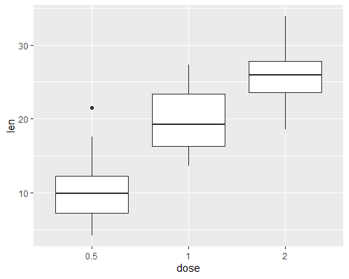

# Rotate the box plot  
p + coord_flip()

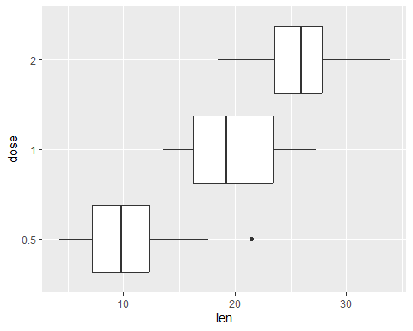

# Notched box plot  
ggplot(ToothGrowth, aes(x=dose, y=len)) +   
 geom_boxplot(notch=TRUE)

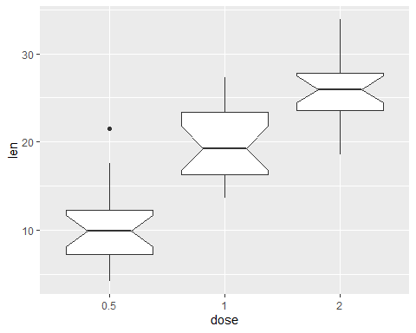

# Change outlier, color, shape and size  
ggplot(ToothGrowth, aes(x=dose, y=len)) +   
 geom_boxplot(outlier.colour="red", outlier.shape=8,  
 outlier.size=4)

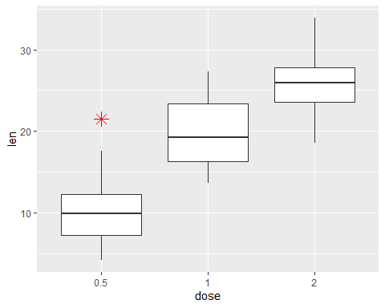

# Add individual data points as jitter  
p <- ggplot(ToothGrowth, aes(x=dose, y=len)) +   
 geom_boxplot() + geom_jitter(shape=16, position=position_jitter(0.2))  
p

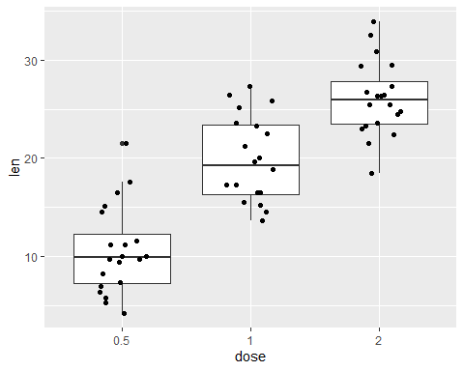

# Add color  
p <- ggplot(ToothGrowth, aes(x=dose, y=len, color=dose)) +   
 geom_boxplot() + geom_jitter(shape=16, position=position_jitter(0.2))  
p

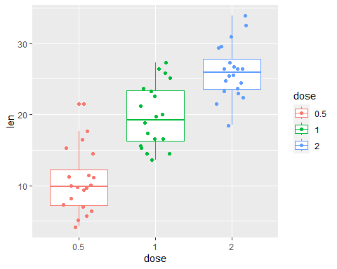

# Fill  
p <- ggplot(ToothGrowth, aes(x=dose, y=len, fill=dose)) +   
 geom_boxplot() + geom_jitter(shape=16, position=position_jitter(0.2))  
p

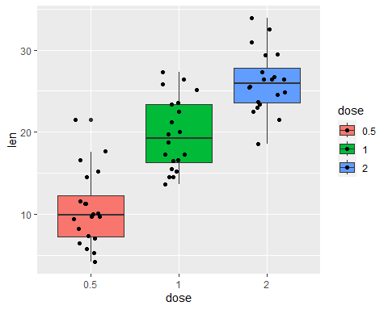

# Boxplot with multiple groups  
ggplot(ToothGrowth, aes(x=dose, y=len, fill=dose)) +  
 geom_boxplot() + stat_summary(fun="mean", geom="point")

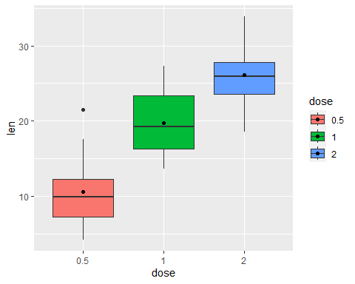

# --------------------------------------------------------------- #  
# Density plots  
df <- data.frame(  
 sex=factor(rep(c("F", "M"), each=200)),  
 weight=round(c(rnorm(200, mean=55, sd=5),  
 rnorm(200, mean=65, sd=5)))  
 )  
head(df)

## sex weight  
## 1 F 51  
## 2 F 58  
## 3 F 56  
## 4 F 52  
## 5 F 55  
## 6 F 49

p <- ggplot(df, aes(x=weight)) +   
 geom_density()  
p

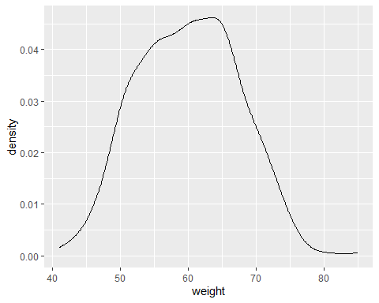

# Add mean line  
p + geom_vline(aes(xintercept=mean(weight)),  
 color="blue", linetype="dashed", size=1)

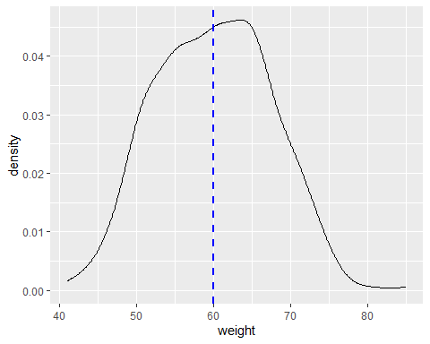

# Change line color and fill color  
ggplot(df, aes(x=weight)) +  
 geom_density(color="darkblue", fill="lightblue")

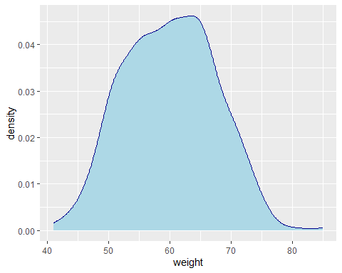

# Change line type  
ggplot(df, aes(x=weight))+  
 geom_density(linetype="dashed")

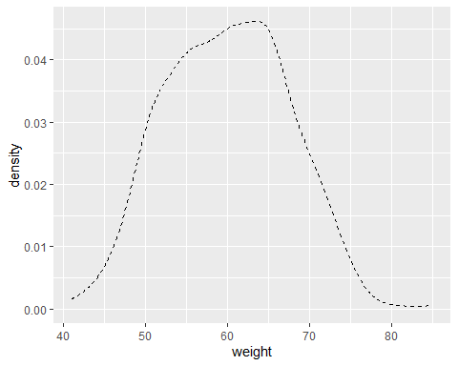

# Change density plot line colors by groups  
ggplot(df, aes(x=weight, color=sex)) +  
 geom_density()

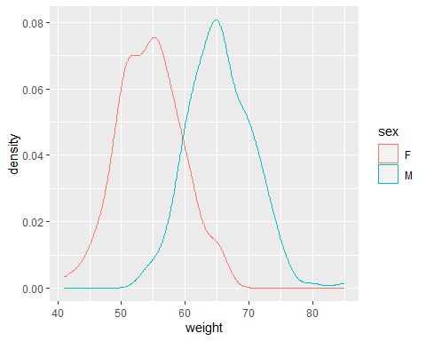

# Change fill by groups  
ggplot(df, aes(x=weight, fill=sex)) +  
 geom_density()

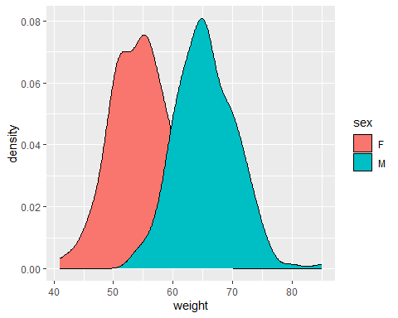

# Add transparency  
ggplot(df, aes(x=weight, fill=sex)) +  
 geom_density(alpha=0.5)

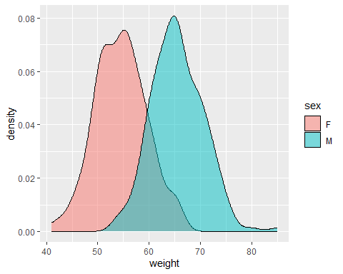

### Section 4. R functions

## Create user-defined functions  
# name_func <- function(args) {  
# commands  
# return()  
# }  
  
# Create a function that will calculate a mean  
# of 2 numbers  
calcMeanTwo <- function(num1, num2) {  
 return(num1 + num2 / 2)  
}  
   
calcMeanTwo(num1 = 2, num2 = 5)

## [1] 4.5

MeanAndSum <- function(num1, num2) {  
 mean <- num1 + num2 / 2  
 sum <- num1 + num2  
 out_list <- list(Mean=mean, Sum=sum)  
 return(out_list)  
}  
  
numList <- MeanAndSum(num1 = 10, num2 = 4)  
numList

## $Mean  
## [1] 12  
##   
## $Sum  
## [1] 14

### Learn R with swirl

### Install package “swirl” and follow

### the instructions

### Run R script command line

### Rscript script.R

### R CMD BATCH script.R

### Will create the file with output

### cat script.Rout

### Add shebang #!/usr/bin/env Rscript

### to be able to run the script as ./script.R