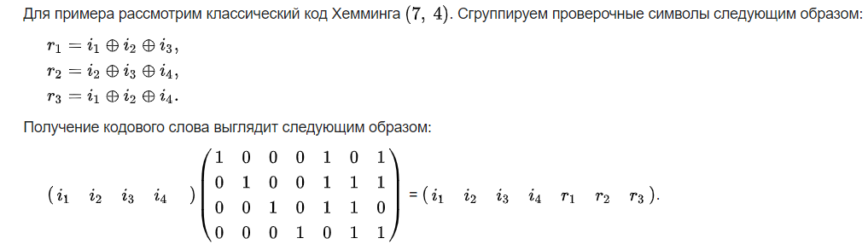

Считаем, что i1-i4 вектор, где i1 младший элемент. Тогда :

in[0] = 1 (0000 0001) при кодировании: 0000000 и 1010001 (в такой невекторной записи младший бит справа)

|  |  |  |  |  |  |  |  |  |  |  |  |  |  |  |  |  |  |
| --- | --- | --- | --- | --- | --- | --- | --- | --- | --- | --- | --- | --- | --- | --- | --- | --- | --- |
| |  |  |  |  | | --- | --- | --- | --- | | 1 | 0 | 0 | 0 | | i1 | i2 | i3 | i4 | | |  |  |  |  | | --- | --- | --- | --- | | 0 | 0 | 0 | 0 | | i1 | i2 | i3 | i4 | |
| |  |  |  |  |  |  |  | | --- | --- | --- | --- | --- | --- | --- | | 1 | 0 | 0 | 0 | 1 | 0 | 1 | | i1 | i2 | i3 | i4 | r1 | r2 | r3 | | |  |  |  |  |  |  |  | | --- | --- | --- | --- | --- | --- | --- | | 0 | 0 | 0 | 0 | 0 | 0 | 0 | | i1 | i2 | i3 | i4 | r1 | r2 | r3 | |

in[1] = 2 (0000 0010) - 0000000 1110010

|  |  |  |  |  |  |  |  |  |  |  |  |  |  |  |  |  |  |
| --- | --- | --- | --- | --- | --- | --- | --- | --- | --- | --- | --- | --- | --- | --- | --- | --- | --- |
| |  |  |  |  | | --- | --- | --- | --- | | 0 | 1 | 0 | 0 | | i1 | i2 | i3 | i4 | | |  |  |  |  | | --- | --- | --- | --- | | 0 | 0 | 0 | 0 | | i1 | i2 | i3 | i4 | |
| |  |  |  |  |  |  |  | | --- | --- | --- | --- | --- | --- | --- | | 0 | 1 | 0 | 0 | 1 | 1 | 1 | | i1 | i2 | i3 | i4 | r1 | r2 | r3 | | |  |  |  |  |  |  |  | | --- | --- | --- | --- | --- | --- | --- | | 0 | 0 | 0 | 0 | 0 | 0 | 0 | | i1 | i2 | i3 | i4 | r1 | r2 | r3 | |

in[2] = 3 (0000 0011) - 0000000 0100011

|  |  |  |  |  |  |  |  |  |  |  |  |  |  |  |  |  |  |
| --- | --- | --- | --- | --- | --- | --- | --- | --- | --- | --- | --- | --- | --- | --- | --- | --- | --- |
| |  |  |  |  | | --- | --- | --- | --- | | 1 | 1 | 0 | 0 | | i1 | i2 | i3 | i4 | | |  |  |  |  | | --- | --- | --- | --- | | 0 | 0 | 0 | 0 | | i1 | i2 | i3 | i4 | |
| |  |  |  |  |  |  |  | | --- | --- | --- | --- | --- | --- | --- | | 1 | 1 | 0 | 0 | 0 | 1 | 0 | | i1 | i2 | i3 | i4 | r1 | r2 | r3 | | |  |  |  |  |  |  |  | | --- | --- | --- | --- | --- | --- | --- | | 0 | 0 | 0 | 0 | 0 | 0 | 0 | | i1 | i2 | i3 | i4 | r1 | r2 | r3 | |

in[3] = 4 (0000 0100) - 0000000 0110100

|  |  |  |  |  |  |  |  |  |  |  |  |  |  |  |  |  |  |
| --- | --- | --- | --- | --- | --- | --- | --- | --- | --- | --- | --- | --- | --- | --- | --- | --- | --- |
| |  |  |  |  | | --- | --- | --- | --- | | 0 | 0 | 1 | 0 | | i1 | i2 | i3 | i4 | | |  |  |  |  | | --- | --- | --- | --- | | 0 | 0 | 0 | 0 | | i1 | i2 | i3 | i4 | |
| |  |  |  |  |  |  |  | | --- | --- | --- | --- | --- | --- | --- | | 0 | 0 | 1 | 0 | 1 | 1 | 0 | | i1 | i2 | i3 | i4 | r1 | r2 | r3 | | |  |  |  |  |  |  |  | | --- | --- | --- | --- | --- | --- | --- | | 0 | 0 | 0 | 0 | 0 | 0 | 0 | | i1 | i2 | i3 | i4 | r1 | r2 | r3 | |

В итоге входная и выходная последовательности бит:

|  |  |  |  |  |  |  |  |
| --- | --- | --- | --- | --- | --- | --- | --- |
| 0000 | 0100 | 0000 | 0011 | 0000 | 0010 | 0000 | 0001 |
| 0000000 | 0110100 | 0000000 | 0100011 | 0000000 | 1110010 | 0000000 | 1010001 |

Разбиваем на байты:

|  |  |  |  |  |  |  |
| --- | --- | --- | --- | --- | --- | --- |
| 00000000 | 11010000 | 00000010 | 00110000 | 00011100 | 10000000 | 01010001 |
| 0 | 208 | 2 | 48 | 28 | 128 | 81 |