Project report – Windpower Basics

Cygnus, Vindkraft, 2 sv. Autumn term 2003

Wind resource advisory opinion

Võiküla, Muhu borough, Saare province

Potential energy production with wind turbines:

Nordex N90 (2.3 MW),
Vestas V-80 (2 MW), Enercon E-70 (2 MW), DeWind D8 (2 MW),
RePower MM82/2000 (2 MW),

Alar Orion
Danel Türk
Marko Moor
Rain Maripuu

Tallinn
January 2005

Title: Wind resource advisory opinion

Võiküla, Muhu borough, Saare province

Participants:
Alar Orion
Danel Türk
Marko Moor
Rain Maripuu

Supervisor: Tore Wizelius, Gotland University

Date: 11.01.2005

Examiner: Tore Wizelius, Gotland University

Preface

This is a project made by 4 students from Estonia during the distance education course Windpower Basics at Gotland University.

The course was carried on from 27th of September to 12 th of December. It ran on a part time basis; full time course that ran for 13 weeks. This means that it was possible to participate in the course by studying in the evenings and on holidays. Distance education means that all course material, exercises and communication with the teachers was available on the Internet, with an electronic classroom as base.

The aim of the course Wind power Basics was to give a basic understanding of wind power, how a wind turbine works, the wind resources, and how this new industrial branch has developed.

We would like to thank our supervisor Tore Wizelius for providing the guidance and support through the entire distance course.

Võiküla, Muhu borough, Saare province

Potential energy production with wind turbines:
Nordex N90 (2.3 MW), Vestas V-80 (2 MW), Enercon E-70 (2 MW),
DeWind D8 (2 MW) ja RePower MM82/2000 (2 MW)

List of data and methods

To Calculate wind survival equation in muhumaa võiküla area, measures has been taken from Estonian Energia windmill located in virtsu. Type Enercon E-40, anemometer situates in 70,6 m from sea level. High includes: anemometer attachment form top – 3m , tower high up to rotor – 65m. Windmill cordinates: Y=471564 and X=6491647. Measurement consist wind data with 10 minutes interval from 2002 year october up to 2004 year april. To enlarge timeseries there have been used data from Estonian meterlogy and hydrology institute in Virtsu and datas from Kuressaare observatory and datas which was gathered in Valjala with Ties Clima by univeristy of tartu.
Advantage of Virtsu windmill data is measuring hight 70,6 m from sea level and modeling parameters validation possibility. This gives us more accurate model.

Table 1. Weibulli distribution (A and k parameters.), average wind speed U, power intensity P and wind velocity recurrence in per mills according to direction of Virtsu wind turbine (2002 october- 2004 aprill).

 | 0 | 30 | 60 | 90 | 120 | 150 | 180 | 210 | 240 | 270 | 300 | 330 | Total
A | 7.4 | 6.8 | 6.9 | 7.3 | 8.6 | 10.9 | 9.2 | 9.6 | 6.7 | 7.2 | 8.8 | 8.8 | 8.2
k | 2.48 | 3.17 | 3.04 | 2.62 | 2.05 | 2.53 | 2.17 | 2.14 | 1.96 | 2.09 | 2.04 | 2.16 | 1.95
U (m/s) | 6.61 | 6.09 | 6.2 | 6.5 | 7.62 | 9.67 | 8.17 | 8.49 | 5.97 | 6.34 | 7.82 | 7.78 | 7.29
P (W/m²) | 280 | 189 | 204 | 257 | 504 | 867 | 591 | 672 | 255 | 285 | 549 | 514 | 465
Sagedus % | 8 | 6 | 7 | 7 | 7 | 10 | 10 | 13 | 6 | 9 | 8 | 11 | 100

U (m/s) | 0 | 30 | 60 | 90 | 120 | 150 | 180 | 210 | 240 | 270 | 300 | 330 | Total
1 | 9 | 12 | 11 | 20 | 16 | 10 | 11 | 13 | 18 | 9 | 13 | 15 | 13
2 | 22 | 32 | 36 | 35 | 32 | 24 | 25 | 23 | 58 | 41 | 39 | 26 | 31
3 | 48 | 71 | 58 | 56 | 49 | 38 | 43 | 43 | 98 | 68 | 48 | 42 | 53
4 | 72 | 119 | 99 | 86 | 71 | 53 | 73 | 59 | 115 | 104 | 65 | 71 | 79
5 | 108 | 125 | 113 | 91 | 78 | 47 | 81 | 61 | 133 | 114 | 70 | 67 | 86
6 | 155 | 125 | 155 | 134 | 102 | 67 | 88 | 83 | 126 | 144 | 92 | 85 | 109
7 | 179 | 177 | 174 | 204 | 111 | 84 | 112 | 108 | 136 | 166 | 119 | 127 | 137
8 | 149 | 150 | 153 | 126 | 129 | 84 | 90 | 106 | 98 | 115 | 114 | 130 | 118
9 | 99 | 95 | 91 | 81 | 95 | 61 | 80 | 83 | 68 | 68 | 98 | 105 | 85
10 | 59 | 54 | 51 | 57 | 67 | 74 | 59 | 76 | 44 | 50 | 71 | 82 | 64
11 | 32 | 27 | 32 | 41 | 49 | 70 | 65 | 67 | 33 | 41 | 64 | 66 | 52
12 | 22 | 8 | 17 | 31 | 37 | 81 | 66 | 76 | 24 | 28 | 55 | 48 | 45
13 | 14 | 4 | 7 | 28 | 48 | 102 | 70 | 63 | 22 | 21 | 42 | 35 | 42
14 | 15 | 1 | 1 | 7 | 37 | 60 | 51 | 43 | 10 | 13 | 28 | 31 | 28
15 | 8 | 0 | 0 | 2 | 36 | 39 | 42 | 27 | 3 | 4 | 23 | 21 | 19
16 | 6 | 0 | 0 | 0 | 25 | 31 | 25 | 19 | 2 | 6 | 22 | 16 | 14
17 | 2 | 0 | 0 | 0 | 11 | 26 | 10 | 15 | 4 | 4 | 14 | 15 | 9
18 | 0 | 0 | 0 | 0 | 7 | 21 | 3 | 9 | 2 | 2 | 9 | 11 | 6
19 | 0 | 0 | 0 | 0 | 2 | 9 | 4 | 7 | 2 | 2 | 8 | 5 | 4
20 | 0 | 0 | 0 | 0 | 0 | 7 | 2 | 7 | 1 | 1 | 4 | 1 | 2
21 | 0 | 0 | 0 | 0 | 0 | 4 | 1 | 5 | 1 | 0 | 2 | 0 | 1
22 | 0 | 0 | 0 | 0 | 0 | 5 | 0 | 3 | 1 | 0 | 0 | 0 | 1
23 | 0 | 0 | 0 | 0 | 0 | 2 | 0 | 1 | 0 | 0 | 0 | 0 | 0
24 | 0 | 0 | 0 | 0 | 0 | 0 | 0 | 0 | 0 | 0 | 0 | 0 | 0

In this research proposed data about wind climate and its resources based on similar data and methodics, wich where researched during European and Denmark wind atlas (Troen, I. & Petersen, E. L., 1988. European Wind Atlas. Risø National Laboratory. Denmark) research. On wind climate modelling is considered with wind speed influencing close surrounding impediments ( like offsprings, causeways, buildings etc.) and from area relief and landuse originate influence on wind speed. If we match with European wind atlas methodics then it is enhanced with territorial divison of wind resources and with claculation methodics of wind speed change by time (Kull, A., 1996. Eesti Tuuleatlas. Tartu Ülikool. Tartu).

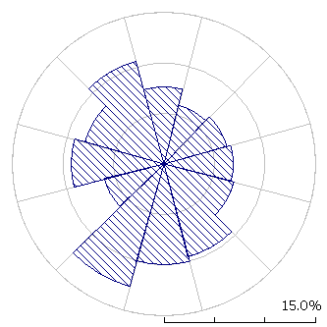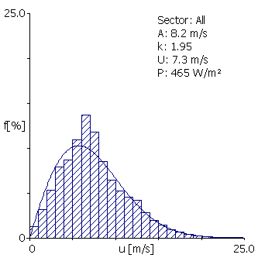

Diagram 1. Virtsu wind turbinedata (2002 oktoober – 2004 aprill) windrose and histogram (differences measured by values and from Weibull’s division are clalculated energy density between +0.15%).

Table 2. Modelled regional wind climate for Muhumaa.

 |  | R-class 0  (0.00 m) | R-class 1  (0.03 m) | R-class 2  (0.10 m) | R-class 3  (0.40 m)
Height 1  (z = 10 m) | m/s  W/m² | 6.58  348 | 4.63  145 | 4.03  96 | 3.18  47
Height 2  (z = 25 m) | m/s  W/m² | 7.20  443 | 5.52  226 | 4.96  166 | 4.18  100
Height 3  (z = 50 m) | m/s  W/m² | 7.73  533 | 6.35  308 | 5.80  240 | 5.04  161
Height 4  (z = 100 m) | m/s  W/m² | 8.36  693 | 7.49  471 | 6.87  364 | 6.05  247
Height 5  (z = 200 m) | m/s  W/m² | 9.21  973 | 9.20  905 | 8.40  685 | 7.35  453

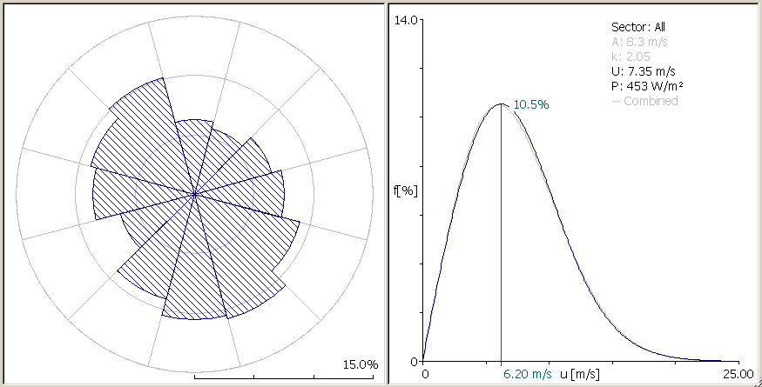

Diagram 2. Modelled windrose and frequency partition of wind at height of 70 meters from ground.

Modelled calculations are based WA^{S}P 8.0 (Wind Atlas Analysis and Application Program) Program was develop in Danish National Laboretory of Wind. This is more widelly used programm for spotting the best location for windturbines. Program PARK is used for calculations how turbines are influence each other in the windpark.

Thanks to the WA^{S}P program the best spots for the turbines were found considering by the other important objects like rodes, facilities and land use. Location of potential spot for windturbin were found by means of wind speed, frequency division of wind (Weibull division), direction of wind recurrence considering 12 quarter (each other is cowering 30º wide sector) and antecedent energy production for each turbine (including production for each sector).

Location of turbines

Windpark is planned next to „Võiküla substation”. Capacity is planned 10 MW. Cadastre divisions next to Võiküla substation are (47801:008:0006, 47801:008:0267, 47801:008:0099, 47801:008:0100) and to the South (47801:008:0368, 47801:008:0398, 47801:008:0363, 47801:008:0370, 47801:008:0358, 47801:008:0367, 47801:008:0067).

Close to the Võiküla substation are plenned electrical direct connection trass. That is why is complicated to built windturbines right next to substation. Direct connection trass ( 50 m from the highway so called highway security zone + 100 m security zone height of the windturbine) and „no construction zone” 200 m from coast. Between those two zones is possible to install no more then 1 windturbin. It is showed on drawing with yellow spot nr. 6 (drawing nr 3). Location for this turbine Estonian north maps coordinate system: L-Est 92 on: X=464 730 m, Y=6 490 700 m.

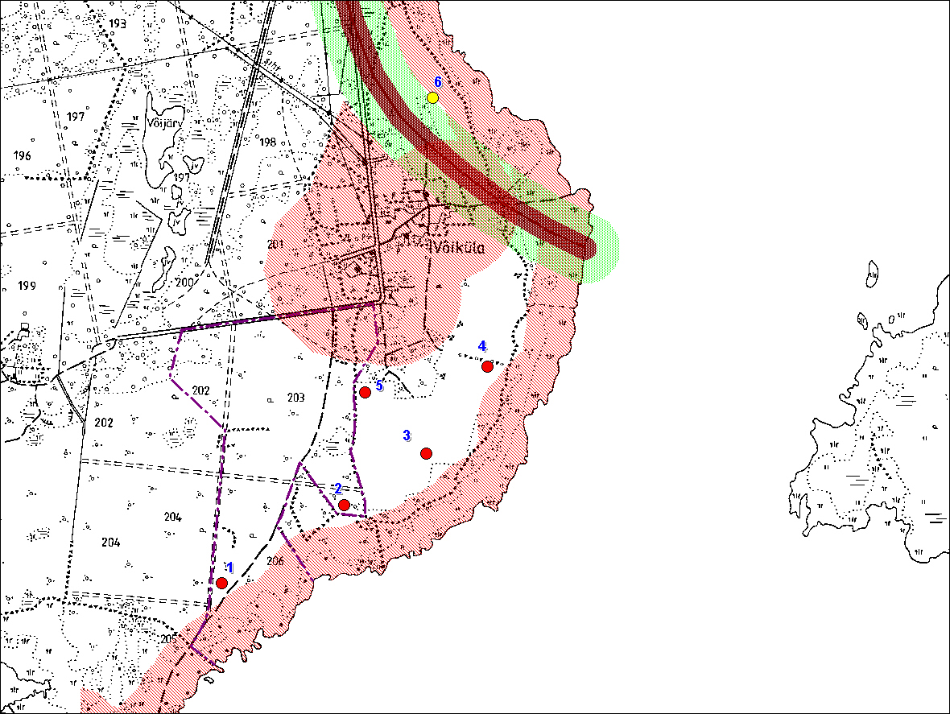

Drawing nr 3. Võiküla s windpark locatoin of turbines first versoin nr. 1.

The situation of the Võiküla windfarm`s wind turbines according to alternative no 1 would be as followes (L-EST 92):
1. X = 463828 m Y = 6488630 m
2. X = 464352 m Y = 6488962 m
3. X = 464700 m Y = 6489183 m
4. X = 464963 m Y = 6489553 m
5. X = 464440 m Y = 6489446 m
The advantage of the alternative no 1 presented on graph 3 is the most efficient use of flat ground of Patarei estate and the positioning of turbines no 1 and 2. The downside is much too big wind wake of the wind turbines no 2, 3 and 5, which reduces production and asymmetric positioning of the turbines in the windfarm which diminishes visual beauty of the windfarm.

Tables 3-12 present the next following information: the number of a wind turbine, coordinates of the location in L-EST 92 system and according to standard tower height the mean wind speed (m/s), production as an individual turbine (Gross, MWh/a), wake (%) and production per turbine in windfarm (Net, MWh/a).

Table 3. Prognosis of the energy production with Nordex N90 (2300 kW). Alternative no. 1.

Turbine no. | Location, L-Est92 |  | Tower height 80m |  |  |  | Tower height 100m
Turbine no. | X (m) | Y (m) | U  m/s | Gross  MWh/a | Wake  % | Net  MWh/a | U  m/s | Gross  MWh/a | Wake  % | Net  MWh/a
1 | 463828 | 6488630 | 7.37 | 7292 | 1.87 | 7156 | 7.71 | 7885 | 1.74 | 7748
2 | 464352 | 6488962 | 7.41 | 7375 | 3.92 | 7085 | 7.74 | 7935 | 3.63 | 7648
3 | 464700 | 6489183 | 7.48 | 7508 | 4.56 | 7166 | 7.79 | 8024 | 4.44 | 7667
4 | 464963 | 6489553 | 7.48 | 7511 | 2.74 | 7304 | 7.78 | 8019 | 2.64 | 7807
5 | 464440 | 6489446 | 7.40 | 7364 | 5.50 | 6959 | 7.72 | 7907 | 5.07 | 7506
Total |  |  |  | 37050 | 3.72 | 35670 |  | 39770 | 3.51 | 38376

Table 4. . Prognosis of the energy production with Enercon E-70 (2000 kW. Alternative no. 1.

Turbine no. | Location, L-Est92 |  | Tower height 64m |  |  |  | Tower height 85m
Turbine no. | X (m) | Y (m) | U  m/s | Gross  MWh/a | Wake  % | Net  MWh/a | U  m/s | Gross  MWh/a | Wake  % | Net  MWh/a
1 | 463828 | 6488630 | 7.01 | 5280 | 1.51 | 5201 | 7.46 | 5956 | 1.36 | 5874
2 | 464352 | 6488962 | 7.06 | 5375 | 3.26 | 5200 | 7.50 | 6022 | 2.99 | 5842
3 | 464700 | 6489183 | 7.17 | 5546 | 3.36 | 5359 | 7.57 | 6131 | 3.32 | 5928
4 | 464963 | 6489553 | 7.18 | 5577 | 2.17 | 5456 | 7.56 | 6133 | 2.07 | 6006
5 | 464440 | 6489446 | 7.06 | 5385 | 4.69 | 5133 | 7.49 | 6012 | 4.19 | 5760
Total |  |  |  | 27164 | 3.00 | 26349 |  | 30254 | 2.79 | 29410

Table 5. Prognosis of the energy production with DeWind D8 (2000 kW). Alternative no. 1.

Turbine no. | Location, L-Est92 |  | Tower height 80m |  |  |  | Tower height 95m
Turbine no. | X (m) | Y (m) | U  m/s | Gross  MWh/a | Wake  % | Net  MWh/a | U  m/s | Gross  MWh/a | Wake  % | Net  MWh/a
1 | 463828 | 6488630 | 7.37 | 6068 | 1.39 | 5983 | 7.63 | 6462 | 1.31 | 6377
2 | 464352 | 6488962 | 7.41 | 6140 | 2.95 | 5961 | 7.66 | 6511 | 2.75 | 6332
3 | 464700 | 6489183 | 7.48 | 6256 | 3.39 | 6043 | 7.72 | 6596 | 3.33 | 6376
4 | 464963 | 6489553 | 7.48 | 6259 | 2.05 | 6130 | 7.71 | 6594 | 1.99 | 6463
5 | 464440 | 6489446 | 7.40 | 6132 | 4.09 | 5881 | 7.64 | 6490 | 3.83 | 6242
Total |  |  |  | 30854 | 2.77 | 29999 |  | 32653 | 2.64 | 31790

Table 6. Prognosis of the energy production with Vestas V-80 (2000 kW). Alternative no. 1.

Turbine no. | Location, L-Est92 |  | Tower height 67m |  |  |  | Tower height 78m
Turbine no. | X (m) | Y (m) | U  m/s | Gross  MWh/a | Wake  % | Net  MWh/a | U  m/s | Gross  MWh/a | Wake  % | Net  MWh/a
1 | 463828 | 6488630 | 7.09 | 5405 | 1.58 | 5320 | 7.33 | 5751 | 1.49 | 5666
2 | 464352 | 6488962 | 7.13 | 5488 | 3.37 | 5304 | 7.37 | 5823 | 3.21 | 5636
3 | 464700 | 6489183 | 7.23 | 6540 | 3.66 | 5433 | 7.45 | 5941 | 3.62 | 5726
4 | 464963 | 6489553 | 7.24 | 5664 | 2.31 | 5533 | 7.45 | 5945 | 2.25 | 5811
5 | 464440 | 6489446 | 7.13 | 5493 | 4.76 | 5230 | 7.36 | 5817 | 4.51 | 5554
Total |  |  |  | 27690 | 3.14 | 26820 |  | 29277 | 3.02 | 28393

Turbine no. | Location, L-Est92 |  | Tower height 100m
Turbine no. | X (m) | Y (m) | U  m/s | Gross  MWh/a | Wake  % | Net  MWh/a
1 | 463828 | 6488630 | 7.71 | 6292 | 1.37 | 6205
2 | 464352 | 6488962 | 7.74 | 6337 | 2.95 | 6150
3 | 464700 | 6489183 | 7.79 | 6412 | 3.53 | 6186
4 | 464963 | 6489553 | 7.78 | 6410 | 2.16 | 6271
5 | 464440 | 6489446 | 7.72 | 6315 | 4.12 | 6054
Total |  |  |  | 31765 | 2.83 | 30867

Table 7. Prognosis of the energy production with RePower MM82 (2000 kW). Alternative no. 1.

Turbine no. | Location, L-Est92 |  | Tower height 59m |  |  |  | Tower height 80m
Turbine no. | X (m) | Y (m) | U  m/s | Gross  MWh/a | Wake  % | Net  MWh/a | U  m/s | Gross  MWh/a | Wake  % | Net  MWh/a
1 | 463828 | 6488630 | 6.89 | 5388 | 1.88 | 5286 | 7.37 | 6106 | 1.66 | 6004
2 | 464352 | 6488962 | 6.94 | 5485 | 3.94 | 5269 | 7.41 | 6176 | 3.59 | 5955
3 | 464700 | 6489183 | 7.05 | 5662 | 4.16 | 5427 | 7.48 | 6291 | 4.09 | 6034
4 | 464963 | 6489553 | 7.07 | 5705 | 2.65 | 5554 | 7.48 | 6293 | 2.51 | 6135
5 | 464440 | 6489446 | 6.94 | 5494 | 5.71 | 5181 | 7.40 | 6168 | 5.03 | 5858
Total |  |  |  | 27734 | 3.67 | 26717 |  | 31034 | 3.38 | 29986

Turbine no. | Location, L-Est92 |  | Tower height 100m
Turbine no. | X (m) | Y (m) | U  m/s | Gross  MWh/a | Wake  % | Net  MWh/a
1 | 463828 | 6488630 | 7.71 | 6607 | 1.54 | 6505
2 | 464352 | 6488962 | 7.74 | 6652 | 3.33 | 6430
3 | 464700 | 6489183 | 7.79 | 6728 | 3.99 | 6459
4 | 464963 | 6489553 | 7.78 | 6725 | 2.42 | 6562
5 | 464440 | 6489446 | 7.72 | 6628 | 4.64 | 6320
Total |  |  |  | 33339 | 3.19 | 32277

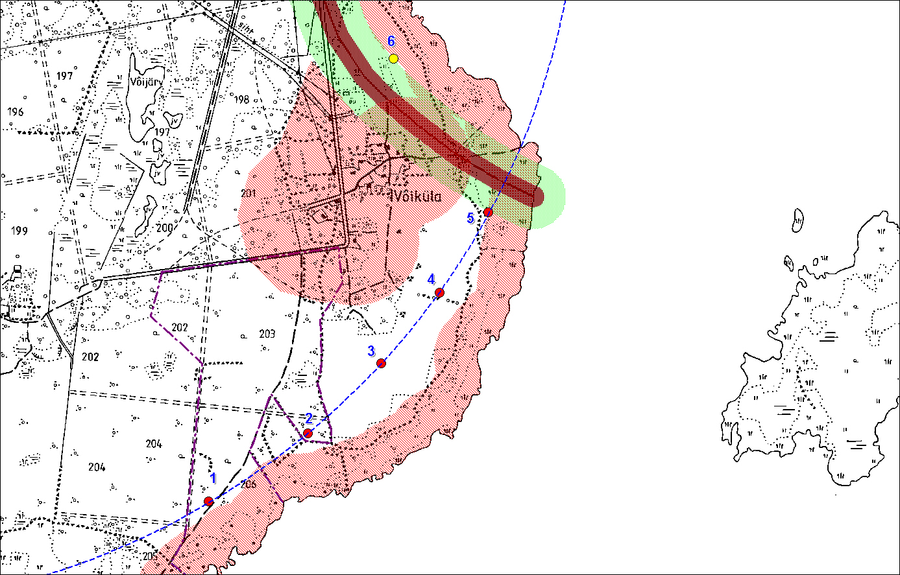

Drawing 4. The situation of the Võiküla windfarm`s wind turbines according to alternative no 2

The positioning of the turbines of Võiküla windfarm`s according to alternative no 2 as presented on Drawing 4 is visualy more attractive and also the park efficienty would be greater. Wind turbines are situated so that they follow the coast line and their locations are also favourable concerning wind. The problem is, that wind turbines no 4 and 5 are located outside the assigned estate.

The situation of the Võiküla windfarm`s wind turbines according to alternative no 2 would be as followes (L-EST 92):
1. X = 463872 m Y = 6488644 m
2. X = 464334 m Y = 6488961 m
3. X = 464673 m Y = 6489285 m
4. X = 464943 m Y = 6489614 m
5. X = 465168 m Y = 6489987 m

Table 8. Prognosis of the energy production with Nordex N90 (2300 kW). Alternative no. 2.

Turbine no. | Location, L-Est92 |  | Tower height 80m |  |  |  | Tower height 100m
Turbine no. | X (m) | Y (m) | U  m/s | Gross  MWh/a | Wake  % | Net  MWh/a | U  m/s | Gross  MWh/a | Wake  % | Net  MWh/a
1 | 463872 | 6488644 | 7.37 | 7299 | 1.66 | 7177 | 7.71 | 7885 | 1.53 | 7764
2 | 464334 | 6488961 | 7.40 | 7361 | 2.42 | 7183 | 7.73 | 7921 | 2.26 | 7742
3 | 464673 | 6489285 | 7.46 | 7474 | 2.94 | 7254 | 7.77 | 7998 | 2.77 | 7777
4 | 464943 | 6489614 | 7.47 | 7501 | 3.31 | 7253 | 7.78 | 8010 | 3.10 | 7762
5 | 465168 | 6489987 | 7.50 | 7554 | 2.38 | 7375 | 7.79 | 8046 | 2.23 | 7867
Total |  |  |  | 37189 | 2.55 | 36243 |  | 39860 | 2.38 | 38911

Table 9. Prognosis of the energy production with Enercon E-70 (2000 kW). Alternative no. 2.

Turbine no. | Location, L-Est92 |  | Tower height 64m |  |  |  | Tower height 85m
Turbine no. | X (m) | Y (m) | U  m/s | Gross  MWh/a | Wake  % | Net  MWh/a | U  m/s | Gross  MWh/a | Wake  % | Net  MWh/a
1 | 463872 | 6488644 | 7.02 | 5287 | 1.39 | 5215 | 7.47 | 5963 | 1.21 | 5891
2 | 464334 | 6488961 | 7.06 | 5375 | 1.92 | 5272 | 7.49 | 6010 | 1.77 | 5904
3 | 464673 | 6489285 | 7.14 | 5512 | 2.36 | 5382 | 7.55 | 6103 | 2.19 | 5969
4 | 464943 | 6489614 | 7.17 | 5567 | 2.70 | 5417 | 7.55 | 6123 | 2.50 | 5970
5 | 465168 | 6489987 | 7.21 | 5635 | 1.94 | 5525 | 7.57 | 6165 | 1.77 | 6056
Total |  |  |  | 27376 | 2.06 | 26811 |  | 30365 | 1.89 | 29790

Table 10. Prognosis of the energy production with DeWind D8 (2000 kW). Alternative no. 2.

Turbine no. | Location, L-Est92 |  | Tower height 80m |  |  |  | Tower height 95m
Turbine no. | X (m) | Y (m) | U  m/s | Gross  MWh/a | Wake  % | Net  MWh/a | U  m/s | Gross  MWh/a | Wake  % | Net  MWh/a
1 | 463872 | 6488644 | 7.37 | 6074 | 1.23 | 6000 | 7.63 | 6466 | 1.14 | 6392
2 | 464334 | 6488961 | 7.40 | 6129 | 1.80 | 6018 | 7.65 | 6498 | 1.70 | 6387
3 | 464673 | 6489285 | 7.46 | 6226 | 2.20 | 6089 | 7.70 | 6572 | 2.09 | 6434
4 | 464943 | 6489614 | 7.47 | 6251 | 2.47 | 6096 | 7.71 | 6586 | 2.35 | 6431
5 | 465168 | 6489987 | 7.50 | 6297 | 1.79 | 6185 | 7.72 | 6618 | 1.69 | 6506
Total |  |  |  | 30977 | 1.90 | 30388 |  | 32739 | 1.80 | 32151

Table 11. Prognosis of the energy production with Vestas V-80 (2000 kW). Alternative no. 2.

Turbine no. | Location, L-Est92 |  | Tower height 67m |  |  |  | Tower height 78m
Turbine no. | X (m) | Y (m) | U  m/s | Gross  MWh/a | Wake  % | Net  MWh/a | U  m/s | Gross  MWh/a | Wake  % | Net  MWh/a
1 | 463872 | 6488644 | 7.09 | 5411 | 1.40 | 5335 | 7.33 | 5758 | 1.31 | 5682
2 | 464334 | 6488961 | 7.13 | 5488 | 2.02 | 5377 | 7.36 | 5814 | 1.93 | 5702
3 | 464673 | 6489285 | 7.21 | 5608 | 2.46 | 5470 | 7.43 | 5911 | 2.36 | 5772
4 | 464943 | 6489614 | 7.24 | 5654 | 2.81 | 5496 | 7.44 | 5938 | 2.70 | 5778
5 | 465168 | 6489987 | 7.27 | 5714 | 2.06 | 5596 | 7.46 | 5985 | 1.95 | 5868
Total |  |  |  | 27876 | 2.16 | 27274 |  | 29406 | 2.06 | 28801

Turbine no. | Location, L-Est92 |  | Tower height 100m
Turbine no. | X (m) | Y (m) | U  m/s | Gross  MWh/a | Wake  % | Net  MWh/a
1 | 463872 | 6488644 | 7.71 | 6292 | 1.20 | 6217
2 | 464334 | 6488961 | 7.73 | 6325 | 1.80 | 6211
3 | 464673 | 6489285 | 7.77 | 6391 | 2.21 | 6249
4 | 464943 | 6489614 | 7.78 | 6402 | 2.52 | 6241
5 | 465168 | 6489987 | 7.79 | 6433 | 1.81 | 6317
Total |  |  |  | 31844 | 1.91 | 31235

Table 12. Prognosis of the energy production with RePower MM82 (2000 kW). Alternative no. 2.

Turbine no. | Location, L-Est92 |  | Tower height 59m |  |  |  | Tower height 80m
Turbine no. | X (m) | Y (m) | U  m/s | Gross  MWh/a | Wake  % | Net  MWh/a | U  m/s | Gross  MWh/a | Wake  % | Net  MWh/a
1 | 463872 | 6488644 | 6.89 | 5388 | 1.68 | 5297 | 7.37 | 6112 | 1.48 | 6021
2 | 464334 | 6488961 | 6.94 | 5485 | 2.36 | 5355 | 7.40 | 6165 | 2.16 | 6032
3 | 464673 | 6489285 | 7.03 | 5626 | 2.87 | 5465 | 7.46 | 6261 | 2.65 | 6095
4 | 464943 | 6489614 | 7.06 | 5695 | 3.28 | 5509 | 7.47 | 6286 | 3.01 | 6096
5 | 465168 | 6489987 | 7.10 | 5760 | 2.39 | 5622 | 7.50 | 6331 | 2.15 | 6195
Total |  |  |  | 27954 | 2.53 | 27248 |  | 31155 | 2.29 | 30440

Turbine no. | Location, L-Est92 |  | Tower height 100m
Turbine no. | X (m) | Y (m) | U  m/s | Gross  MWh/a | Wake  % | Net  MWh/a
1 | 463872 | 6488644 | 7.71 | 6607 | 1.36 | 6517
2 | 464334 | 6488961 | 7.73 | 6639 | 2.02 | 6505
3 | 464673 | 6489285 | 7.77 | 6706 | 2.50 | 6539
4 | 464943 | 6489614 | 7.78 | 6717 | 2.83 | 6527
5 | 465168 | 6489987 | 7.79 | 6748 | 2.02 | 6612
Total |  |  |  | 33418 | 2.15 | 32700

Table 13. Prognosis of production of solitaire wind turbine MWh/a near Võiküla substation, X=464 730 m, Y=6 490 700 m (L-Est 92).

Turbine | 59m | 64m | 67m | 78m | 80m | 85m | 95m | 100m
Nordex N90 |  |  |  |  | 7434 |  |  | 7995
Enercon E70 |  | 5449 |  |  |  | 6082
DeWind D8 |  |  |  |  | 6194 |  | 6565
Vestas V80 |  |  | 5550 | 5875 |  |  |  | 6390
RePower MM82 | 5548 |  |  |  | 6228 |  |  | 6704

Võiküla 110/35/10 kV substation
Turbine no 1
Turbine no 2
Turbine no 3
Turbine no 4
Turbine no 5
Turbine no 6
Turbine no 7
Turbine no 8
Turbine no 9
Turbine no10
Connection point

Drawing 5. Võiküla windfarm`s general electrical scheme.
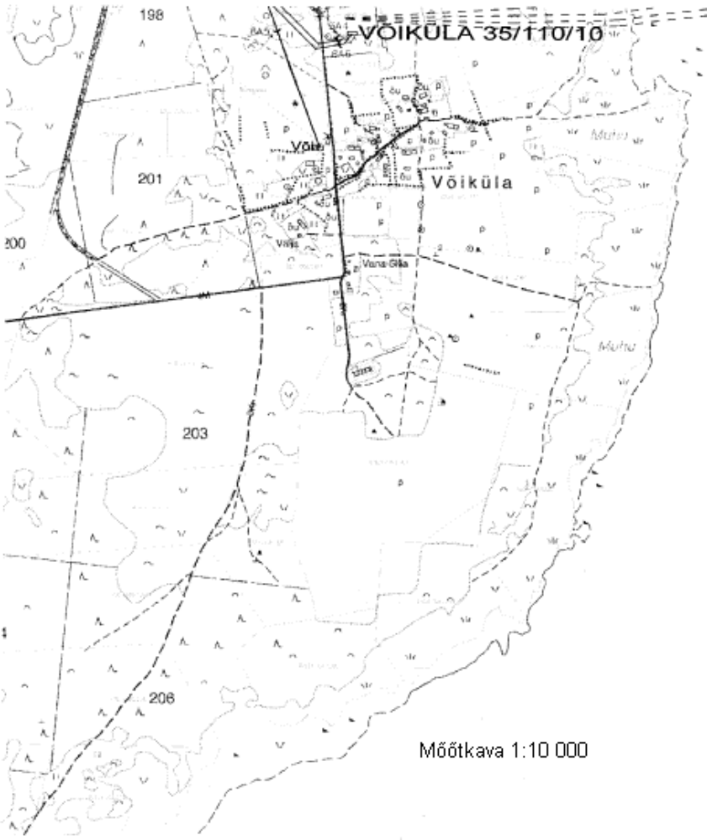
desirable connection
cordinates:
X: 6489340
Y: 464275

Drawing 6. Desirable connection point of Võiküla windfarm.
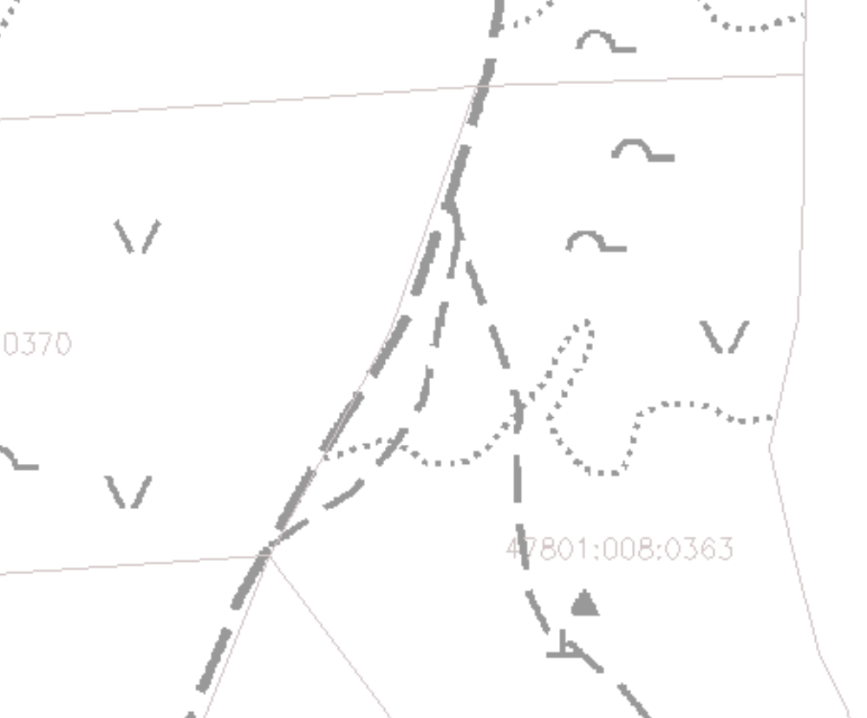
desirable connection
cordinates:
X: 6489340
Y: 464275
scale 1:2000

Drawing T. Desirable connection point of Võiküla windfarm.

Conclusion

Võiküla wind farm

- Several restrictions should be taken into consideration. Requirement on noise prevention zone is caused by local settlement. Generic safety zones are requested along roads and power lines. Wooded areas and wetlands also pose certain restrictions to design of wind farms due to negative effect on wind resources or high construction costs respectively. In the frame of present evaluation those sites are considered as unsuitable.
- Annual energy production ca. form 26,3 GWh/y to 80 GWh/y (ca 0,3% - 0,7% of Estonian consumption).
- Producing wind energy will reduce pollution and released amount of limit will be sold to Finland through Kyoto program. This could help this project to be profitable in a much shorter time. Using wind energy instead of common power stations based on fissile fuel we can save ca. 0,5t CO2 equivalent, witch will be sold based on Kyoto protocol to Finland. For Finland it will help to establish pollution norm for year 2012.
- Project helps to reduces price of green energy and helps to ensure energy system stability. Also this wind farm gives new jobs for people from distant areas.

References
[Dr. Ain Kull, Geograafi Instituut, Tartu Ülikool, Aprill 2004] Tuuleressursi hinnang – Võiküla, Muhu vald, Saare maakond
[Electrowatt-Ekono Oy, 2003] Draft Final Validation Report and Opinion - Validation of Pakri wind farm project in Estonia. Available from: http://global.finland.fi/english/projects/cdm/DRAFTFINALVALIDATIONREPORTR2.PDF
[Eesti Energia, 2002] Environmental report. Available from: http://www.energia.ee/documents/ed20248dbc548d5.pdf
[Eesti Energia, 2003] Alternative energy sources. Available from: http://www.energia.ee/en/about?energiaviewer_folderid=478
[Kallaste, 2002] Pakri Peninsula Wind Farm (Estonia) as a climate change mitigation pilot project in the frame of Joint Implementation. Available from: http://pansy.unep.or.jp/gec/gec.nsf/cc0545bc7408f27649256b47001a7489/c5b721a9791123a049256d0500286cee/$FILE/FS200106.pdf
[EMP-Projects Oy, 2002] Pakri tuulepark – Ühisrakendusprojekti dokumentatsioon. Available from: http://www.envir.ee/oigusaktid/eelnoud/Pakri_PDD180703.pdf
[AS Tuulepargid, 2003] Pakri 20 MW tuulepark. Available from: http://www.tuulepargid.ee/pakri/
http://www.nordex-online.com/_e/produkte_und_service/onshore/n80/N80-info-engl.html
http://www.nordex-online.com/_e/produkte_und_service/onshore/n80/_bilder/n80_technical _description.pdf
http://www.nordex-online.com/_e/produkte_und_service/onshore/n80/datenblaetter.html
http://www.epl.ee/artikkel_245221.html

