

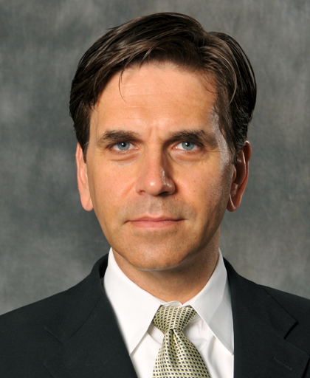
Aleksander Foundation
proudly presents

„Marketing: From Theory to Practice“
(public lecture)

Speaker:
Alexander Chernev, PhD

Alexander Chernev is associate professor of marketing at the Kellogg School of Management, Northwestern University. He holds a Ph.D. in Psychology from Sofia University and a Ph.D. in Business Administration from Duke University. Dr Chernev’s research applies theories and concepts related to consumer behavior and managerial decision making to develop successful corporate branding and customer management strategies.

His research has been published in leading marketing journals, and he has received numerous teaching and research awards. Dr Chernev serves on the editorial boards of top research journals, including Journal of Marketing, Journal of Marketing Research, Journal of Consumer Research, Journal of Consumer Psychology, and International Journal of Research in Marketing. Dr. Chernev’s research has been published in leading marketing journals and has been quoted in business and popular press, including Business Week, Wall Street Journal, Forbes, Newsweek, and New York Times.

Avenue: Sofia University “St. Kliment Ohridski” , Rectorate, America for Bulgaria Hall (224 Auditorium)
Time: January 10th 2011 - 18.30h
Entrance: Send your three names to lecture@aleksanderfoundation.org (since auditorium 224 has limited capacity entrance will be granted on a first-come, first-served basis)

