Climate Change

Slavoljub Petkovic

May 21, 2017

Table of Contents

# Introduction

This project is meant to shed light on several questions related to changes in the climate. I will be using a set of data from Kaggle.com which contains four files with temperature details in the period of time between 1850 and 2013:

1. Global Average Land Temperature by Country (GlobalLandTemperaturesByCountry.csv)
2. Global Average Land Temperature by state (GlobalLandTemperaturesByState.csv)
3. Global Land Temperatures by major cities (GlobalLandTemperaturesByMajorCity.csv)
4. Global Land Temperatures by all cities (GlobalLandTemperaturesByMajorCity.csv)

[Data Location:] (<https://www.kaggle.com/berkeleyearth/climate-change-earth-surface-temperature-data>)

In this research, I will attempt to answer few questions below:

1. What is the difference between the Land and Ocean average temperature over time?
2. What are the top 5 hottest and top 5 coldest major cities in the world?
3. What is the temperature trend for city of residence ( Atlanta)?
4. What kind of climate can we expect in the next 5 years, 10 years, 50 years and 100 years based on Predictive Analysis?
5. Is there an active global warming?
6. What are the key effects of global warming?

I will be providing the analysis that might include dynamic graphs and charts with short explanations of what each of them mean and why it is important for us.

# The evidence for Rapid Climate Change

**Rise of the Sea Level**

Global sea level rose about 8 inches in the last century. The rate in the last two decades, however, is nearly double that of the last century.

**Rise of the Ocean Temperature**

The oceans have absorbed much of this increased heat, with the top 700 meters (about 2,300 feet) of ocean showing warming of 0.302 degrees Fahrenheit since 1969.

**Shrinking of Ice Sheets**

The Greenland and Antarctic ice sheets have decreased in mass. Data from NASA's Gravity Recovery and Climate Experiment show Greenland lost 150 to 250 cubic kilometers (36 to 60 cubic miles) of ice per year between 2002 and 2006, while Antarctica lost about 152 cubic kilometers (36 cubic miles) of ice between 2002 and 2005.

**Glacial Retreat**

Glaciers are retreating almost everywhere around the world — including in the Alps, Himalayas, Andes, Rockies, Alaska and Africa.

**Ocean Acidification**

Since the beginning of the Industrial Revolution, the acidity of surface ocean waters has increased by about 11,12. This increase is the result of humans emitting more carbon dioxide into the atmosphere and hence more being absorbed into the oceans. The amount of carbon dioxide absorbed by the upper layer of the oceans is increasing by about 2 billion tons per year. 13,14

**Increase of the Global Temperature**

The Earth's climate has changed throughout history. Just in the last 650,000 years there have been seven cycles of glacial advance and retreat, with the abrupt end of the last ice age about 7,000 years ago marking the beginning of the modern climate era — and of human civilization. Most of these climate changes are attributed to very small variations in Earth’s orbit that change the amount of solar energy our planet receives.

# Descriptive Analytics

## Analysis Of Global Temperature (Land Vs Ocean)

Based on the Average Temperature Graph bellow, we can see that the average temperature of the land has been significantly increasing with higher rate than the temperature of the ocean. Oceans are heating and cooling much faster than land due to the low density of the water. There are a few factors that could cause the average land temperature to increase with a higher rate than the ocean average temperature. With rapid deforestation, we reduce absorption of greenhouse gases that fuel global warming. Fewer forests will allow larger amounts of greenhouse gases to enter the atmosphere(~15% carbon) and trap the solar rays and heat up the surface thathad once been protected by forest. Industrial effects within developed and developing countries plays a significant role where emission of greenhouse gasses (CO and CO2) directly influences speed and severity of the temperature in those regions and globally as well. The United States constitutes 5% of the world population and contributes 22% of the world’s crbon emission.

# Loading data set  
GlobalTemperatures <- read_csv("C:/GIT/R/Data_Source/GlobalTemperatures.csv")  
# Standardizing the date format  
GlobalTemperatures$dt = as.Date(GlobalTemperatures$dt, "%Y-%m-%d" )   
# Filtering data range  
GlobalTemperatures <- filter(GlobalTemperatures, dt>= "1849-12-31")  
# Extracting the month out of the dt column in to new Monthviw column  
GlobalTemperatures$Month <- month(GlobalTemperatures$dt)  
# Converting month number in to Month Name  
GlobalTemperatures$Month <- month(GlobalTemperatures$Month, label = TRUE)  
# Extracting the year out of the dt column in to new Year column  
GlobalTemperatures$Year <- year(GlobalTemperatures$dt)  
# Remove rows that contains NA  
GlobalTemperatures <- GlobalTemperatures[!is.na(GlobalTemperatures$LandAndOceanAverageTemperature) | !is.na(GlobalTemperatures$LandAverageTemperature),]  
# Calculate AverageOcean Temperature  
GlobalTemperatures$OceanAverageTemperature = as.numeric(GlobalTemperatures$LandAndOceanAverageTemperature) * 2 - as.numeric(GlobalTemperatures$LandAverageTemperature)  
# Summerizing temperature on yearly level  
GlobalTemperaturesSummary <- GlobalTemperatures %>% group_by(Year) %>% summarise(AvgLandTmp = mean(LandAverageTemperature), AvgOcnTmp = mean(OceanAverageTemperature))  
# Ploting Avgerage Ocean Temperature and Average Land temperature on timescale  
Plot_ds <-melt(GlobalTemperaturesSummary, id ="Year")  
ggplot(data= Plot_ds, aes(x=Year, y= value, colour = variable)) +  
 geom_line(size = 1) + coord_cartesian(ylim = c(5, 30)) + xlab("Years") + ylab("Average Temperature") +  
 theme(axis.title = element_text(size = 13), axis.text = element_text(size = 13)) +  
 ggtitle("Average Temperature Trend") +  
 theme(plot.title = element_text(size = 15, lineheight=.8, face="bold")) + facet_grid(Plot_ds$variable ~., scales = "free_y") + theme(legend.position="none")

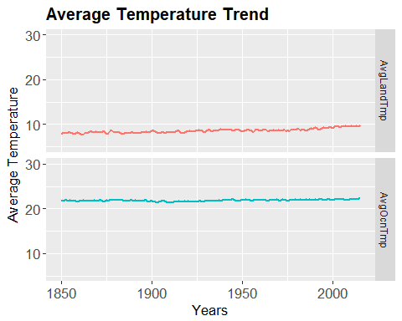

## Minimum and Maximum Average Temperature Trends

Analysis of temperature extremes over time requires daily maximum and minimum temperature data from stations with records of sufficient length, quality, completeness, and temporal homogeneity. Homogeneity of the daily temperature record is an especially difficult challenge due to stations experiencing varying degrees of change over time in location, instrumentation, observing practices, and sitting conditions. In the graph below we can see the amplitudes of change for these extremes. It is clear that both temperature extremes across a century and a half are slightly increasing with corelation of ~90%.

# Extracting min and max values   
GlobalTemperaturesMinMax <- GlobalTemperatures %>% group_by(Year) %>% summarise(AvgMaxTemp = mean(as.numeric(LandMaxTemperature)), AvgMinTemp = mean(as.numeric(LandMinTemperature)))  
# Preparing variable for plot using melt function creating identifier and measured variable.  
Plot_minMAx <-melt(GlobalTemperaturesMinMax, id = "Year")  
# Plotting min and max temperature trend.   
ggplot(data = Plot_minMAx, aes(Year, value, variable)) + geom_line(size = .5) + geom_smooth(size = 1) + facet_grid(Plot_minMAx$variable ~ ., scales = "free_y") + theme(axis.title = element_text(size = 13), axis.text = element_text(size = 13)) +  
 ggtitle("Min And Max Average temperature Trend") +  
 theme(plot.title = element_text(size = 15, lineheight=.8, face="bold"))

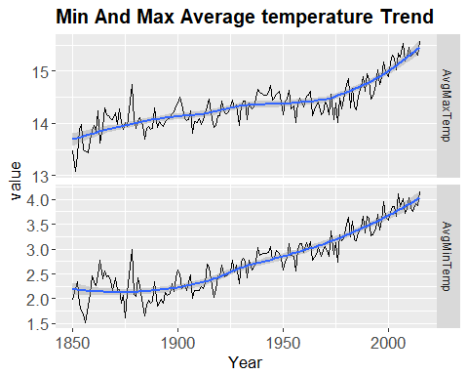

# Runing the coorelation between max and min temperature  
cor(GlobalTemperaturesMinMax$AvgMaxTemp, GlobalTemperaturesMinMax$AvgMinTemp)

## [1] 0.8980115

## Average Temperature Difference Between 1850 and 2013

The Graph bellow illustrates the change in global surface temperature relative to 1850-2013 average temperatures. Thrirteen of the warmest years in the 163-year record all have occurred since 2000.

# Loading data set  
GlobalLandTemperaturesByState <- read_csv("C:/GIT/R/Data_Source/GlobalLandTemperaturesByState.csv")  
# Formating dates  
GlobalLandTemperaturesByState$dt <- as.Date(GlobalLandTemperaturesByState$dt, "%Y-%m-%d")  
# Filtering data range  
GlobalLandTemperaturesByState <- filter(GlobalLandTemperaturesByState, dt>= "1849-12-31")  
# Removing NAs  
GlobalLandTemperaturesByState = na.omit(GlobalLandTemperaturesByState)  
# Extracting Month from dt column in to new Month column  
GlobalLandTemperaturesByState$Month <- month(GlobalLandTemperaturesByState$dt)  
GlobalLandTemperaturesByState$Year <- year(GlobalLandTemperaturesByState$dt)  
# Extract avg temperature by year  
GlobalTempSummary <- GlobalLandTemperaturesByState %>% group_by(Year) %>% summarise(AvgTemp = mean(AverageTemperature))  
# Creating plot  
ggplot(data = GlobalTempSummary, aes(x = Year, y = AvgTemp, colour = AvgTemp)) + geom_point(shape=16, size =3) + geom_smooth(method = 'loess', color = 'blue', size = 2) + xlab("Years") + ylab("AllAverage Temperature") + theme(axis.title = element_text(size = 13), axis.text = element_text(size = 13)) + ggtitle("All States Average Temperature Trend") + theme(plot.title = element_text(size = 15, lineheight=.8, face="bold")) + aes(Colour = AvgTemp) + scale_color_gradient(low = "blue", high = "red")

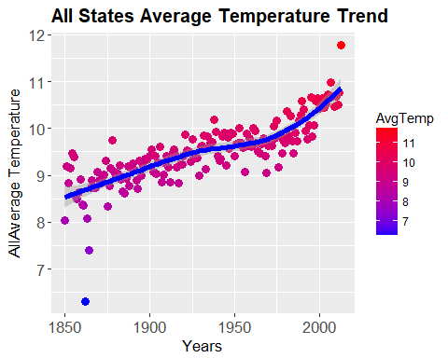

## Top 10 Coldest Major Cities between 1850 - 2013

With the given average temperature for every major city, the bar chart bellow has the top 10 coldest cities in the world with descending rank.

# Loading data set  
GlTempCity <- read_csv("C:/GIT/R/Data_Source/GlobalLandTemperaturesByMajorCity.csv")  
#Formating Data Range  
GlTempCity$dt <- as.Date(GlTempCity$dt, "%Y-%m-%d")  
# Filtering data range  
GlTempCity <- filter(GlTempCity, dt>= "1849-12-31")  
# Filtering out NAs  
GlTempCity = na.omit(GlTempCity)  
# Extracting the month out of dt  
GlTempCity$Month <- month(GlTempCity$dt)  
# Converting Month number to Month Name  
GlTempCity$Month <- month(GlTempCity$Month, label = TRUE)  
# Extracting the year out of dt  
GlTempCity$Year <- year(GlTempCity$dt)  
# Grouping by City with avg. temperature on average  
GlTempSum <- GlTempCity %>% group_by(City, Longitude, Latitude) %>% summarise(AvgTemp = mean(AverageTemperature))  
# Extracting top 10 hotest city  
Top10Hotest <- head(arrange(GlTempSum, desc(AvgTemp)), n= 10)  
# Extracting top 10 coldest city on average  
Top10Coldest <- head(arrange(GlTempSum, AvgTemp), n = 10)  
# Plotting the the top 10 coldest cities  
ggplot(data = Top10Coldest, aes(x = reorder(City, - AvgTemp), y = AvgTemp)) + geom_bar(stat = "identity", position = "dodge", fill="steelblue") + geom_text(aes(label=format(Top10Coldest$AvgTemp, digits = 2)), vjust=1.6, color="white", size=3.5) + theme_minimal() + xlab("Coldest Cities") + ylab("Minimum Avergate Temp in (C)") + theme(axis.title = element_text(size = 13), axis.text = element_text(size = 13)) + ggtitle("Top 10 Coldest cities between 1850 - 2013") + theme(plot.title = element_text(size = 15, lineheight=.8, face="bold")) + theme(axis.text.x = element_text(size = 10, angle = 45, hjust = 1, vjust = 1))

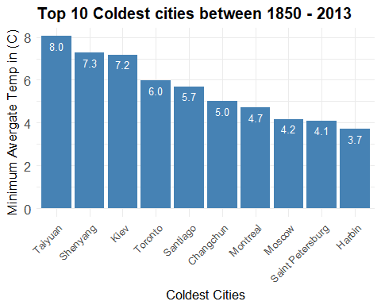

## Top 10 Hottest Major Cities between 1850 - 2013

While we have a drastic difference from the top 10 coldest major cities in the world, the top 10 hottest cities are very similar in comparison in average temperature across a century and half.

# Plotting the top 10 hottest cities  
ggplot(data = Top10Hotest, aes(x = reorder(City, - AvgTemp), y = AvgTemp)) + geom_bar(stat = "identity", position = "dodge", fill="#FF9999") + geom_text(aes(label=format(Top10Hotest$AvgTemp, digits = 2)), vjust=1.6, color="white", size=3.5) + theme_minimal() + xlab("Hottest Cities") + ylab("Maximum Avergate Temp in (C)") + theme(axis.title = element_text(size = 13), axis.text = element_text(size = 13)) + ggtitle("Top 10 hotest cities between 1850 - 2013") + theme(plot.title = element_text(size = 15, lineheight=.8, face="bold")) + theme(axis.text.x = element_text(size = 10, angle = 45, hjust = 1, vjust = 1)) + coord_cartesian(ylim = c(0, 40))

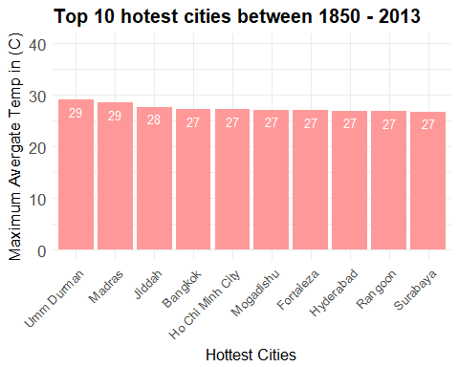

## Coldest vs. Hottest Cities on WorldMap

Using longitude and latitude informations for given data, we can plot the locatin of the top 10 coldest and top 10 hotest cities on the world map. It is interesting to see that all coldest cities, with excpetion to Santiago, are scatered in the Northern Hemisphere. The top 10 hotest cities are scatered over the South Hemisphere.

# Converting Longitude and latitude in correct format in Top10coldest dataset  
Top10Coldest$LAT <- as.numeric(gsub("N|E|S|W", "",Top10Coldest$Latitude))*ifelse(grepl("S",Top10Coldest$Latitude),-1,1)  
Top10Coldest$LONG <- as.numeric(gsub("N|E|S|W", "", Top10Coldest$Longitude))*ifelse(grepl("W",Top10Coldest$Longitude),-1,1)  
# Converting Longitude and latitude in correct format in Top10Hotest dataset  
Top10Hotest$LAT <- as.numeric(gsub("N|E|S|W", "",Top10Hotest$Latitude))*ifelse(grepl("S",Top10Hotest$Latitude),-1,1)  
Top10Hotest$LONG <- as.numeric(gsub("N|E|S|W", "", Top10Hotest$Longitude))*ifelse(grepl("W",Top10Hotest$Longitude),-1,1)  
# Plottinig the coldest and hottest cities on world map  
mapWorld <- borders("world", colour="black", fill="white") # create a layer of borders  
mp <- ggplot() + mapWorld  
mp <- mp+ geom_point(aes(x=Top10Coldest$LONG, y=Top10Coldest$LAT) ,color="blue", size=5, alpha = .5) + ggtitle('Coldest Vs Hotest Major Cities between 1850 and 2013') + theme_fivethirtyeight() + xlab("Longitude") + ylab("Latitude") + theme(axis.title = element_text(size = 13), axis.text = element_text(size = 13)) + theme(plot.title = element_text(size = 15, lineheight=.8, face="bold"))  
mp2 <- ggplot() + mapWorld  
mp2 <- mp+ geom_point(aes(x=Top10Hotest$LONG, y=Top10Hotest$LAT) ,color="red", size=5, alpha =.5)   
mp2

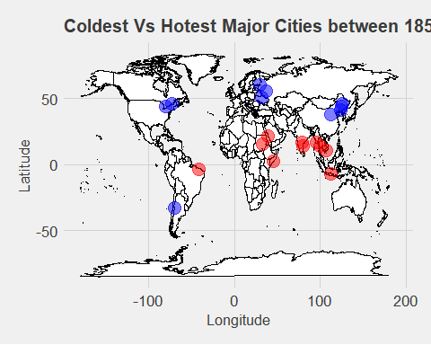

## Average Temperature by all Cities

TempByAllCities <- read_csv("C:/GIT/R/Data_Source/GlobalLandTemperaturesByCity.csv")  
# Eliminating NAs  
TempByAllCities <- na.omit(TempByAllCities)  
# Converting dt to correct dates  
TempByAllCities$dt <- as.Date(TempByAllCities$dt, "%Y-%m-%d")  
# Filtering data range  
TempByAllCities <- filter(TempByAllCities, dt>= "1849-12-31")  
# Extracting the month out of dt  
TempByAllCities$Month <- month(TempByAllCities$dt)  
# Converting Month number to Month Name  
TempByAllCities$Month <- month(TempByAllCities$Month, label = TRUE)  
# Extracting the year out of dt  
TempByAllCities$Year <- year(TempByAllCities$dt)  
# Converting Lat and Long to correct format  
TempByAllCities$LAT <- as.numeric(gsub("N|E|S|W", "",TempByAllCities$Latitude))*ifelse(grepl("S",TempByAllCities$Latitude),-1,1)  
TempByAllCities$LONG <- as.numeric(gsub("N|E|S|W", "", TempByAllCities$Longitude))*ifelse(grepl("W",TempByAllCities$Longitude),-1,1)  
# Grouping the dataset by Country and City  
TempByAllCitiesSum <- TempByAllCities %>% group_by(Country, City) %>% select(AverageTemperature, City ,LAT, LONG, Country) %>% summarise(avgTemp_start = mean(AverageTemperature), long = mean(LONG), lat = mean(LAT))  
# Focusing on year 2013  
Year2013 <- TempByAllCities %>% filter(Year ==2013)  
Year2013 <- Year2013 %>% group_by(Country,City) %>% select(AverageTemperature,City) %>% summarise(avgTemp_end = mean(AverageTemperature))  
# Getting the final dataset  
finalds <- merge(TempByAllCitiesSum,Year2013, by=c('Country','City'))  
# Ploting the avg. temp difference on map  
worldMap <- fortify(map_data("world"), region = "region")  
m <- ggplot() + geom_map(data = worldMap, map = worldMap,aes(x = long, y = lat, map_id = region, group = group),fill = "white", color = "black", size = 0.1)  
m + geom_point(data= finalds,aes(x=long, y=lat, size=avgTemp_end - avgTemp_start,color=avgTemp_end - avgTemp_start),alpha=.2) + theme_fivethirtyeight() + ggtitle('Temperature difference between 1850 and 2013') + theme(axis.text = element_blank(), panel.grid.major = element_blank(), panel.grid.minor = element_blank()) + labs(size = '') + scale_color_gradientn(name='Degrees Celsius',colors=rev(brewer.pal(10,'Spectral'))) + scale_size(guide = 'none') + theme(plot.title = element_text(size = 15, lineheight=.8, face="bold"))

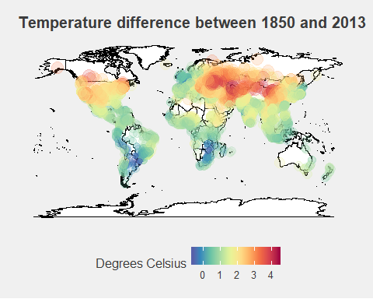

Based on World Map with average temperature changes, we can see that the most significant temperature increase is measured in develoeped countries. It is expected for these countries to be the ones who produce most of the greenhouse gasses such as some of these below:

**Carbon Dioxide (CO2)**

Carbon Dioxide enters the atmosphere through burning fossil fuels (coal, natural gas, and oil), solid waste, trees and wood products, and also as a result of certain chemical reactions (e.g., manufacture of cement). Carbon Dioxide is removed from the atmosphere (or "sequestered") when it is absorbed by plants as part of the biological carbon cycle.

**Methane (CH4)**

Methane is emitted during the production and transport of coal, natural gas, and oil. Methane emissions also result from livestock and other agricultural practices and by the decay of organic waste in municipal solid waste landfills.

**Nitrous Oxide (N2O)**

Nitrous Oxide is emitted during agricultural and industrial activities, as well as during combustion of fossil fuels and solid waste.

**Fluorinated Gases**

Hydrofluorocarbons, Perfluorocarbons, Sulfur Hexafluoride, and Nitrogen Trifluoride are synthetic, powerful greenhouse gases that are emitted from a variety of industrial processes. Fluorinated gases are sometimes used as substitutes for stratospheric ozone-depleting substances (e.g., chlorofluorocarbons, hydrochlorofluorocarbons, and halons). These gases are typically emitted in smaller quantities, but because they are potent greenhouse gases, they are sometimes referred to as High Global Warming Potential gases ("High GWP gases").

## Average Temperature In Atlanta

Since this is a city of my residence I am going to explore the trend of Average temperature between 1850 and 2013 in Atlanta Georgia.

# Extracting data for Atlanta  
ATLTemp <- filter(TempByAllCities, City == "Atlanta")  
ATLTempSum <- ATLTemp %>% group_by(Year) %>% summarise(AvgTemp = mean(AverageTemperature))  
ggplot(ATLTempSum, aes(x=Year, y=AvgTemp)) + geom_point(shape=1, size = 3) + geom_smooth(method="loess", color = 'red', size = 2) + labs(title="Average Temperature in Atlanta ", x="Year", y="Avg. Temperature in (C)") +theme(axis.title = element_text(size = 13), axis.text = element_text(size = 13)) + theme(plot.title = element_text(size = 15, lineheight=.8, face="bold"))

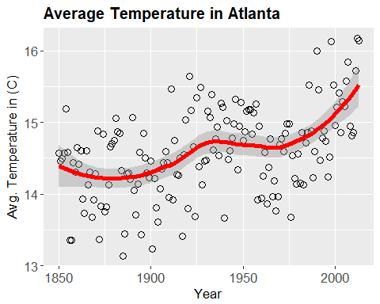 ## Exploring Seasons

Using the temperature data set from every city, we are going to explore the seasonality trend for years between 1850 and 2013

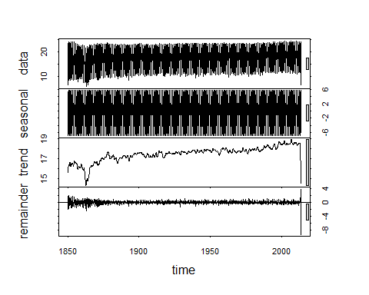

## Temperature Uncertanity for Data used in Descriptive Analytics

With given sets of data we have a level of uncertainity due to imperfections in measurements and collection of the average temperature. Based on the graph below we can see that between 1850 and 1975 we have a decline of uncertainity from 1.5% below 0.5%. The reliability of data stabilizes from 1975 with the exception to two outliers in 2013.

AvgTempUncert <- TempByAllCities %>% group_by(Year) %>% summarise(AvgTempUnc = mean(AverageTemperatureUncertainty))  
ggplot(AvgTempUncert,aes(x= Year,y= AvgTempUncert$AvgTempUnc))+  
 geom_point(shape=1, size = 3)+ geom_smooth(method="loess", size = 2)+ labs(title="Average Temperature Uncertainty Over Time", x="Year", y="Average Temperature Uncertainty") + theme(plot.title = element_text(size = 15, lineheight=.8, face="bold"))

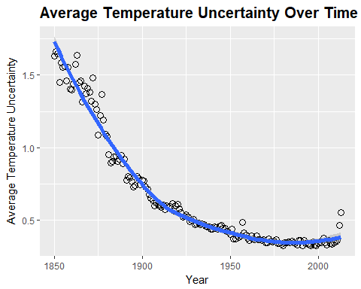

## Conclusions

# Predictive Analytics

Machine learning using algorithms to predict future temperature levels.

## Prediction for next 10 years

## Prediction for next 50 years

## Prediction for next 100 years

# References

IPCC Fifth Assessment Report, Summary for Policymakers

B.D. Santer et.al., “A search for human influences on the thermal structure of the atmosphere,” Nature vol 382, 4 July 1996, 39-46

Gabriele C. Hegerl, “Detecting Greenhouse-Gas-Induced Climate Change with an Optimal Fingerprint Method,” Journal of Climate, v. 9, October 1996, 2281-2306

V. Ramaswamy et.al., “Anthropogenic and Natural Influences in the Evolution of Lower Stratospheric Cooling,” Science 311 (24 February 2006), 1138-1141

B.D. Santer et.al., “Contributions of Anthropogenic and Natural Forcing to Recent Tropopause Height Changes,” Science vol. 301 (25 July 2003), 479-483.

In the 1860s, physicist John Tyndall recognized the Earth's natural greenhouse effect and suggested that slight changes in the atmospheric composition could bring about climatic variations. In 1896, a seminal paper by Swedish scientist Svante Arrhenius first predicted that changes in the levels of carbon dioxide in the atmosphere could substantially alter the surface temperature through the greenhouse effect.

National Research Council (NRC), 2006. Surface Temperature Reconstructions For the Last 2,000 Years. National Academy Press, Washington, D.C.

<http://earthobservatory.nasa.gov/Features/GlobalWarming/page3.php>

<https://www.ipcc.ch/pdf/assessment-report/ar5/syr/AR5_SYR_FINAL_SPM.pdf>

Church, J. A. and N.J. White (2006), A 20th century acceleration in global sea level rise, Geophysical Research Letters, 33, L01602, <doi:10.1029/2005GL024826>.

The global sea level estimate described in this work can be downloaded from the CSIRO website.

<https://www.ncdc.noaa.gov/indicators/>

<http://www.cru.uea.ac.uk/cru/data/temperature>

<http://data.giss.nasa.gov/gistemp>

<https://www.giss.nasa.gov/research/news/20170118/>)

Levitus, et al, "Global ocean heat content 1955–2008 in light of recently revealed instrumentation problems," Geophys. Res. Lett. 36, L07608 (2009).

L. Polyak, et.al., “History of Sea Ice in the Arctic,” in Past Climate Variability and Change in the Arctic and at High Latitudes, U.S. Geological Survey, Climate Change Science Program Synthesis and Assessment Product 1.2, January 2009, chapter 7

R. Kwok and D. A. Rothrock, “Decline in Arctic sea ice thickness from submarine and ICESAT records: 1958-2008,” Geophysical Research Letters, v. 36, paper no. L15501, 2009

<http://nsidc.org/sotc/sea_ice.html>

National Snow and Ice Data Center

World Glacier Monitoring Service

"Attribution of Extreme Weather Events in the Context of Climate Change," National Academies Press, 2016 <https://www.nap.edu/read/21852/chapter/1>

Kunkel, K. et al, "Probable maximum precipitation and climate change," Geophysical Research Letters, (12 April 2013) DOI: 10.1002/grl.50334

Kunkel, K. et al, "Monitoring and Understanding Trends in Extreme Storms: State of the Knowledge," Bulletin of the American Meteorological Society, 2012.

<http://lwf.ncdc.noaa.gov/extremes/cei.html>

<http://www.pmel.noaa.gov/co2/story/What+is+Ocean+Acidification%3F>

<http://www.pmel.noaa.gov/co2/story/Ocean+Acidification>

C. L. Sabine et.al., “The Oceanic Sink for Anthropogenic CO2,” Science vol. 305 (16 July 2004), 367-371

Copenhagen Diagnosis, p. 36.

National Snow and Ice Data Center

C. Derksen and R. Brown, "Spring snow cover extent reductions in the 2008-2012 period exceeding climate model projections," GRL, 39:L19504

<http://nsidc.org/cryosphere/sotc/snow_extent.html>

Rutgers University Global Snow Lab, Data History Accessed August 29, 2011.