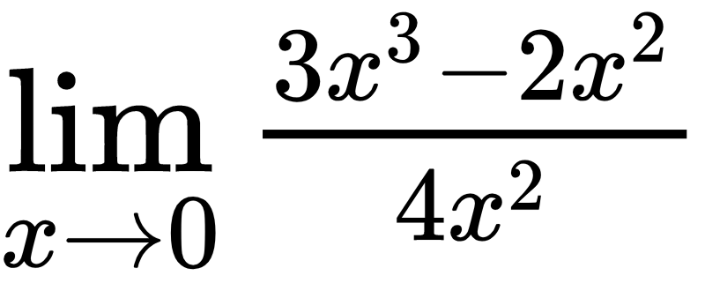 x2 \* (3x – 2) 3x -2 0,(6)

= (0/0) = lim ----------------- = lim --------- = -------

4 \* x2 4 4