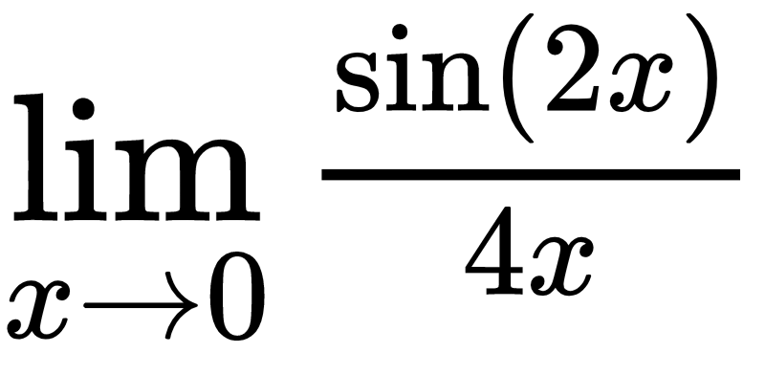

sin(2x) 1

= lim --------- = ---

2 \* 2x 2

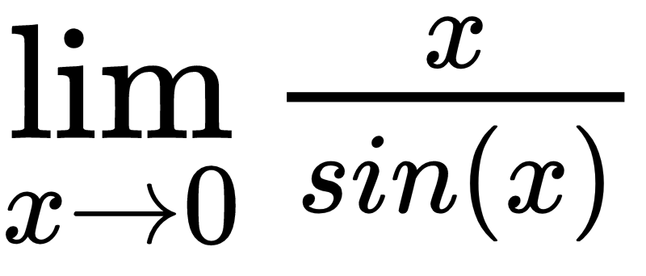

= 1

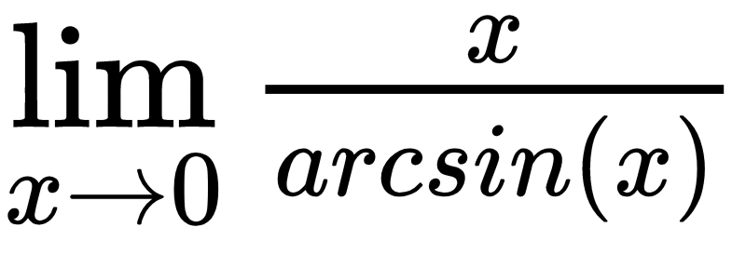

x

= lim ------- = lim (x \* sin x) = 0

sin-1x

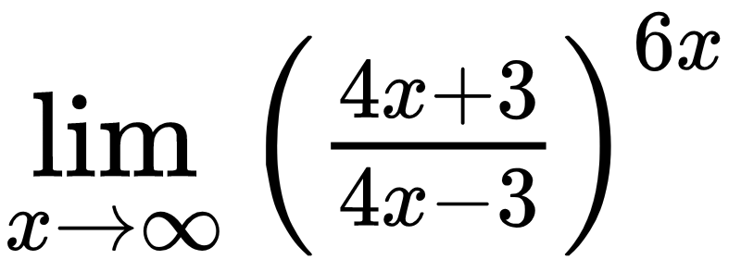

4x – 3 + 6 6

=lim ( --------------- )6x = lim ( 1 + -------- ) 6x

4x – 3 4x – 3

4x-3

z = ------

6

1 1 1

lim (1 + ---)9z +(9/2) = lim(1 + ---)9/2 \* lim(1 + ---)9u = e9

z→∞ z z z