**ILNZU**

“ILNZU” is software that provides business messaging, calling, video meetings and file sharing.

**Roles**: Guest, User

|  |  |
| --- | --- |
| Role | Description |
| Guest | Can sign up and log in. |
| User | Create meeting room, delete room, invite members, remove members, send files. Can view profile and change settings, such as name or password or delete account. |

**Task Management System**

|  |  |  |  |
| --- | --- | --- | --- |
| **Role** | **Use case** | **Description** | **Action name** |
| User | Create meeting room | Create meeting room in system | CreateRoom |
| Delete meeting room | Delete meeting room in system | DeleteRoom |
| Join meeting room | Accept invitation to meeting room | JoinRoom |

**Meeting room Management System**

|  |  |  |  |
| --- | --- | --- | --- |
| **Role** | **Use case** | **Description** | **Action name** |
| Channel admin | Invite other members | Invite other members to existing meeting room | AddMember |
| Remove member | Remove member from existing meeting room | RemoveMember |
| Share files | Send files to other members in meeting room | SendFile |
| Mute other member | Mute other members microphone | MuteMember |
| Channel guest | Share files | Send files to other members in meeting room | SendFile |
| Mute microphone | Mute guest’s microphone | MuteMicrophone |
| Activate microphone | Activate guest’s microphone | ActivateMicrophone |
| Turn off webcam | Turn off guest’s webcam | CameraOff |
|  | Turn on webcam | Turn on guest’s webcam | CameraOn |
|  | Leave meeting room | Remove himself from current meeting room | LeaveRoom |

**Account Management System**

|  |  |  |  |
| --- | --- | --- | --- |
| **Role** | **Use case** | **Description** | **Action name** |
| Guest | Sign up | Sign up in system | SignUp |
| Log in | Log in to the system | LogIn |
| User | Log out | Log out from the system | LogOut |
| Delete account | Delete user’s account from the system | DeleteAccount |
| Change profile | Change settings, such as name or password | ChangeProfile |

**Use case diagrams**

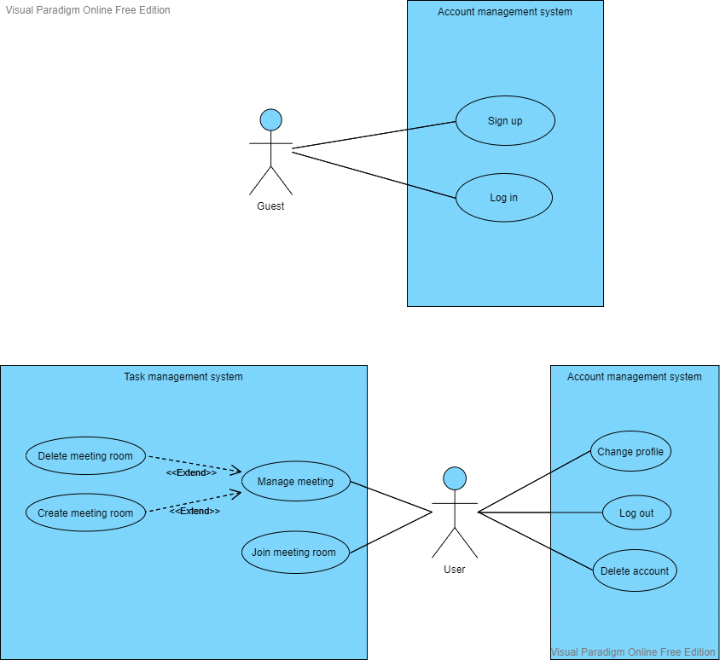

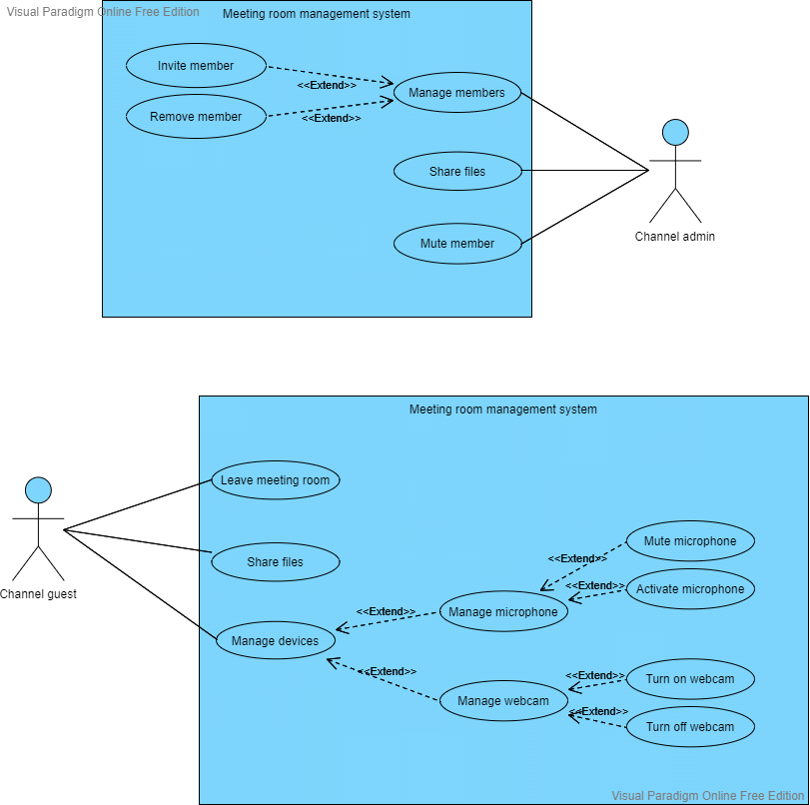

**Sequence diagram**

