1.Uloha
odpoved je D.) a A.)

2.Uloha
Odpoved je C.)

3.Uloha

a.)
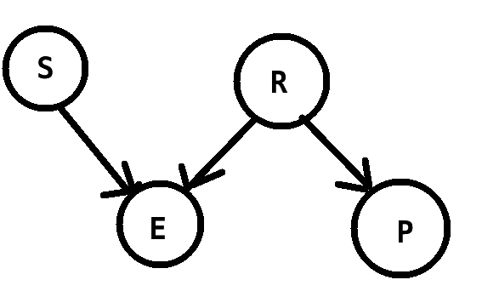

B.)

P(+S) = 0.25
P(+R) = 0.02
P(-S) = 0.75
P(-R) = 0.98
P(+E|-S,-R) = 0.01
P(+E|+S,-R) = 0.80
P(+E|-S,+R) = 0.50
P(+E|+S,+R) = 0.90

P(-E|-S,-R) = 0.99
P(-E|+S,-R) = 0.20
P(-E|-S,+R) = 0.50
P(-E|+S,+R) = 0.10

P(+P|+R) = 0.70
P(+P|-R) = 0.01

P(-P|+R) = 0.30
P(-P|-R) = 0.99

Konkretne hodnoty

P(+S,+R,+E,+P) = P(+S).P(+R).P(+E|+S,+R).P(+P|R+) = 0.25*0.02*0.90*0.70 = 0.00315
P(+S,-R,+E,+P) = P(+S).P(-R).P(+E|+S,-R).P(+P|R-) = 0.25*0.98*0.80*0.01 = 0.00196
P(-S,+R,+E,+P) = P(-S).P(+R).P(+E|-S,+R).P(+P|R+) = 0.75*0.02*0.50*0.70 = 0.00525
P(-S,-R,+E,+P) = P(-S).P(-R).P(+E|-S,-R).P(+P|R-) = 0.75*0.98*0.01*0.01 = 0.0000735

P(+S,+R,+E,-P) = P(+S).P(+R).P(+E|+S,+R).P(-P|R+) = 0.25*0.02*0.90*0.30 = 0.00135
P(+S,-R,+E,-P) = P(+S).P(-R).P(+E|+S,-R).P(-P|R-) = 0.25*0.98*0.80*0.99 = 0.19404
P(-S,+R,+E,-P) = P(-S).P(+R).P(+E|-S,+R).P(-P|R+) = 0.75*0.02*0.50*0.30 = 0.00225
P(-S,-R,+E,-P) = P(-S).P(-R).P(+E|-S,-R).P(-P|R-) = 0.75*0.98*0.01*0.99 = 0.0072765

P(+S,+R,-E,+P) = P(+S).P(+R).P(-E|+S,+R).P(+P|R+) = 0.25*0.02*0.10*0.70 = 0.00035
P(+S,-R,-E,+P) = P(+S).P(-R).P(-E|+S,-R).P(+P|R-) = 0.25*0.98*0.20*0.01 = 0.00049
P(-S,+R,-E,+P) = P(-S).P(+R).P(-E|-S,+R).P(+P|R+) = 0.75*0.02*0.50*0.70 = 0.00525
P(-S,-R,-E,+P) = P(-S).P(-R).P(-E|-S,-R).P(+P|R-) = 0.75*0.98*0.99*0.01 = 0.0072765

P(+S,+R,-E,-P) = P(+S).P(+R).P(-E|+S,+R).P(-P|R+) = 0.25*0.02*0.10*0.30 = 0.00015
P(+S,-R,-E,-P) = P(+S).P(-R).P(-E|+S,-R).P(-P|R-) = 0.25*0.98*0.20*0.99 = 0.04851
P(-S,+R,-E,-P) = P(-S).P(+R).P(-E|-S,+R).P(-P|R+) = 0.75*0.02*0.50*0.30 = 0.00225
P(-S,-R,-E,-P) = P(-S).P(-R).P(-E|-S,-R).P(-P|R-) = 0.75*0.98*0.99*0.99 = 0.7203735

Vysledna tabulka

C.)

P(+E ) = scitam vsetky z tabulky, ktore maju +enter-store , nebudem to rozpisovat, lebo je to dlhe...

teda vysledok je P(+E) = 0.21535

P(+R|+E) = P(+E|+R).P(+R) / P(+E)

Z tohoto potrebujeme zistit

P(+E|+R) = P(+S,+R,+E,+P) + P(+S,+R,+E,-P) + P(-S,+R,+E,+P) + P(-S,+R,+E,-P) = 0.00315 + 0.00135 + 0.00525 + 0.00225 = 0.012000

A teda

P(+R|+E) = P(+E|+R).P(+R) / P(+E) = (0.012000*0.02) / 0.21535 = 0.0011145

4.) Uloha
Pouzijem naivny klasifikator
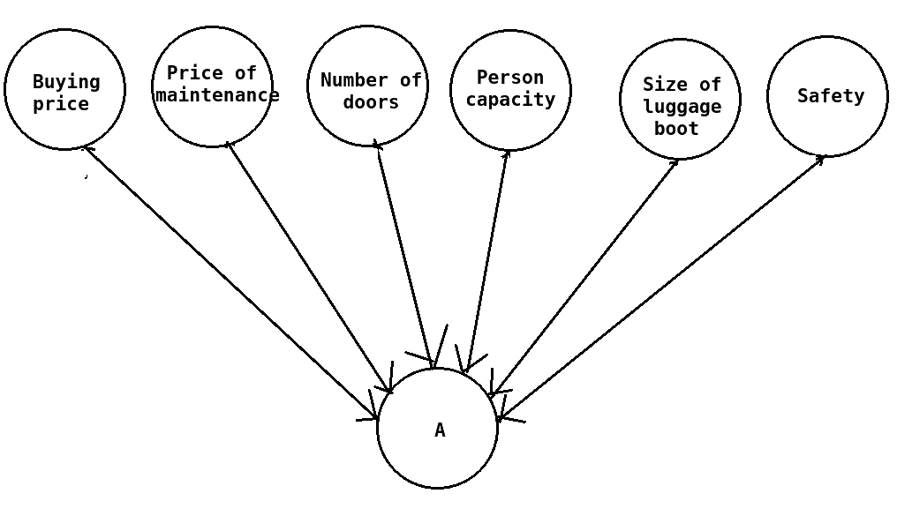
b.) Accuracy = 0.87384

c.) Confusion_matrix =

1161 47 2 0
85 289 10 0
0 46 21 2
0 26 0 39

