Sprint 1
Sprint Goal
The goal of Sprint 1 was to complete the initial clinic management functionalities and divide responsibilities among team members. The sprint focused on patient registration, editing and removing patient records, along with creating use case descriptions, diagrams, GUI design, Java implementation, and database preparation.
Sprint Duration
4–5 Days
Sprint 1 Tasks
Team Member | Responsibility
Esmita | Use Case Descriptions
Anushka | Diagrams
Mourice | GUI
Slavomir | Java Code
Miki | Database

Sprint Backlog
Task | Estimated Hours
Register Patient | 6 hrs
Edit Patient | 4 hrs
Remove Patient | 4 hrs
Use Case Descriptions | 5 hrs
Diagrams | 5 hrs
GUI Design | 6 hrs
JAVA Code | 7 hrs
Database setup | 3 hrs

Total work = 40 hours
Sprint 1 Burndown Data
Time Remaining (days) | Ideal Burndown | Actual Burndown
5 | 40 | 40
4 | 32 | 35
3 | 24 | 27
2 | 16 | 18
1 | 8 | 7
0 | 0 | 0

Sprint 1 Burndown chart
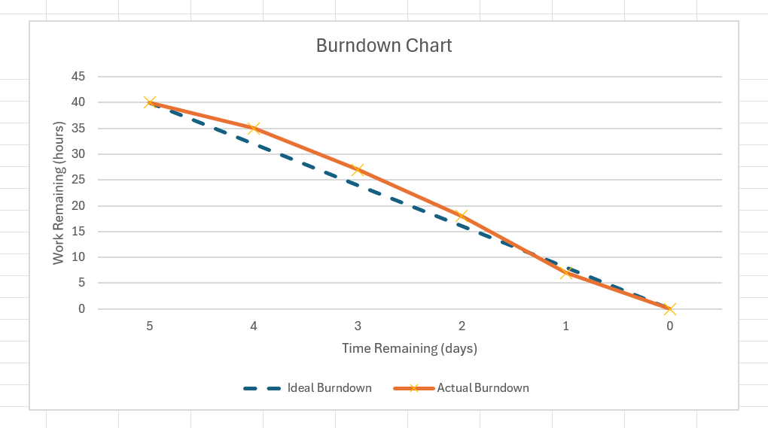

Sprint 2
Sprint Goal
The goal of Sprint 2 was to complete the remaining use case descriptions, diagrams, and database diagram documentation for the clinic management system.
Sprint Duration
3 Days
Sprint 2 Team Responsibilities
Team Member | Responsibility
Esmita | Use Cases 1 and 2 and their activity diagrams
Anushka | Use Cases 4 and 6 and their activity diagrams
Mourice | Use Cases 7 and 8 and their activity diagrams
Slavomir | Use Cases 9 and 10 and their activity diagrams
Miki | Database Diagram

Sprint 2 Backlog
Task | Estimated Hours
Use Case Descriptions | 8 hrs
Activity Diagrams | 7 hrs
Database Diagram | 4 hrs
Documentation Editing | 3 hrs

Total work = 22 hours
Sprint 2 Burndown Chart Data
Time Remaining (Days) | Ideal Burndown | Actual Burndown
3 | 22 | 22
2 | 15 | 17
1 | 7 | 9
0 | 0 | 0

Sprint 2 Burndown Chart
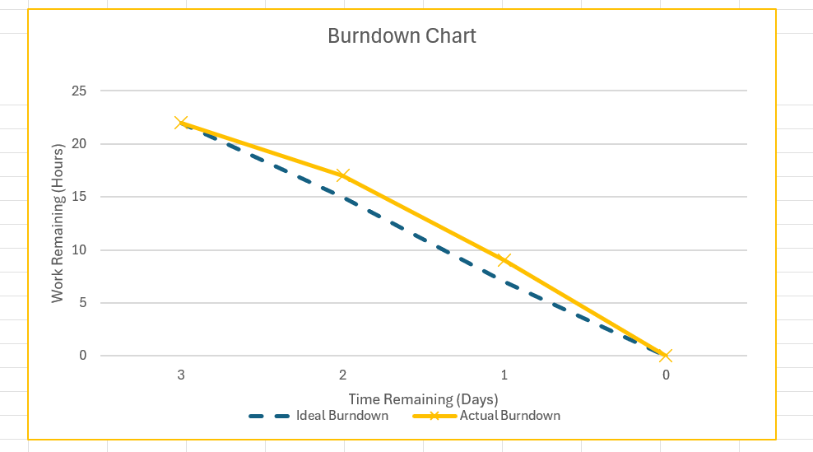

Sprint 3
Sprint Goal
The goal of Sprint 3 was to complete the final implementation tasks of the clinic management system, including database connection, appointment booking functionality, login system, system sequence diagrams, and project tracking documentation.
Sprint Duration
3–4 Days
Sprint 3 Team Responsibilities
Team Member | Responsibility
Miki | Database connection
Mourice | Appointment booking
Slavomir | Login system & System Sequence Diagrams
Anushka | Product Backlog
Esmita | Burndown Charts

Sprint 3 Backlog
Task | Estimated Hours
Database Connection | 7 hrs
Appointment Booking | 6 hrs
Login System | 5 hrs
System Sequence Diagrams | 4 hrs
Product Backlog Update | 2 hrs
Burndown Chart Creation | 2 hrs
Total work hours = 26 hours
Sprint 3 Burndown Chart Data
Time Remaining (Days) | Ideal Burndown | Actual Burndown
4 | 26 | 26
3 | 19 | 21
2 | 13 | 15
1 | 6 | 7
0 | 0 | 0

Sprint 3 Burndown Chart
