**Run Tests from Command Line**

1. Open the command prompt and navigate to project root directory. Example:

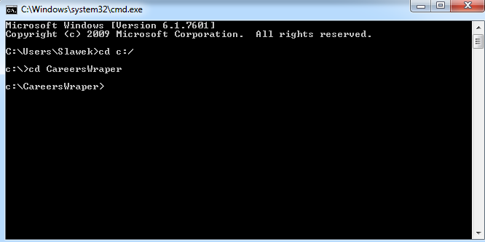

1. Run the following command in the command prompt: ***mvn test***

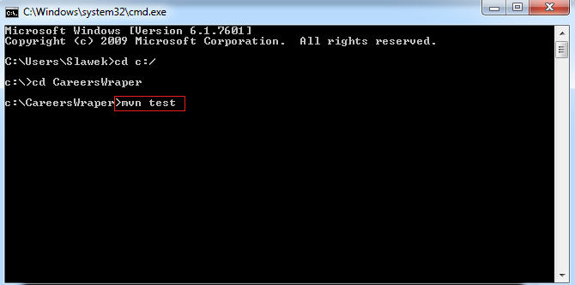

1. Results:

