Denial Appeal System

CS1530 pROJECT

sAMANTHA LAVRINC & bRANDON jABOUT

2022

Contents

Introduction 2

Prerequisites 3

Execution 3

Login Screen 4

Denial List 5

Logout 5

Letter Generation 6

Pre-Generated Appeal Reasons 7

New Appeal Reasons 7

Submit 8

PR 8

Back 8

Logout 8

# Introduction

A medical billing specialist often has multiple responsibilities that inhibit their ability to address individual claim denials. They are often the single patient advocate ensuring that health insurance claims are appropriately considered and approved by the insurance company. Because insurance company policies and CMS guidelines can change annually, denials are a regular occurrence that must be handled within a timely manner set by the insurance company. Since physician group and hospital sizes can vary, daily denials can range anywhere from dozens to hundreds that must be considered and processed by the billing specialist. By streamlining the appeal letter process, our group has the goal of easing the burden of the billing specialist so that they can continue to effectively advocate on behalf of the patient and physician to ensure medical procedures are covered by insurance companies.

The functionality of this software includes:

* Allowing the User to login to the system and displaying an error if the connection cannot be established.
* Displaying a list of all the current insurance claim denials for the user to select.
* Displaying the patient information so that the user can assess whether a new appeal reason should be created.
* Allowing the user to either select a pre-generated appeal reason or create their own.
* Allowing the user to choose whether to save the appeal reason into the database for future use.
* Allowing the user to determine whether the denial was reasonable and set the claim status to patient responsibility if the patient is responsible for any outstanding balance.
* Update the claim status to ‘appeal sent’ if an appeal was generated.
* Generate an appeal letter to send to the insurance company.

By using this software, a company can:

* Increase revenue for the Medical Group
* Reduce procedure write offs from timely filing or timely appeal denials
* Increase ability to determine patterns impacting claim approvals
* Increase appeal letter determination efficiency
* Allow for more effective patient service advocacy
* Allow the billing specialist more time to focus on their other responsibilities

# Prerequisites

1. Run the createDB.sql file in Datagrip to populate the demo tables.
2. Run the populateDB.sql file in Datagrip to populate the demo data.
   1. Within the populateDB.sql file, add your own username and password in the appropriate fields for the last instruction that reads:

**INSERT INTO VALID_USERS (username, password) VALUES ('enterusername**', 'enterpassword**');**

1. Run the FunctionsDB.sql file in Datagrip to create the database functions.
2. Ensure that postgresql-42.2.18.jar ([or the appropriate jar file according to the system](https://jdbc.postgresql.org/download.html)) is listed as a dependency.
3. Ensure that KGradientPanel-SNAPSHOT.jar is listed as a dependency.

# Execution

1. In the command prompt, change directories until you are in the root directory of the Denial Appeal System program.
2. Run the makefile by typing

**make**

1. Start the program by entering one of the following:

**java -cp postgresql-42.2.18.jre7.jar:. DASPackage/DenialAppealSystem.java** (Java 7)

**java -cp postgresql-42.2.18.jar:. DASPackage/DenialAppealSystem.java** (Java 8)

For Windows:

**java -cp "postgresql-42.2.18.jre7.jar;."** **DASPackage/DenialAppealSystem.java** (Java 7)

**java -cp "postgresql-42.2.18.jar;."** **DASPackage/DenialAppealSystem.java** (Java 8)

# Login Screen

To log in, enter a valid username and password for the DataGrip Postgresql Database and select the ‘Login’ button.

# Denial List

Figure 1 - Demonstration data does not include any actual patient information; any similarities are a result of coincidence.

The denial list screen displays a list of patient names, insurance names, the dates of service and denial reasons. This allows the user to reflect on any denial patterns to address and correct filing errors at the point of entry.

To select a denial, double-click on the desired patient. This will bring up a third screen where denial details are displayed for the specified patient.

## Logout

The ‘Logout’ button closes the connection to the database and returns the user to the login screen.

# Letter Generation

Figure 2 - Demonstration data does not include any actual patient information; any similarities are a result of coincidence.

The letter generation screen displays the information required to determine whether the denial reason is accurate according to the services rendered by the physician. It also includes all the information necessary for the user to write and/or save a new appeal reason. When the user selects the ‘Submit’ button, a text document will be generated in the root folder for the user to print and send to the insurance company.

## Pre-Generated Appeal Reasons

A list of previously generated appeal reasons can be selected in the ‘Appeal Reason’ drop-down menu option.



When one of these pre-generated appeal reasons is selected and the user clicks the ‘Submit’ button, the system retrieves the corresponding text that matches the appeal reason to generate a text document which functions as a letter to send to the insurance company on behalf of the patient.

## New Appeal Reasons

An option to create a new appeal reason is included in the software.

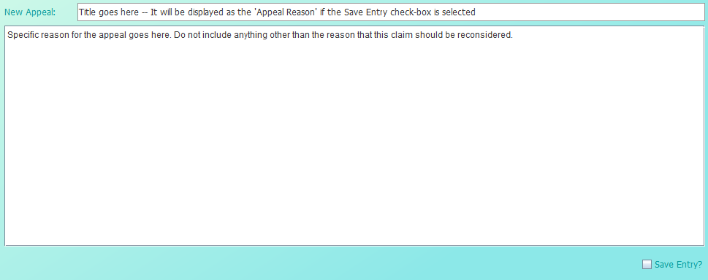

To create a new appeal reason, enter a title for the appeal which will be displayed in the pre-generated appeal reasons if the ‘Save Entry?’ box is selected. Then, in the larger text box, write a specific reason for the claim reconsideration. This will be added to a generated letter which is pre-formatted with specific patient and service information (see below).

If the appeal reason is general and can be applied to future claim denials, the user should select the ‘Save Entry?’ check box prior to clicking the ‘Submit’ button to save the appeal reason to the database.

If the appeal reason is **very specific and contains HIPAA information that should not be saved** in the database, the user **should not** select the ‘Save Entry?’ check box prior to clicking the ‘Submit’ button so that the **appeal reason is not saved to the database.**

## Submit

When the ‘Submit’ button is selected, a text document in the form of an appeal letter will be generated with the user selected appeal information. The program will then update the claim status information to reflect that an appeal was sent to the insurance company on behalf of the patient and is awaiting a response from the insurance company. The user will be returned to the updated denial list of claims.

## PR

The ‘PR’ button should be selected if the user determines that the denial is valid, and the outstanding balance is the responsibility of the patient. The program will then update the claim status information to reflect that the patient is responsible for the outstanding balance. The user will be returned to the updated denial list of claims.

## Back

The ‘Back’ button returns the user to the previous denial list.

## Logout

The ‘Logout’ button closes the connection to the database and returns the user to the login screen.