Sławomir_Dobroś_iOS Developer

Sławomir Dobroś

2016

Table of Contents

Technical information 1

Package contents 1

How to run 1

Customers_self-hosted_service 2

Customers_WinForm_UI 3

Description of the solution 3

# Technical information

* Project is created in Visual Studio 2015
* Used .net framework version 4.5.2
* Can use MS SQL Database or XML file to storage data (instructions below)
* To start “Customers_self-hosted_service.exe” (after build), please use the administrator privileges (protocol of service must register URL address)

# Package contents

|  |  |
| --- | --- |
| Folders and files | Description |
| * Visual Studio Solution   + Customers_self-hosted_service   + Customers_WinForm_UI * Documentation of code * Other projects (code examples)   + xxxxxxxxxxxxxxxxxxxxxxxxx   + yyyyyyyyyyyyyyyyyyyyyyyy * Documentation.pdf | Folder with VS solution |
| VS project: self-hosted service (console application) |
| VS project: user interface example (WinForm application) |
| Documentation of code in HTML (start index.html) **\*** |
| Two other projects not related with this task **\*\*** |
|  |
|  |
| This file |

**\*** dddddd  
**\*\*** ssssssss

# How to run

You need to build both projects in this solution. First I propose ‘self-hosted service’, next ‘WinForm UI’.

### Customers_self-hosted_service

On this stage you can decide which method of data storage you want to use. You can chose between XML File or MS SQL Database.

#### XML file storage

If you decide to use XML file, please type ‘XML_DATA’ compilation symbol in the 'Build' section of project properties (Pic. 1). File will be created automatically during first run.

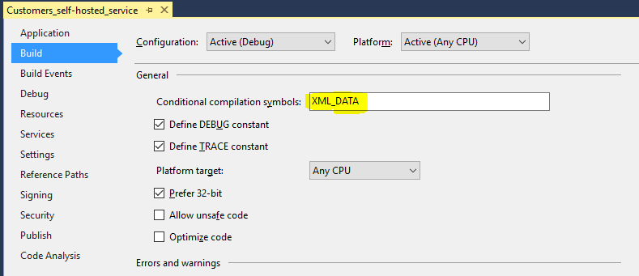  
Pic. 1

#### MS SQL Database

In this case, you should type ‘SQL_DATA’ compilation symbol (the same way as above). You also need to have the prepared database beforehand (the script is available within the project). In project properties settings, enter correct connection string (Pic. 2)

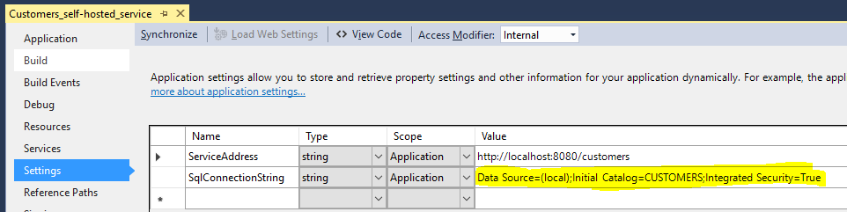

Pic. 2

#### Service endpoint

You can also change address and port number where service endpoint runs. By default it is http://localhost:8080/. To change it, please go to properties of project. Then select the section ‘Settings’ and enter what you need (Pic. 3).

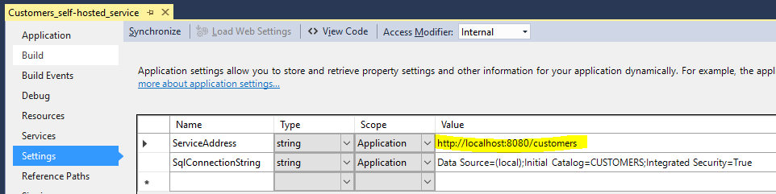

Pic. 3

### Customers_WinForm_UI

If you did not change the address of the self-hosted service, you do not need additional settings to compile it. But if the service is running on a different address or port, you need to configure properly 'CustomersService' in Service References of project.

# Description of the solution

The main goal of this project was to implement a module which will be responsible for creating, removing and updating data of Customer. I decided on using a WCF service application which is working on the server side and a standard WinForm application as user interface. The main benefit of this approach is that created module can communicate not only with another .NET applications but also with any other solution based on the standard wsdl.

Using this solution, it is easy to prepare other interfaces for data entry, eg. for iOS, Android, IIS application etc. It is also possible to create other solutions for automatic data entry. On the server side, we have, therefore, one and the same code, regardless of whether the client application is running on the same computer, on the same local network, or in any other place in the world using the Internet. It also doesn’t matter what operating system is installed on the client computer.

General principles of operation are shown below, on the picture 4.

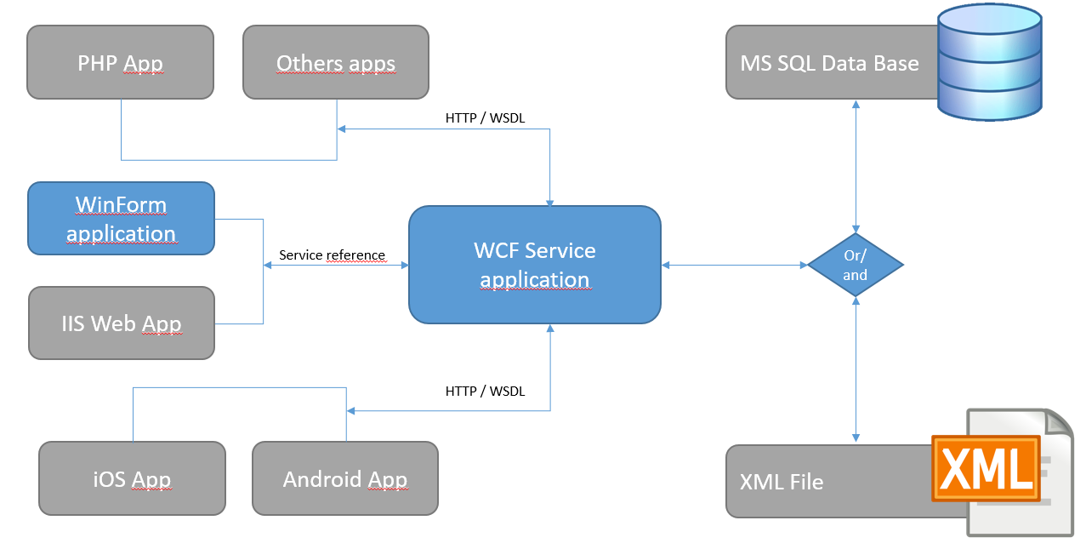

Pic. 4

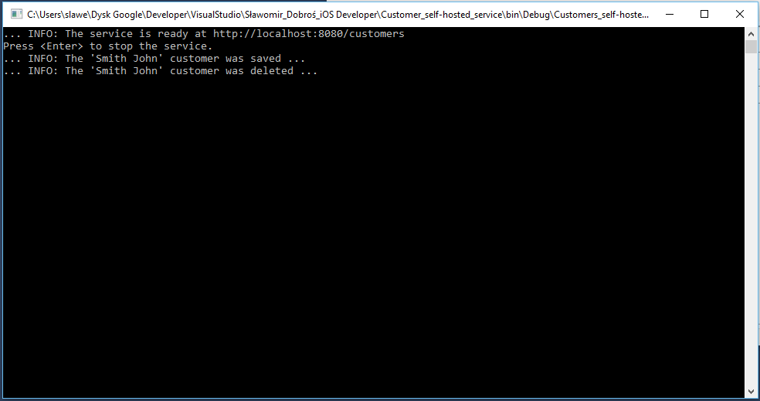

Pic. 5.

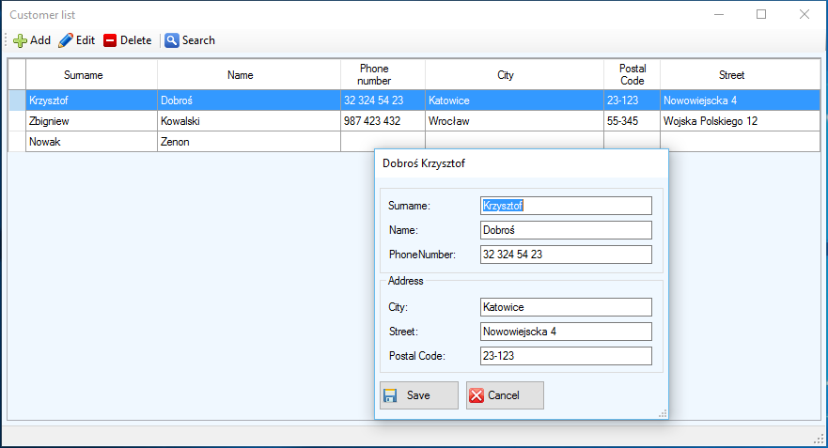

Pic. 6.