**CSY1018**

WEB DEVELOPMENT

ASSIGNMENT

**THE UNIVERSITY OF NORTHAMPTON**



BSC COMPUTING

CSY1018 WEB DEVELOPMENT

WEB ASSIGNMENT

SUBMITTED BY SUBMITTED T0:

NAME: SUSHANT DAHAL

UN ID:17425084

CONTENTS

INTRODUCTION 5

WIREFRAME 6

HOME PAGE 6

CV PAGE 7

BIO PAGE 8

CONTACT PAGE 9

GOOD PRACTISE 10

PAGE LOAD SPEED 10

VISUAL APPEAL 10

NAVIGATION 10

PROGRESS REPORT 11

WEEK 1-4 11

WEEK 5-7 12

WEEK 8-12 14

REFERENCE 17

## 

## 

# 

# INTRODUCTION

THIS ASSIGNMENT IS BEGINNING OF MY WEB DEVELOPMENT WHICH IS QUITE SIMPLE AND I WILL MAKE IT CREATIVE AND ATTRACTIVE. USING HTML AND CSS, I SHOULD HAVE TO CREATE FOUR WEBPAGES INDEX.HTML, CV.HTML, BIO.HTML AND CONTACT.HTML.I WILL VISIT DIFFERENT WEBSITE AND LEARN DIFFERENT IDEA WHEN I WILL START MY ASSIGNMENT.

# WIREFRAME

HOME PAGE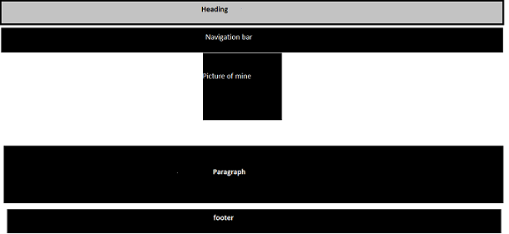

THIS IS MY WIREFRAME FOR THE HOME PAGE AND INCLUDES HEADER WHICH HAS HEADING ON THE TOP OF THE PAGE. NAVIGATION BAR IS JUST BELOW. THE NAVIGATION BAR WILL BE GREEN/BLUE IN COLOR AND WHEN ON HOVER IT WILL CHANGE TO BLACK COLOR. THERE WILL BE LINK TO OTHER PAGE SO USER DON’T HAVE ANY PROBLEM VISITING ANOTHER WEBSITE.

ON THE MIDDLE OF THE PAGE THERE IS MAIN IMAGE. PARAGRAPH IS JUST BELOW WHERE I WILL BE WRITING BRIEF ABOUT LINK IN THE NAVIGATION BAR. FOOTER WILL BE AT THE END OF THE PAGE. THERE WILL BE LINK TO MY FACEBOOK PROFILE.

## CV PAGE

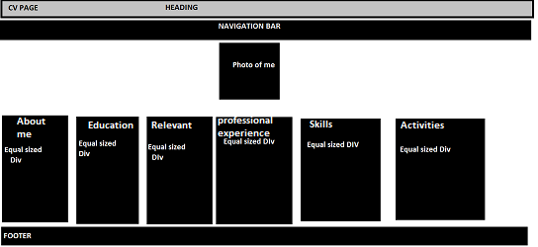

FOR MY CV PAGE I HAVE INCLUDED THE SAME NAVIGATION BAR AND HEADING, WHICH I WILL BE INCLUDING IN EACH PAGE AT THE TOP. ON THE MIDDLE OF THE PAGE WHERE THERE IS A MAIN IMAGE. I HAVE GOT 6 SIX DIV NEXT TO EACH OTHER WHICH INCLUDE ABOUT ME, EDUCATION, RELEVANT WORK, PROFESSIONAL EXPERIENCE, SKILLS AND ACTIVITIES. FOOTER WILL BE AT THE END OF THE PAGE. THERE WILL BE LINK TO MY FACEBOOK PROFILE.

## BIO PAGE

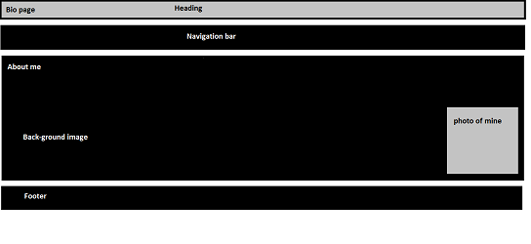

FOR MY BIO PAGE, I HAVE INCLUDED SAME HEADING AND NAVIGATION BAR WHICH I WILL BE INCLUDING ON THE TOP OF THE PAGE. ON THE MIDDLE OF THE PAGE I WILL USE DIV WHICH INCLUDE MY BIO (ABOUT ME). IN THIS DIV I WILL INCLUDE TWO IMAGES BACK-GROUND IMAGE AND PHOTO OF MINE. FOOTER WILL BE AT THE END OF THE PAGE THERE WILL BE LINK TO MY FACEBOOK PROFILE AND I WILL ALSO INCLUDE SCREENSHOT OF THE CURRENT LOCATION OF MINE.

## CONTACT PAGE

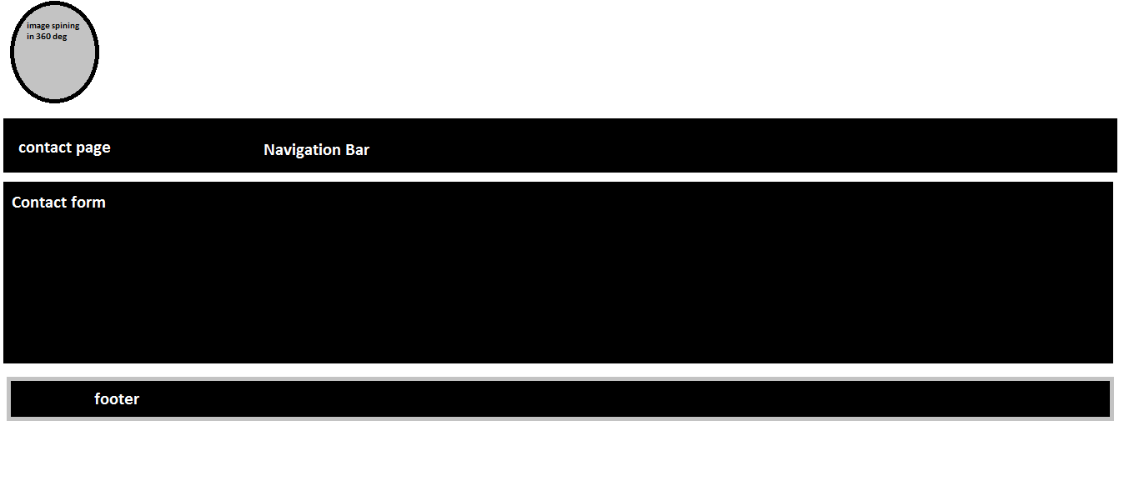

I HAVE INCLUDED ROUNDED IMAGE ON THE TOP OF THE PAGE WHEN ON HOVER THE IMAGE WILL SPIN ON 360 DEG. BELOW THERE IS NAVIGATION BAR WHICH IS LIKE ABOVE PAGES. THE CONTACT FORM WILL BE IN THE MIDDLE OF THE PAGE WHICH WILL HELP VISITOR TO SEND ME AN EMAIL FROM THE FORM. DIV OF THE CONTACT FORM WILL BE SO MUCH ATTRACTIVE I WILL BE USING LINEAR- GRADIENT GREEN, BLUE COLOR IN THE BACKGROUND OF THE DIV WHICH WILL CREATE LOTS OF ATTENTION TO THE USER. FOOTER WILL BE AT THE END OF THE PAGE THERE WILL BE LINK TO MY FACEBOOK PROFILE, TWEETER AND MY PHONE-NUMBER.

# GOOD PRACTISE

## PAGE LOAD SPEED

MAKING ATTRACTIVE WEBSITE IS NOT SUFFICIENT FOR THE GOOD WEBSITE IMPORTANT THING IS HOW FAST IS YOUR WEBPAGE IS LOADING I HAVE TESTED MY WEB PAGE ON TOOLS.PINGDOM.COM AND ITS SHOWS MY WEBPAGE IS LOADING IN 1.43S.(PINGDOM.COM,2017)

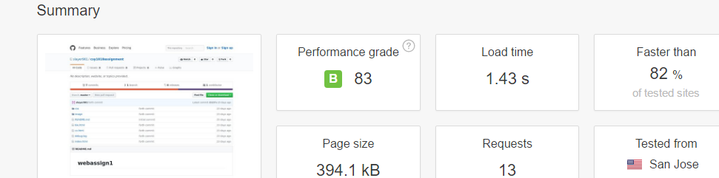

## VISUAL APPEAL

I HAVE MADE QUITE SIMPLE DESIGN AND I HAVE USE PROPER USE OF COLOR. I HAVEN’T USE ANY UNNECESSARY GRAPHIC AND COLOR WHICH MAY BRING BAD IMPACT ON VISITOR.

## NAVIGATION

IT IS QUITE SIMPLE FOR VISITOR TO NAVIGATE MY WHOLE WEBSITE ALSO I HAVE USE NAVIGATION LINK IN ON THE TOP OF EACH WEBPAGE I HAVE CREATED IT WILL BE SIMPLE FOR VISITOR TO VISIT EACH PAGE.

# PROGRESS REPORT

## WEEK 1-4

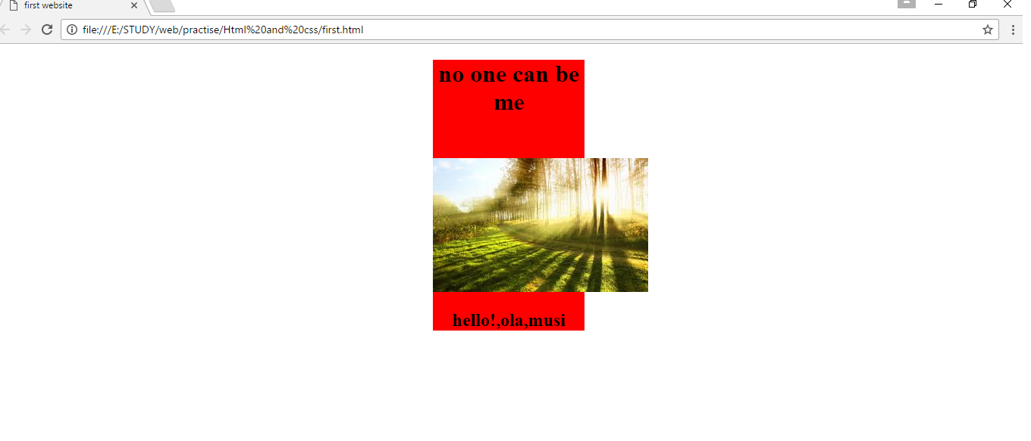

THIS IS MY FIRST PAGE I HAVE CREATED IN FIRST FEW WEEKS HERE I WAS ABLE TO ADD THE PICTURE IN WEBPAGE AND IN THE MIDDLE OF THE PAGE. I COULD ADD HEADING TAG ON THE TOP OF THE PAGE AND PARAGRAPH TAG JUST BELOW PICTURE.

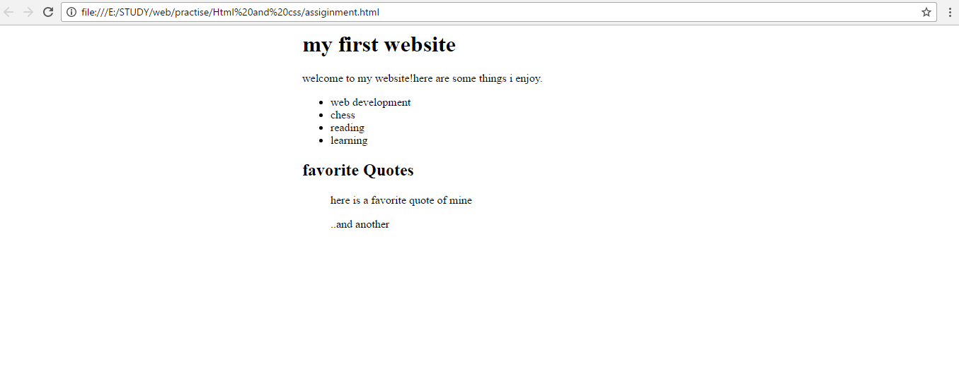

IN THIS WEBPAGE, I COULD LIST OUT THE ITEM USING <UL> TAG AND <LI> TAG FOR LISTING THE ITEM AND I STARTED MY CSS JOURNEY IN THIS PAGE.

## WEEK 5-7

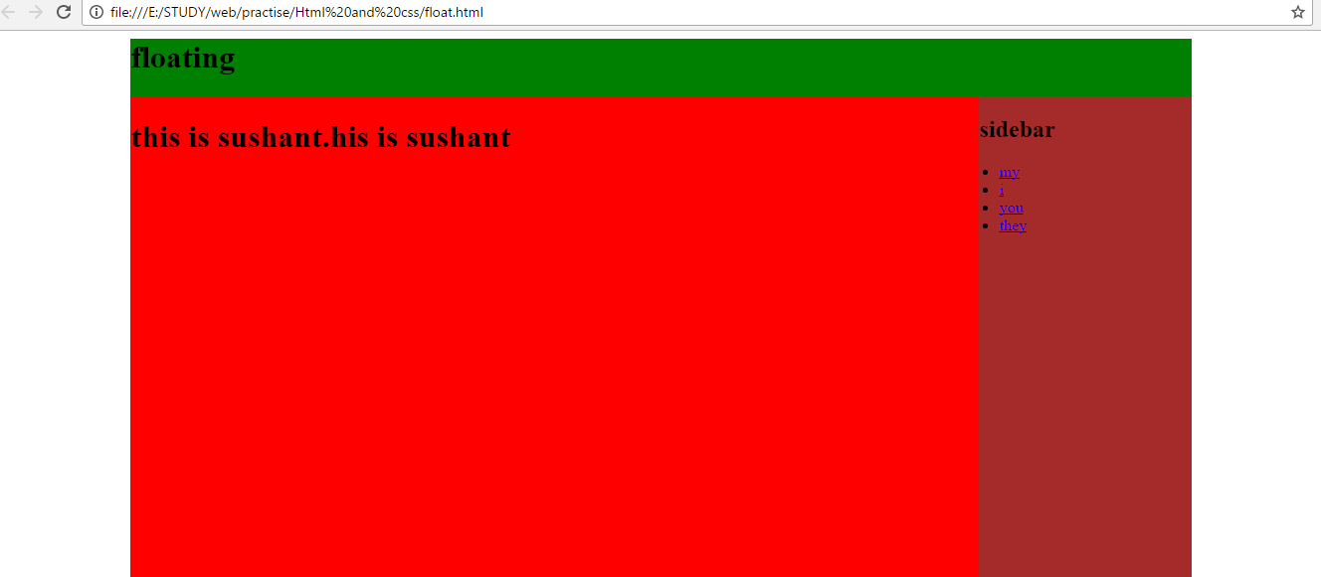

IN THIS WEBPAGE, I COULD UNDERSTAND THE PROCESS OF FLOAT HERE MY SIDEBAR FLOATS TO LEFT AND FINALLY I WAS ABLE TO UNDERSTAND THE USE OF DIV TAG AND ABOUT WIDTH OF THE PAGE HEIGHT OF THE PAGE.

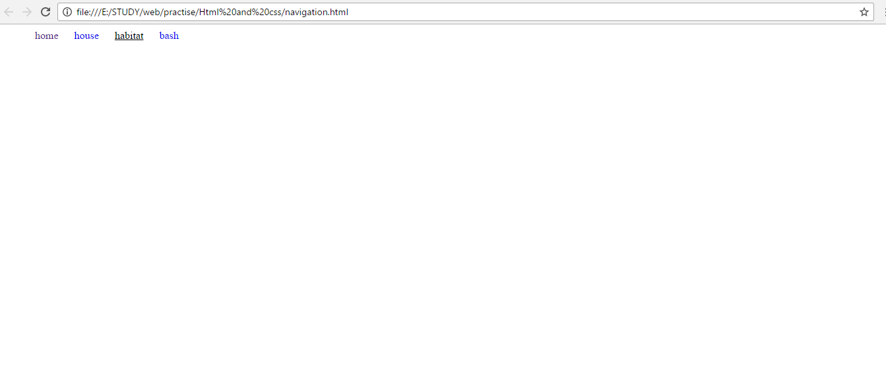

IN THIS WEBPAGE, I HAVE MY NAVIGATION BAR HORIZONTALLY PLACED WHICH IS POSSIBLE BY FLEX. AND I HAVE DONE HOVER TO MY NAVIGATION BAR WHILE TOUCHING WITH MOUSE POINTER IT WILL BE TURN BLUE COLOR TO BLACK COLOR.

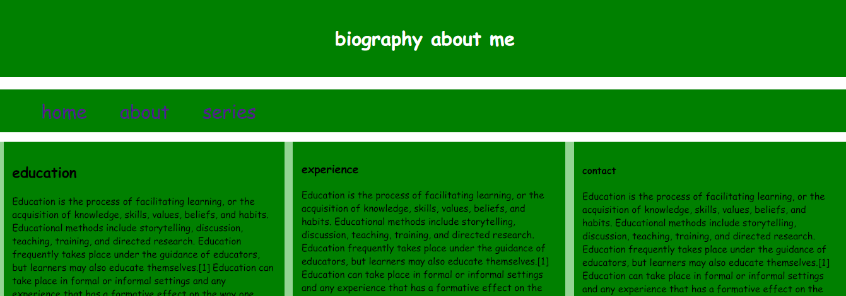

IN THIS WEBPAGE, I HAVE DONE GOOD COLORING AND I WAS ABLE TO MAKE THESE THREE DIV DOWN BELOW NAVIGATION BAR IN VERTICAL FORMAT AND NEXT TO EACH OTHER WITH THE HELP OF FLEX AND JUSTIFY-CONTENT TAG IN CSS.

## WEEK 8-12

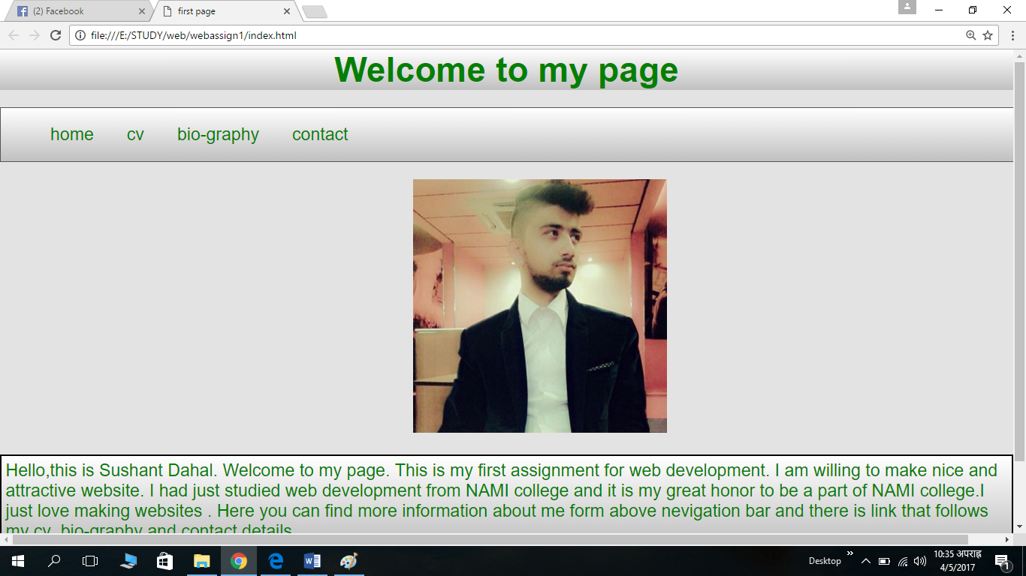

THIS IS MY WEBSITE I HAVE BEEN MAKING THIS IN MY 8TH WEEK I HAVE DONE LOTS OF CHANGE IN MY WEBSITE I HAVE GOT BORDER FOR EVERY DIV IN THIS PAGE AND I HAVE GOT LINEAR GRADIENT BACKGROUND FOR EVERY DIV AND THIS MY HOME PAGE FOR MY ASSIGNMENT.

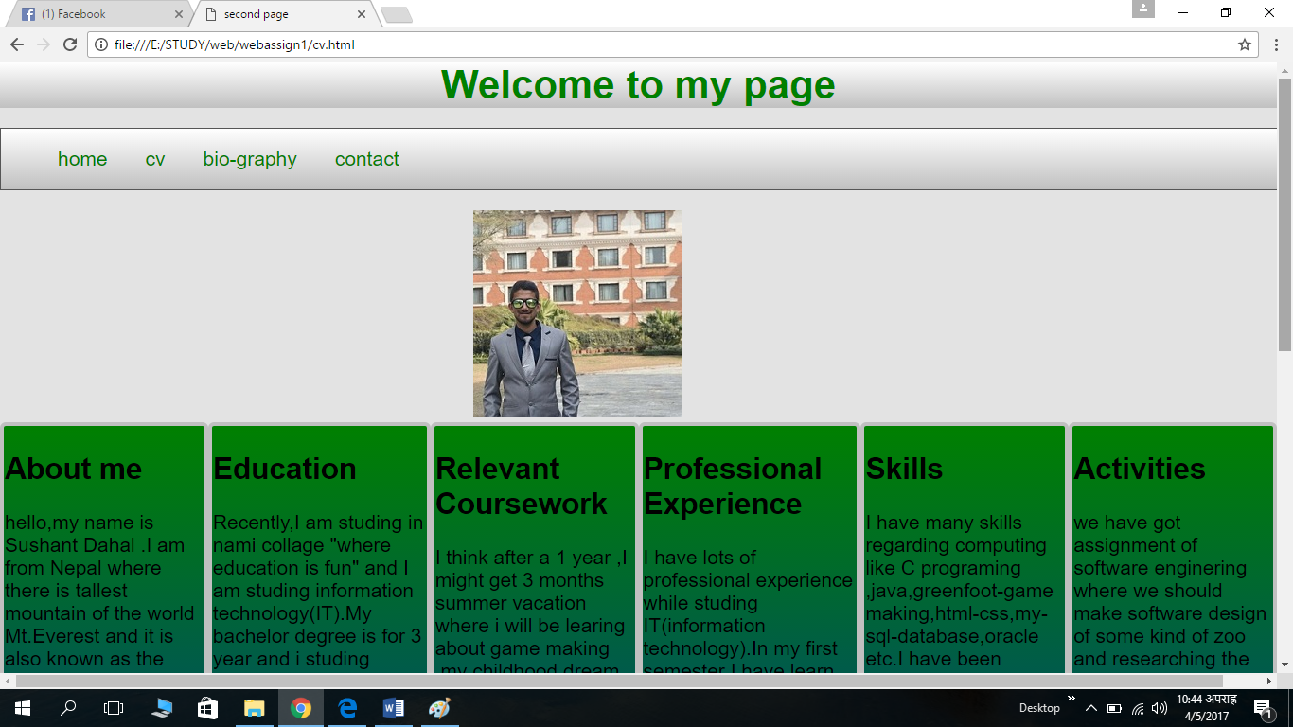

THIS IS MY CV PAGE AND THIS IS FOR MY ASSIGNMENT WHERE HERE I HAVE DESCRIBE ABOUT MY PORTFOLIO. HEADING AND NAVIGATION BAR AND ARE LIKE HOME PAGE AND THERE ARE 6 DIV DOWN BELOW AND THEY ARE NEXT TO EACH OTHER FOLLOWING FLEX.

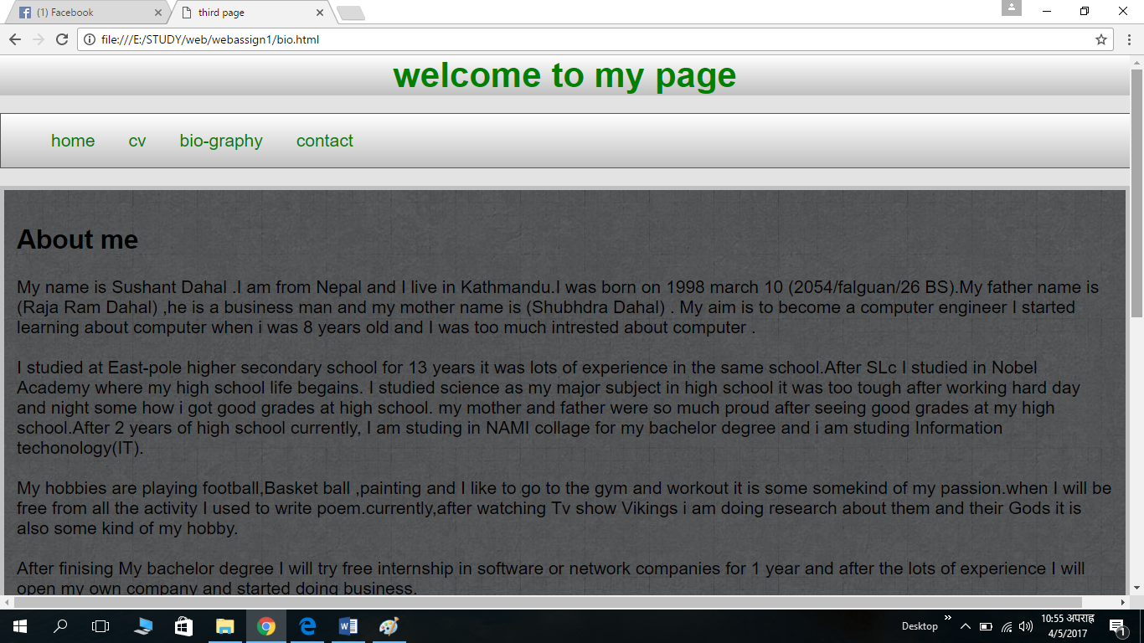

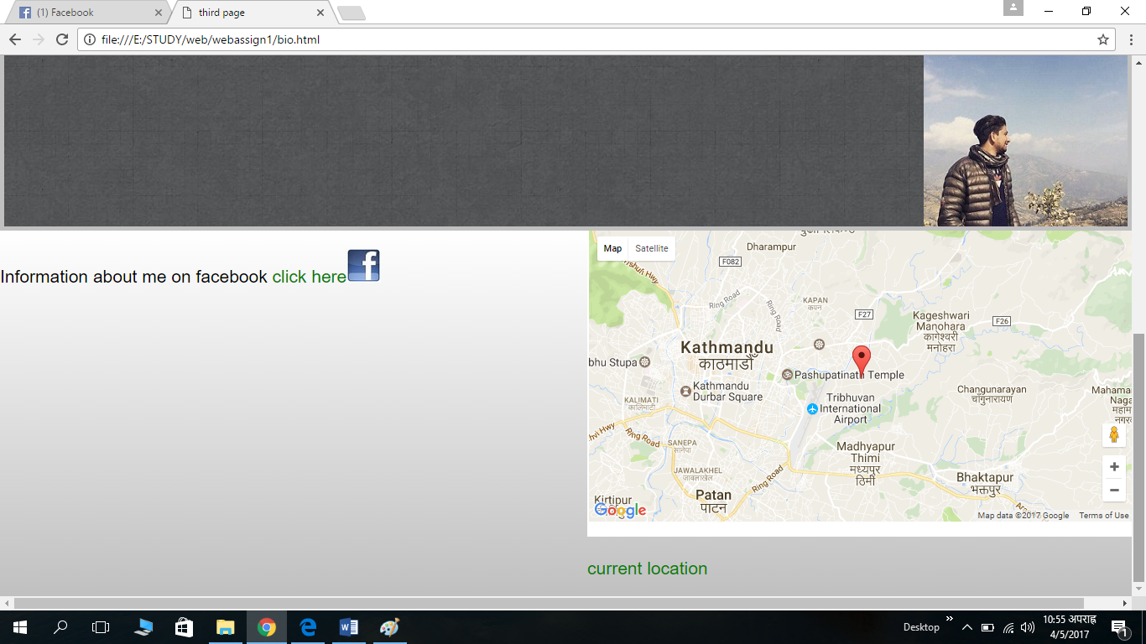

THIS IS MY BIO PAGE WHERE IS HAVE DONE DIFFERENT CHANGE JUST LIKE I HAVE GOT BACKGROUND IMAGE AND PHOTO OF ME ON THE SECTION PART AND ON FOOTER I HAVE SCREEN SHOT OF MY CURRENT LOCATION.

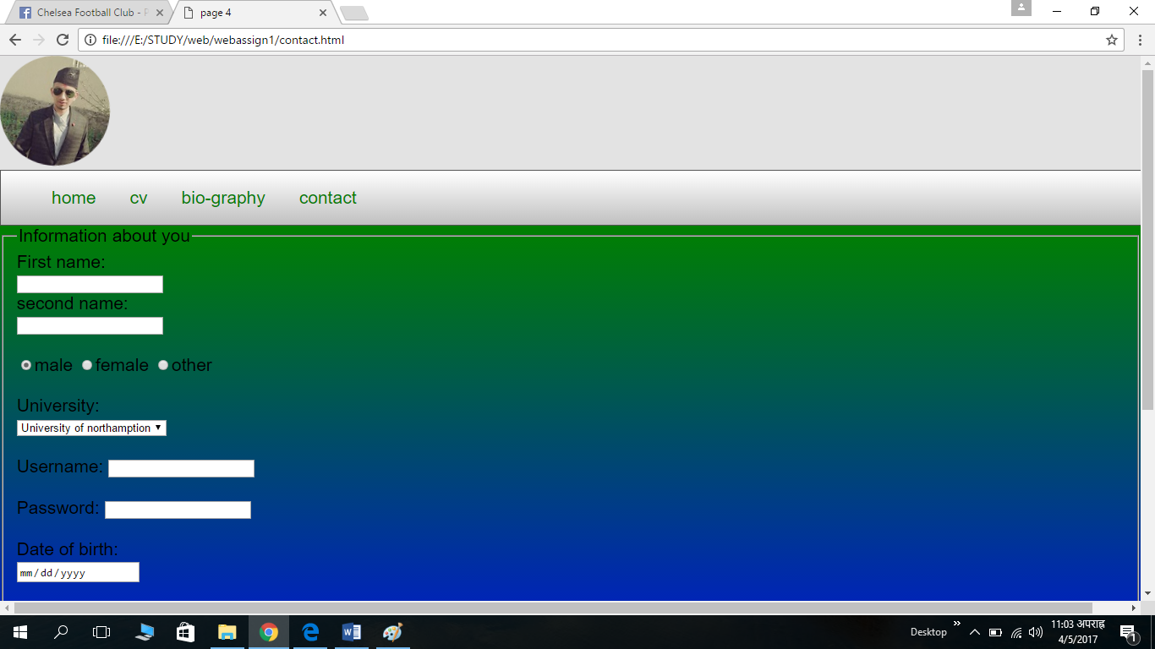

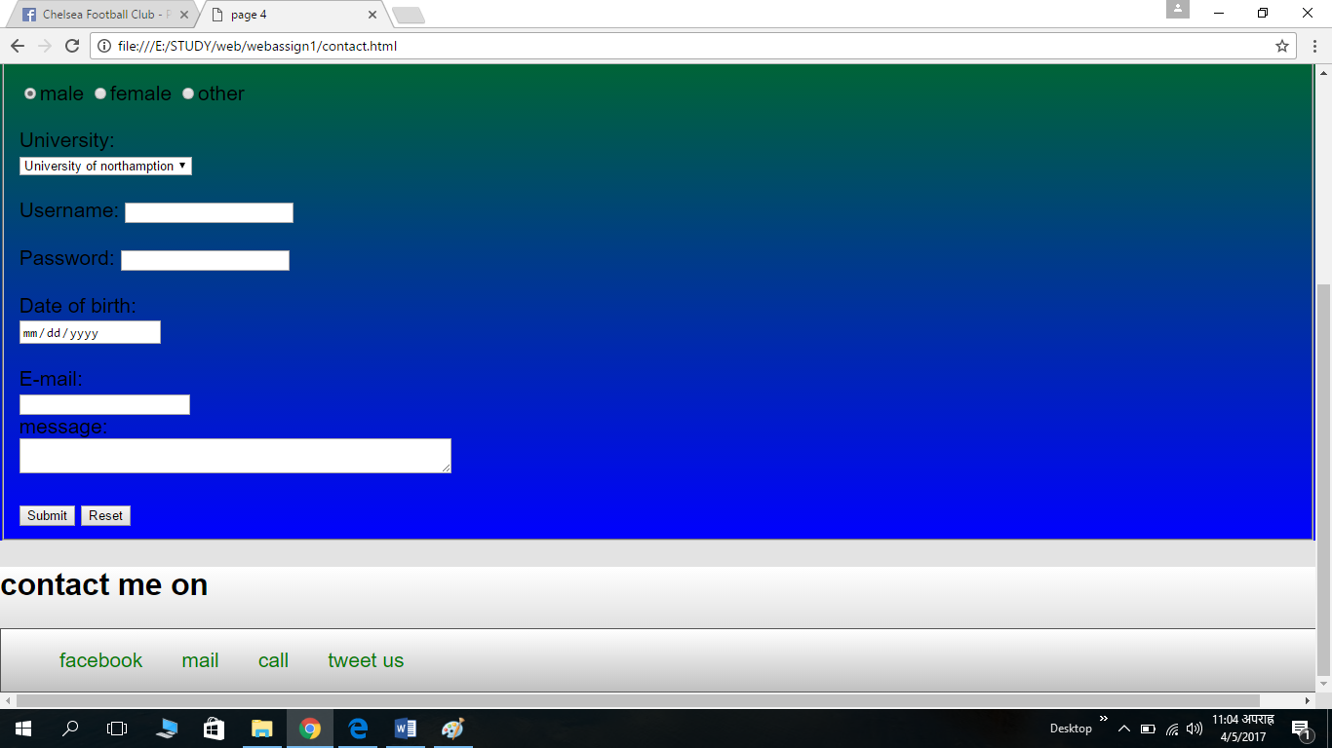

THIS IS MY CONTACT PAGE VISITOR CAN SEND ME EMAIL AFTER VISITING MY WEBSITE, ON THE TOP OF THE PAGE THERE IS ROUNDED IMAGE WHERE I HAVE BORDER RADIUS AND I HAVE ANIMATED THAT IMAGE WHICH CAN TURN 360 DEG WHILE HOVERING. AND IT LAST PAGE FOR MY ASSIGNMENT.

# 

# REFERENCE

NAMICOLLAGE.2014.AVALIBLE FROM : http://nami.edu.np/. [ACCESED ON MARCH 8 2017]

W3SCHOOLS(2017).AVAILABLE FROM <https://www.w3schools.com/> [ACCESED 9TH MARCH 2017]

PINGDOM(2016)AVAILABLE FROM <https://tools.pingdom.com/#!/eN3BOg/https://github.com/slayer901/csy1018assignment> [ACCESED ON 8TH APRIL 2017]

[Envato Tuts+](https://www.youtube.com/channel/UC8lxnUR_CzruT2KA6cb7p0Q)(2012). *COURSE INTRODUCTION(30 DAYS TO LEARN HTML AND CSS).* AVAILABLE FROM <https://www.youtube.com/watch?v=yTHTo28hwTQ&list=PLgGbWId6zgaWZkPFI4Sc9QXDmmOWa1v5F> (ACCESSED 1ST MARCH 2017)